Error lfs
$ git lfs install –skip-smudge

Bash Commands:

Note that “~” corresponds to c:\users\<username>

$ cd ~

Remove a directory

$ rm –r folder

$ echo –n abcd > file01.txt //-n suppress newline

Creates four empty files

$ touch a b c d

Will display the line numbers

$ cat –n file01.txt

$ pwd

$ ls

$ ls –F //to help distinguish directories from regular files

$ ls –la

$ ls -a

$ touch text01.txt // Create empty file

$ echo “line 1” > test01.txt

$ echo “line 1” >> test01.txt

$ cat test01.txt

$ find .git/objects

Git Commands

$ git <git-options> <command> <command-options> <operands>

$ git

$ git help glossary

$ git help –a //list of over 150 commands

$ git help –g //list of common guides

$ git help config

$ git config –h

$ git config --help

Common Commands

add | Add file contents to the index.
bisect | Find by binary search the change that introduced a bug.
branch | List, create, or delete branches.
checkout | Switch branches or restore working tree files.
cherry | Find commits yet to be applied to upstream (branch on the remote).
cherry-pick | Apply the changes introduced by some existing commits.
clone | Clone a repository into a new directory.
commit | Record changes to the repository.
config | Get and set repository or global options.
diff | Show changes between commits, commits and working tree, and so on.
fetch | Download objects and refs from another repository.
grep | Print lines matching a pattern.
help | Display help information.
log | Show commit logs.
merge | Join two or more development histories together.
mv | Move or rename a file, directory, or symlink.
pull | Fetch from, or integrate with, another repository or a local branch.
push | Update remote refs along with associated objects.
rebase | Forward-port local commits to the updated upstream head.
rerere | Reuse recorded resolution for merged conflicts.
reset | Reset current HEAD to the specified state.
revert | Revert some existing commits.
rm | Remove files from the working tree and from the index.
show | Show various types of objects.
status | Show the working tree status.
submodule | Initialize, update, or inspect submodules.
subtree | Merge subtrees and split repositories into subtrees.
tag | Create, list, delete, or verify a tagged object.
worktree | Manage multiple working trees.

Plumbing commands
$ git cat-file
$ git ls-files

the plumbing command, cat-file. You use two options here:
-t = type—shows the type of the object
-p = pretty—prints information about the object

cat-file | Provide content or type and size information for repository objects
commit-tree | Create a new commit object.
count-objects | Count an unpacked number of objects and their disk consumption.
diff-index | Compare a tree to the working tree or index.
for-each-ref | Output information on each ref.
hash-object | Compute object ID and optionally create a blob from a file.
ls-files | Show information about files in the index and the working tree.
merge-base | Find as good common ancestors as possible for a merge.
read-tree | Read tree information into the index.
rev-list | List commit objects in reverse chronological order.
rev-parse | Pick out and massage parameters.
show-ref | List references in a local repository.
symbolic-ref | Read, modify, and delete symbolic refs.
update-index | Register file contents in the working tree to the index.
update-ref | Update the object name stored in a ref safely.
verify-pack | Validate packed Git archive files.
write-tree | Create a tree object from the current index.

When both types are specified, if there is a possibility of Git not being able to tell the difference between a commit | branch | tag and one or more of the filenames or paths, then you can separate the two types using the special separation symbol “--”. Normally, this won’t be needed if a commit is expressed as a SHA1 value, but it may be needed if branch or tag names could be mistaken as names for files or paths.

As an example, the command $ git <command> a1b2c3d4 file1.txt might be clear enough, but git <command> my-tag-name -- my-file-name could be ambiguous enough when parsed to
require the “--” separator symbol.

Arguments supplied either to Git or to Git commands can be abbreviated as a single letter or spelled out as words. One important note here is that if the argument is spelled out, you must precede it with two hyphens, as in --global. If the argument is abbreviated, only one hyphen is required, as in -a

To tell Git to ignore certain files (meaning not to track them), you just need to list them in a Git ignore file. This is a text file named .gitignore that is placed at the root (top level directory) of the local environment

Git Configuration
List the git configurations

$ git config --local --list
$ git config --global --list
$ git config --system --list

Setting git configurations temporarily. Changing the behavior of git log via the -c switch

$ git -c log.date=relative log -2

Setting Git configurations permanently

$ git config --local log.date relative

The --local switch is the default, and it may be omitted

Resetting git configurations

$ git config --local --unset log.date

Edit git configurations files

$ git config --local --edit

Configuring Git’s default editor

$ git config core.editor

$ git config core.editor notepad

$ git –c core.editor=vi config –-local --edit
You can exit the editor vi without saving anything by typing this: :q!

$ git –c core.editor=echo config –-local --edit
The resulting git config command prints the name of the file.

Git History
-p. This option stands for patch, meaning that the history output also displays the differences, or patches, between each change
--stat
--pretty: This option allows you to specify format strings.
--format: This option allows you to create your own custom output format to see the different
pieces of log output in nearly any format.

Display history concisely, using one line per each commit.
-oneline:
--author:
--decorate:

Show the history, displaying the parent commit’s SHA1 ID for each commit.
git log --parents

git log --patch Display the history, showing the file differences between each commit.
git log --stat Display the history, showing a summary of the file changes between each commit.
git log --patch-with-stat Display the history, combining patch and stat output.
git log --oneline file_one Display the history for file_one.
git rev-parse Translate a branch name or a tag name to a specific SHA1 ID.
git checkout YOUR_SHA1ID Change your working directory to match the version specified in YOUR_SHA1ID.
git tag TAG_NAME -m "MESSAGE" YOUR_SHA1ID
Create a tag named TAG_NAME, pointing to YOUR_SHA1ID. The tag will have a short MESSAGE associated with it.
git tag List all tags.
git show TAG_NAME Show information about the tag named TAG_NAME.

Time options
--since
$ git log --since 01.01.2015
$ git log --since “1 month”

--until
--after,
--before

History by files
$ git log file1.txt
will show only the log entries where the file build.gradle was involved

Adding the --name-only option to the log command will show the list of files changed with each commit along with the change information
$ git log --oneline --name-only

Adding a path onto the command (separated from the rest of the command by a double dash [--]) allows you to see just the commits that involved changes on that path.
$ git log --name-only -- web/src/main/webapp

Log Output Format

$ git log --pretty=format:"%h %ad | %s%d [%an]" --date=short
$ git log --pretty=format:"%h ( %ad %an ) %s %d" --graph --date=short
--pretty defines the output format
%h is the abbreviated hash of the commit
%ad is the commit date
%an is the name of the author
%s is the commit message
%d specifies to show commit decorations (for example, branch identifiers or tags)

Searching History
Two other options available with the log command facilitate searching for text in files
The first option, -G, takes a regular expression as an argument and searches for commits that added or removed occurrences of this text.
The second option, -S, takes a string and searches for commits that changed the number of occurrences of the string.

There are two differences here:
➤➤ -G is intended to take a regular expression, while -S normally takes a string.
➤➤ -S only detects situations where the before and after versions of a file have different counts of occurrences of the string.

Partial staging:
You can use the -p option to do this, as in
$ git add -p <file or . or pattern>.

Bypassing the Staging Area
The shortcut is to use the -am option on the command line when doing a commit, as in git commit
-am “comment”.

The one caveat with the -am shortcut is that it will not work for new content or files. The first time
a file is added to Git, it must have the git add command done first.

Resetting the Author Information

$ git commit --amend –reset-author

There are 2 ways for a user to tell Git to include a commit message template at the time of doing a commit:
1. Use the -t (--template) option on the commit command itself.
$ git commit -t <template file location>
2. Configure the default location of the template file globally.
$ git config --global commit.template <template file location>

GIT STATUS

git status [<options>...] [--] [<pathspec>...]

Like other commands, this command can take path specifications, but those are not required. The “--” is a separator used to note where options end and path specifications start. It sits in between and is not required if the specifications are unambiguous enough

Git Diff

Starting at the Staging Area
From the command line, you execute git diff --staged.

Diffing against a Specific Version (SHA1)
The syntax is git diff <identifier>.

If you say git diff HEAD then instead of going up to the staging area to check for differences, Git will bypass the
staging area and compare the working directory against what’s pointed to by HEAD.
$ git diff HEAD

Diff Names Only

If you only want to see the names of the files that are different, you can use the --name-only option
$ git diff --name-only

Diffing Two Commits

The diff command can also be used to diff two different commits in the local repository
$ git diff c25a62d fc5c99f
Compare a specific file in the HEAD revision against the version in the working directory

$ git diff HEAD:file1.txt file1.txt

Note that you could also filter this by an individual file.
$ git diff fc5c99f c25a62d file2.txt

You could have also included the separator “--” between the second SHA1 and the filename, as follows:
$ git diff c25a62d fc5c99f -- file2.txt

However, that is not necessary in this case because the form of the filename is different enough from a SHA1 value to not be confused for a revision.

Git blame
$ git blame file1.txt
$ git blame –L5,10 file1.txt //Line 5 to 10
$ git blame –L5,+6 file1.txt //Line 5 to 10

$ git log --oneline file1.txt
$ git blame SHA1.. –- file1.txt

Git reset
While reset is useful for rolling back to a certain point, it can also be problematic

Only update the HEAD of the local repository
$ git rest --soft SHA1

(default) update the HEAD of the local repository and the staging area
$ git rest --mixed SHA1 //Default

Update the HEAD of the local repository, the staging area and the working directory
$ git rest --hard SHA1

For these reasons, it is recommended to not use reset or any Git operations that change history and could cause difficult merge scenarios on that has been pushed to a remote history

Git revert

TAGS
$ git tag RelCandidate1 <SHA1 value>.

An annotated tag
$ git tag -a <rtag> <SHA1 value> -m "message".

To verify the SHA1 of the commit associated with the tag
git rev-parse <tag>.

If you then try to update that tag to point to another revision, you need to supply the -f option.:
$ git tag -f tag1 4e430fe

To delete a tag, you can use the -d option
$ git tag -d tag1

To see the details of the tag
$ git show annotatedTag1

Chapter 8 Branches

Use the --force option to go ahead and do the switch , overwriting uncommitted changes
$ git checkout --force

$ git branch -v //Verbose

$ git branch --list //list the local branches
$ git branch --list t* //list the local branches with a pattern as an option

$ git branch -d test //delete a branch

$ git log delete_candidate_branch ^current_branch --no-merges
The caret (^) symbol at the start of the second branch argument means not. So the way to read this command is Show me the commits that are in delete_candidate_branch and are NOT in current_branch. The --no-merges option tells Git not to include commits that have been merged in already
$ git log testing ^master --no-merges

git branch -d -f testing
Here, -f is short for --force and, as the name implies, it overrides the warning message and executes the operation. -D is an alias for -d -f.

Renaming a branch
$ git branch -m <current name> <new name>.
$ git branch -m –f <current name> <new name>.
Here, -f is short for --force and, as the name implies, it overrides the warning message and executes the operation. -M is an alias for -m -f.

Internally, in its .git structure, Git is storing the SHA1 values under refs/heads/<name> for branches and under refs/tags/<name> for tags.

Checking Out Individual Files

$ git checkout <reference | SHA1> <filename>.

Chapter 9 Merging content

Cherry-Picking

git cherry-pick b942f21

Specifying a Range of Commits
git cherry-pick -xtheirs b942f21..d9e8b2c
The “-xtheirs” option here specifies a resolution strategy to solve merge issues

As it turns out, when you specify a range with cherry-pick, the range is interpreted as “everything after the starting value and up to and including the ending value.” In order to actually include the starting value, you have to tell Git to use the commit that’s one before that one.

$ git cherry-pick -Xtheirs b942f21^..d9e8b2c

Undoing merge operations

$ git reset --hard <SHA1 value that was current before the merge operation>

ORIG_HEAD

I’ve talked before about the special pointer HEAD that Git maintains to point to the current branch and current commit. Git stores the corresponding reference for whatever HEAD points to as data in the file .git/HEAD. This is generally a reference to another reference for the branch, such as refs/heads/master. If you then look at .git/refs/heads/master, you can actually get the designated SHA1 value for the commit that HEAD (ultimately) references.
When a merge operation happens in Git, Git also saves off another reference named ORIG_HEAD.This value is stored in .git/ORIG_HEAD.

The command is git reset --merge ORIG_HEAD.

It is not strictly required, but you will also use a different option to reset instead of --hard. That option is --merge. The difference between --hard and --merge is that --hard discards all changes in the working directory, while --merge does not discard changes that haven’t been staged. So, if you have other changes you’ve started making since the merge, using the --merge option allows you to keep those changes.

Reflog
While there is only one current value for any of these references, a reflog for each reference records the values as they change over time
$ git reflog

Aborting the merging operation
$ git merge --abort
$ git rebase --abort
$ git cherry-pick --abort

Besides the conflict markers in the local file, there are other ways to look at the diffs when you have a merge conflict. One way is to use the command
git log --merge -p <path>.

$ git log --merge –p file1.txt

You can also use the git show command to see the different versions. If you pass :#:filepath as the arguments, then you can see the various versions involved in the merge. Using 1 for the # in the expression shows the common ancestor; using 2 for the # shows the tip of the current branch; and using 3 for the # shows the result after the merge was attempted.
$ git show :1:file1.txt
master
$ git show :2:file1.txt
still master
$ git show :3:file1.txt
Feature

Resolution Options and Strategies

because recursive is the default strategy, you can just pass the -X<option> without including -s to specify the strategy.
➤➤ Ours: This option tells Git that when a file has been modified on both branches, resulting in a conflict, it must use the version from the current (destination) branch as the resolution.
➤➤ Theirs: This option tells Git that when a file has been modified on both branches, resulting in a conflict, it must use the version from the source branch as the resolution

$ git cherry-pick -Xtheirs d9e8b2c.

Advanced Rebasing Scenario

The advanced syntax looks like this:
$ git rebase --onto newbase branch2 [ branch1]
The way you interpret this is Rebase branch1 off of newbase, but exclude any commits that branch1 and branch2 have in common

So, if you issue the command for the advanced rebase as git rebase --onto master feature topic, then this tells Git to rebase the parts of topic that are not shared with feature onto master.

You can also see the set of commits that are in topic but not in feature by using one of the advanced forms of the log command.

$ git log --oneline topic ^feature

Interactive Rebasing:
$ git rebase –i <start commit>
$ git rebase –i HEAD~3

Chapter 11 Doing more with git
After creating the stash and saving the uncommitted content, Git is basically doing a

$ git reset --hard HEAD operation

When stashing content with Git, by default, it ignores untracked files. In order for Git to stash untracked files, it is necessary to include the -u (--include-untracked) option.
you can look at what you have in the queue.
$ git stash list

More details
$ git stash list –oneline
$ git stash show <stash>
$ git stash show –p <stash>

Restore changing
$ git stash apply stash@{1}
$ git stash pop stash@{2}

Renaming Content
$ git mv file1 file2

Delete Content
git rm

If you want to override Git and remove the content, you can use the -f option to force the removal. If
you have a staged version and want to just remove it from the staging area, you can use the --cached
option. (Recall from my discussion on git diff that the term cache is another [historical] name
for the staging area.) Here again, you would do a git commit to finalize this change in the local
repository.

COMMANDS FOR SEARCHING

$ git grep database -- *.java

These options simply tells the command to search for all instances of the expression (database) in files with the .java extension. Notice the use of the double hyphen (--) separator here. As with other Git commands, the double hyphen separates the command from path-limiting options. The part before the double hyphen is the actual command, and the part after the double hyphen is the selected set for the command to operate against.

To see line numbers when running the command, you normally need to pass the -n option. However, if you want this to always be the default option, you can configure the git config setting of git.lineNumber to true. So, both of the following operations would result in the output including line numbers:

$ git grep -n database -- *.java
or
$ git config grep.lineNumber true

To make the output easier to read, you can use the --break option, which prints a separator line
between matches from different files, and the --heading option, which prints the filename as a
header above the matches for a file instead of on each line.

$ git grep -n --break --heading database -- *.java

You can also use Boolean operators to specify how to grep for multiple instances
When you do use Boolean operators, you need to meet a couple of requirements:
➤➤ The expressions must be surrounded with quotes.
➤➤ The expressions must have the -e option in front of them.

$ git grep -e 'database' --and -e 'access' -- *.java

The or option is just --or,

you can tell Git to grep in the HEAD revision or in one further back.

$ git grep database HEAD -- *.java
$ git grep database b2e575a -- *.java

There is also an option to tell Git to search in the index (staging area), --cached.
$ git grep database b2e575a –cached -- *.java

Git Log Searches
The first option is the -S option. By default, this option takes a string (not a regular expression) and searches the commit history for commits that add or delete that string
$ git log --oneline -S "line 5"

If you want to use the pickaxe option but supply a regular expression, you can add the –pickaxeregex option. As the name suggests, this allows you to pass a regular expression for the argument to the pickaxe (-S) option.

$ git log --oneline --pickaxe-regex -S "line [1-3]"

A similar option that Git provides with the log command is -G.

Clean
Clean up untracked files from your working directory
$ git clean –f

Remove untracked subdirectories
$ git clean -d

The clean command provides two options for working with the .gitignore file: -x and -X. Both of these options tell clean to also clean the items in the .gitignore file.
The difference between -x and -X is that -x allows for cleaning out everything, including what’s ignored, and -X only allows for cleaning out what’s ignored.

Gc
gc stands for garbage collection and, unlike the clean command, which cleans up files in your working directory, gc cleans up internal content in the repository. It has two main functions:
➤➤ To compress revisions of files to save space and increase performance
➤➤ To remove objects that are no longer reachable by any connection in Git

Notes
At some point after making a commit, you may decide that there are additional comments or other non-code information that you’d like to add with the commit. If this is the most recent commit, you can use the git amend functionality and update the commit message.
$ git notes add -m "This is an example of a note" 2f2ea1e

If you want to look at a specific note, you can use the show subcommand.
$ git notes show 2f2ea1e
This is an example of a note

With an additional option, you can create notes in a custom namespace. For example, if you want to create a notes namespace for reviews of previous commits, you can supply that namespace to the --ref option.
$ git notes --ref=review add -m "Looks ok to me" f3b05f90

The simplest way to see notes is to use git log. By default, this command shows notes in the default namespace. To see other namespaces, you can use the --show-notes=<namespace> or --show-notes=* option to see all of them.

Quickly finding where a problem a problem or change was introduced
$ git bisect

Chapter 12:
$ git remote –v

$ git remote add version2 https://

$ git remote rename version2 origin2

$ git remote rm version2

Clone options
The –bare option tells Git to create a bare repository

Viewing information about remote branches
You can easily see the remote tracking branches after a clone by using the –r option
$ git branch –r

IF you want to see the local branches as well as the remote ones you can use the –a option
$ git branch –av (-v verbose)

There is one more variation you can use with the branch command to find out additional information: the -vv flag. (Note that this is two v’s side by side, not one w.) The two v’s tell Git to show extra information that is very useful—namely, any tracking connections between local branches and the remote tracking (upstream) branches

$ git branch –vv

One other way to get the list of branches indirectly is to use the show option for your remote.

$ git remote show origin

Finally, if you take a look at the local config file, you can see where this configuration information is actually stored.
$ cat .git/config

Automatic Mapping
For other remote tracking branches, if you attempt to start working with a local branch with the same name, Git may establish the tracking relationship for you

Manual Mapping
$ git branch test origin2/test
The same result occurs if you explicitly include the --track option.
$ git branch --track test origin2/test

There is also an option named --set-upstream, which is the same as --track in most cases. However, this option is deprecated in Git and will be unsupported at some point, so it is best not to use it.

The other available option is the newer --set-upstream-to option. This option performs a similar function to --track and --set-upstream but is clearer.

$ git branch test
$ git branch -vv | grep test
$ git branch --set-upstream-to=origin/test test

This option can be abbreviated as -u.

$ git branch test
$ git branch -vv | grep test
$ git branch --set-upstream-to=origin/test test

If you are creating a new project or you want to share an existing project with others, you may want to create a new remote repository from your existing code base in your local repository.
1. In the remote area for repositories, make a directory for the repository, change into that directory, and run the following command:
$ git init --bare --shared<options>
The --shared option isn’t required, but it does allow you to configure permissions and access at creation time. See the git init --help page for an explanation of --shared and its possible values.
2. Back in your local environment, add the URL (path) for the new remote area you created as origin (or whatever remote reference name you’d like) to your repository.
$ git remote add origin http://mygitserver.com/myrepopath
3. Now you have a connection to an empty remote. You can use the push operation to push your content over to the remote (which I’ll talk about shortly) using commands like this:
$ git push origin master

Push

So, in most cases, you would use this form:
$ git push <remote repository> <remote branch>

You can, however, also use this form if you are pushing from a local branch that is named differently from the targeted remote branch:
$ git push <remote repository> <local branch>:<remote branch>

The all option pushes all branches.
$ git push –all

The delete option deletes the reference on the remote repository. For example, the following command deletes a remote branch:
$ git push --delete origin testing

By default, push does not push tags over to the remote side. The option --tags tells Git to push tags.

The mirror option tells Git to push everything (tags, remotes, heads, and so on) over. You typically use the --mirror option if you need to migrate or move an entire repository somewhere.

Chapter 13 Understanding remotes

Setup a local feature branch to track the remote feature branc
$ git branch features origin/features

Abort a merge
$ git merge --abort

$ git rebase –-abort
$ git rebase –Xours origin/master

$ git rebase --onto newbase branch2 [ branch1]
The way you interpret this is Rebase branch1 off of newbase, but exclude any commits that branch1 and branch2 have in common.

So, if you issue the command for the advanced rebase as git rebase --onto master feature topic, then this tells Git to rebase the parts of topic that are not shared with feature onto master

Chapter 14 Working with trees and modules in Git

Worktree
$ git worktree add <path> <branch>
$ git worktree add --force <path> <branch>

Create a new worktree with a different branch name based on a existing branch
$ git worktree add -b docs2 ../tmparea4 docs

The -B option allows you to force having a new branch with the same name as an
existing branch.
$ git worktree add -B docs2 ../tmparea4 docs

What happens if you don’t supply a branch name to create? The worktree command creates a new branch with the same name as the target area and based on whatever branch is current in the main working tree.

$ git worktree add ../tmparea5

Git stores the information about working trees in the Git directory area. Assuming the Git directory maps to .git, the working tree information is stored in .git/worktrees/<name of worktree>.

Listing Out the Working Trees
$ git worktree list

There is only one option for list: porcelain. This option lists the worktree information in a more verbose format
$ git worktree list –porcelain
Pruning a Worktree
As its name implies, the prune subcommand removes worktree information. However, it only removes the information from the Git directory (.git) after the actual worktree subdirectory has been manually removed. Here is an example from the main worktree:

$ rm -rf ../tmparea6
$ git worktree prune

-n (--dry-run)—This option tells Git to not execute, but to just explain what it would do.
$ git worktree prune –n

-v (--verbose)—This option tells Git to be more verbose in explaining what it’s doing.
$ git worktree prune –v

SUBMODULES
Git creates and manages a .gitmodules file at the root of the repository
$ cat .gitmodules
[submodule "BVUtils"]
path = BVUtils
url = ../bvutils
branch = master

Add a submodule
$ git submodule add <Remote path> name

$ git submodule status
The output also includes a simple prefix character, defined as:
“-“ if the submodule is not initialized
“+” if the submodule’s current version that’s checked out is different from the SHA1 in the containing repository
“U” if there are merge conflicts in the submodule

Internally, Git stores module information for submodules in a directory named .git/modules. Inside this area, there is a separate subdirectory for each of the modules attached to this project

Cloning with submodules

$ git clone <url>
$ git submodule init
$ git submodule update
There is a shortcut
$ git submodule update --init
Even more helpful git provides an option –recursive to the clone command
$ git clone --recursive <url>
Processing multiple submodules

$ git submodule foreach git log --oneline
Git also provides several variables populated with information that you can use when constructing commands
$name: the name of the submodule
$path: the path of the submodule relative to the superproject
$sha1: the current SHA1 value as recorded in the superproject
$toplevel: the absolute path to the superproject

$ git submodule –-quiet foreach ‘echo $path $sha1’

Updating submodules from their remotes. Multiple approaches

- 1ere approach
$ git pull --recurse-submodules
However this operation does not check out updated references in your submodules. Your submodules are still registering the previous commits as current.

To get the latest commits registered and finish the update, you can just run the submodule command to check out the updates references from the submodule

$ git submodule update

- 2approach

$ git submodule update --remote

3 approach

$ git submodule foreach git pull origin master

The default branch for a submodule is assumed to be master. If you need to change that, you can do it through a simple git config command, such as the following:

$ git config -f .gitmodules submodule.mod2.branch testbranch

Here, the -f option is simply pointing to a different file—the .gitmodules file—and setting the value for the key triple submodule->mod2->branch. Afterward,your .gitmodules file looks like this:

Viewing Submodule Differences

$ git submodule status

$ git diff --submodule

If you run this command (whitout –remote option), this tells Git to update the submodules to the references (SHA1 values) that are current in the superproject.

$ git submodule update

Pushing changes from submodules

The check option argument tells the push command to verify that in each submodule where code has been committed, the commit has also been pushed to at least one remote associated wit the submodule

$ git push --recurse-submodules=check
The on-demand argument tells the push command to try pushing any commits that need to be pushed for the submodules at that point

$ git push --recurse-submodules=on-demand

Unregistering a submodule
$ git submodule deinit

TIP Here is a summary of the basic rules for dealing with submodules and superprojects:

If you update something in a submodule, follow these steps:
1. In the submodule directory, commit and push it out to the submodule’s remote.

2. Go back to the superproject. The superproject should show that that particularsubmodule area has changed—almost like a file in the repository with the submodule name.

3. Stage and commit that changed area (submodule name) in the superproject to ensure that the superproject points to the updated commit in the submodule.

4. Push out that change in the superproject to the superproject’s remote. This ensures that anyone cloning or pulling the superproject gets a version that points to the latest updates in the submodules.

If you pull an update of the superproject, follow these steps:
1. Ensure that you have also pulled the latest versions of the submodules (using the recurse-submodules option or foreach subcommand, or by pulling each area).

2. In the superproject, run the submodule update to check out the commit in the submodule that corresponds to the submodule references in the superproject.

SUBTREES
Another kind of functionality is available in Git that provides a similar working model without the worry of trying to keep things synchronized: subtrees

When you add a subtree, by default, all of the project’s history is also added in the subdirectory. To avoid adding all of the history, you can use a squash option. This squash option is similar to the squash option you used in the interactive rebasing functionality. It compresses the history for the project that is being added into one commit.

~/subtrees/local/myproject$ git remote add sub_origin ~/subtrees/remotes/subproj.git
~/subtrees/local/myproject$ git subtree add --prefix subproject --squash sub_origin master

If you later need to pull some changes into your subtree, you can use a similar version of the subtree command with pull.
$ git subtree pull --prefix subproject sub_origin master –squash

$ git --version

Learn Git in a Month of Lunches
Commands

List all the commands

$ git [switches] <command> [<args>]

List the files in the repository
$ git ls-files

$ git --version

$ git config -–system --list
$ git config -–global --list
$ git config -–system --list

Add
$ git add -–dry-run . //Showing what it would done//
$ git add . //

$ git add –p

Reset
To undo a staging area change, you have to use git reset, which is the opposite of git add.
$ git reset file01.txt //To undo the staging area change that you made

Resetting a file to the last committed version
Check out the latest committed version of the file into your working directory
$ git checkout -- math.sh

Pagination
$ git –p log

Diff
Show any changes between the tracked files in the current directory and the repository
$ git diff

Show any changes between the staging area and the repository
$ git diff --staged

Log
$ git log --stat
$ git log --shortstat
$ git log --oneline
$ git log --parents –-abbrev-commit
$ git log --patch
$ git log --patch-with-stat
$ git log --author=luc

$ git rev-parse HEAD
$ git rev-parse master

Tag
$ git tag name –m message SHAID

Delete the master branch, using the -d switch to git branch:

$ git branch -d master

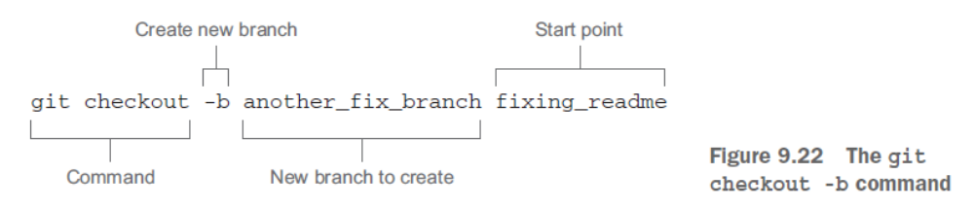
The starting point that you used in the TRY IT NOW section was the branch you created before. There’s nothing wrong with using a current branch as a starting point! The starting point can also be a commit SHA1 ID or a tag.

List all branches.
git branch

Create a new branch named dev. (This branch points to the same commit as HEAD.)
git branch dev

Change your working directory to the branch named dev.
git checkout dev

Delete the branch named master.
git branch -d master

View history of the repository across all branches (see section 9.2.3).
git log --graph –decorate --pretty=oneline --all --abbrev-commit

Make an alias named lol for the git log command in the previous row (see the Above
and Beyond sidebar).
git config --global alias.lol "log --graph --decorate --pretty=oneline --all --abbrev-commit"

List all branches with SHA1 ID information.
git branch -v

Make a branch using YOUR_SHA1ID as the starting point.
git branch fixing_readme YOUR_SHA1ID

Make a branch named another_fix_branch using branch fixing_readme as the starting point.
git checkout -b another_fix_branch fixing_readme

Show a record of all the times you changed branches (via git checkout).
git reflog

Set the current work in progress (WIP) to a stash (holding area), so you can perform a git checkout.
git stash

git stash list List works in progress that you’ve stashed away.

git stash pop Apply the most recently saved stash to the current working directory; remove it from the stash.

Checking the difference between two branches

The git diff command has an interesting syntax you can use to determine the differences between two branches.

git diff master...bugfix

$ git config --global merge.tool Kdiff3

Indicate the difference between BRANCH1 and BRANCH2 relative to when they first became different.
git diff BRANCH1...BRANCH2

Summarize the difference between BRANCH1 and BRANCH2, by listing each file and its status.
git diff --name-status BRANCH1...BRANCH2

Abandon a merge between two conflicted branches.
git merge –abort

Show the base commit between BRANCH1 and BRANCH2.
git merge-base BRANCH1 BRANCH2

git branch --all Show remote-tracking branches in addition to local branches.

Viewing branches in your clone

Knowing the branches available in a repository is important. Here’s the command-
line equivalent to get a simplified list of branches

git log --simplify-by-decoration --decorate --all –oneline

The Git command git ls-tree lists all the files in a tree. The git ls-tree command is a helpful way to get the list of files for any part of your Git history.
git ls-tree –r HEAD

Collaborating with remotes
The simplest form of the git remote command shows only the name of the remote

$ git remote
$ git remote -v

Now use git remote to rename origin:
git remote rename origin beginning

Adding a remote

Add a remote named bob that points to the local repositoryin ../math.bob.
git remote add bob ../math.bob

Interrogating (querying) the remote repository by exercising the git ls-remote command. This command returns a list of the SHA1 IDs of each branch and tag (each reference) on the remote repository.

You can compare this to SHA1 IDs of the current local repo (math.carol) by typing the following:

git ls-remote .

In this command, the period (.) represents the current local repository. This should give you the same listing!

Pushing your changes

Making comparisons in this fashion is a little tedious (git ls-remote) . A better way is to use the git remote command’s show subcommand

git remote –v show origin

pushing a new branch
The command will not only push the branch, but also create the remote-tracking branch in your local repository.
git push --set-upstream origin new_branch.

You need to run git push with the --set-upstream switch only once. When you use this switch, Git writes this information into a configuration file.

git config --get-regexp branch

This command retrieves configuration settings that match the string branch. The meaning of --get-regexp is get regular expression, which means git config will match any configuration with the word branch in it.

Deleting branches on the remote

git push origin :new_branch

Using a colon causes the git push command to use the more complex meaning of the fourth argument

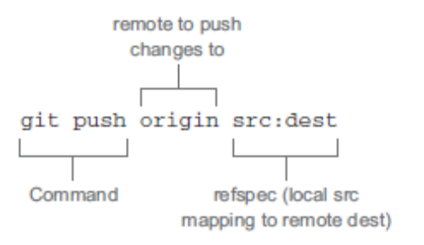
the fourth argument to git push is a refspec, a colon-separated string that describes the mapping between a source and destination branch

Using git push origin master is equivalent to using git push origin master:master

When you omit src from the full form, leaving the string :master, you’re telling Git to delete that remote branch

Pushing and deleting tags

You’re going to tag the commit that is two commits behind the HEAD (which is the last commit). The arcane syntax (HEAD^^) says from HEAD, go two commits back

git tag -a two_back -m "Two behind the HEAD" HEAD^^

To push your tag, type this:
git push origin two_back

Delete this tag, and confirm that it’s no longer on the remote:
git push origin :two_back

Your local tag still exists. To delete this, use git tag with the -d switch:
git tag -d two_back

Using git pull: a two-part operation
git pull is a two-part operation. In its default mode, git pull is shorthand for git fetch followed by git merge FETCH_HEAD
The second step of git pull is to run git merge FETCH_HEAD. What is FETCH_HEAD? It’s a reference to the
remote branch that you just fetched in the previous section

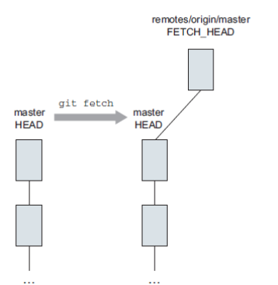
git rev-parse FETCH_HEAD
This should give you a SHA1 ID that points to the latest commit from the remote’s master branch. Keep in mind that this remote master branch is already in your local repository. You can access it by its special name, origin/
master.
git rev-parse origin/master
This last command should give you the same SHA1 ID as FETCH_HEAD.

you can ask Git to indicate what is different between these two branches,
git diff HEAD..FETCH_HEAD

Finally, and most important, FETCH_HEAD is used as the argument to git merge
git merge FETCH_HEAD

Restricting pulls to fast-forwards only
You can run git pull to incorporate only commits that are descendants of your current branch, using the --
ff-only switch. This prevents Git from doing any automated work, unless it’s a fastforward merge.
git pull --ff-only

Software archaeology

Let’s identify from the git log output those commits that represent merges of two branches.
git log --parents –oneline

Rather than finding these merges by hand, you can use the --merges switch:
git log --merges

Limiting the display of commits

LIMITING BY FILE
you’ll limit the git log output to the commits that affected one or more files:
git log --oneline readme.txt
git log --oneline readme.txt renamed_file

FINDING SPECIFIC COMMITS
You can tell git log to show only those commit messages that match a particular string by using the --grep switch to search commit messages for that string
git log --grep=change
This should list any commits that have the word change in the commit message

LIMITING BY TIME RANGE
git log --since 10/10/2014 --until 10/24/2014

LIMITING BY AUTHOR
You can also limit commits to a particular author, with the --author switch.

An easy way to get the list of authors from a repository is to use git shortlog.
After you have an author’s name or email address, you can restrict commits to that one author by passing it into the git log --author command.
git log --author="Rick Umali"
git log --author="Rick"

Seeing differences with git log
Use this command to display the number of files that have changed between the most current commit (HEAD) and its immediate predecessor (HEAD^):
git log --stat HEAD^..HEAD
The interesting syntax is the double-period. It specifies a revision range.

If you wanted to see what changed in the files since the last commit, try this:
git log --patch HEAD^..HEAD
It’s possible to combine patch and stat with --patch-with-stat

You can limit the output by typing the following:
git log --patch ef47d3f^..ef47d3f – file1
git log --patch ef47d3f^..ef47d3f – file1 file2

In these commands, you have to separate the files with a double-dash. When you type the commands, you’ll see that the git log output is limited to the files you specified.

This shows all the branches
git log --graph --decorate --oneline --all

git log --graph --decorate --oneline branch_03
This command limits the git log output to one branch, which is easier to see.

git log --graph --decorate --oneline branch_03 branch_10 master
This form passes in three branches to the git log command

git name-rev 80f5738
The git name-rev command produces a name for a commit, based on the nearest branch.

Another way to determine what branch a commit belongs to is to use git branch --contains:
git branch -r --contains ce051a3

This command outputs the string origin/new_feature, meaning that this SHA1 ID is part of the remote-tracking branch new_feature. If you check out the new_feature branch and type git branch --contains ce051a3, you’ll see the output new_feature.

Finding files of interest

To limit your history to those commits that contained a specific string. You did this by using the git log --grep command. But this searches only the text in the commit messages. If you’re looking for files that contain a particular string, you’ll need to use the git grep command

git grep change

Finding which revision updated a specific line of code

git gui blame math.sh

git blame math.sh

Understanding git rebase

The .. syntax shows the commits between master and new_feature.
git log --oneline master..new_feature

Using git reflog and git reset to revert your repo

git reflog

To reset your repository back to the earlier state, type this:
git reset --hard HEAD@{4}

cleaning up history
git rebase --interactive master

Professional git
The general form of commands is as follows:

$ git <git-options> <command> <command-options> <operands>

Undoing a configuration setting

$ git config --unset --global user.name

$ git config --list

$ git config --global –list

One short configuration
$ git -c <configuration setting>=<value> <rest of command line>
Aliases
git config <scope option> alias.<name> <command string>.

To seee the stored objects:
$ find .git/objects -type f
After
$ git cat-file –p 45dddf display its contents
$ git cat-file –t 45dddf returns the type of an object

One shot configuration

Le mécanisme que Git utilise pour réaliser les sommes de contrôle est appelé une empreinte SHA-1. C’est une chaîne de caractères composée de 40 caractères hexadécimaux (de 0 à 9 et de a à f) calculée en fonction du contenu du fichier ou de la structure du répertoire considéré. Une empreinte SHA-1 ressemble à ceci :

Git Configuration
/etc/gitconfig | $ git config --system
~/.gitconfig | $ git config –global
.git/config | $ git config

$ git config --global core.editor notepad
$ git config commit.template .gitmessage.txt
$ git config --global --edit

Add the lines to configure merge and diff tools
[merge]
tool = p4merge
[mergetool "p4merge"]
path = C:\\Program Files\\Perforce\\p4merge.exe
[diff]
tool = p4merge
[difftool "p4merge"]
path = C:\\Program Files\\Perforce\\p4merge.exe

or
$ git config --global diff.tool p4merge
$ git config --global difftool.p4merge.path 'C:\Program Files\Perforce\p4merge.exe'
$ git config --global merge.tool p4merge
$ git config --global mergetool.p4merge.path 'C:\Program Files\Perforce\p4merge.exe'

Les trois états

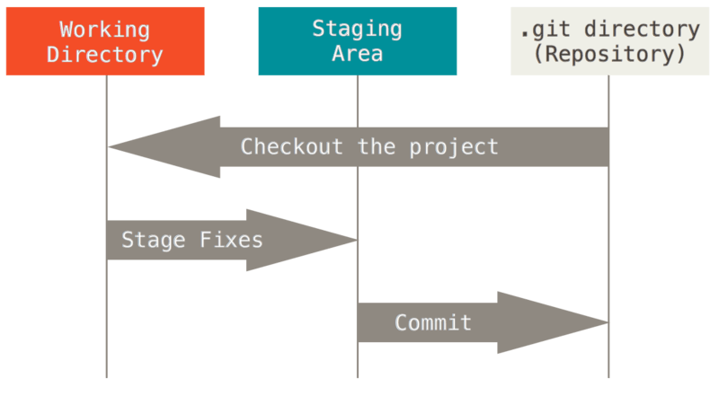

Paramétrage à la première utilisation de Git

Git contient un outil appelé git config
Ces variables peuvent être stockées dans trois endroits différents :
- Fichier gitconfig
c:\Program Files (x86)\Git\etc\gitconfig:
$ git config --system
- Global level Fichier .gitconfig:
C:\users\<username>\.gitconfig
Spécifique à votre utilisateur.
$ git config --global
- Repository level
File config located in the folder .git

$ git config --list

Sur les systèmes Windows, Git recherche le fichier .gitconfig dans le répertoire $HOME(%USERPROFILE% dans l’environnement natif de Windows) qui est C:\Documents and Settings\$USER ou C:\Users\$USER la plupart du temps, selon la version ($USER devient %USERNAME% dans l’environnement de Windows). Il recherche tout de même /etc/gitconfig, bien qu’il soit relatif à la racine MSys, qui se trouve où vous aurez décidé d’installer Git sur votre système Windows. Si vous utilisez une version 2.x ou supérieure de Git pour Windows, il y a aussi un fichier de configuration système à C:\Documents and Settings\All Users\Application Data\Git\config sur Windows XP, et dans C:\ProgramData\Git\config sur Windows Vista et supérieur. Ce fichier de configuration ne peut être modifié qu’avec la commande git config -f <fichier> en tant qu’administrateur.

Commands in shell

Votre identité

vous pouvez utiliser la commande git config –list pour lister tous les réglages que Git a pu trouver jusqu’ici
git config <paramètre>
$ git config user.name
John Doe

$ git config --global user.name "John Doe"
$ git config --global user.email johndoe@example.com
$ git config --global color.diff auto
$ git config --global color.status auto
$ git config --global color.branch auto
$ cat ~/.gitconfig
If you want to set different values for a specific project, just leave out the —global and it will write the same snippet into your .git/config file in that repository, which will overwrite your global values.

$ git config --global credential.helper cache

$ git add .
$ git commit –m “my first comit”
This will add all of your current files into your new repository and index and then create your first commit object, pointing your new master branch to it.

Obtenir de l’aide

git help <commande>

Par example
$ git help config

Démarrer un dépôt Git

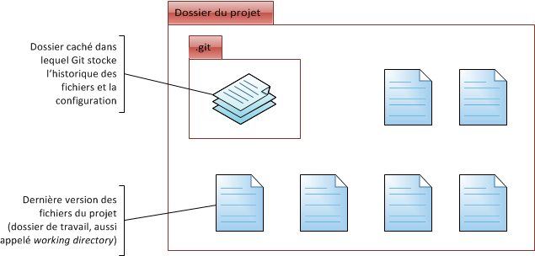

Initialisation d’un dépôt Git dans un répertoire existant
git init

Cloner un dépôt existant
$ git clone https://github.com/libgit2/libgit2

$ git clone https://github.com/libgit2/libgit2 monlibgit2
Cette commande réalise la même chose que la précédente, mais le répertoire cible s’appelle monlibgit

Enregistrer des modifications dans le dépôt

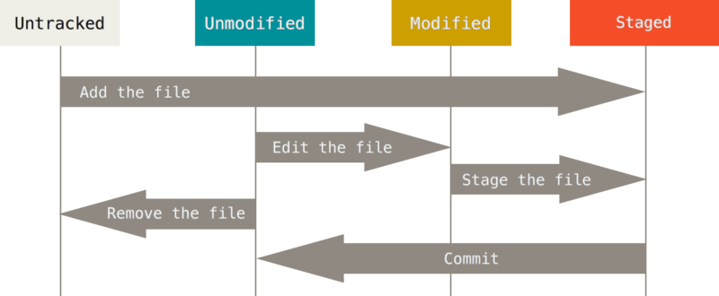

Vérifier l’état des fichiers
$ git status
$ git status –s
$ git status --short

Les nouveaux fichiers qui ne sont pas suivis sont précédés de ??, les fichiers nouveaux et indexés sont précédés de A, les fichiers modifiés de M et ainsi de suite. Il y a deux colonnes d’état - celle de gauche indique l’état de l’index et celle de droite l’état du dossier de travail.

Placer de nouveaux fichiers sous suivi de version
$ git add LISEZMOI

La commande git add accepte en paramètre un chemin qui correspond à un fichier ou un répertoire ; dans le cas d’un répertoire, la commande ajoute récursivement tous les fichiers de ce répertoire.
Sa signification s’approche plus de « ajouter ce contenu pour la prochaine validation » que de « ajouter ce contenu au projet »

Ignorer des fichiers
on peut énumérer les patrons de noms de fichiers à ignorer dans un fichier .gitignore.
Voici un autre exemple de fichier .gitignore :
# pas de fichier .a
*.a
# mais suivre lib.a malgré la règle précédente
!lib.a
# ignorer uniquement le fichier TODO à la racine du projet
/TODO
# ignorer tous les fichiers dans le répertoire build
build/
# ignorer doc/notes.txt, mais pas doc/server/arch.txt
doc/*.txt
# ignorer tous les fichiers .txt sous le répertoire doc/
doc/**/*.txt

Inspecter les modifications indexées et non indexées

Là où git status répond de manière générale à ces questions, git diff montre les lignes exactes qui ont été ajoutées, modifiées ou effacées
git diff compare le contenu du répertoire de travail avec la zone d’index.
Si vous souhaitez visualiser les modifications indexées qui feront partie de la prochaine validation, vous pouvez utiliser git diff –-staged
Il est important de noter que git diff ne montre pas les modifications réalisées depuis la dernière validation — seulement les modifications qui sont non indexées.

Valider vos modifications
$ git commit
$ git commit -m "Story 182: Fix benchmarks for speed"

pour commiter tous les fichiers qui étaient listés dans git status (vert et rouge)

$ git commit -a

Effacer des fichiers
$ git rm file1

Efface fichier de la zone de travail et de la zone d’index
Si le fichier est modifié et indexe. La suppression doit etre forcée
$ git rm –f file1

$ git rm --cached file1
Abondonner suivi de version d’un fichier et le garder dans la copie de travail
$ git mv file1 file2

Log
$ git log
$ git log –p -2 Avec un diff
$ git log --stat Avec statistiques
$ git log --oneline (--online = --pretty=oneline --abbrev-commit)
$ git log --pretty=online
$ git log --pretty=short
$ git log --pretty=medium
$ git log --pretty=Full
$ git log --pretty=Fuller
$ git log --oneline --graph
$ git log --abbrev-commit --graph
$ git log –n5
$ git log --since=”last week”
$ git log --since=”last day”
$ git log --since=”last hour”
$ git log --since=”last minute”
$ git log --since=”2 days”
$ git log --author=””
$ git log --grep=”” Checher mots clés dans les messages de validation
$ git log -S=nom_fonction tous les commits qui ajoutent ou retirent du texte comportant cette chaine
$ git log fichier1

Formatting Log Output

git log –pretty==oneline
git log –pretty==short
git log –pretty==medium
git log –pretty==full
git log –pretty==fuller

$ git log
$ git log -p
$ git log --stat

Vous pouvez parcourir les logs avec les touches « Page up », « Page down » et les flèches directionnelles, et quitter en appuyant sur la touche « Q »
git log –n 5

Modifier le dernier commit

$ git commit --amend

Desindexer un fichier
$ git reset HEAD file

reset commande dangereuse conjuguée avec l’option --hard. Appeler git reset sans option n’est pas dangereux. Cela ne touche qu ‘a la zone d’index.
to discard changes in working directory

$ git checkout -- file
Tout ce que vous perdez avnt de l’ avoir validé n’ a aucune chance d’etre recuperable par Git

Working with Remotes

Showing Your Remotes
$ git remote
$ git remote -v

Add a remote
$ git remote add [nomcourt] [url]

Inspecting a Remote
$ git remote show origin

Removing and Renaming Remotes
$ git remote rename name newname

$ git remote rm name

Tagging
Listing Your Tags
$ git tag

Git uses two main types of tags: lightweight and annotated
Annotated tags
$ git tag –a v1.4 –m “message”
$ git tag –a v1.4 9fceb02 –m “message”

you can see the tag data along with the commit that was tagged by using the git show command:
$ git show v1.4

Lightweight tags

$ git tag v1.4

git tag v1.4 9fceb02

By default, the git push command doesn’t transfer tags to remote servers.

you can run

$ git push origin [tagname]

you can also use the --tags option to the git push command to push all th tags

$ git push origin --tags

Checking out Tags
Il n’est pas vraiment possible d’extraire une étiquette avec Git, puisque les étiquettes ne peuvent pas être modifiées. Si vous souhaitez ressortir dans votre copie de travail une version de votre dépôt correspondant à une étiquette spécifique, le plus simple consiste à créer une branche à partir de cette étiquette :
$ git checkout -b version2 v2.0.0
Extraction des fichiers: 100% (602/602), fait.
Basculement sur la nouvelle branche 'version2'

Git Aliases
For example, to correct the usability problem you encountered with unstaging a file, you can add your own unstage alias to Git:
$ git config --global alias.unstage 'reset HEAD --'
This makes the following two commands equivalent:
$ git unstage fileA
$ git reset HEAD -- fileA

Branch
$ git branch
$ git branch –v

Branches fusionneés qu on peut supprimer
$ git branch --merged

Branches non fusionneés
$ git branch --no-merged

$ git merge branch1

Conflit, git n’a pas automatiquement cree le commit de fusion. IL a arrete le temps de que vous resolviez le conflit. Pour verifier quels fichiers n’ont pas été fusionnés lancer la commande git status.
Apres avoir resolu chaque conflit, lancez la commande git add sur chaque fichier
Ensuite git commit pour finaliser le commit de fusion

Push branches
$ git push serveurdistant branch

$ git push serveurdistant branch:newbranch

$ git checkout –b branch nomdistant/branch
Shortcut
$ git checkout --track nomdistant/branch

Si vous avez déjà une branche locale
$ git branch –u orgin/branch1

When you have a tracking branch set up, you can reference its upstream branch with the @{upstream} or @{u} shorthand
$ git branch @{u} ⬄ git merge origin/master

If you want to see what tracking branches you have set up, you can use the -vv option to git branch.
$ git branch -vv

It’s important to note that these numbers are only since the last time you fetched from each server. This command does not reach out to the servers,
$ git fetch --all;
$ git branch -vv

Deleting Remote Branches
$ Git push origin --delete branch

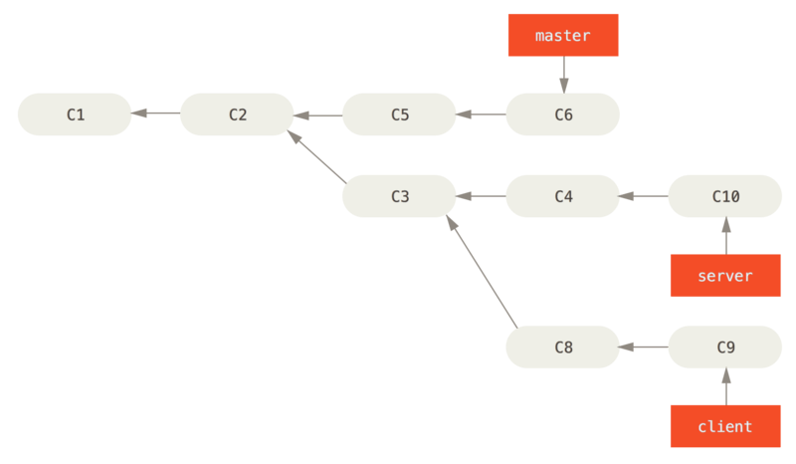

$ git rebase --onto master server client
Replay c8 and c9 on master branch

$ git rebase branchebase branchethematique
Cette commande rejoue les modifications de branchethematique sur le sommet de la branche branchebase

interactive add
git add –i

Removing
For removing files from your index and your working directory you can run
Git rm <filename>

Branch
Create a branch and switch to it
git branch newfunc
git checkout newfunc

or
git checkout –b newfunc

List existing branches
$ git branch
$ git branch –v // Verbose
$ git branch –a // ⬄--all Including remote branches

Show
$ Git show-ref
Annuler le dernier commit
git reset HEAD^
HEAD dernier commit
HEAD^ avant dernier commit
HEAD^^ avant avant dernier commit
HEAD~2 avant avant dernier commit
Seul le commit est retiré de Git ; les fichiers restent modifiés

Annule les commits et ecrase tous les changements
git reset –hard HEAD^

Git is not really a single binary, but a collection of dozens of small specialized programs,

Git Internals

Git Object Types
Git objects are the actual data of Git, the main thing that the reposi - tory is made up of
All of these types of objects are stored in the Git Object Database, which is kept in the Git Directory. Each object is compressed (with 14 Zlib) and referenced by the SHA-1 value of its contents plus a small header (SHA stands for Secure Hash Algorithm)

In Git, the contents of files are stored as blobs. It is important to note that it is the contents that are stored, not the files. The names and modes of the files are not stored with the blob, just the contents.

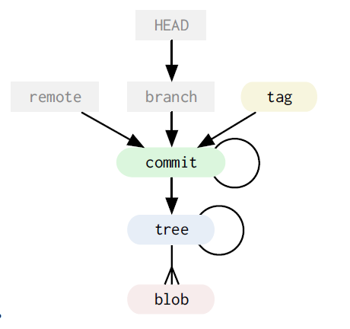

The Commit
So, now that we can store arbitrary trees of content in Git, where does the ‘history’ part of ‘tree history storage system’ come in? The answer is the commit object.
The Tag
The final type of object you will find in a Git database is the tag. This is an object that provides a permanent shorthand name for a particular commit.
The Git Data Model
the Git object data is a directed acyclic graph
References
In addition to the Git objects, which are immutable – that is, they cannot ever be changed, there are references also stored in Git. Unlike the objects, references can constantly change. They are simple pointers to a particular commit, something like a tag, but easily moveable.

A branch in Git is nothing more than a file in the .git/refs/heads/ directory that contains the SHA-1 of the most recent commit of that branch

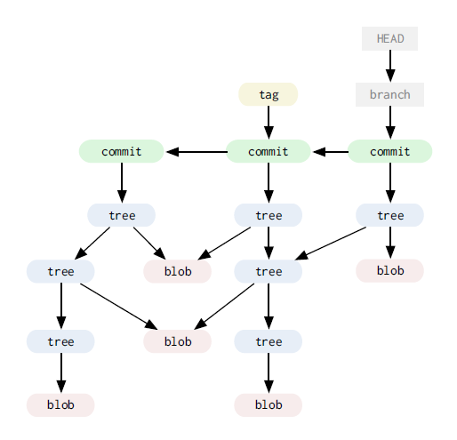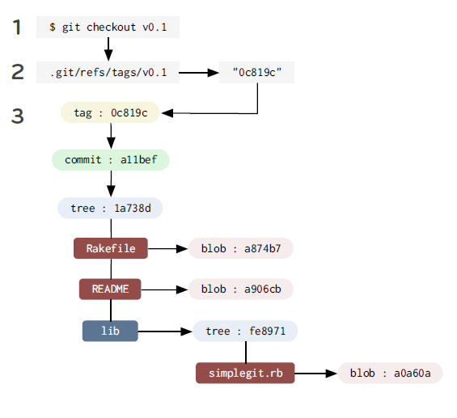

In fact, in Git the act of creating a new branch is simply writing a file in the .git/refs/heads directory that has the SHA-1 of the last commit for that branch.

The Treeish
- Full SHA-1
- PARTIAL SHA-1
dae86e
- Branch or tag name
Anything in .git/refs/heads
- Carrot parent
dae86e^N
this refers to the Nth parent of that commit. Only really helpful for commits that merged two or more commits
- Tilde spec
dae86e~N
refers to the Nth generation grandparent of that commit
dae86e~5 ⬄ dae86e^^^^^
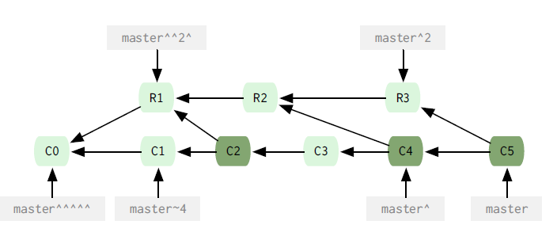
- Tree pointer
dae86e^{tree}
This points to th tree of that commit

Git repository
- .git/config
- .git/index
index file of the Git project
- .git/objects/
Main directory that holds the data of your Git objects ( Content of the files , commit, tree and tag obejcts)
This is the main directory that holds the data of your git objects that is all the contents you have ever checked in plus your commit, tree and tag objects. The files are stored by their SHA-1 values. The first two characters make up the subdirectory and the last 38 is the filename
a576fac355dd17e39fd2671b010e36299f713b4d ⬄ [GIT_DIR]/objects/a5/76fac355dd17e39fd2671b010e36299f713b4d
- .git/refs/
This directory normally has 3 directories in it
Heads
Remote
Tags
- .git/HEAD
This file holds a reference to the branch you are currently on. This tells Git what to use as the parent of your next commit
- .git/hooks
Contains shell scripts that are invoked after the git command

Working directory
Your working directory is temporary – everything is stored permanently in your git repository. Your working directory is a just a copy of a tree so you can edit it and commit changes

Browsing Git
- git show master^
command to view the trees
- git ls-tree master^
- git ls-tree –r –t master^ (run it recursively)

Command to view blobs
- git cat-file –t ae850bd view type
- git cat-file –p ae850bd print blob

graphical interfcaces
- gitk
- git instaweb

Searching Git
Git has an easy way for searching through treess in your repository whitout having to check them out into your working directory
git grep

Git diff
If you simply run git diff with no arguments, it will show the differences between your working directory and the index

Branching
Command to see the differences between the branches
Git diff –stat master newfunc
git merge newfunc
git branch –d newfunc

Undoing a merge

git reset
By default it will only reset your index, leaving the partially merged files in your directory.
git reset –hard
--hard makes sure both your index file and working directory are changed

Rebasing
git rebase master
if there is a conflict, yout have three things you can do here
- fix the file runs git add on it and run git rebase –continue
- run git rebase --abort will reset us to what our repo looks like before tried the rebase
- run git rebase –skip skips this patch , abandoning the change forever

When you clone a repository, it in essence copies all the git objects to a new directory, checks you out a single local branch named the same as the HEAD branch on the cloned repo (normally master) and stores all the other branches under a remote reference by default named ‘origin’
git checkout –track newfunction origin/newfunction
--track indicates that you may want to pull from or push to the origin of this branch later
Bare repository Is a repository without a working directory

Statshing
git stash
take the changes from the last commit to the current state of your working directory and store it manually
I can see my stashes by running
git stash list
git stash show stash@{1}
git stash show stash@{0}
git stash show stash@{2}

git diff stash@{1}

And finally I can apply it
git stash apply stash@{1}
git stash apply without the actual stash reference it will just apply the last trash you saved on that branch

Tagging
Creating a tag in git is much like making abranch. A tag is basically a signed branch that never moves
git tag –a v0.1 -m

Multiple remotes
Decentralized part in git. You can add multiple repositories
git remote add mycap https://
git remote add official https://
useful information about a remote branch
git remote show origin

Extra tools
- git gc: runs the garbage collector for your repository
- git fsck: does an integrity check of the git filesystem
- git prune: Removes objects that are no longer pointed to by any object in any reachable branch
git prune –n : to see what it will do

Git from the inside out
The .git directory and its contents are Git’s. All the other files are collectively known as the working copy. They are the user’s.

Add some files
$ git add data/letter.txt

This command has two effects.
- First, it creates a new blob file in the .git/objects/ directory.
For example, Git hashes the cotent to 2e65efe2a145dda7ee51d1741299f848e5bf752e. The first two characters are used as the name of a directory inside the objects database: .git/objects/2e/. The rest of the hash is used as the name of the blob file that holds the content of the added file: .git/objects/2e/65efe2a145dda7ee51d1741299f848e5bf752e.
- Second, git add adds the file to the index. The index is a list that contains every file that Git has been told to keep track of. It is stored as a file at .git/index.

Make a commit
git commit -m 'a1'

The commit command has three steps. It creates a tree graph to represent the content of the version of the project being committed. It creates a commit object. It points the current branch at the new commit object
- Git records the current state of the project by creating a tree graph from the index. This tree graph records the location and content of every file in the project.
The graph is composed of two types of object: blobs and trees.
Blobs are stored by git add. They represent the content of files.
Trees are stored when a commit is made. A tree represents a directory in the working copy.
- git commit creates a commit object after creating the tree graph. The commit object is just another text file in .git/objects/:
- Finally, the commit command points the current branch at the new commit object. Which is the current branch? Git goes to the HEAD file at .git/HEAD and finds:
ref: refs/heads/master
This says that HEAD is pointing at master. master is the current branch.
HEAD and master are both refs. A ref is a label used by Git or the user to identify a specific commit.

HEAD pointing at master and master pointing at the a1 commit

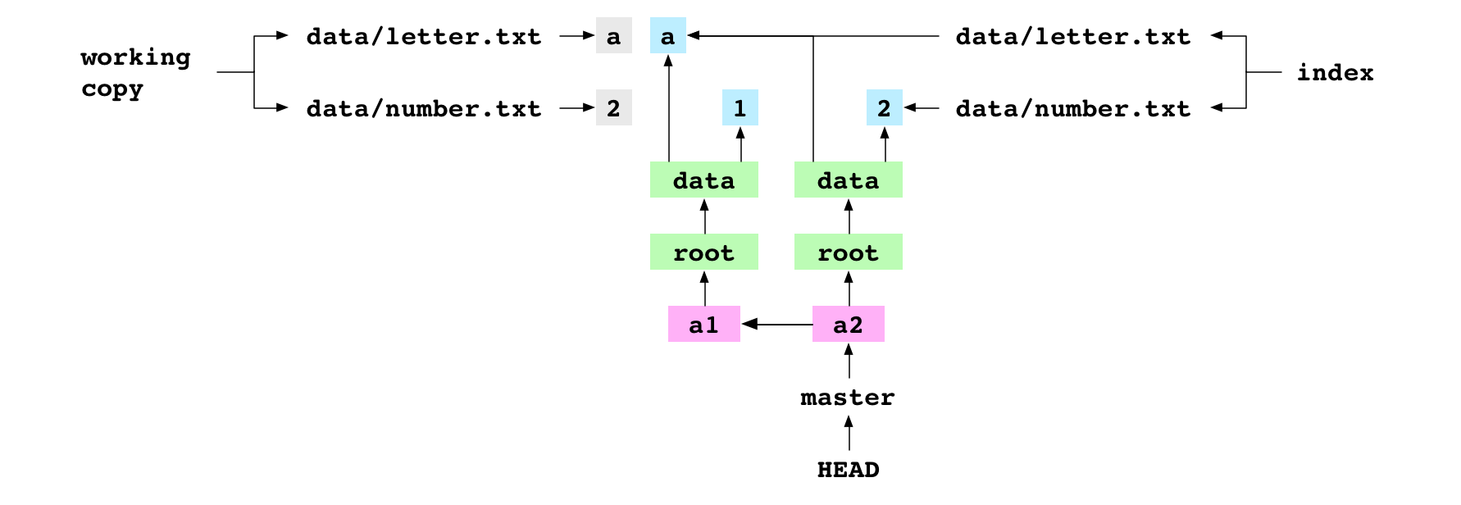

Check out a commit
git checkout 37888c2

Create a branch
git branch deputy

The user creates a new branch called deputy. This just creates a new file at .git/refs/heads/deputy that contains the hash that HEAD is pointing at: the hash of the a3 commit.

Merge an ancestor

git merge master

Merging two branches means merging two commits. The first commit is the one that deputy points at: the receiver. The second commit is the one that master points at: the giver. For this merge, Git does nothing. It reports it is Already up-to-date.

Merge a descendent

master checked out and pointing at the a2 commit

git checkout master

git merge deputy

They merge deputy into master. Git discovers that the receiver commit, a2, is an ancestor of the giver commit, a3. It can do a fast-forward merge.
It gets the giver commit and gets the tree graph that it points at. It writes the file entries in the tree graph to the working copy and the index. It “fast-forwards” master to point at a3.

a3 commit from deputy fast-forward merged into master

Merge two commits from different lineages
$ printf '4' > data/number.txt
$ git add data/number.txt
$ git commit -m 'a4'

The user sets the content of number.txt to 4 and commits the change to master.
$ git checkout deputy
$ printf 'b' > data/letter.txt
$ git add data/letter.txt
$ git commit -m 'b3'

The user checks out deputy. They set the content of data/letter.txt to b and commit the change to deputy.

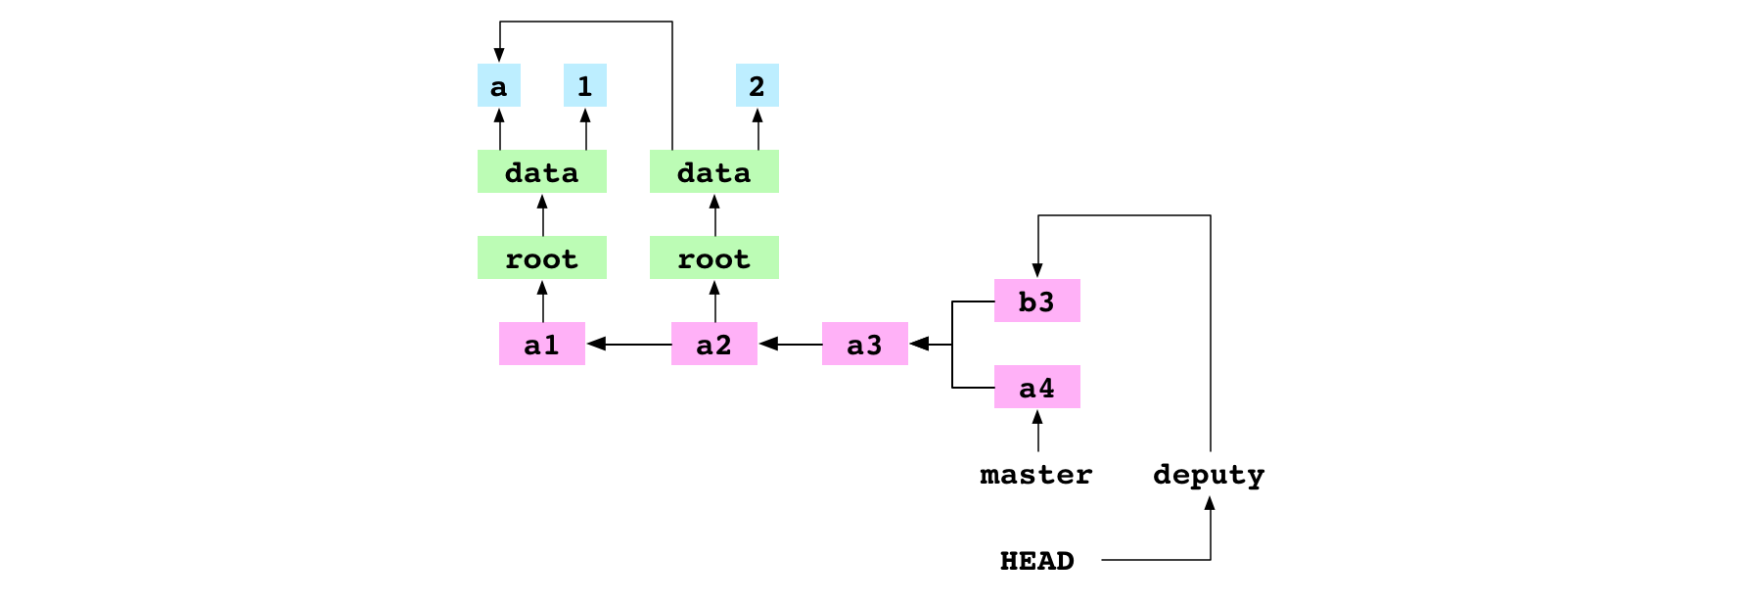
a4 committed to master, b3 committed to deputy and deputy checked out

The user merges master into deputy.
git merge master -m 'b4'

Git discovers that the receiver, b3, and the given, a4, are in different lineages. It makes a merge commit. This process has eight steps.
- First, Git writes the hash of the giver commit to a file at alpha/.git/MERGE_HEAD. The presence of this file tells Git it is in the middle of merging.
- Second, Git finds the base commit: the most recent ancestor that the receiver and giver commits have in common.
- Third, Git generates the indices for the base, receiver and giver commits from their tree graphs.
- Fourth, Git generates a diff that combines the changes made to the base by the receiver commit and the giver commit. This diff is a list of file paths that point to a change: add, remove, modify or conflict.
Git gets the list of all the files that appear in the base, receiver or giver indices. For each one, it compares the index entries to decide the change to make to the file. It writes a corresponding entry to the diff. In this case, the diff has two entries.
The first entry is for data/letter.txt. The content of this file is a in the base, b in the receiver and a in the giver. The content is different in the base and receiver. But it is the same in the base and giver. Git sees that the content was modified by the receiver, but not the giver. The diff entry for data/letter.txt is a modification, not a conflict.
The second entry in the diff is for data/number.txt. In this case, the content is the same in the base and receiver, and different in the giver. The diff entry for data/letter.txt is also a modification.
- Fifth, the changes indicated by the entries in the diff are applied to the working copy. The content of data/letter.txt is set to b and the content of data/number.txt is set to 4.

- Sixth, the changes indicated by the entries in the diff are applied to the index. The entry for data/letter.txt is pointed at the b blob and the entry for data/number.txt is pointed at the 4 blob

- Seventh, the updated index is committed
- Eighth, Git points the current branch, deputy, at the new commit.
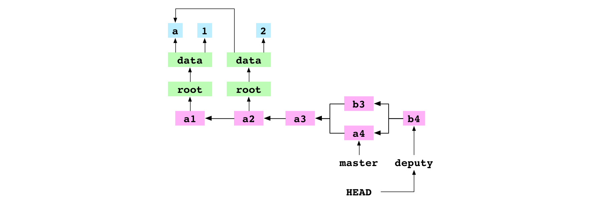
Notice that the commit has two parents.

b4, the merge commit resulting from the recursive merge of a4 into b3

Merge two commits from different lineages that both modify the same file
$ git checkout master
$ git merge deputy

The user checks out master. They merge deputy into master. This fast-forwards master to the b4 commit. master and deputy now point at the same commit.

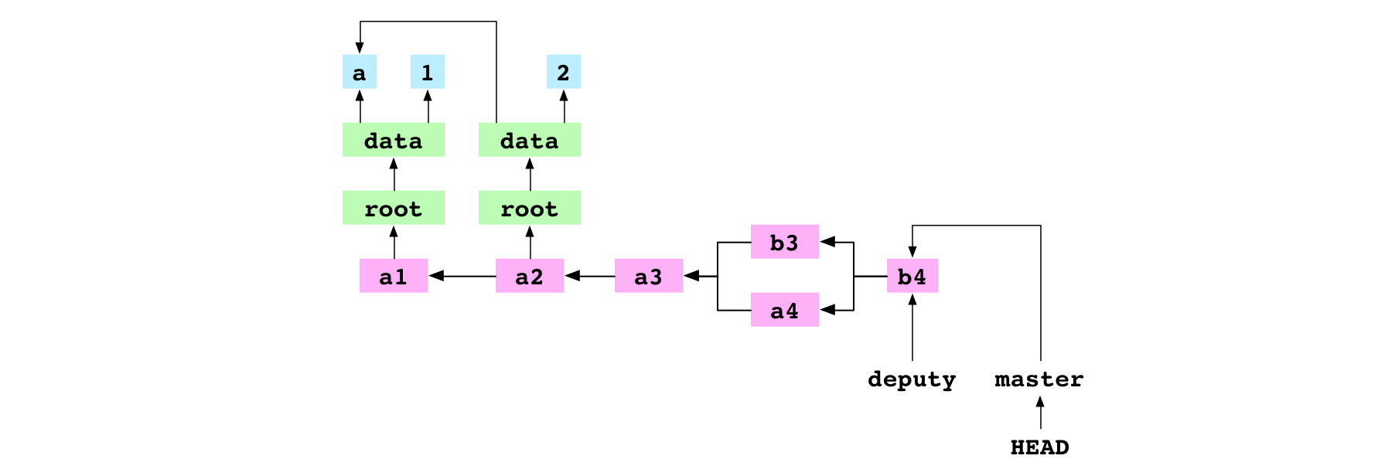
deputy merged into master to bring master up to the latest commit, b4

The user checks out deputy. They set the content of data/number.txt to 5 and commit the change to deputy.
$ git checkout deputy
$ printf '5' > data/number.txt
$ git add data/number.txt
$ git commit -m 'b5'

The user checks out master. They set the content of data/number.txt to 6 and commit the change to master.
$ git checkout master
$ printf '6' > data/number.txt
$ git add data/number.txt
$ git commit -m 'b6'

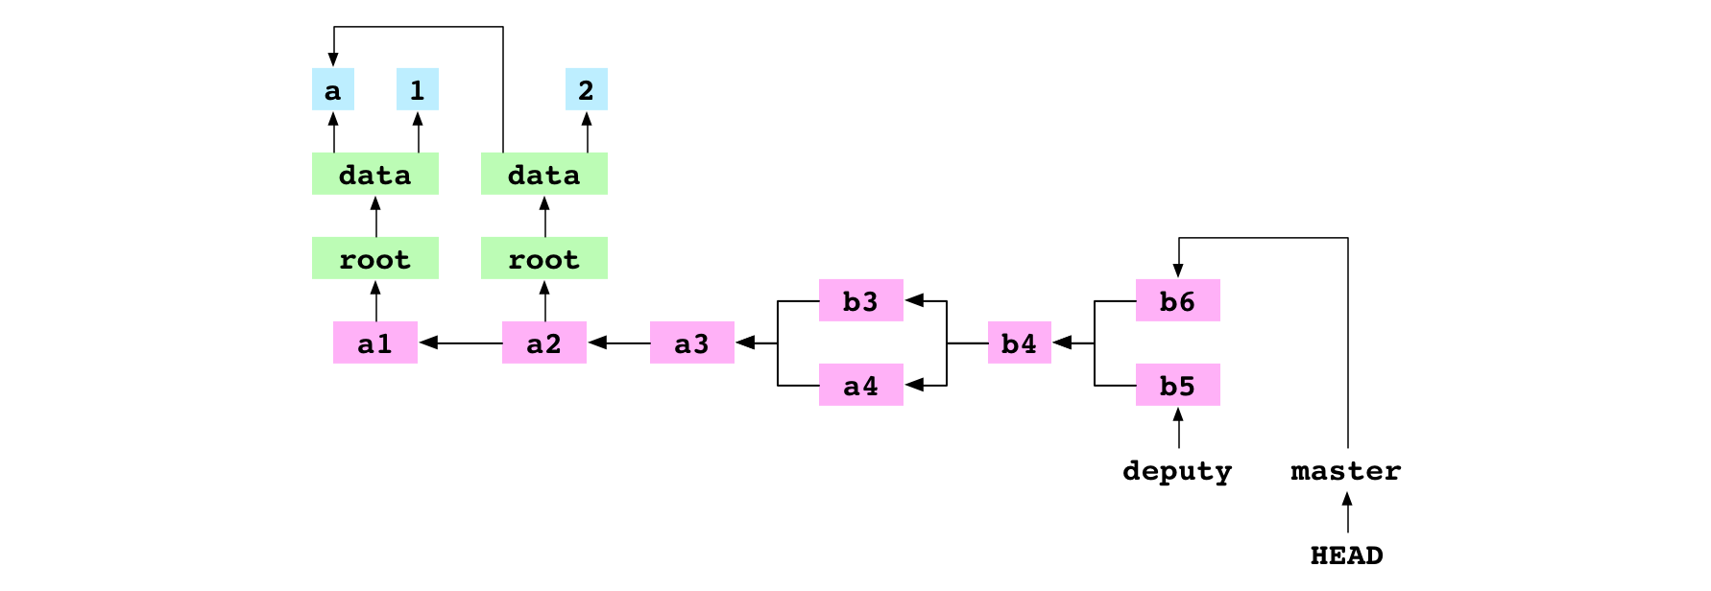
b5 commit on deputy and b6 commit on master

$ git merge deputy

The user merges deputy into master. There is a conflict and the merge is paused.
The user merges deputy into master. There is a conflict and the merge is paused. The process for a conflicted merge follows the same first six steps as the process for an unconflicted merge:
set .git/MERGE_HEAD,
find the base commit,
generate the indices of the base, receiver and giver commits,
create a diff,
update the working copy
update the index.
Because of the conflict, the seventh commit step and eighth ref update step are never taken. Let’s go through the steps again and see what happens.

First, Git writes the hash of the giver commit to a file at .git/MERGE_HEAD
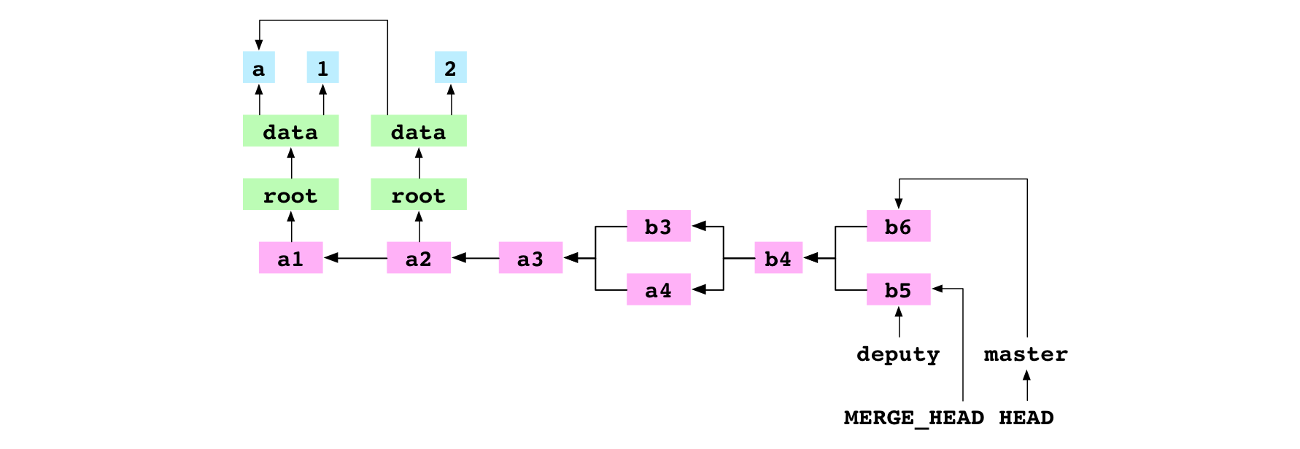
MERGE_HEAD written during merge of b5 into b6

Second, Git finds the base commit, b4.
Third, Git generates the indices for the base, receiver and giver commits.
Fourth, Git generates a diff that combines the changes made to the base by the receiver commit and the giver commit. This diff is a list of file paths that point to a change: add, remove, modify or conflict.
In this case, the diff contains only one entry: data/number.txt. The entry is marked as a conflict because the content for data/number.txt is different in the receiver, giver and base.
Fifth, the changes indicated by the entries in the diff are applied to the working copy. For a conflicted area, Git writes both versions to the file in the working copy. The content of data/number.txt is set to:
<<<<<<< HEAD
6
=======
5
>>>>>>> deputy

Sixth, the changes indicated by the entries in the diff are applied to the index. Entries in the index are uniquely identified by a combination of their file path and stage. The entry for an unconflicted file has a stage of 0. Before this merge, the index looked like this, where the 0s are stage values:
0 data/letter.txt 63d8dbd40c23542e740659a7168a0ce3138ea748
0 data/number.txt 62f9457511f879886bb7728c986fe10b0ece6bcb

After the merge diff is written to the index, the index looks like this:
0 data/letter.txt 63d8dbd40c23542e740659a7168a0ce3138ea748
1 data/number.txt bf0d87ab1b2b0ec1a11a3973d2845b42413d9767
2 data/number.txt 62f9457511f879886bb7728c986fe10b0ece6bcb
3 data/number.txt 7813681f5b41c028345ca62a2be376bae70b7f61

he entry for data/letter.txt at stage 0 is the same as it was before the merge. The entry for data/number.txt at stage 0 is gone. There are three new entries in its place. The entry for stage 1 has the hash of the base data/number.txt content. The entry for stage 2 has the hash of the receiver data/number.txt content. The entry for stage 3 has the hash of the giver data/number.txt content. The presence of these three entries tells Git that data/number.txt is in conflict.
The merge pauses
~/alpha $ printf '11' > data/number.txt
~/alpha $ git add data/number.txt

The user integrates the content of the two conflicting versions by setting the content of data/number.txt to 11. They add the file to the index. Git adds a blob containing 11. Adding a conflicted file tells Git that the conflict is resolved. Git removes the data/number.txt entries for stages 1, 2 and 3 from the index. It adds an entry for data/number.txt at stage 0 with the hash of the new blob. The index now reads:
0 data/letter.txt 63d8dbd40c23542e740659a7168a0ce3138ea748
0 data/number.txt 9d607966b721abde8931ddd052181fae905db503

Seventh, the user commits.
git commit -m 'b11'

Git sees .git/MERGE_HEAD in the repository, which tells it that a merge is in progress. It checks the index and finds there are no conflicts. It creates a new commit, b11, to record the content of the resolved merge. It deletes the file at .git/MERGE_HEAD. This completes the merge.
Eighth, Git points the current branch, master, at the new commit
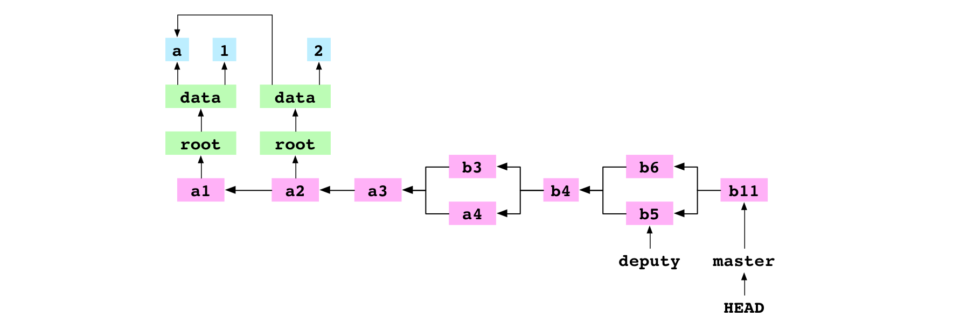
b11, the merge commit resulting from the conflicted, recursive merge of b5 into b6

Remove a file
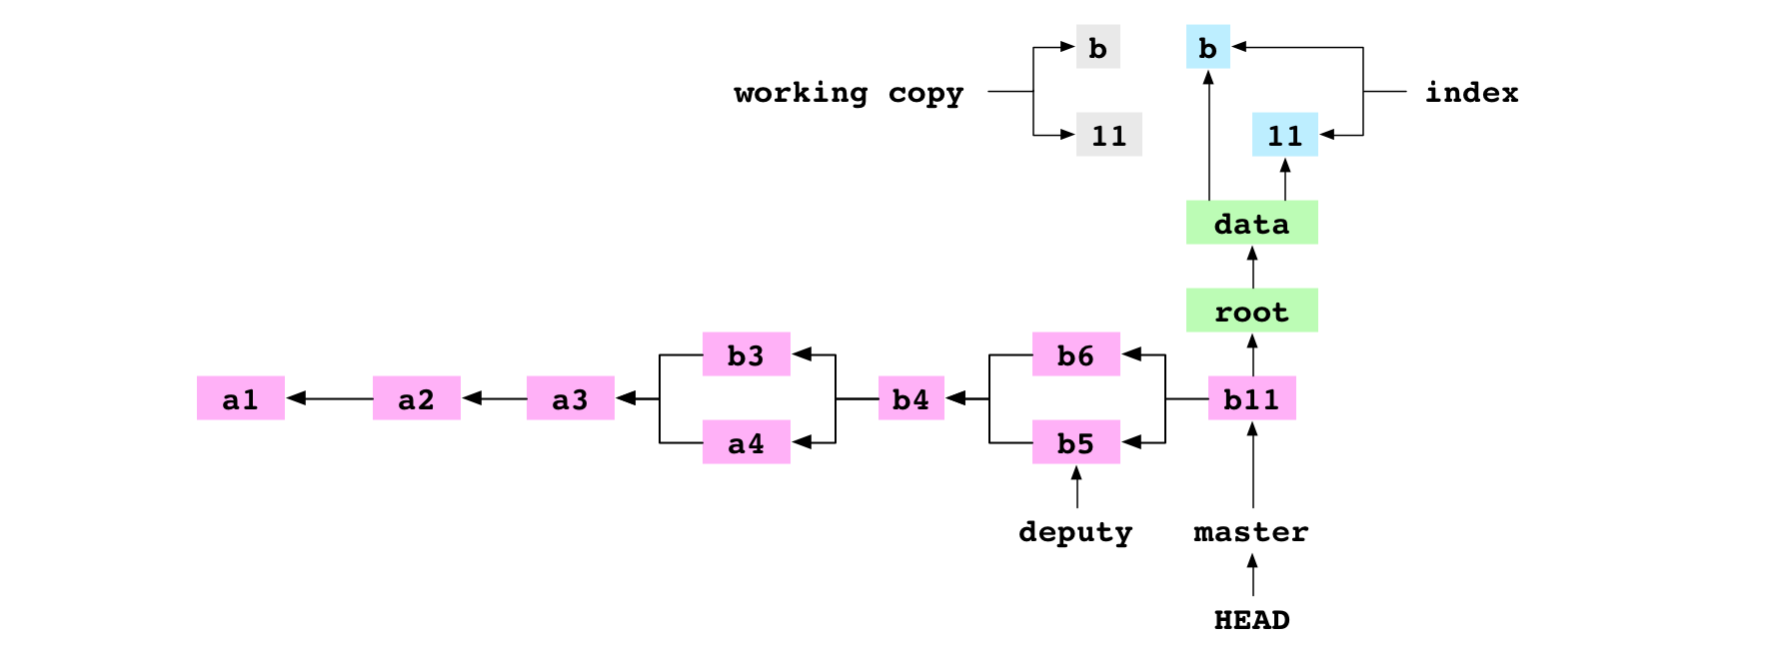
git rm data/letter.txt

The user tells Git to remove data/letter.txt. The file is deleted from the working copy. The entry is deleted from the index
git commit -m '11'

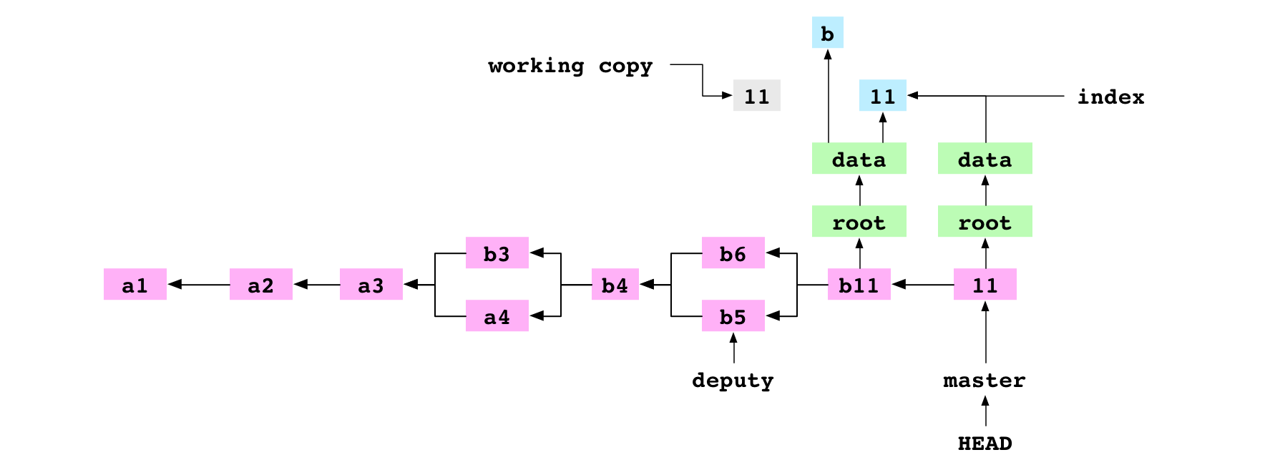
11 commit made after data/letter.txt rm ed

Copy a repository
~/alpha $ cd ..
~ $ cp -R alpha bravo

The user copies the contents of the alpha/ repository to the bravo/ directory. This produces the following directory structure:

├── alpha
| └── data
| └── number.txt
└── bravo
└── data
└── number.txt

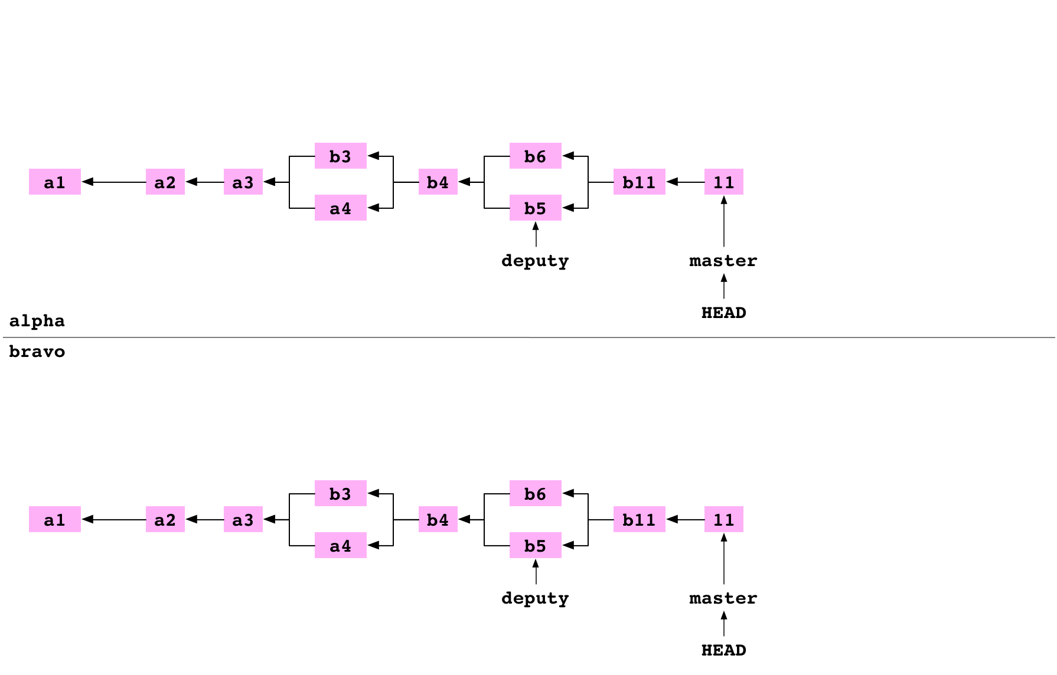
New graph created when alpha cp ed to bravo

Link a repository to another repository
~ $ cd alpha
~/alpha $ git remote add bravo ../bravo

The user moves back into the alpha repository. They set up bravo as a remote repository on alpha. This adds some lines to the file at alpha/.git/config:
[remote "bravo"]
url = ../bravo/

These lines specify that there is a remote repository called bravo in the directory at ../bravo.

Fetch a branch from a remote
~/alpha $ cd ../bravo
~/bravo $ printf '12' > data/number.txt
~/bravo $ git add data/number.txt
~/bravo $ git commit -m '12'

The user goes into the bravo repository. They set the content of data/number.txt to 12 and commit the change to master on bravo.
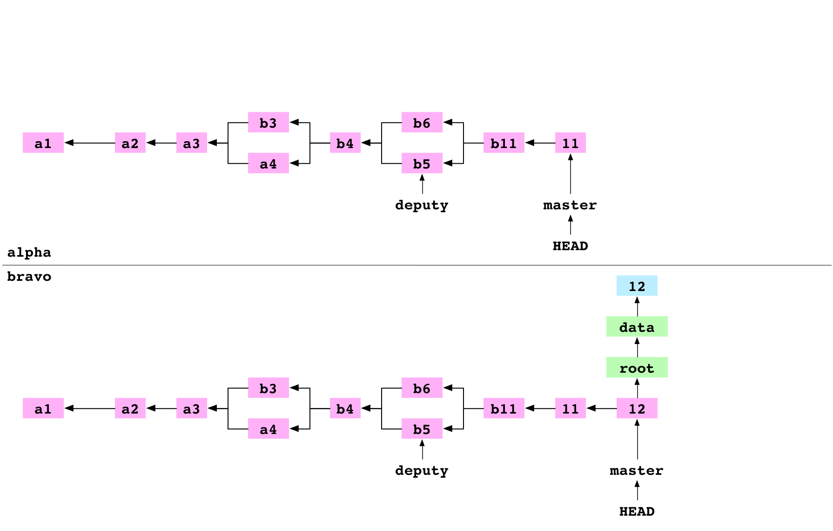

~/bravo $ cd ../alpha
~/alpha $ git fetch bravo master

The user goes into the alpha repository. They fetch master from bravo into alpha. This process has four steps.
- First, Git gets the hash of the commit that master is pointing at on bravo. This is the hash of the 12 commit.
- Second, Git makes a list of all the objects that the 12 commit depends on: the commit object itself, the objects in its tree graph, the ancestor commits of the 12 commit and the objects in their tree graphs. It removes from this list any objects that the alpha object database already has. It copies the rest to alpha/.git/objects/.
- Third, the content of the concrete ref file at alpha/.git/refs/remotes/bravo/master is set to the hash of the 12 commit.
- Fourth, the content of alpha/.git/FETCH_HEAD is set to:
This indicates that the most recent fetch command fetched the 12 commit of master from bravo.

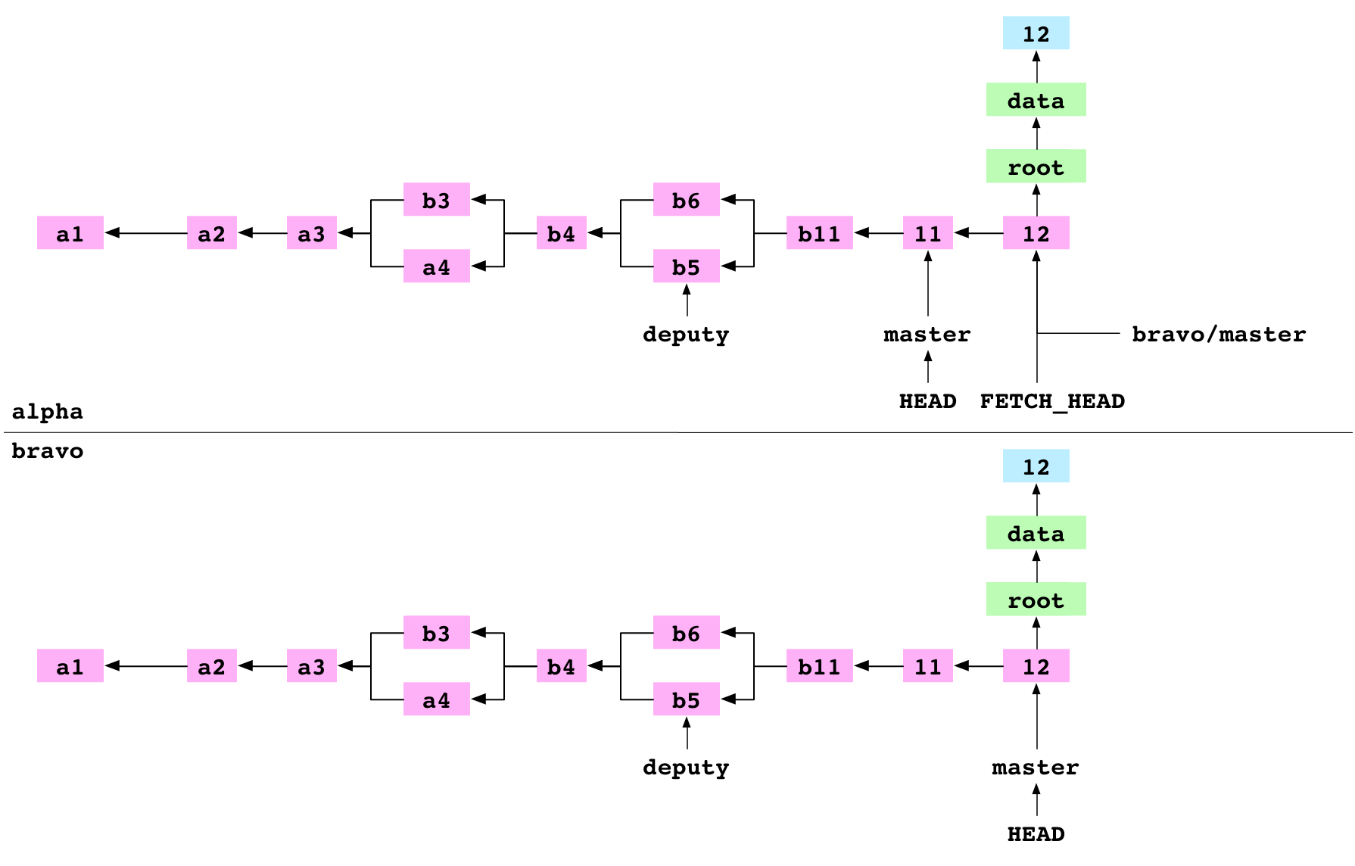

Merge FETCH_HEAD
git merge FETCH_HEAD

The user merges FETCH_HEAD. FETCH_HEAD is just another ref. It resolves to the 12 commit, the giver. HEAD points at the 11 commit, the receiver. Git does a fast-forward merge and points master at the 12 commit.
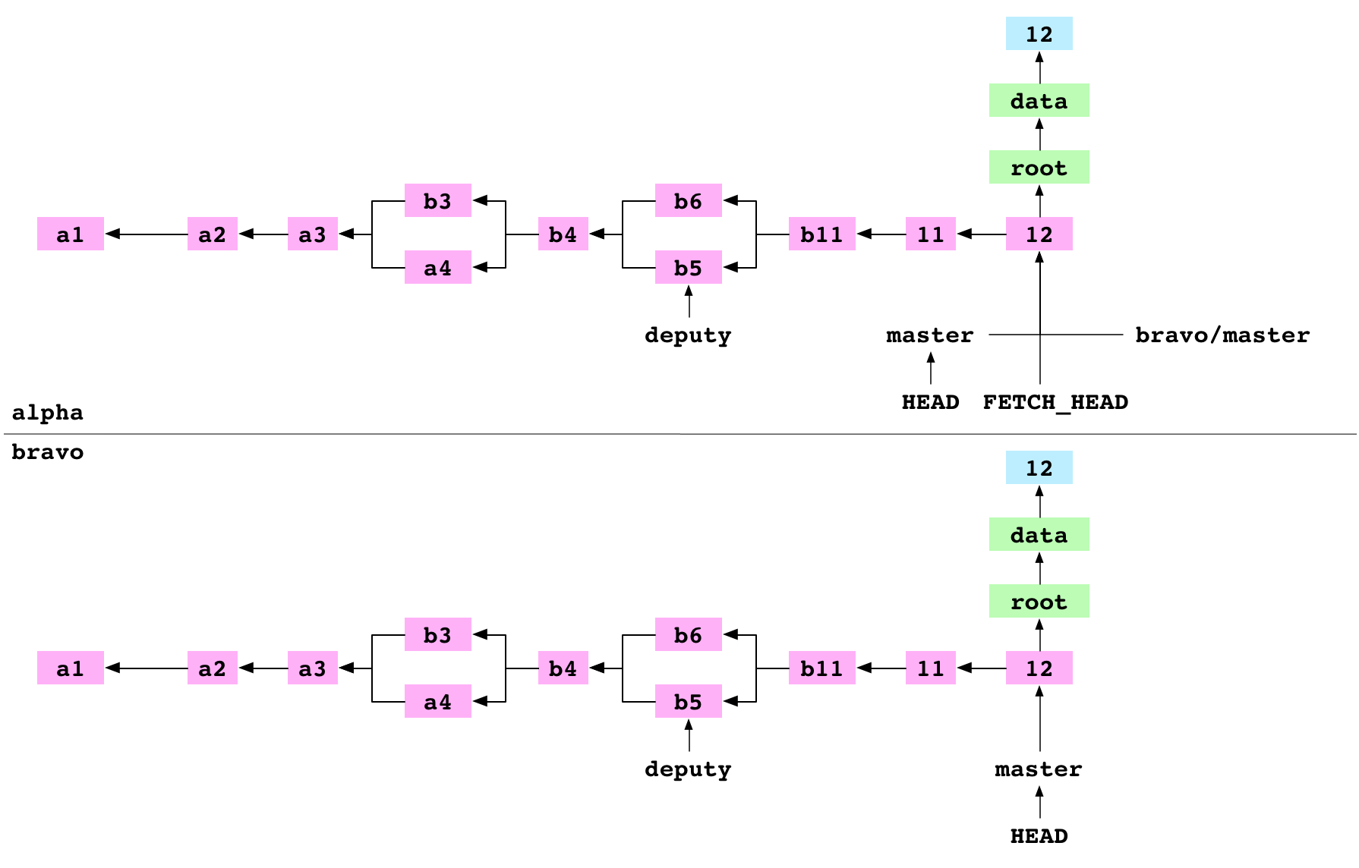
alpha after FETCH_HEAD merged

Pull a branch from a remote
git pull bravo master

The user pulls master from bravo into alpha. Pull is shorthand for “fetch and merge FETCH_HEAD”. Git does these two commands and reports that master is Already up-to-date

Clone a repository
~/alpha $ cd ..
~ $ git clone alpha charlie

The user moves into the directory above. They clone alpha to charlie. Cloning to charlie has similar results to the cp the user did to produce the bravo repository. Git creates a new directory called charlie. It inits charlie as a Git repo, adds alpha as a remote called origin, fetches origin and merges FETCH_HEAD.

Clone a bare repository

/alpha $ cd ..
~ $ git clone alpha delta --bare
Cloning into bare repository 'delta'

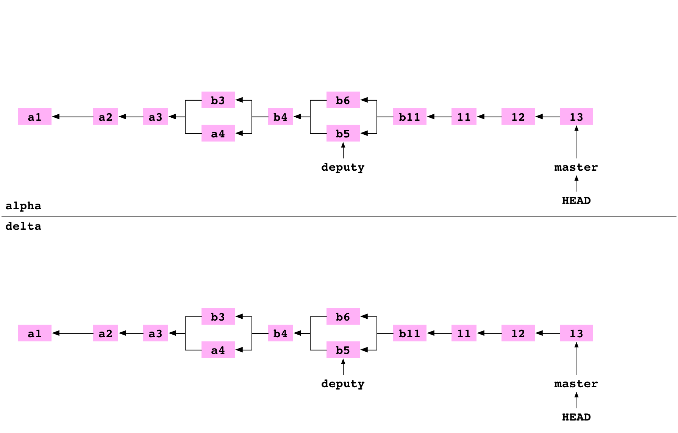
The user moves into the directory above. They clone delta as a bare repository. This is an ordinary clone with two differences. The config file indicates that the repository is bare. And the files that are normally stored in the .git directory are stored in the root of the repository:

Push a branch to a bare repository
The user goes back into the alpha repository. They set up delta as a remote repository on alpha.

~ $ cd alpha
~/alpha $ git remote add delta ../delta

They set the content of data/number.txt to 14 and commit the change to master on alpha.
~/alpha $ printf '14' > data/number.txt
~/alpha $ git add data/number.txt
~/alpha $ git commit -m '14'

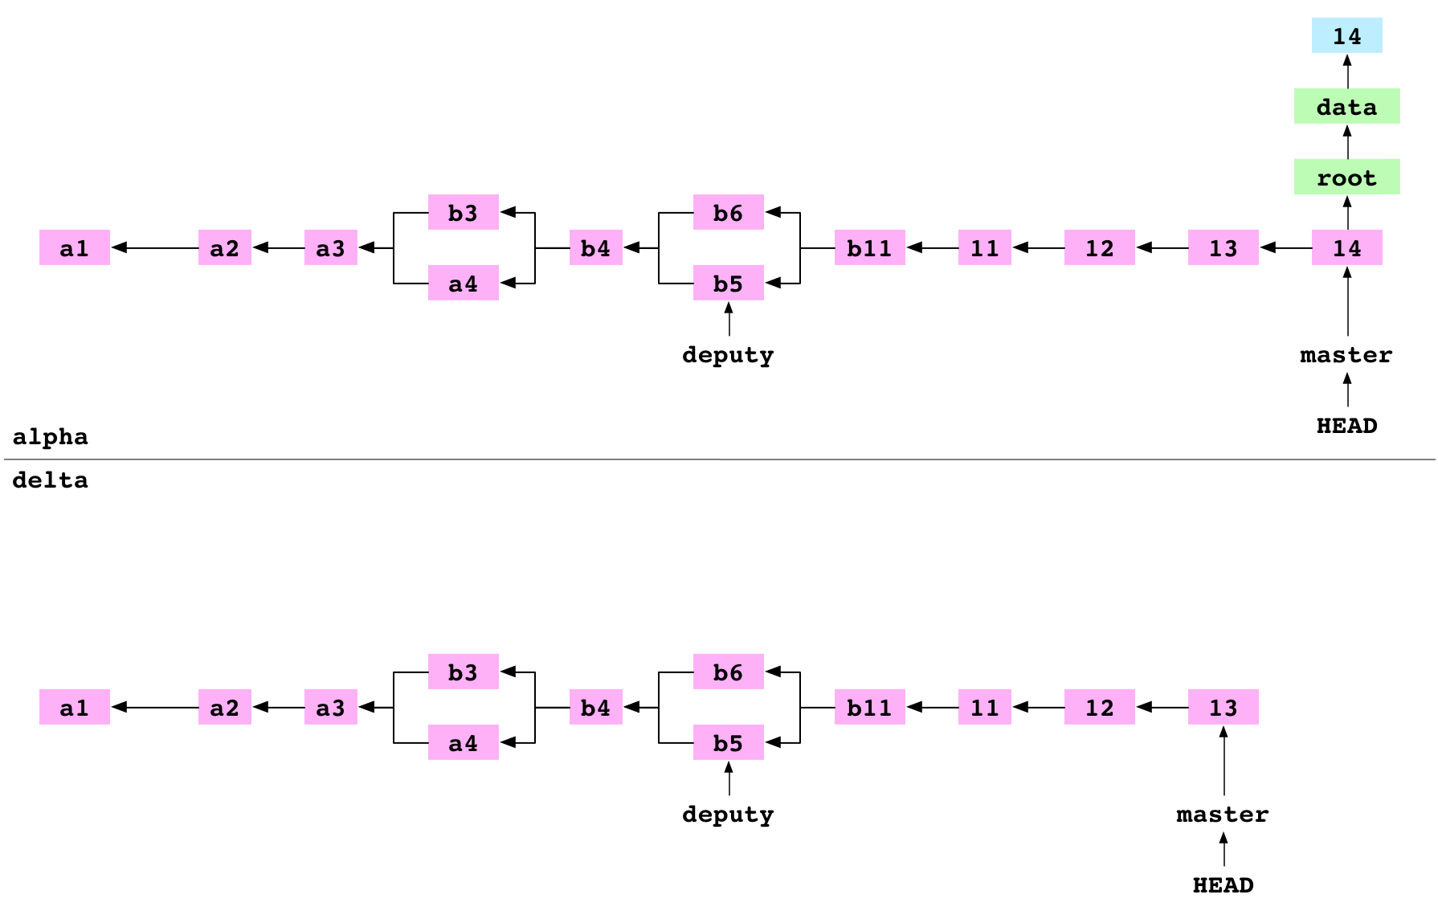
git push delta master

They push master to delta. Pushing has three steps.
First, all the objects required for the 14 commit on the master branch are copied from alpha/.git/objects/ to delta/objects/.
Second, delta/refs/heads/master is updated to point at the 14 commit.
Third, alpha/.git/refs/remotes/delta/master is set to point at the 14 commit. alpha has an up-to-date record of the state of delta.
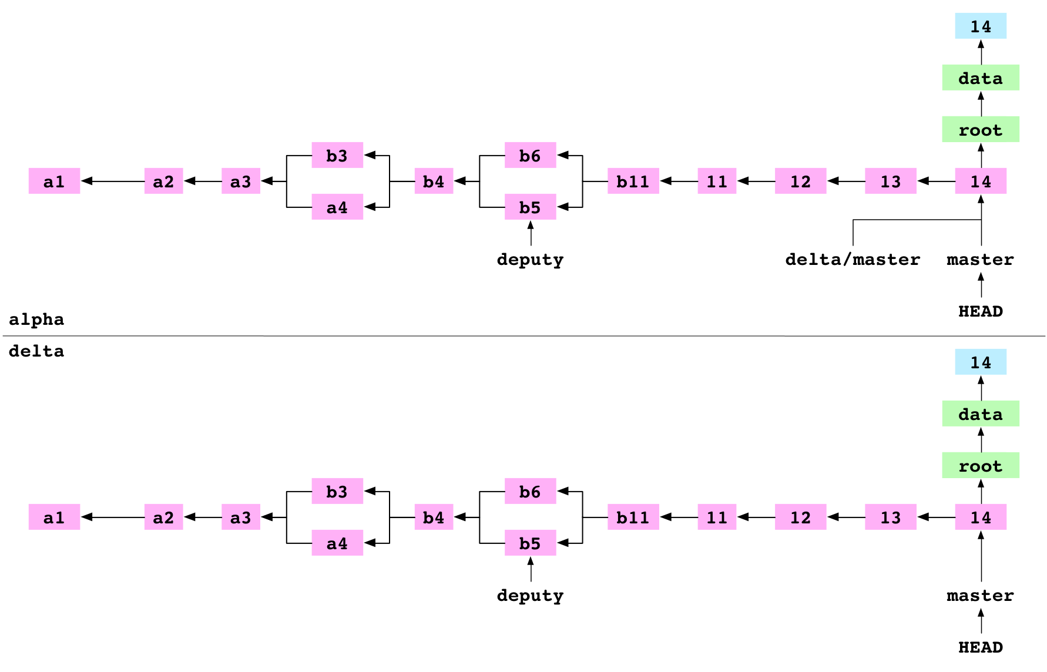

Git for humans

Config
git config [--global] <key> <value>
git config –global user.name “xxxxxx”

git clone <url> [directory]
directory different name folder

> git status [-s] [Path/to/thing]

Remove files from git
git rm filename1
command doesn’t care if the deleted file has been deleted or not. Stages the deletion for the next commit

if you have already deleted a tracked file manually? Well you have two options
> git commit -a
> git rm <filename>
git mv filename1 filename2

> git reset filename.txt
The opposite of git add. You can use git reset to un-stage it. We are not moving the file from index back into our working directory, we are just deleting the file from the index. Our working copy copy unaffected. The working copy remains unaffected. We could run the git rest command without appending a file. If we did this, all the files in the index would have been discardedtouch
git reset
all the files in the index would have been discarded
git commit [-a] [-m “Your message”]
-a or –all option stage any changes you’ ve made to your working copy. Only files are already tracked
git branch [-r|-a]
Shows a list of all your branches. By default, it shows you only branches on your local copy of the repo. The -r option can show you all the branches you’ve fetched from remotes; -a shows you both local and remote branches.
git branch <branchname> [<commit>]
If you give a branch name as an argument to git branch, it’ll create a branch with that name, starting at the current commit (or at any commit you specify, if you provide its ID).

git checkout [-b] <branchname-or-commit>
Updates your working copy to match the given branch or commit—in essence, switching you into that branch/commit. If you check out a branch, Git sets that as the current branch so you can add commits to it. If you check out a commit or tag, Git “detaches” from any branch—you can make commits, but they will only be retrievable by their commit IDs.

$ git merge <otherbranch>
Merges otherbranch into the current branch,
git merge --no-commit otherbranhc
git remote add <name> <url>
Adds a remote with the given name and URL to your local Git project settings.

git remote rm <name>
Removes the remote from your project settings along with any remote tracking branches you may have fetched from the server

git push <remotename> <branchname>
Pushes the current state of branchname to the remote named remotename..

git pull <remotename> <branchname>
Pulls down the current state of branchname from the remote to your local copy, and attempts to merge it into your current branch.

git fetch <remotename>
Copies everything from the remote to your local copy. When you run git pull, a fetch happens automatically.

git log [—oneline] [—pretty] [<branchname-or-commit>]
Shows a reverse-ordered list of commits, starting from the current head

git diff [—stat] [<branchname-or-commit>]
Generates a “diff ”—a visual representation of the differences between two commits. The --stat option produces a summary view showing a list of files changed, with how many lines were added and deleted in each one.

git tag [-a] [-m] <tagname> [<commit>]
Tags a commit with the name you provide, which you can use as a static, friendly name for that commit. The -a flag tells Git to create an annotated tag, which includes information about when the tag was created, by whom, and a message saying what it’s about, just like a commit. (Otherwise, Git creates a “lightweight” tag, which references a commit but doesn’t create any of that other info.) If you create an annotated tag, make sure to include the --message/-m argument, again, just like a commit.

git tag -d <tagname>
You shouldn’t need to delete a tag, but if you do, you can do it by passing the -d (for “delete”) option to git tag.

git tag -l
Outputs a list of all the tags in your repository.

nuclear options
git add –all
git add –A

Reading Log
git log –-pretty=online
git log –-pretty=short
git log –-pretty=medium
git log –-pretty=full
git log –-pretty=fuller

git log --online
git log –online master..origin/master
git log –online brancheA..brancheB
It shows a list of all the commits in branch that aren’t in branchA

If brancheA is checked out
git log –online ..brancheB

Filtering the log
git log –author=adel –grep=407 --oneline
git log –author=user –grep=pattern -–oneline file

Editor
git config --global core.editor notepad

Differences
shows the differences between HEAD and HEAD~1
git diff HEAD~1:
git diff –-stat HEAD~1: Shows the stat

Tag
Lightweight tag
git tag tagname CommitID

Annotated tag:
git tag tagname CommitID –a –m “Message jhjk”;
To delete a tag
git –d tagname

Tags likes branches can and shoud be shared on a remote
Git push tagname

$ git remote //list the remotes
$ git remote add name url // add a remote
$ git push remote branch
Simplest way to set up a tracking relationship is to include –u
$ git push –u orgin branch

$ git branch –r
$ git branch -a

Git in the trenches

-config: This is the main configuration file for git
- HEAD: this file is a pointer to the parent commit of your current branch
- ORIG_HEAD Hold the previous SHA-1 hash that HEAD pointed to.
- objects: this is the directory that holds all the actual files that are stored in the repository
- refs: this folder holds the files that contain information about local branches, remote branches and tags

Tells us the type of object
> git cat-file –t cfe23c
Tells us the size of the object
> git cat-file –s cfe23c
Shows that the object contains
> git cat-file –p cfe23c

Log
> git log
This command will search through the commits in a repository and will return a list of commits which introduced or removed the specific string
> git log –S «string»
To shrink the search scope we can append a path
> git log –S «string» file
> git log HEAD~1..HEAD
> git log –p –since=”last week”
> git log –p –since=”last day”
> git log –p –since=”last hour”
> git log –p –since=”last minute”
> git log –p –since=”last minute” -- filename

-n parameter limit the commits
> git log –n6

$ git log --graph –pretty=oneline --all --abbrev-commit --decorate
--graph draw a graph
online reduces the commit details to one line
--all shows all the branches
--abbrev-commit tells git to abbreviate the commit IDs to a sensible length
-- decorate shows us the tag and branch references
$ git log --graph --oneline --all --decorate
Edit the file .config
[alias]
logg = log --graph –pretty=oneline --all --abbrev-commit --decorate

Grep
Find all files in our working tree
git grep text

Diff
Find out what the changes are between our current commit and one of the previous ones
> git diff HEAD~1
> git diff commit1 commit2 --files

Tag
Shows all the tag
> git tag
> git tag v1.0a
Shows the commit SHA-1 hash object referred by the given name
> git rev-parse v1.0a
> git tag v0.9 163f0
> git diff v0.9..v1.0a
Annotated tag (object type tag)
> git tag v1.0b –m “message”
> git show v1.0b
Delete a tag
> git tag –d v1.0b
Overwrite a tag with the same name with different information
> git tag –f v1.0b

Branch

List the branches
> git branch
> git branch tutu
> git branch tutu 9710177
> git branch –v (verbosely list all the branches)
> git checkout tutu
> git checkout –b tutu
git reset isn’ only used to reset files in the index, but in fact git reset can actually perform many more tasks
> git reset --hard 9710177
> git branch –d tutu (delete)
> git branch –D tutu (force deletion)
git merge tutu
git reset --merge Reset a merge

Finds the best common ancestor
git merge-base branch1 branch2

Show

Shows the information pointed to by the reference
git show <reference>

Stash
$ git stash
$ git stash list
$ git stash show stash@{0}
-p option show us exactly what is contained in the stash
$ git stash show stash@{0} –p
$ git stash apply stash@{0}
$ git stash drop stash@{0}

Rebase
Runs the rebase tool interactively
$ git rebase –i HEAD~3

Lift all commits between the common ancestor of branchA and branchB and replay them on top of branchB
$ git rebase <branchA> <branchB>

Lift all the commits between the common ancestor of branchA and branch B and replay them on top of branchC
$ git rebase –onto <branchC> <branchA> <branchB>

Conflict
$ git rebase –continue Or ¤ $ git rebase -abort

GUI

> git gui

Commandes git (notes)
Annulation modifications fichier
git checkout

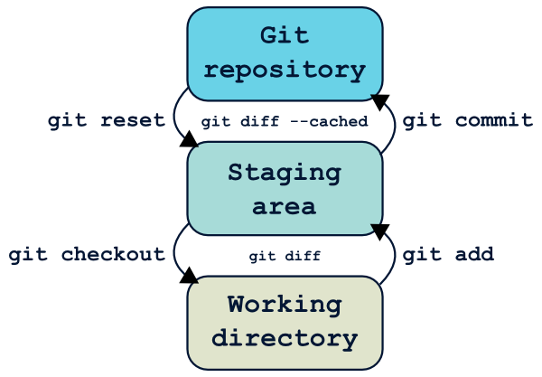
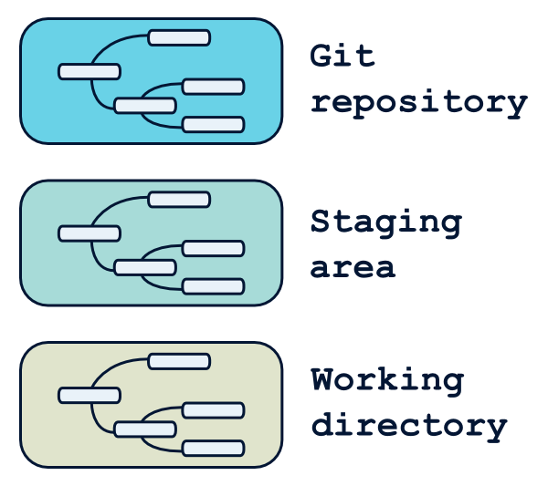
Reflog
Git conserve un log de tous les déplacements de la référence HEAD, accessible grâce à la commande git reflog.
$ git checkout .
# Supprime toutes les modifications en cours qui ne sont pas dans le staging

$ git checkout accounts/
# Supprime toutes les modifications de fichiers contenues dans accounts/

$ git checkout v1.0.1 accounts/
# Récupère dans le rép. de travail le répertoire "accounts" tel qu'il était dans la version 1.0.1

$ git reset v1.0.1 --soft # Déplace HEAD… et c'est tout !
$ git reset v1.0.1 --mixed # Déplace HEAD, et met à jour le staging. C'est le mode par défaut.
$ git reset v1.0.1 --hard # Déplace HEAD, met à jour le staging et le répertoire de travail

Attention, contrairement à git checkout, git reset --hard écrasera votre répertoire de travail même si vous avez des modifications en cours. Il est donc possible de perdre du travail.
- la référence HEAD ne sera pas déplacée ;
- les modifications seront limitées au chemin de fichier spécifié ;

$ git reset # Équivalent à git reset --mixed HEAD, supprime toutes les modifications entre le dernier commit et la staging area

$ git reset --hard # Supprime toutes les modifications par rapport au dernier commit

$ git reset --hard v1.0.0 # Supprime tous les commits depuis la v1.0.0 (récupérables grâce au reflog)

$ git reset HEAD^ # Annule le dernier commit, mais laisse le répertoire de travail en l'état

$ git reset accounts/ # Annule les modifications sous accounts/ qui sont dans le staging

$ git reset --hard accounts/ # Cette combinaison d'option est interdite, et renvoie une erreur

Delete the last commit
$ git reset –hard HEAD~1

Tracing changes in afile
$ git blame filename1
$ git gui blame filename1
$ git show 8d512654

https://bitbucket.org/
https://www.atlassian.com/git/tutorials
https://delicious-insights.com/en/posts/getting-solid-at-git-rebase-vs-merge/
https://delicious-insights.com/en/archives/
http://tbaggery.com/2008/04/19/a-note-about-git-commit-messages.html
https://chris.beams.io/posts/git-commit/#seven-rules
https://24ways.org/2015/git-rebasing/
https://alistapart.com/article/git-the-safety-net-for-your-projects

https://fr.atlassian.com/git/tutorials
http://nvie.com/posts/a-successful-git-branching-model/
http://www.gitforvisualstudio.com/resources/
http://gitforteams.com/
https://www.cesdb.com/
http://pioupioum.fr/developpement/git-alias-productivite.html#annuler-dernier-commit
http://www.alexgirard.com/git-book/basic/branches-et-merges/
$ git clone –bare
pour créer une copie d’un depot git sur un serveur sans repertoire de travail
git diff pour voir la difference entre deux arbres
$ git diff //working folder and the staged zone
$ git diff --staged //entre index et dernier commit
$ git diff master branchA //entre deux commits
$ git diff branchA..branchB //difference entre branches
$ git difftool

$ git commit –am
$ git commit –amend
$ git commit –S //sign the commit

$ git reset --hard
$ git rm
$ git rm --cached
$ git clean // supprimer indesirables fichiers
$ git branch –u //definier branche de suivi
$ git checkout
$ git checkout --track
$ git merge
$ git merge --abort
$ git mergetool
$ git log –p
$ git log –-stat
$ git log –-pretty=
$ git log --oneline
$ git log --decorate
$ git log --graph
$ git log branchA..branchB
$ git push -–delete branchA //delete remote branch
$ git push –tags //pour partager kes tags
$ git remote pour travailler base de depots distants

Tilap.net
Annulez le commit en question proprement

$git revert XXX
$git push

Git community Book
Subversion, CVS, Perforce, Mercurial et les autres utilisent tous un système de stockage de Delta — ils stockent les différences entre un commit et le suivant. Git ne fait pas ça — il stocke une vue instantanée de la représentation de tous les fichiers de votre projet dans une structure hiérarchisée chaque fois que vous faites un commit. C’est un concept très important pour comprendre comment utiliser Git.

$ git show 6ff87c4664

La commande polyvalente git show peut aussi être utilisée pour examiner un objet « tree », mais git ls-tree vous donnera plus de détails.
$ git ls-tree fb3a8bdd0ce

$ git log –pretty =raw

$ git cat-file –t 857f

$ git cat-file –p 857f

$ git diff
$ git diff –-cached

Resoudre une merge
$ git add file.txt
$ git commit

Annuler merge
Revenir a l’etat initial
$ git reset –hard HEAD

Analyser historique
$ git log v2.5..
$ git log test..master
$ git log Foo.cs
$ git log --oneline BV.Common/Computations/

Git community book

The Git Object Model

there are four different types of objects: "blob", "tree", "commit", and "tag".

- A "blob" is used to store file data - it is generally a file.
- A "tree" is basically like a directory - it references a bunch of other trees and/or blobs (i.e. files and sub-directories)
- A "commit" points to a single tree, marking it as what the project looked like at a certain point in time. It contains meta-information about that point in time, such as a timestamp, the author of the changes since the last commit, a pointer to the previous commit(s), etc.
- A "tag" is a way to mark a specific commit as special in some way. It is normally used to tag certain commits as specific releases or something along those lines.

Blob Object
A blob generally stores the contents of a file.
Git show to examine the contents of any blob.
$ git show 6ff87c4664

Tree Object
A tree is a simple object that has a bunch of pointers to blobs and other trees

The ever-versatile git show command can also be used to examine tree objects. but git ls-tree will give you more details.

$ git ls-tree fb3a8bdd0ce

Commit Object
The "commit" object links a physical state of a tree with a description of how we got there and why.

You can use the --pretty=raw option to git show to examine your favorite commit:

git show -s --pretty=raw 2be7fcb476

Without --cached, git-diff will show you any changes that you've made but not yet added to the index.
$ git diff --cached

Annuler un merge

Si vous êtes bloqués et décidés de laisser tomber en jetant tout vos brouillons par la fenêtre, vous pouvez toujours revenir à l'état où vous vous trouviez avant le merge avec la commande:
$ git reset --hard HEAD
If you get stuck and decide to just give up and throw the whole mess away, you can always return to the pre-merge state with
$ git reset --hard HEAD

Reviewing History - Git Log

$ git log v2.5.. # commits since (not reachable from) v2.5
$ git log test..master # commits reachable from master but not test
$ git log master..test # commits reachable from test but not master
$ git log master...test # commits reachable from either test or
# master, but not both
$ git log --since="2 weeks ago" # commits from the last 2 weeks
$ git log Makefile # commits that modify Makefile
$ git log fs/ # commits that modify any file under fs/
$ git log -S'foo()' # commits that add or remove any file data
# matching the string 'foo()'
$ git log --no-merges # dont show merge commits

You can also ask git log to show patches:
$ git log -p

If you pass the --stat option to 'git log', it will show you which files have changed in that commit and how many lines were added and removed from each.
$ git log --stat

Formatting the Log
You can also format the log output almost however you want. The '--pretty' option can take a number of preset formats, such as 'oneline':

$ git log --pretty=oneline

You can also use ‘short’, 'medium', 'full', 'fuller', 'email' or 'raw'

If those formats aren't exactly what you need, you can also create your own format with the '--pretty=format

$ git log --pretty=format:'%h was %an, %ar, message: %s'

Lastly, you can reverse the order of the log with the '--reverse' option.

Comparing Commits - Git Diff

You can generate diffs between any two versions of your project

$ git diff master..test

That will produce the diff between the tips of the two branches

$ git diff master...test

You will commonly use git-diff for figuring out differences between your last commit, your index, and your current working directory. A common use is to simply run
$ git diff

which will show you changes in the working directory that are not yet staged for the next commit. If you want to see what is staged for the next commit, you can run

$ git diff --cached

Lastly, you can run
$ git diff HEAD
which shows changes in the working directory since your last commit

If you want to see how your current working directory differs from the state of the project in another branch, you can run something like
$ git diff test
You can also limit the comparison to a specific file or subdirectory by adding a path limiter:

$ git diff HEAD -- ./lib
That command will show the changes between your current working directory and the last commit (or, more accurately, the tip of the current branch), limiting the comparison to files in the 'lib' subdirectory.

If you don't want to see the whole patch, you can add the '--stat' option
$ git diff --stat

$ git log -p master..origin/master
shows a list of all the changes that made

After examining those changes, you could merge the changes into her master branch:
$ git merge origin/master

http://www.steelconstruction.info/Design_software_and_tools#Compression_resistance
http://www.ilsb.tuwien.ac.at/links/felinks.html
http://www.ce.memphis.edu/7117/notes/notes.html
felt.sourceforge.net/felt.pdf
https://sourceforge.net/projects/sas-civil/?source=typ_redirect
https://sourceforge.net/p/objectiveframe/code/HEAD/tree/trunk/src/util/
https://sourceforge.net/projects/slffea/?source=directory
https://sourceforge.net/projects/bars3d/?source=directory
https://sourceforge.net/projects/femta/?source=directory

