Introduction
Git is a version control system (VCS)

A Brief History of Revision Control

Files and Folders
The simplest form of version control.
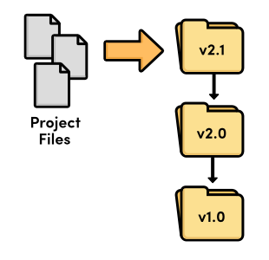
Revision control with files and folders

Local VCS

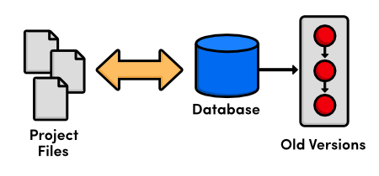
Local version control

At this point, versioning only took place on the developer’s local computer—there was no way to efficiently share code amongst several programmers

.

Centralized VCS
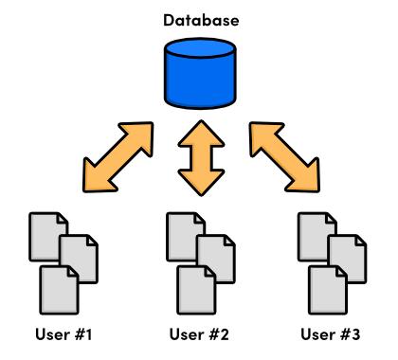
Centralized version control

Distributed VCS
The next generation of revision control programs shifted away from the idea of a single centralized repository, opting instead to give every developer their own local copy of the entire project. The resulting distributed network of repositories let each developer work in isolation, much like a local VCS—but now the conflict resolution problem of CVCS had a much more elegant solution.
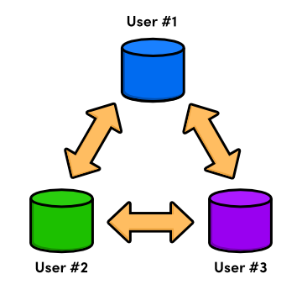
Distributed version control
Since there was no longer a central repository, everyone could develop at their own pace, store the updates locally, and put off merging conflicts until their convenience. In addition, distributed version control systems (DVCS) focused on efficient management for separate branches of development, which made it much easier to share code, merge conflicts, and experiment with new ideas.
The local nature of DVCSs also made development much faster, since you no longer had to perform actions over a network. And, since each user had a complete copy of the project, the risk of a server crash, a corrupted repository, or any other type of data loss was much lower than that of their CVCS predecessors.

The Birth of Git
As a source code manager for the entire Linux kernel, Git had several unique constraints, including:
- Reliability
- Efficient management of large projects
- Support for distributed development
- Support for non-linear development

Installation
For Windows users, Git installation will install a special command shell called Git Bash.
To test your installation, open a new command prompt and run
> git --version.

The Basics
This module explores the fundamental Git workflow:
- Creating a repository,
- Staging
- committing snapshots
- configuring options
- viewing the state of a repository.

Initialize the Git Repository
cd /path/to/my-git-repo
git init

Notice that there is now a .git directory in my-git-repo that stores all the tracking data for our repository. The .git folder is the only difference between a Git repository and an ordinary folder, so deleting it will turn your project back into an unversioned collection of files

View the Repository Status
It would be helpful to view the status of our new repository.
git status
This status message tells us that we’re on our initial commit and that we have nothing to commit but “untracked files”. An untracked file is one that is not under version control. Git doesn’t automatically track files because there are often project files that we don’t want to keep under revision control.

Stage a Snapshot
So, we need to explicitly tell Git to add index.html to the repository. The aptly named git add command tells Git to start tracking index.html:
git add index.html
git status
In place of the “Untracked files” list, you should see the following status.
# Changes to be committed:
# (use "git rm --cached <file>..." to unstage)
#
# new file: index.html
We’ve just added index.html to the snapshot for the next commit. A snapshot represents the state of your project at a given point in time. In this case, we created a snapshot with one file: index.html. If we ever told Git to revert to this snapshot, it would replace the entire project folder with this one file, containing the exact same HTML as it does right now.
Git’s term for creating a snapshot is called staging because we can add or remove multiple files before actually committing it to the project history. Staging gives us the opportunity to group related changes into distinct snapshots—a practice that makes it possible to track the meaningful progression of a software project (instead of just arbitrary lines of code).

Commit the Snapshot
We have staged a snapshot, but we still need to commit it to the project history. The next command will open a text editor and prompt you to enter a message for the commit.
git commit
Type Create index page for the message, leave the remaining text, save the file, and exit the editor. You should see the message 1 files changed among a mess of rather ambiguous output. This changed file is our index.html.
As we just demonstrated, saving a version of your project is a two step process:
- Staging. Telling Git what files to include in the next commit.
- Committing. Recording the staged snapshot with a descriptive message.
Staging files with the git add command doesn’t actually affect the repository in any significant way—it just lets us get our files in order for the next commit. Only after executing git commit will our snapshot be recorded in the repository. Committed snapshots can be seen as “safe” versions of the project. Git will never change them, which means you can do almost anything you want to your project without losing those “safe” revisions. This is the principal goal of any version control system.
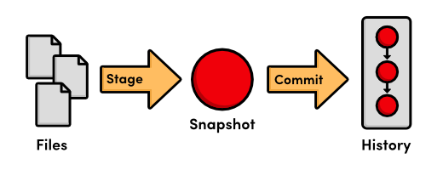
The stage/commit process

View the Repository History
Note that git status now tells us that there is nothing to commit, which means our current state matches what is stored in the repository. The git status command will only show us uncommitted changes—to view our project history, we need a new command:
git log
When you execute this command, Git will output information about our one and only commit, which should look something like this:
commit b650e4bd831aba05fa62d6f6d064e7ca02b5ee1b
Author: unknown <user@computer.(none)>
Date: Wed Jan 11 00:45:10 2012 -0600

Create index page
Let’s break this down. First, the commit is identified with a very large, very random-looking string (b650e4b...). This is an SHA-1 checksum of the commit’s contents, which ensures that the commit will never be corrupted without Git knowing about it. All of your SHA-1 checksums will be different than those displayed in this tutorial due to the different dates and authors in your commits. In the next module, we’ll see how a checksum also serves as a unique ID for a commit.
Next, Git displays the author of the commit. But since we haven’t told Git our name yet, it just displays unknown with a generated username. Git also outputs the date, time, and timezone (-0600) of when the commit took place. Finally, we see the commit message that was entered in the previous step.

Configure Git
Before committing any more snapshots, we should probably tell Git who we are. We can do this with the git config command:
git config --global user.name "Your Name"
git config --global user.email your.email@example.com
Be sure to replace Your Name and your.email@example.com with your actual name and email. The --global flag tells Git to use this configuration as a default for all of your repositories. Omitting it lets you specify different user information for individual repositories, which will come in handy later on.

Create New HTML Files
Let’s continue developing our website a bit. Start by creating a file called orange.html with the following content.
<!DOCTYPE html>
<html lang="en">
<head>
<title>The Orange Page</title>
<meta charset="utf-8" />
</head>
<body>
<h1 style="color: #F90">The Orange Page</h1>
<p>Orange is so great it has a
<span style="color: #F90">fruit</span> named after it.</p>
</body>
</html>
Then, add a blue.html page:
<!DOCTYPE html>
<html lang="en">
<head>
<title>The Blue Page</title>
<meta charset="utf-8" />
</head>
<body>
<h1 style="color: #00F">The Blue Page</h1>
<p>Blue is the color of the sky.</p>
</body>
</html>

Stage the New Files
Next, we can stage the files the same way we created the first snapshot.
git add orange.html blue.html
git status
Notice that we can pass more than one file to git add. After adding the files, your status output should look like the following:
# On branch master
# Changes to be committed:
# (use "git reset HEAD <file>..." to unstage)
#
# new file: blue.html
# new file: orange.html
Try running git log. It only outputs the first commit, which tells us that blue.html and orange.html have not yet been added to the repository’s history. Remember, we can see staged changes with git status, but not with git log. The latter is used only for committed changes.
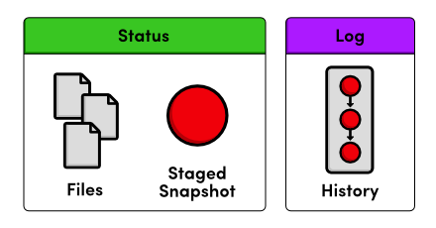Status output vs. Log output

Commit the New Files
Let’s commit our staged snapshot:
git commit
Use Create blue and orange pages as the commit message, then save and close the file. Now, git log should output two commits, the second of which reflects our name/email configuration. This project history can be visualized as:
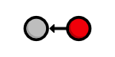Current project history
Each circle represents a commit, the red circle designates the commit we’re currently viewing, and the arrow points to the preceding commit. This last part may seem counterintuitive, but it reflects the underlying relationship between commits (that is, a new commit refers to its parent commit). You’ll see this type of diagram many, many times throughout this tutorial.

Modify the HTML Pages
The git add command we’ve been using to stage new files can also be used to stage modified files. Add the following to the bottom of index.html, right before the closing </body> tag:
<h2>Navigation</h2>
<ul>
<li style="color: #F90">
<a href="orange.html">The Orange Page</a>
</li>
<li style="color: #00F">
<a href="blue.html">The Blue Page</a>
</li>
</ul>
Next, add a home page link to the bottom of orange.html and blue.html (again, before the </body> line):
<p><a href="index.html">Return to home page</a></p>
You can now navigate between pages when viewing them in a web browser.

Stage and Commit the Snapshot
Once again, we’ll stage the modifications, then commit the snapshot.
git status
git add index.html orange.html blue.html
git status
git commit -m "Add navigation links"
The -m option lets you specify a commit message on the command line instead of opening a text editor. This is just a convenient shortcut (it has the exact same effect as our previous commits).
Our history can now be represented as the following. Note that the red circle, which represents the current commit, automatically moves forward every time we commit a new snapshot.
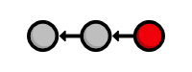Current project history

Explore the Repository’s History
The git log command comes with a lot of formatting options, a few of which will be introduced throughout this tutorial. For now, we’ll just use the convenient --oneline flag:
git log --oneline
Condensing output to a single line is a great way to get a high-level overview of a repository. Another useful configuration is to pass a filename to git log:
git log --oneline blue.html
This displays only the blue.html history. Notice that the initial Create index page commit is missing, since blue.html didn’t exist in that snapshot.

Conclusion
In this module, we introduced the fundamental Git workflow: edit files, stage a snapshot, and commit the snapshot. We also had some hands-on experience with the components involved in this process:
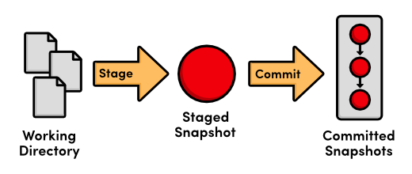The fundamental Git workflow
The distinction between the working directory, the staged snapshot, and committed snapshots is at the very core of Git version control. Nearly all other Git commands manipulate one of these components in some way, so understanding the interplay between them is a fantastic foundation for mastering Git.
The next module puts our existing project history to work by reverting to previous snapshots. This is all you need to start using Git as a simple versioning tool for your own projects.

Quick Reference
git init | Create a Git repository in the current folder
git status | View the status of each file in a repository
git add <file> | Stage a file for the next commit
git commit | Commit the staged files with a descriptive message
git log | View a repository’s commit history
git config --global user.name "<name>" | Define the author name to be used in all repositories
git config --global user.email <email> | Define the author email to be used in all repositories

.
.

Undoing Changes
In the last module, we learned how to record versions of a project into a Git repository. The whole point of maintaining these “safe” copies is peace of mind: should our project suddenly break, we’ll know that we have easy access to a functional version, and we’ll be able to pinpoint precisely where the problem was introduced.
To this end, storing “safe” versions isn’t much help without the ability to restore them. Our next task is to learn how to view the previous states of a project, revert back to them, and reset uncommitted changes.

Download the repository for this module
If you’ve been following along from the previous module, you already have everything you need. Otherwise, download the zipped Git repository from the above link, uncompress it, and you’re good to go.

Display Commit Checksums
As a quick review, let’s display our repository’s history. Navigate a command prompt (or Git Bash) to the my-git-repo folder and run the following.
git log --oneline
The output for this should look similar to the following, but contain different commit checksums.
1c310d2 Add navigation links
54650a3 Create blue and orange pages
b650e4b Create index page
Git only outputs the first 7 characters of the checksum (remember that you can see the full version with the default formatting of git log). These first few characters effectively serve as a unique ID for each commit.

View an Old Revision
Using the new git checkout command, we can view the contents of a previous snapshot. Make sure to change 54650a3 in the following command to the ID of your second commit.
git checkout 54650a3
This will output a lot of information about a detached HEAD state. You can ignore it for now. All you need to know is that the above command turns your my-git-repo directory into an exact replica of the second snapshot we committed in The Basics.
Open the HTML files in a text editor or web browser to verify that the navigation links we added in the third commit have disappeared. Running git log will also tell us that the third commit is no longer part of the project. After checking out the second commit, our repository history looks like the following (the red circle represents the current commit).
Checking out the 2nd commit

View an Older Revision
Let’s go even farther back in our history. Be sure to change b650e4b to the ID of your first commit.
git checkout b650e4b
Now, the blue.html and orange.html files are gone, as is the rest of the git log history.
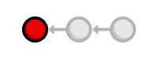Checking out the 1st commit
In the last module, we said that Git was designed to never lose a committed snapshot. So, where did our second and third snapshots go? A simple git status will answer that question for us. It should return the following message:
# Not currently on any branch.
nothing to commit (working directory clean)
Compare this with the status output from the previous module:
# On branch master
nothing to commit (working directory clean)
All of our actions in The Basics took place on the master branch, which is where our second and third commits still reside. To retrieve our complete history, we just have to check out this branch. This is a very brief introduction to branches, but it’s all we need to know to navigate between commits. The next module will discuss branches in full detail.

Return to Current Version
We can use the same git checkout command to return to the master branch.
git checkout master
This makes Git update our working directory to reflect the state of the master branch’s snapshot. It re-creates the blue.html and orange.html files for us, and the content of index.html is updated as well. We’re now back to the current state of the project, and our history looks like:
Current project history

Tag a Release
Let’s call this a stable version of the example website. We can make it official by tagging the most recent commit with a version number.
git tag -a v1.0 -m "Stable version of the website"
Tags are convenient references to official releases and other significant milestones in a software project. It lets developers easily browse and check out important revisions. For example, we can now use the v1.0 tag to refer to the third commit instead of its random ID. To view a list of existing tags, execute git tag without any arguments.
In the above snippet, the -a flag tells Git to create an annotated tag, which lets us record our name, the date, and a descriptive message (specified via the -m flag). We’ll use this tag to find the stable version after we try some crazy experiments.

Try a Crazy Experiment
We’re now free to add experimental changes to the example site without affecting any committed content. Create a new file called crazy.html and add the following HTML.
<!DOCTYPE html>
<html lang="en">
<head>
<title>A Crazy Experiment</title>
<meta charset="utf-8" />
</head>
<body>
<h1>A Crazy Experiment</h1>
<p>We're trying out a <span style="color: #F0F">crazy</span>
<span style="color: #06C">experiment</span>!

<p><a href="index.html">Return to home page</a></p>
</body>
</html>

Stage and Commit the Snapshot
Stage and commit the new file as usual.
git add crazy.html
git status
git commit -m "Add a crazzzy experiment"
git log
It’s a good practice to run git status to see exactly what you’re committing before running git commit -m. This will keep you from unintentionally committing a file that doesn’t belong in the current snapshot.
As expected, the new snapshot shows up in the repository’s history. If your log history takes up more than one screen, you can scroll down by pressing Space and return to the command line by pressing the letter q.

View the Stable Commit
Let’s go back and take a look at our stable revision. Remember that the v1.0 tag now serves as a user-friendly shortcut to the third commit’s ID.
git checkout v1.0
After seeing the stable version of the site, we decide to scrap the crazy experiment. But, before we undo the changes, we need to return to the master branch. If we didn’t, all of our updates would be on some non-existent branch. As we’ll discover next module, you should never make changes directly to a previous revision.
git checkout master
git log --oneline
At this point, our history should look like the following:
514fbe7 Add a crazzzy experiment
1c310d2 Add navigation links
54650a3 Create blue and orange pages
b650e4b Create index page

Undo Committed Changes
We’re ready to restore our stable tag by removing the most recent commit. Make sure to change 514fbe7 to the ID of the crazy experiment’s commit before running the next command.
git revert 514fbe7
This will prompt you for a commit message with a default of Revert "Add a crazzzy experiment".... You can leave the default message and close the file. After verifying that crazy.html is gone, take a look at your history with git log --oneline.
506bb9b Revert "Add a crazzzy experiment"
514fbe7 Add a crazzzy experiment
1c310d2 Add navigation links
54650a3 Create blue and orange pages
b650e4b Create index page
Notice that instead of deleting the “crazzzy experiment” commit, Git figures out how to undo the changes it contains, then tacks on another commit with the resulting content. So, our fifth commit and our third commit represent the exact same snapshot, as shown below. Again, Git is designed to never lose history: the fourth snapshot is still accessible, just in case we want to continue developing it.
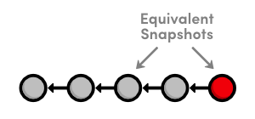Current project history
When using git revert, remember to specify the commit that you want to undo—not the stable commit that you want to return to. It helps to think of this command as saying “undo this commit” rather than “restore this version.”

Start a Smaller Experiment
Let’s try a smaller experiment this time. Create dummy.html and leave it as a blank file. Then, add a link in the “Navigation” section of index.html so that it resembles the following.
<h2>Navigation</h2>
<ul>
<li style="color: #F90">
<a href="orange.html">The Orange Page</a>
</li>
<li style="color: #00F">
<a href="blue.html">The Blue Page</a>
</li>
<li>
<a href="dummy.html">The Dummy Page</a>
</li>
</ul>
In the next section, we’re going to abandon this uncommitted experiment. But since the git revert command requires a commit ID to undo, we can’t use the method discussed above.

Undo Uncommitted Changes
Before we start undoing things, let’s take a look at the status of our repository.
git status
We have a tracked file and an untracked file that need to be changed. First, we’ll take care of index.html:
git reset --hard
This changes all tracked files to match the most recent commit. Note that the --hard flag is what actually updates the file. Running git reset without any flags will simply unstage index.html, leaving its contents as is. In either case, git reset only operates on the working directory and the staging area, so our git log history remains unchanged.
Next, let’s remove the dummy.html file. Of course, we could manually delete it, but using Git to reset changes eliminates human errors when working with several files in large teams. Run the following command.
git clean -f
This will remove all untracked files. With dummy.html gone, git status should now tell us that we have a “clean” working directory, meaning our project matches the most recent commit.
Be careful with git reset and git clean. Both operate on the working directory, not on the committed snapshots. Unlike git revert, they permanently undo changes, so make sure you really want to trash what you’re working on before you use them.

Conclusion
As noted in the previous module, most Git commands operate on one of the three main components of a Git repository: the working directory, the staged snapshot, or the committed snapshots. The git reset command undoes changes to the working directory and the staged snapshot, while git revert undoes changes contained in committed snapshots. Not surprisingly, git status and git log directly parallel this behavior.
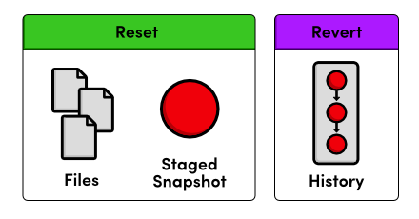Resetting vs. Reverting
I mentioned that instead of completely removing a commit, git revert saves the commit in case you want to come back to it later. This is only one reason for preserving committed snapshots. When we start working with remote repositories, we’ll see that altering the history by removing a commit has dramatic consequences for collaborating with other developers.
This module also introduces the concept of switching between various commits and branches with git checkout. Branches round out our discussion of the core Git components, and they offer an elegant option for optimizing your development workflow. In the next module, we’ll cover the basic Git branch commands.

Quick Reference
git checkout <commit-id>
View a previous commit.
git tag -a <tag-name> -m "<description>"
Create an annotated tag pointing to the most recent commit.
git revert <commit-id>
Undo the specified commit by applying a new commit.
git reset --hard
Reset tracked files to match the most recent commit.
git clean -f
Remove untracked files.
git reset --hard / git clean -f
Permanently undo uncommitted changes.

Branches, Part I
Branches are the final component of Git version control. This gives us four core elements to work with throughout the rest of this tutorial:
- The Working Directory
- The Staged Snapshot
- Committed Snapshots
- Development Branches
In Git, a branch is an independent line of development. For example, if you wanted to experiment with a new idea without using Git, you might copy all of your project files into another directory and start making your changes. If you liked the result, you could copy the affected files back into the original project. Otherwise, you would simply delete the entire experiment and forget about it.
This is the exact functionality offered by Git branches—with some key improvements. First, branches present an error-proof method for incorporating changes from an experiment. Second, they let you store all of your experiments in a single directory, which makes it much easier to keep track of them and to share them with others. Branches also lend themselves to several standardized workflows for both individual and collaborative development, which will be explored in the latter half of the tutorial.
Download the repository for this module
If you’ve been following along from the previous module, you already have everything you need. Otherwise, download the zipped Git repository from the above link, uncompress it, and you’re good to go.

View Existing Branches
Let’s start our exploration by listing the existing branches for our project.
git branch
This will display our one and only branch: * master. The master branch is Git’s default branch, and the asterisk next to it tells us that it’s currently checked out. This means that the most recent snapshot in the master branch resides in the working directory:
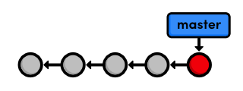The master branch
Notice that since there’s only one working directory for each project, only one branch can be checked out at a time.

Checkout the Crazy Experiment
The previous module left out some details about how checking out previous commits actually works. We’re now ready to tackle this topic in depth. First, we need the checksums of our committed snapshots.
git log --oneline
This outputs the following history.
506bb9b Revert "Add a crazzzy experiment"
514fbe7 Add a crazzzy experiment
1c310d2 Add navigation links
54650a3 Create blue and orange pages
b650e4b Create index page
Check out the crazy experiment from the last module, remembering to change 514fbe7 to the ID of your fourth commit.
git checkout 514fbe7
This command returns a message that says we’re in a detached HEAD state and that the HEAD is now at 514fbe7. The HEAD is Git’s internal way of indicating the snapshot that is currently checked out. This means the red circle in each of our history diagrams actually represents Git’s HEAD. The following figure shows the state of our repository before and after we checked out an old commit.
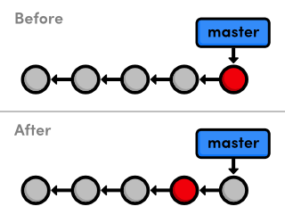
Checking out the 4th commit
As shown in the “before” diagram, the HEAD normally resides on the tip of a development branch. But when we checked out the previous commit, the HEAD moved to the middle of the branch. We can no longer say we’re on the master branch since it contains more recent snapshots than the HEAD. This is reflected in the git branch output, which tells us that we’re currently on (no branch).

Create a New Branch
We can’t add new commits when we’re not on a branch, so let’s create one now. This will take our current working directory and fork it into a new branch.
git branch crazy
Note that git branch is a versatile command that can be used to either list branches or create them. However, the above command only creates the crazy branch—it doesn’t check it out.
git checkout crazy
We’re now free to experiment in the working directory without disturbing anything in the master branch. The crazy branch is a completely isolated development environment that can be visualized as the following.
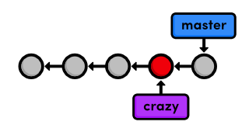Creating a new branch
Right now, the crazy branch, HEAD, and working directory are the exact same as the fourth commit. But as soon as we add another snapshot, we’ll see a fork in our project history.

Make a Rainbow
We’ll continue developing our crazy experiment by changing crazy.html to the following.
<!DOCTYPE html>
<html lang="en">
<head>
<title>A Crazy Experiment</title>
<meta charset="utf-8" />
</head>
<body>
<h1>A Crazy Experiment</h1>
<p>Look! A Rainbow!</p>

<ul>
<li style="color: red">Red</li>
<li style="color: orange">Orange</li>
<li style="color: yellow">Yellow</li>
<li style="color: green">Green</li>
<li style="color: blue">Blue</li>
<li style="color: indigo">Indigo</li>
<li style="color: violet">Violet</li>
</ul>

<p><a href="index.html">Return to home page</a></p>
</body>
</html>

Stage and Commit the Rainbow
Hopefully, you’re relatively familiar with staging and committing snapshots by now:
git add crazy.html
git status
git commit -m "Add a rainbow to crazy.html"
After committing on the crazy branch, we can see two independent lines of development in our project:
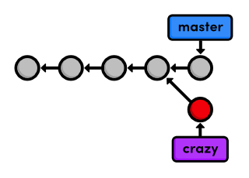Forked project history
Also notice that the HEAD (designated by the red circle) automatically moved forward to the new commit, which is intuitively what we would expect when developing a project.
The above diagram represents the complete state of our repository, but git log only displays the history of the current branch:
677e0e0 Add a rainbow to crazy.html
514fbe7 Add a crazzzy experiment
*1c310d2 Add navigation links
*54650a3 Create blue and orange pages
*b650e4b Create index page
Note that the history before the fork is considered part of the new branch (marked with asterisks above). That is to say, the crazy history spans all the way back to the first commit:
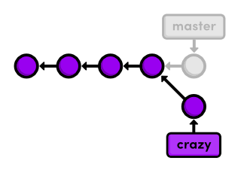History of the crazy branch
The project as a whole now has a complex history; however, each individual branch still has a linear history (snapshots occur one after another). This means that we can interact with branches in the exact same way as we learned in the first two modules.

Rename the Rainbow
Let’s add one more snapshot to the crazy branch. Rename crazy.html to rainbow.html, then use the following Git commands to update the repository.
git status
git rm crazy.html
git status
git add rainbow.html
git status
The git rm command tells Git to stop tracking crazy.html (and delete it if necessary), and git add starts tracking rainbow.html. The renamed: crazy.html -> rainbow.html message in the final status output shows us that Git is smart enough to figure out when we’re renaming a file.
Our snapshot is staged and ready to be committed:
git commit -m "Rename crazy.html to rainbow.html"
git log --oneline
After this addition, our complete repository history looks like the following. Remember that the crazy branch doesn’t include any commits in master after the fork.
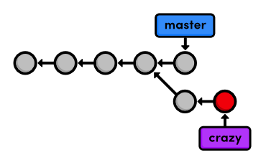Current project history

Return to the Master Branch
Let’s switch back to the master branch:
git checkout master
git branch
git log --oneline
After the checkout, crazy.html doesn’t exist in the working directory, and the commits from the last few steps don’t appear in the history. These two branches became completely independent development environments after they forked. You can think of them as separate project folders that you switch between with git checkout. They do, however, share their first four commits.
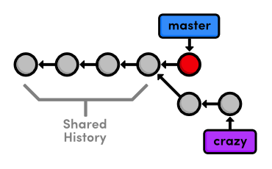Shared branch history

Create a CSS Branch
We’re going to put our crazy experiment on the backburner for now and turn our attention to formatting the HTML pages with a cascading stylesheet (CSS). Again, if you’re not all that comfortable with HTML and CSS, the content of the upcoming files isn’t nearly as important as the Git commands used to manage them.
Let’s create and check out a new branch called css.
git branch css
git checkout css
The new branch points to the currently checked out snapshot, which happens to coincide with the master branch:
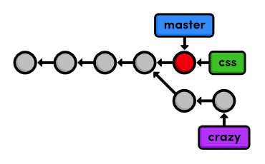Creating the css branch

Add a CSS Stylesheet
Next, create a file called style.css with the following content. This CSS is used to apply formatting to the HTML in our other files.
body {
padding: 20px;
font-family: Verdana, Arial, Helvetica, sans-serif;
font-size: 14px;
color: #111;
}

p, ul {
margin-bottom: 10px;
}

ul {
margin-left: 20px;
}
Commit the stylesheet in the usual fashion.
git add style.css
git status
git commit -m "Add CSS stylesheet"

Link the Stylesheet
We still need to tell the HTML pages to use the formatting in style.css. Add the following text on a separate line after the <title> element in index.html, blue.html, and orange.html (remember that rainbow.html only exists in the crazy branch). You should be able to see the CSS formatting by opening index.html in a web browser.
<link rel="stylesheet" href="style.css" />
Commit the changes.
git add index.html blue.html orange.html
git status
git commit -m "Link HTML pages to stylesheet"
git log --oneline
This results in a repository history that looks like:
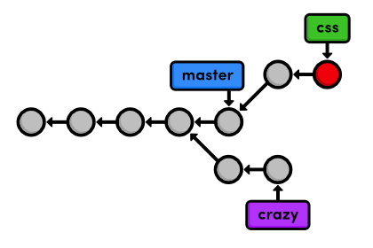Current project history

Return to the Master Branch (Again)
The css branch let us create and test our formatting without threatening the stability of the master branch. But, now we need to merge these changes into the main project. Before we attempt the merge, we need to return to the master branch.
git checkout master
Verify that style.css doesn’t exist and that HTML pages aren’t linked to it. Our repository history remains unchanged, but the working directory now matches the snapshot pointed to by the master branch.
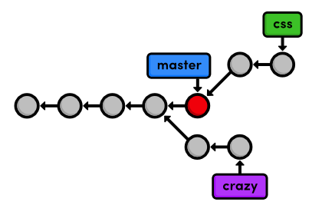Current project history
Take a look at the git log --oneline output as well.
af23ff4 Revert "Add a crazzzy experiment"
a50819f Add a crazzzy experiment
4cd95d9 Add navigation links
dcb9e07 Create blue and orange pages
f757eb3 Create index page
As expected, there is no mention of the CSS additions in the history of master, but we’re about to change that.

Merge the CSS Branch
Use the git merge command to take the snapshots from the css branch and add them to the master branch.
git merge css
Notice that this command always merges into the current branch: css remains unchanged. Check the history to make sure that the css history has been added to master.
git log --oneline
The following diagram visualizes the merge.
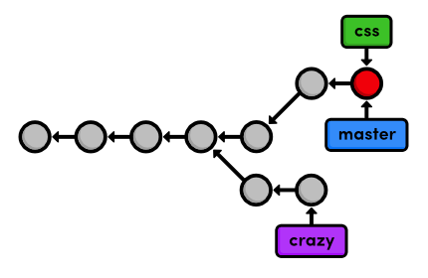Merging the css branch into master
Instead of re-creating the commits in css and adding them to the history of master, Git reuses the existing snapshots and simply moves the tip of master to match the tip of css. This kind of merge is called a fast-forward merge, since Git is “fast-forwarding” through the new commits in the css branch.
After the merge, both branches have the exact same history, which makes them redundant. Unless we wanted to keep developing on the css branch, we’re free to get rid of it.

Delete the CSS Branch
We can safely delete a branch by passing the -d flag to git branch.
git branch -d css
git branch
Since css and master represent the same branch, our history looks the same, though the css branch has been removed. I’ve also put the master branch’s commits in a straight line in the following visualization, making it easier to track during the upcoming modules.
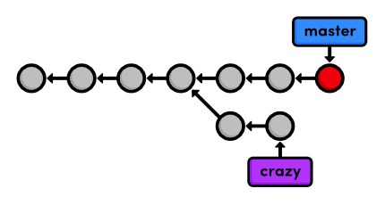Deleting the css branch
Deleting branches is a relatively “safe” operation in the sense that Git will warn you if you’re deleting an unmerged branch. This is just another example of Git’s commitment to never losing your work.

Conclusion
This module used two branches to experiment with new additions. In both cases, branches gave us an environment that was completely isolated from the “stable” version of our website (the master branch). One of our experiments is waiting for us in the next module, while our CSS changes have been merged into the stable project, and its branch is thus obsolete. Using branches to develop small features like these is one of the hallmarks of Git-based software management.
While this module relied heavily on branch diagrams to show the complete state of the repository, you don’t need to keep this high-level overview in mind during your everyday development. Creating a new branch is really just a way to request an independent working directory, staging snapshot, and history. You can think of branches as a way to multiply the functionality presented in the first two module.
Next, we’ll practice our branch management skills by examining the typical workflow of veteran Git users. We’ll also discover more complicated merges than the fast-forward merge introduced above.

Quick Reference
git branch
List all branches.
git branch <branch-name>
Create a new branch using the current working directory as its base.
git checkout <branch-name>
Make the working directory and the HEAD match the specified branch.
git merge <branch-name>
Merge a branch into the checked-out branch.
git branch -d <branch-name>
Delete a branch.
git rm <file>
Remove a file from the working directory (if applicable) and stop tracking the file.

Branches, Part II
Now that we’ve covered the mechanics behind Git branches, we can discuss the practical impact that they have on the software development process. Instead of introducing new commands, this module covers how the typical Git user applies this workflow to real projects, as well as some of the problems that arise in a branched environment.
To Git, a branch is a branch, but it’s often useful to assign special meaning to different branches. For example, we’ve been using master as the stable branch for our example project, and we’ve also used a temporary branch to add some CSS formatting. Temporary branches like the latter are called topic branches because they exist to develop a certain topic, then they are deleted. We’ll work with two types of topic branches later in this module.
Amid our exploration of Git branches, we’ll also discover that some merges cannot be “fast-forwarded.” When the history of two branches diverges, a dedicated commit is required to combine the branches. This situation may also give rise to a merge conflict, which must be manually resolved before anything can be committed to the repository.
Download the repository for this module
If you’ve been following along from the previous module, you already have everything you need. Otherwise, download the zipped Git repository from the above link, uncompress it, and you’re good to go.

Continue the Crazy Experiment
Let’s start by checking out the crazy branch.
git branch
git checkout crazy
git log --oneline
The crazy branch is a longer-running type of topic branch called a feature branch. This is fitting, as it was created with the intention of developing a specific feature. It’s also a term that makes Git’s contribution to the development workflow readily apparent: branches enable you to focus on developing one clearly defined feature at a time.
This brings us to my rule-of-thumb for using Git branches:
- Create a new branch for each major addition to your project.
- Don’t create a branch if you can’t give it a specific name.
Following these simple guidelines will have a dramatic impact on your programming efficiency.

Merge the CSS Updates
Note that the CSS formatting we merged into master is nowhere to be found. This presents a bit of a problem if we want our experiment to reflect these updates. Conveniently, Git lets us merge changes into any branch (not just the master branch). So, we can pull the updates in with the familiar git merge command. Remember that merging only affects the checked-out branch.
git merge master
git log --oneline
As of Git 1.7.10, this will open your editor and prompt you for a message explaining why the commit was necessary. You can use the default Merge branch 'master' into crazy. When you save and close the file, you’ll notice an extra commit in your project history. Recall that our first merge didn’t add any new commits; it just “fast-forwarded” the tip of the master branch. This was not the case for our new merge, which is shown below.
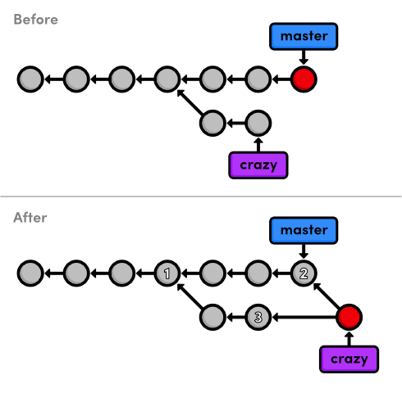Merging master into the crazy branch
Take a moment to examine why the current merge couldn’t be a fast-forward one. How could Git have walked the crazy pointer over to the tip of the master branch? It’s not possible without backtracking, which kind of defeats the idea of “fast-forwarding.” We’re left with a new way to combine branches: the 3-way merge.
A 3-way merge occurs when you try to merge two branches whose history has diverged. It creates an extra merge commit to function as a link between the two branches. As a result, it has two parent commits. The above figure visualizes this with two arrows originating from the tip of crazy. It’s like saying “this commit comes from both the crazy branch and from master.” After the merge, the crazy branch has access to both its history and the master history.
The name comes from the internal method used to create the merge commit. Git looks at three commits (numbered in the above figure) to generate the final state of the merge.
This kind of branch interaction is a big part of what makes Git such a powerful development tool. We can not only create independent lines of development, but we can also share information between them by tying together their histories with a 3-way merge.

Style the Rainbow Page
Now that we have access to the CSS updates from master, we can continue developing our crazy experiment. Link the CSS stylesheet to rainbow.html by adding the following HTML on the line after the <title> element.
<link rel="stylesheet" href="style.css" />
Stage and commit the update, then check that it’s reflected in the history.
git status
git commit -a -m "Add CSS stylesheet to rainbow.html"
git log --oneline
Notice that we skipped the staging step this time around. Instead of using git add, we passed the -a flag to git commit. This convenient parameter tells Git to automatically include all tracked files in the staged snapshot. Combined with the -m flag, we can stage and commit snapshots with a single command. However, be careful not to include unintended files when using the -a flag.

Link to the Rainbow Page
We still need to add a navigation link to the home page. Change the “Navigation” section of index.html to the following.
<h2>Navigation</h2>
<ul>
<li style="color: #F90">
<a href="orange.html">The Orange Page</a>
</li>
<li style="color: #00F">
<a href="blue.html">The Blue Page</a>
</li>
<li>
<a href="rainbow.html">The Rainbow Page</a>
</li>
</ul>
As usual, stage and commit the snapshot.
git commit -a -m "Link index.html to rainbow.html"
git log --oneline

Fork an Alternative Rainbow
Next, we’re going to brainstorm an alternative to the current rainbow.html page. This is a perfect time to create another topic branch:
git branch crazy-alt
git checkout crazy-alt
Remember, we can do whatever we want here without worrying about either crazy or master. When git branch creates a branch, it uses the current HEAD as the starting point for the new branch. This means that we begin with the same files as crazy (if we called git branch from master, we would have had to re-create rainbow.html). After creating the new branch, our repository’s history looks like:
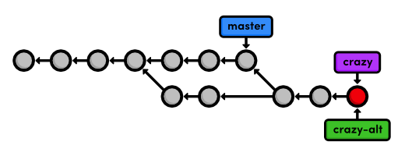Creating the crazy-alt branch

Change the Rainbow
Change the colorful list in rainbow.html from:
<ul>
<li style="color: red">Red</li>
<li style="color: orange">Orange</li>
<li style="color: yellow">Yellow</li>
<li style="color: green">Green</li>
<li style="color: blue">Blue</li>
<li style="color: indigo">Indigo</li>
<li style="color: violet">Violet</li>
</ul>
to the following:
<div style="background-color: red"></div>
<div style="background-color: orange"></div>
<div style="background-color: yellow"></div>
<div style="background-color: green"></div>
<div style="background-color: blue"></div>
<div style="background-color: indigo"></div>
<div style="background-color: violet"></div>
Then, add some CSS formatting to <head> on the line after the <meta> element:
<style>
div {
width: 300px;
height: 50px;
}
</style>
If you open rainbow.html in a browser, you should now see colorful blocks in place of the colorful text. Don’t forget to commit the changes:
git commit -a -m "Make a REAL rainbow"
The resulting project history is show below, with the first four commits omitted for the sake of presentation.
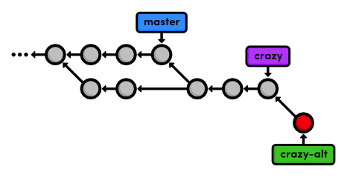Committing on the crazy-alt branch

Emergency Update!
Our boss called in with some breaking news! He needs us to update the site immediately, but what do we do with our rainbow.html developments? Well, the beauty of Git branches is that we can just leave them where they are and add the breaking news to master.
We’ll use what’s called a hotfix branch to create and test the news updates. In contrast to our relatively long-running feature branch (crazy), hotfix branches are used to quickly patch a production release. For example, you’d use a hotfix branch to fix a time-sensitive bug in a public software project. This distinction is useful for demonstrating when it’s appropriate to create a new branch, but it is purely conceptual—a branch is a branch according to Git.
git checkout master
git branch news-hotfix
git checkout news-hotfix
Change the “News” list in index.html to match the following.
<h2 style="color: #C00">News</h2>
<ul>
<li><a href="news-1.html">Blue Is The New Hue</a></li>
</ul>
And, create a new HTML page called news-1.html with the following content.
<!DOCTYPE html>
<html lang="en">
<head>
<title>Blue Is The New Hue</title>
<link rel="stylesheet" href="style.css" />
<meta charset="utf-8" />
</head>
<body>
<h1 style="color: #079">Blue Is The New Hue</h1>
<p>European designers have just announced that
<span style="color: #079">Blue</span> will be this year's
hot color.</p>

<p><a href="index.html">Return to home page</a></p>
</body>
</html>
We can’t use git commit -a to automatically stage news-1.html because it’s an untracked file (as shown in git status). So, let’s use an explicit git add:
git add index.html news-1.html
git status
git commit -m "Add 1st news item"
Test these additions in a browser to make sure that the links work, it’s typo free, etc. If everything looks good, we can “publish” the changes by merging them into the stable master branch. Isolating this in a separate branch isn’t really necessary for our trivial example, but in the real world, this would give you the opportunity to run build tests without touching your stable project.

Publish the News Hotfix
Remember that to merge into the master branch, we first need to check it out.
git checkout master
git merge news-hotfix
Since master now contains the news update, we can delete the hotfix branch:
git branch -d news-hotfix
git branch
The following diagram reflects our repository’s history before and after the merge. Can you figure out why was this a fast-forward merge instead of a 3-way merge?
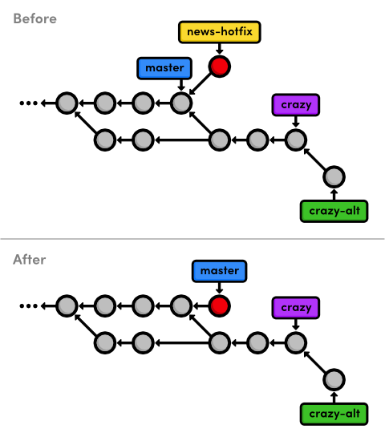Fast-forwarding master to the news-hotfix branch
Also notice that we have another fork in our history (the commit before master branches in two directions), which means we should expect to see another merge commit in the near future.

Complete the Crazy Experiment
Ok, let’s finish up our crazy experiment with one more commit.
git checkout crazy
Note that the news article is nowhere to be found, as should be expected (this branch is a completely isolated development environment).
We’ll finish up our crazy experiment by adding a news item for it on the home page. Change the news list in index.html to the following:
<h2 style="color: #C00">News</h2>
<ul>
<li><a href="rainbow.html">Our New Rainbow</a></li>
</ul>
Astute readers have probably observed that this directly conflicts with what we changed in the news-hotfix branch. We should not manually add in the other news item because it has no relationship with the current branch. In addition, there would be no way to make sure the link works because news-1.html doesn’t exist in this branch. This may seem trivial, but imagine the errors that could be introduced had news-hotfix made dozens of different changes.
We’ll simply stage and commit the snapshot as if there were no conflicts:
git commit -a -m "Add news item for rainbow"
git log --oneline
Look at all those experimental commits (marked with asterisks below)!
*42fa173 Add news item for rainbow
*7147cc5 Link index.html to rainbow.html
*6aa4b3b Add CSS stylesheet to rainbow.html
b9ae1bc Merge branch 'master' into crazy
ae4e756 Link HTML pages to stylesheet
98cd46d Add CSS stylesheet
*33e25c9 Rename crazy.html to rainbow.html
*677e0e0 Add a rainbow to crazy.html
506bb9b Revert "Add a crazzzy experiment"
*514fbe7 Add a crazzzy experiment
1c310d2 Add navigation links
54650a3 Create blue and orange pages
b650e4b Create index page

Publish the Crazy Experiment
We’re finally ready to merge our crazy branch back into master.
git checkout master
git merge crazy
You should get a message that reads:
Auto-merging index.html
CONFLICT (content): Merge conflict in index.html
Automatic merge failed; fix conflicts and then commit the result.
This is our first merge conflict. Conflicts occur when we try to merge branches that have edited the same content. Git doesn’t know how to combine the two changes, so it stops to ask us what to do. We can see exactly what went wrong with the familiar git status command:
# On branch master
# Changes to be committed:
#
# new file: rainbow.html
#
# Unmerged paths:
# (use "git add/rm <file>..." as appropriate to mark resolution)
#
# both modified: index.html
#
We’re looking at the staged snapshot of a merge commit. We never saw this with the first 3-way merge because we didn’t have any conflicts to resolve. But now, Git stopped to let us modify files and resolve the conflict before committing the snapshot. The “Unmerged paths” section contains files that have a conflict.
Open up index.html and find the section that looks like:
<<<<<<< HEAD
<li><a href="news-1.html">Blue Is The New Hue</a></li>
=======
<li><a href="rainbow.html">Our New Rainbow</a></li>
>>>>>>> crazy
Git went ahead and modified the conflicted file to show us exactly which lines are afflicted. The format of the above text shows us the difference between the two versions of the file. The section labeled <<<<<<< HEAD shows us the version in the current branch, while the part after the ======= shows the version in the crazy branch.

Resolve the Merge Conflicts
We can change the affected lines to whatever we want in order to resolve the conflict. Edit the news section of index.html to keep changes from both versions:
<h2 style="color: #C00">News</h2>
<ul>
<li><a href="news-1.html">Blue Is The New Hue</a></li>
<li><a href="rainbow.html">Our New Rainbow</a></li>
</ul>
The <<<<<<<, =======, and >>>>>>> markers are only used to show us the conflict and should be deleted. Next, we need to tell Git that we’re done resolving the conflict:
git add index.html
git status
That’s right, all you have to do is add index.html to the staged snapshot to mark it as resolved. Finally, complete the 3-way merge:
git commit
We didn’t use the -m flag to specify a message because Git already gives us a default message for merge commits. It also gives us a “Conflicts” list, which can be particularly handy when trying to figure out where something went wrong in a project. Save and close the file to create the merge commit.
The final state of our project looks like the following.
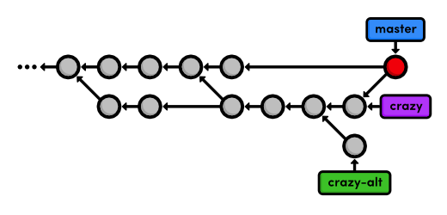Merging the crazy branch into master

Cleanup the Feature Branches
Since our crazy experiment has been successfully merged, we can get rid of our feature branches.
git branch -d crazy
git branch -d crazy-alt
As noted in the last module, the git branch -d command won’t let you delete a branch that contains unmerged changes. But, we really do want to scrap the alternative experiment, so we’ll follow the error message’s instructions for overriding this behavior:
git branch -D crazy-alt
Because we never merged crazy-alt into master, it is lost forever. However, the crazy branch is still accessible through its commits, which are now reachable via the master branch. That is to say, it is still part of the structure of the repository’s history, even though we deleted our reference to it.
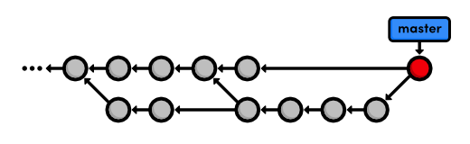Deleting the feature branches
Fast-forward merges are not reflected in the project history. This is the tangible distinction between fast-forward merges and 3-way merges. The next module will discuss the appropriate usage of both and the potential complications of a non-linear history.

Conclusion
This module demonstrated the three most common uses of Git branches:
- To develop long-running features (crazy)
- To apply quick updates (news-hotfix)
- To record the evolution of a project (master)
In the first two cases, we needed an isolated environment to test some changes before integrating them with our stable code. As you get more comfortable with Git, you should find yourself doing virtually everything in an isolated topic branch, then merging it into a stable branch once you’re done. Practically, this means you’ll never have a broken version of your project.
We used the permanent master branch as the foundation for all of these temporary branches, effectively making it the historian for our entire project. In addition to master, many programmers often add a second permanent branch called develop. This lets them use master to record really stable snapshots (e.g., public releases) and use develop as more of a preparation area for master.
This module also introduced the 3-way merge, which combines two branches using a dedicated commit. The 3-way merge and the fast-forward merge are actually what makes branching so powerful: they let developers share and integrate independent updates with reliable results.
Next, we’ll learn how to clean up our repository’s history. Using a new Git command, we’ll be able to better manage merge commits and make sure our history is easy to navigate.

Quick Reference
git commit -a -m "<message>"
Stage all tracked files and commit the snapshot using the specified message.
git branch -D <branch-name>
Force the removal of an unmerged branch (be careful: it will be lost forever).

Rebasing
Let’s start this module by taking an in-depth look at our history. The six commits asterisked below are part of the same train of thought. We even developed them in their own feature branch. However, they show up interspersed with commits from other branches, along with a superfluous merge commit (b9ae1bc). In other words, our repository’s history is kind of messy:
ec1b8cb Merge branch 'crazy'
*42fa173 Add news item for rainbow
3db88e1 Add 1st news item
*7147cc5 Link index.html to rainbow.html
*6aa4b3b Add CSS stylesheet to rainbow.html
b9ae1bc Merge branch 'master' into crazy
ae4e756 Link HTML pages to stylesheet
98cd46d Add CSS stylesheet
*33e25c9 Rename crazy.html to rainbow.html
*677e0e0 Add a rainbow to crazy.html
506bb9b Revert "Add a crazzzy experiment"
*514fbe7 Add a crazzzy experiment
1c310d2 Add navigation links
54650a3 Create blue and orange pages
b650e4b Create index page
Fortunately, Git includes a tool to help us clean up our commits: git rebase. Rebasing lets us move branches around by changing the commit that they are based on. Conceptually, this is what it allows us to do:
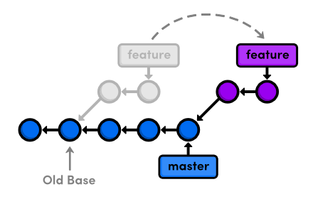Rebasing a feature branch onto master
After rebasing, the feature branch has a new parent commit, which is the same commit pointed to by master. Instead of joining the branches with a merge commit, rebasing integrates the feature branch by building on top of master. The result is a perfectly linear history that reads more like a story than the hodgepodge of unrelated edits shown above.
To explore Git’s rebasing capabilities, we’ll need to build up our example project so that we have something to work with. Then, we’ll go back and rewrite history using git rebase.
Download the repository for this module
If you’ve been following along from the previous module, you already have everything you need. Otherwise, download the zipped Git repository from the above link, uncompress it, and you’re good to go.

Create an About Section
We’ll begin by creating an about page for the website. Remember, we should be doing all of our work in isolated branches so that we don’t cause any unintended changes to the stable version of the project.
git branch about
git checkout about
The next few steps break this feature into several unnecessarily small commits so that we can see the effects of a rebase. First, make a new directory in my-git-repo called about. Then, create the empty file about/index.html. Stage and commit a snapshot.
git add about
git status
git commit -m "Add empty page in about section"
Note that git add can also add entire directories to the staging area.

Add an About Page
Next, we’ll add some HTML to about/index.html:
<!DOCTYPE html>
<html lang="en">
<head>
<title>About Us</title>
<link rel="stylesheet" href="../style.css" />
<meta charset="utf-8" />
</head>
<body>
<h1>About Us</h1>
<p>We're a small, colorful website with just two employees:</p>

<ul>
<li><a href="me.html">Me: The Developer</a></li>
<li><a href="mary.html">Mary: The Graphic Designer</a></li>
</ul>

<p><a href="../index.html">Return to home page</a></p>
</body>
</html>
Stage and commit the snapshot.
git status
git commit -a -m "Add contents to about page"
After a few commits on this branch, our history looks like the following.
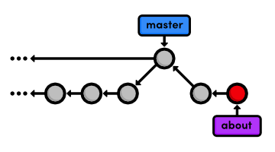Adding the about branch

Another Emergency Update!
Our boss just gave us some more breaking news! Again, we’ll use a hotfix branch to update the site without affecting our about page developments. Make sure to base the updates on master, not the about branch:
git checkout master
git branch news-hotfix
git checkout news-hotfix
git branch
Change the “News” section in index.html to:
<h2 style="color: #C00">News</h2>
<ul>
<li><a href="news-1.html">Blue Is The New Hue</a></li>
<li><a href="rainbow.html">Our New Rainbow</a></li>
<li><a href="news-2.html">A Red Rebellion</a></li>
</ul>
Commit a snapshot:
git status
git commit -a -m "Add 2nd news item to index page"
Then, create a new page called news-2.html:
<!DOCTYPE html>
<html lang="en">
<head>
<title>A Red Rebellion</title>
<link rel="stylesheet" href="style.css" />
<meta charset="utf-8" />
</head>
<body>
<h1 style="color: #C03">A Red Rebellion</h1>

<p>Earlier today, several American design firms
announced that they have completely rejected the use
of blue in any commercial ventures. They have
opted instead for <span style="color: #C03">Red</span>.</p>

<p><a href="index.html">Return to home page</a></p>
</body>
</html>
Stage and commit another snapshot:
git add news-2.html
git status
git commit -m "Add article for 2nd news item"

Publish News Hotfix
We’re ready to merge the news update back into master.
git checkout master
git merge news-hotfix
git branch -d news-hotfix
The master branch hasn’t been altered since we created news-hotfix, so Git can perform a fast-forward merge. Our repository now looks like the following.
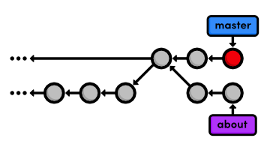Fast-forwarding master to the news-hotfix

Rebase the About Branch
This puts us in the exact same position as we were in before our first 3-way merge. We want to pull changes from master into a feature branch, only this time we’ll do it with a rebase instead of a merge.
git checkout about
git rebase master
git log --oneline
Originally, the about branch was based on the Merge branch 'crazy-experiment' commit. The rebase took the entire about branch and plopped it onto the tip of the master branch, which is visualized in the following diagram. Also notice that, like the git merge command, git rebase requires you to be on the branch that you want to move.
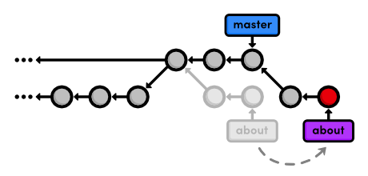Rebasing the about branch onto master
After the rebase, about is a linear extension of the master branch, enabling us to do a fast-forward merge later on. Rebasing also allowed us to integrate the most up-to-date version of master without a merge commit.

Add a Personal Bio
With our news hotfix out of the way, we can now continue work on our about section. Create the file about/me.html with the following contents:
<!DOCTYPE html>
<html lang="en">
<head>
<title>About Me</title>
<link rel="stylesheet" href="../style.css" />
<meta charset="utf-8" />
</head>
<body>
<h1>About Me</h1>
<p>I'm a big nerd.</p>

<h2>Interests</h2>
<ul>
<li>Computers</li>
<li>Mathematics</li>
<li>Typography</li>
</ul>

<p><a href="index.html">Return to about page</a></p>
</body>
</html>
Then, commit the changes to the repository.
git add about/me.html
git commit -m "Add HTML page for personal bio"
git log --oneline
Remember that thanks to the rebase, about rests on top of master. So, all of our about section commits are grouped together, which would not be the case had we merged instead of rebased. This also eliminates an unnecessary fork in our project history.

Add Dummy Page for Mary
Once again, the next two snapshots are unnecessarily trivial. However, we’ll use an interactive rebase to combine them into a single commit later on. That’s right, git rebase not only lets you move branches around, it enables you to manipulate individual commits as you do so.
Create a new empty file in the about section: about/mary.html.
git add about
git status
git commit -m "Add empty HTML page for Mary's bio"

Link to the About Section
Then, add a link to the about page in index.html so that its “Navigation” section looks like the following.
<h2>Navigation</h2>
<ul>
<li>
<a href="about/index.html">About Us</a>
</li>
<li style="color: #F90">
<a href="orange.html">The Orange Page</a>
</li>
<li style="color: #00F">
<a href="blue.html">The Blue Page</a>
</li>
<li>
<a href="rainbow.html">The Rainbow Page</a>
</li>
</ul>
Don’t forget to commit the change:
git commit -a -m "Add link to about section in home page"

Clean Up the Commit History
Before we merge into the master branch, we should make sure we have a clean, meaningful history in our feature branch. By rebasing interactively, we can choose how each commit is transferred to the new base. Specify an interactive rebase by passing the -i flag to the rebase command:
git rebase -i master
This should open up a text editor populated with all of the commits introduced in the about branch, listed from oldest to newest. The listing defines exactly how Git will transfer the commits to the new base. Leaving it as is will do a normal git rebase, but if we move the lines around, we can change the order in which commits are applied.
In addition, we can replace the pick command before each line to edit it or combine it with other commits. All of the available commands are shown in the comment section of the rebase listing, but right now, we only need the squash command. This will condense our unnecessarily small commits into a single, meaningful snapshot. Change your listing to match the following:
pick 5cf316e Add empty page in about section
squash 964e013 Add contents to about page
pick 89db9ab Add HTML page for personal bio
squash 2bda8e5 Add empty HTML page for Mary's bio
pick 915466f Add link to about section in home page
Then, begin the rebase by saving and closing the editor. The following list describes the rebasing process in-depth and tells you what you need to change along the way.
- Git moves the 5cf316e commit to the tip of master.
- Git combines the snapshots of 964e013 and 5cf316e.
- Git stops to ask you what commit message to use for the combined snapshot. It automatically includes the messages of both commits, but you can delete that and simplify it to just Create the about page. Save and exit the text editor to continue.
- Git repeats this process for commits 89db9ab and 2bda8e5. Use Begin creating bio pages for the message.
- Git adds the final commit (915466f) on top of the commits created in the previous steps.
You can see the result of all this activity with git log --oneline, as well as in the diagram below. The five commits originally in about have been condensed to three, and two of them have new messages. Also notice that they all have different commit ID’s. These new ID’s tell us that we didn’t just move a couple of commits—we’ve literally rewritten our repository history with brand new commits.
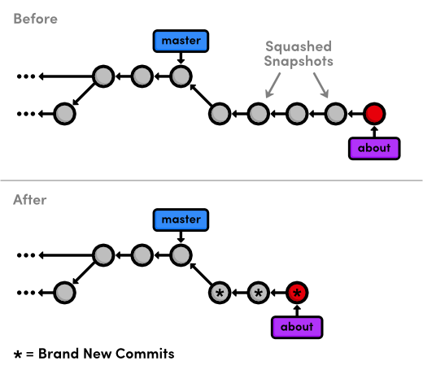Results of the interactive rebase
Interactive rebasing gives you complete control over your project history, but this can also be very dangerous. For example, if you were to delete a line from the rebase listing, the associated commit wouldn’t be transferred to the new base, and its content would be lost forever. In a future module, we’ll also see how rewriting history can get you in trouble with public Git repositories.

Stop to Amend a Commit
The previous rebase only stopped us to edit the messages of each commit. We can take this one step further and alter a snapshot during the rebase. Start by running another interactive rebasing session. Note that we’ve still been using master as the new base because it selects the desired commits from the about branch.
git rebase -i master
Specify the edit command for the second commit, as shown below.
pick 58dec2a Create the about page
edit 6ac8a9f Begin creating bio pages
pick 51c958c Add link to about section in home page
When Git starts to move the second commit to the new base, it will stop to do some “amending.” This gives you the opportunity to alter the staged snapshot before committing it.
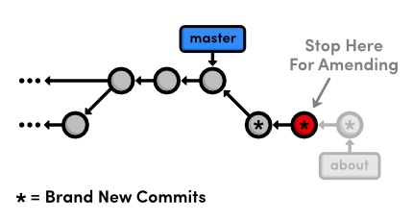Stopping to amend a commit
We’ll leave a helpful note for Mary, whom we’ll meet in the Remotes module. Open up about/mary.html and add the following.
[Mary, please update your bio!]
We’re currently between commits in a rebase, but we can alter the staged snapshot in the exact same way as we have been throughout this entire tutorial:
git add about/mary.html
git status
git commit --amend
You can use the default message created by git commit. The new --amend flag tells Git to replace the existing commit with the staged snapshot instead of creating a new one. This is also very useful for fixing premature commits that often occur during normal development.

Continue the Interactive Rebase
Remember that we’re in the middle of a rebase, and Git still has one more commit that it needs to re-apply. Tell Git that we’re ready to move on with the --continue flag:
git rebase --continue
git log --oneline
Note that our history still appears to be the same (because we used the default commit message above), but the Begin creating bio pages commit contains different content than it did before the rebase, along with a new ID.
If you ever find yourself lost in the middle of a rebase and you’re afraid to continue, you can use the --abort flag to abandon it and start over from scratch.

Publish the About Section
The point of all this interactive rebasing is to generate a meaningful history that we can merge back into master. And, since we’ve rebased about onto the tip of master, Git will be able to perform a fast-forward merge instead of using a merge commit to join the two branches.
git checkout master
git log --oneline
git merge about
git log --oneline
Don’t forget to delete the obsolete about branch.
git branch -d about
Our final history is shown in the figure below. As you can see, a linear history is much easier to comprehend than the back-and-forth merging of the previous module. But on the other hand, we don’t have the slightest notion of how we got to our current state.
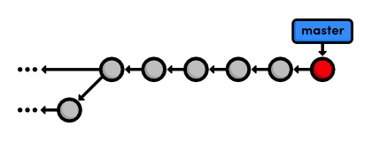Merging and deleting the about branch

Conclusion
Rebasing enables fast-forward merges by moving a branch to the tip of another branch. It effectively eliminates the need for merge commits, resulting in a completely linear history. To an outside observer, it will seem as though you created every part of your project in a neatly planned sequence, even though you may have explored various alternatives or developed unrelated features in parallel. Rebasing gives you the power to choose exactly what gets stored in your repositories.
This can actually be a bit of a controversial topic within the Git community. Some believe that the benefits discussed in this module aren’t worth the hassle of rewriting history. They take a more “pure” approach to Git by saying that your history should reflect exactly what you’ve done, ensuring that no information is ever lost. Furthermore, an advanced configuration of git log can display a linear history from a highly-branched repository.
But, others contend that merge commits should be meaningful. Instead of merging at arbitrary points just to access updates, they claim that merge commits should represent a symbolic joining of two branches. In particular, large software projects (such as the Linux kernel) typically advocate interactive rebasing to keep the repository as clean and straightforward as possible.
The use of git rebase is entirely up to you. Customizing the evolution of your project can be very beneficial, but it might not be worth the trouble when you can accomplish close to the same functionality using merges exclusively. As a related note, you can use the following command to force a merge commit when Git would normally do a fast-forward merge.
git merge --no-ff <branch-name>
The next module will get a little bit more involved in our project history. We’ll try fixing mistakes via complex rebases and even learn how to recover deleted commits.

Quick Reference
git rebase <new-base>
Move the current branch’s commits to the tip of <new-base>, which can be either a branch name or a commit ID.
git rebase -i <new-base>
Perform an interactive rebase and select actions for each commit.
git commit --amend
Add staged changes to the most recent commit instead of creating a new one.
git rebase --continue
Continue a rebase after amending a commit.
git rebase --abort
Abandon the current interactive rebase and return the repository to its former state.
git merge --no-ff <branch-name>
Force a merge commit even if Git could do a fast-forward merge.

Rewriting History
The previous module on rebasing taught us how to move commits around and perform some basic edits while doing so, but now we’re going to really get our hands dirty. We’ll learn how to split up commits, revive lost snapshots, and completely rewrite a repository’s history to our exact specifications.
Hopefully, this module will get you much more comfortable with the core Git components, as we’ll be inspecting and editing the internal makeup of our project.
Download the repository for this module
If you’ve been following along from the previous module, you already have everything you need. Otherwise, download the zipped Git repository from the above link, uncompress it, and you’re good to go.

Create the Red Page
First, let’s create a new branch and add a few more HTML pages.
git checkout -b new-pages
git branch
Notice that we created a new branch and checked it out in a single step by passing the -b flag to the git checkout command.
Next, create the file red.html and add the following content:
<!DOCTYPE html>
<html lang="en">
<head>
<title>The Red Page</title>
<link rel="stylesheet" href="style.css" />
<meta charset="utf-8" />
</head>
<body>
<h1 style="color: #C00">The Red Page</h1>
<p>Red is the color of <span style="color: #C00">passion</span>!</p>

<p><a href="index.html">Return to home page</a></p>
</body>
</html>
We’ll hold off on committing this page for the moment.

Create the Yellow Page
Create a file called yellow.html, which should look like the following.
<!DOCTYPE html>
<html lang="en">
<head>
<title>The Yellow Page</title>
<link rel="stylesheet" href="style.css" />
<meta charset="utf-8" />
</head>
<body>
<h1 style="color: #FF0">The Yellow Page</h1>
<p>Yellow is the color of <span style="color: #FF0">the sun</span>!</p>

<p><a href="index.html">Return to home page</a></p>
</body>
</html>

Link and Commit the New Pages
Next, we’ll link both new pages to the home page. Add the following items to the “Navigation” section in index.html:
<li style="color: #C00">
<a href="red.html">The Red Page</a>
</li>
<li style="color: #FF0">
<a href="yellow.html">The Yellow Page</a>
</li>
Then, commit all of these changes in a single snapshot.
git add red.html yellow.html index.html
git status
git commit -m "Add new HTML pages"
This is an example of a bad commit. It performed multiple, unrelated tasks, and it has a relatively generic commit message. Thus far, we haven’t really specified when it’s appropriate to commit changes, but the general rules are essentially the same as for branch creation:
- Commit a snapshot for each significant addition to your project.
- Don’t commit a snapshot if you can’t come up with a single, specific message for it.
This will ensure that your project has a meaningful commit history, which gives you the ability to see exactly when and where a feature was added or a piece of functionality was broken. However, in practice, you’ll often wind up committing several changes in a single snapshot, since you won’t always know what constitutes a “well-defined” addition as you’re developing a project. Fortunately, Git lets us go back and fix up these problem commits after the fact.

Create and Commit the Green Page
Let’s create one more page before splitting that “bad” commit: Add the following HTML to a file called green.html.
<!DOCTYPE html>
<html lang="en">
<head>
<title>The Green Page</title>
<link rel="stylesheet" href="style.css" />
<meta charset="utf-8" />
</head>
<body>
<h1 style="color: #0C0">The Green Page</h1>
<p><span style="color: #0C0">Green</span> is the color of earth.</p>

<p><a href="index.html">Return to home page</a></p>
</body>
</html>
Add a link to index.html in the “Navigation” section:
<li style="color: #0C0">
<a href="green.html">The Green Page</a>
</li>
And finally, stage the green page and commit the snapshot.
git add green.html index.html
git status
git commit -m "Add green page"

Begin an Interactive Rebase
The commits introduced in our new-pages branch are:
4c3027c Add green page
db96c72 Add new HTML pages
But, we want these commits to look more like:
4c3027c Add green page
9b1a64f Add yellow page
77a1cf1 Add red page
To achieve this, we can use the same interactive rebasing method covered in the previous module, only this time we’ll actually create commits in the middle of the rebasing procedure.
git rebase -i master
Change the rebase listing to the following, then save the file and exit the editor to begin the rebase.
edit db96c72 Add new HTML pages
pick 4c3027c Add green page

Undo the Generic Commit
First, let’s take a look at where we are with git log --oneline:
db96c72 Add new HTML pages
7070b0e Add link to about section in home page
...
When Git encountered the edit command in the rebase configuration, it stopped to let us edit the commit. As a result, the green page commit doesn’t appear in our history yet. This should be familiar from the previous module. But instead of amending the current commit, we’re going to completely remove it:
git reset --mixed HEAD~1
git log --oneline
git status
The git reset command moves the checked out snapshot to a new commit, and the HEAD~1 parameter tells it to reset to the commit that occurs immediately before the current HEAD (likewise, HEAD~2 would refer to second commit before HEAD). In this particular case, HEAD~1 happens to coincide with master. The effect on our repository can be visualized as:
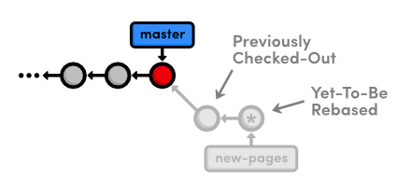Resetting to HEAD~1
You may recall from Undoing Changes that we used git reset --hard to undo uncommitted changes to our project. The --hard flag told Git to make the working directory look exactly like the most recent commit, giving us the intended effect of removing uncommitted changes.
But, this time we used the --mixed flag to preserve the working directory, which contains the changes we want to separate. That is to say, the HEAD moved, but the working directory remained unchanged. Of course, this results in a repository with uncommitted modifications. We now have the opportunity to add the red.html and yellow.html files to distinct commits.

Split the Generic Commit
Let’s start with the red page. Since we only want to commit content that involves the red page, we’ll have to manually go in and remove the yellow page’s link from the “Navigation” section. In index.html, change this section to match the following:
<h2>Navigation</h2>
<ul>
<li>
<a href="about/index.html">About Us</a>
</li>
<li style="color: #F90">
<a href="orange.html">The Orange Page</a>
</li>
<li style="color: #00F">
<a href="blue.html">The Blue Page</a>
</li>
<li>
<a href="rainbow.html">The Rainbow Page</a>
</li>
<li style="color: #C00">
<a href="red.html">The Red Page</a>
</li>
</ul>
Now, we can group the red page’s updates into an independent commit.
git add red.html index.html
git status
git commit -m "Add red page"
Next up is the yellow page. Go ahead and add it back to the “Navigation” section in index.html:
<li style="color: #FF0">
<a href="yellow.html">The Yellow Page</a>
</li>
And again, stage and commit the snapshot.
git add yellow.html index.html
git status
git commit -m "Add yellow page"
We’ve successfully split up the contents of a single commit into two new snapshots, as shown below.
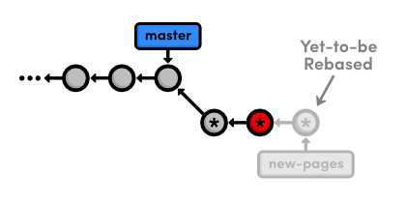Creating two new commits while rebasing
But, don’t forget that the rebase still needs to transfer the green page:
git rebase --continue
To summarize, we removed the “bad” commit from the current branch with git reset, keeping the contained HTML files intact with the --mixed flag. Then, we committed them in separate snapshots with the usual git add and git commit commands. The point to remember is that during a rebase you can add, delete, and edit commits to your heart’s content, and the entire result will be moved to the new base.

Remove the Last Commit
Next, we’re going to “accidentally” remove the green page commit so we can learn how to retrieve it via Git’s internal repository data.
git reset --hard HEAD~1
git status
git log --oneline
This moves the checked-out commit backward by one snapshot, along with the new-pages pointer. Note that git status tells us that we have nothing to commit, since the --hard flag obliterated any changes in the working directory. And of course, the git log output shows that the new-pages branch no longer contains the green commit.
This behavior is slightly different from the reset we used in the interactive rebase: this time the branch moved with the new HEAD. Since we were on (no branch) during the rebase, there was no branch tip to move. However, in general, git reset is used to move branch tips around and optionally alter the working directory via one of its many flags (e.g., --mixed or --hard).
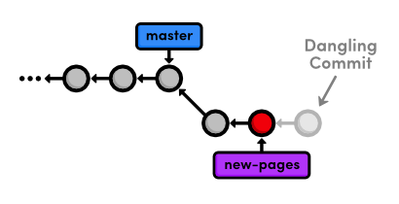Removing the most recent commit
The commit that we removed from the branch is now a dangling commit. Dangling commits are those that cannot be reached from any branch and are thus in danger of being lost forever.

Open the Reflog
Git uses something called the reflog to record every change you make to your repository. Let’s take a look at what it contains:
git reflog
The resulting output should look something like the following. Depending on your version of Git, the messages might be slightly different. You can press Space to scroll through the content or q to exit.
9b1a64f HEAD@{0}: reset: moving to HEAD~1
002185c HEAD@{1}: rebase -i (finish): returning to refs/heads/new-pages
002185c HEAD@{2}: rebase -i (pick): Add green page
9b1a64f HEAD@{3}: commit: Add yellow page
77a1cf1 HEAD@{4}: commit: Add red page
7070b0e HEAD@{5}: reset: moving to HEAD~1
...
The above listing reflects our last few actions. For example, the current HEAD, denoted by HEAD@{0}, resulted from reseting HEAD to HEAD~1. Four actions ago, the yellow page was applied during our rebase, as shown in HEAD@{3}.
The reflog is a chronological listing of our history, without regard for the repository’s branch structure. This lets us find dangling commits that would otherwise be lost from the project history.

Revive the Lost Commit
At the beginning of each reflog entry, you’ll find a commit ID representing the HEAD after that action. Check out the commit at HEAD@{2}, which should be where the rebase added the green page (change the ID below to the ID from your reflog).
git checkout 002185c
This puts us in a detached HEAD state, which means our HEAD is no longer on the tip of a branch. We’re actually in the opposite situation as we were in Undoing Changes when we checked out a commit before the branch tip. Now, we’re looking at a commit after the tip of the branch, but we still have a detached HEAD:
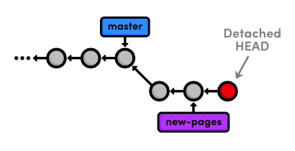Checking out a dangling commit
To turn our dangling commit into a full-fledged branch, all we have to do is create one:
git checkout -b green-page
We now have a branch that can be merged back into the project:
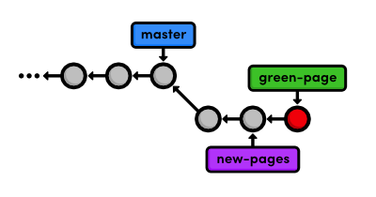Creating a branch from the dangling commit
The above diagram makes it easy to see that the green-page branch is an extension of new-pages, but how would we figure this out if we weren’t drawing out the state of our repository every step of the way?

Filter the Log History
To view the differences between branches, we can use Git’s log-filtering syntax.
git log new-pages..green-page
This will display all commits contained in green-page that aren’t in the new-pages branch. The above command tells us that green-page contains one more snapshot than new-pages: our dangling commit (although, it’s not really dangling anymore since we created a branch for it).
You can also use this syntax to limit the output of git log. For example, to display the last 4 commits on the current branch, you could use:
git log HEAD~4..HEAD
However, this is a bit verbose for such a common task, so Git developers added the -n flag as an easier way to limit output.
git log -n 4
The -n 4 parameter tells Git to show only the last four commits from the current HEAD, making it the equivalent of the HEAD~4..HEAD syntax shown above. Similarly, -n 3, -n 2, and -n 1 would display three, two, and one commit, respectively. This feature becomes very useful once a repository grows beyond one screenful of history.

Merge in the Revived Branch
We’ve revived our lost commit, and now we’re ready to merge everything back into the master branch. Before we do the merge, let’s see exactly what we’re merging:
git checkout master
git log HEAD..green-page --stat
The git log HEAD..green-page command shows us only those commits in green-page that aren’t in master (since master is the current branch, we can refer to it as HEAD). The new --stat flag includes information about which files have been changed in each commit. For example, the most recent commit tells us that 14 lines were added to the green.html file and 3 lines were added to index.html:
commit 002185c71e6674915eb75be2afb4ca52c2c7fd1b
Author: Ryan <ryan.example@rypress.com>
Date: Wed Jan 11 06:49:50 2012 -0600

Add green page

green.html | 14 ++++++++++++++
index.html | 3 +++
2 files changed, 17 insertions(+), 0 deletions(-)
If we didn’t already know what was in this new commit, the log output would tell us which files we needed to look at. But, we authored all of these changes, so we can skip right to the merge.
git merge green-page
The following diagram shows the state of our repository after the merge.
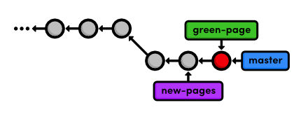Fast-forwarding master to the green-page branch
Note that the green-page branch already contains all the history of new-pages, which is why we merged the former instead of the latter. If this wasn’t the case, Git would complain when we try to run the following command.
git branch -d new-pages
We can go ahead and delete the green page branch, too.
git branch -d green-page

Conclusion
This module took an in-depth look at rebasing, resetting, and the reflog. We learned how to split old commits into one or more new commits, and how to revive “lost” commits. Hopefully, this has given you a better understanding of the interaction between the working directory, the stage, branches, and committed snapshots. We also explored some new options for displaying our commit history, which will become an important skill as our project grows.
We did a lot of work with branch tips this module. It’s important to realize that Git uses the tip of a branch to represent the entire branch. That is to say, a branch is actually a pointer to a single commit—not a container for a series of commits. This idea has been implicitly reflected in our diagrams:
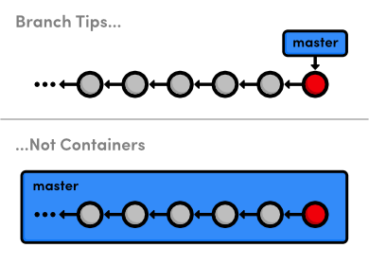Branch tips, not containers
The history is represented by the parent of each commit (designated by arrows), not the branch itself. So, to request a new branch, all Git has to do is create a reference to the current commit. And, to add a snapshot to a branch, it just has to move the branch reference to the new commit. An understanding of Git’s branch representation should make it easier to wrap your head around merging, rebasing, and other kinds of branch manipulation.
We’ll revisit Git’s internal representation of a repository in the final module of this tutorial. But now, we’re finally ready to discuss multi-user development, which happens to rely entirely on Git branches.

Quick Reference
git reflog
Display the local, chronological history of a repository.
git reset --mixed HEAD~<n>
Move the HEAD backward <n> commits, but don’t change the working directory.
git reset --hard HEAD~<n>
Move the HEAD backward <n> commits, and change the working directory to match.
git log <since>..<until>
Display the commits reachable from <until> but not from <since>. These parameters can be either commit ID’s or branch names.
git log --stat
Include extra information about altered files in the log output.

Remotes
Simply put, a remote repository is one that is not your own. It can be another Git repository that’s on your company’s network, the internet, or even your local filesystem, but the point is that it’s a repository distinct from your my-git-repo project.
We’ve already seen how branches can streamline a workflow within a single repository, but they also happen to be Git’s mechanism for sharing commits between repositories. Remote branches act just like the local branches that we’ve been using, only they represent a branch in someone else’s repository.
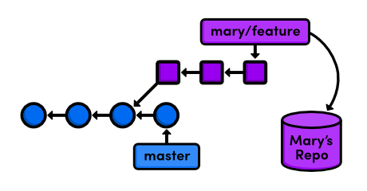Accessing a feature branch from a remote repository
This means that we can adapt our merging and rebasing skills to make Git a fantastic collaboration tool. Over the next few modules, we’ll be exploring various multi-user workflows by pretending to be different developers working on our example website.
For several parts of this module, we’re going to pretend to be Mary, the graphic designer for our website. Mary’s actions are clearly denoted by including her name in the heading of each step.
Download the repository for this module
If you’ve been following along from the previous module, you already have everything you need. Otherwise, download the zipped Git repository from the above link, uncompress it, and you’re good to go.

Clone the Repository (Mary)
First, Mary needs her own copy of the repository to work with. The Distributed Workflows module will discuss network-based remotes, but right now we’re just going to store them on the local filesystem.
cd /path/to/my-git-repo
cd ..
git clone my-git-repo marys-repo
cd marys-repo
The first two lines navigate the command shell to the directory above my-git-repo. Make sure to change /path/to/my-git-repo to the actual path to your repository. The git clone command copies our repository into marys-repo, which will reside in the same directory as my-git-repo. Then, we navigate to Mary’s repository so we can start pretending to be Mary.
Run git log to verify that Mary’s repository is in fact a copy of our original repository.

Configure The Repository (Mary)
First off, Mary needs to configure her repository so that we know who contributed what to the project.
git config user.name "Mary"
git config user.email mary.example@rypress.com
You may recall from the first module that we used a --global flag to set the configuration for the entire Git installation. But since Mary’s repository is on the local filesystem, she needs a local configuration.
Use a text editor to open up the file called config in the .git folder of Mary’s project (you may need to enable hidden files to see .git). This is where local configurations are stored, and we see Mary’s information at the bottom of the file. Note that this overrides the global configuration that we set in The Basics.

Start Mary’s Day (Mary)
Today, Mary is going to be working on her bio page, which she should develop in a separate branch:
git checkout -b bio-page
Mary can create and check out branches just like we did in our copy of the project. Her repository is a completely isolated development environment, and she can do whatever she wants in here without worrying about what’s going on in my-git-repo. Just as branches are an abstraction for the working directory, the staged snapshot, and a commit history, a repository is an abstraction for branches.

Create Mary’s Bio Page (Mary)
Let’s complete Mary’s biography page. In marys-repo, change about/mary.html to:
<!DOCTYPE html>
<html lang="en">
<head>
<title>About Mary</title>
<link rel="stylesheet" href="../style.css" />
<meta charset="utf-8" />
</head>
<body>
<h1>About Mary</h1>
<p>I'm a graphic designer.</p>

<h2>Interests</h2>
<ul>
<li>Oil Painting</li>
<li>Web Design</li>
</ul>

<p><a href="index.html">Return to about page</a></p>
</body>
</html>
Again, we’re developing this in a branch as a best-practice step: our master branch is only for stable, tested code. Stage and commit the snapshot, then take a look at the result.
git commit -a -m "Add bio page for Mary"
git log -n 1
The Author field in the log output should reflect the local configurations we made for Mary’s name and email. Remember that the -n 1 flag limits history output to a single commit.

Publish the Bio Page (Mary)
Now, we can publish the bio page by merging into the master branch.
git checkout master
git merge bio-page
Of course, this results in a fast-forward merge. We’ll eventually pull this update into my-git-repo once we stop pretending to be Mary. Here’s what Mary’s repository looks like compared to ours:
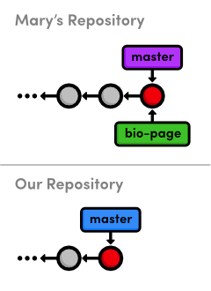Merging Mary’s bio-page branch with her master
Notice that both repositories have normal, local branches—we haven’t had any interaction between the two repositories, so we don’t see any remote branches yet. Before we switch back to my-git-repo, let’s examine Mary’s remote connections.

View Remote Repositories (Mary)
Mary can list the connections she has to other repositories using the following command.
git remote
Apparently, she has a remote called origin. When you clone a repository, Git automatically adds an origin remote pointing to the original repository, under the assumption that you’ll probably want to interact with it down the road. We can request a little bit more information with the -v (verbose) flag:
git remote -v
This shows the full path to our original repository, verifying that origin is a remote connection to my-git-repo. The same path is designated as a “fetch” and a “push” location. We’ll see what these mean in a moment.

Return to Your Repository (You)
Ok, we’re done being Mary, and we can return to our own repository.
cd ../my-git-repo
Notice that Mary’s bio page is still empty. It’s very important to understand that this repository and Mary’s repository are completely separate. While she was altering her bio page, we could have been doing all sorts of other things in my-git-repo. We could have even changed her bio page, which would result in a merge conflict when we try to pull her changes in.

Add Mary as a Remote (You)
Before we can get ahold of Mary’s bio page, we need access to her repository. Let’s look at our current list of remotes:
git remote
We don’t have any (origin was never created because we didn’t clone from anywhere). So, let’s add Mary as a remote repository.
git remote add mary ../marys-repo
git remote -v
We can now use mary to refer to Mary’s repository, which is located at ../marys-repo. The git remote add command is used to bookmark another Git repository for easy access, and our connections can be seen in the figure below.
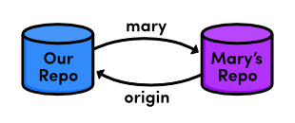Connections to remote repositories
Now that our remote repositories are setup, we’ll spend the rest of the module discussing remote branches.

Fetch Mary’s Branches (You)
As noted earlier, we can use remote branches to access snapshots from another repository. Let’s take a look at our current remote branches with the -r flag:
git branch -r
Again, we don’t have any. To populate our remote branch listing, we need to fetch the branches from Mary’s repository:
git fetch mary
git branch -r
This will go to the “fetch” location shown in git remote -v and download all of the branches it finds there into our repository. The resulting branches are shown below.
mary/bio-page
mary/master
Remote branches are always listed in the form <remote-name>/<branch-name> so that they will never be mistaken for local branches. The above listing reflects the state of Mary’s repository at the time of the fetch, but they will not be automatically updated if Mary continues developing any of her branches.
That is to say, our remote branches are not direct links into Mary’s repository—they are read-only copies of her branches, stored in our own repository. This means that we would have to do another fetch to access new updates.
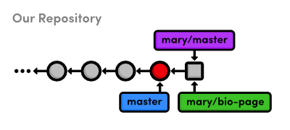Mary’s remote branches in our repository
The above figure shows the state of our repository. We have access to Mary’s snapshots (represented as squares) and her branches, even though we don’t have a real-time connection to Mary’s repository.

Check Out a Remote Branch
Let’s check out a remote branch to review Mary’s changes.
git checkout mary/master
This puts us in a detached HEAD state, just like we were in when we checked out a dangling commit. This shouldn’t be that surprising, considering that our remote branches are copies of Mary’s branches. Checking out a remote branch takes our HEAD off the tip of a local branch, illustrated by the following diagram.
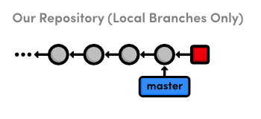Checking out Mary’s master branch
We can’t continue developing if we’re not on a local branch. To build on mary/master we either need to merge it into our own local master or create another branch. We did the latter in Branches, Part I to build on an old commit and in the previous module to revive a “lost” commit, but right now we’re just looking at what Mary did, so the detached HEAD state doesn’t really affect us.

Find Mary’s Changes
We can use the same log-filtering syntax from the previous module to view Mary’s changes.
git log master..mary/master --stat
This shows us what Mary has added to her master branch, but it’s also a good idea to see if we’ve added any new changes that aren’t in Mary’s repository:
git log mary/master..master --stat
This won’t output anything, since we haven’t altered our database since Mary cloned it. In other words, our history hasn’t diverged—we’re just behind by a commit.

Merge Mary’s Changes
Let’s approve Mary’s changes and integrate them into our own master branch.
git checkout master
git merge mary/master
Even though mary/master is a remote branch, this still results in a fast-forward merge because there is a linear path from our master to the tip of mary/master:
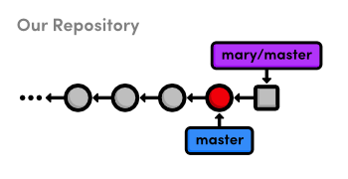Before merging Mary’s master branch into our own
After the merge, the snapshots from Mary’s remote branch become a part of our local master branch. As a result, our master is now synchronized with Mary’s:
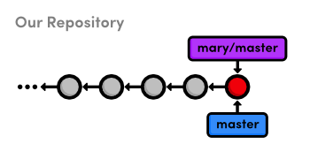After merging Mary’s master branch into our own
Notice that we only interacted with Mary’s master branch, even though we had access to her bio-page. If we hadn’t been pretending to be Mary, we wouldn’t have known what this feature branch was for or if it was ready to be merged. But, since we’ve designated master as a stable branch for the project, it was safe to integrate those updates (assuming Mary was also aware of this convention).

Push a Dummy Branch
To complement our git fetch command, we’ll take a brief look at pushing. Fetching and pushing are almost opposites, in that fetching imports branches, while pushing exports branches to another repository. Let’s take a look:
git branch dummy
git push mary dummy
This creates a new branch called dummy and sends it to Mary. Switch into Mary’s repository to see what we did:
cd ../marys-repo
git branch
You should find a new dummy branch in her local branch listing. I said that git fetch and git push are almost opposites because pushing creates a new local branch, while fetching imports commits into remote branches.
Now, put yourself in Mary’s shoes. She was developing in her own repository when, all of a sudden, a new dummy branch appeared out of nowhere. Obviously, pushing branches into other people’s repositories can make for a chaotic workflow. So, as a general rule, you should never push into another developer’s repository. But then, why does git push even exist?
Over the next few modules, we’ll see that pushing is a necessary tool for maintaining public repositories. Until then, just remember to never, ever push into one of your friend’s repositories. Let’s get rid of these dummy branches and return to our repository.
git branch -d dummy
cd ../my-git-repo
git branch -d dummy

Push a New Tag
An important property of git push is that it does not automatically push tags associated with a particular branch. Let’s examine this by creating a new tag.
git tag -a v2.0 -m "An even stabler version of the website"
We now have a v2.0 tag in my-git-repo, which we can see by running the git tag command. Now, let’s try pushing the branch to Mary’s repository.
git push mary master
Git will say her master branch is already up-to-date, and her repository will remain unchanged. Instead of pushing the branch that contains the tag, Git requires us to manually push the tag itself:
git push mary v2.0
You should now be able to see the v2.0 tag in Mary’s repository with a quick git tag. It’s very easy to forget to push new tags, so if it seems like your project has lost a tag or two, it’s most likely because you didn’t to push them to the remote repository.

Conclusion
In this module, we learned how remote branches can be used to access content in someone else’s repository. The remotes listed in git remote are merely bookmarks for a full path to another repository. We used a local path, but as we’ll soon see, Git can use the SSH protocol to access repositories on another computer.
The convention of master as a stable branch allowed us to pull changes without consulting Mary, but this doesn’t necessarily have to be the case. When implementing your own workflow, Git offers you a lot of flexibility about when and where you should pull from your team members. As long as you clearly define your project conventions, you can designate special uses or privileges to any branch.
That said, it’s important to note that remotes are for people, whereas branches are for topics. Do not create separate branches for each of your developers—give them separate repositories and bookmark them with git remote add. Branches should always be for project development, not user management.
Now that we know how Git shares information between repositories, we can add some more structure to our multi-user development environment. The next module will show you how to set up and access a shared central repository.

Quick Reference
git clone <remote-path>
Create a copy of a remote Git repository.
git remote
List remote repositories.
git remote add <remote-name> <remote-path>
Add a remote repository.
git fetch <remote-name>
Download remote branch information, but do not merge anything.
git merge <remote-name>/<branch-name>
Merge a remote branch into the checked-out branch.
git branch -r
List remote branches.
git push <remote-name> <branch-name>
Push a local branch to another repository.
git push <remote-name> <tag-name>
Push a tag to another repository.

Centralized Workflows
In the previous module, we shared information directly between two developers’ repositories: my-git-repo and marys-repo. This works for very small teams developing simple programs, but larger projects call for a more structured environment. This module introduces one such environment: the centralized workflow.
We’ll use a third Git repository to act as a central communication hub between us and Mary. Instead of pulling changes into my-git-repo from marys-repo and vice versa, we’ll push to and fetch from a dedicated storage repository. After this module, our workflow will look like the following.
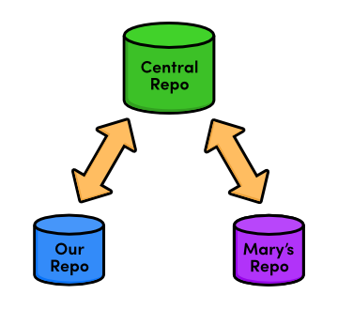The centralized workflow
Typically, you would store the central repository on a server to allow internet-based collaboration. Unfortunately, server configuration can vary among hosting providers, making it hard to write universal step-by-step instructions. So, we’ll continue exploring remote repositories using our local filesystem, just like in the previous module.
If you have access to a server, feel free to use it to host the central repository that we’re about to create. You’ll have to provide SSH paths to your server-based repository in place of the paths provided below, but other than that, you can follow this module’s instructions as you find them. For everyone else, our network-based Git experience will begin in the next module.
Download the repositories for this module
If you’ve been following along from the previous module, you already have everything you need. Otherwise, download the zipped Git repositories from the above link, uncompress them, and you’re good to go.

Create a Bare Repository (Central)
First, let’s create our central “communication hub.” Again, make sure to change /path/to/my-git-repo to the actual path to your repository. If you’ve decided to host the central repository on your server, you should SSH into it and run the git init command wherever you’d like to store the repository.
cd /path/to/my-git-repo
cd ..
git init --bare central-repo.git
As in the very first module, git init creates a new repository. But this time, we used the --bare flag to tell Git that we don’t want a working directory. This will prevent us from developing in the central repository, which eliminates the possibility of messing up another user’s environment with git push. A central repository is only supposed to act as a storage facility—not a development environment.
If you examine the contents of the resulting central-repo.git folder, you’ll notice that it contains the exact same files as the .git folder in our my-git-repo project. Git has literally gotten rid of our working directory. The conventional .git extension in the directory name is a way to convey this property.

Update Remotes (Mary and You)
We’ve successfully set up a central repository that can be used to share updates between us, Mary, and any other developers. Next, we should add it as a remote to both marys-repo and my-git-repo.
cd marys-repo
git remote rm origin
git remote add origin ../central-repo.git
Now for our repository:
cd ../my-git-repo
git remote add origin ../central-repo.git
git remote rm mary
Note that we deleted the remote connections between Mary and our my-git-repo folder with git remote rm. For the rest of this module, we’ll only use the central repository to share updates.
If you decided to host the central repository on a server, you’ll need to change the ../central-repo.git path to: ssh://user@example.com/path/to/central-repo.git, substituting your SSH username and server location for user@example.com and the central repository’s location for path/to/central-repo.git.

Push the Master Branch (You)
We didn’t clone the central repository—we just initialized it as a bare repository. This means it doesn’t have any of our project history yet. We can fix that using the git push command introduced in the last module.
git push origin master
Our central repository now contains our entire master branch, which we can double-check with the following.
cd ../central-repo.git
git log
This should output the familiar history listing of the master branch.
Recall that git push creates local branches in the destination repository. We said it was dangerous to push to a friend’s repository, as they probably wouldn’t appreciate new branches appearing at random. However, it’s safe to create local branches in central-repo.git because it has no working directory, which means it’s impossible to disturb anyone’s development.

Add News Update (You)
Let’s see our new centralized collaboration workflow in action by committing a few more snapshots.
cd ../my-git-repo
git checkout -b news-item
Create a file called news-3.html in my-git-repo and add the following HTML.
<!DOCTYPE html>
<html lang="en">
<head>
<title>Middle East's Silent Beast</title>
<link rel="stylesheet" href="style.css" />
<meta charset="utf-8" />
</head>
<body>
<h1 style="color: #D90">Middle East's Silent Beast</h1>
<p>Late yesterday evening, the Middle East's largest
design house&mdash;until now, silent on the West's colorful
disagreement&mdash;announced the adoption of
<span style="color: #D90">Yellow</span> as this year's
color of choice.</p>

<p><a href="index.html">Return to home page</a></p>
</body>
</html>
Next, add a link to the “News” section of index.html so that it looks like:
<h2 style="color: #C00">News</h2>
<ul>
<li><a href="news-1.html">Blue Is The New Hue</a></li>
<li><a href="rainbow.html">Our New Rainbow</a></li>
<li><a href="news-2.html">A Red Rebellion</a></li>
<li><a href="news-3.html">Middle East's Silent Beast</a></li>
</ul>
Stage and commit a snapshot.
git add news-3.html index.html
git status
git commit -m "Add 3rd news item"

Publish the News Item (You)
Previously, “publishing” meant merging with the local master branch. But since we’re only interacting with the central repository, our master branch is private again. There’s no chance of Mary pulling content directly from our repository.
Instead, everyone accesses updates through the public master branch, so “publishing” means pushing to the central repository.
git checkout master
git merge news-item
git branch -d news-item
git push origin master
After merging into master as we normally would, git push updates the central repository’s master branch to reflect our local master. From our perspective, the push can be visualized as the following:
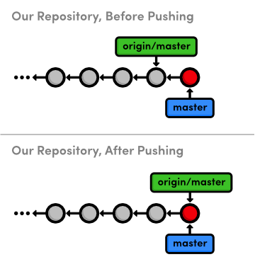Pushing master to the central repository
Note that this accomplishes the exact same thing as going into the central repository and doing a fetch/fast-forward merge, except git push allows us to do everything from inside my-git-repo. We’ll see some other convenient features of this command later in the module.

Update CSS Styles (Mary)
Next, let’s pretend to be Mary again and add some CSS formatting (she is our graphic designer, after all).
cd ../marys-repo
git checkout -b css-edits
Add the following to the end of style.css:
h1 {
font-size: 32px;
}

h2 {
font-size: 24px;
}

a:link, a:visited {
color: #03C;
}
And, stage and commit a snapshot.
git commit -a -m "Add CSS styles for headings and links"

Update Another CSS Style (Mary)
Oops, Mary forgot to add some formatting. Append the h3 styling to style.css:
h3 {
font-size: 18px;
margin-left: 20px;
}
And of course, stage and commit the updates.
git commit -a -m "Add CSS styles for 3rd level headings"

Clean Up Before Publishing (Mary)
Before Mary considers pushing her updates to the central repository, she needs to make sure she has a clean history. This must be done by Mary, because it’s near-impossible to change history after it has been made public.
git rebase -i master
This highlights another benefit of using isolated branches to develop independent features. Mary doesn’t need to go back and figure out what changes need to be rebased, since they all reside in her current branch. Change the rebase configuration to:
pick 681bd1c Add CSS styles for headings and links
squash eabac68 Add CSS styles for 3rd level headings
When Git stops to ask for the combined commit message, just use the first commit’s message:
Add CSS styles for headings and links
Consider what would have happened had Mary rebased after pushing to the central repository. She would be re-writing commits that other developers may have already pulled into their project. To Git, Mary’s re-written commits look like entirely new commits (since they have different ID’s). This situation is shown below.
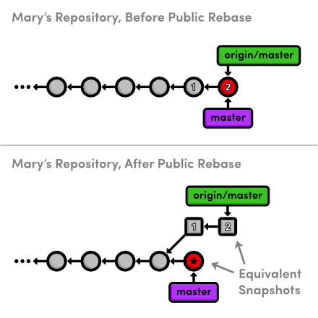Squashing a public commit
The commits labeled 1 and 2 are the public commits that Mary would be rebasing. Afterwards, the public history is still the exact same as Mary’s original history, but now her local master branch has diverged from origin/master—even though they represent the same snapshot.
So, to publish her rebased master branch to the central repository, Mary would have to merge with origin/master. This cannot be a fast-forward merge, and the resulting merge commit is likely to confuse her collaborators and disrupt their workflow.
This brings us to the most important rule to remember while rebasing: Never, ever rebase commits that have been pushed to a shared repository.
If you need to change a public commit, use the git revert command that we discussed in Undoing Changes. This creates a new commit with the required modifications instead of re-writing old snapshots.

Publish CSS Changes (Mary)
Now that her history is cleaned up, Mary can publish the changes.
git checkout master
git merge css-edits
git branch -d css-edits
She shouldn’t push the css-edits branch to the server, since it’s no longer under development, and other collaborators wouldn’t know what it contains. However, if we had all decided to develop the CSS edits together and wanted an isolated environment to do so, it would make sense to publish it as an independent branch.
Mary still needs to push the changes to the central repository. But first, let’s take a look at the state of everyone’s project.
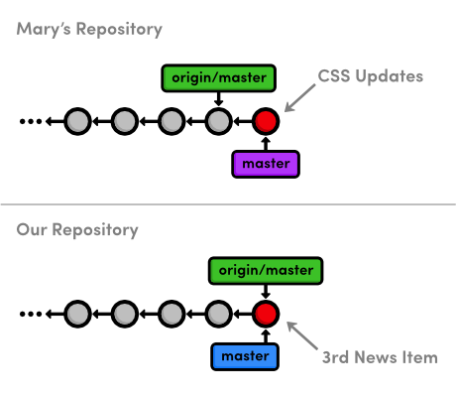Before publishing Mary’s CSS changes
You might be wondering how Mary can push her local master up to the central repository, since it has progressed since Mary last fetched from it. This is a common situation when many developers are working on a project simultaneously. Let’s see how Git handles it:
git push origin master
This will output a verbose rejection message. It seems that Git won’t let anyone push to a remote server if it doesn’t result in a fast-forward merge. This prevents us from losing the Add 3rd news item commit that would need to be overwritten for origin/master to match mary/master.

Pull in Changes (Mary)
Mary can solve this problem by pulling in the central changes before trying to push her CSS changes. First, she needs the most up-to-date version of the origin/master branch.
git fetch origin
Remember that Mary can see what’s in origin/master and not in the local master using the .. syntax:
git log master..origin/master
And she can also see what’s in her master that’s not in origin/master:
git log origin/master..master
Since both of these output a commit, we can tell that Mary’s history diverged. This should also be clear from the diagram below, which shows the updated origin/master branch.
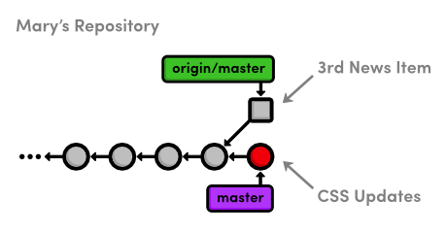Fetching the central repository’s master branch
Mary is now in the familiar position of having to pull in changes from another branch. She can either merge, which cannot be fast-forwarded, or she can rebase for a linear history.
Typically, you’ll want to rebase your changes on top of those found in your central repository. This is the equivalent of saying, “I want to add my changes to what everyone else has already done.” As previously discussed, rebasing also eliminates superfluous merge commits. For these reasons, Mary will opt for a rebase.
git rebase origin/master
git push origin master
After the rebase, Mary’s master branch contains everything from the central repository, so she can do a fast-forward push to publish her changes.
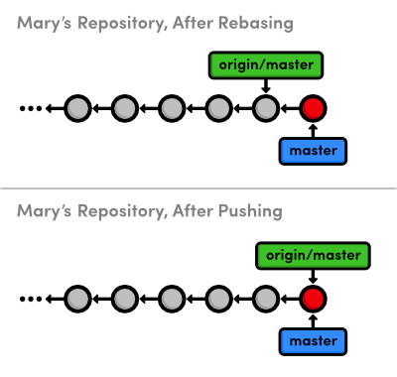Updating the central repository’s master

Pull in Changes (You)
Finally, we’ll switch back to our repository and pull in Mary’s CSS formatting.
cd ../my-git-repo
git fetch origin
git log master..origin/master --stat
git log origin/master..master --stat
Of course, the second log command won’t output anything, since we haven’t added any new commits while Mary was adding her CSS edits. It’s usually a good idea to check this before trying to merge in a remote branch. Otherwise, you might end up with some extra merge commits when you thought you were fast-forwarding your branch.
git merge origin/master
Our repository is now synchronized with the central repository. Note that Mary may have moved on and added some new content that we don’t know about, but it doesn’t matter. The only changes we need to know about are those in central-repo.git. While this doesn’t make a huge difference when we’re working with just one other developer, imagine having to keep track of a dozen different developers’ repositories in real-time. This kind of chaos is precisely the problem a centralized collaboration workflow is designed to solve:
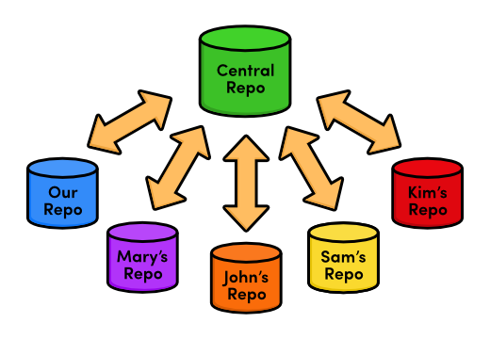The centralized workflow with many developers
The presence of a central communication hub condenses all this development into a single repository and ensures that no one overwrites another’s content, as we discovered while trying to push Mary’s CSS updates.

Conclusion
In this module, we introduced another remote repository to serve as the central storage facility for our project. We also discovered bare repositories, which are just like ordinary repositories—minus the working directory. Bare repositories provide a “safe” location to push branches to, as long as you remember not to rebase the commits that it already contains.
We hosted the central repository on our local filesystem, right next to both ours and Mary’s projects. However, most real-world central repositories reside on a remote server with internet access. This lets any developer fetch from or push to the repository over the internet, making Git a very powerful multi-user development platform. Having the central repository on a remote server is also an affordable, convenient way to back up a project.
Next up, we’ll configure a network-based repository using a service called GitHub. In addition to introducing network access for Git repositories, this will open the door for another collaboration standard: the integrator workflow.

Quick Reference
git init --bare <repository-name>
Create a Git repository, but omit the working directory.
git remote rm <remote-name>
Remove the specified remote from your bookmarked connections.

Distributed Workflows
Now that we know how to share information via a centralized workflow, we can appreciate some of the drawbacks of this collaboration model. While it may be convenient, allowing everyone to push to an “official” repository raises some legitimate security concerns. It means that for anyone to contribute content, they need access to the entire project.
This is fine if you’re only interacting with a small team, but imagine a scenario where you’re working on an open-source software project and a stranger found a bug, fixed it, and wants to incorporate the update into the main project. You probably don’t want to give them push-access to your central repository, since they could start pushing all sorts of random snapshots, and you would effectively lose control of the project.
But, what you can do is tell the contributor to push the changes to their own public repository. Then, you can pull their bug fix into your private repository to ensure it doesn’t contain any undeclared code. If you approve their contributions, all you have to do is merge them into a local branch and push it to the main repository, just like we did in the previous module. You’ve become an integrator, in addition to an ordinary developer:
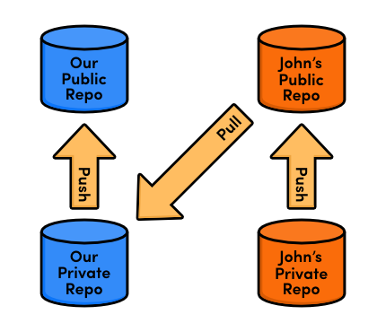The integrator workflow
In this module, we’ll experience all of this first-hand by creating a free public repository on Bitbucket.org and incorporating a contribution from an anonymous developer named John. Bitbucket is a DVCS hosting provider that makes it very easy to set up a Git repository and start collaborating with a team of developers.
Download the repositories for this module
If you’ve been following along from the previous module, you already have everything you need. Otherwise, download the zipped Git repositories from the above link, uncompress them, and you’re good to go.

Create a Bitbucket Account
The first part of this module will walk you through setting up a Bitbucket account. Navigate your web browser to Bitbucket.org and sign up for a free account.
The Bitbucket logo
You can choose any username for your account, but the email address should match the one you assigned to your Git installation with git config in The Basics. If you need to change your email, you can run another git config --global user.email you@example.com command.

Create a Public Repository (You)
To create our first networked Git repository, log into your Bitbucket account, and navigate to Repositories > Create repository. Use my-git-repo as the Repository Name, and anything you like for the Description field. Since this is just an example project, go ahead and uncheck the This is a private repository field. Select HTML/CSS for the Language field, then go ahead and click Create repository.
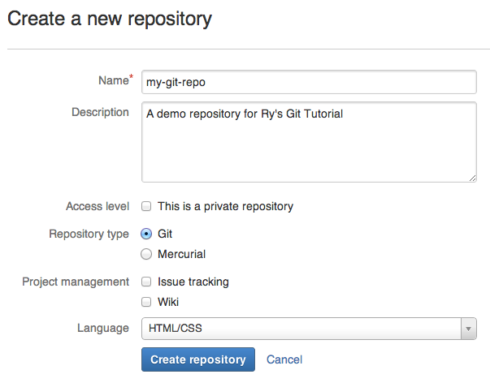Bitbucket’s new repository form
Essentially, we just ran git init --bare on a Bitbucket server. We can now push to and fetch from this repository as we did with central-repo.git in the previous module.
After initialization, Bitbucket offers some helpful instructions, but don’t follow them just yet—we’ll walk through importing an existing repository in the next section.
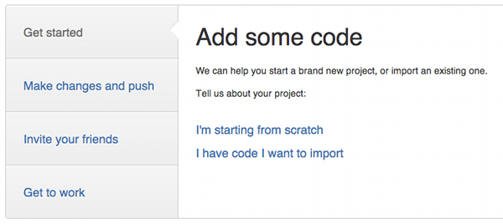Bitbucket’s setup instructions

Push to the Public Repository (You)
Before populating this new repository with our existing my-git-repo project, we first need to point our origin remote to the Bitbucket repository. Be sure to change the <username> portion to your actual Bitbucket username.
cd /path/to/my-git-repo
git remote rm origin
git remote add origin https://<username>@bitbucket.org/<username>/my-git-repo.git
The utility of remotes should be more apparent than in previous modules, as typing the full path to this repository every time we needed to interact with it would be rather tedious.
To populate the remote repository with our existing code, we can use the same push mechanism as with a centralized workflow. When prompted for a password, use the one that you signed up with.
git push origin master

Browse the Public Repository (You)
We should now be able to see our project on the Bitbucket site. The Source tab displays all of the files in the project, and the Commits tab contains the entire commit history. Note that the branch structure of the repository is also visualized to the left of each commit.
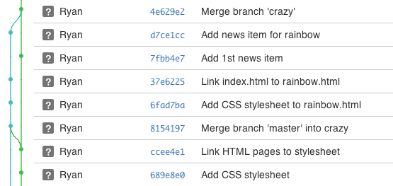Our history in Bitbucket’s Commit tab
This repository now serves as the “official” copy of our example website. We’ll tell everyone else to download from this repository, and we’ll push all the changes from our local my-git-repo to it. However, it’s important to note that this “official” status is merely a convention. As the master branch is just another branch, our Bitbucket repository is just another repository according to Git.
Having both a public and a private repository for each developer makes it easy to incorporate contributions from third-parties, even if you’ve never met them before.

Clone the Repository (John)
Next, we’re going to pretend to be John, a third-party contributor to our website. John noticed that we didn’t have a pink page and, being the friendly developer that he is, wants to create one for us. We’d like to let him contribute, but we don’t want to give him push-access to our entire repository—this would allow him to re-write or even delete all of our hard work.
Fortunately, John knows how to exploit Bitbucket’s collaboration potential. He’ll start by cloning a copy of our public repository:
cd /path/to/my-git-repo
cd ..
git clone http://bitbucket.org/<username>/my-git-repo.git johns-repo
cd johns-repo
You should now have another copy of our repository called johns-repo in the same folder as my-git-repo. This is John’s private repository—a completely isolated environment where he can safely develop the pink page. Let’s quickly configure his name and email:
git config user.name "John"
git config user.email john.example@rypress.com

Add the Pink Page (John)
Of course, John should be developing his contributions in a dedicated feature branch.
git checkout -b pink-page
In addition to being a best practice, this makes it easy for the integrator to see what commits to include. When John’s done, he’ll tell us where to find his repository and what branch the new feature resides in. Then, we’ll be able merge his content with minimal effort.
Create the file pink.html and add the following code:
<!DOCTYPE html>
<html lang="en">
<head>
<title>The Pink Page</title>
<link rel="stylesheet" href="style.css" />
<meta charset="utf-8" />
</head>
<body>
<h1 style="color: #F0F">The Pink Page</h1>
<p>Pink is <span style="color: #F0F">girly,
flirty and fun</span>!</p>

<p><a href="index.html">Return to home page</a></p>
</body>
</html>
Add the pink page to the “Navigation” section in index.html:
<li style="color: #F0F">
<a href="pink.html">The Pink Page</a>
</li>
Then, stage and commit the snapshot as normal.
git add pink.html index.html
git status
git commit -m "Add pink page"

Publish the Pink Page (John)
Now, John needs to publish his contributions to a public repository. Remember that we don’t want him to push to our public repository, which is stored in his origin remote. In fact, he can’t push to origin for reasons we’ll discuss in a moment.
Instead, he’ll create his own Bitbucket repository that we can pull contributions from. In the real world, John would have his own Bitbucket account, but for convenience, we’ll just store his public repository under our existing account. Once again, navigate to your Bitbucket home page and click Repositories > Create repository to create John’s public repository. For the Name field, use johns-repo.
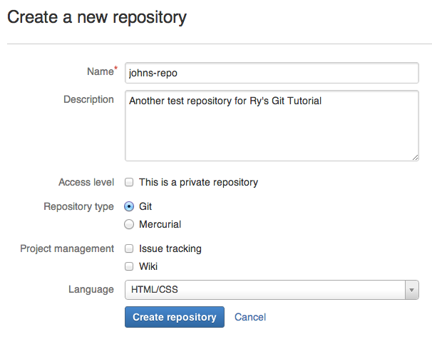John’s new repository form
Back in John’s private repository, we’ll need to add this as a remote:
git remote add john-public https://<username>@bitbucket.org/<username>/johns-repo.git
This is where John will publish the pink page for us to access. Since he’s pushing with HTTPS, he’ll need to enter the password for his Bitbucket account (which is actually the password for your account).
git push john-public pink-page
All John needs to do now is tell us the name of the feature branch and send us a link to his repository, which will be:
http://bitbucket.org/<username>/johns-repo.git
Note that John used a different path for pushing to his public repository than the one he gave us for fetching from it. The most important distinction is the transport protocol: the former used https:// while the latter used http://. Accessing a repository over HTTPS (or SSH) lets you fetch or push, but as we saw, requires a password. This prevents unknown developers from overwriting commits.
On the other hand, fetching over HTTP requires no username or password, but pushing is not possible. This lets anyone fetch from a repository without compromising its security. In the integrator workflow, other developers access your repository via HTTP, while you publish changes via HTTPS. This is also the reason why John can’t push to his origin remote.
Of course, if you’re working on a private project, anonymous HTTP access would be disabled for that repository.

View John’s Contributions (You)
Ok, we’re done being John and we’re ready to integrate his code into the official project. Let’s start by switching back into our repository and adding John’s public repository as a remote.
cd ../my-git-repo
git remote add john http://bitbucket.org/<username>/johns-repo.git
Note that we don’t care about anything in John’s private repository—the only thing that matters are his published changes. Let’s download his branches and take a look at what he’s been working on:
git fetch john
git branch -r
git log master..john/pink-page --stat
We can visualize this history information as the following.
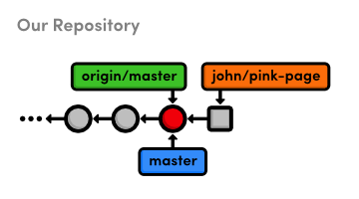Before merging John’s pink-page branch
Let’s take a look at his actual changes:
git checkout john/pink-page
Open up the pink.html file to see if it’s ok. Remember that John isn’t a trusted collaborator, and we would normally have no idea what this file might contain. With that in mind, it’s incredibly important to verify its contents. Never blindly merge content from a third-party contributor.

Integrate John’s Contributions (You)
Assuming we approve John’s updates, we’re now ready to merge it into the project.
git checkout master
git merge john/pink-page
Notice that is the exact same way we incorporated Mary’s changes in the centralized workflow, except now we’re pulling from and pushing to different locations:
The integrator workflow with John
Furthermore, John’s workflow is just like ours: develop in a local, private repository, then push changes to the public one. The integrator workflow is merely a standardized way of organizing the collaboration effort—nothing has changed about how we develop locally, and we’re using the same Git commands as we have been for the last few modules.

Publish John’s Contributions (You)
We’ve integrated John’s contribution into our local my-git-repo repository, but no one else knows what we’ve done. It’s time to publish our master branch again.
git push origin master
Since we designated our public Bitbucket repository as the “official” source for our project, everyone (i.e., Mary and John) will now be able to synchronize with it.

Update Mary’s Repository (Mary)
Mary should now be pulling changes from our Bitbucket repository instead of the central one from the previous module. This should be fairly easy for her to configure.
cd ../marys-repo
git remote rm origin
git remote add origin http://bitbucket.org/<username>/my-git-repo.git
Again, remember to change <username> to your Bitbucket account’s username. For the sake of brevity, we’ll do a blind merge to add John’s updates to Mary’s repository (normally, Mary should check what she’s integrating before doing so).
git checkout master
git fetch origin
git rebase origin/master
For Mary, it doesn’t really matter that the updates came from John. All she has to know is that the “official” master branch moved forward, prompting her to synchronize her private repository.

Update John’s Repository (John)
John still needs to incorporate the pink page into his master branch. He should not merge directly from his pink-page topic branch because we could have edited his contribution before publishing it or included other contributions along with it. Instead, he’ll pull from the “official” master:
cd ../johns-repo
git checkout master
git fetch origin
git rebase origin/master
If John had updated master directly from his local pink-page, it could have wound up out-of-sync from the main project. For this reason, the integrator workflow requires that everyone pull from a single, official repository, while they all push to their own public repositories:
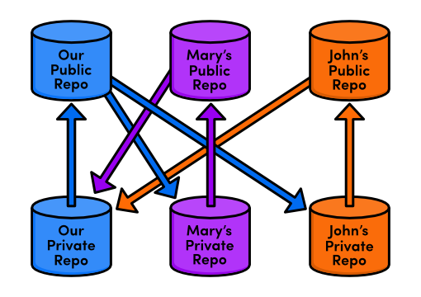The integrator workflow with many developers
In this way, additions from one contributor can be approved, integrated, and made available to everyone without interrupting anyone’s independent developments.

Conclusion
Using the integrator workflow, our private development process largely remains the same (develop a feature branch, merge it into master, and publish it). But, we’ve added an additional task: incorporating changes from third-party contributors. Luckily, this doesn’t require any new skills—just access to a few more remote repositories.
While this setup forces us to keep track of more remotes, it also makes it much, much easier to work with a large number of developers. You’ll never have to worry about security using an integrator workflow because you’ll still be the only one with access to the “official” repository.
There’s also an interesting side-effect to this kind of security. By giving each developer their own public repository, the integrator workflow creates a more stable development environment for open-source software projects. Should the lead developer stop maintaining the “official” repository, any of the other participants could take over by simply designating their public repository as the new “official” project. This is part of what makes Git a distributed version control system: there is no single central repository that Git forces everyone to rely upon.
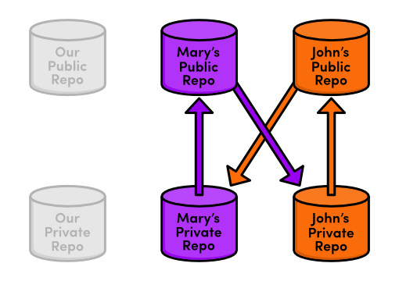John/Mary taking over project maintenance
In the next module, we’ll take a look at an even more flexible way to share commits. This low-level approach will also give us a better understanding of how Git internally manages our content.

Patch Workflows
Thus far, all of the collaboration workflows we’ve seen rely heavily on branches. For example, in the last module, a contributor had to publish an entire branch for us to merge into our project. However, it’s also possible to communicate directly on the commit level using a patch.
A patch file represents a single set of changes (i.e., a commit) that can be applied to any branch, in any order. In this sense, the patch workflow is akin to interactive rebasing, except you can easily share patches with other developers. This kind of communication lessens the importance of a project’s branch structure and gives complete control to the project maintainer (at least with regards to incorporating contributions).
Integrating on the commit level will also give us a deeper understanding of how a Git repository records project history.
Download the repositories for this module
If you’ve been following along from the previous module, you already have everything you need. Otherwise, download the zipped Git repositories from the above link, uncompress them, and you’re good to go. If you’ve set up a Bitbucket account, you should also run the following commands to configure the downloaded repositories:
cd /path/to/my-git-repo
git remote add origin https://<username>@bitbucket.org/<username>/my-git-repo.git
cd ../marys-repo
git remote add origin http://bitbucket.org/<username>/my-git-repo.git

Change the Pink Page (Mary)
We’ll begin by pretending to be Mary again. Mary didn’t like the pink page that John contributed and wants to change it.
cd /path/to/marys-repo
git checkout -b pink-page
Developing in a new branch not only gives Mary an isolated environment, it also makes it easier to create a series of patches once she’s done editing the pink page. Find these lines in pink.html:
<p>Pink is <span style="color: #F0F">girly,
flirty and fun</span>!</p>
and change them to the following.
<p>Only <span style="color: #F0F">real men</span> wear pink!</p>
Stage and commit the update as normal.
git commit -a -m "Change pink to a manly color"
Note that Mary’s local development process doesn’t change at all. Patches—like the centralized and integrator workflows—are merely a way to share changes amongst developers. It has little effect on the core Git concepts introduced in the first portion of this tutorial.

Create a Patch (Mary)
Mary can create a patch from the new commit using the git format-patch command.
git format-patch master
This creates a file called 0001-Change-pink-to-a-manly-color.patch that contains enough information to re-create the commit from the last step. The master parameter tells Git to generate patches for every commit in the current branch that’s missing from master.
Open up the patch file in a text editor. As shown by the addresses in the top of the file, it’s actually a complete email. This makes it incredibly easy to send patches to other developer. Further down, you should see the following.
index 98e10a1..828dd1a 100644
--- a/pink.html
+++ b/pink.html
@@ -7,8 +7,7 @@
</head>
<body>
<h1 style="color: #F0F">The Pink Page</h1>
- <p>Pink is <span style="color: #F0F">girly,
- flirty and fun</span>!</p>
+ <p>Only <span style="color: #F0F">real men</span> wear pink!</p>

<p><a href="index.html">Return to home page</a></p>
</body>
This unique formatting is called a diff, because it shows the difference between two versions of a file. In our case, it tells us what happened to the pink.html file between the 98e10a1 and 828dd1a commits (your patch will contain different commit ID’s). The -7,8 +7,7 portion describes the lines affected in the respective versions of the file, and the rest of the text shows us the content that has been changed. The lines beginning with - have been deleted in the new version, and the line starting with + has been added.
While you don’t have to know the ins-and-outs of diffs to make use of patches, you do need to understand that a single patch file represents a complete commit. And, since it’s a normal file (and also an email), it’s much easier to pass around than a Git branch.
Delete the patch file for now (we’ll re-create it later).

Add a Pink Block (Mary)
Before learning how to turn patches back into commits, Mary will add one more snapshot.
In pink.html, add the following on the line after the <meta> tag.
<style>
div {
width: 300px;
height: 50px;
}
</style>
And, add the next line of HTML after Only real men wear pink!:
<div style="background-color: #F0F"></div>
Stage and commit the snapshot.
git commit -a -m "Add a pink block of color"
Mary’s repository now contains two commits after the tip of master:
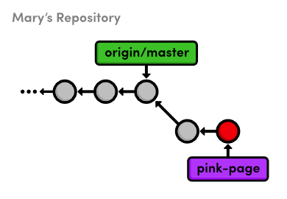Adding two commits on the pink-page branch

Create Patch of Entire Branch (Mary)
Mary can use the same command as before to generate patches for all the commits in her pink-page branch.
git format-patch master
The first patch is the exact same as we previously examined, but we also have a new one called 0002-Add-a-pink-block-of-color.patch. Note that the first line of the commit message will always be used to make a descriptive filename for the patch. You should find the following diff in the second patch.
index 828dd1a..2713b10 100644
--- a/pink.html
+++ b/pink.html
@@ -4,10 +4,17 @@
<title>The Pink Page</title>
<link rel="stylesheet" href="style.css" />
<meta charset="utf-8" />
+ <style>
+ div {
+ width: 300px;
+ height: 50px;
+ }
+ </style>
</head>
<body>
<h1 style="color: #F0F">The Pink Page</h1>
<p>Only <span style="color: #F0F">real men</span> wear pink!</p>
+ <div style="background-color: #F0F"></div>

<p><a href="index.html">Return to home page</a></p>
</body>
This is the same formatting as the first patch, except its lack of - lines indicate that we only added HTML during the second commit. As you can see, this patch is really just a machine-readable summary of our actions from the previous section.

Mail the Patches (Mary)
Now that Mary has prepared a series of patches, she can send them to the project maintainer (us). In the typical patch workflow, she would send them via email using one of the following methods:
- Copying and pasting the contents of the patch files into an email client. If she uses this method, Mary would have to make sure that her email application doesn’t change the whitespace in the patch upon sending it.
- Sending the patch file as an attachment to a normal email.
- Using the convenient git send-email command and specifying a file or a directory of files to send. For example, git send-email . will send all the patches in the current directory. Git also requires some special configurations for this command. Please consult the official Git documentation for details.
The point is, the .patch files need to find their way into the Git repository of whoever wants to add it to their project. For our example, all we need to do is copy the patches into the my-git-repo directory that represents our local version of the project.

Apply the Patches (You)
Copy the two patch files from marys-repo into my-git-repo. Using the new git am command, we can use these patches to add Mary’s commits to our repository.
cd ../my-git-repo
git checkout -b patch-integration
git am < 0001-Change-pink-to-a-manly-color.patch
git log master..HEAD --stat
First, notice that we’re doing our integrating in a new topic branch. Again, this ensures that we won’t destroy our existing functionality and gives us a chance to approve changes. Second, the git am command takes a patch file and creates a new commit from it. The log output shows us that our integration branch contains Mary’s update, along with her author information.
Let’s repeat the process for the second commit.
git am < 0002-Add-a-pink-block-of-color.patch
git log master..HEAD --stat
The git am command is configured to read from something called “standard input,” and the < character is how we can turn a file’s contents into standard input. As it’s really more of an operating system topic, you can just think of this syntax as a quirk of the git am command.
After applying this patch, our integration branch now looks exactly like Mary’s pink-page branch. We applied Mary’s patches in the same order she did, but that didn’t necessarily have to be the case. The whole idea behind patches is that they let you isolate a commit and move it around as you please.

Integrate the Patches (You)
Once again, we’re in the familiar situation of integrating a topic branch into the stable master branch.
git checkout master
git merge patch-integration
git branch -d patch-integration
git clean -f
git push origin master
Mary’s updates are now completely integrated into our local repository, so we can get rid of the patch files with git clean. This was also an appropriate time to push changes to the public repository so other developers can access the most up-to-date version of the project.

Update Mary’s Repository (Mary)
Mary might be tempted to merge her pink-page branch directly into her master branch, but this would be a mistake. Her master branch must track the “official” repository’s master, as discussed in the previous module.
cd ../marys-repo
git checkout master
git fetch origin
git rebase origin/master
git branch -D pink-page
git clean -f
Patches are a convenient way to share commits amongst developers, but the patch workflow still requires an “official” repository that contains everybody’s changes. What would have happened if Mary wasn’t the only one sending patches to us? We may very well have applied several different patches or applied Mary’s contributions in a different order. Using Mary’s pink-page to update her master branch would completely ignore all these updates.
Taking this into consideration, our final patch workflow resembles the following.
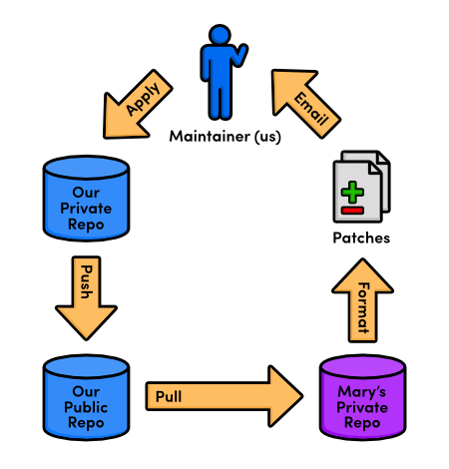The patch workflow

Conclusion
Whereas remote repositories are a way to share entire branches, patches are a way to send individual commits to another developer. Keep in mind that patches are usually only sent to a project maintainer, who then integrates them into the “official” project for all to see. It would be impossible for everyone to communicate using only patches, as no one would be applying them in the same order. Eventually, everyone’s project history would look entirely different.
In many ways, patches are a simpler way to accept contributions than the integrator workflow from the previous module. Only the project maintainer needs a public repository, and he’ll never have to peek at anyone else’s repository. From the maintainer’s perspective, patches also provide the same security as the integrator workflow: he still won’t have to give anyone access to his “official” repository. But, now he won’t have to keep track of everybody’s remote repositories, either.
As a programmer, you’re most likely to use patches when you want to fix a bug in someone else’s project. After fixing it, you can send them a patch of the resulting commit. For this kind of one-time-fix, it’s much more convenient for you to generate a patch than to set up a public Git repository.
This module concludes our discussion of the standard Git workflows. Hopefully, you now have a good idea of how Git can better manage your personal and professional software projects using a centralized, integrator, or patch workflow. In the next module, we’ll switch gears and introduce a variety of practical Git commands.

Quick Reference
git format-patch <branch-name>
Create a patch for each commit contained in the current branch but not in <branch-name>. You can also specify a commit ID instead of <branch-name>.
git am < <patch-file>
Apply a patch to the current branch.

Tips & Tricks
This module presents a broad survey of useful Git utilities. We’ll take a step back from the theoretical aspects of Git and focus on common tasks like preparing a project for release and backing up a repository. While working through this module, your goal shouldn’t be to master all of these miscellaneous tools, but rather to understand why they were created and when they might come in handy.
Download the repositories for this module
If you’ve been following along from the previous module, you already have everything you need. Otherwise, download the zipped Git repositories from the above link, uncompress them, and you’re good to go.

Archive The Repository
First, let’s export our repository into a ZIP archive. Run the following command in your local copy of my-git-repo.
git archive master --format=zip --output=../website-12-10-2012.zip
Or, for Unix users that would prefer a tarball:
git archive master --format=tar --output=../website-12-10-2012.tar
This takes the current master branch and places all of its files into a ZIP archive (or a tarball), omitting the .git directory. Removing the .git directory removes all version control information, and you’re left with a single snapshot of your project.
You can send the resulting archive to a client for review, even if they don’t have Git installed on their machine. This is also an easy way to create Git-independent backups of important revisions, which is always a good idea.

Bundle the Repository
Similar to the git archive command, git bundle turns a repository into a single file. However, in this case, the file retains the versioning information of the entire project. Try running the following command.
git bundle create ../repo.bundle master
It’s like we just pushed our master branch to a remote, except it’s contained in a file instead of a remote repository. We can even clone it using the same git clone command:
cd ..
git clone repo.bundle repo-copy -b master
cd repo-copy
git log
cd ../my-git-repo
The log output should show you the entire history of our master branch, and repo.bundle is also the origin remote for the new repository. This is the exact behavior we encountered when cloning a “normal” Git repository.
Bundles are a great way to backup entire Git repositories (not just an isolated snapshot like git archive). They also let you share changes without a network connection. For example, if you didn’t want to configure the SSH accounts for a private Git server, you could bundle up the repository, put it on a jump drive, and walk it over to your co-worker’s computer. Of course, this could become a bit tiresome for active projects.
We won’t be needing the repo.bundle file and repo-copy folder, so go ahead and delete them now.

Ignore a File
Remember that Git doesn’t automatically track files because we don’t want to record generated files like C binaries or compiled Python modules. But, seeing these files under the “Untracked files” list in git status can get confusing for large projects, so Git lets us ignore content using a special text file called .gitignore. Each file or directory stored in .gitignore will be invisible to Git.
Let’s see how this works by creating a file called notes.txt to store some personal (private) comments about the project. Add some text to it and save it, then run the following.
git status
As expected, this will show notes.txt in the “Untracked files” section. Next, create a file called .gitignore in the my-git-repo folder and add the following text to it. Windows users can create a file that starts with a period by executing the touch .gitignore command in Git Bash (you should also make sure hidden files are visible in your file browser).
notes.txt
Run another git status and you’ll see that the notes file no longer appears under “Untracked files”, but .gitignore does. This is a common file for Git-based projects, so let’s add it to the repository.
git add .gitignore
git commit -m "Add .gitignore file"
git status
You can also specify entire directories in .gitignore or use the * wildcard to ignore files with a particular extension. For example, the following is a typical .gitignore file for a simple C project. It tells Git to overlook all .o, .out, and .exe files in the repository.
*.o
*.out
*.exe

Stash Uncommitted Changes
Next, we’ll take a brief look at stashing, which conveniently “stashes” away uncommitted changes. Open up style.css and change the h1 element to:
h1 {
font-size: 32px;
font-family: "Times New Roman", serif;
}
Now let’s say we had to make an emergency fix to our project. We don’t want to commit an unfinished feature, and we also don’t want to lose our current CSS addition. The solution is to temporarily remove these changes with the git stash command:
git status
git stash
git status
Before the stash, style.css was listed as “Changed by not updated.” The git stash command hid these changes, giving us a clean working directory. We’re now able to switch to a new hotfix branch to make our important updates—without having to commit a meaningless snapshot just to save our current state.
Let’s pretend we’ve completed our emergency update and we’re ready to continue working on our CSS changes. We can retrieve our stashed content with the following command.
git stash apply
The style.css file now looks the same as it did before the stash, and we can continue development as if we were never interrupted. Whereas patches represent a committed snapshot, a stash represents a set of uncommitted changes. It takes the uncommitted modifications, stores them internally, then does a git reset --hard to give us a clean working directory. This also means that stashes can be applied to any branch, not just the one from which it was created.
In addition to temporarily storing uncommitted changes, this makes stashing a simple way to transfer modifications between branches. So, for example, if you ever found yourself developing on the wrong branch, you could stash all your changes, checkout the correct branch, then run a git stash apply.
Let’s undo these CSS updates before moving on.
git reset --hard

Hook into Git’s Internals
Arguably, Git’s most useful configuration options are its hooks. A hook is a script that Git executes every time a particular event occurs in a repository. In this section, we’ll take a hands-on look at Git hooks by automatically publishing our website every time someone pushes to the central-repo.git repository.
In the central-repo.git directory, open the hooks directory and rename the file post-update.sample to post-update. After removing the .sample extension, this script will be executed whenever any branch gets pushed to central-repo.git. Replace the default contents of post-update with the following.
#!/bin/sh

# Output a friendly message
echo "Publishing master branch!" >&2

# Remove the old `my-website` directory (if necessary)
rm -rf ../my-website

# Create a new `my-website` directory
mkdir ../my-website

# Archive the `master` branch
git archive master --format=tar --output=../my-website.tar

# Uncompress the archive into the `my-website` directory
tar -xf ../my-website.tar -C ../my-website

exit 0
While shell scripts are outside the scope of this tutorial, the majority of commands in the above code listing should be familiar to you. In short, this new post-update script creates an archive of the master branch, then exports it into a directory called my-website. This is our “live” website.
We can see the script in action by pushing a branch to the central-repo.git repository.
git push ../central-repo.git master
After the central repository receives the new master branch, our post-update script is executed. You should see the Publishing master branch! message echoed from the script, along with a new my-website folder in the same directory as my-git-repo. You can open index.html in a web browser to verify that it contains all the files from our master branch, and you can also see the intermediate .tar archive produced by the hook.
This is a simple, unoptimized example, but Git hooks are infinitely versatile. Each of the .sample scripts in the hooks directory represents a different event that you can listen for, and each of them can do anything from automatically creating and publishing releases to enforcing a commit policy, making sure a project compiles, and of course, publishing websites (that means no more clunky FTP uploads). Hooks are even configured on a per-repository basis, which means you can run different scripts in your local repository than your central repository.
For a detailed description of the available hooks, please consult the official Git documentation.

View Diffs Between Commits
Up until now, we’ve been using git log --stat to view the changes introduced by new commits. However, this doesn’t show us which lines have been changed in any given file. For this level of detail, we need the git diff command. Let’s take a look at the updates from the Add a pink block of color commit:
git diff HEAD~2..HEAD~1
This will output the diff between the Add a pink block of color commit (HEAD~1) and the one before it (HEAD~2):
index 828dd1a..2713b10 100644
--- a/pink.html
+++ b/pink.html
@@ -4,10 +4,17 @@
<title>The Pink Page</title>
<link rel="stylesheet" href="style.css" />
<meta charset="utf-8" />
+ <style>
+ div {
+ width: 300px;
+ height: 50px;
+ }
+ </style>
</head>
<body>
<h1 style="color: #F0F">The Pink Page</h1>
<p>Only <span style="color: #F0F">real men</span> wear pink!</p>
+ <div style="background-color: #F0F"></div>

<p><a href="index.html">Return to home page</a></p>
</body>
This diff looks nearly identical to the patches we created in the previous module, and it shows exactly what was added to get from HEAD~2 to HEAD~1. The git diff command is incredibly useful for pinpointing contributions from other developers. For example, we could have used the following to view the differences between John’s pink-page branch and our master before merging it into the project in Distributed Workflows.
git diff master..john/pink-page
This flexible command can also generate a detailed view of our uncommitted changes. Open up blue.html, make any kind of change, and save the file. Then, run git diff without any arguments:
git diff
And, just in case we forgot what was added to the staging area, we can use the --cached flag to generate a diff between the staged snapshot and the most recent commit:
git add blue.html
git diff --cached
A plain old git diff won’t output anything after blue.html is added to the staging area, but the changes are now visible through the --cached flag. These are the three main configurations of the git diff command.

Reset and Checkout Files
We’ve used git reset and git checkout many times throughout this tutorial; however, we’ve only seen them work with branches/commits. You can also reset and check out individual files, which slightly alters the behavior of both commands.
The git reset we’re accustomed to moves the current branch to a new commit and optionally updates the working directory to match. But when we pass a file path, git reset updates the staging area to match the given commit instead of the working directory, and it doesn’t move the current branch pointer. This means we can remove blue.html from the staged snapshot with the following command.
git reset HEAD blue.html
git status
This makes the blue.html in the staging area match the version stored in HEAD, but it leaves the working directory and current branch alone. The result is a staging area that matches the most recent commit and a working directory that contains the modified blue.html file. In other words, this type of git reset can be used to unstage a file:
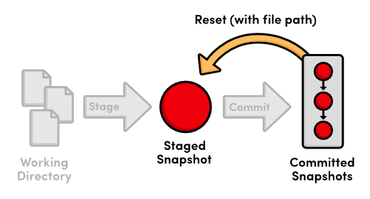Using git reset with a file path
Let’s take this one step further with git checkout. The git checkout we’ve been using updates the working directory and switches branches. If we add a file path to git checkout, it narrows its focus to only the specified file and does not update the branch pointer. This means that we can “check out” the most recent version of blue.html with the following command.
git checkout HEAD blue.html
git status
Our blue.html file now looks exactly like the version stored in HEAD, and we thus have a clean working directory. Passing a file path to git checkout reverts that file to the specified commit.
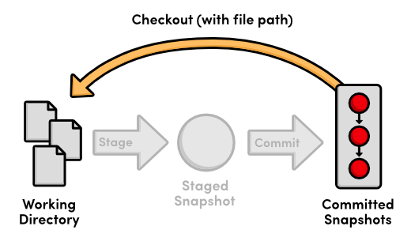Using git checkout with a file path
To summarize the file-path behavior of git reset and git checkout, both take a committed snapshot as an reference point and make a file in the staging area or the working directory match that reference, respectively.

Aliases and Other Configurations
Typing git checkout every time you wanted to see a new branch over the last ten modules has been a bit verbose. Fortunately, Git lets you create aliases, which are shortcuts to other commands. Let’s create a few aliases for our most common commands:
git config --global alias.co checkout
git config --global alias.ci commit
git config --global alias.br branch
Now, we can use git co instead of git checkout, git ci for committing, and git br for listing branches. We can even use git br <branch-name> for creating a new branch.
Git stores these aliases in a global config file, similar to the local config file we looked at in Mary’s repository (marys-repo/.git/config). By default, global configurations reside in ~/.gitconfig, where the ~ character represents your home directory. This file should resemble the following.
[user]
name = Ryan
email = ryan.example@rypress.com
[alias]
co = checkout
ci = commit
br = branch
Of course, your settings should reflect the name and email you entered in The Basics. As you can see, all of our new aliases are also stored in .gitconfig. Let’s add a few more useful configurations by modifying this file directly. Append the following to .gitconfig.
[color]
status = always
[core]
editor = gvim
This makes sure Git colorizes the output of git status and that it uses the gVim text editor for creating commit messages. To use a different editor, simply change gvim to the command that opens your editor. For example, Emacs users would use emacs, and Notepad users would use notepad.exe.
Git includes a long list of configuration options, all of which can be found in the official manual. Note that storing your global configurations in a plaintext file makes it incredibly easy to transfer your settings to a new Git installation: just copy ~/.gitconfig onto your new machine.

Conclusion
In this module, we learned how to export snapshots, backup repositories, ignore files, stash temporary changes, hook into Git’s internals, generate diffs, reset individual files, and create shorter aliases for common commands. While it’s impossible to cover all of Git’s supporting features in a hands-on guide such as this, I hope that you now have a clearer picture of Git’s numerous capabilities.
With all of these convenient features, it’s easy to get so caught up in designing the perfect workflow that you lose sight of Git’s underlying purpose. As you add new commands to your repertoire, remember that Git should always make it easier to develop a software project—never harder. If you ever find that Git is causing more harm than good, don’t be scared to drop some of the advanced features and go back to the basics.
The final module will go a long way towards helping you realize the full potential of Git’s version control model. We’ll explore Git’s internal database by manually inspecting and creating snapshots. Equipped with this low-level knowledge, you’ll be more than ready to venture out into the reality of Git-based project management.

Quick Reference
git archive <branch-name> --format=zip --output=<file>
Export a single snapshot to a ZIP archive called <file>.
git bundle create <file> <branch-name>
Export an entire branch, complete with history, to the specified file.
git clone repo.bundle <repo-dir> -b <branch-name>
Re-create a project from a bundled repository and checkout <branch-name>.
git stash
Temporarily stash changes to create a clean working directory.
git stash apply
Re-apply stashed changes to the working directory.
git diff <commit-id>..<commit-id>
View the difference between two commits.
git diff
View the difference between the working directory and the staging area.
git diff --cached
View the difference between the staging area and the most recent commit.
git reset HEAD <file>
Unstage a file, but don’t alter the working directory or move the current branch.
git checkout <commit-id> <file>
Revert an individual file to match the specified commit without switching branches.
git config --global alias.<alias-name> <git-command>
Create a shortcut for a command and store it in the global configuration file.

Plumbing
In Rewriting History, I talked about the internal representation of a Git repository. I may have mislead you a bit. While the reflog, interactive rebasing, and resetting may be more complex features of Git, they are still considered part of the porcelain, as is every other command we’ve covered. In this module, we’ll take a look at Git’s plumbing—the low-level commands that give us access to Git’s true internal representation of a project.
Unless you start hacking on Git’s source code, you’ll probably never need to use the plumbing commands presented below. But, manually manipulating a repository will fill in the conceptual details of how Git actually stores your data, and you should walk away with a much better understanding of the techniques that we’ve been using throughout this tutorial. In turn, this knowledge will make the familiar porcelain commands even more powerful.
We’ll start by inspecting Git’s object database, then we’ll manually create and commit a snapshot using only Git’s low-level interface.
Download the repository for this module
If you’ve been following along from the previous module, you already have everything you need. Otherwise, download the zipped Git repository from the above link, uncompress it, and you’re good to go.

Examine Commit Details
First, let’s take a closer look at our latest commit with the git cat-file plumbing command.
git cat-file commit HEAD
The commit parameter tells Git that we want to see a commit object, and as we already know, HEAD refers to the most recent commit. This will output the following, although your IDs and user information will be different.
tree 552acd444696ccb1c3afe68a55ae8b20ece2b0e6
parent 6a1d380780a83ef5f49523777c5e8d801b7b9ba2
author Ryan <ryan.example@rypress.com> 1326496982 -0600
committer Ryan <ryan.example@rypress.com> 1326496982 -0600

Add .gitignore file
This is the complete representation of a commit: a tree, a parent, user data, and a commit message. The user information and commit message are relatively straightforward, but we’ve never seen the tree or parent values before.
A tree object is Git’s representation of the “snapshots” we’ve been talking about since the beginning of this tutorial. They record the state of a directory at a given point, without any notion of time or author. To tie trees together into a coherent project history, Git wraps each one in a commit object and specifies a parent, which is just another commit. By following the parent of each commit, you can walk through the entire history of a project.
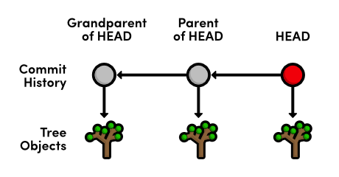Commit and tree objects
Notice that each commit refers to one and only one tree object. From the git cat-file output, we can also infer that trees use SHA-1 checksums for their ID’s. This will be the case for all of Git’s internal objects.

Examine a Tree
Next, let’s try to inspect a tree using the same git cat-file command. Make sure to change 552acd4 to the ID of your tree from the previous step.
git cat-file tree 552acd4
Unfortunately, trees contain binary data, which is quite ugly when displayed in its raw form. So, Git offers another useful plumbing command:
git ls-tree 552acd4
This will output the contents of the tree, which looks an awful lot like a directory listing:
100644 blob 99ed0d431c5a19f147da3c4cb8421b5566600449 .gitignore
040000 tree ab4947cb27ef8731f7a54660655afaedaf45444d about
100644 blob cefb5a651557e135666af4c07c7f2ab4b8124bd7 blue.html
100644 blob cb01ae23932fd9704fdc5e077bc3c1184e1af6b9 green.html
100644 blob e993e5fa85a436b2bb05b6a8018e81f8e8864a24 index.html
100644 blob 2a6deedee35cc59a83b1d978b0b8b7963e8298e9 news-1.html
100644 blob 0171687fc1b23aa56c24c54168cdebaefecf7d71 news-2.html
...
By examining the above output, we can presume that “blobs” represent files in our repository, whereas trees represent folders. Go ahead and examine the about tree with another git ls-tree to see if this really is the case. You should see the contents of our about folder.
So, blob objects are how Git stores our file data, tree objects combine blobs and other trees into a directory listing, then commit objects tie trees into a project history. These are the only types of objects that Git needs to implement nearly all of the porcelain commands we’ve been using, and their relationship is summed up as follows:
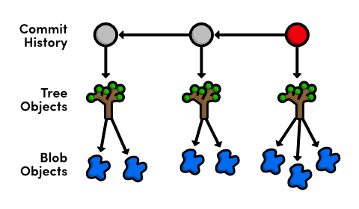Commit, tree, and blob objects

Examine a Blob
Let’s take a look at the blob associated with blue.html (be sure to change the following to the ID next to blue.html in your tree output).
git cat-file blob cefb5a6
This should display the entire contents of blue.html, confirming that blobs really are plain data files. Note that blobs are pure content: there is no mention of a filename in the above output. That is to say, the name blue.html is stored in the tree that contains the blob, not the blob itself.
You may recall from The Basics that an SHA-1 checksum ensures an object’s contents is never corrupted without Git knowing about it. Checksums work by using the object’s contents to generate a unique character sequence. This not only functions as an identifier, it also guarantees that an object won’t be silently corrupted (the altered content would generate a different ID).
When it comes to blob objects, this has an additional benefit. Since two blobs with the same data will have the same ID, Git must share blobs across multiple trees. For example, our blue.html file hasn’t been changed since it was created, so our repository will only have a single associated blob, and all subsequent trees will refer to it. By not creating duplicate blobs for each tree object, Git vastly reduces the size of a repository. With this in mind, we can revise our Git object diagram to the following.
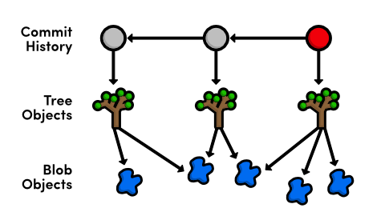Commit, tree, and shared blob objects
However, as soon as you change a single line in a file, Git must create a new blob object because its contents will have changed, resulting in a new SHA-1 checksum.

Examine a Tag
The fourth and final type of Git object is the tag object We can use the same git cat-file command to show the details of a tag.
git cat-file tag v2.0
This will output the commit ID associated with v2.0, along with the tag’s name, author, creation date, and message. The straightforward relationship between tags and commits gives us our finalized Git object diagram:
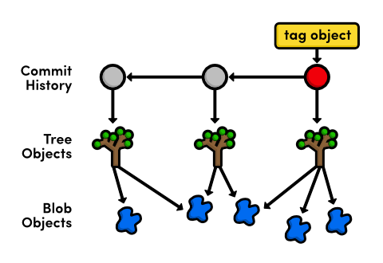Commit, tree, blob, and tag objects

Inspect Git’s Branch Representation
We now have the tools to fully explore Git’s branch representation. Using the -t flag, we can determine what kind of object Git uses for branches.
git cat-file -t master
That’s right, a branch is just a reference to a commit object, which means we can view it with a normal git cat-file.
git cat-file commit master
This will output the exact same information as our original git cat-file commit HEAD. It seems that both the master branch and HEAD are simply references to a commit object.
Using a text editor, open up the .git/refs/heads/master file. You should find the commit checksum of the most recent commit, which you can view with git log -n 1. This single file is all Git needs to maintain the master branch—all other information is extrapolated through the commit object relationships discussed above.
The HEAD reference, on the other hand, is recorded in .git/HEAD. Unlike the branch tips, HEAD is not a direct link to a commit. Instead, it refers to a branch, which Git uses to figure out which commit is currently checked out. Remember that a detached HEAD state occurred when HEAD did not coincide with the tip of any branch. Internally, all this means to Git is that .git/HEAD doesn’t contain a local branch. Try checking out an old commit:
git checkout HEAD~1
Now, .git/HEAD should contain a commit ID instead of a branch. This tells Git that we’re in a detached HEAD state. Regardless of what state you’re in, the git checkout command will always record the checked-out reference in .git/HEAD.
Let’s get back to our master branch before moving on:
git checkout master

Explore the Object Database
While we have a basic understanding of Git’s object interaction, we have yet to explore where Git keeps all of these objects. In your my-git-repo repository, open the folder .git/objects. This is Git’s object database.
Each object, regardless of type, is stored as a file, using its SHA-1 checksum as the filename (sort of). But, instead of storing all objects in a single folder, they are split up using the first two characters of their ID as a directory name, resulting in an object database that looks something like the following.
00 10 28 33 3e 51 5c 6e 77 85 95 f7
01 11 29 34 3f 52 5e 6f 79 86 96 f8
02 16 2a 35 41 53 63 70 7a 87 98 f9
03 1c 2b 36 42 54 64 71 7c 88 99 fa
0c 26 30 3c 4e 5a 6a 75 83 91 a0 info
0e 27 31 3d 50 5b 6b 76 84 93 a2 pack
For example, an object with the following ID:
7a52bb857229f89bffa74134ee3de48e5e146105
is stored in a folder called 7a, using the remaining characters (52bb8...) as a filename. This gives us an object ID, but before we can inspect items in the object database, we need to know what type of object it is. Again, we can use the -t flag:
git cat-file -t 7a52bb8
Of course, change the object ID to an object from your database (don’t forget to combine the folder name with the filename to get the full ID). This will output the type of commit, which we can then pass to a normal call to git cat-file.
git cat-file blob 7a52bb8
My object was a blob, but yours may be different. If it’s a tree, remember to use git ls-tree to turn that ugly binary data into a pretty directory listing.

Collect the Garbage
As your repository grows, Git may automatically transfer your object files into a more compact form know as a “pack” file. You can force this compression with the garbage collection command, but beware: this command is undo-able. If you want to continue exploring the contents of the .git/objects folder, you should do so before running the following command. Normal Git functionality will not be affected.
git gc
This compresses individual object files into a faster, smaller pack file and removes dangling commits (e.g., from a deleted, unmerged branch).
Of course, all of the same object ID’s will still work with git cat-file, and all of the porcelain commands will remain unaffected. The git gc command only changes Git’s storage mechanism—not the contents of a repository. Running git gc every now and then is usually a good idea, as it keeps your repository optimized.

Add Files to the Index
Thus far, we’ve been discussing Git’s low-level representation of committed snapshots. The rest of this module will shift gears and use more “plumbing” commands to manually prepare and commit a new snapshot. This will give us an idea of how Git manages the working directory and the staging area.
Create a new file called news-4.html in my-git-repo and add the following HTML.
<!DOCTYPE html>
<html lang="en">
<head>
<title>Indigo Invasion</title>
<link rel="stylesheet" href="style.css" />
<meta charset="utf-8" />
</head>
<body>
<h1 style="color: #A0C">Indigo Invasion</h1>
<p>Last week, a coalition of Asian designers, artists,
and advertisers announced the official color of Asia:
<span style="color: #A0C">Indigo</span>.</p>

<p><a href="index.html">Return to home page</a></p>
</body>
</html>
Then, update the index.html “News” section to match the following.
<h2 style="color: #C00">News</h2>
<ul>
<li><a href="news-1.html">Blue Is The New Hue</a></li>
<li><a href="rainbow.html">Our New Rainbow</a></li>
<li><a href="news-2.html">A Red Rebellion</a></li>
<li><a href="news-3.html">Middle East's Silent Beast</a></li>
<li><a href="news-4.html">Indigo Invasion</a></li>
</ul>
Instead of git add, we’ll use the low-level git update-index command to add files to the staging area. The index is Git’s term for the staged snapshot.
git status
git update-index index.html
git update-index news-4.html
The last command will throw an error—Git won’t let you add a new file to the index without explicitly stating that it’s a new file:
git update-index --add news-4.html
git status
We’ve just moved the working directory into the index, which means we have a snapshot prepared for committal. However, the process won’t be quite as simple as a mere git commit.

Store the Index in the Database
Remember that all commits refer to a tree object, which represents the snapshot for that commit. So, before creating a commit object, we need to add our index (the staged tree) to Git’s object database. We can do this with the following command.
git write-tree
This command creates a tree object from the index and stores it in .git/objects. It will output the ID of the resulting tree (yours may be different):
5f44809ed995e5b861acf309022ab814ceaaafd6
You can examine your new snapshot with git ls-tree. Keep in mind that the only new blobs created for this commit were index.html and news-4.html. The rest of the tree contains references to existing blobs.
git ls-tree 5f44809
So, we have our tree object, but we have yet to add it to the project history.

Create a Commit Object
To commit the new tree object, we need to manually figure out the ID of the parent commit.
git log --oneline -n 1
This will output the following line, though your commit ID will be different. We’ll use this ID to specify the parent of our new commit object.
3329762 Add .gitignore file
The git commit-tree command creates a commit object from a tree and a parent ID, while the author information is taken from an environment variable set by Git. Make sure to change 5f44809 to your tree ID, and 3329762 to your most recent commit ID.
git commit-tree 5f44809 -p 3329762
This command will wait for more input: the commit message. Type Add 4th news item and press Enter to create the commit message, then Ctrl-Z and Enter for Windows or Ctrl-D for Unix to specify an “End-of-file” character to end the input. Like the git write-tree command, this will output the ID of the resulting commit object.
c51dc1b3515f9f8e80536aa7acb3d17d0400b0b5
You’ll now be able to find this commit in .git/objects, but neither HEAD nor the branches have been updated to include this commit. It’s a dangling commit at this point. Fortunately for us, we know where Git stores its branch information.
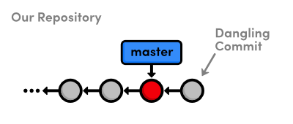Creating a dangling commit

Update HEAD
Since we’re not in a detached HEAD state, HEAD is a reference to a branch. So, all we need to do to update HEAD is move the master branch forward to our new commit object. Using a text editor, replace the contents of .git/refs/heads/master with the output from git commit-tree in the previous step.
If this file seems to have disappeared, don’t fret! This just means that the git gc command packed up all of our branch references into single file. Instead of .git/refs/heads/master, open up .git/packed-refs, find the line with refs/heads/master, and change the ID to the left of it.
Now that our master branch points to the new commit, we should be able to see the news-4.html file in the project history.
git log -n 2
The last four sections explain everything that happens behind the scenes when we execute git commit -a -m "Some Message". Aren’t you glad you won’t have to use Git’s plumbing ever again?
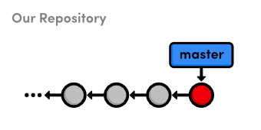Manually updating the master branch

Conclusion
After this module, you hopefully have a solid grasp of the object database that underlies almost every Git command. We examined commits, trees, blobs, tags, and branches, and we even created a commit object from scratch. All of this was meant to give you a deeper understanding of Git’s porcelain commands, and you should now feel ready to adapt Git to virtually any task you could possibly demand from a version control system.
As you migrate these skills to real-world projects, remember that Git is merely a tool for tracking your files, not a cure-all for managing software projects. No amount of intimate Git knowledge can make up for a haphazard set of conventions within a development team.
Thus concludes our journey through Git-based revision control. This tutorial was meant to prepare you for the realities of distributed software development—not to transform you into a Git expert overnight. You should be able to manage your own projects, collaborate with other Git users, and, perhaps most importantly, understand exactly what any other piece of Git documentation is trying to convey.
Your job now is to take these skills and apply them to new projects, sift through complex histories that you’ve never seen before, talk to other developers about their Git workflows, and take the time to actually try all of those “I wonder what would have happened if…” scenarios. Good luck!
For questions, comments, or suggestions, please contact us.

Quick Reference
git cat-file <type> <object-id>
Display the specified object, where <type> is one of commit, tree, blob, or tag.
git cat-file -t <object-id>
Output the type of the specified object.
git ls-tree <tree-id>
Display a pretty version of the specified tree object.
git gc
Perform a garbage collection on the object database.
git update-index [--add] <file>
Stage the specified file, using the optional --add flag to denote a new untracked file.
git write-tree
Generate a tree from the index and store it in the object database. Returns the ID of the new tree object.
git commit-tree <tree-id> -p <parent-id>
Create a new commit object from the given tree object and parent commit. Returns the ID of the new commit object.

A Hacker’s Guide to Git is now available as an e-book. You can purchase it on Leanpub.
- Introduction
- Repositories
- Tree Objects
- Commits
- References
- Branches
- Tags
- Merging
- Rebasing
- Cherry-Picking
- Rebasing (Continued)
- Remotes
  - Cloning
  - Pushing
  - Remote-Tracking Branches
  - Fetching
  - Pulling
- Toolkit
  - git-reflog
  - git-fsck
  - git-stash
  - git-describe
  - git-rev-parse
  - git-bisect

Introduction
Git is currently the most widely used version control system in the world, mostly thanks to GitHub. By that measure, I’d argue that it’s also the most misunderstood version control system in the world.
This statement probably doesn’t ring true straight away because on the surface, Git is pretty simple. It’s really easy to pick up if you’ve come from another VCS like Subversion or Mercurial. It’s even relatively easy to pick up if you’ve never used a VCS before. Everybody understands adding, committing, pushing and pulling; but this is about as far as Git’s simplicity goes. Past this point, Git is shrouded by fear, uncertainty and doubt.
Once you start talking about branching, merging, rebasing, multiple remotes, remote-tracking branches, detached HEAD states… Git becomes less of an easily-understood tool and more of a feared deity. Anybody who talks about no-fast-forward merges is regarded with quiet superstition, and even veteran hackers would rather stay away from rebasing “just to be safe”.
I think a big part of this is due to many people coming to Git from a conceptually simpler VCS – probably Subversion – and trying to apply their past knowledge to Git. It’s easy to understand why people want to do this. Subversion is simple, right? It’s just files and folders. Commits are numbered sequentially. Even branching and tagging is simple – it’s just like taking a backup of a folder.
Basically, Subversion fits in nicely with our existing computing paradigms. Everybody understands files and folders. Everybody knows that revision #10 was the one after #9 and before #11. But these paradigms break down when you try to apply them to Git.
That’s why trying to understand Git in this way is wrong. Git doesn’t work like Subversion at all. Which can be pretty confusing. You can add and remove files. You can commit your changes. You can generate diffs and patches which look just like the ones that Subversion generates. So how can something which appears so similar really be so different?
Complex systems like Git become much easier to understand once you figure out how they really work. The goal of this guide is to shed some light on how Git works under the hood. We’re going to take a look at some of Git’s core concepts including its basic object storage, how commits work, how branches and tags work, and we’ll look at the different kinds of merging in Git including the much-feared rebase. Hopefully at the end of it all, you’ll have a solid understanding of these concepts and will be able to use some of Git’s more advanced features with confidence.
It’s worth noting at this point that this guide is not intended to be a beginner’s introduction to Git. This guide was written for people who already use Git, but would like to better understand it by taking a peek under the hood, and learn a few neat tricks along the way. With that said, let’s begin.

Repositories
At the core of Git, like other VCS, is the repository. A Git repository is really just a simple key-value data store. This is where Git stores, among other things:
- Blobs, which are the most basic data type in Git. Essentially, a blob is just a bunch of bytes; usually a binary representation of a file.
- Tree objects, which are a bit like directories. Tree objects can contain pointers to blobs and other tree objects.
- Commit objects, which point to a single tree object, and contain some metadata including the commit author and any parent commits.
- Tag objects, which point to a single commit object, and contain some metadata.
- References, which are pointers to a single object (usually a commit or tag object).
You don’t need to worry about all of this just yet; we’ll cover these things in more detail later.
The important thing to remember about a Git repository is that it exists entirely in a single .git directory in your project root. There is no central repository like in Subversion or CVS. This is what allows Git to be a distributed version control system – everybody has their own self-contained version of a repository.
You can initialize a Git repository anywhere with the git init command. Take a look inside the .git folder to get a glimpse of what a repository looks like.
$ git init
Initialized empty Git repository in /home/demo/demo-repository/.git/
$ ls -l .git
total 32
drwxrwxr-x 2 demo demo 4096 May 24 20:10 branches
-rw-rw-r-- 1 demo demo 92 May 24 20:10 config
-rw-rw-r-- 1 demo demo 73 May 24 20:10 description
-rw-rw-r-- 1 demo demo 23 May 24 20:10 HEAD
drwxrwxr-x 2 demo demo 4096 May 24 20:10 hooks
drwxrwxr-x 2 demo demo 4096 May 24 20:10 info
drwxrwxr-x 4 demo demo 4096 May 24 20:10 objects
drwxrwxr-x 4 demo demo 4096 May 24 20:10 refs
The important directories are .git/objects, where Git stores all of its objects; and .git/refs, where Git stores all of its references.
We’ll see how all of this fits together as we learn about the rest of Git. For now, let’s learn a little bit more about tree objects.

Tree Objects
A tree object in Git can be thought of as a directory. It contains a list of blobs (files) and other tree objects (sub-directories).
Imagine we had a simple repository, with a README file and a src/ directory containing a hello.c file.
README
src/
hello.c
This would be represented by two tree objects: one for the root directory, and another for the src/ directory. Here’s what they would look like.

tree 4da454..
blob | 976165.. | README
tree | 81fc8b.. | src

tree 81fc8b..
blob | 1febef.. | hello.c
If we draw the blobs (in green) as well as the tree objects (in blue), we end up with a diagram that looks a lot like our directory structure.
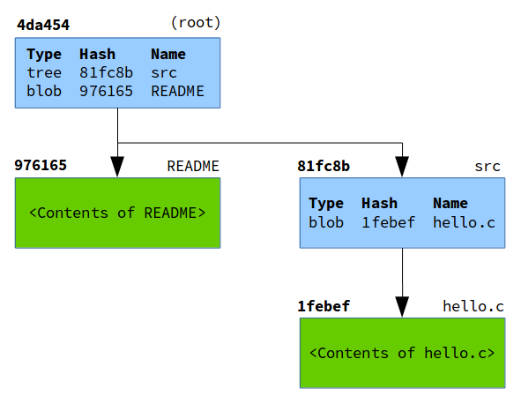
Notice how given the root tree object, we can recurse through every tree object to figure out the state of the entire working tree. The root tree object, therefore, is essentially a snapshot of your repository at a given time. Usually when Git refers to “the tree”, it is referring to the root tree object.
Now let’s learn how you can track the history of your repository with commit objects.

Commits
A commit object is essentially a pointer that contains a few pieces of important metadata. The commit itself has a hash, which is built from a combination of the metadata that it contains:
- The hash of the tree (the root tree object) at the time of the commit. As we learned in Tree Objects, this means that with a single commit, Git can build the entire working tree by recursing into the tree.
- The hash of any parent commits. This is what gives a repository its history: every commit has a parent commit, all the way back to the very first commit.
- The author’s name and email address, and the time that the changes were authored.
- The committer’s name and email address, and the time that the commit was made.
- The commit message.
Let’s see a commit object in action by creating a simple repository.
$ git init
Initialized empty Git repository in /home/demo/simple-repository/.git/
$ echo 'This is the readme.' > README
$ git add README
$ git commit -m "First commit"
[master (root-commit) d409ca7] First commit
1 file changed, 1 insertion(+)
create mode 100644 README
When you create a commit, Git will give you the hash of that commit. Using git show with the --format=raw flag, we can see this newly-created commit’s metadata.
$ git show --format=raw d409ca7

commit d409ca76bc919d9ca797f39ae724b7c65700fd27
tree 9d073fcdfaf07a39631ef94bcb3b8268bc2106b1
author Joseph Wynn <joseph@wildlyinaccurate.com> 1400976134 -0400
committer Joseph Wynn <joseph@wildlyinaccurate.com> 1400976134 -0400

First commit

diff --git a/README b/README
new file mode 100644
index 0000000..9761654
--- /dev/null
+++ b/README
@@ -0,0 +1 @@
+This is the readme.

Notice how although we referenced the commit by the partial hash d409ca7, Git was able to figure out that we actually meant d409ca76bc919d9ca797f39ae724b7c65700fd27. This is because the hashes that Git assigns to objects are unique enough to be identified by the first few characters. You can see here that Git is able to find this commit with as few as four characters; after which point Git will tell you that the reference is ambiguous.
$ git show d409c
$ git show d409
$ git show d40
fatal: ambiguous argument 'd40': unknown revision or path not in the working tree.

References
In previous sections, we saw how objects in Git are identified by a hash. Since we want to manipulate objects quite often in Git, it’s important to know their hashes. You could run all your Git commands referencing each object’s hash, like git show d409ca7, but that would require you to remember the hash of every object you want to manipulate.
To save you from having to memorize these hashes, Git has references, or “refs”. A reference is simply a file stored somewhere in .git/refs, containing the hash of a commit object.
To carry on the example from Commits, let’s figure out the hash of “First commit” using references only.
$ git status
On branch master
nothing to commit, working directory clean
git status has told us that we are on branch master. As we will learn in a later section, branches are just references. We can see this by looking in .git/refs/heads.
$ ls -l .git/refs/heads/
total 4
-rw-rw-r-- 1 demo demo 41 May 24 20:02 master
We can easily see which commit master points to by reading the file.
$ cat .git/refs/heads/master
d409ca76bc919d9ca797f39ae724b7c65700fd27
Sure enough, master contains the hash of the “First commit” object.
Of course, it’s possible to simplify this process. Git can tell us which commit a reference is pointing to with the show and rev-parse commands.
$ git show --oneline master
d409ca7 First commit
$ git rev-parse master
d409ca76bc919d9ca797f39ae724b7c65700fd27
Git also has a special reference, HEAD. This is a “symbolic” reference which points to the tip of the current branch rather than an actual commit. If we inspect HEAD, we see that it simply points to refs/head/master.
$ cat .git/HEAD
ref: refs/heads/master
It is actually possible for HEAD to point directly to a commit object. When this happens, Git will tell you that you are in a “detached HEAD state”. We’ll talk a bit more about this later, but really all this means is that you’re not currently on a branch.

Branches
Git’s branches are often touted as being one of its strongest features. This is because branches in Git are very lightweight, compared to other VCS where a branch is usually a clone of the entire repository.
The reason branches are so lightweight in Git is because they’re just references. We saw in References that the master branch was simply a file inside .git/refs/heads. Let’s create another branch to see what happens under the hood.
$ git branch test-branch
$ cat .git/refs/heads/test-branch
d409ca76bc919d9ca797f39ae724b7c65700fd27
It’s as simple as that. Git has created a new entry in .git/refs/heads and pointed it at the current commit.
We also saw in References that HEAD is Git’s reference to the current branch. Let’s see that in action by switching to our newly-created branch.
$ cat .git/HEAD
ref: refs/heads/master
$ git checkout test-branch
Switched to branch 'test-branch'
$ cat .git/HEAD
ref: refs/heads/test-branch
When you create a new commit, Git simply changes the current branch to point to the newly-created commit object.
$ echo 'Some more information here.' >> README
$ git add README
$ git commit -m "Update README in a new branch"
[test-branch 7604067] Update README in a new branch
1 file changed, 1 insertion(+)
$ cat .git/refs/heads/test-branch
76040677d717fd090e327681064ac6af9f0083fb
Later on we’ll look at the difference between local branches and remote-tracking branches.

Tags
There are two types of tags in Git – lightweight tags and annotated tags.
On the surface, these two types of tags look very similar. Both of them are references stored in .git/refs/tags. However, that’s about as far as the similarities go. Let’s create a lightweight tag to see how they work.
$ git tag 1.0-lightweight
$ cat .git/refs/tags/1.0-lightweight
d409ca76bc919d9ca797f39ae724b7c65700fd27
We can see that Git has created a tag reference which points to the current commit. By default, git tag will create a lightweight tag. Note that this is not a tag object. We can verify this by using git cat-file to inspect the tag.
$ git cat-file -p 1.0-lightweight
tree 9d073fcdfaf07a39631ef94bcb3b8268bc2106b1
author Joseph Wynn <joseph@wildlyinaccurate.com> 1400976134 -0400
committer Joseph Wynn <joseph@wildlyinaccurate.com> 1400976134 -0400

First commit
$ git cat-file -p d409ca7
tree 9d073fcdfaf07a39631ef94bcb3b8268bc2106b1
author Joseph Wynn <joseph@wildlyinaccurate.com> 1400976134 -0400
committer Joseph Wynn <joseph@wildlyinaccurate.com> 1400976134 -0400

First commit
You can see that as far as Git is concerned, the 1.0-lightweight tag and the d409ca7 commit are the same object. That’s because the lightweight tag is only a reference to the commit object.
Let’s compare this to an annotated tag.
$ git tag -a -m "Tagged 1.0" 1.0
$ cat .git/refs/tags/1.0
10589beae63c6e111e99a0cd631c28479e2d11bf
We’ve passed the -a (--annotate) flag to git tag to create an annotated tag. Notice how Git creates a reference for the tag just like the lightweight tag, but this reference is not pointing to the same object as the lightweight tag. Let’s use git cat-file again to inspect the object.
$ git cat-file -p 1.0
object d409ca76bc919d9ca797f39ae724b7c65700fd27
type commit
tag 1.0
tagger Joseph Wynn <joseph@wildlyinaccurate.com> 1401029229 -0400

Tagged 1.0
This is a tag object, separate to the commit that it points to. As well as containing a pointer to a commit, tag objects also store a tag message and information about the tagger. Tag objects can also be signed with a GPG key to prevent commit or email spoofing.
Aside from being GPG-signable, there are a few reasons why annotated tags are preferred over lightweight tags.
Probably the most important reason is that annotated tags have their own author information. This can be helpful when you want to know who created the tag, rather than who created the commit that the tag is referring to.
Annotated tags are also timestamped. Since new versions are usually tagged right before they are released, an annotated tag can tell you when a version was released rather than just when the final commit was made.

Merging
Merging in Git is the process of joining two histories (usually branches) together. Let’s start with a simple example. Say you’ve created a new feature branch from master, and done some work on it.
$ git checkout -b feature-branch
Switched to a new branch 'feature-branch'
$ vim feature.html
$ git commit -am "Finished the new feature"
[feature-branch 0c21359] Finished the new feature
1 file changed, 1 insertion(+)
At the same time, you need to fix an urgent bug. So you create a hotfix branch from master, and do some work in there.
$ git checkout master
Switched to branch 'master'
$ git checkout -b hotfix
Switched to a new branch 'hotfix'
$ vim index.html
$ git commit -am "Fixed some wording"
[hotfix 40837f1] Fixed some wording
1 file changed, 1 insertion(+), 1 deletion(-)
At this point, the history will look something like this.
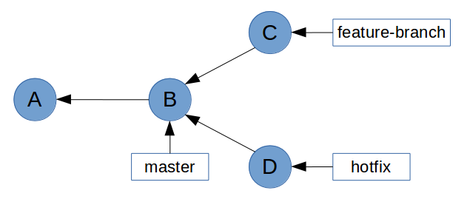
Now you want to bring the bug fix into master so that you can tag it and release it.
$ git checkout master
Switched to branch 'master'
$ git merge hotfix
Updating d939a3a..40837f1
Fast-forward
index.html | 2 +-
1 file changed, 1 insertion(+), 1 deletion(-)
Notice how Git mentions fast-forward during the merge. What this means is that all of the commits in hotfix were directly upstream from master. This allows Git to simply move the master pointer up the tree to hotfix. What you end up with looks like this.
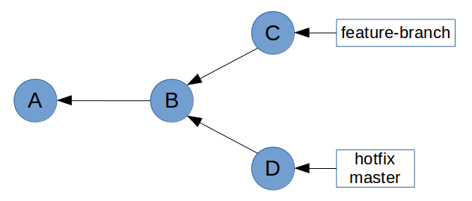
Now let’s try and merge feature-branch into master.
$ git merge feature-branch
Merge made by the 'recursive' strategy.
feature.html | 1 +
1 file changed, 1 insertion(+)
This time, Git wasn’t able to perform a fast-forward. This is because feature-branch isn’t directly upstream from master. This is clear on the graph above, where master is at commit D which is in a different history tree to feature-branch at commit C.
So how did Git handle this merge? Taking a look at the log, we see that Git has actually created a new ”merge” commit, as well as bringing the commit from feature-branch.
$ git log --oneline
8ad0923 Merge branch 'feature-branch'
0c21359 Finished the new feature
40837f1 Fixed some wording
d939a3a Initial commit
Upon closer inspection, we can see that this is a special kind of commit object – it has two parent commits. This is referred to as a merge commit.
$ git show --format=raw 8ad0923

commit 8ad09238b0dff99e8a99c84d68161ebeebbfc714
tree e5ee97c8f9a4173f07aa4c46cb7f26b7a9ff7a17
parent 40837f14b8122ac6b37c0919743b1fd429b3bbab
parent 0c21359730915c7888c6144aa8e9063345330f1f
author Joseph Wynn <joseph@wildlyinaccurate.com> 1401134489 +0100
committer Joseph Wynn <joseph@wildlyinaccurate.com> 1401134489 +0100

Merge branch 'feature-branch'
This means that our history graph now looks something like this (commit E is the new merge commit).
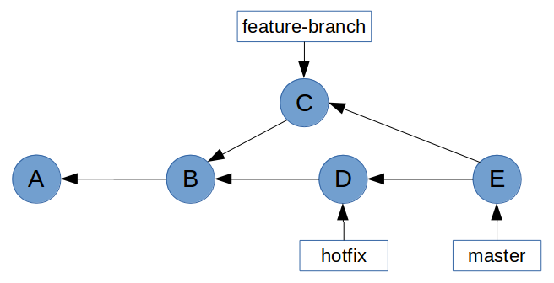
Some people believe that this sort of history graph is undesirable. In the Rebasing (Continued) section, we’ll learn how to prevent non-fast-forward merges by rebasing feature branches before merging them with master.

Rebasing
Rebasing is without a doubt one of Git’s most misunderstood features. For most people, git rebase is a command that should be avoided at all costs. This is probably due to the extraordinary amount of scaremongering around rebasing. “Rebase Considered Harmful”, and “Please, stay away from rebase” are just two of the many anti-rebase articles you will find in the vast archives of the Internet.
But rebase isn’t scary, or dangerous, so long as you understand what it does. But before we get into rebasing, I’m going to take a quick digression, because it’s actually much easier to explain rebasing in the context of cherry-picking.

Cherry-Picking
What git cherry-pick does is take one or more commits, and replay them on top of the current commit. Imagine a repository with the following history graph.
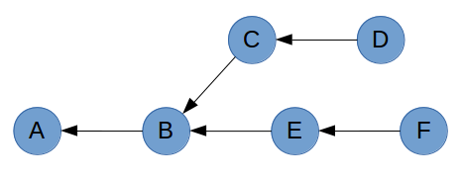
If you are on commit D and you run git cherry-pick F, Git will take the changes that were introduced in commit F and replay them as a new commit (shown as F’) on top of commit D.
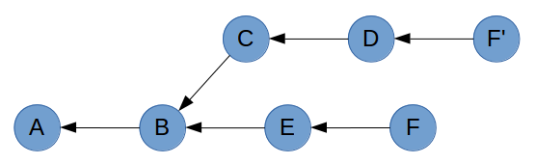
The reason you end up with a copy of commit F rather than commit F itself is due to the way commits are constructed. Recall that the parent commit is part of a commit’s hash. So despite containing the exact same changes, author information and timestamp; F’ will have a different parent to F, giving it a different hash.
A common workflow in Git is to develop features on small branches, and merge the features one at a time into the master branch. Let’s recreate this scenario by adding some branch labels to the graphs.
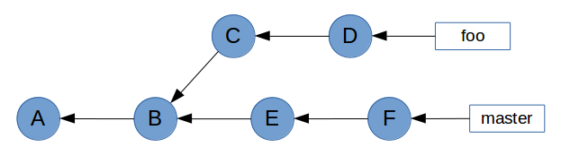
As you can see, master has been updated since foo was created. To avoid potential conflicts when foo is merged with master, we want to bring master’s changes into foo. Because master is the base branch, we want to play foo’s commits on top of master. Essentially, we want to change commit C’s parent from B to F.
It’s not going to be easy, but we can achieve this with git cherry-pick. First, we need to create a temporary branch at commit F.
$ git checkout master
$ git checkout -b foo-tmp
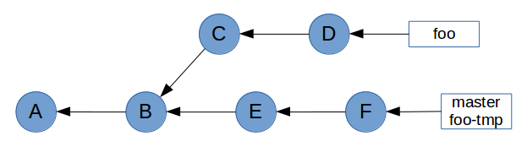
Now that we have a base on commit F, we can cherry-pick all of foo’s commits on top of it.
$ git cherry-pick C D
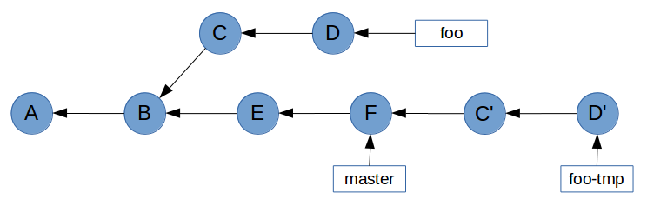
Now all that’s left to do is point foo at commit D’, and delete the temporary branch foo-tmp. We do this with the reset command, which points HEAD (and therefore the current branch) at a specified commit. The --hard flag ensures our working tree is updated as well.
$ git checkout foo
$ git reset --hard foo-tmp
$ git branch -D foo-tmp
This gives the desired result of foo’s commits being upstream of master. Note that the original C and D commits are no longer reachable because no branch points to them.
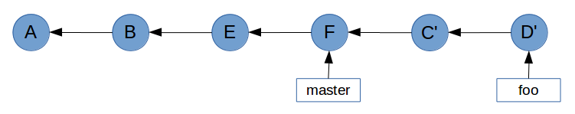

Rebasing (Continued)
While the example in Cherry-Picking worked, it’s not practical. In Git, rebasing allows us to replace our verbose cherry-pick workflow…
$ git checkout master
$ git checkout -b foo-tmp
$ git cherry-pick C D
$ git checkout foo
$ git reset --hard foo-tmp
$ git branch -D foo-tmp
…With a single command.
$ git rebase master foo
With the format git rebase <base> <target>, the rebase command will take all of the commits from <target> and play them on top of <base> one by one. It does this without actually modifying <base>, so the end result is a linear history in which <base> can be fast-forwarded to <target>.
In a sense, performing a rebase is like telling Git, “Hey, I want to pretend that <target> was actually branched from <base>. Take all of the commits from <target>, and pretend that they happened after <base>“.
Let’s take a look again at the example graph from Merging to see how rebasing can prevent us from having to do a non-fast-forward merge.
All we have to do to enable a fast-forward merge of feature-branch into master is run git rebase master feature-branch before performing the merge.
$ git rebase master feature-branch
First, rewinding head to replay your work on top of it...
Applying: Finished the new feature
This has brought feature-branch directly upstream of master.
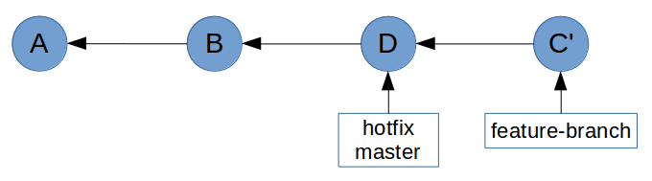
Git is now able to perform a fast-forward merge.
$ git checkout master
$ git merge feature-branch
Updating 40837f1..2a534dd
Fast-forward
feature.html | 1 +
1 file changed, 1 insertion(+)

Remotes
In order to collaborate on any Git project, you need to utilise at least one remote repository. Unlike centralised VCS which require a dedicated server daemon, a Git remote is simply another Git repository. In order to demonstrate this, we first need to understand the concept of a bare repository.
Recall that Git stores the entire repository inside the .git directory. Inside this directory are blobs and tree objects which can be traversed to build a snapshot of the entire project. This means that Git doesn’t actually need a working tree – it only uses the working tree to figure out what changes have been made since the last commit. This is easily demonstrated if you delete a file from a repository, and then run git checkout <file>. Despite being removed from the file system, Git can still restore the file because it has previously stored it in the repository. You can do the same thing with entire directories and Git will still be able to restore everything by traversing its tree objects.
It is therefore possible to have a repository which can store your project’s history without actually having a working tree. This is called a bare repository. Bare repositories are most commonly used as a “central” repository where collaborators can share changes. The mechanism for sharing these changes will be explained in detail in the Pushing and Pulling sections. For now, let’s look at creating a bare repository.
$ git init --bare
Initialised empty Git repository in /home/demo/bare-repo/
$ ls -l
total 12
drwxrwxr-x 1 demo demo 0 May 31 12:58 branches
-rw-rw-r-- 1 demo demo 66 May 31 12:58 config
-rw-rw-r-- 1 demo demo 73 May 31 12:58 description
-rw-rw-r-- 1 demo demo 23 May 31 12:58 HEAD
drwxrwxr-x 1 demo demo 328 May 31 12:58 hooks
drwxrwxr-x 1 demo demo 14 May 31 12:58 info
drwxrwxr-x 1 demo demo 16 May 31 12:58 objects
drwxrwxr-x 1 demo demo 18 May 31 12:58 refs
Notice how rather than creating a .git directory for the repository, git init --bare simply treats the current directory as the .git directory.
There’s really not much to this repository. The only interesting things it contains are a HEAD reference which points to the master branch (which doesn’t exist yet), and a config file which has the bare flag set to true. The other files aren’t of much interest to us.
$ find . -type f
./info/exclude
./hooks/commit-msg.sample
./hooks/pre-commit.sample
./hooks/pre-push.sample
./hooks/pre-rebase.sample
./hooks/pre-applypatch.sample
./hooks/applypatch-msg.sample
./hooks/post-update.sample
./hooks/prepare-commit-msg.sample
./hooks/update.sample
./description
./HEAD
./config

$ cat HEAD
ref: refs/heads/master
$ cat config
[core]
repositoryformatversion = 0
filemode = true
bare = true

So what can we do with this repository? Well, nothing much right now. Git won’t let us modify the repository because it doesn’t have a working tree to modify. (Note: this isn’t strictly true. We could painstakingly use Git’s low-level commands to manually create and store objects in Git’s data store, but that is beyond the scope of this guide. If you’re really interested, read Git Internals - Git Objects).
$ touch README
$ git add README
fatal: This operation must be run in a work tree
The intended use of this repository is for other collaborators to clone and pull changes from, as well as push their own changes to.

Cloning
Now that we’ve set up a bare repository, let’s look at the concept of cloning a repository.
The git clone command is really just a shortcut which does a few things for you. With its default configuration, it will:
- Create remote-tracking branches for each branch in the remote.
- Check out the branch which is currently active (HEAD) on the remote.
- Perform a git pull to bring the current branch and working tree up-to-date with the remote.
The clone command takes a URL and supports a number of transport protocols including HTTP, SSH, and Git’s own protocol. It also supports plain old file paths, which is what we’ll use.
$ cd ..
$ git clone bare-repo/ clone-of-bare-repo
Cloning into 'clone-of-bare-repo'...
warning: You appear to have cloned an empty repository.
done.
Let’s inspect this cloned repository to see how Git has set it up.
$ cd clone-of-bare-repo/
$ find . -type f
./.git/info/exclude
./.git/hooks/commit-msg.sample
./.git/hooks/pre-commit.sample
./.git/hooks/pre-push.sample
./.git/hooks/pre-rebase.sample
./.git/hooks/pre-applypatch.sample
./.git/hooks/applypatch-msg.sample
./.git/hooks/post-update.sample
./.git/hooks/prepare-commit-msg.sample
./.git/hooks/update.sample
./.git/description
./.git/HEAD
./.git/config

$ cat .git/HEAD
ref: refs/heads/master
$ ls -l .git/refs/heads/
total 0
$ cat .git/config
[core]
repositoryformatversion = 0
filemode = true
bare = false
logallrefupdates = true
[remote "origin"]
url = /home/demo/bare-repo/
fetch = +refs/heads/*:refs/remotes/origin/*
[branch "master"]
remote = origin
merge = refs/heads/master
This is quite literally a clone of bare-repo. The only difference is that this repository contains a few extra lines in .git/config.
First, it contains a remote listing for “origin”, which is the default name given to a repository’s main remote. This tells Git the URL of the repository, and which references it should retrieve when performing a git fetch.
Below that is a branch listing. This is the configuration for a remote-tracking branch. But before we get into that, let’s store some data in the remote repository.

Pushing
We’ve just cloned a completely empty repository, and we want to start working on it.
$ echo 'Project v1.0' > README
$ git add README
$ git commit -m "Add readme"
[master (root-commit) 5d591d5] Add readme
1 file changed, 1 insertion(+)
create mode 100644 README
Notice that even though it didn’t technically exist (there was nothing in .git/refs/heads), this commit has been made to the master branch. That’s because the HEAD of this repository pointed to master, so Git has gone ahead and created the branch for us.
$ cat .git/refs/heads/master
5d591d5fafd538610291f45bec470d1b4e77891e
Now that we’ve completed some work, we need to share this with our collaborators who have also cloned this repository. Git makes this really easy.
$ git push origin master
Counting objects: 3, done.
Writing objects: 100% (3/3), 231 bytes | 0 bytes/s, done.
Total 3 (delta 0), reused 0 (delta 0)
To /home/demo/bare-repo/
* [new branch] master -> master
Notice how we specified both the remote (origin) and the branch (master) that we want Git to push. It is possible to simply run git push, but this can be dangerous and is generally advised against. Running git push without any arguments can (depending on your configuration) push all remote-tracking branches. This is usually okay, but it can result in you pushing changes which you don’t want collaborators to pull. In the worst case, you can destroy other collaborators’ changes if you specify the --force flag.
So, let’s take a look at the remote repository to see what happened.
$ cd ../bare-repo/
$ cat refs/heads/master
5d591d5fafd538610291f45bec470d1b4e77891e

$ git show 5d591d5
commit 5d591d5fafd538610291f45bec470d1b4e77891e
Author: Joseph Wynn <joseph@wildlyinaccurate.com>
Date: Sat May 31 14:08:34 2014 +0100

Add readme

diff --git a/README b/README
new file mode 100644
index 0000000..5cecdfb
--- /dev/null
+++ b/README
@@ -0,0 +1 @@
+Project v1.0
As we expected, the remote repository now contains a master branch which points to the commit that we just created.
Essentially what happened when we ran git push, is Git updated the remote’s references, and sent it any objects required to build those references. In this case, git push updated the remote’s master to point at 5d591d5, and sent it the 5d591d5 commit object as well as any tree and blob objects related to that commit.

Remote-Tracking Branches
As we saw in Cloning, a remote-tracking branch is essentially just a few lines in .git/config. Let’s take a look at those lines again.
[branch "master"]
remote = origin
merge = refs/heads/master
The line [branch "master"] denotes that the following configuration applies to the local master branch.
The rest of the configuration specifies that when this remote-tracking branch is fetched, Git should fetch the master branch from the origin remote.
Besides storing this configuration, Git also stores a local copy of the remote branch. This is simply stored as a reference in .git/refs/remotes/<remote>/<branch>. We’ll see more about how this works in Fetching.

Fetching
The git fetch command is fairly simple. It takes the name of a remote (unless used with the --all flag, which fetches all remotes), and retrieves any new references and all objects necessary to complete them.
Recall what a remote’s configuration looks like.
[remote "origin"]
url = /home/demo/bare-repo/
fetch = +refs/heads/*:refs/remotes/origin/*
The fetch parameter here specifies a mapping of <remote-refs>:<local-refs>. The example above simply states that the references found in origin’s refs/heads/* should be stored locally in refs/remotes/origin/*. We can see this in the repository that we cloned earlier.
$ ls -l .git/refs/remotes/origin/
total 4
-rw-rw-r-- 1 demo demo 41 May 31 14:12 master
Let’s see a fetch in action to get a better idea of what happens. First, we’ll create a new branch on the remote repository.
$ cd ../bare-repo/
$ git branch feature-branch
Now we’ll run git fetch from the clone.
$ cd ../clone-of-bare-repo/
$ git fetch origin
From /home/demo/bare-repo
* [new branch] feature-branch -> origin/feature-branch
This has done a couple of things. First, it has created a reference for the remote branch in .git/refs/remotes/origin.
$ cat .git/refs/remotes/origin/feature-branch
5d591d5fafd538610291f45bec470d1b4e77891e
It has also updated a special file, .git/FETCH_HEAD with some important information. We’ll talk about this file in more detail soon.
$ cat .git/FETCH_HEAD
5d591d5fafd538610291f45bec470d1b4e77891e branch 'master' of /home/demo/bare-repo
5d591d5fafd538610291f45bec470d1b4e77891e not-for-merge branch 'feature-branch' of /home/demo/bare-repo
What is hasn’t done is created a local branch. This is because Git understands that even though the remote has a feature-branch, you might not want it in your local repository.
But what if we do want a local branch which tracks the remote feature-branch? Git makes this easy. If we run git checkout feature-branch, rather than failing because no local feature-branch exists, Git will see that there is a remote feature-branch available and create a local branch for us.
$ git checkout feature-branch

Branch feature-branch set up to track remote branch feature-branch from origin.
Switched to a new branch 'feature-branch'
Git has done a couple of things for us here. First, it has created a local feature-branch reference which points to the same commit as the remote feature-branch.
$ cat .git/refs/remotes/origin/feature-branch
5d591d5fafd538610291f45bec470d1b4e77891e
$ cat .git/refs/heads/feature-branch
5d591d5fafd538610291f45bec470d1b4e77891e
It has also created a remote-tracking branch entry in .git/config.
$ cat .git/config
[core]
repositoryformatversion = 0
filemode = true
bare = false
logallrefupdates = true
[remote "origin"]
url = /home/demo/bare-repo/
fetch = +refs/heads/*:refs/remotes/origin/*
[branch "master"]
remote = origin
merge = refs/heads/master
[branch "feature-branch"]
remote = origin
merge = refs/heads/feature-branch

Pulling
The git pull command is, like git clone, a nice shortcut which essentially just runs a few lower-level commands. In short, with the format git pull <remote> <branch>, the git pull command does the following:
- Runs git fetch <remote>.
- Reads .git/FETCH_HEAD to figure out if <branch> has a remote-tracking branch which should be merged.
- Runs git merge if required, otherwise quits with an appropriate message.
At this point, it helps to understand Git’s FETCH_HEAD. Every time you run git fetch, Git stores information about the fetched branches in .git/FETCH_HEAD. This is referred to as a short-lived reference, because by default Git will override the contents of FETCH_HEAD every time you run git fetch.
Let’s introduce some new commits to our remote repository so that we can see this in practice.
$ git clone bare-repo/ new-clone-of-bare-repo
Cloning into 'new-clone-of-bare-repo'...
done.

$ cd new-clone-of-bare-repo/
$ git checkout feature-branch
Branch feature-branch set up to track remote branch feature-branch from origin.
Switched to a new branch 'feature-branch'

$ echo 'Some more information.' >> README
$ git commit -am "Add more information to readme"
[feature-branch 7cd83c2] Add more information to readme
1 file changed, 1 insertion(+)
$ git push origin feature-branch
Counting objects: 5, done.
Writing objects: 100% (3/3), 298 bytes | 0 bytes/s, done.
Total 3 (delta 0), reused 0 (delta 0)
To /home/demo/bare-repo/
5d591d5..7cd83c2 feature-branch -> feature-branch
Now, using the steps outlined earlier, let’s manually perform a git pull on the other clone to pull in the changes we just introduced.
$ cd ../clone-of-bare-repo/
$ git fetch origin
remote: Counting objects: 5, done.
remote: Total 3 (delta 0), reused 0 (delta 0)
Unpacking objects: 100% (3/3), done.
From /home/demo/bare-repo
5d591d5..7cd83c2 feature-branch -> origin/feature-branch
$ cat .git/FETCH_HEAD
7cd83c29d7360dfc432d556fdbf03eb83ec5158d branch 'feature-branch' of /home/demo/bare-repo
5d591d5fafd538610291f45bec470d1b4e77891e not-for-merge branch 'master' of /home/demo/bare-repo
At this point, Git has updated our local copy of the remote branch, and updated the information in FETCH_HEAD.
$ cat .git/refs/heads/feature-branch
5d591d5fafd538610291f45bec470d1b4e77891e
$ cat .git/refs/remotes/origin/feature-branch
7cd83c29d7360dfc432d556fdbf03eb83ec5158d
We know from FETCH_HEAD that the fetch introduced some changes to feature-branch. So all that’s left to do to complete the “pull” is perform a merge.
$ git merge FETCH_HEAD
Updating 5d591d5..7cd83c2
Fast-forward
README | 1 +
1 file changed, 1 insertion(+)
And that’s it – we’ve just performed a git pull without actually running git pull. Of course, it is much easier to let Git take care of these details. Just to be sure that the outcome is the same, we can run git pull as well.
$ git reset --hard HEAD^1
HEAD is now at 5d591d5 Add readme
$ git pull origin feature-branch
From /home/demo/bare-repo
* branch feature-branch -> FETCH_HEAD
Updating 5d591d5..7cd83c2
Fast-forward
README | 1 +
1 file changed, 1 insertion(+)

Toolkit
With a solid understanding of Git’s inner workings, some of the more advanced Git tools start to make more sense.

git-reflog
Whenever you make a change in Git that affects the tip of a branch, Git records information about that change in what’s called the reflog. Usually you shouldn’t need to look at these logs, but sometimes they can come in very handy.
Let’s say you have a repository with a few commits.
$ git log --oneline
d6f2a84 Add empty LICENSE file
51c4b49 Add some actual content to readme
3413f46 Add TODO note to readme
322c826 Add empty readme
You decide, for some reason, to perform a destructive action on your master branch.
$ git reset --hard 3413f46
HEAD is now at 3413f46 Add TODO note to readme
Since performing this action, you’ve realised that you lost some commits and you have no idea what their hashes were. You never pushed the changes; they were only in your local repository. git log is no help, since the commits are no longer reachable from HEAD.
$ git log --oneline
3413f46 Add TODO note to readme
322c826 Add empty readme
This is where git reflog can be useful.
$ git reflog
3413f46 HEAD@{0}: reset: moving to 3413f46
d6f2a84 HEAD@{1}: commit: Add empty LICENSE file
51c4b49 HEAD@{2}: commit: Add some actual content to readme
3413f46 HEAD@{3}: commit: Add TODO note to readme
322c826 HEAD@{4}: commit (initial): Add empty readme
The reflog shows a list of all changes to HEAD in reverse chronological order. The hash in the first column is the value of HEAD after the action on the right was performed. We can see, therefore, that we were at commit d6f2a84 before the destructive change.
How you want to recover commits depends on the situation. In this particular example, we can simply do a git reset --hard d6f2a84 to restore HEAD to its original position. However if we have introduced new commits since the destructive change, we may need to do something like cherry-pick all the commits that were lost.
Note that Git’s reflog is only a record of changes for your local repository. If your local repository becomes corrupt or is deleted, the reflog won’t be of any use (if the repository is deleted the reflog won’t exist at all!)
Depending on the situation, you may find git fsck more suitable for recovering lost commits.

git-fsck
In a way, Git’s object storage works like a primitive file system – objects are like files on a hard drive, and their hashes are the objects’ physical address on the disk. The Git index is exactly like the index of a file system, in that it contains references which point at an object’s physical location.
By this analogy, git fsck is aptly named after fsck (“file system check”). This tool is able to check Git’s database and verify the validity and reachability of every object that it finds.
When a reference (like a branch) is deleted from Git’s index, the object(s) they refer to usually aren’t deleted, even if they are no longer reachable by any other references. Using a simple example, we can see this in practice. Here we have a branch, feature-branch, which points at f71bb43. If we delete feature-branch, the commit will no longer be reachable.
$ git branch
feature-branch
* master
$ git rev-parse --short feature-branch
f71bb43
$ git branch -D feature-branch
Deleted branch feature-branch (was f71bb43).
At this point, commit f71bb43 still exists in our repository, but there are no references pointing to it. By searching through the database, git fsck is able to find it.
$ git fsck --lost-found
Checking object directories: 100% (256/256), done.
dangling commit f71bb43907bffe0bce2967504341a0ece7a8cb68
For simple cases, git reflog may be preferred. Where git fsck excels over git reflog, though, is when you need to find objects which you never referenced in your local repository (and therefore would not be in your reflog). An example of this is when you delete a remote branch through an interface like GitHub. Assuming the objects haven’t been garbage-collected, you can clone the remote repository and use git fsck to recover the deleted branch.

git-stash
git stash takes all changes to your working tree and index, and “stashes” them away, giving you a clean working tree. You can then retrieve those changes from your stash and re-apply them to the working tree at any time with git stash apply. A common use for the stash command is to save some half-finished changes in order to checkout another branch.
This seems fairly simple at first, but the mechanism behind the stash command is actually quite complex. Let’s build a simple repository to see how it works.
$ git init
Initialised empty Git repository in /home/demo/demo-repo/.git/
$ echo 'Foo' > test.txt
$ git add test.txt
$ git commit -m "Initial commit"
[master (root-commit) 2522332] Initial commit
1 file changed, 1 insertion(+)
create mode 100644 test.txt
Now let’s make some changes, and stash them.
$ echo 'Bar' >> test.txt
$ git stash
Saved working directory and index state WIP on master: 2522332 Initial commit
HEAD is now at 2522332 Initial commit
Stashes in Git are put onto a stack, with the most recently-stashed on top. You can list all current stashes with git stash list.
$ git stash list
stash@{0}: WIP on master: 2522332 Initial commit
Right now we only have one stash: stash@{0}. This is actually a reference, which we can inspect.
$ git show stash@{0}
commit f949b46a417a4f1595a9d12773c89cce4454a958
Merge: 2522332 1fbe1cc
Author: Joseph Wynn <joseph@wildlyinaccurate.com>
Date: Sat Jul 5 00:15:51 2014 +0100

WIP on master: 2522332 Initial commit

diff --cc test.txt
index bc56c4d,bc56c4d..3b71d5b
--- a/test.txt
+++ b/test.txt
@@@ -1,1 -1,1 +1,2 @@@
Foo
++Bar
From this we can see that the stash is pointing to a commit object. What’s interesting is that the stash commit is a merge commit. We’ll look into that in a bit, but first: where is this commit?
$ git log --oneline
2522332 Initial commit

$ git branch
* master

$ git fsck --lost-found
Checking object directories: 100% (256/256), done.
It’s not in the current branch, and there are no other branches it could be in. git-fsck hasn’t found any dangling commits, so it must be referenced somewhere. But where?
The answer is simple: Git creates a special reference for the stash which isn’t seen by commands like git branch and git tag. This reference lives in .git/refs/stash. We can verify this with git show-ref.
$ git show-ref
25223321ec2fbcb718b7fbf99485f1cb4d2f2042 refs/heads/master
f949b46a417a4f1595a9d12773c89cce4454a958 refs/stash
So why does Git create a merge commit for a stash? The answer is relatively simple: as well as recording the state of the working tree, git stash also records the state of the index (also known as the “staging area”). Since it’s possible for the index and the working tree to contain changes to the same file, Git needs to store the states separately.
This gives us a history that looks a little like this:
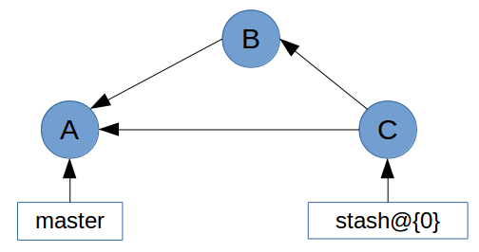
In this history graph, the tree of commit C contains the changes to the working tree. Commit C’s first parent is the commit that HEAD pointed to when the stash was created (commit A). The second parent (commit B) contains the changes to the index. It is with these two commits that Git is able to re-apply your stashed changes.

git-describe
Git’s describe command is summed up pretty neatly in the documentation:
git-describe - Show the most recent tag that is reachable from a commit
This can be helpful for things like build and release scripts, as well as figuring out which version a change was introduced in.
git describe will take any reference or commit hash, and return the name of the most recent tag. If the tag points at the commit you gave it, git describe will return only the tag name. Otherwise, it will suffix the tag name with some information including the number of commits since the tag and an abbreviation of the commit hash.
$ git describe v1.2.15
v1.2.15
$ git describe 2db66f
v1.2.15-80-g2db66f5

If you want to ensure that only the tag name is returned, you can force Git to remove the suffix by passing --abbrev=0.
$ git describe --abbrev=0 2db66f
v1.2.15

git-rev-parse
git rev-parse is an ancillary plumbing command which takes a wide range of inputs and returns one or more commit hashes. The most common use case is figuring out which commit a tag or branch points to.
$ git rev-parse v1.2.15
2a46f5e2fbe83ccb47a1cd42b81f815f2f36ee9d
$ git rev-parse --short v1.2.15
2a46f5e

git-bisect
git bisect is an indispensable tool when you need to figure out which commit introduced a breaking change. The bisect command does a binary search through your commit history to help you find the breaking change as quickly as possible. To get started, simply run git bisect start, and tell Git that the commit you’re currently on is broken with git bisect bad. Then, you can give Git a commit that you know is working with git bisect good <commit>.
$ git bisect start
$ git bisect bad
$ git bisect good v1.2.15
Bisecting: 41 revisions left to test after this (roughly 5 steps)
[b87713687ecaa7a873eeb3b83952ebf95afdd853] docs(misc/index): add header; general links
Git will then checkout a commit and ask you to test whether it’s broken or not. If the commit is broken, run git bisect bad. If the commit is fine, run git bisect good. After doing this a few times, Git will be able to pinpoint the commit which first introduced the breaking change.
$ git bisect bad
e145a8df72f309d5fb80eaa6469a6148b532c821 is the first bad commit
Once the bisect is finished (or when you want to abort it), be sure to run git bisect reset to reset HEAD to where it was before the bisect

