New Stuff:

Colon syntax

$ git show :/fix
# shows the last commit which has the word "fix" in its message

$ git show :/^Merge
# shows the last merge commit

Short Status

$ git status -s –b

Word Diffing
$ git diff --word-diff

$ git add –p

git gui

Describing commits:
$ git describe HEAD

Git under the hood

Inspecting Git Objects

$ git cat-file -p HEAD

The trees
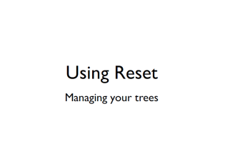
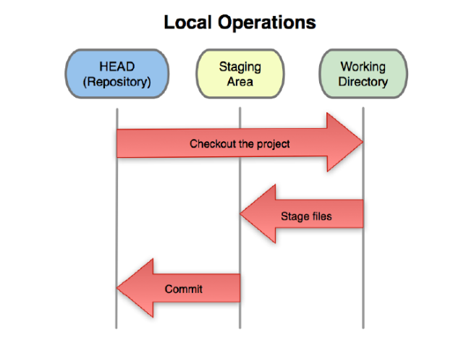
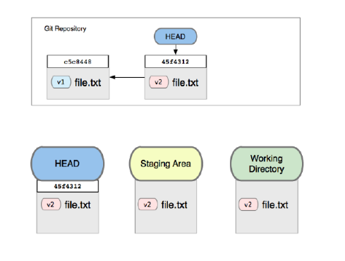
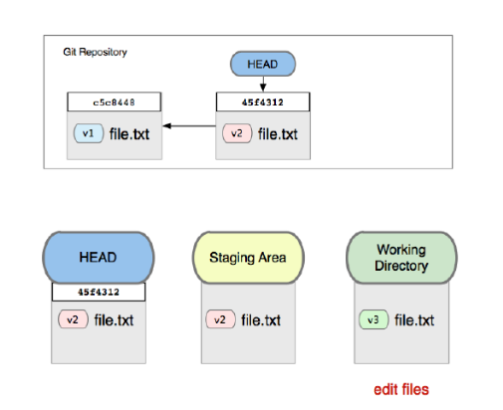
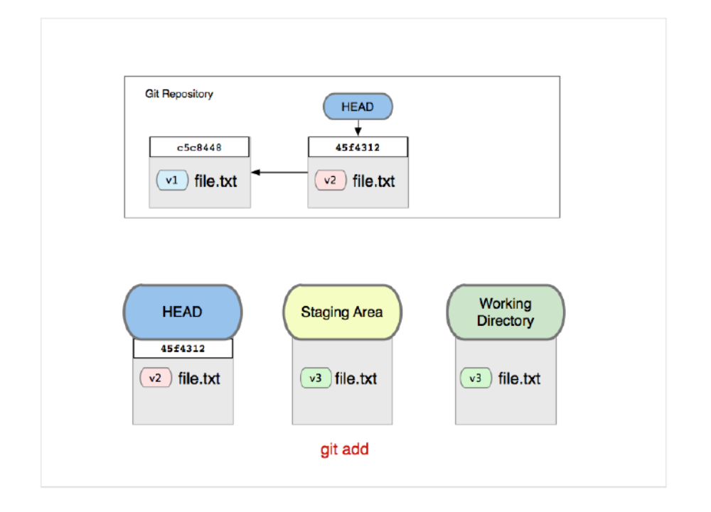
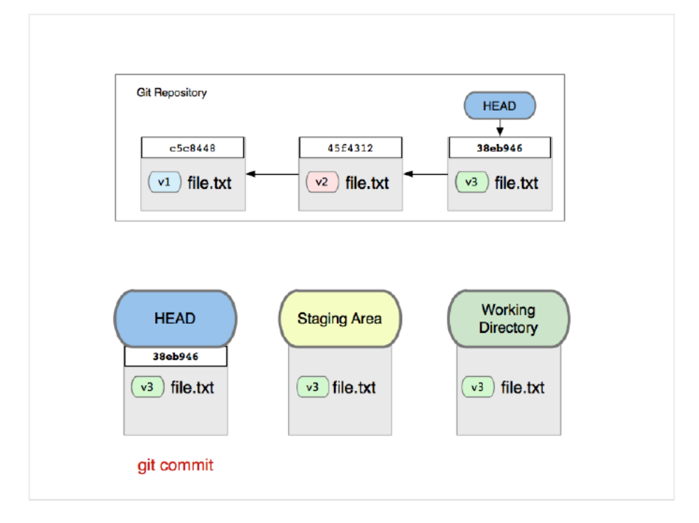
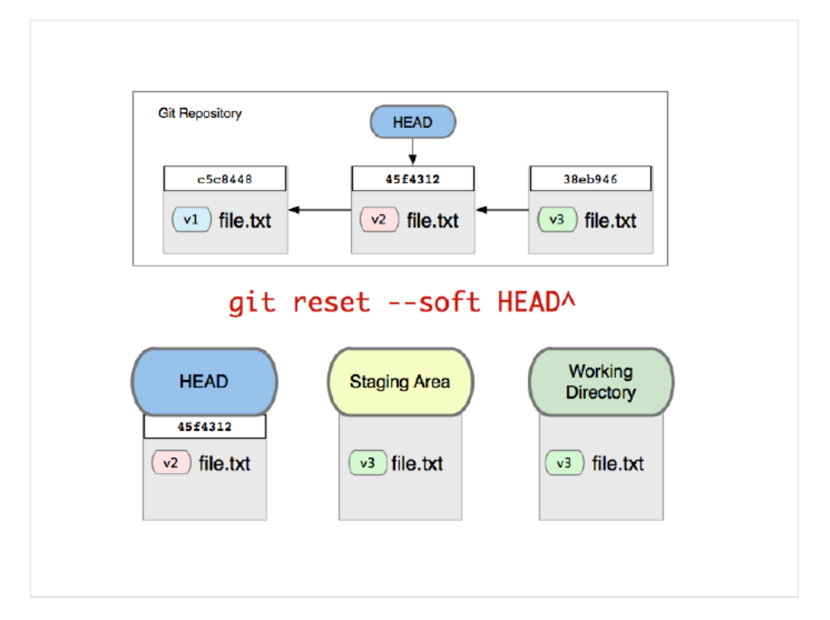
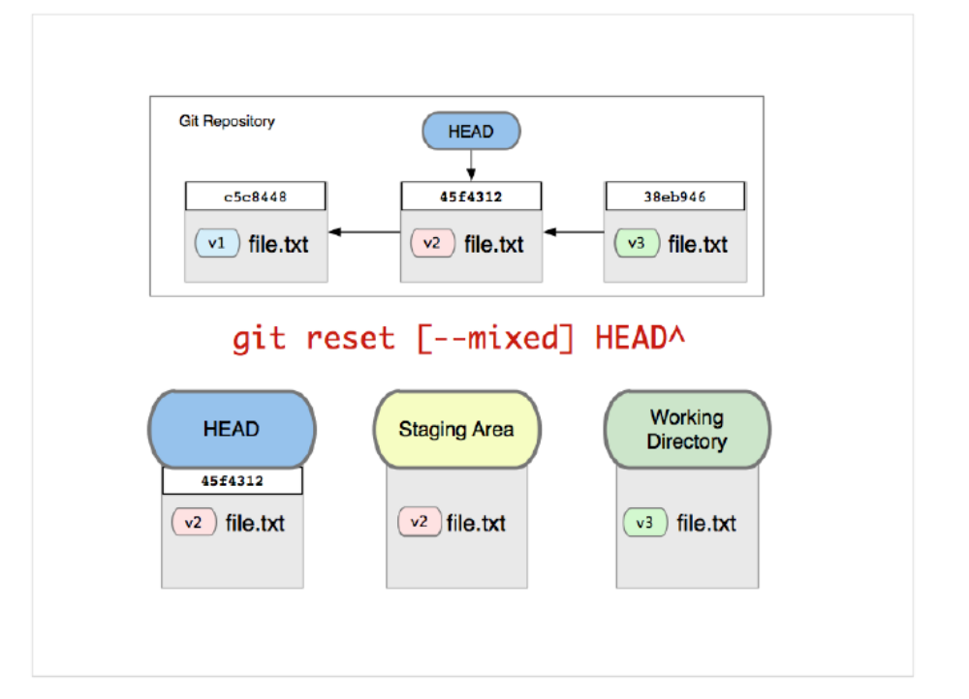
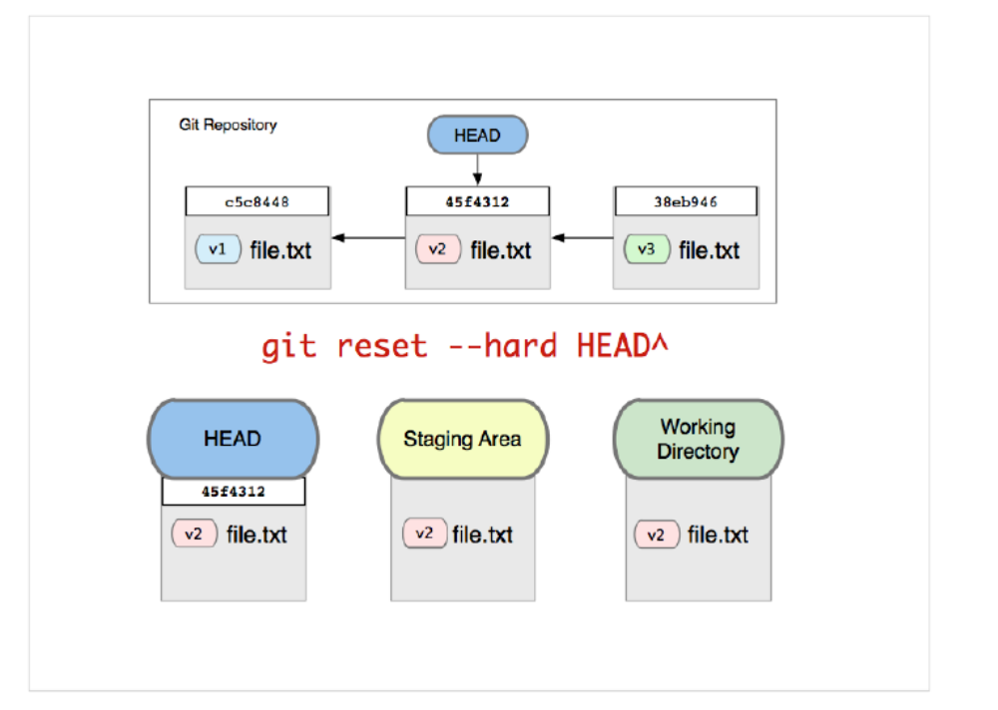

git reset [--mixed] HEAD – file

Undo last commit
$ git reset [--mixed] HEAD~
moves HEAD back and moves index back

Squash the last 2 commits into a new one
$ git reset --soft HEAD~2
$ git commit
moves HEAD back, keeps index

Tutorial

Edit two files, stage one
Run git reset HEAD to undo the stage
Re-stage the file and commit

Run git reset --soft HEAD~ to undo the commit but keep the staged files
Commit again

Run git reset HEAD~ to undo the commit and all staging;
Commit again

Run git reset --hard HEAD~ to lose the commit and all that work

Stashing and Cleaning

Saving work in progress
$ git status –s
$ git stash
$ git status
$ git stash apply

git stash --keep-index
$ git status -s
MM kidgloves.rb
$ git stash --keep-index
$ git status -s
M kidgloves.rb
$ git stash apply

$ git stash save 'my really good stash'
$ git stash list
$ git stash show --stat stash@{0}
$ git stash drop stash@{1}

Cleaning
git clean –fdx
-f: Actually run the thing
-d: do directories too
-x: ignore the ignores

