bgen/static void NumQuery()
{
var numbers = new int[] { 1, 4, 9, 16, 25, 36 };

var evenNumbers = from p in numbers
where (p % 2) == 0
select p;
}

https://www.alexkras.com/category/git/
http://marklodato.github.io/visual-git-guide/index-en.html
https://github.com/MarkLodato/visual-git-guide
https://www.atlassian.com/git/tutorials/resetting-checking-out-and-reverting

https://davidwalsh.name/tutorials/git

Introduction
It is an introduction to Git that is currently the most widely used version control system in the world, mostly thanks to GitHub. It’s also the most misunderstood version control system in the world.

Everybody understands adding, committing, pushing and pulling; but this is about as far as Git’s simplicity goes. Past this point, Git is shrouded by fear, uncertainty and doubt. Once you start talking about branching, merging, rebasing, multiple remotes, remote-tracking branches, detached HEAD states… Git becomes less of an easily-understood tool and more of a feared deity.

Complex systems like Git become much easier to understand once you figure out how they really work. The goal of this guide is to shed some light on how Git works under the hood.

Git is an open source distributed version control system created in 2005 to manage the entire Linux kernel. Instead storing file information in a central repository, Git gives every developer a full copy of the repository

A Brief History of Revision Control

A version control system is a software designed to keep track of the changes made to files over time.

There are a number of benefits to using VCS including the following:

The ability to undo changes. You can recover an earlier version of you work

A complete history of all the changes

Documentation of why changes are made. Often it is hard to remember why a change was made

Multiple streams of history.

Working on a team , VCS provides a number of additional benefits

The ability to resolve conflicts

Independent streams of history.

More specifically, Git is a distributed version control system which means that everyone working with a project, not just the current state of the files.

Github is platform where you can upload a copy of your Git repository. But more than than a centralized location to share your repository, it allows you to collaborate much more easily with other people on your projects. It does that by providing a web interface to manage it

Files and Folders
The simplest form of version control.
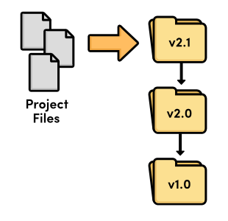
Revision control with files and folders

Local VCS

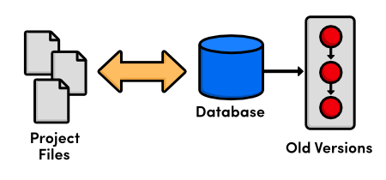
Local version control

At this point, versioning only took place on the developer’s local computer—there was no way to efficiently share code between several programmers

Centralized VCS
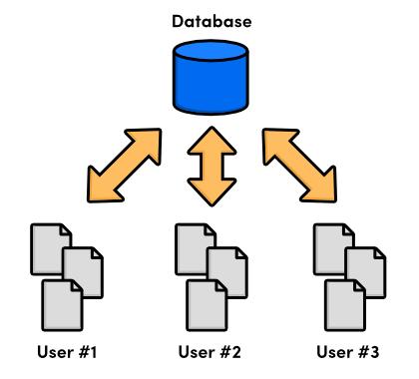
Centralized version control

Distributed VCS
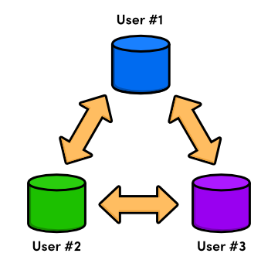
Distributed version control

- There was no longer a central repository, everyone could develop at their own pace, store the updates locally, and put off merging conflicts until their convenience.
- The local nature of DVCSs also made development much faster, since you no longer had to perform actions over a network. And, since each user had a complete copy of the project, the risk of a server crash, a corrupted repository, or any other type of data loss was much lower than that of their CVCS predecessors.

The Birth of Git
As a source code manager for the entire Linux kernel, Git had several unique constraints, including:
- Reliability
- Efficient management of large projects
- Support for distributed development
- Support for non-linear development

Installation
For Windows users, Git installation will install a special command shell called Git Bash. To test your installation, open a new command prompt and run

$ git --version.

The Basics

Initialize the Git Repository

$ mkdir myrepo
$ cd myrepo
$ git init

Git is designed to be as unobtrusive as possible. Notice that there is now a .git directory in myrepo that stores all the tracking data for our repository. The .git folder is the only difference between a Git repository and an ordinary folder, so deleting it will turn your project back into an unversioned collection of files

git init can be run without any arguments to create the local Git repository in the current directory. Under the myrepo repository directory, a .git is created with various files and directories in the current directory.

$ find .git

.git/config //Contains the configuration of the local repository
.git/HEAD //Head pointer
.git/hooks
...
.git/objects // Object storage
.git/objects/info
.git/objects/pack
.git/refs
.git/refs/heads //Contains the branch pointers
.git/refs/tags //Contains the tag pointers

Configure Git
Git comes with a long list of configurations options from your name to your favorite merge tool. You can set options with the git config or by manually editing a file called .gitconfig in your home directory.

The first thing you do with any Git installation is set you name an email.

$ git config --global user.name "Your Name"
$ git config --global user.email your.email@example.com

Once you’ve installed Git, the first thing you need to do is to tell Git your name and email (particularly before creating any commits). Rather than usernames, Git uses a name and an email address to identify the author of a commit.

We can do this with the git config command:

$ git config --global user.name "Your Name"
$ git config --global user.email your.email@example.com

The --global option tells Git to use this configuration as a default for all of your repositories. Omitting it lets you specify different user information for individual repositories, which will come in handy later on.

First off, Mary needs to configure her repository so that we know who contributed what to the project.
git config user.name "Mary"
git config user.email mary.example@rypress.com
You may recall from the first module that we used a --global flag to set the configuration for the entire Git installation. But since Mary’s repository is on the local filesystem, she needs a local configuration.
Use a text editor to open up the file called config in the .git folder of Mary’s project (you may need to enable hidden files to see .git). This is where local configurations are stored, and we see Mary’s information at the bottom of the file. Note that this overrides the global configuration that we set in The Basics.

Git’s command line relies on a text editor for most of its input. You can forece Git to use your editor of choice with the core.editor option

$ git config --global core.editor notepad

Git supports aliasing commands

$ git config --global alias.st status

The fundamental Git workflow
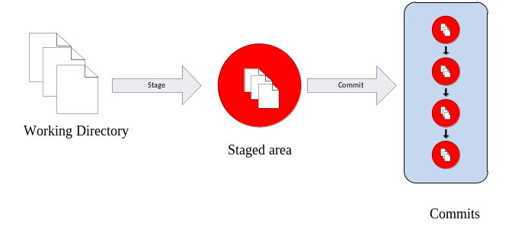
The stage/commit process

The distinction between the working directory, the staged snapshot, and committed snapshots is at the core of Git version control. Nearly all other Git commands manipulate one of these components in some way, so understanding the interplay between them is a fantastic foundation for mastering Git.

Most Git commands operate on one of the three main components of a Git repository: the working directory, the staged snapshot, or the committed snapshots.

The working directory is where the developer edit files and compile code.
The staging area is an intermediary between the working directory and the local repository

A Git repository is the local collection of all the files related to a particular Git version control system and contains a .git subdirectory in its root. Git keeps track of the state of the files in the repository’s directory on disk.

Git repositories store all their data on your local machine. Making commits, viewing history, and requesting differences between commits are all local operations that don’t require a network connection. This makes all these operations much faster in Git than with centralized version control systems such as Subversion.

Under the new Git repository directory, a .git subdirectory is created with various files and directories under it.

View the Repository Status
It would be helpful to view the status of the new repository.

$ git status
$ git status -s

It outputs the state of the working directory and staging aea

It’s a good practice to run git status to see exactly what you’re committing before running git commit

Stage a Snapshot

$ echo “abcd” > file1.txt
$ git add file1.txt
$ git status

git add command tells Git to start tracking file1.txt. Git add file1.txt to the snapshot for the next commit. A snapshot represents the state of your project at a given point in time. Git’s term for creating a snapshot is called staging. We can add or remove multiple files before actually committing it to the project history.

Git’s staging area gives you a plcae to organize a commit before adding it to the project history. Staging is the process of moving changes from the working directory to the staged snapshot. It gives you the opportunity to pick and choose related changes from the working directory, instead of committing everything all at once

To delete a file from project, you need to add it to the staging area like a new or modified file.The next command will stage the deletion and stop tracking the file but it won’t delete the file from he working directory

$ git rm --cached file1.txt

If you need more detailed information about the changes in your working directory or staging area, you can generate a diff

$ git diff

This outputs a diff of every unstaged changes in your working directory. You can also generate a diff of all staged changes with the --cached flag

$ git diff --cached

Commit the Snapshot
Commits represent every saved version of a project which makes them the atomic unit of Git based version control.

The next command will open a text editor and prompt you to enter a message for the commit.

$ git commit

The -m option lets you specify a commit message on the command line instead of opening a text editor. This is just a convenient shortcut.

$ git commit -m "Add navigation links"

The --message flag for git commit can be abbreviated to -m (all abbreviations use a single -). If this flag is omitted, Git opens a text editor (specified by the EDITOR or GIT_EDITOR environment variable) to prompt you for the commit message

It can also take the --all (or -a) flag to add all changes to files tracked in the repository into a new commit

Saving a version of your project is a two step process:
- Staging. Telling Git what files to include in the next commit.
- Committing. Recording the staged snapshot with a descriptive message.

Staging files with the git add command doesn’t actually affect the repository in any significant way—it just lets us get our files in order for the next commit. Only after executing git commit will our snapshot be recorded in the repository. Committed snapshots can be seen as “safe” versions of the project.

Our history can now be represented as the following. Note that the red circle, which represents the current commit, automatically moves forward every time we commit a new snapshot.
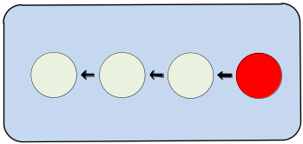
Current project history
Notice that we skipped the staging step this time around. Instead of using git add, we passed the -a flag to git commit. This convenient parameter tells Git to automatically include all tracked files in the staged snapshot. Combined with the -m flag, we can stage and commit snapshots with a single command

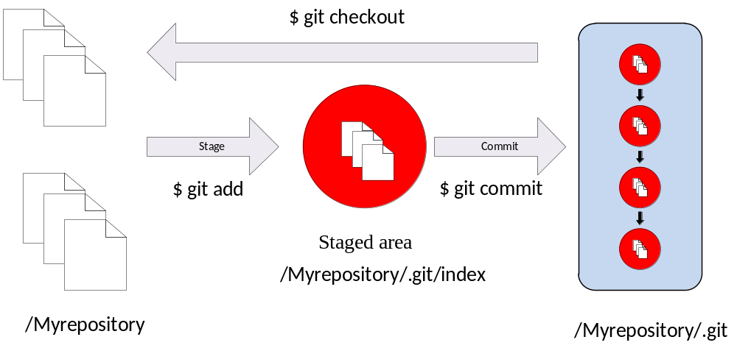

Rather than require all changes in the working tree to build up new commits, git allows files to be added incrementally to the index.

View the Repository History
The git status command will only show us staged changes. To view our project history (committed changes), we need a new command git log

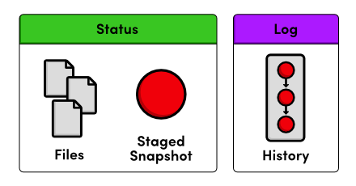
Status output vs. Log output

The git log command comes with a lot of formatting options. For now, we’ll just use the convenient --oneline flag. Git outputs only the first 7 characters of the checksum. These first few characters effectively serve as a unique ID for each commit

$ git log --oneline

Condensing output to a single line is a great way to get a high-level overview of a repository. Another useful configuration is to pass a filename to git log:

$ git log --oneline file1.txt

This displays only the file1.txt history.

If your log history takes up more than one screen, you can scroll down by pressing Space and return to the command line by pressing the letter q.

We can use the same log-filtering syntax from the previous module to view Mary’s changes.
git log master..mary/master --stat

git log can take a --patch (or -p) flag to show the diff for each commit output. It can also take --stat or --word-diff flag to show a diffstat or word diff.

This also gives a natural grouping of commands:
- Stage/Working directory: git add, git rm, git status
- Committed History: git commit, git log

View an Old Revision
Using the new git checkout command, we can view the contents of a previous snapshot.

$ git checkout 54650a3

This will output a lot of information about a detached HEAD state.

We can use the same git checkout command to return to the master branch.

$ git checkout master

This makes Git update our working directory to reflect the state of the master branch’s snapshot.

Tag a Release
Tags are convenient references to official releases and other significant milestones in a software project. It lets developers easily browse and check out important revisions. For example, we can now use the v1.0 tag to refer to an commit instead of its random ID.

In the above snippet, the -a flag tells Git to create an annotated tag, which lets us record our name, the date, and a descriptive message (specified via the -m flag).

$ git tag -a v1.0 -m "Stable version of the website"

To view a list of existing tags, execute git tag without any arguments.

Viewing the differences between commit
git diff can take path arguments after a -- to request only the differences between particular paths:

$ git diff master~1 master -- file1.tx
Show only the differences to the file1.txt file between the previous and latest commits

git diff without an argument displays the difference between the current working directory and the index staging area
git diff master displays the difference between the current working directory and the last commit on the default master branch

Diffs are shown by default in, git in a format known as a unified format diff. two common alternatives to a atypical unified format diff are
- diffstat (--stat)
- word diff (--word-diff)

Undo Committed Changes (Undoing changes)

In git undoing can take on many different meanings
- Undo changes in the working directory
- Undo changes in the staging area
- Undo an entire commit

To complicate things even further, there are multiple ways to undo a commit. You can either
- Simply delete the commit from the project history
- Leave the commit as is, using a new commit to undo the changes introduced by the first commit

Undoing in the working directory
$ git reset --hard HEAD
$ git clean -f
Git reset makes the working directory and the stage match the files in the most recent commit (also called HEAD). To get rid of untracked files, you have to use the git clean command.

Undoing Individual files

The following command will make a single file in the working directory match the version in the most recent commit

$ git checkout HEAD file1.txt

Undoing in the staging area

Omitting the –hard flag tells Git to leave the working directory alone. The staged version of the file matches HEAD

$ git reset HEAD file1.txt

Undoing the commits

There are two ways to undo a commit using Git. You can either reset it by simply removing it from the project history or you can revert it by generating a new commit that gets rid of the changes introduced in the original

$ git reset HEAD~1

The last commit is removed from the history.

To remedy the problems introduced by resetting public commits, there is new away to undo commits: revert. Instead of altering existing commits, reverting adds a new commit that undoes the problem commit

This is the ideal way of undoing changes that have been committed to a public repository

Amending
You can also amend the most recent commit by staging changes as usual then running:
$ git commit –amend

This replaces the previous commit instead creating a new one, which is very useful if you forgot to add files. You must be careful when using the –amend flag, since it rewrites history much like git reset

We’re ready to restore our stable tag by removing the most recent commit.

Undo the specified commit by applying a new commit

$ git revert 514fbe7

This will prompt you for a commit message with a default of Revert "Add a crazzzy experiment".... You can leave the default message and close the file.

Take a look at your history with git log --oneline.
506bb9b Revert "Add a crazzzy experiment"
514fbe7 Add a crazzzy experiment
1c310d2 Add navigation links
54650a3 Create blue and orange pages
b650e4b Create index page

Notice that instead of deleting the “crazzzy experiment” commit, Git figures out how to undo the changes it contains, then tacks on another commit with the resulting content. So, our fifth commit and our third commit represent the exact same snapshot, as shown below. Again, Git is designed to never lose history: the fourth snapshot is still accessible, just in case we want to continue developing it.

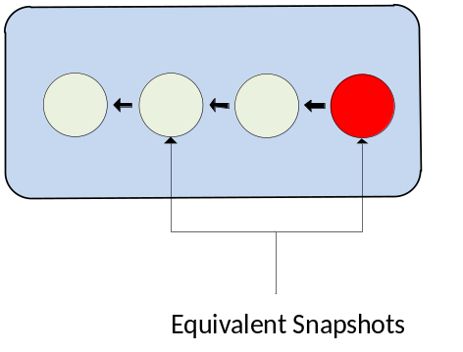
Current project history

When using git revert, remember to specify the commit that you want to undo—not the stable commit that you want to return to. It helps to think of this command as saying “undo this commit” rather than “restore this version.”

Undo Uncommitted Changes
$ git reset --hard

This changes all tracked files to match the most recent commit. Note that the --hard flag is what actually updates the file. Running git reset without any flags will simply unstage tracked files, leaving its contents as is. In either case, git reset only operates on the working directory and the staging area, so our git log history remains unchanged.

To remove all untracked files, run the following command

$ git clean -f

Commands git reset and git clean operates on the working directory, not on the committed snapshots. Unlike git revert, they permanently undo changes, so make sure you really want to trash what you’re working on before you use them.

The git reset command undoes changes to the working directory and the staged snapshot, while git revert undoes changes contained in committed snapshots. git status and git log directly parallel this behavior.

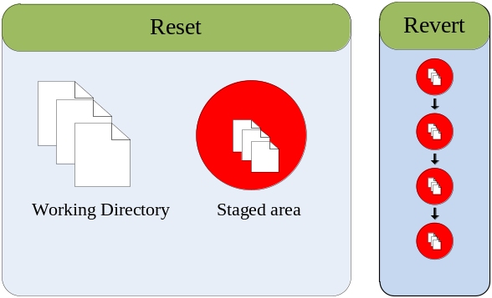
Resetting vs. Reverting
I mentioned that instead of completely removing a commit, git revert saves the commit in case you want to come back to it later. This is only one reason for preserving committed snapshots.


With remote repositories, Altering the history by removing a commit has dramatic consequences for collaborating with other developers.

Branches
Branches are the final component of Git version control. In Git, a branch is an independent line of development. They offer an elegant option for optimizing your development workflow.

Let’s start our exploration by listing the existing branches for our project.

$ git branch

The master branch is Git’s default branch, and the asterisk next to it tells us that it’s currently checked out.

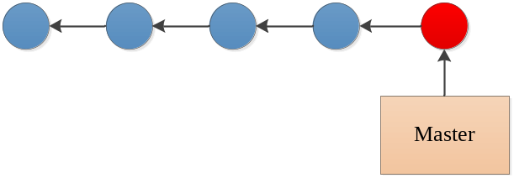

The master branch

Only one branch can be checked out at a time.

git checkout HEAD~1

This command returns a message that says we’re in a detached HEAD state. The HEAD is Git’s internal way of indicating the snapshot that is currently checked out. This means the red circle in each of our history diagrams actually represents Git’s HEAD. The following figure shows the state of our repository before and after we checked out an old commit.

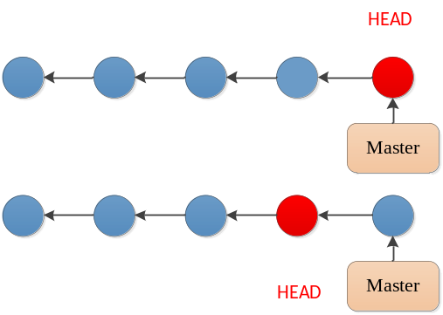
Checking out the 4th commit
As shown in the “before” diagram, the HEAD normally resides on the tip of a development branch. But when we checked out the previous commit, the HEAD moved to the middle of the branch. We can no longer say we’re on the master branch since it contains more recent snapshots than the HEAD. This is reflected in the git branch output, which tells us that we’re currently on (no branch).

Create a New Branch
We can’t add new commits when we’re not on a branch, so let’s create one now. This will take our current working directory and fork it into a new branch.

$ git branch test

Note that git branch is a versatile command that can be used to either list branches or create them. However, the above command only creates the test branch—it doesn’t check it out.

$ git checkout test

The test branch is a completely isolated development environment that can be visualized as the following.

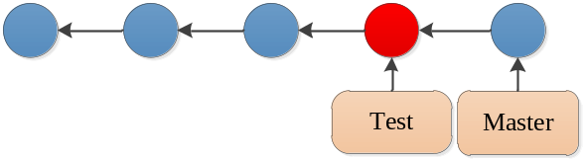
Creating a new branch

Notice that we created a new branch and checked it out in a single step by passing the -b flag to the git checkout command.

$ git checkout -b test

Right now, the test branch, HEAD, and working directory are the exact same as the fourth commit. After committing on the test branch, we can see two independent lines of development in our project:

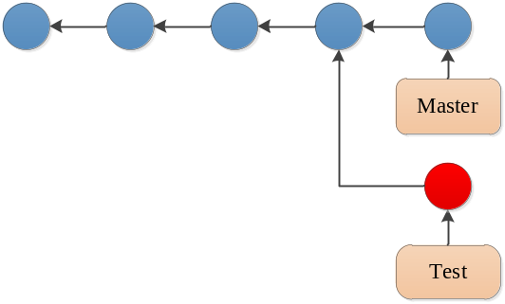
Forked project history
The HEAD (designated by the red circle) automatically moved forward to the new commit, which is intuitively what we would expect when developing a project.
When git branch creates a branch, it uses the current HEAD as the starting point for the new branch. After creating the new branch, our repository’s history looks like:

Rename the Rainbow
Let’s add one more snapshot to the crazy branch. Rename crazy.html to rainbow.html, then use the following Git commands to update the repository.
git status
git rm crazy.html
git status
git add rainbow.html
git status
The git rm command tells Git to stop tracking crazy.html (and delete it if necessary), and git add starts tracking rainbow.html. The renamed: crazy.html -> rainbow.html message in the final status output shows us that Git is smart enough to figure out when we’re renaming a file.
Our snapshot is staged and ready to be committed:
git commit -m "Rename crazy.html to rainbow.html"
git log --oneline
After this addition, our complete repository history looks like the following. Remember that the crazy branch doesn’t include any commits in master after the fork.
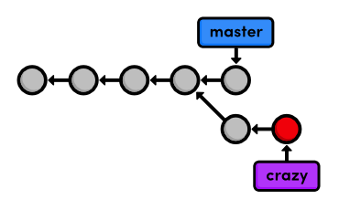
Current project history
These two branches became completely independent development environments after they forked. You can think of them as separate project folders that you switch between with git checkout. They do, however, share their first four commits.

MERGE
Let’s create and check out a new branch called test which happens to coincide with the master branch and commit some changes. This results in a repository history that looks like:

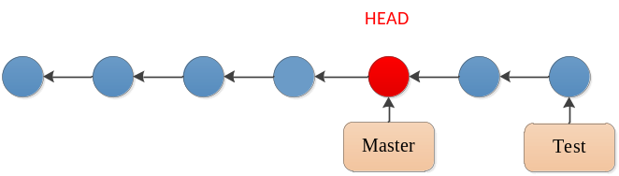
Current project history

The test branch let us create and test our code without threatening the stability of the master branch. To merge these changes into the master branch. Use the git merge command to take the snapshots from the test branch and add them to the master branch.

$ git checkout master
$ git merge test

This command always merges into the current branch: test remains unchanged. Check the history to make sure that the test history has been added to master. The following diagram visualizes the merge.

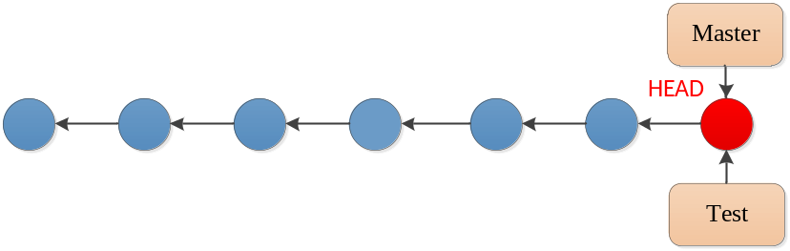
Merging the test branch into master

Instead of re-creating the commits in test and adding them to the history of master, Git reuses the existing snapshots and simply moves the tip of master to match the tip of test. This kind of merge is called a fast-forward merge, since Git is “fast-forwarding” through the new commits in the test branch.

After the merge, both branches have the exact same history, which makes them redundant. Unless we wanted to keep developing on the test branch, we’re free to get rid of it. We can safely delete a branch by passing the -d flag to git branch.

$ git branch -d test

Deleting branches is a relatively “safe” operation in the sense that Git will warn you if you’re deleting an unmerged branch.

Merge the CSS Updates
Some merges cannot be “fast-forwarded.” When the history of two branches diverges, a dedicated commit is required to combine the branches. This situation may also give rise to a merge conflict, which must be manually resolved before anything can be committed to the repository.

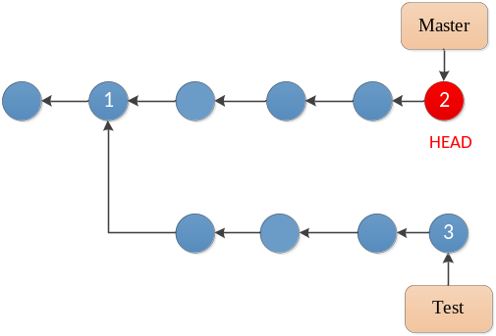
Before merge

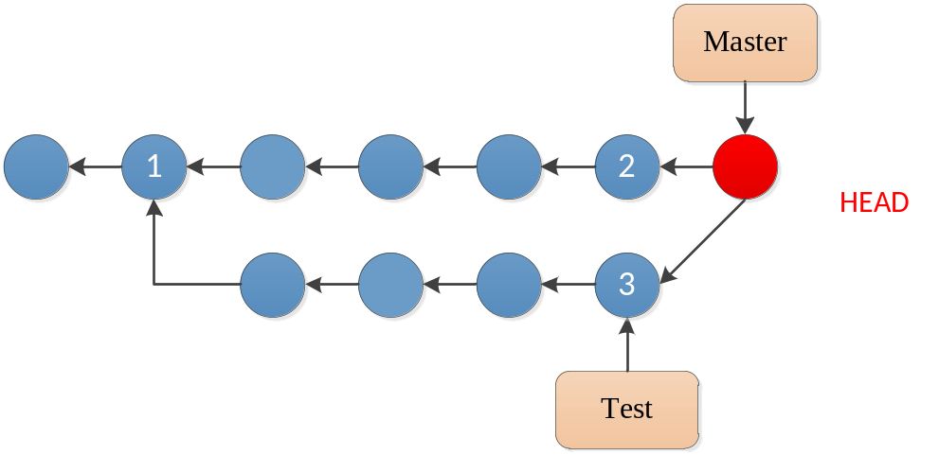
Merging test into the master branch
We’re left with a new way to combine branches: the 3-way merge. A 3-way merge occurs when you try to merge two branches whose history has diverged. It creates an extra merge commit to function as a link between the two branches. As a result, it has two parent commits. The name comes from the internal method used to create the merge commit. Git looks at three commits (numbered in the above figure) to generate the final state of the merge.
merge conflict

Conflicts occur when we try to merge branches that have edited the same content. Git doesn’t know how to combine the two changes, so it stops to ask us what to do. We can see exactly what went wrong with the familiar git status command:

# On branch master
# Changes to be committed:
#
# new file: file1.txt
#
# Unmerged paths:
# (use "git add/rm <file>..." as appropriate to mark resolution)
#
# both modified: file2.txt
#

We’re looking at the staged snapshot of a merge commit. Git stopped to let us modify files and resolve the conflict before committing the snapshot. The “Unmerged paths” section contains files that have a conflict.

Open up file2.txt and find the section that looks like:

<<<<<<< HEAD

=======

>>>>>>> test

Git went ahead and modified the conflicted file to show us exactly which lines are afflicted. The format of the above text shows us the difference between the two versions of the file. The section labeled <<<<<<< HEAD shows us the version in the current branch, while the part after the ======= shows the version in the test branch. The <<<<<<<, =======, and >>>>>>> markers are only used to show us the conflict and should be deleted.

Next, we need to tell Git that we’re done resolving the conflict.That’s right, all you have to do is add index.html to the staged snapshot to mark it as resolved. Finally, complete the 3-way merge:

$ git add file2.txt
$ git status
git commit

We didn’t use the -m flag to specify a message because Git already gives us a default message for merge commits. It also gives us a “Conflicts” list, which can be particularly handy when trying to figure out where something went wrong in a project. Save and close the file to create the merge commit.

The git branch -d command won’t let you delete a branch that contains unmerged changes. But, we really do want to scrap the alternative experiment, so we’ll follow the error message’s instructions for overriding this behavior:

git branch -D crazy-alt

Because we never merged crazy-alt into master, it is lost forever.

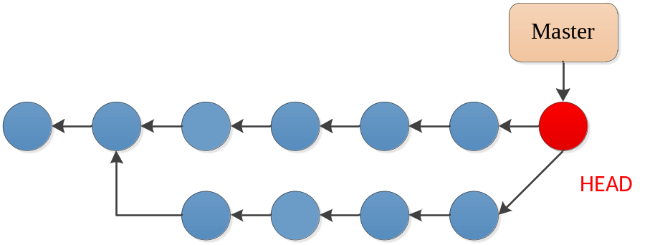

Stage all tracked files and commit the snapshot using the specified message

The test branch hasn’t been altered since we created news-hotfix.

Rebasing

Rebasing lets us move branches around by changing the commit that they are based on. Conceptually, this is what it allows us to do:

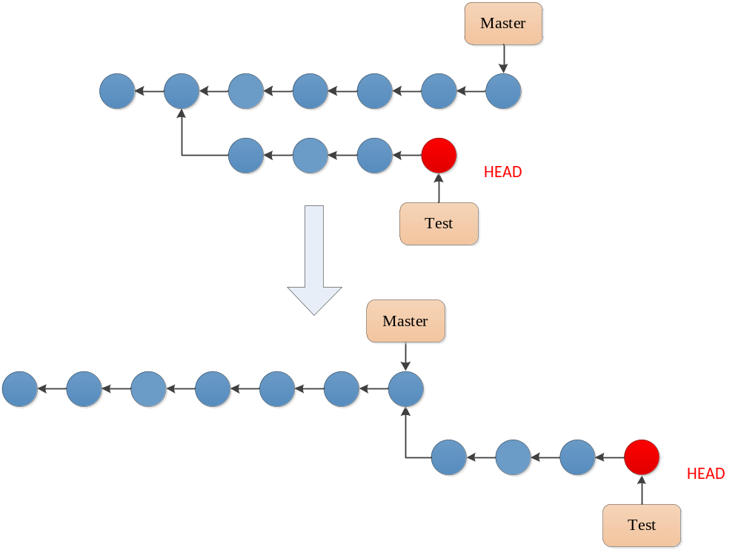
Rebasing “test” branch onto master

After rebasing, the test branch has a new parent commit, which is the same commit pointed to by master. Instead of joining the branches with a merge commit, rebasing integrates the feature branch by building on top of master. The result is a perfectly linear history

Like the git merge command, git rebase requires you to be on the branch that you want to move. After the rebase, about is a linear extension of the master branch, enabling us to do a fast-forward merge later on. Rebasing also allowed us to integrate the most up-to-date version of master without a merge commit.

git rebase not only lets you move branches around, it enables you to manipulate individual commits as you do so. By rebasing interactively, we can choose how each commit is transferred to the new base. Specify an interactive rebase by passing the -i flag to the rebase command:

$ git rebase -i master

This should open up a text editor populated with all of the commits introduced in the about branch, listed from oldest to newest. The listing defines exactly how Git will transfer the commits to the new base. Leaving it as is will do a normal git rebase, but if we move the lines around, we can change the order in which commits are applied. In addition, we can replace the pick command before each line to edit it or combine it with other commits. All of the available commands are shown in the comment section of the rebase listing, but right now, we only need the squash command.
Then, begin the rebase by saving and closing the editor. The following list describes the rebasing process in-depth and tells you what you need to change along the way.
Interactive rebasing gives you complete control over your project history,
The previous rebase only stopped us to edit the messages of each commit. We can take this one step further and alter a snapshot during the rebase. Start by running another interactive rebasing session. Note that we’ve still been using master as the new base because it selects the desired commits from the about branch.
git rebase -i master
Specify the edit command for the second commit, as shown below.
pick 58dec2a Create the about page
edit 6ac8a9f Begin creating bio pages
pick 51c958c Add link to about section in home page
When Git starts to move the second commit to the new base, it will stop to do some “amending.” This gives you the opportunity to alter the staged snapshot before committing it.
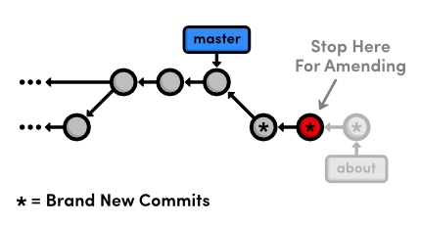
Stopping to amend a commit
We’re currently between commits in a rebase, but we can alter the staged snapshot in the exact same way as we have been throughout this entire tutorial:
git add about/mary.html
git status
git commit --amend
You can use the default message created by git commit. The new --amend flag tells Git to replace the existing commit with the staged snapshot instead of creating a new one. This is also very useful for fixing premature commits that often occur during normal development.
Remember that we’re in the middle of a rebase, and Git still has one more commit that it needs to re-apply. Tell Git that we’re ready to move on with the --continue flag:
git rebase --continue
git log –oneline

If you ever find yourself lost in the middle of a rebase and you’re afraid to continue, you can use the --abort flag to abandon it and start over from scratch.
The point of all this interactive rebasing is to generate a meaningful history that we can merge back into master. And, since we’ve rebased about onto the tip of master, Git will be able to perform a fast-forward merge instead of using a merge commit to join the two branches.

Rebasing enables fast-forward merges by moving a branch to the tip of another branch. It effectively eliminates the need for merge commits, resulting in a completely linear history. To an outside observer, it will seem as though you created every part of your project in a neatly planned sequence, even though you may have explored various alternatives or developed unrelated features in parallel. Rebasing gives you the power to choose exactly what gets stored in your repositories.

As a related note, you can use the following command to force a merge commit when Git would normally do a fast-forward merge.
git merge --no-ff <branch-name>

git commit --amend
Add staged changes to the most recent commit instead of creating a new one.
git rebase --continue
Continue a rebase after amending a commit.
git rebase --abort
Abandon the current interactive rebase and return the repository to its former state.
git merge --no-ff <branch-name>
Force a merge commit even if Git could do a fast-forward merge.

Create the Red Page
To achieve this, we can use the same interactive rebasing method covered in the previous module, only this time we’ll actually create commits in the middle of the rebasing procedure.
git rebase -i master
Change the rebase listing to the following, then save the file and exit the editor to begin the rebase.
edit db96c72 Add new HTML pages
pick 4c3027c Add green page

Undo the Generic Commit
First, let’s take a look at where we are with git log --oneline:
db96c72 Add new HTML pages
7070b0e Add link to about section in home page
...
When Git encountered the edit command in the rebase configuration, it stopped to let us edit the commit. As a result, the green page commit doesn’t appear in our history yet. This should be familiar from the previous module. But instead of amending the current commit, we’re going to completely remove it:
git reset --mixed HEAD~1
git log --oneline
git status
The git reset command moves the checked out snapshot to a new commit, and the HEAD~1 parameter tells it to reset to the commit that occurs immediately before the current HEAD (likewise, HEAD~2 would refer to second commit before HEAD). In this particular case, HEAD~1 happens to coincide with master. The effect on our repository can be visualized as:
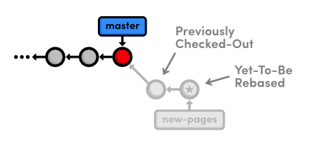Resetting to HEAD~1
You may recall from Undoing Changes that we used git reset --hard to undo uncommitted changes to our project. The --hard flag told Git to make the working directory look exactly like the most recent commit, giving us the intended effect of removing uncommitted changes.
But, this time we used the --mixed flag to preserve the working directory, which contains the changes we want to separate. That is to say, the HEAD moved, but the working directory remained unchanged. Of course, this results in a repository with uncommitted modifications. We now have the opportunity to add the red.html and yellow.html files to distinct commits.

Split the Generic Commit
Let’s start with the red page. Since we only want to commit content that involves the red page, we’ll have to manually go in and remove the yellow page’s link from the “Navigation” section. In index.html, change this section to match the following:
<h2>Navigation</h2>
<ul>
<li>
<a href="about/index.html">About Us</a>
</li>
<li style="color: #F90">
<a href="orange.html">The Orange Page</a>
</li>
<li style="color: #00F">
<a href="blue.html">The Blue Page</a>
</li>
<li>
<a href="rainbow.html">The Rainbow Page</a>
</li>
<li style="color: #C00">
<a href="red.html">The Red Page</a>
</li>
</ul>
Now, we can group the red page’s updates into an independent commit.
git add red.html index.html
git status
git commit -m "Add red page"
Next up is the yellow page. Go ahead and add it back to the “Navigation” section in index.html:
<li style="color: #FF0">
<a href="yellow.html">The Yellow Page</a>
</li>
And again, stage and commit the snapshot.
git add yellow.html index.html
git status
git commit -m "Add yellow page"
We’ve successfully split up the contents of a single commit into two new snapshots, as shown below.
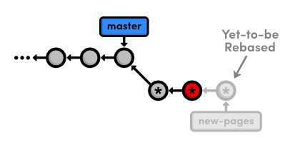Creating two new commits while rebasing
But, don’t forget that the rebase still needs to transfer the green page:
git rebase --continue
To summarize, we removed the “bad” commit from the current branch with git reset, keeping the contained HTML files intact with the --mixed flag. Then, we committed them in separate snapshots with the usual git add and git commit commands. The point to remember is that during a rebase you can add, delete, and edit commits to your heart’s content, and the entire result will be moved to the new base.

Remove the Last Commit
Next, we’re going to “accidentally” remove the green page commit so we can learn how to retrieve it via Git’s internal repository data.
git reset --hard HEAD~1
git status
git log --oneline
This moves the checked-out commit backward by one snapshot, along with the new-pages pointer. Note that git status tells us that we have nothing to commit, since the --hard flag obliterated any changes in the working directory. And of course, the git log output shows that the new-pages branch no longer contains the green commit.
This behavior is slightly different from the reset we used in the interactive rebase: this time the branch moved with the new HEAD. Since we were on (no branch) during the rebase, there was no branch tip to move. However, in general, git reset is used to move branch tips around and optionally alter the working directory via one of its many flags (e.g., --mixed or --hard).
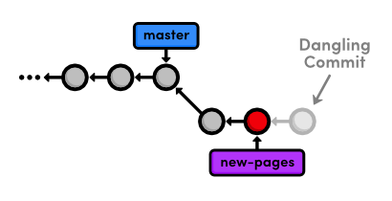Removing the most recent commit
The commit that we removed from the branch is now a dangling commit. Dangling commits are those that cannot be reached from any branch and are thus in danger of being lost forever.

Open the Reflog
Git uses something called the reflog to record every change you make to your repository. Let’s take a look at what it contains:
git reflog
The resulting output should look something like the following. Depending on your version of Git, the messages might be slightly different. You can press Space to scroll through the content or q to exit.
9b1a64f HEAD@{0}: reset: moving to HEAD~1
002185c HEAD@{1}: rebase -i (finish): returning to refs/heads/new-pages
002185c HEAD@{2}: rebase -i (pick): Add green page
9b1a64f HEAD@{3}: commit: Add yellow page
77a1cf1 HEAD@{4}: commit: Add red page
7070b0e HEAD@{5}: reset: moving to HEAD~1
...
The above listing reflects our last few actions. For example, the current HEAD, denoted by HEAD@{0}, resulted from reseting HEAD to HEAD~1. Four actions ago, the yellow page was applied during our rebase, as shown in HEAD@{3}.
The reflog is a chronological listing of our history, without regard for the repository’s branch structure. This lets us find dangling commits that would otherwise be lost from the project history.

Revive the Lost Commit
At the beginning of each reflog entry, you’ll find a commit ID representing the HEAD after that action. Check out the commit at HEAD@{2}, which should be where the rebase added the green page (change the ID below to the ID from your reflog).
git checkout 002185c
This puts us in a detached HEAD state, which means our HEAD is no longer on the tip of a branch. We’re actually in the opposite situation as we were in Undoing Changes when we checked out a commit before the branch tip. Now, we’re looking at a commit after the tip of the branch, but we still have a detached HEAD:
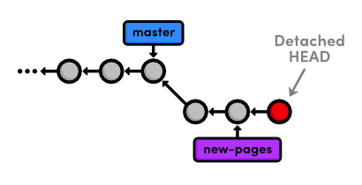Checking out a dangling commit
To turn our dangling commit into a full-fledged branch, all we have to do is create one:
git checkout -b green-page
We now have a branch that can be merged back into the project:
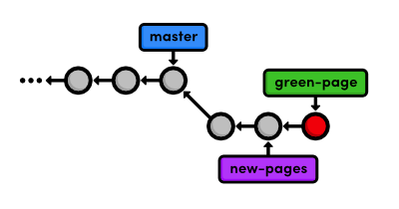Creating a branch from the dangling commit
The above diagram makes it easy to see that the green-page branch is an extension of new-pages, but how would we figure this out if we weren’t drawing out the state of our repository every step of the way?

Filter the Log History
To view the differences between branches, we can use Git’s log-filtering syntax.
git log new-pages..green-page
This will display all commits contained in green-page that aren’t in the new-pages branch. The above command tells us that green-page contains one more snapshot than new-pages: our dangling commit (although, it’s not really dangling anymore since we created a branch for it).
You can also use this syntax to limit the output of git log. For example, to display the last 4 commits on the current branch, you could use:
git log HEAD~4..HEAD
However, this is a bit verbose for such a common task, so Git developers added the -n flag as an easier way to limit output.
git log -n 4
The -n 4 parameter tells Git to show only the last four commits from the current HEAD, making it the equivalent of the HEAD~4..HEAD syntax shown above. Similarly, -n 3, -n 2, and -n 1 would display three, two, and one commit, respectively. This feature becomes very useful once a repository grows beyond one screenful of history.

Merge in the Revived Branch
We’ve revived our lost commit, and now we’re ready to merge everything back into the master branch. Before we do the merge, let’s see exactly what we’re merging:
git checkout master
git log HEAD..green-page --stat
The git log HEAD..green-page command shows us only those commits in green-page that aren’t in master (since master is the current branch, we can refer to it as HEAD). The new --stat flag includes information about which files have been changed in each commit. For example, the most recent commit tells us that 14 lines were added to the green.html file and 3 lines were added to index.html:
commit 002185c71e6674915eb75be2afb4ca52c2c7fd1b
Author: Ryan <ryan.example@rypress.com>
Date: Wed Jan 11 06:49:50 2012 -0600

Add green page

green.html | 14 ++++++++++++++
index.html | 3 +++
2 files changed, 17 insertions(+), 0 deletions(-)
If we didn’t already know what was in this new commit, the log output would tell us which files we needed to look at. But, we authored all of these changes, so we can skip right to the merge.
git merge green-page
The following diagram shows the state of our repository after the merge.
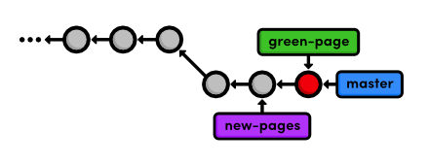Fast-forwarding master to the green-page branch
.
It’s important to realize that Git uses the tip of a branch to represent the entire branch. That is to say, a branch is actually a pointer to a single commit—not a container for a series of commits.

Quick Reference
git reflog
Display the local, chronological history of a repository.
git reset --mixed HEAD~<n>
Move the HEAD backward <n> commits, but don’t change the working directory.
git reset --hard HEAD~<n>
Move the HEAD backward <n> commits, and change the working directory to match.
git log <since>..<until>
Display the commits reachable from <until> but not from <since>. These parameters can be either commit ID’s or branch names.
git log --stat
Include extra information about altered files in the log output.

Remotes
Mary can list the connections she has to other repositories using the following command.

$ git remote

When you clone a repository by default, git automatically adds an origin remote pointing to the original repository. We can request a little bit more information with the -v (verbose) flag:

$ git remote -v

This shows the full path to our original repository, verifying that origin is a remote connection to my-git-repo. The same path is designated as a “fetch” and a “push” location. We’ll see what these mean in a moment.

So, let’s add Mary as a remote repository.

git remote add mary ../marys-repo
git remote -v

We can now use mary to refer to Mary’s repository, which is located at ../marys-repo. The git remote add command is used to bookmark another Git repository for easy access, and our connections can be seen in the figure below.
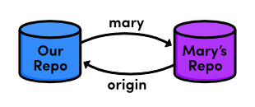
Connections to remote repositories
Now that our remote repositories are setup, we’ll spend the rest of the module discussing remote branches.

Fetch Mary’s Branches (You)
As noted earlier, we can use remote branches to access snapshots from another repository. Let’s take a look at our current remote branches with the -r flag:

$ git branch -r

Again, we don’t have any. To populate our remote branch listing, we need to fetch the branches from Mary’s repository:

$ git fetch mary
$ git branch -r

This will go to the “fetch” location shown in git remote -v and download all of the branches it finds there into our repository. The resulting branches are shown below.

mary/bio-page
mary/master

Remote branches are always listed in the form <remote-name>/<branch-name> so that they will never be mistaken for local branches. The above listing reflects the state of Mary’s repository at the time of the fetch, but they will not be automatically updated if Mary continues developing any of her branches.

That is to say, our remote branches are not direct links into Mary’s repository—they are read-only copies of her branches, stored in our own repository. This means that we would have to do another fetch to access new updates.
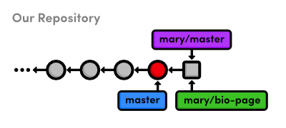
Mary’s remote branches in our repository
The above figure shows the state of our repository. We have access to Mary’s snapshots (represented as squares) and her branches, even though we don’t have a real-time connection to Mary’s repository.

Check Out a Remote Branch
Let’s check out a remote branch to review Mary’s changes.
git checkout mary/master
This puts us in a detached HEAD state, just like we were in when we checked out a dangling commit. This shouldn’t be that surprising, considering that our remote branches are copies of Mary’s branches. Checking out a remote branch takes our HEAD off the tip of a local branch, illustrated by the following diagram.
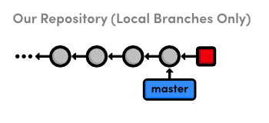Checking out Mary’s master branch
We can’t continue developing if we’re not on a local branch. To build on mary/master we either need to merge it into our own local master or create another branch. We did the latter in Branches, Part I to build on an old commit and in the previous module to revive a “lost” commit, but right now we’re just looking at what Mary did, so the detached HEAD state doesn’t really affect us.

Push a Dummy Branch
To complement our git fetch command, we’ll take a brief look at pushing. Fetching and pushing are almost opposites, in that fetching imports branches, while pushing exports branches to another repository. Let’s take a look:
git branch dummy
git push mary dummy
This creates a new branch called dummy and sends it to Mary. Switch into Mary’s repository to see what we did:

Push a New Tag
An important property of git push is that it does not automatically push tags associated with a particular branch.
$ git tag -a v2.0 -m "An even stabler version of the website"

Git requires us to manually push the tag itself:

git push mary v2.0

Quick Reference
git remote
List remote repositories.

Plumbing
Git purposes also plumbing commands—the low-level commands that give us access to Git’s true internal representation of a project. But, manually manipulating a repository will fill in the conceptual details of how Git actually stores your data, and you should walk away with a much better understanding of the techniques that we’ve been using throughout this tutorial. In turn, this knowledge will make the familiar porcelain commands even more powerful.

We’ll start by inspecting Git’s object database,

Git is a version control system built on top of an object store. Git creates and stores a collection of objects when you commit. The object store is stored inside the Git repository.

The file-contents reference is actually a reference to a tree object. A tree object stores a reference to all the blob objects at a particular point in time and other tree objects if there are any subdirectories. A blob object stores the contents of a particular version of a particular single file in the Git repository

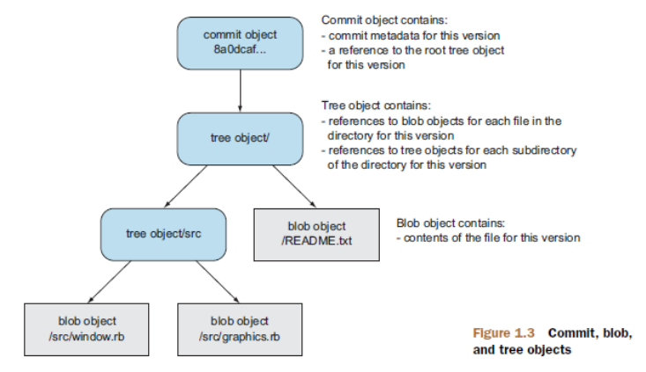

Examine Commit Details
git cat-file plumbing command. Using the -t flag, we can determine what kind of object

$ git cat-file -p HEAD

The p parameter tells Git that we want to see a commit object, and as we already know, HEAD refers to the most recent commit. This will output the following,

$ git cat-file -p HEAD
tree a5533e93dc038819f4e3a093109af7427fa1dba5
parent e7afc31aeaec6ff0fc264e361375ffb420e8706d
author Laurence Guimard <laurence.guimard@bureauveritas.com> 1498585573 +0200
committer Laurence Guimard <laurence.guimard@bureauveritas.com> 1498585573 +0200

MA-345: Le Export All Panels était encore visible à tors sur "Show ship motions & reference points"

Au passage titre de la Grid clarifié

This is the complete representation of a commit: a tree, a parent, user data, and a commit message.

A tree object is Git’s representation of the “snapshots” we’ve been talking about since the beginning of this tutorial. They record the state of a directory at a given point, without any notion of time or author. To tie trees together into a coherent project history, Git wraps each one in a commit object and specifies a parent, which is just another commit. By following the parent of each commit, you can walk through the entire history of a project.

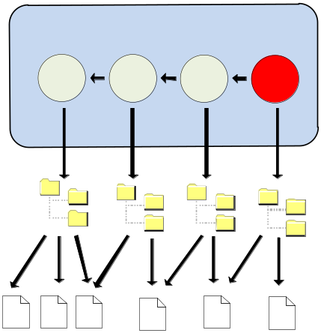
Commit, tree and blob objects
Each commit refers to one tree object. From the git cat-file output, we can also infer that trees use SHA-1 checksums for their ID’s. This will be the case for all of Git’s internal objects.

Examine a Tree
Next, let’s try to inspect a tree using the same git cat-file command. Make sure to change 552acd4 to the ID of your tree from the previous step.

$ git cat-file -p a5533
100644 blob a63a79abb0384f14a0f9adb71ef14727c4ef616a .gitignore
100644 blob 5dd0d0746eb4b2e91a9c604ad226838486eb4f17 .gitmodules
040000 tree 6b59d45a095b6305730f7f078649ad642827bc48 BV.Common
040000 tree db9ec596b6121a3f6ca9f1e515aba12e7891d571 BV.Mars.Kernel
040000 tree 831f14974dc7eecdb2e52a286167cf273e72eb13 BV.Mars.Rules
040000 tree d486115fea1586e5e3e53a06d1a07f441c9ed69e BV.Mars.Services
040000 tree c90cd035c5909fecc8e9699af0576cf3afe36c8d BV.Mars.UI
040000 tree 0676b0b148ee4ab583cf4d8f8aa0ddf5e956a866 BV.Mars.UI2
…………….

Unfortunately, trees contain binary data, which is quite ugly when displayed in its raw form. So, Git offers another useful plumbing command:

$ git ls-tree 6b59d
100644 blob 1dbf84ed08d1cd7638d1d099d01d3c089650ca92 BV.Common.csproj
040000 tree d134c92effb09f2da93027ae36335bdef66cc942 Computations
040000 tree eb1282ddd8a472e5b2cddeaa21bd09da96ca9664 Controls
040000 tree 779cdb9145d9e5a7c949fed62b1b680416cac68a Drawing
040000 tree b3d62935bb3e4455ae69cee18ce80ee7b06de14a Forms
040000 tree b60d52bce42d6253566939da931e71a6096739b9 Physics
040000 tree 6ba3696abad10aeeed961553632f9f6b1c733389 Properties
040000 tree 483d21400d2a269f5dac606c19eaf56dd63daf94 Reporting
040000 tree 3d9d40f530a8b168e4d63f6bb66f3ebfc1ebfdf5 Resolution
100644 blob 8196b800e1af3e35d2dd80998ddad253acac692e Strings.Designer.cs
100644 blob 3cf3c1c14e4221e930f3c343ca04e663d79b4ddd Strings.resx
100644 blob 175f28b1a3cecb6735ddbca0468d9364bf148b25 StyleCop.Cache
040000 tree 6f21110cd493e53177ee4304f954d1f4bb230dbd Utilities

By examining the above output,“blobs” represent files in our repository, whereas trees represent folders.
So, blob objects are how Git stores our file data, tree objects combine blobs and other trees into a directory listing, then commit objects tie trees into a project history. These are the only types of objects that Git needs to implement nearly all of the porcelain commands we’ve been using, and their relationship is summed up as follows:

Examine a Blob
This should display the entire contents of blue.html, confirming that blobs really are plain data files.

$ git cat-file -p 1dbf84
<?xml version="1.0" encoding="utf-8"?>
<Project ToolsVersion="12.0" DefaultTargets="Build" xmlns="http://schemas.microsoft.com/developer/msbuild/2003">
<PropertyGroup>
<Configuration
…………

Note that blobs are pure content: there is no mention of a filename in the above output. The name blue.html is stored in the tree that contains the blob, not the blob itself.

An SHA-1 checksum ensures an object’s contents is never corrupted without Git knowing about it. Checksums work by using the object’s contents to generate a unique character sequence. This not only functions as an identifier, it also guarantees that an object won’t be silently corrupted (the altered content would generate a different ID).
When it comes to blob objects, this has an additional benefit. Since two blobs with the same data will have the same ID, Git must share blobs across multiple trees. For example, our blue.html file hasn’t been changed since it was created, so our repository will only have a single associated blob, and all subsequent trees will refer to it. By not creating duplicate blobs for each tree object, Git vastly reduces the size of a repository.
However, as soon as you change a single line in a file, Git must create a new blob object because its contents will have changed, resulting in a new SHA-1 checksum.

Examine a Tag
The fourth and final type of Git object is the tag object We can use the same git cat-file command to show the details of a tag.
$ git cat-file -t v2.0
$ git cat-file -p v2.0
This will output the commit ID associated with v2.0, along with the tag’s name, author, creation date, and message. The straightforward relationship between tags and commits gives us our finalized Git object diagram:

Inspect Git’s Branch Representation
$ git cat-file -t master
$ git cat-file -p master

A branch is just a reference to a commit object. This will output the exact same information as our original git cat-file -p HEAD. It seems that both the master branch and HEAD are simply references to a commit object.
Using a text editor, open up the .git/refs/heads/master file. You should find the commit checksum of the most recent commit, which you can view with git log -1. This single file is all Git needs to maintain the master branch—all other information is extrapolated through the commit object relationships discussed above.

The HEAD reference, on the other hand, is recorded in .git/HEAD. Unlike the branch tips, HEAD is not a direct link to a commit. Instead, it refers to a branch, which Git uses to figure out which commit is currently checked out. Remember that a detached HEAD state occurred when HEAD did not coincide with the tip of any branch. Internally, all this means to Git is that .git/HEAD doesn’t contain a local branch. Try checking out an old commit:

git checkout HEAD~1
Now, .git/HEAD should contain a commit ID instead of a branch. This tells Git that we’re in a detached HEAD state. Regardless of what state you’re in, the git checkout command will always record the checked-out reference in .git/HEAD.
Let’s get back to our master branch before moving on:
git checkout master

Explore the Object Database
Git keeps all of these objects in the folder .git/objects. This is Git’s object database. Each object, regardless of type, is stored as a file, using its SHA-1 checksum as the filename (sort of). But, instead of storing all objects in a single folder, they are split up using the first two characters of their ID as a directory name, resulting in an object database that looks something like the following.
For example, an object with the following ID:
7a52bb857229f89bffa74134ee3de48e5e146105
is stored in a folder called 7a, using the remaining characters (52bb8...) as a filename. This gives us an object ID, but before we can inspect items in the object database, we need to know what type of object it is. Again, we can use the -t flag:
git cat-file -t 7a52bb8
Of course, change the object ID to an object from your database (don’t forget to combine the folder name with the filename to get the full ID). This will output the type of commit, which we can then pass to a normal call to git cat-file.
git cat-file blob 7a52bb8
My object was a blob, but yours may be different. If it’s a tree, remember to use git ls-tree to turn that ugly binary data into a pretty directory listing.

Collect the Garbage
As your repository grows, Git may automatically transfer your object files into a more compact form know as a “pack” file. You can force this compression with the garbage collection command, but beware: this command is undo-able. If you want to continue exploring the contents of the .git/objects folder, you should do so before running the following command. Normal Git functionality will not be affected.
git gc
This compresses individual object files into a faster, smaller pack file and removes dangling commits (e.g., from a deleted, unmerged branch).
Of course, all of the same object ID’s will still work with git cat-file, and all of the porcelain commands will remain unaffected. The git gc command only changes Git’s storage mechanism—not the contents of a repository. Running git gc every now and then is usually a good idea, as it keeps your repository optimized.

Add Files to the Index
Thus far, we’ve been discussing Git’s low-level representation of committed snapshots. The rest of this module will shift gears and use more “plumbing” commands to manually prepare and commit a new snapshot. This will give us an idea of how Git manages the working directory and the staging area.
Create a new file called news-4.html in my-git-repo and add the following HTML.
<!DOCTYPE html>
<html lang="en">
<head>
<title>Indigo Invasion</title>
<link rel="stylesheet" href="style.css" />
<meta charset="utf-8" />
</head>
<body>
<h1 style="color: #A0C">Indigo Invasion</h1>
<p>Last week, a coalition of Asian designers, artists,
and advertisers announced the official color of Asia:
<span style="color: #A0C">Indigo</span>.</p>

<p><a href="index.html">Return to home page</a></p>
</body>
</html>
Then, update the index.html “News” section to match the following.
<h2 style="color: #C00">News</h2>
<ul>
<li><a href="news-1.html">Blue Is The New Hue</a></li>
<li><a href="rainbow.html">Our New Rainbow</a></li>
<li><a href="news-2.html">A Red Rebellion</a></li>
<li><a href="news-3.html">Middle East's Silent Beast</a></li>
<li><a href="news-4.html">Indigo Invasion</a></li>
</ul>
Instead of git add, we’ll use the low-level git update-index command to add files to the staging area. The index is Git’s term for the staged snapshot.
git status
git update-index index.html
git update-index news-4.html
The last command will throw an error—Git won’t let you add a new file to the index without explicitly stating that it’s a new file:
git update-index --add news-4.html
git status
We’ve just moved the working directory into the index, which means we have a snapshot prepared for committal. However, the process won’t be quite as simple as a mere git commit.

Store the Index in the Database
Remember that all commits refer to a tree object, which represents the snapshot for that commit. So, before creating a commit object, we need to add our index (the staged tree) to Git’s object database. We can do this with the following command.
git write-tree
This command creates a tree object from the index and stores it in .git/objects. It will output the ID of the resulting tree (yours may be different):
5f44809ed995e5b861acf309022ab814ceaaafd6
You can examine your new snapshot with git ls-tree. Keep in mind that the only new blobs created for this commit were index.html and news-4.html. The rest of the tree contains references to existing blobs.
git ls-tree 5f44809
So, we have our tree object, but we have yet to add it to the project history.

Create a Commit Object
To commit the new tree object, we need to manually figure out the ID of the parent commit.
git log --oneline -n 1
This will output the following line, though your commit ID will be different. We’ll use this ID to specify the parent of our new commit object.
3329762 Add .gitignore file
The git commit-tree command creates a commit object from a tree and a parent ID, while the author information is taken from an environment variable set by Git. Make sure to change 5f44809 to your tree ID, and 3329762 to your most recent commit ID.
git commit-tree 5f44809 -p 3329762
This command will wait for more input: the commit message. Type Add 4th news item and press Enter to create the commit message, then Ctrl-Z and Enter for Windows or Ctrl-D for Unix to specify an “End-of-file” character to end the input. Like the git write-tree command, this will output the ID of the resulting commit object.
c51dc1b3515f9f8e80536aa7acb3d17d0400b0b5
You’ll now be able to find this commit in .git/objects, but neither HEAD nor the branches have been updated to include this commit. It’s a dangling commit at this point. Fortunately for us, we know where Git stores its branch information.
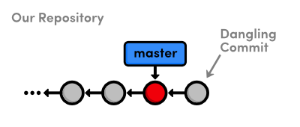Creating a dangling commit

Update HEAD
Since we’re not in a detached HEAD state, HEAD is a reference to a branch. So, all we need to do to update HEAD is move the master branch forward to our new commit object. Using a text editor, replace the contents of .git/refs/heads/master with the output from git commit-tree in the previous step.
If this file seems to have disappeared, don’t fret! This just means that the git gc command packed up all of our branch references into single file. Instead of .git/refs/heads/master, open up .git/packed-refs, find the line with refs/heads/master, and change the ID to the left of it.
Now that our master branch points to the new commit, we should be able to see the news-4.html file in the project history.
git log -n 2
The last four sections explain everything that happens behind the scenes when we execute git commit -a -m "Some Message". Aren’t you glad you won’t have to use Git’s plumbing ever again?
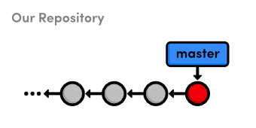Manually updating the master branch

Quick Reference
git cat-file <type> <object-id>
Display the specified object, where <type> is one of commit, tree, blob, or tag.
git cat-file -t <object-id>
Output the type of the specified object.
git ls-tree <tree-id>
Display a pretty version of the specified tree object.
git gc
Perform a garbage collection on the object database.
git update-index [--add] <file>
Stage the specified file, using the optional --add flag to denote a new untracked file.
git write-tree
Generate a tree from the index and store it in the object database. Returns the ID of the new tree object.
git commit-tree <tree-id> -p <parent-id>
Create a new commit object from the given tree object and parent commit. Returns the ID of the new commit object.

Centralized Workflows

Create a Bare Repository (Central)
git init --bare central-repo.git
git init creates a new repository, the --bare flag to tell Git that we don’t want a working directory. This will prevent us from developing in the central repository, which eliminates the possibility of messing up another user’s environment with git push. A central repository is only supposed to act as a storage facility—not a development environment.
If you examine the contents of the resulting central-repo.git folder, you’ll notice that it contains the exact same files as the .git folder in our my-git-repo project.The conventional .git extension in the directory name is a way to convey this property.

Update Remotes (Mary and You)
git remote rm origin
git remote add origin ../central-repo.git

Push the Master Branch (You)
We didn’t clone the central repository—we just initialized it as a bare repository. This means it doesn’t have any of our project history yet. We can fix that using the git push command introduced in the last module.
git push origin master

Publish CSS Changes (Mary)
Now that her history is cleaned up, Mary can publish the changes.
git checkout master
git merge css-edits
git branch -d css-edits
She shouldn’t push the css-edits branch to the server, since it’s no longer under development, and other collaborators wouldn’t know what it contains. However, if we had all decided to develop the CSS edits together and wanted an isolated environment to do so, it would make sense to publish it as an independent branch.
Mary still needs to push the changes to the central repository. But first, let’s take a look at the state of everyone’s project.

Before publishing Mary’s CSS changes
It seems that Git won’t let anyone push to a remote server if it doesn’t result in a fast-forward merge.

Create a Bitbucket Account
The first part of this module will walk you through setting up a Bitbucket account. Navigate your web browser to Bitbucket.org and sign up for a free account.
The Bitbucket logo
You can choose any username for your account, but the email address should match the one you assigned to your Git installation with git config in The Basics. If you need to change your email, you can run another git config --global user.email you@example.com command.

Archive The Repository
First, let’s export our repository into a ZIP archive. Run the following command in your local copy of my-git-repo.
git archive master --format=zip --output=../website-12-10-2012.zip
This takes the current master branch and places all of its files into a ZIP archive (or a tarball), omitting the .git directory. Removing the .git directory removes all version control information, and you’re left with a single snapshot of your project. This is also an easy way to create Git-independent backups of important revisions, which is always a good idea.

Bundle the Repository
Similar to the git archive command, git bundle turns a repository into a single file. However, in this case, the file retains the versioning information of the entire project.

$ git bundle create ../repo.bundle master

Bundles are a great way to backup entire Git repositories (not just an isolated snapshot like git archive). They also let you share changes without a network connection.

Stash Uncommitted Changes
The git stash command hid these changes, giving us a clean working directory. We’re now able to switch to a new hotfix branch to make our important updates—without having to commit a meaningless snapshot just to save our current state.

We can retrieve our stashed content with the following command.

git stash apply

A stash represents a set of uncommitted changes. It takes the uncommitted modifications, stores them internally, then does a git reset --hard to give us a clean working directory. This also means that stashes can be applied to any branch, not just the one from which it was created.
In addition to temporarily storing uncommitted changes, this makes stashing a simple way to transfer modifications between branches. So, for example, if you ever found yourself developing on the wrong branch, you could stash all your changes, checkout the correct branch, then run a git stash apply.

View Diffs Between Commits
Up until now, we’ve been using git log --stat to view the changes introduced by new commits. However, this doesn’t show us which lines have been changed in any given file. For this level of detail, we need the git diff command.
$ git diff HEAD~2..HEAD~1
The git diff command is incredibly useful for pinpointing contributions from other developers. For example, we could have used the following to view the differences between John’s pink-page branch and our master before merging it into the project in Distributed Workflows.
git diff master..john/pink-page
This flexible command can also generate a detailed view of our uncommitted changes. Then, run git diff without any arguments:
git diff
We can use the --cached flag to generate a diff between the staged snapshot and the most recent commit:
git diff --staged
A plain old git diff won’t output anything after blue.html is added to the staging area, but the changes are now visible through the --cached flag. These are the three main configurations of the git diff command.

Reset and Checkout Files
The git reset we’re accustomed to moves the current branch to a new commit and optionally updates the working directory to match. But when we pass a file path, git reset updates the staging area to match the given commit instead of the working directory, and it doesn’t move the current branch pointer.
git reset HEAD file1.txt
git status
This makes the blue.html in the staging area match the version stored in HEAD, but it leaves the working directory and current branch alone. The result is a staging area that matches the most recent commit and a working directory that contains the modified blue.html file. In other words, this type of git reset can be used to unstage a file:
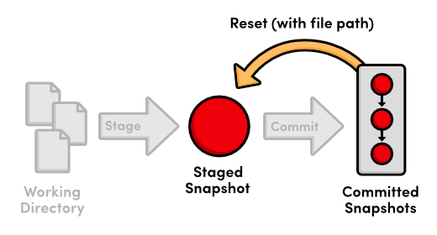
Using git reset with a file path
Let’s take this one step further with git checkout. The git checkout we’ve been using updates the working directory and switches branches. If we add a file path to git checkout, it narrows its focus to only the specified file and does not update the branch pointer. This means that we can “check out” the most recent version of blue.html with the following command.
git checkout HEAD blue.html
git status
Our blue.html file now looks exactly like the version stored in HEAD, and we thus have a clean working directory. Passing a file path to git checkout reverts that file to the specified commit.
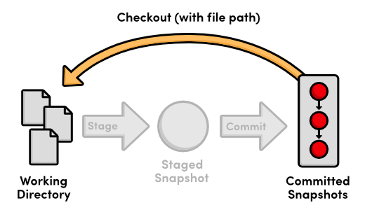
Using git checkout with a file path
To summarize the file-path behavior of git reset and git checkout, both take a committed snapshot as an reference point and make a file in the staging area or the working directory match that reference, respectively.

Aliases and Other Configurations
Typing git checkout every time you wanted to see a new branch over the last ten modules has been a bit verbose. Fortunately, Git lets you create aliases, which are shortcuts to other commands. Let’s create a few aliases for our most common commands:
git config --global alias.co checkout
git config --global alias.ci commit
git config --global alias.br branch
Git stores these aliases in a global config file, similar to the local config file we looked at in Mary’s repository (marys-repo/.git/config). By default, global configurations reside in ~/.gitconfig, where the ~ character represents your home directory. This file should resemble the following.
[user]
name = Ryan
email = ryan.example@rypress.com
[alias]
co = checkout
ci = commit
br = branch
Of course, your settings should reflect the name and email you entered in The Basics. As you can see, all of our new aliases are also stored in .gitconfig. Let’s add a few more useful configurations by modifying this file directly. Append the following to .gitconfig.
[color]
status = always
[core]
editor = gvim
This makes sure Git colorizes the output of git status and that it uses the gVim text editor for creating commit messages. To use a different editor, simply change gvim to the command that opens your editor. For example, Emacs users would use emacs, and Notepad users would use notepad.exe.

Conclusion
With all of these convenient features, it’s easy to get so caught up in designing the perfect workflow that you lose sight of Git’s underlying purpose. As you add new commands to your repertoire, remember that Git should always make it easier to develop a software project—never harder. If you ever find that Git is causing more harm than good, don’t be scared to drop some of the advanced features and go back to the basics.
The final module will go a long way towards helping you realize the full potential of Git’s version control model. We’ll explore Git’s internal database by manually inspecting and creating snapshots. Equipped with this low-level knowledge, you’ll be more than ready to venture out into the reality of Git-based project management.

Quick Reference
git archive <branch-name> --format=zip --output=<file>
Export a single snapshot to a ZIP archive called <file>.
git bundle create <file> <branch-name>
Export an entire branch, complete with history, to the specified file.
git clone repo.bundle <repo-dir> -b <branch-name>
Re-create a project from a bundled repository and checkout <branch-name>.
git stash
Temporarily stash changes to create a clean working directory.
git stash apply
Re-apply stashed changes to the working directory.
git diff <commit-id>..<commit-id>
View the difference between two commits.
git diff
View the difference between the working directory and the staging area.
git diff --cached
View the difference between the staging area and the most recent commit.
git reset HEAD <file>
Unstage a file, but don’t alter the working directory or move the current branch.
git checkout <commit-id> <file>
Revert an individual file to match the specified commit without switching branches.
git config --global alias.<alias-name> <git-command>
Create a shortcut for a command and store it in the global configuration file.

