Task 2 – Calculator App
Objective
Build a mini interactive JavaScript application using DOM manipulation.
Technologies Used
- HTML5
- CSS3
- JavaScript
Features
- Addition
- Subtraction
- Multiplication
- Division
- Clear button
- Responsive design
- Interactive UI
DOM Manipulation Used
- document.getElementById()
- Event handling using onclick
- Dynamic display updates

Code Snippets
- index.html
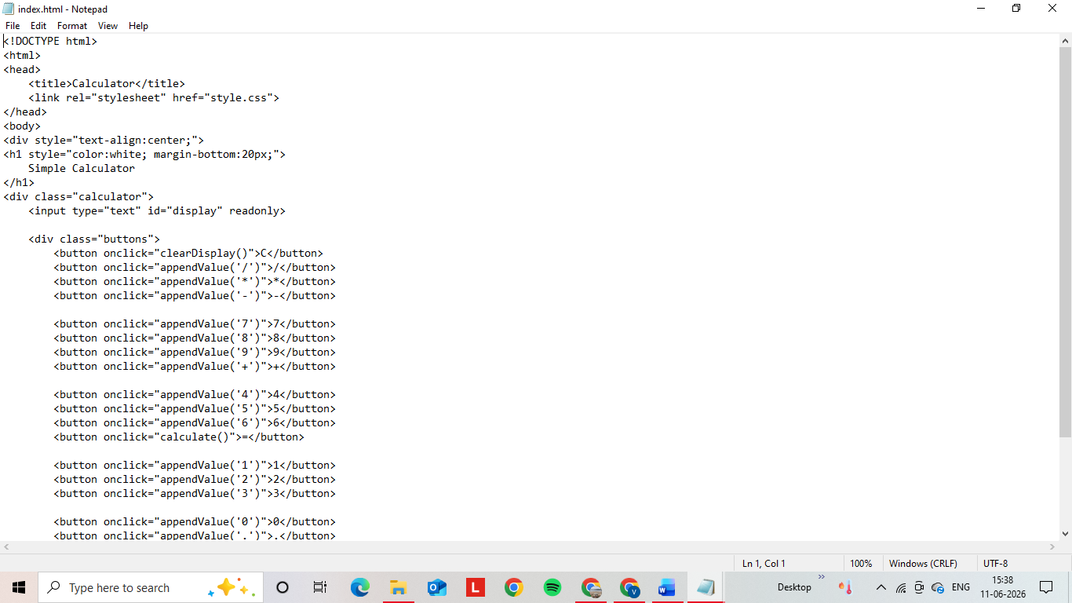
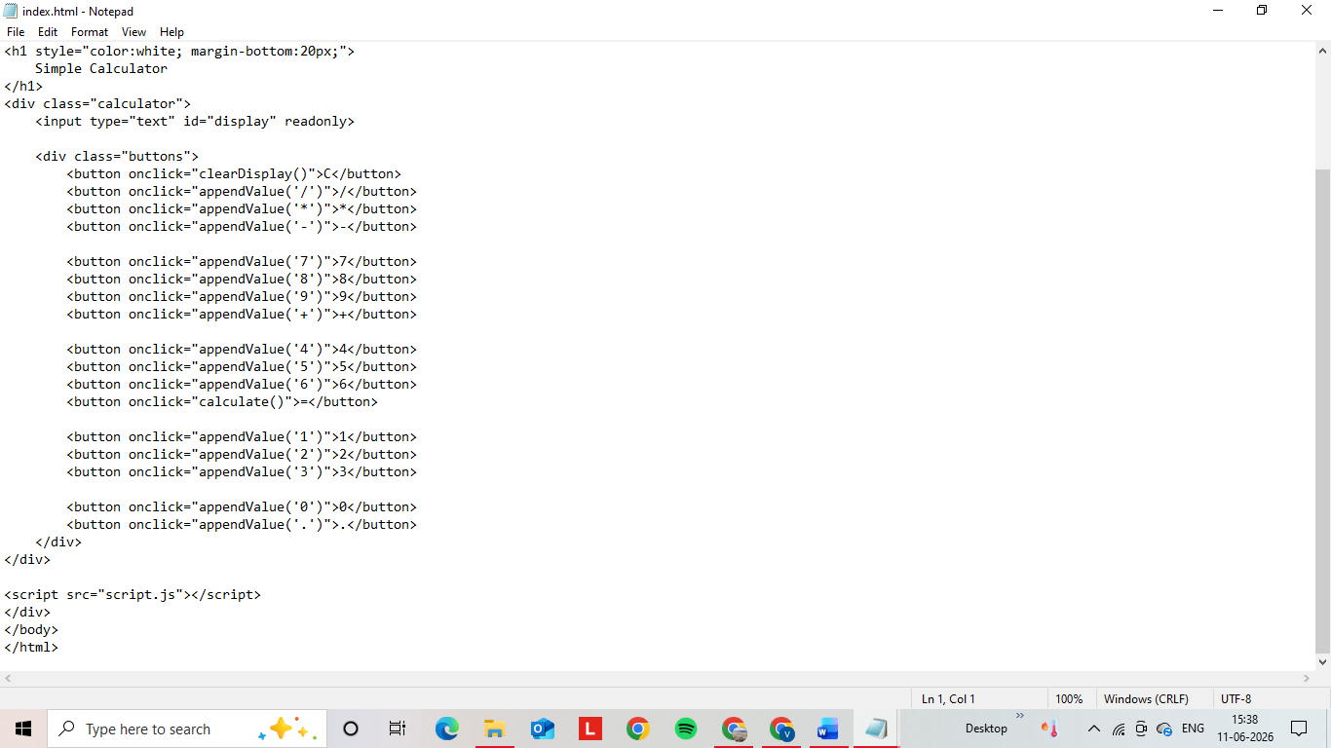

- style.css
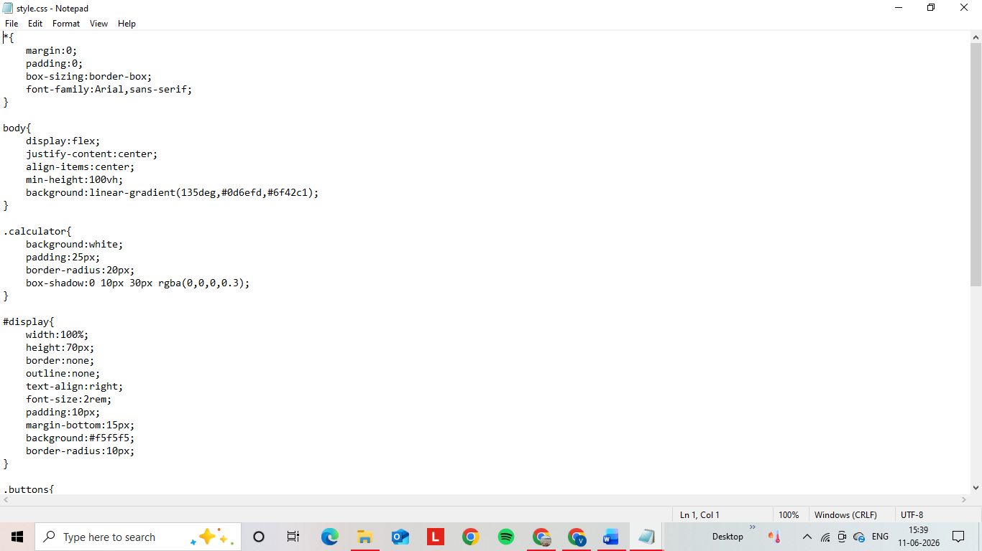
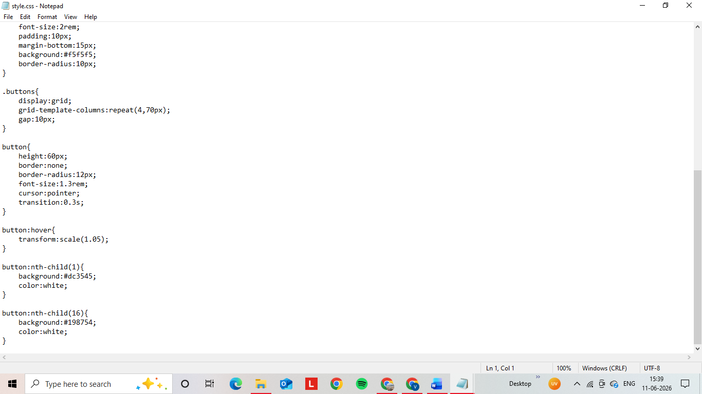

- script.js
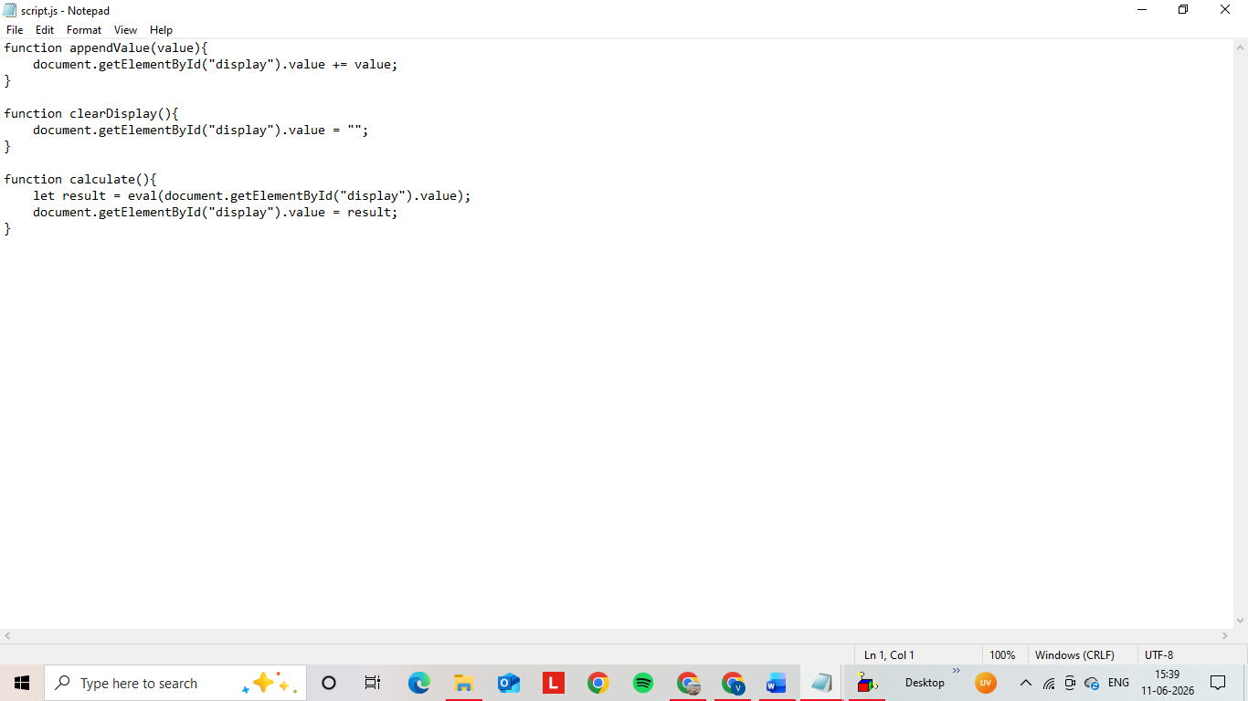

Output Screenshots
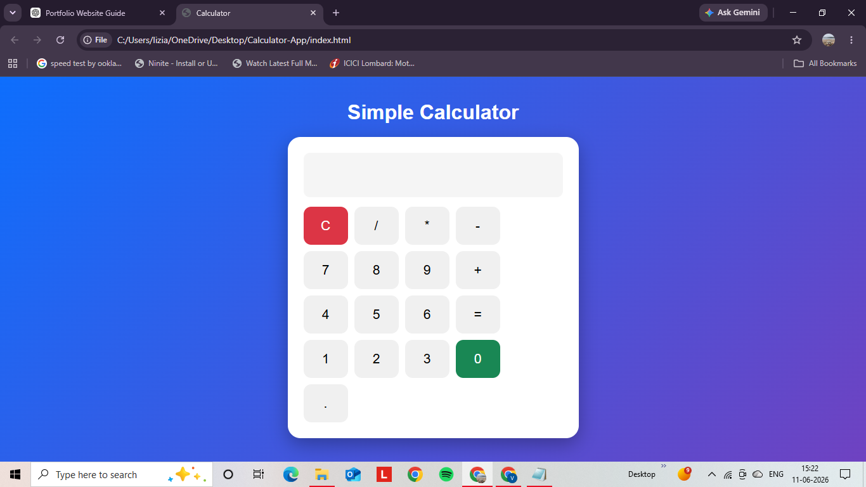
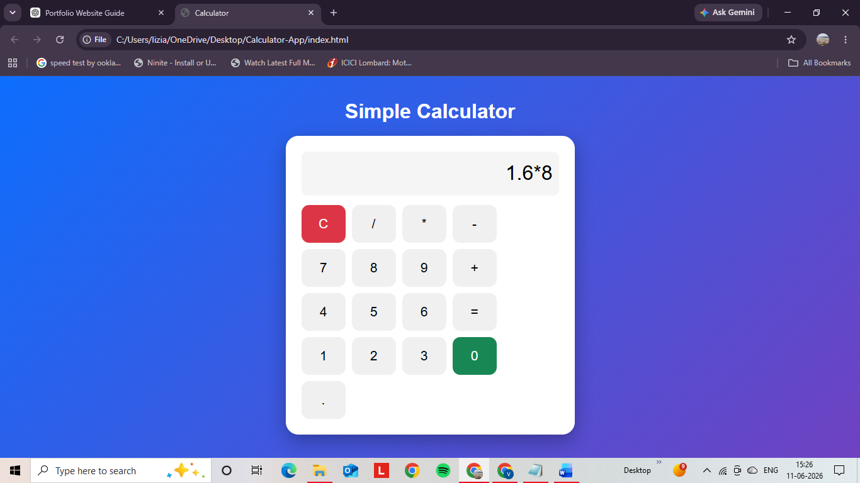
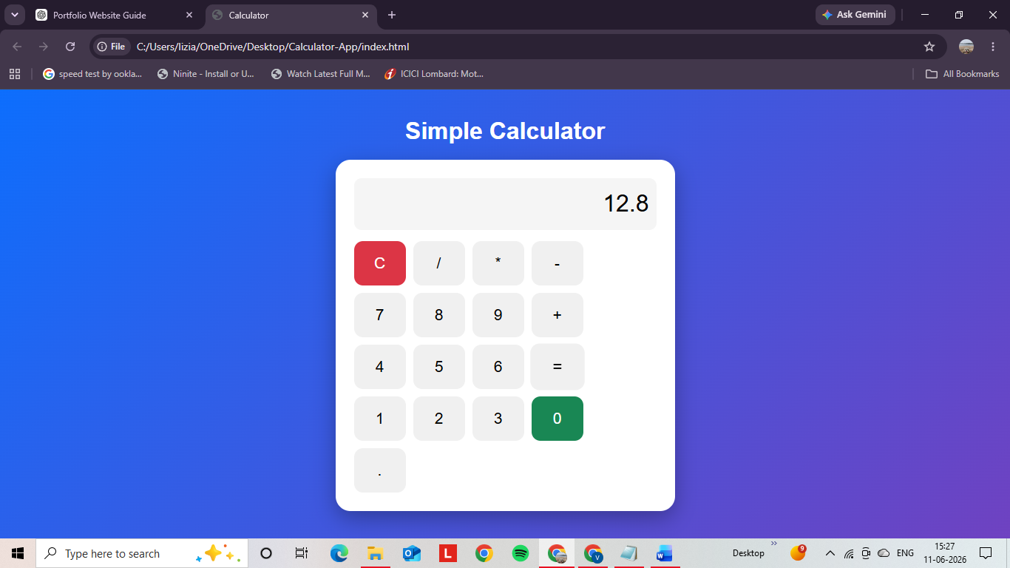
GitHub Repository Link
https://github.com/PVenu46/alfidotech-calculator
Live Hosted Link
//pvenu46.github.io/alfidotech-calculator/
Conclusion
Successfully developed a responsive Calculator Application using HTML, CSS, and JavaScript. The application performs basic arithmetic operations and demonstrates DOM manipulation concepts.

