ALFIDO TECH INTERNSHIP
TASK 1: PERSONAL PORTFOLIO WEBSITE
Objective:
Create a mobile-friendly personal portfolio website with Home, Skills, Projects, and Contact sections using HTML, CSS, Bootstrap, and JavaScript.
Tools Used:
• HTML5
• CSS3
• Bootstrap 5
• JavaScript
• Visual Studio Code
• GitHub
• GitHub Pages
Project Description:
A responsive personal portfolio website was developed to showcase personal information, technical skills, projects, and contact details. The website includes smooth navigation, responsive design, and resume download functionality.
Features:
• Responsive Navigation Bar
• Home Section with Profile Image
• Skills Section
• Projects Section
• Contact Section
• Resume Download Option
• Smooth Scrolling
• Mobile-Friendly Design

Code Snippets:
Index.html
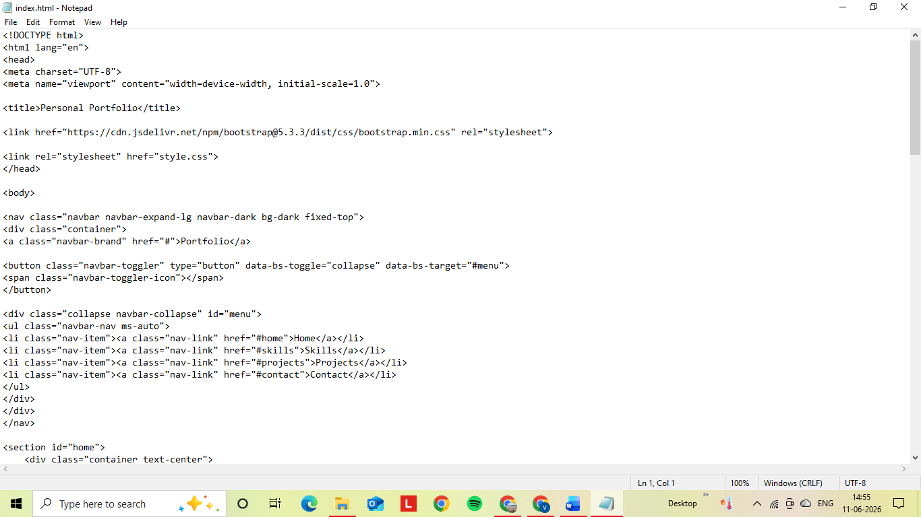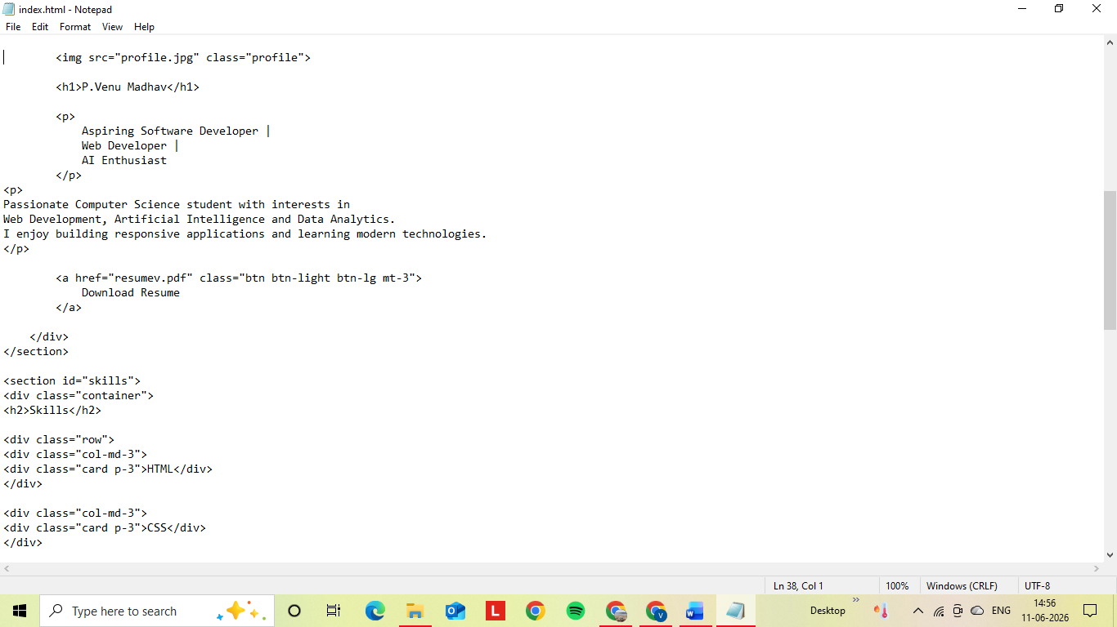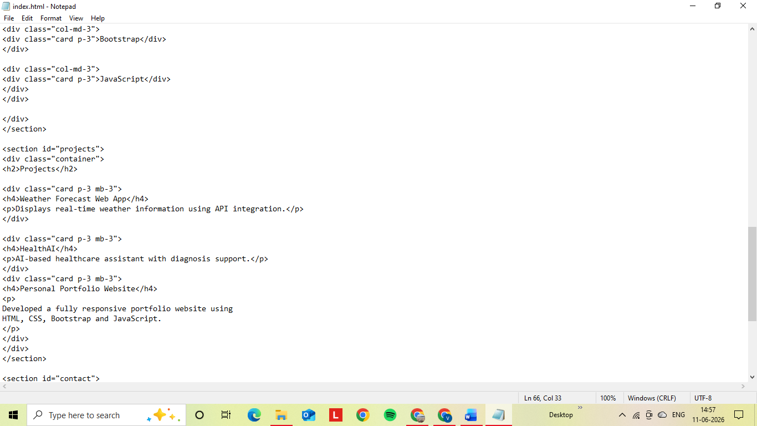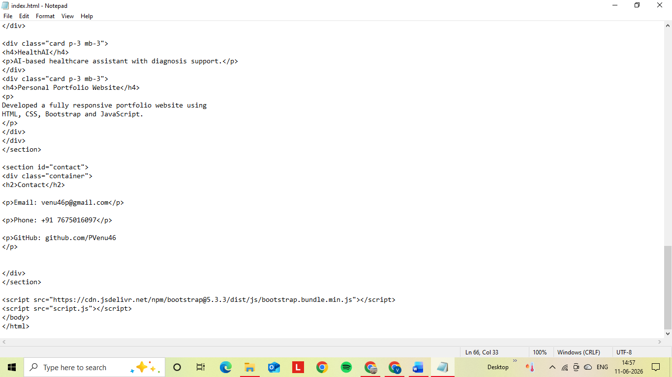

style.css
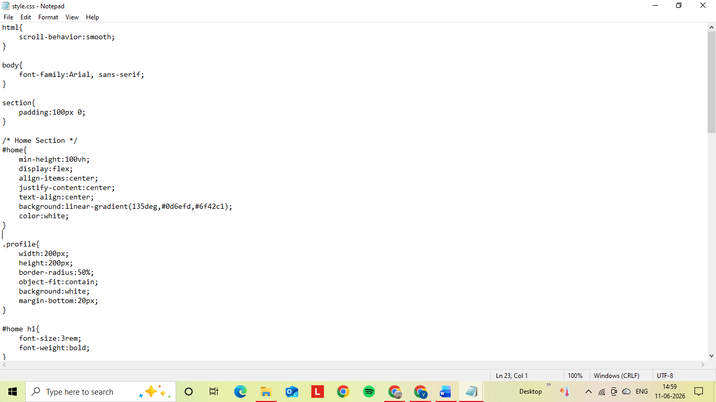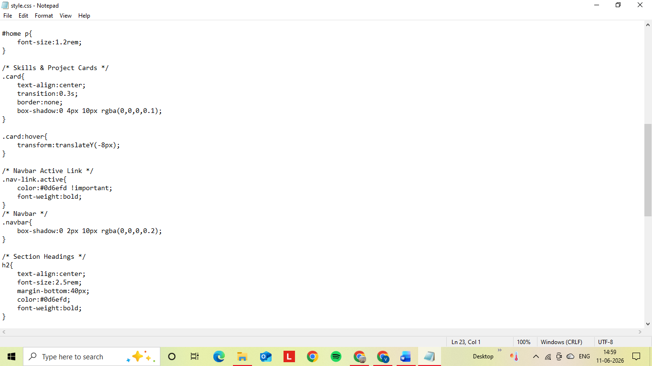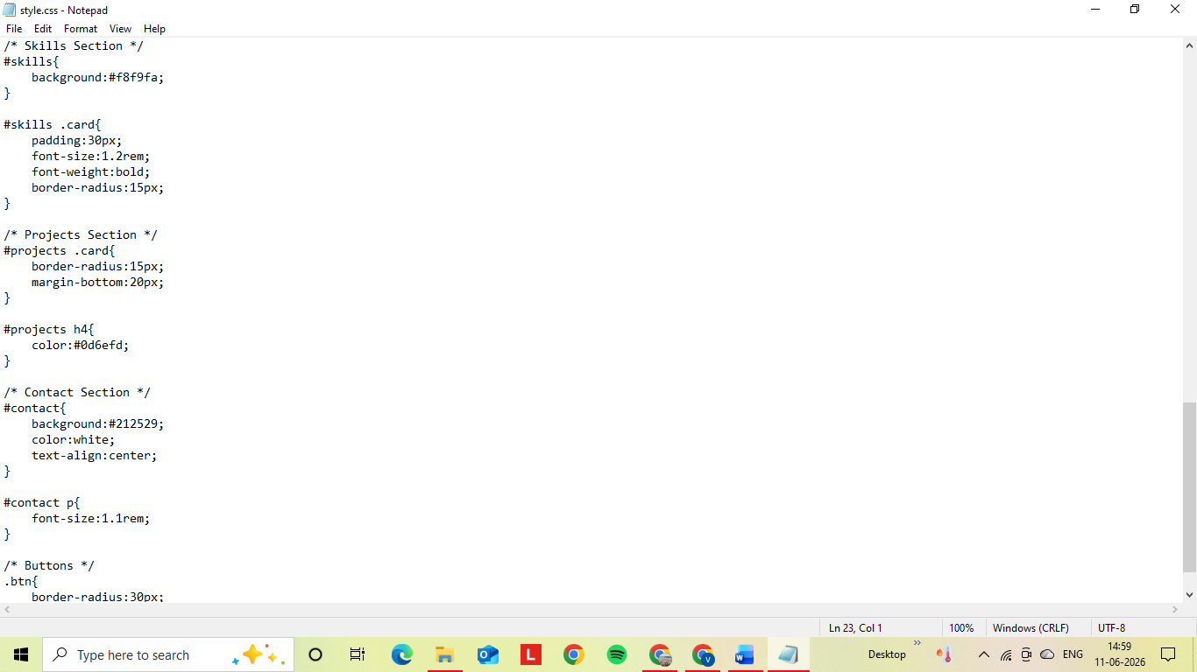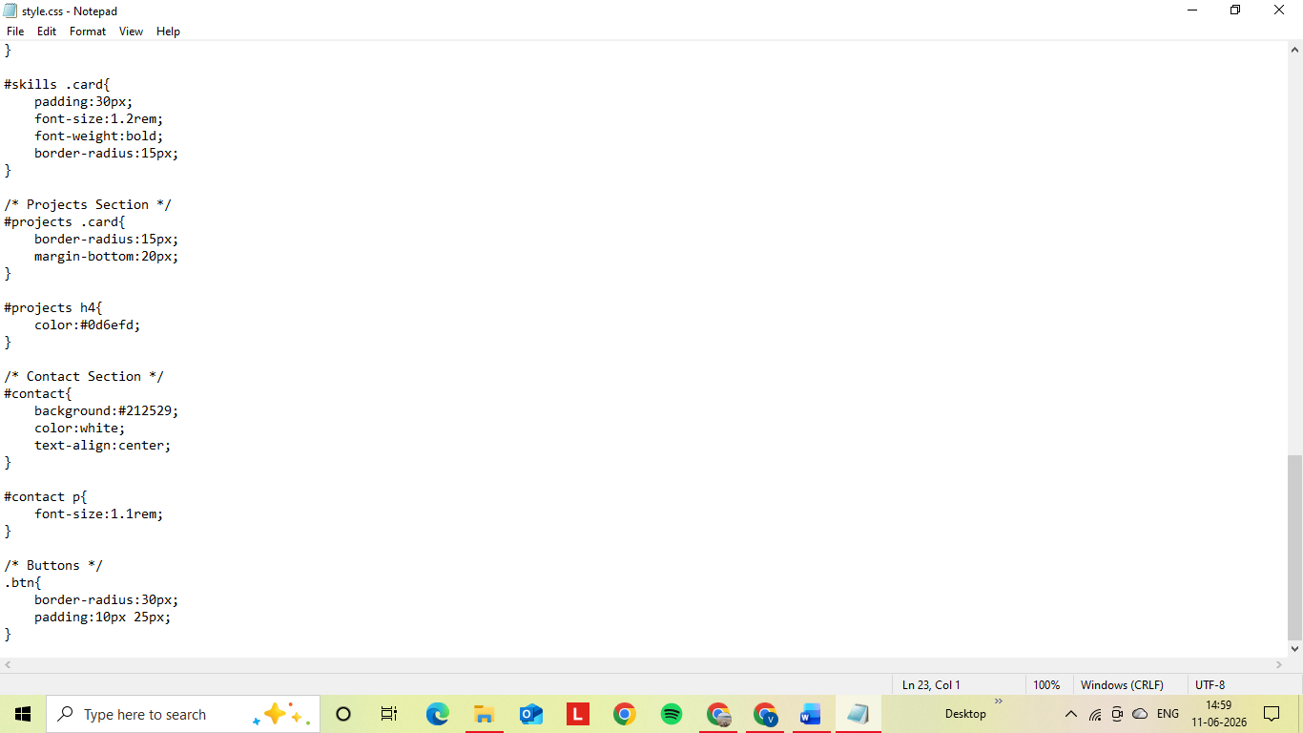

Script.js
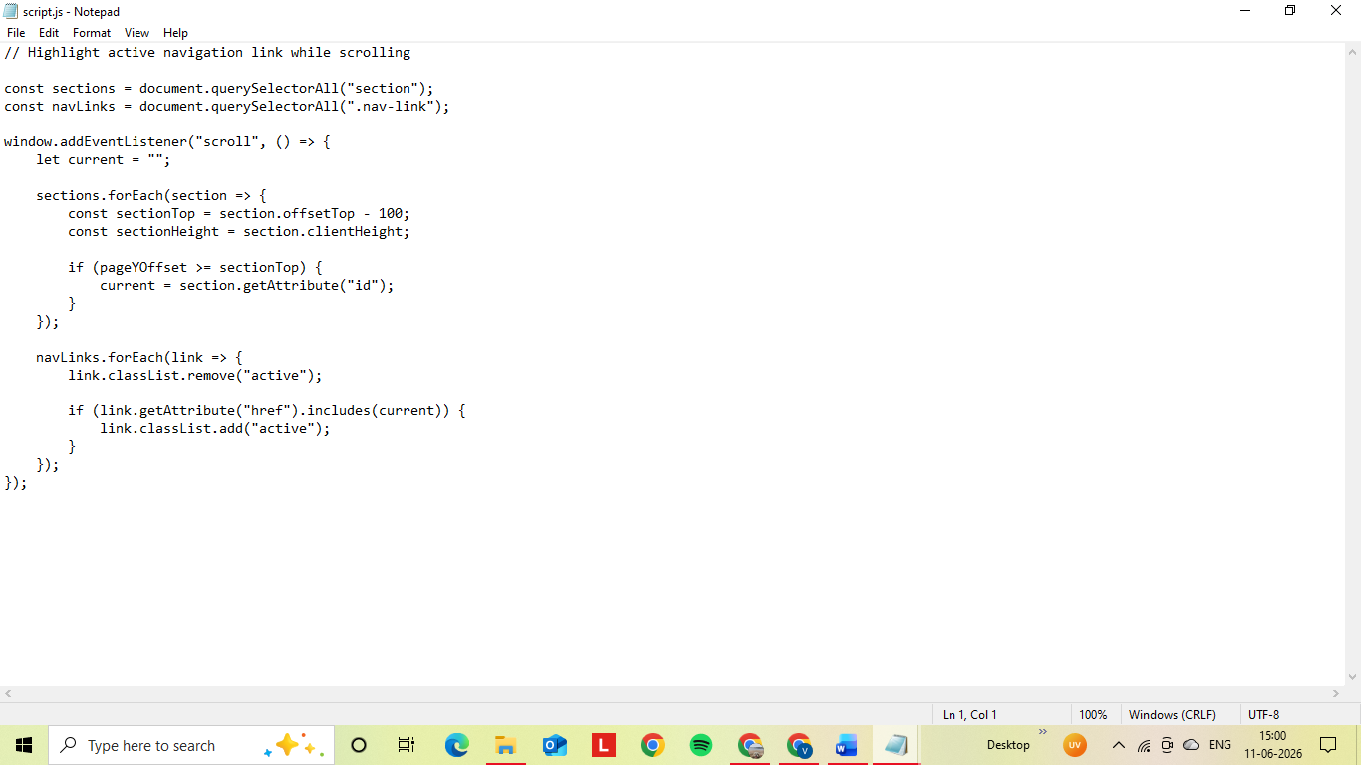

Output Screenshots:
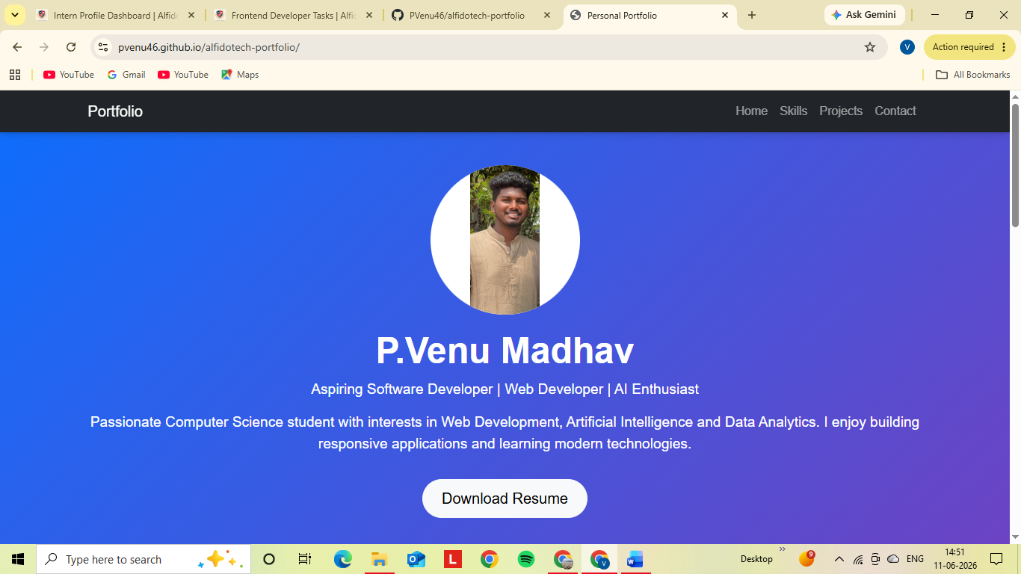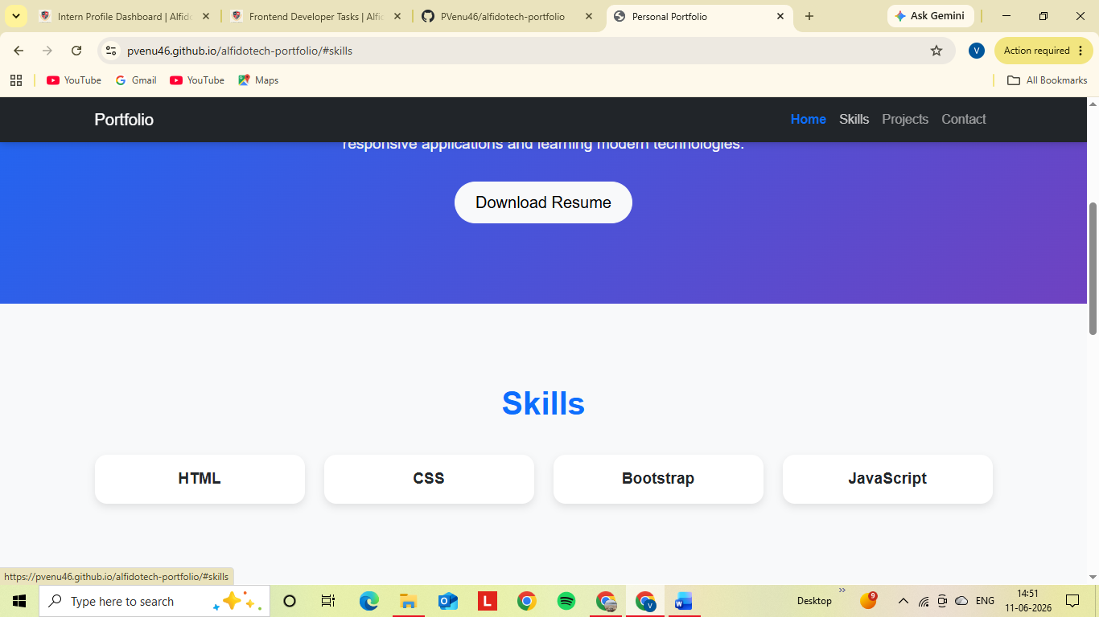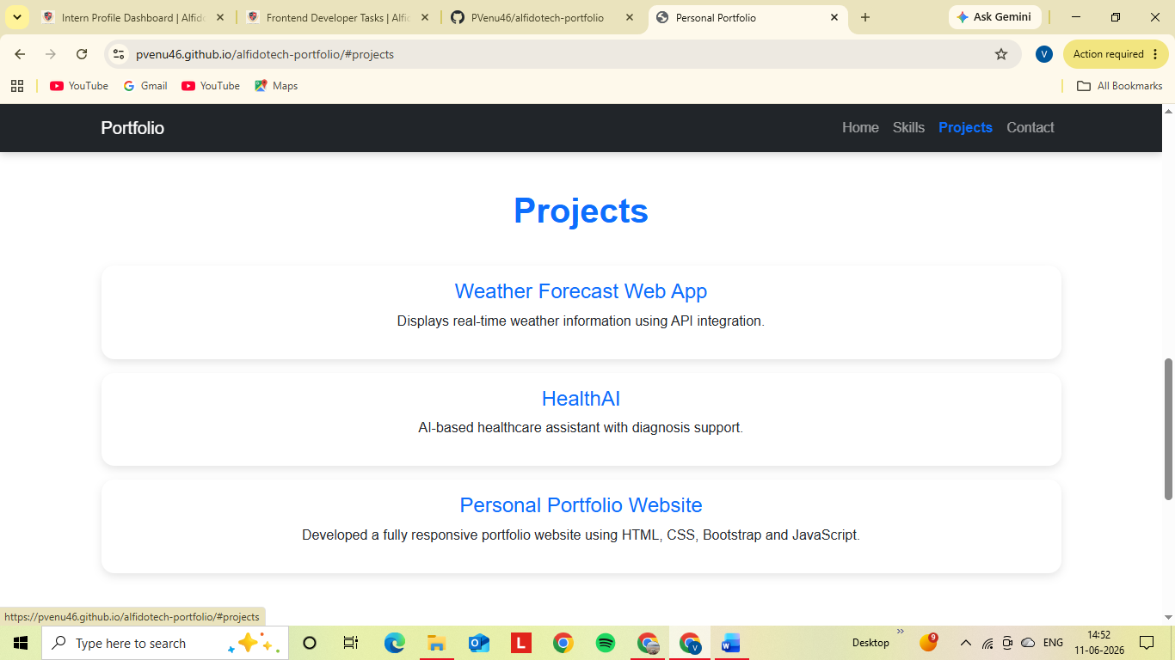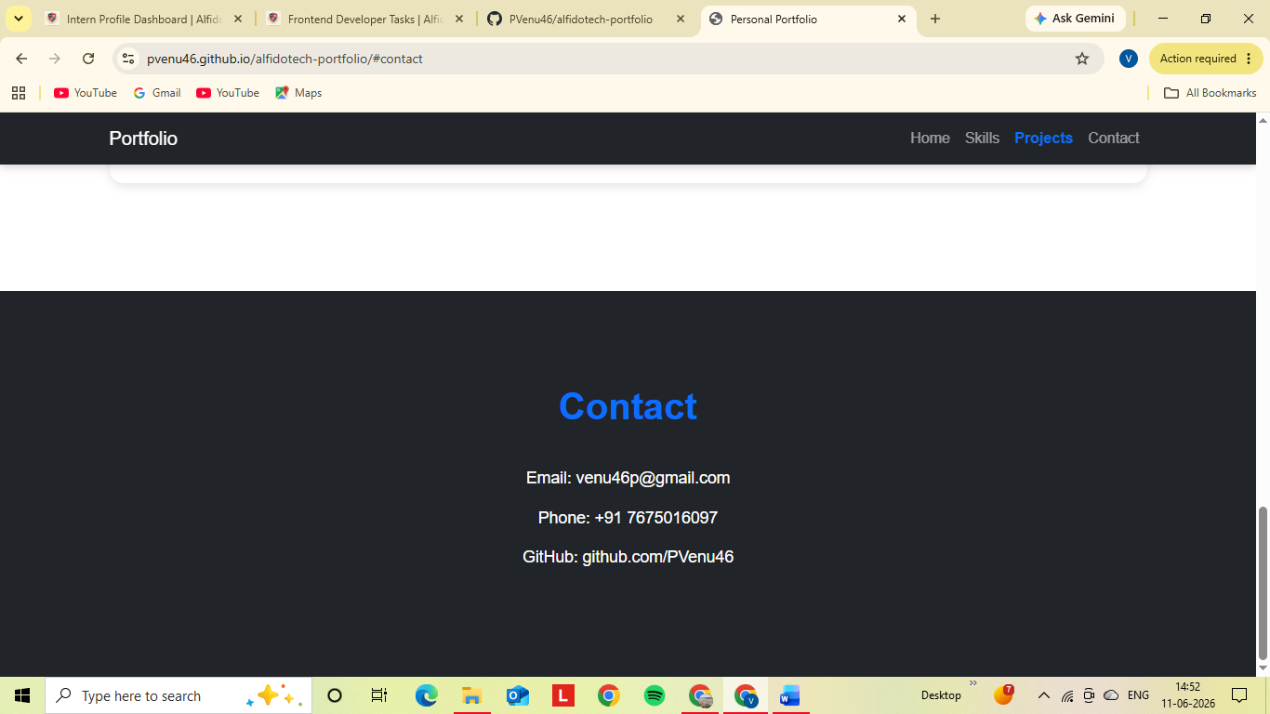
GitHub Repository Link:
https://github.com/PVenu46/alfidotech-portfolio
Live Hosted Website Link:
https://pvenu46.github.io/alfidotech-portfolio/
Conclusion:
Successfully developed and deployed a responsive personal portfolio website using HTML, CSS, Bootstrap, and JavaScript. The website is hosted using GitHub Pages and accessible online.

