**Mailchimp feedback**

**Mailchimp plan free - Mailchimp plan - Over 2000 subscribers**

<http://kb.mailchimp.com/accounts/billing/about-mailchimp-pricing-plans>

<http://kb.mailchimp.com/accounts/billing/upgrade-your-account?&_ga=1.220204120.1700912971.1456576116>

<http://kb.mailchimp.com/lists/managing-subscribers/how-to-reconfirm-a-list>

**Currently 899 – Safari Newsletter Subscription**

Re-validate users - some content – add additional names to list

Send a Reconfirmation Message

Create online form to capture newsletter and campaign interest

<http://kb.mailchimp.com/lists/managing-subscribers/how-to-reconfirm-a-list>

903 (2000 max for free one)

re-validate users - some content

Send a Reconfirmation Message

Create online form to capture newsletter and campaign interest

[mailchimp@gondwanatoursandsafaris.com](mailto:mailchimp@gondwanatoursandsafaris.com)

**Removed accounts**

**Duplicates**

ad.bosch@vodamail.co.za Ad & Leonne van den bosch

Alex.Valls@BAKERNET.com Alex

allen.webb@xtra.co.nz Allan Webb

amarna@bluewin.ch Karin Muller

deboer@it.bw Leretha de Boer

hbeentjes@uts-caribbean.com Marja Beentjes

nahuelhuapi_3@hotmail.com Marta Allegranzi

raudkivi@5star.net.nz Barbara Raudkivi

riaan@shabangasafaris.co.za Riaan van Niekerk

rocklands@elvin.co.za Wendy Pieterse

rosebud@zol.co.zw Carol McCammon

shelas@mweb.co.za Sheila Sanders

smosojane@gov.bw Anne Musau

sophie.jean-baptiste@orange.fr JB&B

tonyhorn88@hotmail.com Anthony Horn

touchwood@info.bw Peter David

vellemad@visa.com Duncan Velleman

vinpete@yahoo.com Peter Vin

**Issues**

coelho_camarinha@hotmaiç.com Jose Miguel Craveiro Pereira Coelho

relics@spacenetonline.com Ovinder Kapoor

**Agenda**

* Feedback
  + Timesheets and tracking
  + Bugs and fixes
* Payments
* Branding and changes
* PWR services
* Repository
* Mailchimp

Hetzner fees discussion

Policy referral and agreement

Formalizing contracts and agreements

**Bugs and Errors resolved**

<https://trello.com/c/Y6Y1pH4f>

**Wordfence and Monitor.us**

<https://mail.google.com/mail/u/0/?tab=wm#search/label%3A.-websites+gondwanatoursandsafaris>

<https://mail.google.com/mail/u/0/?tab=wm#search/label%3A.-websites+gondwanatoursandsafaris/1556ce17e935775b>

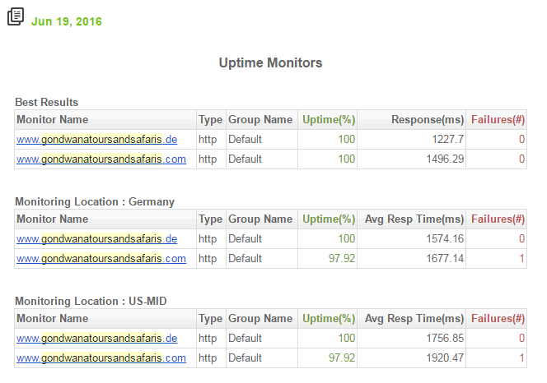

<http://dashboard.monitor.us/>

**Duri timesheet**

Jan 12 - 1 hr - Worked on broken page 7 Nächte Budget Flugsafari

Feb 4 - 1 hr - Fixed Somalisa Camp image links (Database)

May 19 - 2 hrs - Fixed home page background image cut off (.com & .de)

May 25 - 2 hrs - Clean up .com site

                      - Removed unused files, themes & plugins

May 29 - 2 hrs - Clean up .de site

                      - Removed unused files, themes & plugins

Jun 9 - 2 hrs - RHS sidebar that was pushed to the bottom (.de)

Jun 10 - 2 hrs - RHS sidebar that was pushed to the bottom (.de)

Jun 11 - 2 hrs - RHS sidebar that was pushed to the bottom (.com)

Jun 11 - 1 hr - Imported site code into version repository (bitbucket)

Jun 11 - 2 hrs - gallery page images not aligned (.com)

Jun 12 - 1 hr - gallery page images not aligned (.de)

total of 18 hours

main benefits of having source code checked into a version control system:

 - It tracks the changes to every source code file over time and allows you to roll back to previous versions easily

 - Allows multiple developers to work on the source code independently of each other

 - Source code is stored in central location which is access controlled, backed up and secured

 - Allows you to see the difference between two (or more) versions of a source code file

 - Allows you to see history of work done over time

<https://trello.com/b/OmAuB5RN/gondwana>

**Comparative analysis**

**Current Hetzner bill due for payment**

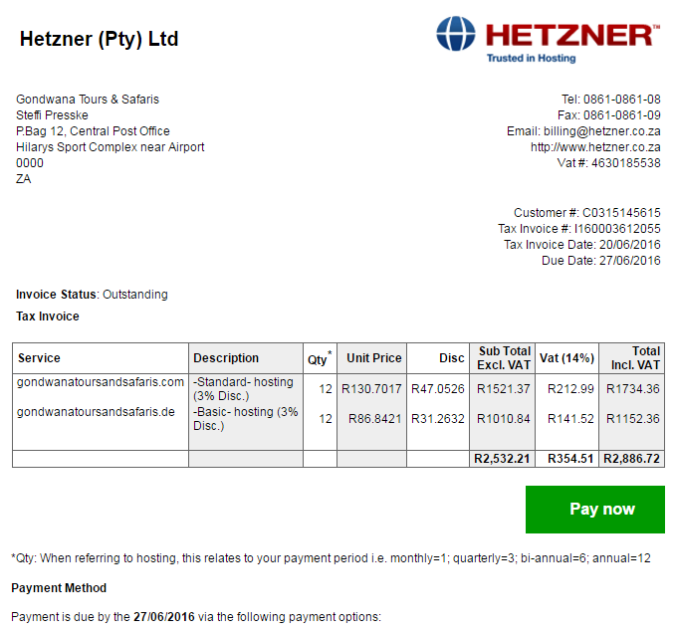

Comparison :

<http://hostingweb.co.za/web-hosting-south-africa/best-web-hosting-for-your-money-april-2016/>

* Pay Hetzner Fee R2886.72 – due 27/06 - agreed
* Hetzner Policy change – not affect our form setup

Changes listed here <https://trello.com/c/QwLKnzkf>

**PWR Consulting – update**

* Contracts and NDA agreements
* New branding – name change and domain
* Building nice development team
* Paymo is now decided as PWR vehicle to track and report tasks and time.

<https://app.paymoapp.com/#Paymo.Dashboard/>

**Peacefulwarrior Consulting service list to Gondwana**

**Included in management: 3 domains**

* Gondwanatourssafaris**.com**
* Gondwanatourssafaris**.de**
* Gondwanatourssafaris**.co.uk**

**List of Services to domains**

* Hetzner ISP Administration – registrations, communications and payments
* Weekly backups with disaster recovery(DR) implemented plans
* Application updates, upgrades, space management
* Security and availability monitoring
* Bug Fixes, error corrections and failure management using DR when required
* Development – new functionality and enhancements
* Marketing – campaign development, SEO
* Best practices frameworks implemented – version repositories, staging platforms
* Time and Task tracking using active ticketing

**BitBucket Repositories**

[**https://bitbucket.org/vohligh/gondwana.com**](https://bitbucket.org/vohligh/gondwana.com)

**Feedback on Mailchimp**

[**https://login.mailchimp.com**](https://login.mailchimp.com)