**PassItOn System Architecture Design**

* **Stakeholders**

For this project I will be the sole stakeholder. I have no investors, employees, or overhead. My grade will rely on this project and having a finished product will be essential.

* **Concerns**
  + The Purpose of the PassItOn note application is not only to create a note application that anyone can use but also be a platform to show off my abilities.
  + Finalizing and deploying this project seems quite feasible. Due to the small amount of in scope features there shouldn’t be any issues getting the base application running. The hope is to be able to move on to some of the out-of-scope features before the project is due.
  + Because the stakeholder is relying on this project to receive a decent grade in the classroom it is imperative that it gets done on time. The grade and reputation are the major risks to the stakeholder.
  + Once the project is complete the stakeholder will be responsible to maintenance and upgrades to the PassItOn application.
* **Viewpoints**

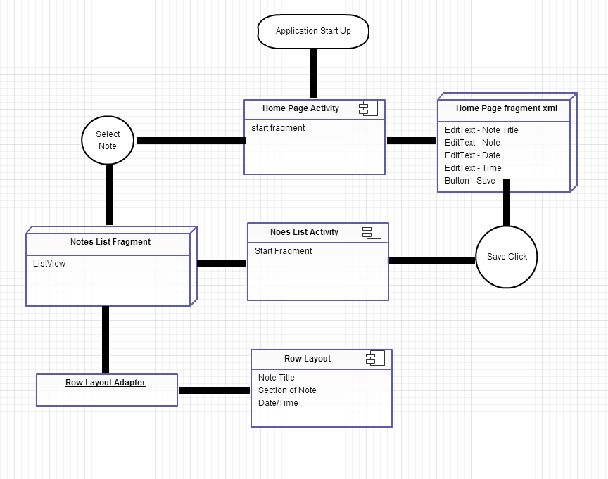

* **Views** 
  + Logical view
    - The system will provide users with a tool to store notes. There will be a home screen and a notes list screen. Upon selecting a note from the notes list screen you will be brought back to the home screen where all of the fields will be populated with the information from that note.
      * Home page
      * Notes page
  + Development view
    - Development will take place via the Eclipse IDE. The final product will be deployed to the google play store to be downloaded for any Android device. This means that all code will be written in java.
  + Process view
    - The Android framework uses fragments and activities to switch views. To move between views the system uses Intents. views will be outlined in xml which can be further edited via java.
  + Physical view
    - PassItOn will use the touch screen display to create a seamless user interface. Some of the out of scope features will leverage bluetooth, WiFi, and NFC capabilities built into Android devices.
* **Models**
  + Java
  + Android SDK
  + Android/ Java development
  + Eclipse IDE
* **Rationale**
  + By having a low number of in-scope requirements it allows the programmer to get the important things done right and on time. If there were too many features for the time allotted the engineer may rush through steps that should be better thought out.
  + Why Android? Android is a well documented platform that has been used for a couple years. You can write applications in java, a language that I need to become more familiar with.