Binding DSM satellite receivers

DSM satellites must be bound to a specific transmitter before they can be used with the px4fmu/ps4io flight controller. In typical situations this is accomplished using a DSM master receiver connected to the satellite receiver via a 3-wire serial interface. Most DSM master receivers only provide PWM signals for each control channel which are not supported by the PX4. The px4io board however does support direct connection to a DSM satellite receiver via a specialized 3-pin ‘Spektrum’ connector. In order eliminate the need for the more expensive DSM master receiver to bind the satellite, DSM satellite bind support is provided by the PX4 firmware.
The px4io bind command allows you to put a DSM satellite receiver into bind mode. Since this feature requires that the DSM VCC line (red wire) be cut and routed through relay one, it is not enabled by default in order not to affect those not using a DSM satellite receiver or wishing to use relay one for other purposes. This modification to the DSM cable is necessary in order to provide the PX4 control over the DSM satellite power line.
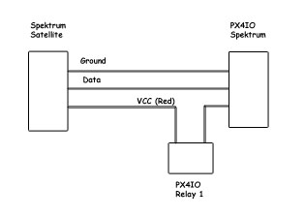
NOTE: Binding DSM2 satellites in 11-bit mode is not supported due to potential bug in some DSM2 receiver streams when in 11-bit mode. Furthermore the px4io software folds 11 bit data down to 10 bits so there is no resolution advantage to to 11-bit mode.
To enable the feature the RC_RL1_DSM_VCC parameter must be set to a non-zero value from the console, or using QGroundControl:
param set RC_RL1_DSM_VCC 1
From the console you can initiate DSM bind mode with:
uorb start
param set RC_RL1_DSM_VCC 1
px4io start
px4io bind dsm2
For binding a DSMX satellite to a DSMX transmitter you would instead use:
px4io bind dsmx
Your receiver module should start a rapid flash and you can follow the normal binding sequence of your transmitter.
Note: The value of parameter RC_RL1_DSM_VCC defaults to 0, so none of this will have any effect on an unmodified DSM receiver connection. For this feature to work, the power wire (red) must be cut and each side connected to a terminal on relay1 of the px4io board as shown in the above diagram.
This has been tested using Spektrum as well as Hobby King 'Orange' DSM2 satellite receivers, and Hobby King 'Orange' DSMX satellite receivers.

