**Week 2**

**SL4J Logging exercises**

**Exercise 1: Logging Error Messages and Warning Levels**

1. Adding SLF4J and Logback dependencies to your `pom.xml` file

<project xmlns="http://maven.apache.org/POM/4.0.0" xmlns:xsi="http://www.w3.org/2001/XMLSchema-instance" xsi:schemaLocation="http://maven.apache.org/POM/4.0.0 https://maven.apache.org/xsd/maven-4.0.0.xsd">

<modelVersion>4.0.0</modelVersion>

<groupId>SLF4J</groupId>

<artifactId>SLF4J</artifactId>

<version>0.0.1-SNAPSHOT</version>

<dependencies>

<dependency>

<groupId>org.slf4j</groupId>

<artifactId>slf4j-api</artifactId>

<version>1.7.30</version>

</dependency>

<dependency>

<groupId>ch.qos.logback</groupId>

<artifactId>logback-classic</artifactId>

<version>1.2.3</version>

</dependency>

</dependencies>

<build>

<sourceDirectory>src</sourceDirectory>

<plugins>

<plugin>

<artifactId>maven-compiler-plugin</artifactId>

<version>3.13.0</version>

<configuration>

<release>21</release>

</configuration>

</plugin>

</plugins>

</build>

</project>

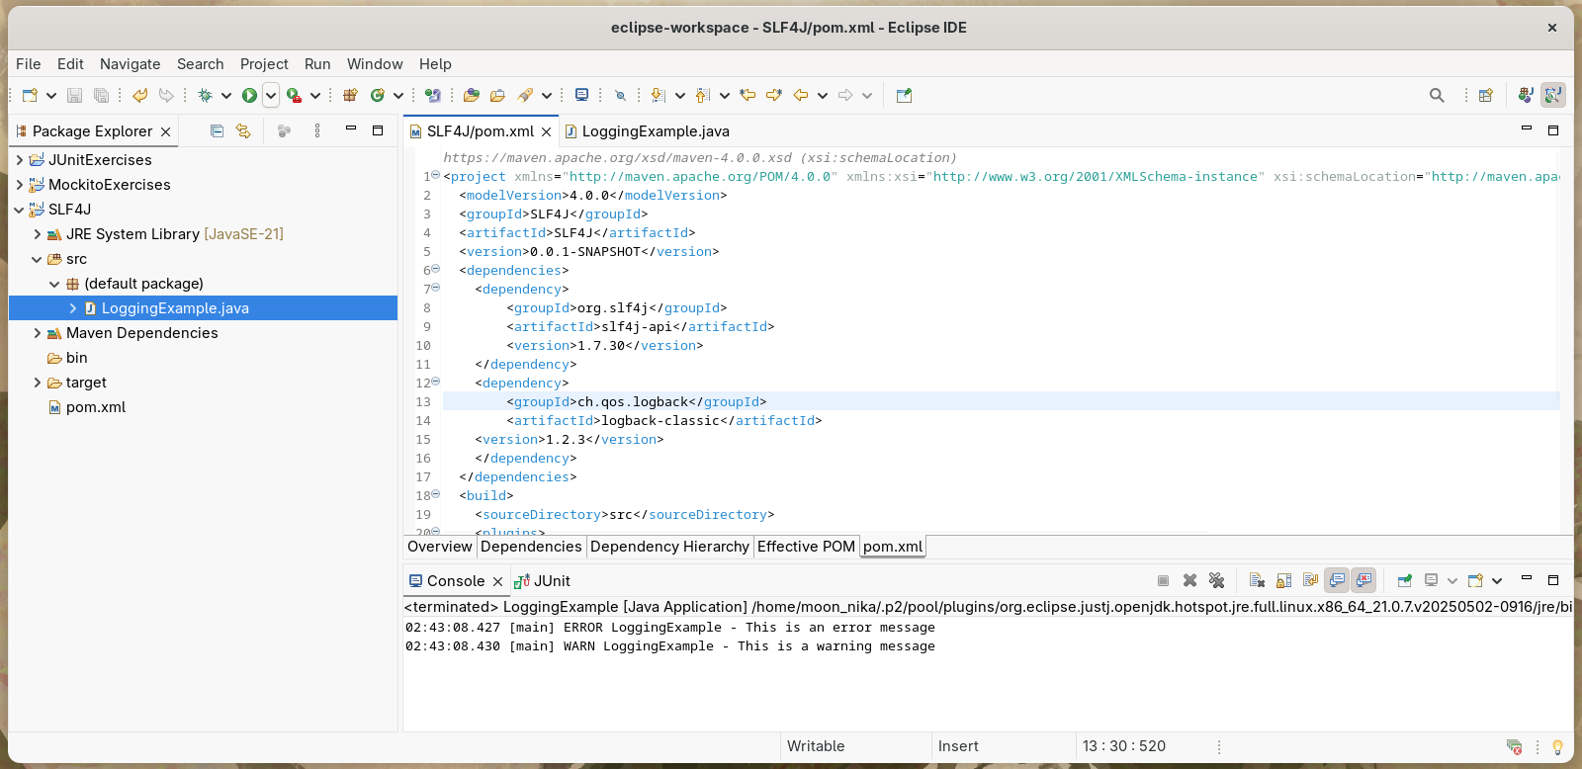

2. Create a Java class that uses SLF4J for logging

**import** org.slf4j.Logger;

**import** org.slf4j.LoggerFactory;

**public** **class** LoggingExample {

**private** **static** **final** Logger ***logger*** = LoggerFactory.*getLogger*(LoggingExample.**class**);

**public** **static** **void** main(String[] args) {

***logger***.error("This is an error message");

***logger***.warn("This is a warning message");

}

}

