**Exercise 2: Employee Management System - Creating Entities**

**Business Scenario:**

Define JPA entities for Employee and Department with appropriate relationships.

**Instructions:**

1. **Creating JPA Entities:**

Define Employee entity with fields: id, name, email, department.

Define Department entity with fields: id, name.

1. **Mapping Entities to Database Tables:**

Use annotations like @Entity, @Table, @Id, @GeneratedValue, etc.

Define one-to-many relationship between Department and Employee.

package com.company.entity;

import jakarta.persistence.*;

import lombok.*;

import org.springframework.data.annotation.CreatedBy;

import org.springframework.data.annotation.LastModifiedBy;

import org.springframework.data.annotation.CreatedDate;

import org.springframework.data.annotation.LastModifiedDate;

import org.springframework.data.jpa.domain.support.AuditingEntityListener;

import java.time.LocalDateTime;

@NamedQueries({

@NamedQuery(

name = "Employee.findByEmail",

query = "SELECT e FROM Employee e WHERE e.email = :email"

),

@NamedQuery(

name = "Employee.findByDeptName",

query = "SELECT e FROM Employee e WHERE e.department.name = :deptName"

)

})

@Entity

@EntityListeners(AuditingEntityListener.class)

@Table(name = "employees")

@Data

@NoArgsConstructor

@AllArgsConstructor

public class Employee {

@Id

@GeneratedValue(strategy = GenerationType.IDENTITY)

private Long id;

private String name;

private String email;

@ManyToOne

@JoinColumn(name="department_id")

private Department department;

public String getName() {

return name;

}

@CreatedDate

private LocalDateTime createdDate;

@LastModifiedDate

private LocalDateTime modifiedDate;

@CreatedBy

private String createdBy;

@LastModifiedBy

private String modifiedBy;

}

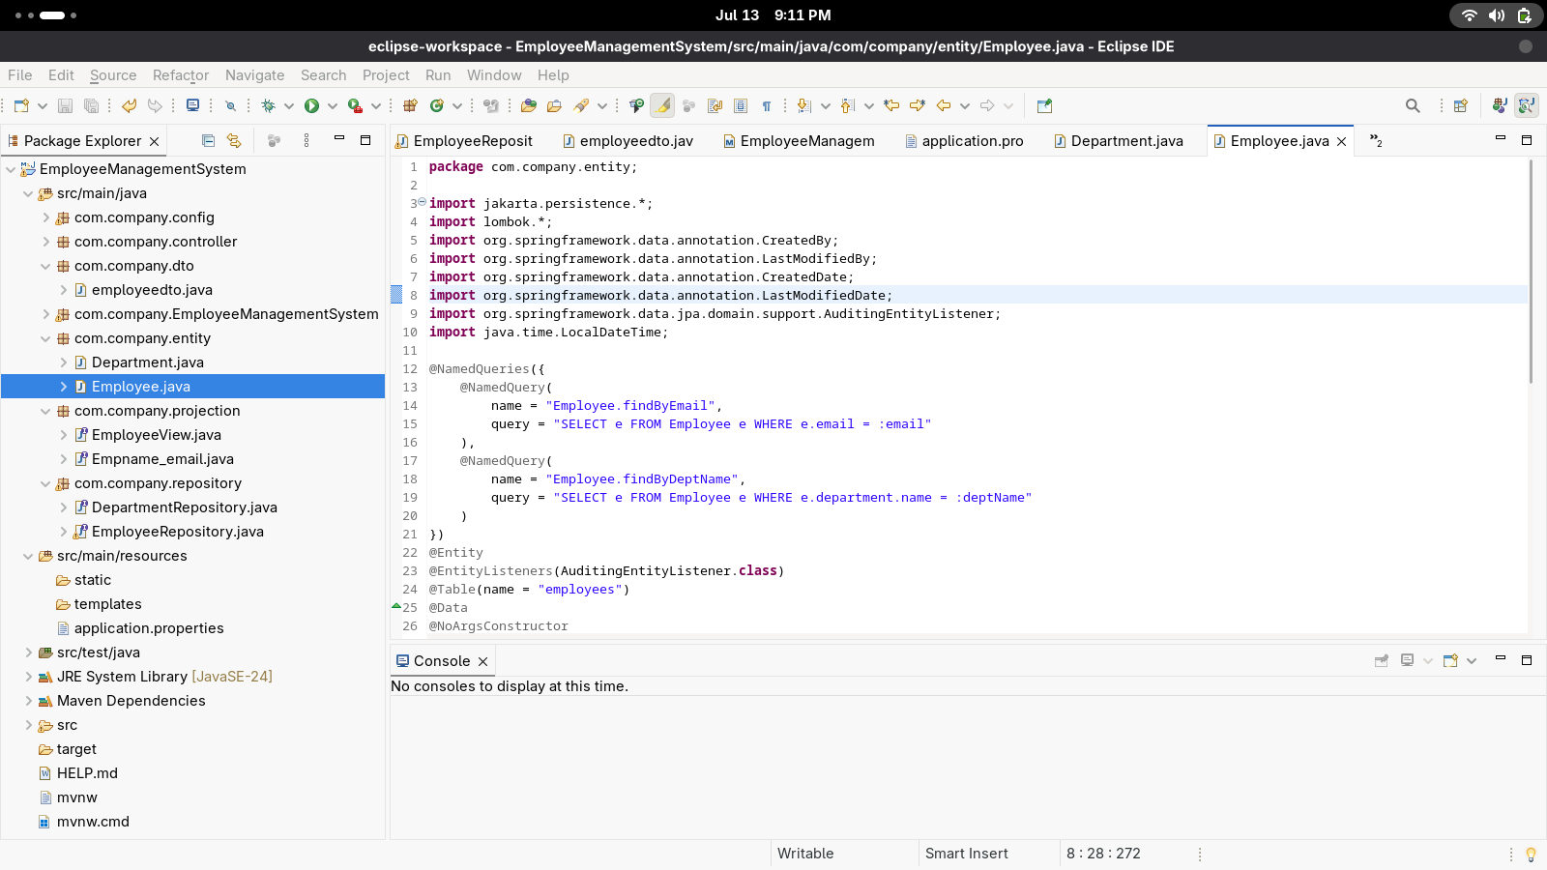

package com.company.entity;

import jakarta.persistence.*;

import lombok.*;

import org.springframework.data.annotation.CreatedBy;

import org.springframework.data.annotation.LastModifiedBy;

import org.springframework.data.annotation.CreatedDate;

import org.springframework.data.annotation.LastModifiedDate;

import org.springframework.data.jpa.domain.support.AuditingEntityListener;

import java.time.LocalDateTime;

import java.util.List;

@Entity

@EntityListeners(AuditingEntityListener.class)

@Table(name = "departments")

@Data

@NoArgsConstructor

@AllArgsConstructor

public class Department {

@Id

@GeneratedValue(strategy = GenerationType.IDENTITY)

private long id;

private String name;

@OneToMany(mappedBy = "Employee", cascade = CascadeType.ALL)

private List<Employee> employees; @CreatedDate

private LocalDateTime createdDate;

@LastModifiedDate

private LocalDateTime modifiedDate;

@CreatedBy

private String createdBy;

@LastModifiedBy

private String modifiedBy;

}

