**WEEK 4**

**Spring Rest**

**Exercise: Hello World RESTful Web Service:**

**CODE:**

**HelloController.java:**

package com.cognizant.spring_learn;

import org.slf4j.Logger;

import org.slf4j.LoggerFactory;

import org.springframework.web.bind.annotation.GetMapping;

import org.springframework.web.bind.annotation.RestController;

@RestController

public class HelloController {

private static final Logger LOGGER = LoggerFactory.getLogger(HelloController.class);

@GetMapping("/hello")

public String sayHello() {

LOGGER.info("START: sayHello()");

String message = "Hello World!!";

LOGGER.info("END: sayHello()");

return message;

}

}

**SpringLearnApplication.java:**

package com.cognizant.spring_learn;

import java.text.ParseException;

import java.text.SimpleDateFormat;

import java.util.Date;

import org.springframework.boot.SpringApplication;

import org.springframework.boot.autoconfigure.SpringBootApplication;

import org.springframework.context.ApplicationContext;

import org.springframework.context.support.ClassPathXmlApplicationContext;

import org.slf4j.Logger;

import org.slf4j.LoggerFactory;

@SpringBootApplication

public class SpringLearnApplication {

private static final Logger LOGGER = LoggerFactory.getLogger(SpringLearnApplication.class);

public static void main(String[] args) {

SpringApplication.run(SpringLearnApplication.class, args);

displayDate();

displayCountry();

}

public static void displayDate() {

LOGGER.info("START");

ApplicationContext context = new ClassPathXmlApplicationContext("date-format.xml");

SimpleDateFormat format = context.getBean("dateFormat", SimpleDateFormat.class);

try {

Date date = format.parse("31/12/2018");

LOGGER.debug("Date: " + date);

} catch (ParseException e) {

System.out.println("Error parsing date.");

e.printStackTrace();

}

((ClassPathXmlApplicationContext) context).close();

LOGGER.info("END");

}

public static void displayCountry() {

LOGGER.info("START");

ApplicationContext context = new ClassPathXmlApplicationContext("country.xml");

Country country = context.getBean("country", Country.class);

LOGGER.debug("Country : {}", country.toString());

((ClassPathXmlApplicationContext) context).close();

LOGGER.info("END");

}

}

**application.properties:**

spring.application.name=spring-learn

server.port=8081

logging.level.org.springframework=INFO

logging.level.com.cognizant.spring_learn=DEBUG

logging.pattern.console=%d{yyMMdd}|%d{HH:mm:ss.SSS}|%-20.20thread|%5p|%-25.25logger{25}|%25M|%m%n

**Output:**

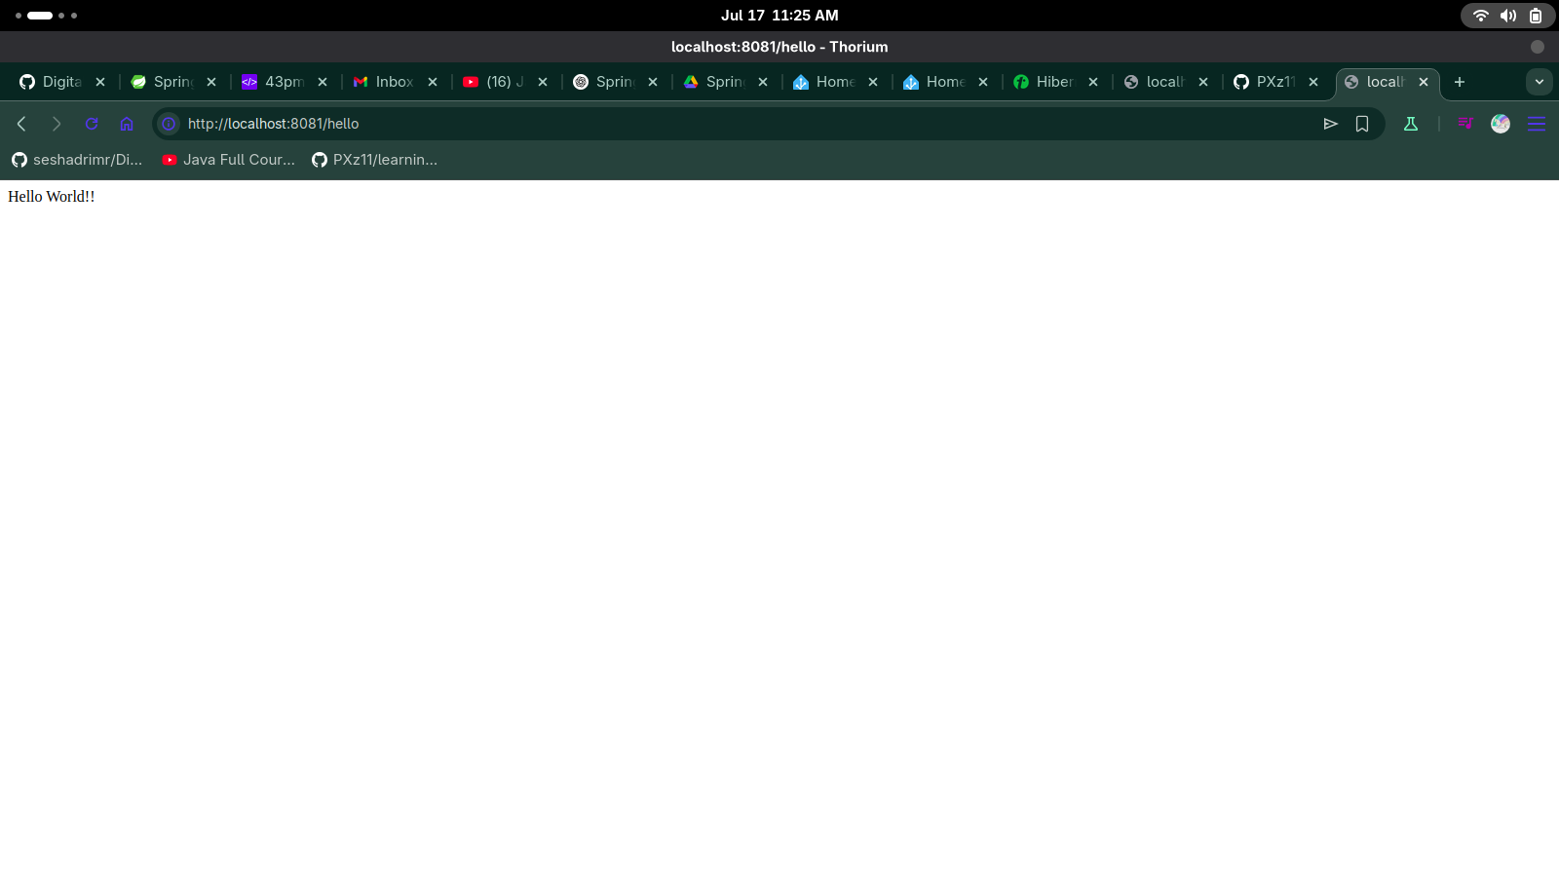

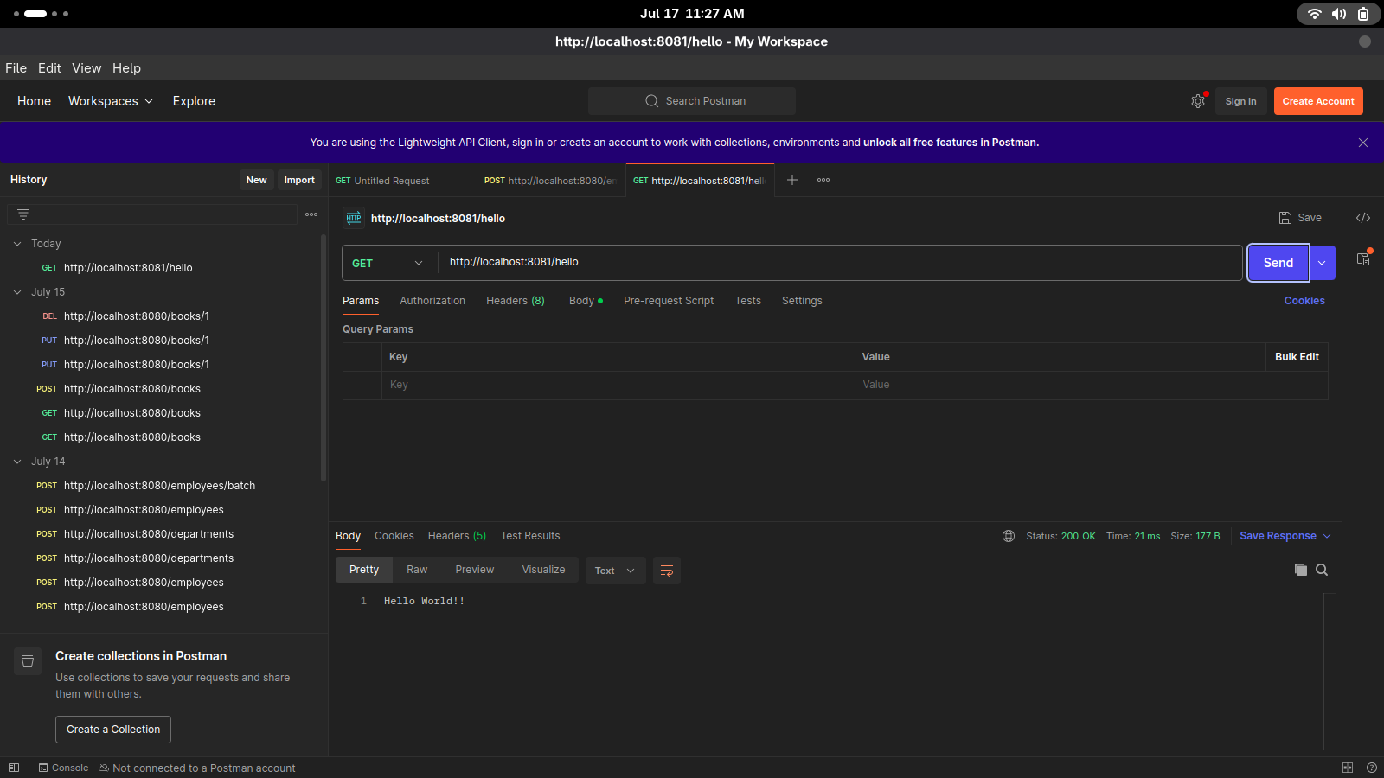

**Exercise: REST - Country Web Service:**

**CODE:**

**Country.java:**

package com.cognizant.spring_learn.model;

public class Country {

private String code;

private String name;

public Country() {}

public Country(String code, String name) {

this.code = code;

this.name = name;

}

public String getCode() {

return code;

}

public void setCode(String code) {

this.code = code;

}

public String getName() {

return name;

}

public void setName(String name) {

this.name = name;

}

}

**CountryController.java:**

package com.cognizant.spring_learn.model;

import org.slf4j.Logger;

import org.slf4j.LoggerFactory;

import org.springframework.web.bind.annotation.RequestMapping;

import org.springframework.web.bind.annotation.RestController;

import com.cognizant.spring_learn.model.CountryController;

import org.springframework.context.ApplicationContext;

import org.springframework.context.support.ClassPathXmlApplicationContext;

@RestController

public class CountryController {

private static final Logger LOGGER = LoggerFactory.getLogger(CountryController.class);

private final ApplicationContext context;

public CountryController() {

LOGGER.debug("Getting ApplicationContext from country.xml");

context = new ClassPathXmlApplicationContext("country.xml");

}

@RequestMapping("/country")

public Country getCountryIndia() {

LOGGER.info("START getCountryIndia");

Country country = (Country) context.getBean("country");

LOGGER.info("END getCountryIndia");

return country;

}

}

**application.properties:**

spring.application.name=spring-learn

server.port=8081

logging.level.org.springframework=INFO

logging.level.com.cognizant.spring_learn=DEBUG

logging.pattern.console=%d{yyMMdd}|%d{HH:mm:ss.SSS}|%-20.20thread|%5p|%-25.25logger{25}|%25M|%m%n

**country.xml:**

<?xml version="1.0" encoding="UTF-8"?>

<beans xmlns="http://www.springframework.org/schema/beans"

xmlns:xsi="http://www.w3.org/2001/XMLSchema-instance"

xsi:schemaLocation="http://www.springframework.org/schema/beans

https://www.springframework.org/schema/beans/spring-beans.xsd">

<bean id="country" class="com.cognizant.spring_learn.Country">

<property name="code" value="IN" />

<property name="name" value="India" />

</bean>

</beans>

**Output:**

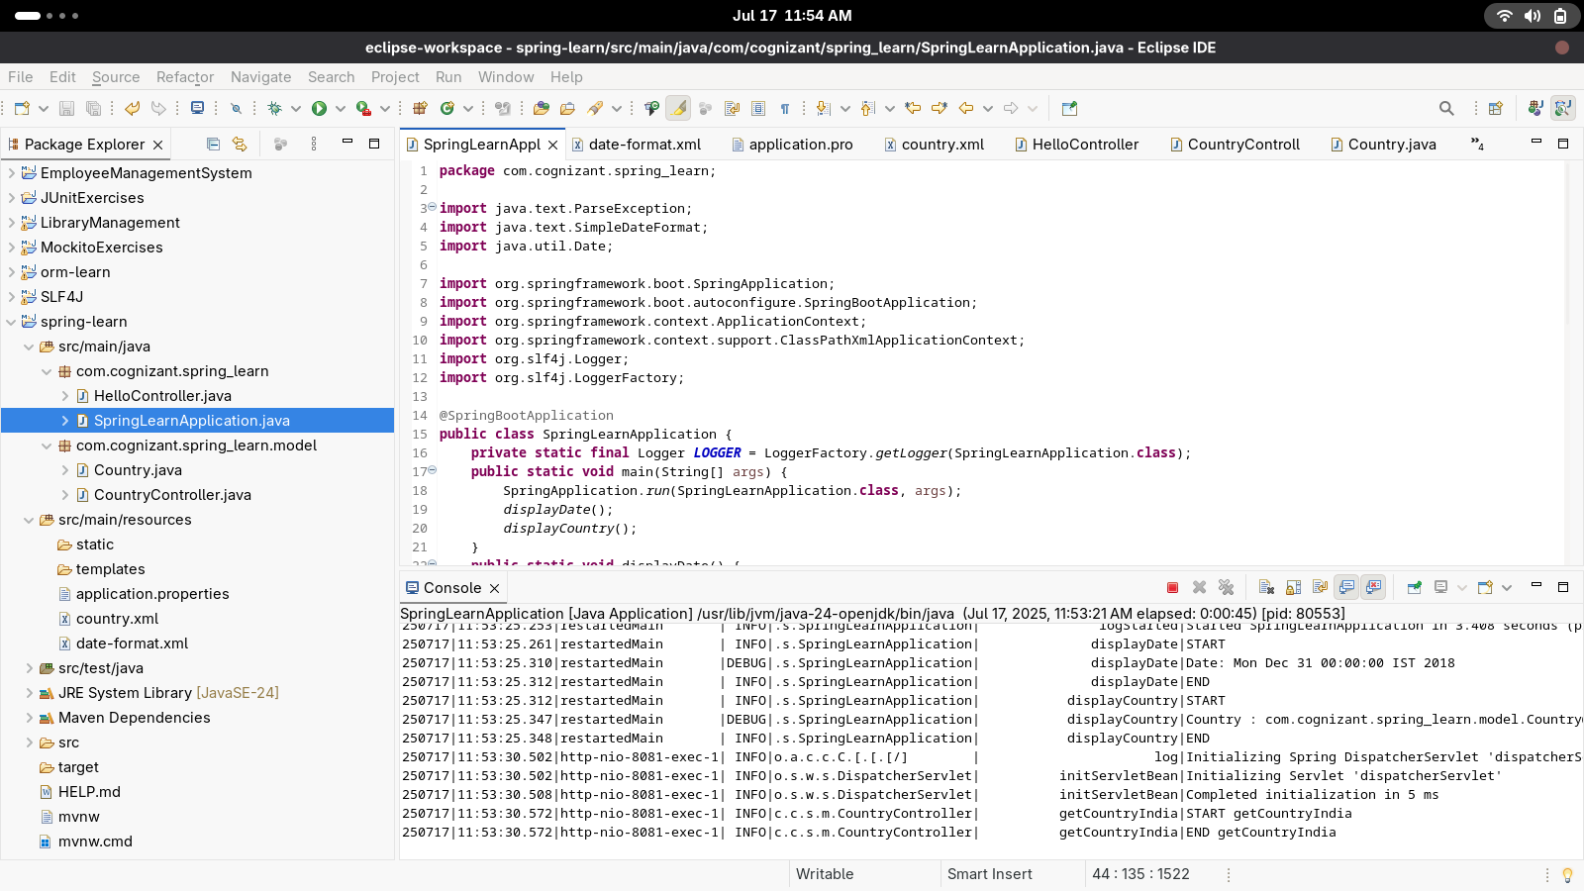

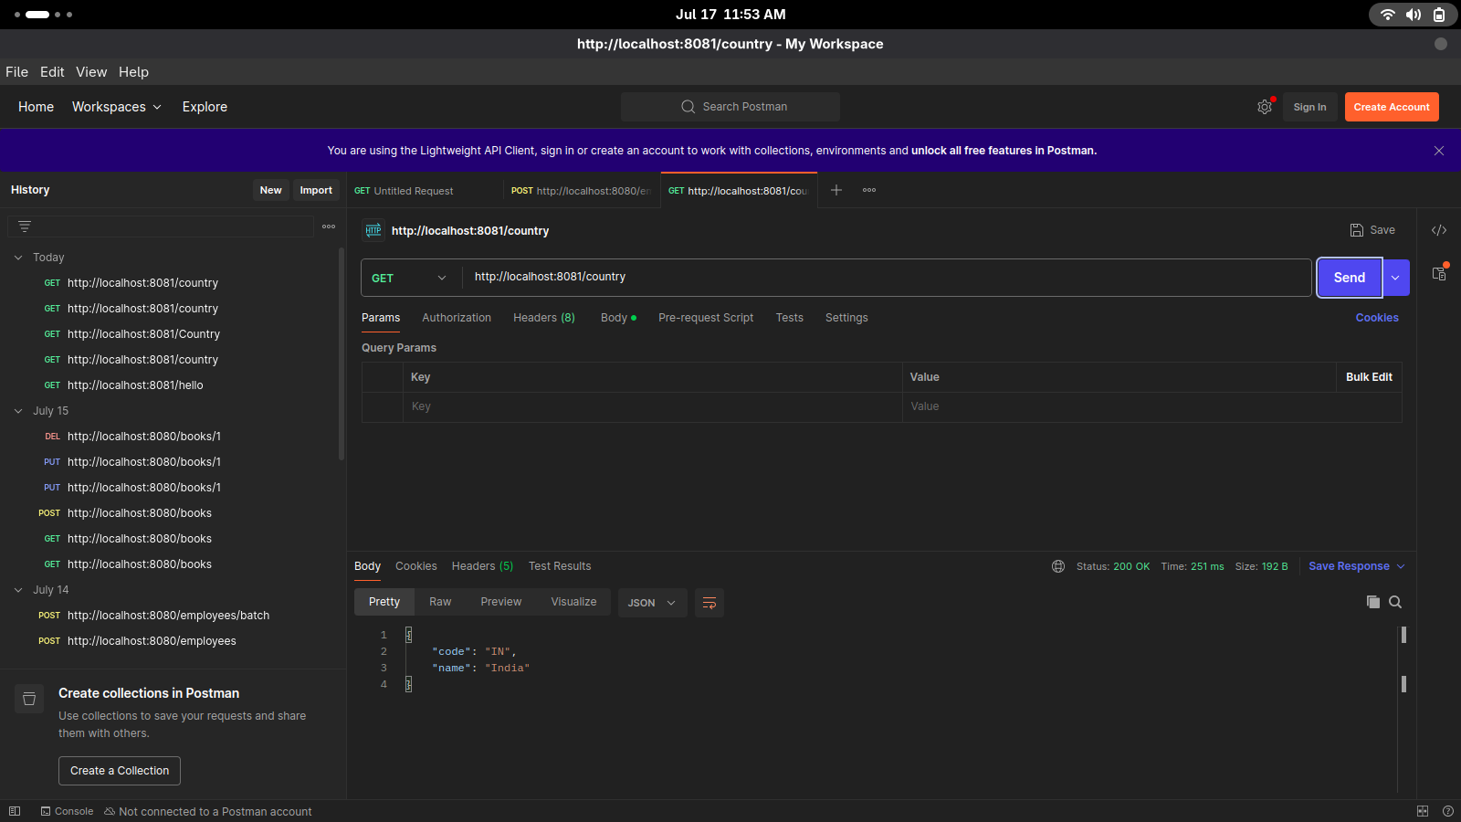

**REST - Get country based on country code   
 Code**

package com.cognizant.spring_learn.service;

import com.cognizant.springlearn.model.Country;

import org.springframework.beans.factory.annotation.Autowired;

import org.springframework.context.ApplicationContext;

import org.springframework.stereotype.Service;

import java.util.List;

@Service

public class CountryService {

@Autowired

private ApplicationContext context;

public Country getCountry(String code) {

List<Country> countryList = (List<Country>) context.getBean("countryList");

return countryList.stream()

.filter(c -> c.getCode().equalsIgnoreCase(code))

.findFirst()

.orElse(null); // Return null or throw exception as needed

}

}

OUTPUT:

