Read and Import Excel File into DataSet using C# and ADO

1. Create an Excel file and name it **test.** **xlsx** and then save it in D drive. Here is the sample of the Excel file you need to create. It shows two columns, **id** and **name** with their data.

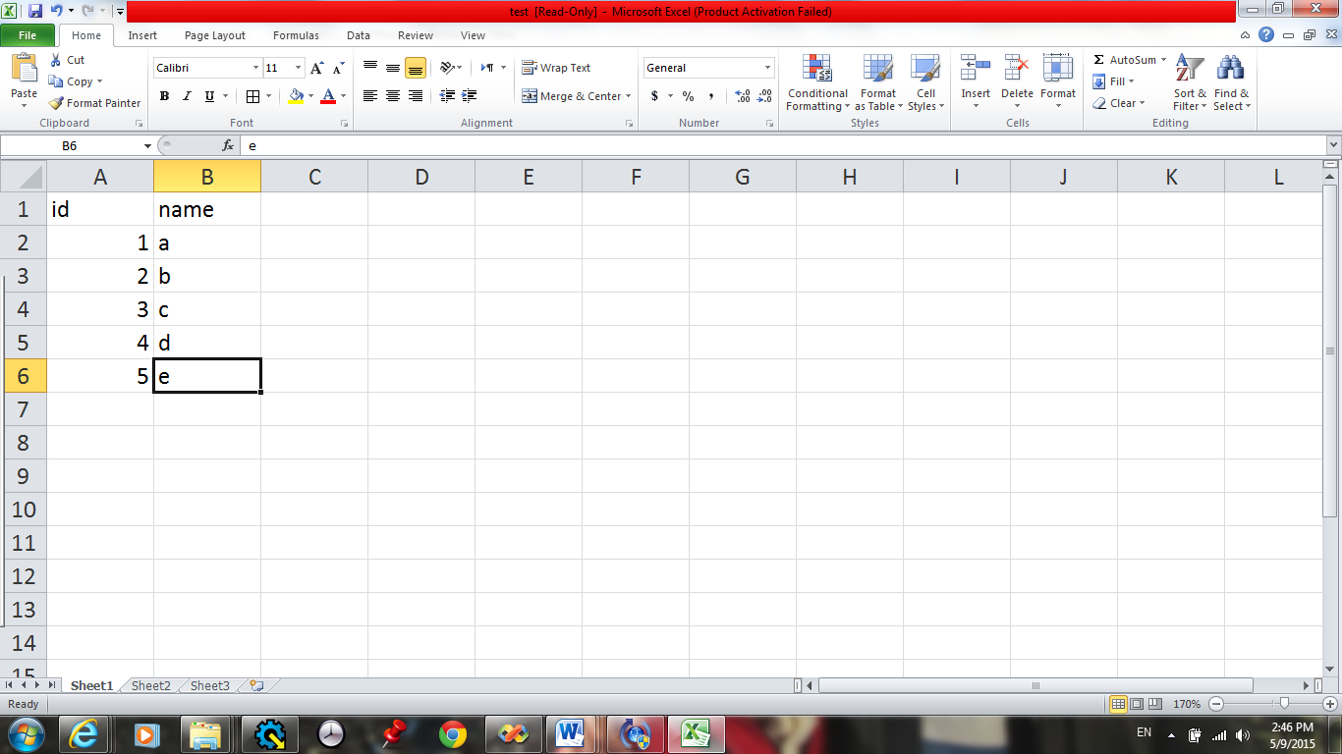

1. Create a new Windows Forms Application project using Visual C#.
2. Just add a **dataGridView** to the form and the following code to the form load and run it.

using System;

using System.Drawing;

using System.Windows.Forms;

using System.Collections.Generic;

using System.ComponentModel;

using System.Data;

using System.Linq;

using System.Text;

namespace WindowsFormsApplication_Excel

{

public partial class Form1 : Form

{

public Form1()

{

InitializeComponent();

}

private void Form1_Load(object sender, EventArgs e)

{

try

{

System.Data.OleDb.OleDbConnection MyConnection;

System.Data.DataSet DtSet;

System.Data.OleDb.OleDbDataAdapter MyCommand;

MyConnection = new System.Data.OleDb.OleDbConnection("Provider=Microsoft.ACE.OLEDB.12.0;Data Source='D:\\test.xlsx';Extended Properties=Excel 8.0;");

MyCommand = new System.Data.OleDb.OleDbDataAdapter("select * from [Sheet1$]", MyConnection);

MyCommand.TableMappings.Add("Table", "TestTable");

DtSet = new System.Data.DataSet();

MyCommand.Fill(DtSet);

dataGridView1.DataSource = DtSet.Tables[0];

MyConnection.Close();

}

catch (Exception ex)

{

MessageBox.Show(ex.ToString());

}

}

}

}