
RFID BASED HOME SECURITY SYSTEM

UNDER THE GUIDANCE OF-
Dr.Rama Sreekanth Sir

SUBMITTED BY-
G.V.Bhupathi Varma(17BEC7082)
G.Hima Vamsi(17BCD7082)
P.Yashoda Rishita(17BES7046)
G.Shivani(17BCD7031)
C.Vamsi(17BCD7040)

ABSTRACT(Summary)
- RFID based gate opening uses a microcontroller along with circuits monitoring entry and exit of cars.
- The owners are allowed an entry only when their RFID card is swiped.
- Display indication besides indicating the gate is open or gate is close.

INDEX
- Introduction
- Background
- Problem definition
- Objective
- Methodology/Procedure
- Results and Discussion
- Conclusion and future scope
- References

INTRODUCTION
Automatic identiﬁcation and access control system has become necessary to overcome the security threats faced by many. By installing the system at the entrance will only allow the authorised persons to enter the premises. The system can also be installed at various points inside the premises to track the person’s movement and to restrict their access to sensitive areas in the premises.
RFID- it stands for radio-frequency identification. RFID based access-control system allows only authorised people to enter a particular area of an establishment. With the help of RFID technology we can create smart systems that can be used personnel identiﬁcation.RFID systems usually comprises of three components: an RFID Card, an RFID Reader Module and a host device. Active RFID Tags are battery powered and they have an electronically erasable and programmable memory so we use Passive RFID beside Active RFID(Passive RFID-coil and microchip charges through induction).

BACKGROUND
Today systems based on radio-frequency identification (RFID) technology are helping to move Weiser’s vision closer to reality. These systems consist of tags (small silicon chips that contain identifying data and sometimes other information) and of readers that automatically receive and decode that data.
The responsive RFID home—and conference room, office building and car—are still far away, but RFID technology is already in limited use. The tags, often as small as a grain of rice, now hide in ID cards and wristbands, windshieldmounted toll tags, gasoline quick-purchase tokens, and electronic ear tags for livestock, and they have begun to appear in auto key-chain antitheft devices, toys (Hasbro Star Wars figures) and other products. They have also timed runners in road races, and last year a company in Mexico began a service to implant tags under the skin of children as an antikidnapping measure.

PROBLEM DEFINITION
Even though RFID Technology is secure, the security can be increased by integrating other security measures like facial detection, ﬁnger print scanner etc. As the card details are stored in the micro controller, only a limited number of card details can be stored. This can be increased by implementing a memory unit like EEPROM.{electrically erasable PROM}.

OBJECTIVE
Our objective is to design a security system using RFID. By installing the system at the entrance will only allow the authorised persons to enter the premises. The system can also be installed at various points inside the premises to track the person’s movement and to restrict their access to sensitive areas in the premises.

METHODOLOGY/PROCEDURE
When the circuit is powered ON, the microcontroller will initially display a message as “Swipe the Card” on the LCD display.
When the RFID Card or Tag is swiped against the RFID reader, it will detect the ID card and sends the unique card no. to the microcontroller via serial terminal.
With the help of suitable programming, we need to compare the received card no. with the numbers that are already stored in the microcontroller or any database like external memory unit.
If the received number is matched with the already stored number, then the microcontroller will display the name of the card holder on the LCD and activates the motor driver IC. As a result, the door is opened for a predefined duration after which the door is automatically closed.
If there is no match for the received numbers with the stored numbers, then the microcontroller will not open the door and displays a message as “Access Denied” on the LCD display.

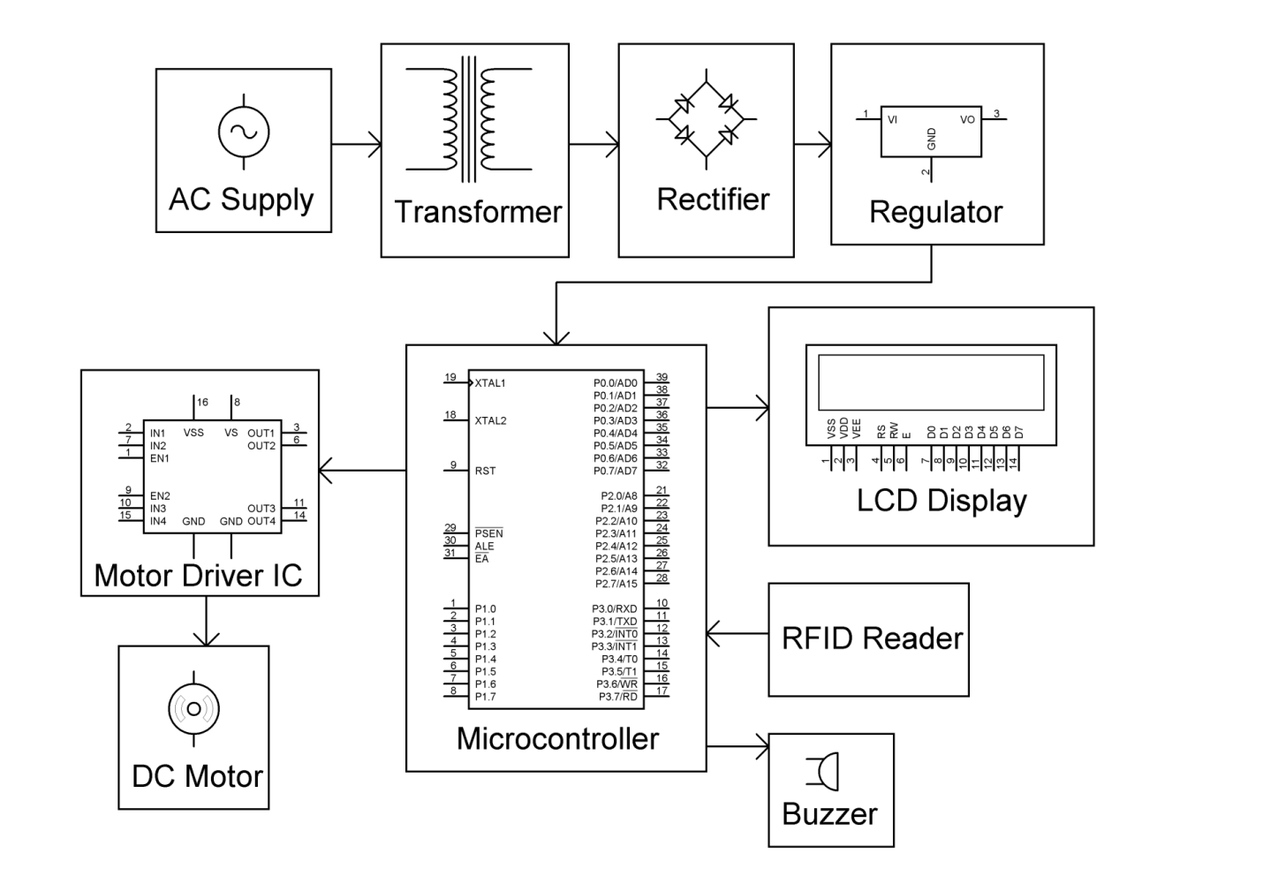

RESULTS AND DISCUSSION
With the help of suitable programming, we need to compare the received card no. with the numbers that are already stored in the microcontroller or any database like external memory unit.
If the received number is matched with the already stored number, then the microcontroller will display the name of the card holder on the LCD and activates the motor driver IC. As a result, the door is opened for a predefined duration after which the door is automatically closed.
If there is no match for the received numbers with the stored numbers, then the microcontroller will not open the door and displays a message as “Access Denied” on the LCD display.

CONCLUSION AND FUTURE SCOPE
We can add voice recognition to the system. Even though RFID Technology is secure, the security can be increased by integrating other security measures like facial detection, ﬁnger print scanner etc. As the card details are stored in the micro controller, only a limited number of card details can be stored. This can be increased by implementing a memory unit like EEPROM.{electrically erasable PROM}.

REFERENCES
- Electronicshub.org

CODE
#include<reg51.h>
#include<string.h>
sbit buzzer = P2^3;
sbit m1 = P0^1;
sbit m2 = P0^2;
const char *CARD1="4500412CF8DF";
//int card_day1=0;
const char *CARD2="4500418F77EC";
void delay_ms(int);
void serial_init();
char serial_rec();
void GSM_INIT();
void lcd_string(unsigned char *, unsigned char);
void lcd_data(unsigned char);
void lcd_cmd(unsigned char);
void lcd_ini();
void distribute(int);
int compare_card(char *);
void motor(int);
void compaire();
int s,r,d,m, cb;
sbit rs = P2^2;
sbit rw = P2^1;
sbit en = P2^0;
#define lcd_data_pin P1
char card_id[11];
unsigned int k=65;
unsigned char current_byte = 0;
void lcd_ini() //Function to inisialize the LCD
{
lcd_cmd(0x28); // for using 8-bit 2 row LCD
delay_ms(5);
lcd_cmd(0x0C);
delay_ms(5); //Force cursor to blink at line 1 positon 0
lcd_cmd(0x01);
}
void lcd_cmd(unsigned char comm) //Function to send command to LCD.
{
lcd_data_pin=comm;
en=1;
rs=0;
delay_ms(1);
en=0;
}
void lcd_data(unsigned char disp) //Function to send data to LCD.
{
lcd_data_pin=disp;
en=1;
rs=1;
delay_ms(1);
en=0;
}
void lcd_string(unsigned char *disp, unsigned char loc) //Function to send string data to LCD.
{
int x;
lcd_cmd(loc);
for(x=0;disp[x]!='0';x++)
{
lcd_data(disp[x]);
}
}
void delay_ms(int count)
{
int i,j;
for(i=0;i<=count;i++)
{
for(j=0;j<=54;j++)
{
if(RI)
{
//check_serial();
break;
break;
}
}
}
}
void serial_init()
{
TMOD=0x20; //Enable Timer 1
TH1=0XFD;
SCON=0x50;
TR1=1;
EA=1;
}
void recieve() interrupt 4 // Function to recieve data serialy from RS232
{
card_id[current_byte]=SBUF;
RI=0; // Reset the serial interrupt after recieving the byte
current_byte++;
}
void GAIT()
{
lcd_cmd(0x01);
lcd_string(" GATE IS OPEN", 0x80);
m1=1;
m2=0;
delay_ms(5500);
lcd_cmd(0x01);
lcd_string(" GATE IS STOP ", 0x80);
lcd_string(" kindly go ", 0xC0);
m1=0;
m2=0;
delay_ms(500);
buzzer =1;
lcd_cmd(0x01);
lcd_string(" GATE WILL ", 0x80);
lcd_string(" CLOSE SOON ", 0x0C);
delay_ms(2000);
buzzer =0;
lcd_cmd(0x01);
lcd_string("GATE IS CLOSE", 0x80);
m1=0;
m2=1;
delay_ms(500);
m1=0;
m2=1;
}
int compare_card(char *num)
{ int i,c1=0,c2=0,c3=0;
for(i=0;i<12;i++)
{
if(num[i]==CARD1[i])
{
c1++;
}
}
for(i=0;i<12;i++)
{
if(num[i]==CARD2[i])
{
c2++;
}
}
if(c1==12)
{
lcd_cmd(0x01);
lcd_string("CAR NUMBER ONE ", 0x80);
lcd_string("IS AUTHORISED ", 0xC0);
delay_ms(2000);
GAIT();
}
else if(c2==12)
{
lcd_cmd(0x01);
lcd_string("CAR NUMBER TWO ", 0x80);
lcd_string("IS AUTHORISED ", 0xC0);
delay_ms(2000);
GAIT();
}
else
{
lcd_cmd(0x01);
lcd_string("CARD DETAILS", 0x80);
lcd_string("NOT FOUND", 0xC0);
delay_ms(3000);
}
}
int main()
{
rw=0; //s=0; r=0; d=0; m1=0; m2=1; m=0; cb=0;
buzzer=0;
lcd_ini();
serial_init();
lcd_string("WELCOME", 0x80);
delay_ms(2000);
lcd_cmd(0x01);
lcd_string(" RFID BASED ", 0x80);
lcd_string(" GATE OPENING ", 0xC0);
delay_ms(2000);
IE=0x90; //Interrupt enable
delay_ms(100);
while(1)
{
lcd_string(" KINDLY SWIPE ", 0x80);
lcd_string(" YOUR RF CARD ", 0xC0);
if(current_byte==12)
{
current_byte=0;
compare_card(card_id);
}

}
}

-----------

