Guide to Creating Donation Links on PayPal

Step 1: Log in to PayPal
- Access your PayPal account at www.paypal.com.

Step 2: Navigate to PayPal Buttons
- Go to your profile (https://www.paypal.com/myaccount/profile)
- Select Seller Tools
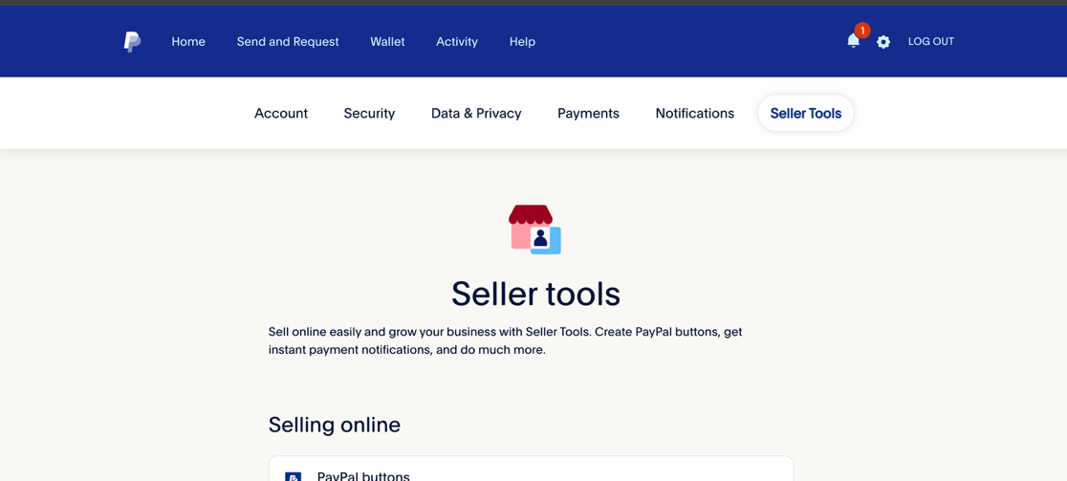
- Under the Selling Online heading click on “Paypal Buttons”
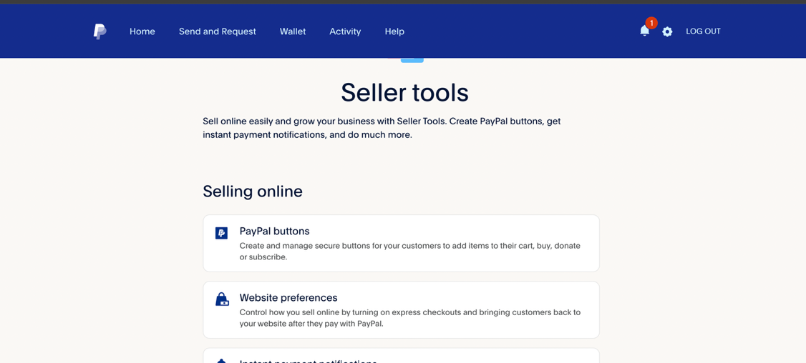
- Create a “Donate” Button

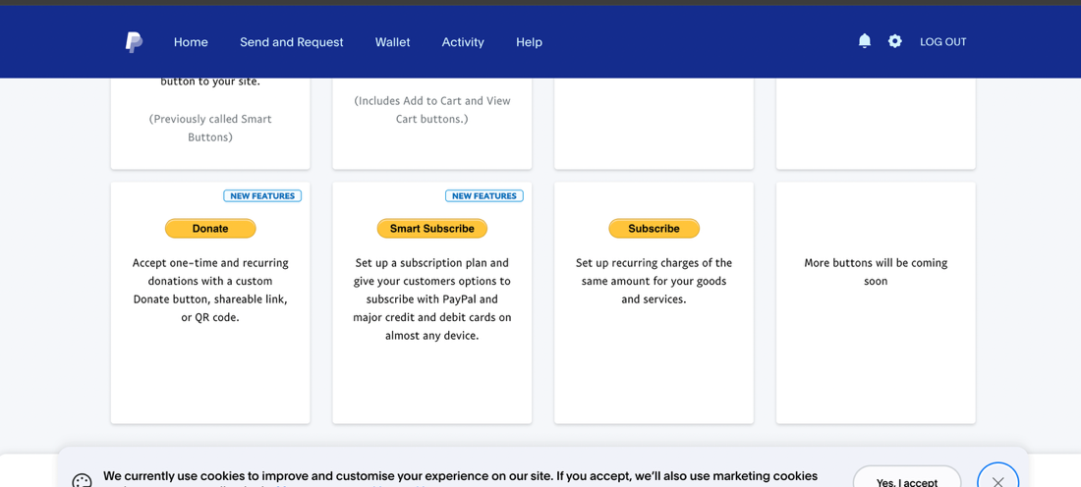
- Click on “Get a link” under the Create a link heading
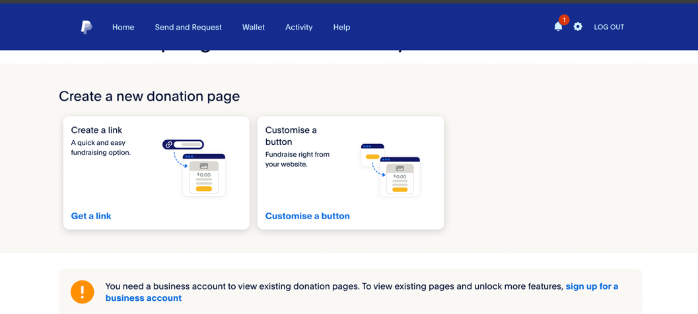

Step 3: Create a Donation Button
- Page 1:
  - Your Display name is your official PayPal name, so if you want to change that you have to change your PayPal Name
  - Add a message, haven’t talked to Nektary about this, but if you guys would like a message underneath the donate button, saying thank you or anything else, you can add it under the “Add an inspiring message to your donation page (Optional)” heading
  - Once this is done, press continue
- Page 2:
  - Currency: AUD
  - How Much: Click the “Any Amount” option
  - Again, another thing I haven’t discuss, but assuming we are allowing monthly recurring donations, so keep the checked.
- Press “Finish”
- Press the “Get Link” button, copy the link that comes up, this is the link that directs to your PayPal donation page, make sure you keep a copy of it as once you leave this page, you can’t come back (unless you have a payed Business account). 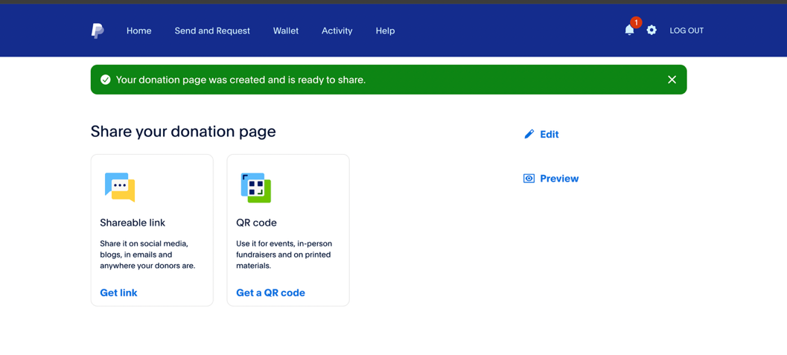

Step 4: Link has been created
- Send the link to me/Nektary to put into the website.

