LEFT

STRAIGHT

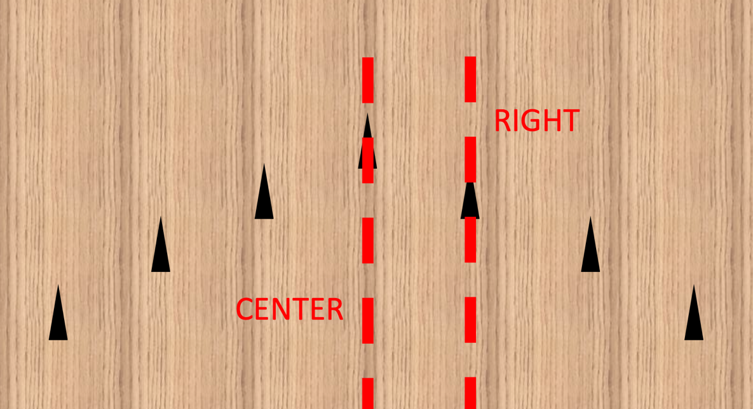

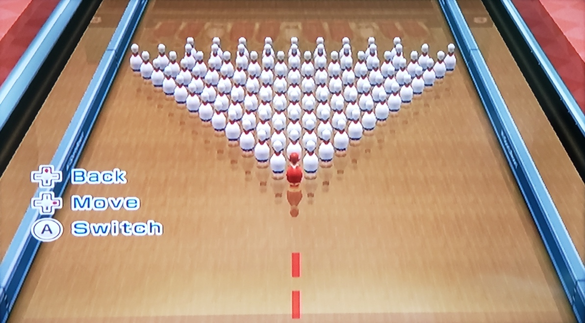

CENTER

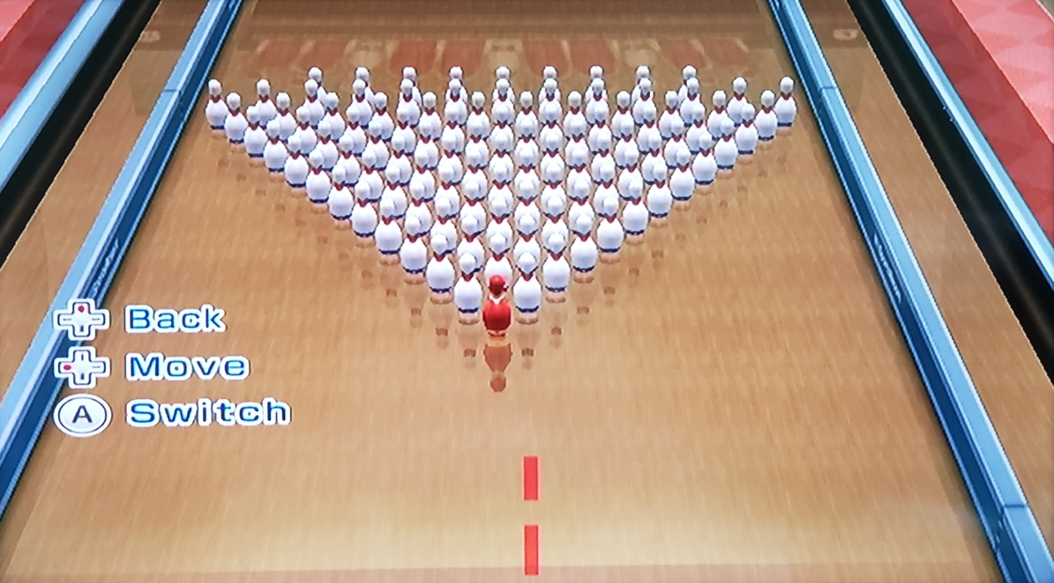

RIGHT

LATE

NOT LATE