1. Write a query to get a Product list (id, name, unit price) where current products cost less than $20.

SELECT ProductID, ProductName, UnitPrice

FROM Products

WHERE Discontinued = 0 AND UnitPrice < 20

ORDER BY UnitPrice DESC

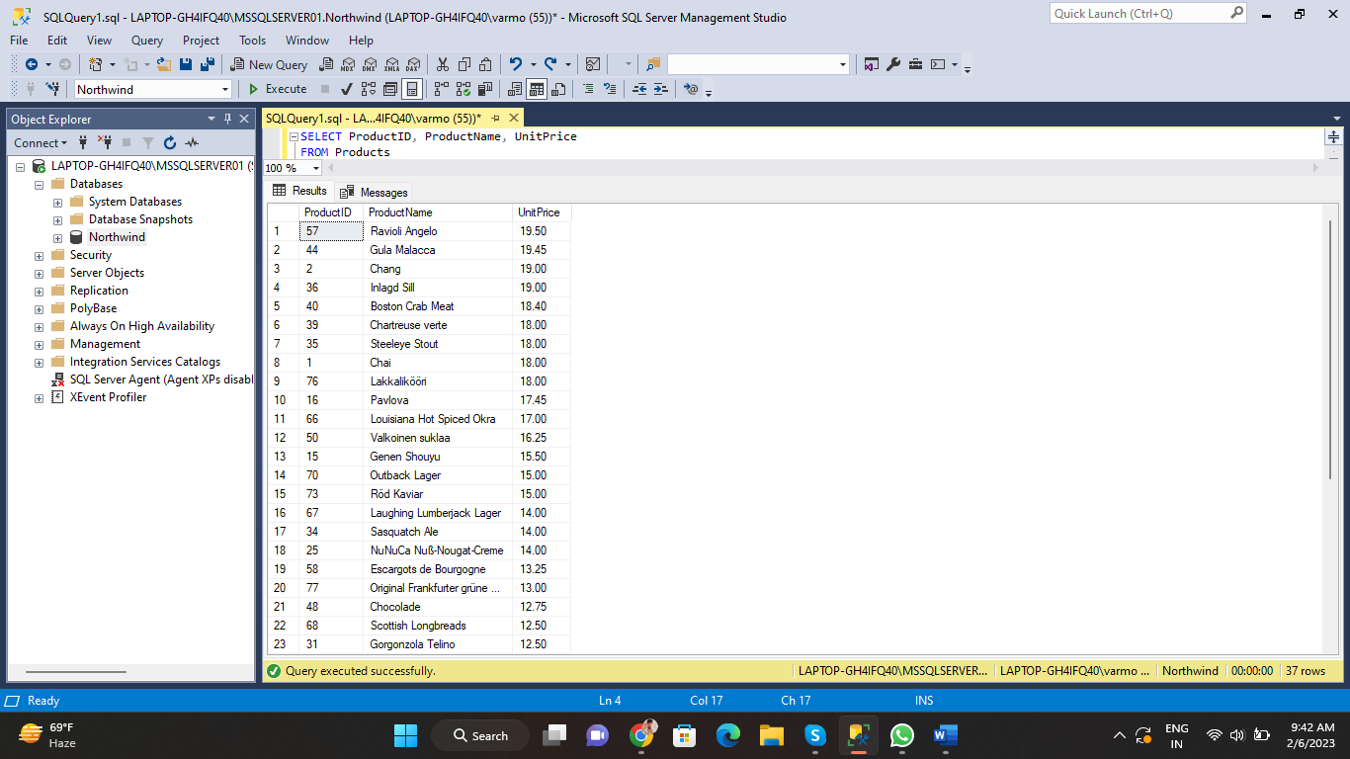

1. Write a query to get Product list (id, name, unit price) where products cost between $15 and $25.

SELECT ProductID, ProductName, UnitPrice

FROM Products

WHERE UnitPrice BETWEEN 15 AND 25

ORDER BY UnitPrice ASC

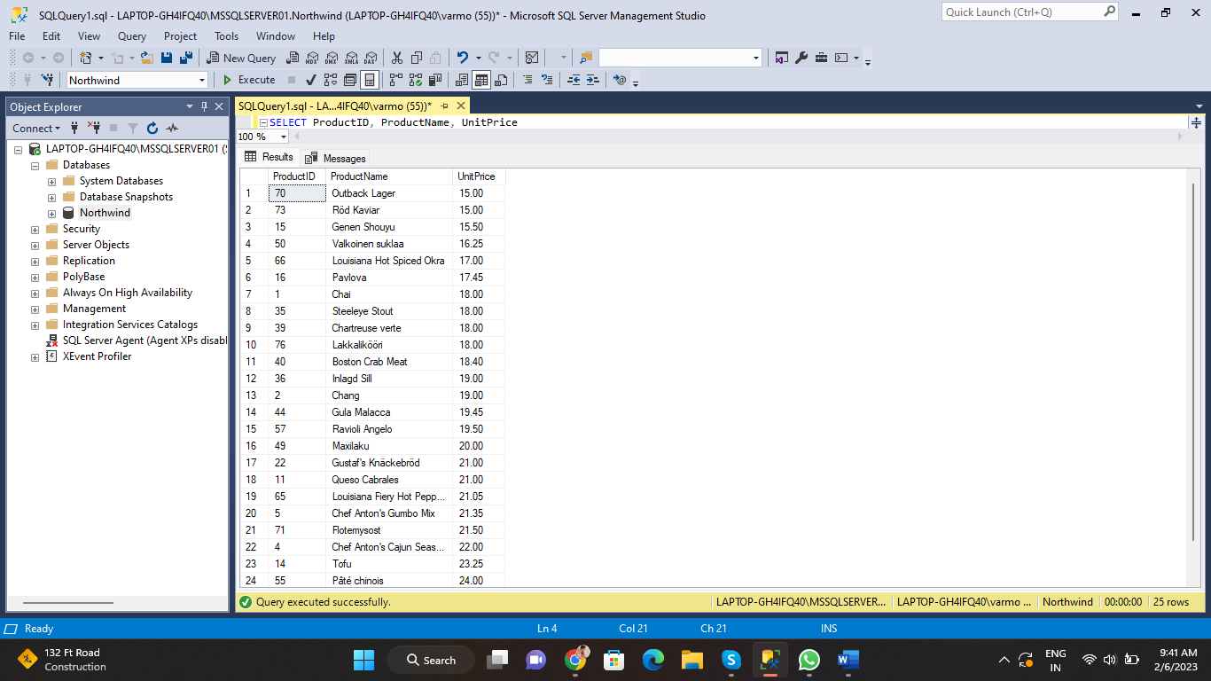

1. Write a query to get Product list (name, unit price) of above average price.

SELECT ProductID, ProductName, UnitPrice

FROM Products

WHERE UnitPrice > (SELECT AVG(UnitPrice) FROM Products)

ORDER BY UnitPrice ASC

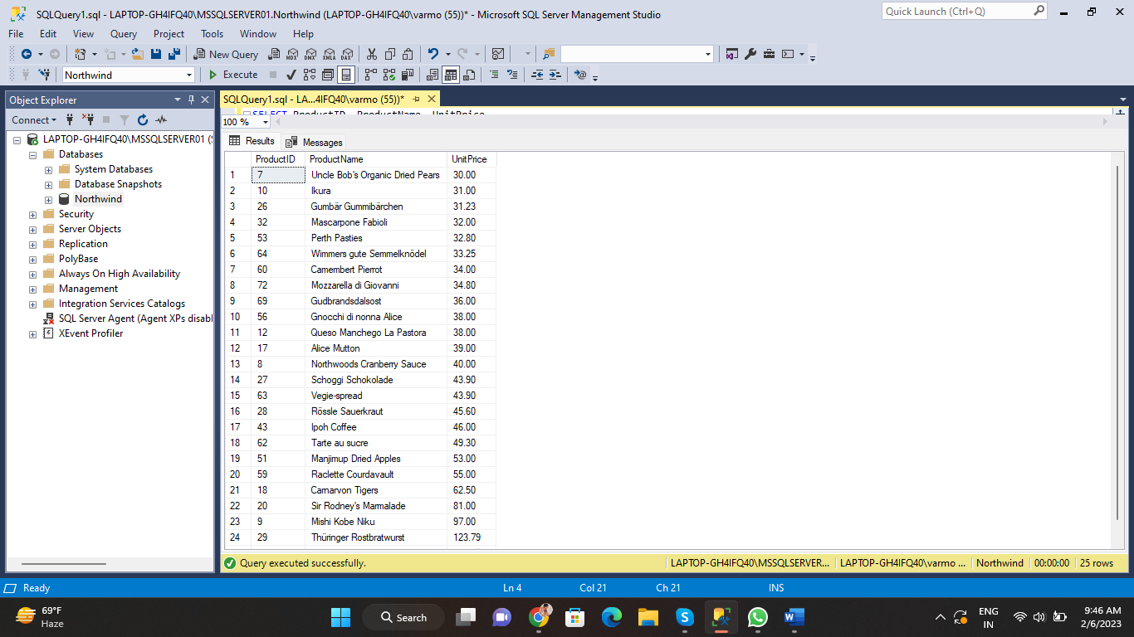

1. Write a query to get Product list (name, unit price) of ten most expensive products.

SELECT TOP 10 ProductID, ProductName, UnitPrice

FROM Products

ORDER BY UnitPrice DESC

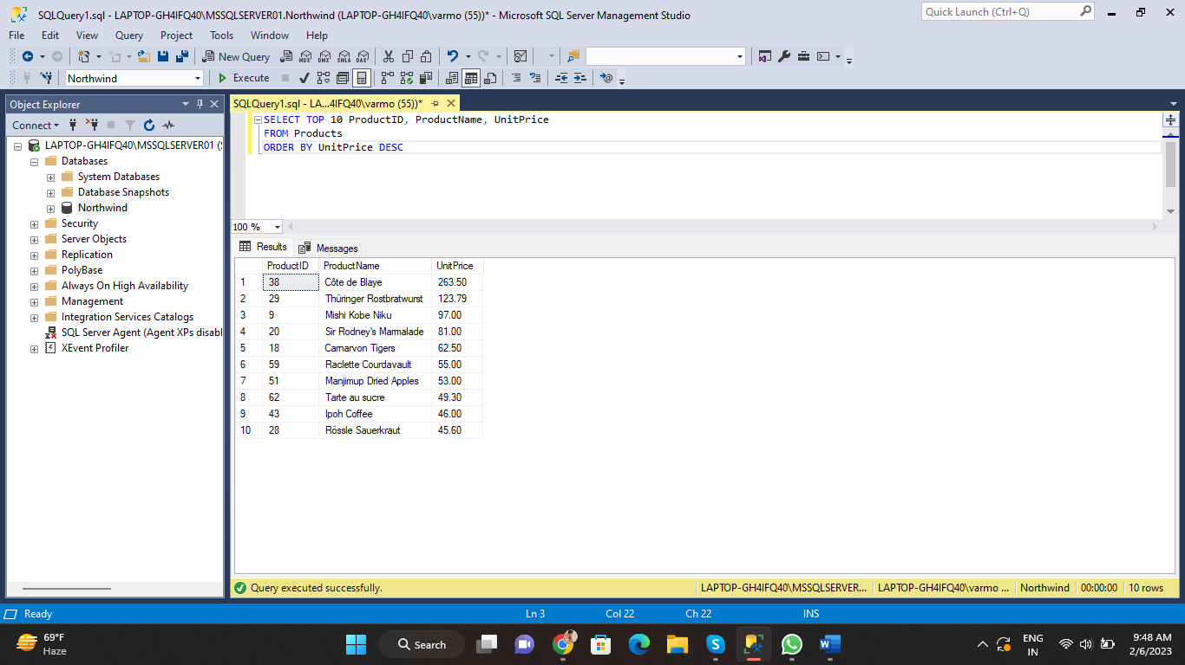

1. Write a query to count current and discontinued products.

SELECT COUNT(Discontinued)

FROM Products

GROUP BY Discontinued

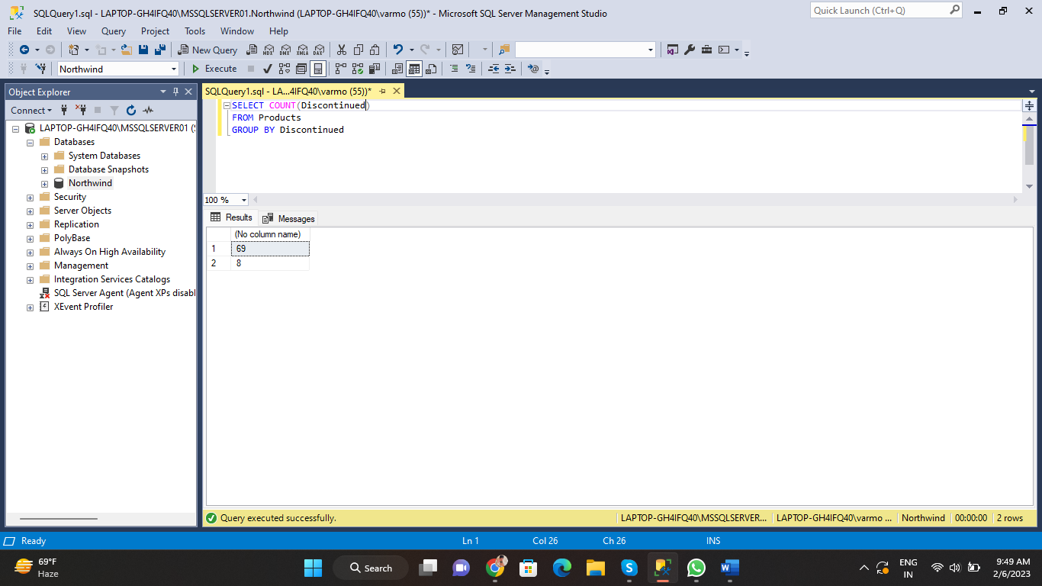

1. Write a query to get Product list (name, units on order , units in stock) of stock is less than the quantity on order.

SELECT ProductName, UnitsOnOrder, UnitsInStock

FROM Products

WHERE UnitsInStock < UnitsOnOrder

