1. write a SQL query to find Employees who have the biggest salary in their Department

Select e.emp_id AS EmployeeID,

e.emp_name AS EmloyeeName,

e.Salary AS MaxSalary,

d.dept_id AS DepartmentID,

d.dept_name AS DepartmentName

From Employee e

Inner Join Department d

On e.dept_id = d.dept_id

Where Salary In(

Select Max(Salary)

From Employee

Group By dept_id

)

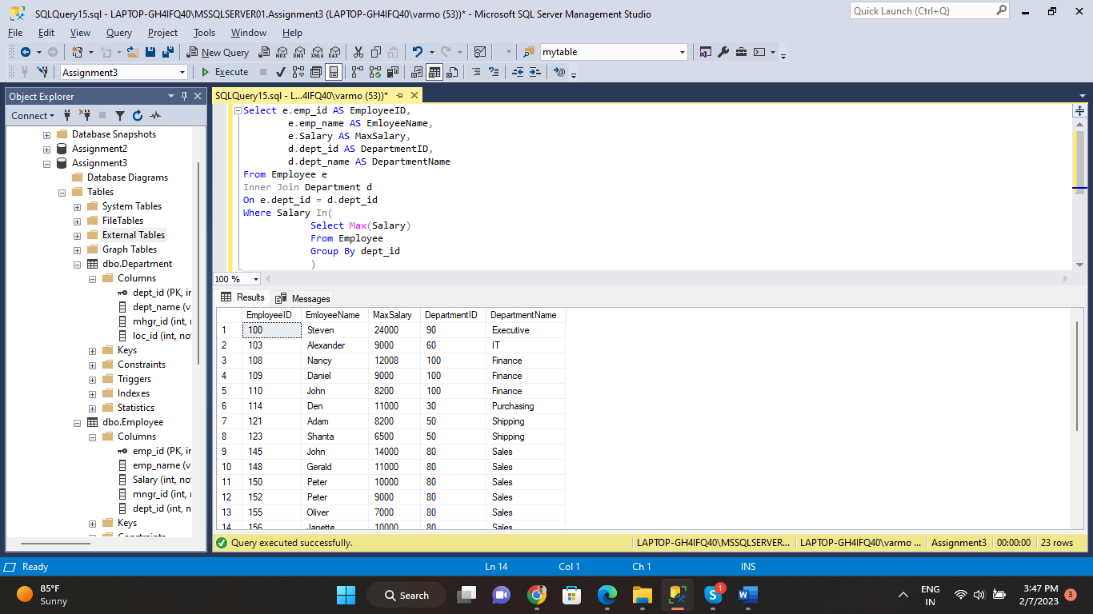

2. write a SQL query to find Departments that have less than 3 people in it

SELECT d.dept_name

FROM Employee e

INNER JOIN Department d

ON e.dept_id = d.dept_id

GROUP BY d.dept_name

HAVING COUNT(*) < 3

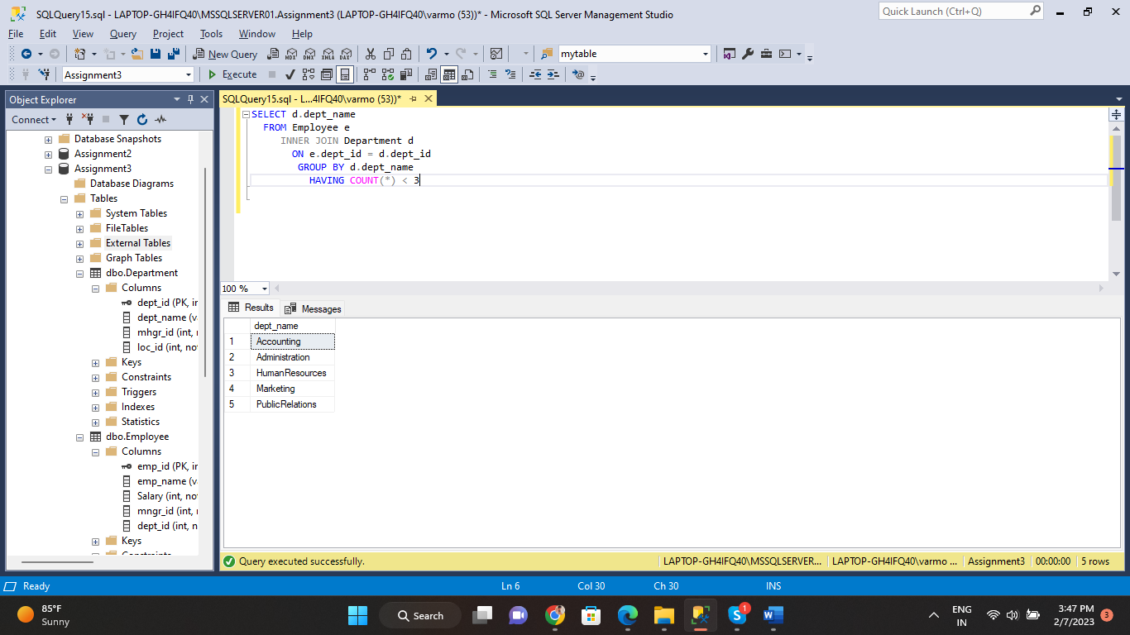

3. write a SQL query to find All Department along with the number of people there

Select d.dept_name AS DepartmentName,

count(e.emp_id) AS "No of Employees"

From Employee e

Inner Join Department d

On e.dept_id = d.dept_id

Group By d.dept_name

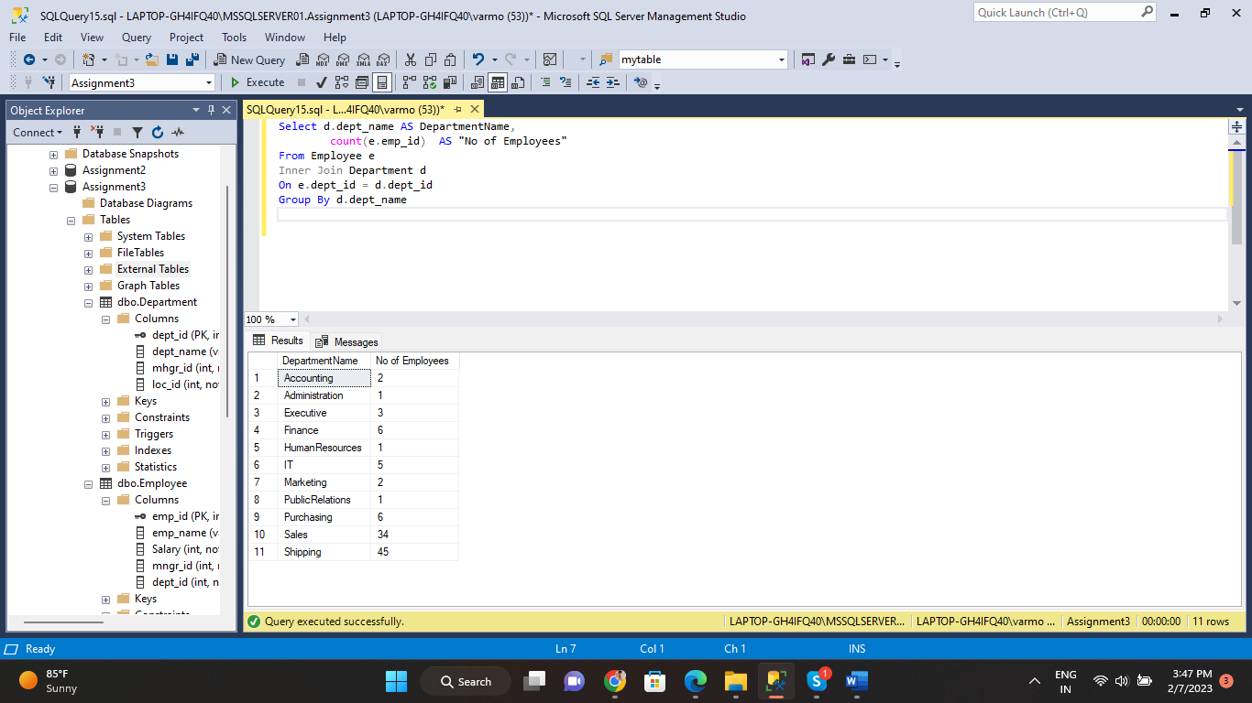

4. write a SQL query to find All Department along with the total salary there

Select d.dept_name AS DepartmentName,

sum(e.Salary) AS "Total Salary"

From Employee e

Inner Join Department d

On e.dept_id = d.dept_id

Group By d.dept_name

