1. Create a stored procedure in the Northwind database that will calculate the average value of Freight for a specified customer.Then, a business rule will be added that will be triggered before every Update and Insert command in the Orders controller,and will use the stored procedure to verify that the Freight does not exceed the average freight. If it does, a message will be displayed and the command will be cancelled.

Create or Alter proc sp_avgfreightofcstmr

@cust_id varchar(10),

@cust_freight float

As

Begin

Declare @avg_freight_customer float

Select @avg_freight_customer = avg(o.Freight)

from Customers c

Inner Join Orders o

On c.CustomerID = o.CustomerID and c.CustomerID = @cust_id

Group By c.CustomerID;

if (@avg_freight_customer < @cust_freight)

Begin

Insert Into Orders(Freight) values (@cust_freight);

End

Else

Begin

Print 'Data Not added to the table'

End

End

Exec sp_avgfreightofcstmr 'VINET',15.2

Create or Alter Trigger tr_Orders_ForCheckInsert

on Orders

Instead Of Insert

AS

Begin

Declare @CustomerId Varchar(10)

Declare @Freight Float

Select @CustomerId from inserted

Select @Freight from inserted

Execute sp_avgfreightofcstmr @CustomerId,@Freight

End

insert into Orders(CustomerID,Freight) values ('VINET',1.09)

Select * from Orders

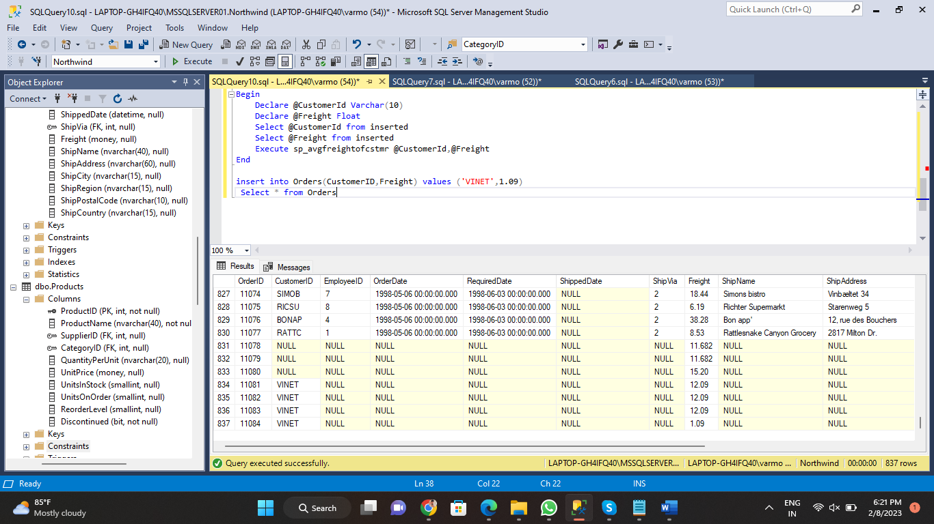

2. write a SQL query to Create Stored procedure in the Northwind database to retrieve Employee Sales by Country

CREATE PROCEDURE usp_Employees_Sales_By_Country

AS

BEGIN

SELECT e.EmployeeID AS 'ID',

e.FirstName + ' ' + e.LastName AS 'Employee Name',

o.ShipCountry AS 'Country',

ROUND(SUM(od.UnitPrice * od.quantity - (od.UnitPrice * od.quantity * od.discount)), 2) AS 'Total Sale'

FROM Employees e

JOIN Orders o ON e.EmployeeID = o.EmployeeID

JOIN [Order Details] od ON o.OrderID = od.OrderID

GROUP BY e.EmployeeID, e.FirstName, e.LastName, o.ShipCountry

ORDER BY e.EmployeeID

END

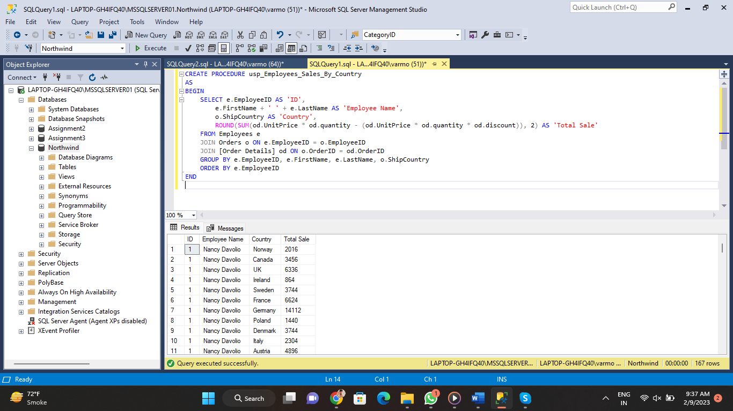

3. write a SQL query to Create Stored procedure in the Northwind database to retrieve Sales by Year

Create or Alter Procedure sp_SalesByCountry

As

Begin

Select Datename(Year,o.ShippedDate),

Round(Sum(od.UnitPrice * od.Quantity - (od.UnitPrice * od.Quantity * od.Discount)), 2) As "Total Sale"

From Orders o

Join [Order Details] od

On o.OrderID = od.OrderID And o.ShippedDate Is Not Null

Group By DateName(Year, o.ShippedDate)

Order By DateName(Year, o.ShippedDate)

End

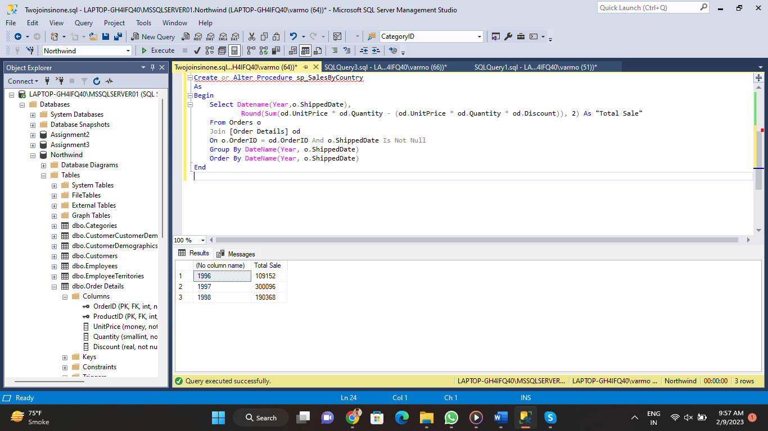

4. write a SQL query to Create Stored procedure in the Northwind database to retrieve Sales By Category

CREATE PROCEDURE usp_Sales_By_Category

AS

BEGIN

SELECT c.CategoryID, c.CategoryName,

ROUND(SUM(od.UnitPrice * od.Quantity - (od.UnitPrice * od.Quantity * od.Discount)), 2) AS 'Total Sale'

FROM Categories c

JOIN Products p ON P.CategoryID = c.CategoryID

JOIN [Order Details] od ON od.ProductID = p.ProductID

GROUP BY c.CategoryID, c.CategoryName

ORDER BY c.CategoryName

END

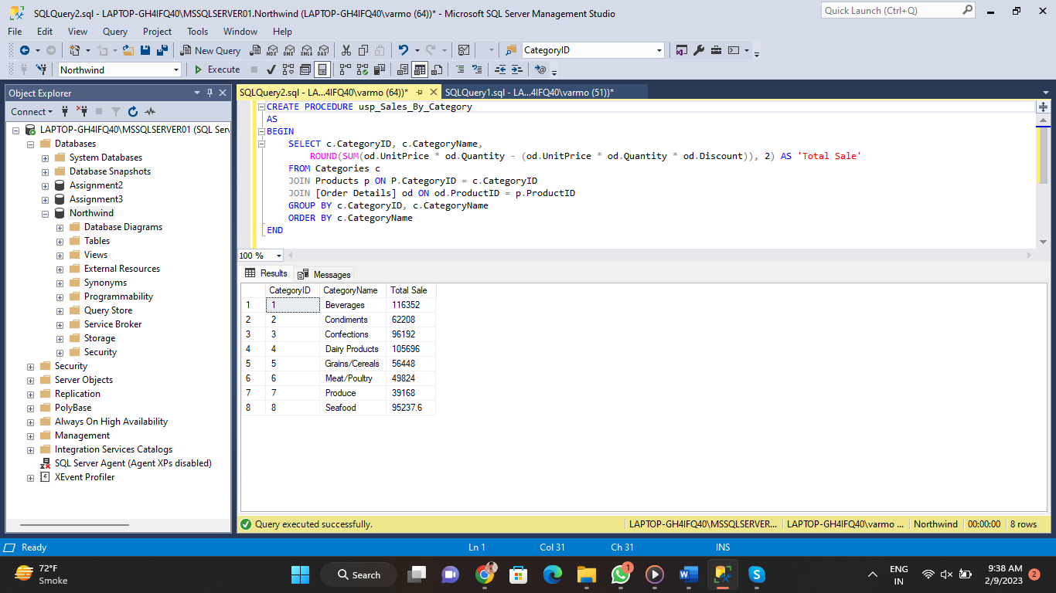

5. write a SQL query to Create Stored procedure in the Northwind database to retrieve Ten Most Expensive Products

Create or Alter Proc sp_TopTenProduct

As

Begin

Select Top 10 ProductName, UnitPrice

From Products

Order By Unitprice DESC

End

Execute sp_TopTenProduct

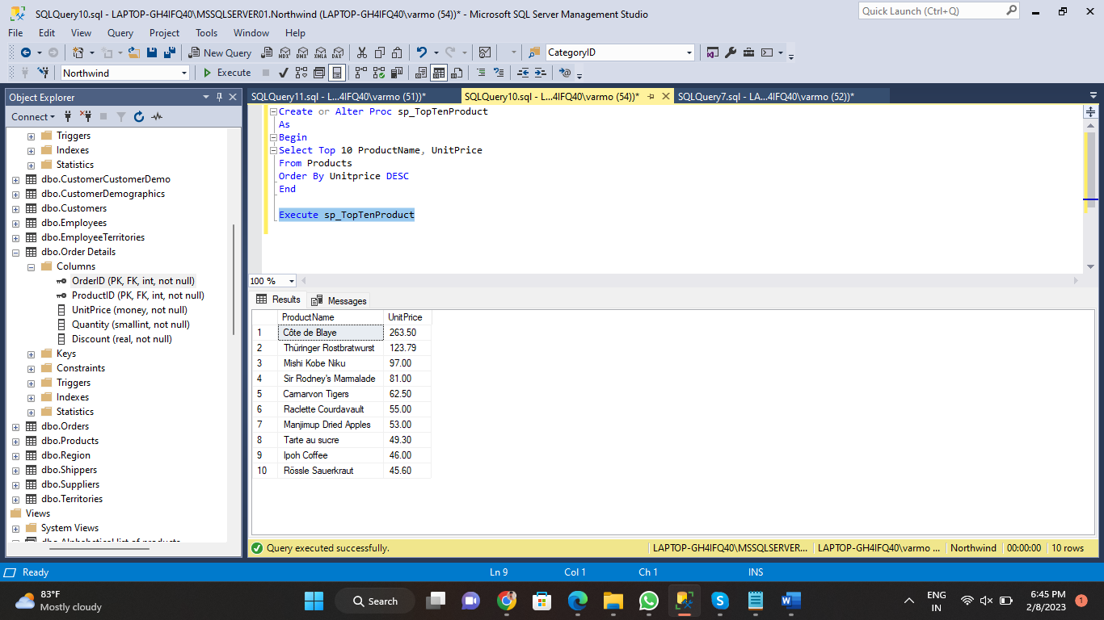

6. write a SQL query to Create Stored procedure in the Northwind database to insert Customer Order Details

Create or Alter Proc sp_OrderDetails_insert

@Order_ID Int,

@Product_ID Int,

@Unit_Price Float,

@Quntity Int,

@Discount Int

As

Begin

If((Select Count(@Order_ID) From Orders) <> 1)

Begin

Insert Into [Order Details] (OrderID,ProductID,UnitPrice,Quantity,Discount) Values (@Order_ID,@Product_ID,@Unit_Price,@Quntity,@Discount)

End

End

sp_OrderDetails_insert 11079,12,20.2,12,0.15

select * from [Order Details]

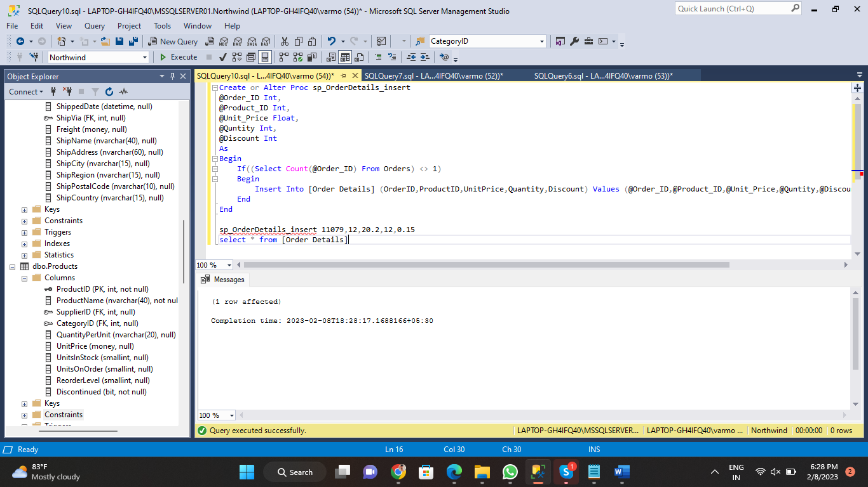

7. write a SQL query to Create Stored procedure in the Northwind database to update Customer Order Details

Create or Alter Proc sp_OrderDetails_update

@Order_ID Int,

@Product_ID Int,

@Unit_Price Float,

@Quntity Int,

@Discount Int

As

Begin

If((Select Count(@Order_ID) From Orders) <> 0)

Begin

Update [Order Details] Set UnitPrice = @Unit_Price, Quantity = @Quntity, Discount = @Discount where OrderID = @Order_ID

End

End

sp_OrderDetails_update 11079, 13, 15.2, 13, 0.15

