INTERNET
Server Server
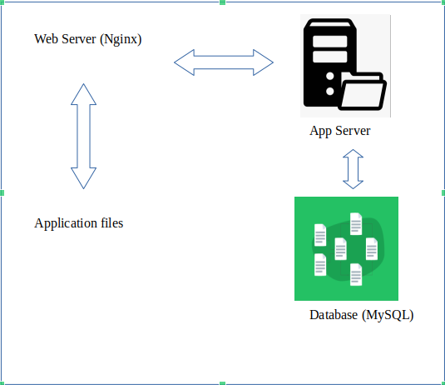

8.8.8.8 HTTP HTTP Load Balancer (HA Proxy) Active – Passive
MASTER REPLICA
LAMP LAMP HTTP HTTP Request Response

