Screenshots of Project

1. PyCharm Database

2)Home Page

3)View Record

4)New Records

5)Update Record

6) Delete Record

7) Postman Get all teams

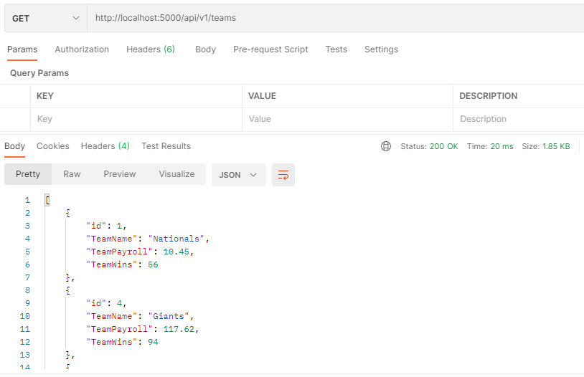

8) Postman Get1 team

9) Postman Post

10) Postman Put

11) Postman Delete

