

**COMPUTER GRAPHICS AND MULTIMEDIA [CSE3016]**

**FINAL REPORT OF THE PROJECT**

**Faculty:** Dr. Pavithra L K

**Project by:**

KUNDETI PAVAN KUMAR --19BCE1821

**AN**

**AUGMENTED**

**REALITY (AR)**

**APPLICATION**

**Abstract**

Technology in education can influence students to learn actively and can motivate them, leading to an effective process of learning. Previous research has identified the problem that technology will create a passive learning process if the technology used does not promote critical thinking, meaning-making or metacognition. Since its introduction, augmented reality (AR) has been shown to have good potential in making the learning process more active, effective and meaningful. This is because its advanced technology enables users to interact with virtual and real-time applications and brings the natural experiences to the user. In addition, the merging of AR with education has recently attracted research attention because of its ability to allow students to be immersed in realistic experiences. Therefore, this concept paper reviews the research that has been conducted on AR. The review describes the application of AR in a number of fields of learning including Medicine, Chemistry, Mathematics, Physics, Geography, Biology, Astronomy and History. This paper also discusses the advantages of AR compared to traditional technology (such as e-learning and courseware) and traditional teaching methods (chalk and talk and traditional books). The review of the results of the research shows that, overall, AR technologies have a positive potential and advantages that can be adapted in education. The review also indicates the limitations of AR which could be addressed in future research.

Keywords: augmented reality, technology, education.

**Introduction**

Augmented reality (AR) is a new technology that has emerged with potential for application in education. While a lot of research has been conducted on AR, few studies have been conducted in the education field. The number of studies on AR is growing due to the effectiveness of this technology in recent years. AR has been used in different fields in education. In particular, AR provides an efficient way to represent a model that needs visualization. AR also supports the seamless interaction between the real and virtual environments and allows a tangible interface metaphor to be used for object manipulation. The complex nature of the architecture, engineering, construction, and facility management (AEC/FM) industry and its high demand for access to information for evaluation, communication and collaboration, increases the industry’s need for information technologies. Recent visualization technologies such as virtual and augmented reality technologies are ideal in this environment.

A simple augmented reality use case is: a user captures the image of a real-world object, and the underlying platform detects a marker, which triggers it to add a virtual object on top of the real-world image and displays on your camera screen. AR applications can become the backbone of the education industry.

* Augmented Reality is a technology that has changed the face of smartphone apps and gaming. ... AR apps act as a magic window for the viewers that lets them see the holograms and manipulate 3D models.
* We will be using an updated version of UNITY for developing and making the scene and an updated version of VUFORIA for the database and that makes the user experience more interactive and refining.

**Literature Review**

This section presents a review of the extant research on the application of AR. This review is organized according to the application of AR technologies in a number of fields of study in education, namely, Medicine, Chemistry, Mathematics, Physics, Biology, Astronomy and History. Research on the application of AR in these fields is reviewed in order to evaluate the potential of AR in education. Table 2 summarizes the meta-analysis of the research conducted on AR in different fields. The analysis includes examples of how the AR technology was implemented in the respective fields. Expanding on the studies shown in Table [1](https://www.frontiersin.org/articles/10.3389/frobt.2018.00037/full#T1), [Swan and Gabbard (2005)](https://www.frontiersin.org/articles/10.3389/frobt.2018.00037/full#B258) conducted the first comprehensive survey of AR user studies. They reviewed 1,104 AR papers published in four important venues between 1992 and 2004; among these papers they found only 21 that reported formal user studies. They classified these user study papers into three categories: (1) low-level perceptual and cognitive issues such as depth perception, (2) interaction techniques such as virtual object manipulation, and (3) collaborative tasks. The next comprehensive survey was by [Dünser et al. (2008)](https://www.frontiersin.org/articles/10.3389/frobt.2018.00037/full" \l "B61), who used a list of search queries across several common bibliographic databases, and found 165 AR-related publications reporting user studies. In addition to classifying the papers into the same categories as [Swan and Gabbard (2005)](https://www.frontiersin.org/articles/10.3389/frobt.2018.00037/full#B258), they additionally classified the papers based on user study methods such as objective, subjective, qualitative, and informal. In another literature survey, [Bai and Blackwell (2012)](https://www.frontiersin.org/articles/10.3389/frobt.2018.00037/full#B18) reviewed 71 AR papers reporting user studies, but they only considered papers published in the International Symposium on Mixed and Augmented Reality (ISMAR) between 2001 and 2010. They also followed the classification of [Swan and Gabbard (2005)](https://www.frontiersin.org/articles/10.3389/frobt.2018.00037/full#B258), but additionally identified a new category of studies that investigated user experience (UX) issues. Their review thoroughly reported the evaluation goals, performance measures, UX factors investigated, and measurement instruments used. Additionally, they also reviewed the demographics of the studies' participants. However there has been no comprehensive study since 2010, and none of these earlier studies used an impact measure to determine the significance of the papers reviewed.

Some researchers have also published review papers focused on more specific classes of user studies. For example, [Kruijff et al. (2010)](https://www.frontiersin.org/articles/10.3389/frobt.2018.00037/full" \l "B148) reviewed AR papers focusing on the perceptual pipeline, and identified challenges that arise from the environment, capturing, augmentation, display technologies, and user. Similarly, [Livingston et al. (2013)](https://www.frontiersin.org/articles/10.3389/frobt.2018.00037/full#B176) published a review of user studies in the AR X-ray vision domain. As such, their review deeply analyzed perceptual studies in a niche AR application area. Finally, [Rankohi and Waugh (2013)](https://www.frontiersin.org/articles/10.3389/frobt.2018.00037/full" \l "B223) reviewed AR studies in the construction industry, although their review additionally considers papers without user studies. In addition to these papers, many other AR papers have included literature reviews which may include a few related user studies such as [Wang et al. (2013)](https://www.frontiersin.org/articles/10.3389/frobt.2018.00037/full#B283), [Carmigniani et al. (2011)](https://www.frontiersin.org/articles/10.3389/frobt.2018.00037/full" \l "B43), and [Papagiannakis et al. (2008)](https://www.frontiersin.org/articles/10.3389/frobt.2018.00037/full" \l "B214).

**Proposed Work**

The concept of VR could be traced at the mid of 1960 when Ivan Sutherland in a pivotal manuscript attempted to describe VR as a window through which a user perceives the virtual world as if looked, felt, sounded real and in which the user could act realistically ([Sutherland, 1965](https://www.frontiersin.org/articles/10.3389/fpsyg.2018.02086/full#B96)).

Since that time and in accordance with the application area, several definitions have been formulated: for example, [Fuchs and Bishop (1992)](https://www.frontiersin.org/articles/10.3389/fpsyg.2018.02086/full#B48) defined VR as “real-time interactive graphics with 3D models, combined with a display technology that gives the user the immersion in the model world and direct manipulation” ([Fuchs and Bishop, 1992](https://www.frontiersin.org/articles/10.3389/fpsyg.2018.02086/full#B48)); [Gigante (1993)](https://www.frontiersin.org/articles/10.3389/fpsyg.2018.02086/full" \l "B50) described VR as “The illusion of participation in a synthetic environment rather than external observation of such an environment. VR relies on a 3D, stereoscopic head-tracker displays, hand/body tracking and binaural sound. VR is an immersive, multi-sensory experience” ([Gigante, 1993](https://www.frontiersin.org/articles/10.3389/fpsyg.2018.02086/full" \l "B50)); and “Virtual reality refers to immersive, interactive, multi-sensory, viewer-centered, 3D computer generated environments and the combination of technologies required building environments” ([Cruz-Neira, 1993](https://www.frontiersin.org/articles/10.3389/fpsyg.2018.02086/full#B37)).

As we can notice, these definitions, although different, highlight three common features of VR systems: immersion, perception to be present in an environment, and interaction with that environment ([Biocca, 1997](https://www.frontiersin.org/articles/10.3389/fpsyg.2018.02086/full" \l "B11); [Lombard and Ditton, 1997](https://www.frontiersin.org/articles/10.3389/fpsyg.2018.02086/full#B66); [Loomis et al., 1999](https://www.frontiersin.org/articles/10.3389/fpsyg.2018.02086/full#B67); [Heeter, 2000](https://www.frontiersin.org/articles/10.3389/fpsyg.2018.02086/full" \l "B53); [Biocca et al., 2001](https://www.frontiersin.org/articles/10.3389/fpsyg.2018.02086/full" \l "B12); [Bailenson et al., 2006](https://www.frontiersin.org/articles/10.3389/fpsyg.2018.02086/full" \l "B7); [Skalski and Tamborini, 2007](https://www.frontiersin.org/articles/10.3389/fpsyg.2018.02086/full" \l "B90); [Andersen and Thorpe, 2009](https://www.frontiersin.org/articles/10.3389/fpsyg.2018.02086/full#B3); [Slater, 2009](https://www.frontiersin.org/articles/10.3389/fpsyg.2018.02086/full#B91); [Sundar et al., 2010](https://www.frontiersin.org/articles/10.3389/fpsyg.2018.02086/full#B95)). Specifically, immersion concerns the amount of senses stimulated, interactions, and the reality’s similarity of the stimuli used to simulate environments. This feature can depend on the properties of the technological system used to isolate user from reality ([Slater, 2009](https://www.frontiersin.org/articles/10.3389/fpsyg.2018.02086/full#B91)). Butthere has been no work on AR in education sector. So, we caught this point and this motivated us to develop this project.

**Modules and Objective**

• To create an Augmented reality app for education/knowledge purpose and to increase the reach of knowledge to every person using the graphics in the database of VUFORIA.

• To explain the concepts/theories and various interesting topics around the world by taking the person to a hybrid environment and showing them the 3D-virtual reality experience with the help of audio/video.

**MODULE-1**

**• VUFORIA**

• We will be deploying and installing the Vuforia in UNITY 3D application and setting up the scenes and required assets for the AR app and also deploying a camera in the scene environment under the UNITY GAME COMPONENT section.

• Finally Making a 3D view environment in the UNITY application.

• Here we will implement a user controlled camera to navigate 3D worlds using keyboard and mouse input.

**MODULE-2**

**• DATABASE**

• Here we will be creating a database in Vuforia Application and setting up the requires constraints and linking it to the UNIITY 3D app and adjusting the sample images/graphics with a precised coordinates and linking those pictures with audio/video clips for the understanding which makes the user experience more interactive and refining.

**MODULE-3**

• Here in module-3 we will be making an android app and other requirements in a smartphone using Android studio by connecting the smartphone to the AR app developing pc/laptop and then we link our database(VUFORIA) to UNITY and deploying to the smartphone(!! The smartphone must run on an any Android operating system).

Finally the Augmented reality App can be used on the smartphone after completing the above phases and the main highilight thing is the AUGMENTED REALITY App works without network connection too.

**ARCHITECTURE of AR app**

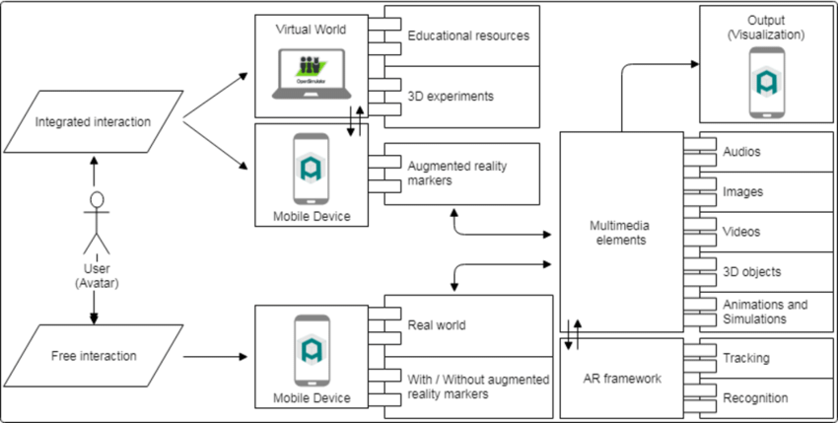

**(fig-1) Architecture of our AR application**

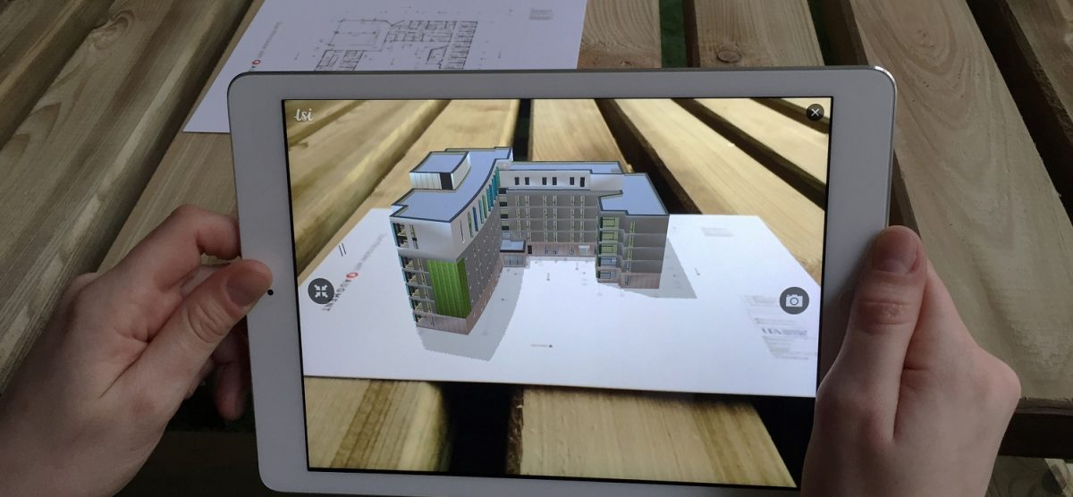

**(fig-2) Sample implementation of the proposed work**



**(fig-3 ) Animated representation of AR technology**

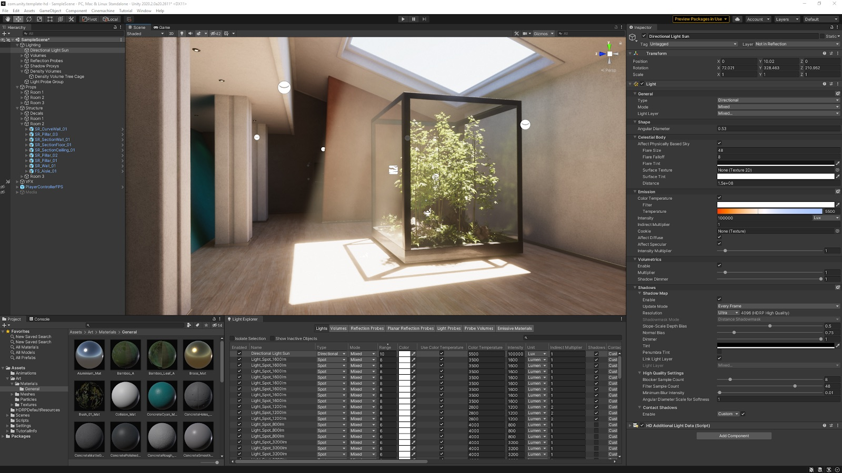

**(fig-4) creating new material and analysing the surroundings with UNITY3D application.**



**(fig-5) UNITY3D application**



**(fig-6) Basic idea working with UNITY3D, detecting the Image Target and creating its model target.**

**(fig-7) Workspace of our UNITY3D application.**

**(fig-8) Here we are setting the image taregts in the 3D scene.**

**(fig-9) After setting up the image target with the help of UNITY3D and VUFORIA database we now set up the QUAD on these images for the model targets and adding the required components like image and video/audio components**.

**Requirements**

**Software Requirements-**

UNITY 3D and VUFORIA progams.

 Operating system like Windows 8 and Windows 10 is the platform required

 A Visual C++ compiler is required for compiling the source code to make the executable file which can then be directly executed.

**Hardware Requirements-**

The hardware requirements are very minimal and the software can be made to run on most of the machines. Processor: Above x86 Processor speed: 500 MHz and above

 RAM: 64 MB or above storage space 4GB and more

Monitor Resolution: A color monitor with a minimum resolution of 640*480.

This review of the research conducted in several fields in education shows that AR technology has the potential to be further developed in education. This is because the advantages and beneficial uses of AR features are able to engage students in learning processes and help improve their visualization skills. The features can also help teachers to explain well and make the students easily understand what they are taught. The use of AR technology has also received positive feedback from participants and students who have shown their interest in using AR in their learning processes. These good responses are important because they indicate the willingness of students to actively engage in their studies through AR tools. AR technology is still new in education, thus there are still some limitations. However, the review of the research indicates that most of the limitations are related to technical issues. Such limitations can be overcome over time as research on the integration of AR in education is replicated and improved. When the potential of AR technologies is more fully explored, the beneficial functions of AR can begin to be used widely in all fields of education and the efficiency of the teaching and learning process will be improved.

Students commonly find Science subjects to be abstract, requiring a depth of understanding and visualization skills (Gilbert, 2004). When students have difficulties in understanding the concept well, it leads to misconceptions. According to Palmer (2001), misconception among students has to be taken into account because it can interfere with the students’ learning of scientific principles and concepts. Thus, the selection of teaching method plays an important factor in avoiding or minimizing the students’ misconception (Palmer, 2001). Visualization technologies have exciting potential for facilitating understanding and preventing misconceptions in the scientific domain (Hay et al., 2000). Kozhevnikov and Thornton (2007) found that is possible to improve students’ visualization skills by presenting a variety of abstract visual images and allowing the students to manipulate and explore the images. There is a wide range of available technologies that can be used for the visualization of abstract concepts. Examples of visualization technologies that have been examined in previous research include animation, virtual environments and simulation. Dede et al. (1996) suggest that students can improve their mastery of abstract concepts through the use of virtual environments that have been designed for learning. Robertson et al. (2008) found that animation together with interesting data and an engaging presenter helps the audience understand the results of an analysis of information. These visualization technologies can be used to address the problem of misconception and help students understand better.

**Object Identification Technique for Artificial Objects**

The process of the object identification can be generally described by a set of operations outlined on Fig. 10. Specific implementation of these steps can partially differ. First three steps can be described as an image preprocessing. In this phase, the image is usually converted into a grayscale version and then thresholded into binary image. Obviously there is a number of approaches designed for specific environments. Most significant problem in this phase is dealing with different light conditions in various locations. Therefore it is not possible to use a single threshold value for all light conditions is dealing with this problem and outlines the principle of enhanced algorithm for dynamic thresholding. The following steps are the image analysis itself. The goal of this step is to decompose the image into a set of objects described by their vertices and edges. The application of the morphological analysis method is usual solution.

The result is a tree or list of image elements. At this moment it is possible to find all objects which fulfil some specific criterion (e.g. all potential squares given by four edges). Further image analysis partially differs according to the nature of the application and what kind of objects should be identified. Common approach in AR is usage of different square markers. Advantage of a square marker is that it is extremely simple to find all such potential markers in the tree or list given by the morphological analysis. Each potential marker is transformed into the camera plane (step 5 on Fig. 10.) and compared with predefined templates. Another solution is an hybrid approach.

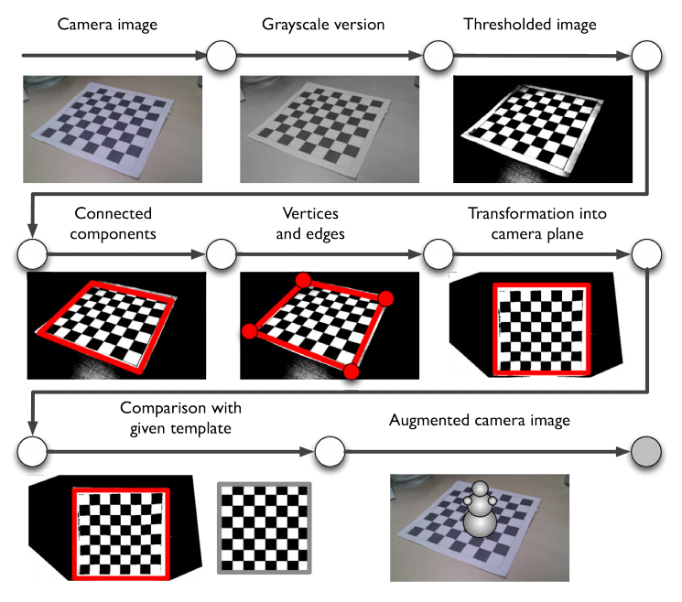

**(fig-10) General structure of a common augmented reality application based on artificial markers.**

It is possible to partially identify the position and orientation of the device using GPS and compass and match the scene exactly using simplified image analysis. Image analysis used comprises of identification of specific shapes that should be found in a given location – e.g. rectangle of a show case in the museum. From the point of view of image analysis this approach is similar to the previous case. It is obvious that these techniques are not suitable for identification of complex structures such as buildings. In this case it is again necessary to identify some clearly specified features within the complex objects in order to simplify the image analysis.

**Conclusion**

In conclusion, the advancement and price of hardware has enabled running such technology on devices at our disposal already. Technologies like virtual and augmented reality can have a large variety of benefits in the present time. specially in educational processs, where it is hard to acquire the materials, tools and equipment required for object for best experimentation. In this report a character act like a for user which will save him an effort, time and tuition cost as he can access to his class in any time and any place, also there is conversation section which is most important as it help user to have courage and broke his shame ice wall and try to speak because he feels more comfortable as he know he is dealing with only a virtual character than dealing with real person. There is different kind of section when user study a specific section it helps him to save new words easily as it shows him the 3D model of object and pronounce it names at same time which helps him to memorize better than only repeating a word orally.

**References**

[1] O. Pasaréti, H. Hajdú, T. Matuszka, A. Jámbori, I. Molnár and M. Turcsányi-Szabó, "Augmented Reality in education," in Informatika Szakmódszertani Konferencia, 2011.

[2] K. Lee, "Augmented Reality in Education and Training," TechTrends, vol. 56, no. 2, pp. 13-21, 2012..

[3] Reallusion Inc., "iClone," 2019. [Online]. Available: <https://www.reallusion.com/charactercreator/production.html>

[4] Autodesk Inc., "Maya3D," 2018. [Online]. Available: https://www.autodesk.com/products/maya/o verview.

[5] Unity3D, "Unity3d," 2018. [Online]. Available: doi : 10.25007/ajnu.v8n3a366 32 Academic Journal of Nawroz University (AJNU) <https://unity3d.com/unity>.

[6] Unity3D, "AR Foundation," 2018. [Online]. Available: https://docs.unity3d.com/Packages/com.unity [.xr.arfoundation@1.0/manual/index.html](mailto:.xr.arfoundation@1.0/manual/index.html)

[7] YouTube link: <https://www.youtube.com/watch?v=MtiUx_szKbI&t=1255s>

[8] <https://www.researchgate.net/publication/335525338_Proposed_System_for_Education_Augmented_Reality_Self_English_Learning>.

[9] <https://www.researchgate.net/publication/281336331_A_Review_of_Research_on_Augmented_Reality_in_Education_Advantages_and_Applications/link/5636d06608ae88cf81bd1495/download>

[10] <https://www.frontiersin.org/articles/10.3389/fpsyg.2018.02086/full>