Revealing Governance Patterns by Taking Snapshots of Open-Source Communities

Alexandra Leta, Student, Vrije Universiteit Amsterdam

**Abstract**—TO BE ADDED

**Index Terms**—TO BE ADDED

# 1. Introduction

Software projects continue to grow in size and complexity and an important requirement for studying snapshots of development communities is the acquisition and analysis of data from software repositories. Analysis of software systems communities and their evolution is needed to better understand the characteristics of software systems and projects and can be used to uncover knowledge and assist in software developments. Literature in software development communities already recognizes the need to study the effect of organizational structures on the quality of software, motivating further studies for understanding, representing and supporting social structures and communities.

The relationship among software communities’ practices and characteristics related to community types arises an interesting research problem as an emerging body of literature reveals open source software development as an alternative to proprietary software. **The main challenge imposed by open source software is related to its basic motivations and values of the institutions that develop, market, and use open software.** The purpose of analyzing snapshots of open-source software communities is to reveal patterns in the software development process and social interactions that occur in these communities. This set of community characteristics and metrics could be used to understand how developers interact while working on a project and to study the effects of these social interactions under conditions in which different projects have different levels of developer skill, and where features added by developers have the potential to influence other features.

## 2. Background & Motivation

Open source software communities are defined as a group of people who share similar goals, interests, beliefs, and value systems in a common domain of recurring activity or work **[1.2-Walt]**.

This characterization is used by researchers to investigate groups of people working together and using information technology systems.

The study of open-source community characteristics and their mapping to different community types help us understand the social structure of a community in order to be able to overcome different communication and collaborating barriers that may hinder a successful development process. A common method for acquiring knowledge on software communities patterns is to study the data provided by software tools used by community members. Previous studies on gathering data from software repositories have been conducted and their results were offered back to the community for further research purposes. Howison et al, in the FLOSSmole project **[1.2-Flossmole]**, extracted a dataset which consists of metadata about the software packages, such as numbers of downloads or the employed programming language. The Flossmetrics project provides a dataset consisting of source code size, structure and evolution metrics from several open source software projects. A common problem identified in software repositories analysis is tracking developer identities across data sources as most software configuration management systems rely on user names to identify developers, while mailing lists and bug tracking software use the developers’ emails. A possible solution to the problem is offered by Git, which uses emails to identify developers, while both bug descriptions and wiki entries coming from the same developers feature their identity details.

## 3. Research Questions

The number of people that manage to work together successfully to create high quality, widely used products is remarkably large. The research questions are aimed at understanding basic parameters of the process of creating open source software and how are these parameters related to the community type. The project aims to provide metrics resources on development practices in the open source software industry and to identify and understand patterns of development practices in this industry. **What are the community and organizational patterns in open source development communities?**

In order to provide an answer for these questions the grounded theory research method is considered. Using this technique, the research findings constitute a theoretical framework “grounded” in the data, with built-in test of the theory incorporated into the results. The first step in analyzing data collected is to perform open coding, the process of breaking down, examining, comparing and categorizing the data **[1.4-Grounded]**. The next step involves reexamining the data, looking for connections between categories.

## 4. Approach & Methodology

The main purpose of this research is to construct and analyse information and metrics on software development and their relation with software communities, using existing methodologies and tools. Software communities members use tools such as project's mailing lists, versioning systems, bug-tracking systems, discussion forums to enable peer collaboration in the software development process. This process leaves an accessible trail of data upon which interesting analyses can be built, but despite of the large set of data researchers often face significant challenges in using it. The Mining Software Repositories field analyzes the rich data available in software repositories to uncover actionable information about software systems and projects [1.3-Ahmed].

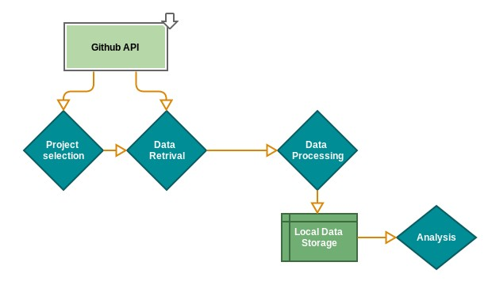

This project is designed to gather collaborative data of open source software community, process and analyze this data in order to identify patterns that are most relevant for this community. We will focus on community types that are most consistent with open-source development, namely: Formal Networks, Informal Networks, Informal Communities and Networks of Practice **[1.3-Titans]**. Using data gathered from software repositories and attached collaboration tools we define a set of properties for each analyzed repository. We define quality attributes and their accepted values for community types most compatible with open-source software in order to understand patterns in the open-source development process. Using this data and additional information extracted from the literature in social communities we can validate metrics that measure these key-attributes.

The results provided by this research process are reproducible, extensible and easy to compare when applied on multiple repositories. The open source software community development method poses a serious challenge to the commercial software businesses that dominate the software markets **[1.3-ACS]** and this project creates the opportunity to exploit the diversity of existing research, to compare and contrast results in order to expand our knowledge regarding how social communities interactions could affect the software development process.

## 4.1. Repository analysis

In order to address the research question and understand how community members’ interactions can influence the quality of the development process, we need key measures of project evolution and social interactions during the development process. The study of software developments snapshots includes creating basic summary reports about the state of the source code, as well as network analyses of open source development teams. Summary reports should include the number of operations, chosen programming language, the number of developers per project, etc. This data is useful for creating general statistical information about open source projects.

When conducting research with data from software repositories, an initial step involves retrieving of the project data to be analysed. Storing the processed data and running the analysis on updated collection of data will allow metrics to be compared over time, supporting historical comparisons and trying to make the analyses reproducible and extendable.

Members of the software development communities do not work in a single or central workplace, and often there is no formal management hierarchy in place to schedule, plan, and coordinate tasks and resources. Instead, developers contribute their effort to projects that they find significant, or otherwise professionally compelling. The snapshot data of this community includes data significant for the most common activities performed by its members: writing code and comments, fixing and submitting bugs, collaborating in order to find better solutions for their projects. GitHub Archive records the public GitHub timeline, archives it, and makes it easily accessible for further analysis and this archive dataset can be accessed via Google BigQuery.

Moreover, GitHub provides access to its internal data stores through an extensive REST API which researchers can use to access a rich collection of data and which enables retrieving commits to the projects’ repositories and events generated through user actions on project resources. Moreover, GitHub facilitates project contributions from non-team members, offers software forge facilities, such as a issue tracker, a wiki, and developer collaboration channel. The provided JSON format data is constantly updated and it allows running arbitrary queries and analysis over the entire dataset. This community data is used to compute attributes values related to the software development process in order to study some of the known phenomena observed in the open source software development community and provide a better insight into their common practices and interactions.

We use metrics to increase our understanding of core software development activities and the overall nature of community participation in software projects. An important project quality metric is its complexity which can be used to predict the incidents of faults in code. A case study which used data derived from the change history of open source projects shows that change complexity metrics, based on the code change process, are reliable predictors of fault potential **[2-Hasan]**. Similarly, researchers investigate how collaborative activities carried out by the developers such as social networks [2-R30], work dependencies [2-R10] [2-R] and daily routines [2-R27] are connected to the software product quality.

Using these variables we can assess the important project properties such as formality, which can be determined by calculating the number of milestones assigned to the project, number of user groups, etc. Another important property is the degree of formality which can be monitored by investigating the presence of social and informal interactions between developers. The degree of engagement from community members evaluates members’ engagement, by analyzing member’s participation levels.

The following open source tools were used for the data extraction, processing and visualization:

* GitHub Java API: library for communicating with the GitHub API, supporting the GitHub v3 API **[E-Git]**. The client package contains classes communicate with the GitHub API over HTTPS. The client package is also responsible for converting JSON responses to appropriate Java model classes. The package contains the classes that invoke API calls and return model classes representing resources that were created, read, updated, or deleted.
* Gephi Toolkit: Java library which provides useful and efficient network visualization and exploration techniques **[Gephi-Tool]**. The toolkit is a single JAR that could be used in applications and achieve tasks that can be done in Gephi automatically.
* Google Geocoding API: used for converting the addresses of repositories members into geographic coordinates, which is used to calculate distances. This API **[Geo]** provides a direct way to access services via an HTTP request.

The final set of data includes attribute values for software repositories, the name and version of the project, meta-data, and additional statistics. Evaluation and analysis is performed after the metric computations are performed.

The vast majority of repositories hosted on Github are representative for open source software projects. Based on the evidence from **[1.3-Titans, [39-Titans], [36-Titans]** the community types most consistent with open source software development communities are represented by: Formal Networks, Informal Networks, Informal Communities and Networks of Practice. Moreover, after analyzing the community types **[Titans]** produced a set of metrics defining the key attributes for these communities and a set of threshold values that are most representative for different community types using SourceForge project data. The current approach uses Github repositories as data sources as it has became the world's largest open source community. Github provides an extensive REST API, which enables researchers to retrieve both the commits to the projects’ repositories and events generated through user actions on project resources and has emerged as a popular project hosting, mirroring and collaboration platform **[Ghtorrent]**.

For the selected Github repositories we computed the attributes values identifying the mentioned communities types, using similar metrics. After computing the key-attributes values, the repositories where further analysed by defining a set of quality metrics and their values. **[Using the attributes values that define different community types and quality attributes values]**

The following query was used to select the most popular repositories available on Github, considering the number of pull requests attached to the repository as a project reputation metric. GitHub Archive is a project which pushes its extensive collection of GitHub data to Google BigQuery. BigQuery in turn lets you write SQL-style queries on ginormous datasets like this one. The data generated from this activity can reveal interesting trends across many industries, including popularity of programming languages over time, defect rates, contribution metrics, and popularity of specific frameworks and libraries.[1]

|  |
| --- |
| SELECT repository_name, repository_organization, repository_url, max(repository_forks) max_forks,  FROM [githubarchive:github.timeline]  WHERE repository_has_issues  and repository_has_wiki  and repository_watchers > 0  and repository_organization!=""  GROUP BY repository_name, repository_organization, repository_url  ORDER BY max_forks DESC |

The most important attributes identified for **Formal Networks** are **formality** and **membership status**. Using the approach defined in **[1.3-Titans]** the attribute value formality can be computed using information regarding the number of milestones assigned to a project and the project lifetime. Only a limited number of projects hosted on Github have defined properties such as issues and milestones; our framework restricted the repository selection to projects that have these two properties. The membership attributes evaluates whether members and rigorously selected. For computing the value of this attribute we took into consideration the membership types assigned to a repository member: contributor and collaborator, as defined by the Github API. A contributor is member outside the core development team of the project who wants to contribute some changes to a project and a collaborator is a member on the core development team of the project and has commit access to the main repository of the project. The value associated to the hierarchy degree represents the percentage of contributors from the total number of repository members.

**Informal networks** are defined by properties such as **informality [[** **INSERT PICTURE HERE]], openness** and **lack of governance.** For each repository member we can extract the repositories to which he has contributed, using the RepositoryService and the company, in case we has filled this profile information. Using this collected data about users and their activity we can compute the value for the informality attribute. The lack of governance attribute is computed based on the information regarding project milestones and project lifetime. **[Floss-ok]** Open source communities approach to project milestones does not follow a common pattern. A comparison of release practices of important open source projects **[Erenkrantz]** analyzed properties such as dimensions of release authority, approval of releases and formats revealed considerable differences among projects. The results show that some projects have quite informal release schedules, following the pattern of releasing early and releasing often, whilst in other projects **[Glance]** releases come at an irregular rate. The Github API imposes a restriction for requests regarding team components and team organization. Only users that are members of a specific repository can access this data, therefore the value for the openness attribute could not be computed.

Figure **[[** **INSERT PICTURE HERE]]** represents the geographical distribution of members collaborating on one of the considered repositories. The same representation is available for each repository as most Github users have a location property defined. Using the Google Geocoding API we convert the addresses into geographic coordinates, which are used to calculate the **average distance** between community members. In addition to average distance attribute, cultural distance, self-similarity and number of active members are also key-attributes for **Networks of Practice**. We computed the values for **cultural distance** using the indices defined by Hofstede in a study on cultural dimension; for each community member who has the location property, we determined the index values for his country. Github users profiles don't include their skills; based on the defined programming language **[[** **INSERT PICTURE HERE]]** for repositories to which a user has contributed we were able to determine a set of skills for each user and compute the value for the **self-similarity** attribute.

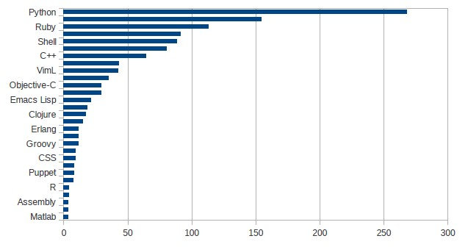

The CommitService allows retrieving the commits for a repository, limiting their number proportional to the maximum number of requests allowed by the Github API. Based of the list of commits we can determine the number of users whose total number of commits contribution is equal to at least half of the commit activity.

Based on the evidence from **[1.3-Titans], [36-Titans]** engagement, self-similarity and dispersion are key attributes defining an **Informal Community**. One indicator of high engagement within a community is the number of comments members post. Using the PullRequestService and CommitService resources we extracted comments posted by community members that were commenting of a pull request or adding a comment for a commit event. Using properties such a comment author and date we were able to compute the average number of comments posted by repository members. Figure **[[** **INSERT PICTURE HERE]]** presents the monthly number of comments distribution for the **[X]** repository.

**4.2. Quality of the development community**

After determining the values for key attributes of open-source community types, we produced a set of metrics to better asses the quality of different development communities. Values and thresholds for these attributes were identified using the same set of Github repositories defined in the previous step.

* 1. **Group cohesiveness [**fluctuationResilience**]**

Github is providing an easy accessible channel for software developers to share their projects and collaborate on them. This “social coding” environment allows developers to connect with each other based on common interests and projects. Activity traces of attention such as following, watching, and comment activity are an indicator that the community cares about that person, project, or action and lead to developer attention to that person, artifact or event **[Social-C]**. When following another user, members will get notifications on their personal dashboards about their Github activity.

We considered followers associativity as an indicator of how closely community members interact, measuring preference to connect to other repository members. For each community member we determined the number of users that he follows or is followed by and are members of the same community, measuring preference to connect to other community members. According to **[Social-C]** members follow the actions of other developers because they trust their coding skills, reporting interest in how they coded, what projects are working on and following. Frequent follow subscriptions indicate that group members are more inclined to participate readily and to stay with the group, trusting their collaborators and contributing to group cohesiveness.

|  |  |  |
| --- | --- | --- |
| Goal | Purpose | Measure |
| Issue | The group cohesiveness of |
| Object | Repository members |
| Viewpoint | From the external observer point of view |
| Question | Q1 | Are users paying interest in their collaborators activity? |
| Metrics | M1 | Average number of user-follow events within community members. |
| Question | Q2 | Are users collaborating on repository items? |
| Metrics | M2 | Average number of user connections established by collaboration on files. |

An additional metric which quantifies how tightly community members collaborate on repository items is related to the number of community members that commit on common repository artifacts. For each contributor we determined the list of other repository contributors that have made changes on the same set or a subset of the files that the user committed to. Frequent collaborations on files between users indicates that they are willing to collaborate and possess linking bonds which increases social relations cohesiveness.[[**INSERT PICTURE HERE]]**

* 1. **Social processes [Community invol, Distribution of responsibilities]**[teamCharacteristics]

Social processes are dynamic interactions among community members as they work on a project**[Floss-ok]**. To evaluate engagement of community members in social processes, we used data regarding their participation in activities such as blogging, repository watching and their committing longevity within the project. For each analyzed repository we computed the number of community members that have defined a **blog** property in the profile, the number of users who are **watching** the repository activity and the **time span** of members' activity.

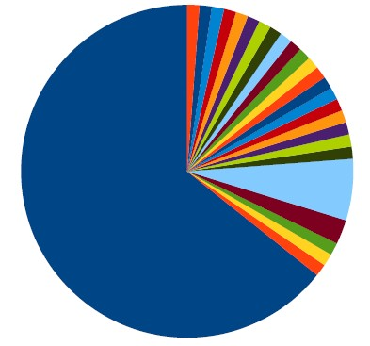

Software development is not an isolated type of activity **[Understand SW]**. Known as an individual-intensive activity, coding is also complemented by other social processes and research work in **[Blogging]** shows that a significant part of the developers working hours and spent interacting in various ways with other community members. Blogs as used broadcast mediums, but also as a means of exchanging technical ideas or share knowledge on relevant topics. In **[Blogging]** a blogger is defines as a “networker” who establishes social relations consisting of semantic references to allow for continuous communication, as well as of social references to express a social tie to another person.

Repository watching is recognized as a measure of community approval for a project and also it supports learning and acquiring technical knowledge. Visible information about community interest in the form of watcher count for a repository is an indicator that a project has a high quality. A Case Study on Social Coding in Github**[Social-C]** indicates that community members use the number of watchers for a project as a signal that the project has community interest. We used the number of repository watch subscriptions as a metric for social processes that occur in the context of a development project.

Committer longevity is an measure of how long one author remains part of the community. The CommitService allows us to retrieve repository commits and for each commit we can extract information such as author, creation date, files that are affected by the commit. For each user we extract the dates of his first and last commit within the community and determine the time span of his activity. [[**INSERT PICTURE HERE]] C**ommunity members contribution time span during the project lifetime indicates the knowledge level and his involvement within the community.

|  |  |  |
| --- | --- | --- |
| Goal | Purpose | Measure |
| Issue | The team social characteristics |
| Object | Repository members |
| Viewpoint | From the external observer point of view |
| Question | Q1 | Are users involved in interactions related to knowledge exchange? |
| Metrics | M1 | Percentage of community members which publish blog posts. |
| Question | Q2 | Do other users manifest their interest on the current repository? |
| Metrics | M2 | Average number of repository-watch events within community members. |
| Question | Q3 | How long authors remain part of the community? |
| Metrics | M3 | Average user activity time span. |

* 1. **Workload allocation [Tasks allocation]**

Number of commits pushed by each user, the set of users who collaborate on files through commits and the set of members whose contribution counts for a high percentage of the community workload are metrics that indicate how the project workload is divided among community members. These variables can be determined by retrieving and analyzing events that are generated by users' actions on project resources and they measure how responsibilities and collaboration are distributed across community members.

The case study presented in **[User-Invo]** is a key concept in project development and has positive effects on project success and user satisfaction. Record attributes contain information about the person who initiated the commit event and we used attributes values to measure the number of commit events initiated by users .We used members commit contribution as a measure of individual productivity and community involvement.

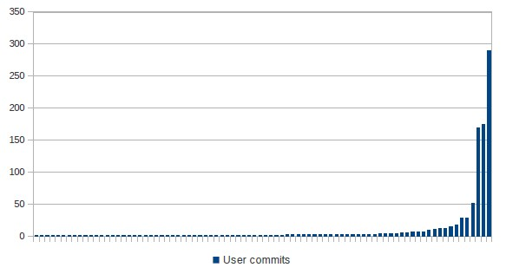

We observed that [[**INSERT PICTURE HERE]]**

We also examined the development activities of repository contributors to see if they were working together on common tasks. Collaboration on project files fosters interaction between community members and it is a valuable data source for tracking these interactions. We investigated the repository file structure without storing the contents of files. ContentsService and DataService allow us to extract the repository file structure and obtain a list of commit history for each individual file. Based in this information we computed the number of community members which collaborate on repositories items and an median value of collaborators at the repository level. Using this data we observed that [[**INSERT PICTURE HERE]].**

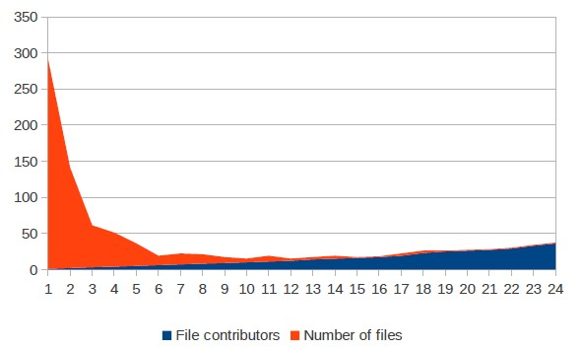

An additional metric which indicates how tasks are divided among repository contributors is the number of users whose contribution counts for at least 50% of the number of commits.

|  |  |  |
| --- | --- | --- |
| Goal | Purpose | Measure |
| Issue | The workload allocation for |
| Object | Repository members |
| Viewpoint | From the external observer point of view |
| Question | Q1 | How is the workload divided among community members? |
| Metrics | M1 | Number of commits pushed by each user. |
| Question | Q2 | Are users collaborating on repository items? |
| Metrics | M2 | Number of individuals participating in the development of one specific file. |
| Question | Q3 | Are the repository actions divided equally among community members? |
| Metrics | M3 | Members whose contribution counts for a high percentage of the community workload . |

* 1. **Project dynamics [Project characteristics]**

For the analyzed repositories we checked whether they have an attached Wiki. According to **[Wiki]** project wikis can serve as a knowledge repository, a means for staging the project, a coordination mechanism, and a shared workspace. Repositories which contain a Wiki provide useful information on project artifacts and other resources that were included or linked in, ensuring ease to access to data. Moreover some repository wikis store historical information about the project, such as releases, project versions, providing a better insight into the dynamics of the project.

IssueService allows us to retrieve issue related events and we used it to compute the monthly evolution of these events. Events such as Open Issue, Close Issue, Merge Pull Request, Create Pull Request were divided using event creation date and we computed the standard deviation of the number of monthly events. The Case Study shows that **[X] [[INSERT PICTURE HERE]]**

Issue reopen events after being closed are part of the software development process. [**BUGS**] identified some one the most common causes of issue reopen: developers initially did not understand the task purpose and as a result the issue was incorrectly closed, the issues did not have enough information to understand the bug and locate its root or the severity or impact of a bug has been underestimated. We focused on computing an estimation of reopened issues compared to the total number of issues. The number of milestones assigned to the project is also an important attribute for project dynamics and community formality.

|  |  |  |
| --- | --- | --- |
| Goal | Purpose | Measure |
| Issue | The project dynamics of |
| Object | Project repository |
| Viewpoint | From the external observer point of view |
| Question | Q1 | Are project members ensuring ease of access to project information? |
| Metrics | M1 | Existence of publicly available Wiki. |
| Question | Q2 | How are issue events evolving throughout project life span? |
| Metrics | M2 | Monthly evolution of issues. |
| Question | Q3 | How often do issues get re-opened? |
| Metrics | M3 | Percentage of re-opened issues from the total number of issues. |

|  |  |
| --- | --- |
| A description... | A description... |

* 1. **Social Structure**

The open source software development is a highly decentralized process and it is defined by volunteer effort where developers freely join projects that they find appealing [**Undeva**]. In order to analyze the social structure and organisation of open-source communities, we collected data regarding user collaborations using API requests to each analyzed repository. Based on the described data extraction mechanism, we obtained a network of nodes representing community members and edges representing a particular interaction between two members. Each graph representation is stored is a separate file and can be used for further analysis or can be extended by adding new nodes and connections between them. We considered that two nodes are connected if at least one of the following condition is fulfilled:

1. Common projects: two community members have at least one common repository to which they are contributing, except for the currently analyzed repository
2. List of followers: between the considered community members exists either a “is following” or “follows” relation
3. Pull request interaction: we consider the connection between the pull request author and other community members that are participating on the pull request

Using the dataset of interactions we analyzed structural features for the user collaborations network and studied differences in the type of community. Using measures from social network analysis we can quantify how tightly community members collaborate and how resilient collaboration topologies are against the loss of central community members. Similar studies have been conducted for open source projects [link 3, 6] but the present paper also studies how the network analytic measures are mapped to different open source community types.

Most commonly used network graphs characteristics consists of metrics such as size and density, difference centrality types: degree, betweenness, closeness, clustering coefficient and analysis of paths between nodes. A definition of “community” in the context of social networks is a subnetwork whose intra-community edges are denser than the inter-community edges. The used the algorithms provided by the Gephi library to compute the average clustering coefficient, modularity and closeness-centrality and visualize the network structure for the considered repositories.

The community structure of a network is defined as the division of network nodes into subsets of nodes within which the connections are dense, but between which they are sparser [26]. Modularity is an indicator of the strength of these sub-communities measuring how well a network can be divided into clearly defined subsets of nodes. Studies in [LATENT] show that community structure exists within the development communities of open-source projects because communities members spontaneously form sub-communities and communicate more with people within subgroups than outside them. Figure **[X-modularity]** shows that the **modularity** values are statistically significant and reflect how people associate and communicate compared to modularity values of random associations network.

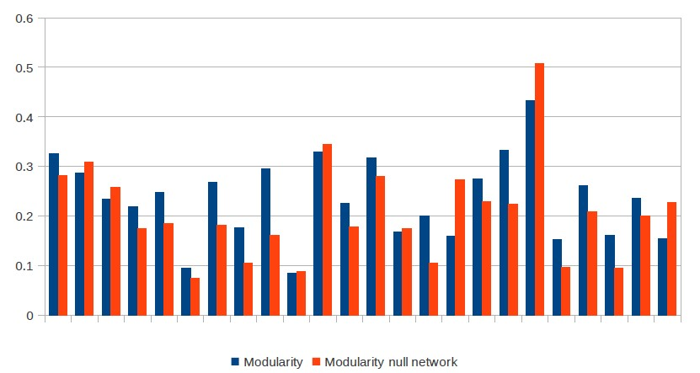

The **[X]** line indicates the modularity values for the considered repositories and the **[Y]** line is the distribution of modularity values obtained from random networks with the same number of edges and nodes. **[[INSERT PICTURE HERE**]]

|  |  |  |
| --- | --- | --- |
| Goal | Purpose | Measure |
| Issue | The social structure of |
| Object | Project members |
| Viewpoint | From the external observer point of view |
| Question | Q1 | Are the community members divided in subgroups with dense connections within them and sparse connections between them? |
| Metrics | M1 | Network modularity. |
| Question | Q2 | Which is the degree to which nodes in a graph tend to cluster together? |
| Metrics | M2 | Clustering coefficient. |
| Question | Q3 | How closely do nodes in the graph communicate with other nodes ? |
| Metrics | M3 | Closeness-centrality. |

Clustering coefficient is a statistical property which measures how complete the neighborhood of a node is [36]. The clustering coefficient of a vertex is the probability that any two randomly chosen neighbors of the vertex are linked together. A key element in defining the clustering coefficient for a node is a triangle which, in the context of an undirected graph, is a set of three vertices such that each possible edge between them is present in the graph. The clustering coefficient value is computed by dividing the number of triangles containing the vertex by the number of possible edges between its neighbors. The **clustering coefficient** of the whole graph represents the average of this value for all the vertices and in order this value to be meaningful it should be significantly higher than in version of the network where all of the edges have been randomized. **[[INSERT PICTURE HERE**]]

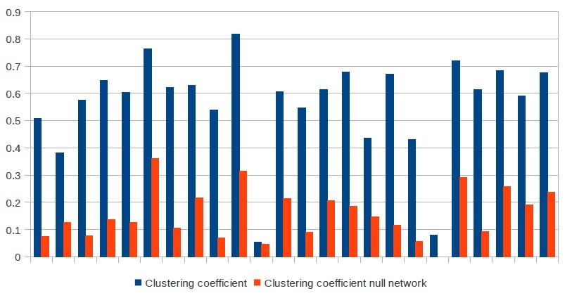

We computed the **average degree** nodes for each of the considered repositories as th average number of edges that are adjacent to the community node. 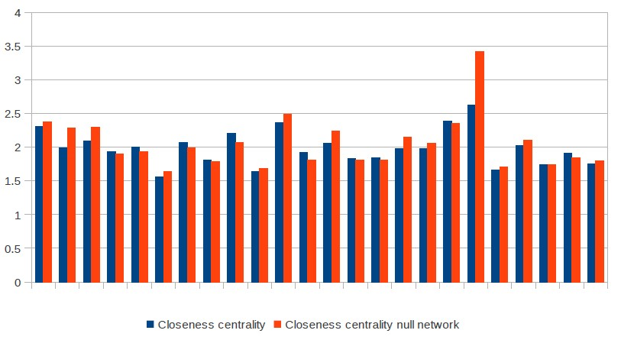

**Closeness centrality** is defined as the average distance from a given node to all other nodes in the network and measures how close each community member is to all other users. An important metric for the analysis of social networks are centrality indices defined on the vertices of the graph **[Bavelas]**. They are designed to rank the community members according to their position in the network and interpreted as the prominence of actors embedded in a social structure. Centrality indices are based on shortest paths linking pairs of actors, measuring the average distance from other users and the ratio of shortest paths an user lies on. High centrality scores indicate that a vertex can reach others on relatively short paths, or that a vertex lies on considerable fractions of shortest paths connecting others. We used aggregated value of per-node closeness-centrality the measure whether there are connections between all community members, or whether there is a smaller set of key members who are responsible for most of the connections.

To understand better how social graphs representing community members interactions differ from graphs randomly generated we created a network which matches the original network in some of its topological features, but which does not display community structure. We compared the values of social structure metrics of the initial network and the corresponding values in the null model. The null model preserves the number of nodes and connections between them, but the connections are randomized, obtaining a **randomized** version of the original network.

|  |  |
| --- | --- |
|  |  |

**Word Frequency**

To get a better insight of the most popular topics used in the communication between community members we also computed a list of most frequently used words. The content of the comments and other user interactions could be useful for measuring the degree of formality for different community types, placing them in either a formal or informal network.

## 4. Results

Patterns can be defined as structures that make statements only about restricted regions of the space spanned by the variables of the data [49].

These structures might represent Web pages that are all about the same topic or people that socialize together. The discovery of pattern structures in complex networks is an essential and challenging task in many disciplines, including business, social science, engineering, and biology. Therefore researchers have a great interest in this subject and have been approached it differently through data mining methods, social network analysis, etc. This diversity is not limited to the techniques used to implement this task, but it is also applied to its applications.

|  |  |  |  |  |
| --- | --- | --- | --- | --- |
|  | **Formal Network** | **Informal Network** | **Network of Practice** | **Informal Community** |
| **Group cohesiveness** | | | | |
| Average user-follow events within members | 0.008 | 0.019 | 0.012 | 0.012 |
| Average user connections established by collaboration on files | 0.224 | 0.143 | 0.182 | 0.184 |
| **Social processes** | | | | |
| Percentage of members which publish blog posts | 0.568 | 0.729 | 0.638 | 0.656 |
| Average repository-watch events within members | 49.669 | 30.555 | 35.565 | 31.682 |
| **Average user activity time span [[Okish-graph]]** | **0.11** | **0.334** | **0.489** | **0.225** |
| **Workload allocation** | | | | |
| Number of commits pushed by each user **[[Okish-graph]]** | 28.506 | 13.528 | 23.514 | 28.271 |
| Number of individuals participating in the development of one specific file **[[Okish-graph]]** | 2.349 | 3.789 | 2.505 | 2.372 |
| Member whose contribution counts for a high % of the community workload | 2.111 | 1.8 | 2.25 | 1.875 |
| **Project dynamics** | | | | |
| Existence of publicly available Wiki | True | True | True | True |
| Monthly evolution of issues **[[OKish-graph]]** | 286.13 | 250.26 | 259.58 | 265.49 |
| Percentage of re-opened issues from the total number of issues | 0.47 | 0.96 | 1.21 | 0.92 |
| **Social Structure** | | | | |
| Network modularity **[[OK-graph]]** | 0.255 | 0.139 | 0.243 | 0.226 |
| Clustering coefficient **[[OK-graph]]** | 0.525 | 0.717 | 0.602 | 0.62 |
| Closeness-centrality **[[OK-graph]]** | 2.058 | 1.705 | 1.988 | 1.921 |

## 5. Discussion

The first step in analyzing open source software development communities was computing the values of 12 key-attributes which are most representative for open-source communities. Taking into consideration the thresholds these attributes as defined in [Titans] we identified:

* 9 repositories that matched the Formal Network thresholds for formality and membership status
* 5 repositories that matched the Informal Network thresholds for informality, openness and non-governance
* 13 repositories that matched the Network of Practice thresholds for dispersion, self-organisation, self-similarity, openness and size
* 9 repositories that matched Informal Community thresholds for self-organisation, self-similarity, openness and dispersion

For the Informal Community key-attribute, engagement, according to [Titans] each member of an informal community should post no less than 30 comments per-month. As presented in **[X.Y]** a large percentage of users have a activity time span value smaller than 5 days, as many repository contributors have a low degree of engagement, contributing only for a short period. We ignored the this engagement attribute when selecting the range of repositories which matched the identified thresholds for a high level of engagement.

For the considered repositories we applied the set of metrics defined in **[X]** which describe group cohesiveness, workload allocation, project dynamics, community social structure and social processes that occur within these communities.

The average user-follow events that occur within community members has similar values for the considered community types. However, formal networks display a slightly lower number of user-follow events, indicating that community members prefer less to connect to other repository members within communities with a high hierarchy degree. The second metric which describes community cohesiveness indicates that members of formal networks establish more connections through collaboration on files than informal network members do.

By analyzing the social processes which occur within different community types, we observed that members of an informal network express more interest in publishing blogs. This behavior can explained by taking into account that a blogger is defined as a “networker” (a person who establishes social relations consisting of semantic references to allow for continuous communication) and that the key-attribute of an informal network is represented by the informality of communication between members.

In the set of metrics regarding workload allocation, the values for average number of commits pushed by each user are similar for the considered community types. Nevertheless, this metric is not representative for any of the considered community types. The next metrics – number of members whose contribution counts for a high percentage of the community workload – indicates that a small group of repository members is responsible for a large range of commits. Although the selected projects where rated with a high popularity based on the number of forks, the number of users whose contribution counted for at least half of the commits was smaller than 5 for all considered repositories.

By studying metrics of projects dynamics we observed that only 0.08% of the analyzed repositories didn't have a Wiki property defined. Taking into consideration that the analyzed repositories where selected among the most popular public repositories hosted on Github, we can state that is a common pattern for repositories to provide useful information on project artifacts and other resources that were included or linked in, ensuring ease to access to data.

The percentage of re-opened issues from the total number of issues indicates less re-opened issues for formal networks.

Social structure metrics have similar values for all considered community types. We observed in figure **[X-modula]** that the **modularity** values for the considered repositories are significantly higher compared to modularity values of random networks of associations, indicating a good collaboration.

The closeness centrality values indicate that there are better connections between all community members compared to a community with random associations or communities where there is a smaller set of key members who are responsible for most of the connections.

The differences between the clustering coefficient of community network and their associated null model are not significant.

One of the limitations in the current study is a product of a common pattern that we identified for the considered repositories. Some of the advantages of having access to Github data resources through REST API calls is that it allows fast data retrieval for all repositories that are shared publicly, without being forced to entirely check out this data. However, among the disadvantages we can consider the limit of 5000 requests per hour for authenticated users and the restricted access to data regarding team members and status for users that are not registered as team members.

## 6. Conclusion

We have studied metrics that capture different attributes in the social organization of open-source software development communities.

The project provides support for collecting communication and development data on open-source software projects hosted on Github. The process of collecting metric is applied on a range of **25** distinct software repositories. The next contribution is to determine a number of metrics and the correlation between these metrics and the community characteristics. Finally, we describe metric values statistically, getting a first overview of the value ranges for some metrics suits.

We found that in all cases, evidence of strong community structure existed within the communication patterns of the participants. In addition, in all cases where our data was complete, the division of the project into subcommunities was also

representative of the collaboration behavior of the develop-

ers.

The set of key-attributes that are frequently associated with open-source communities and the attributes measuring the product quality could be further extended.

We view the social organisation from the perspective of time-evolving networks and highlight how projects, although simi lar in terms of size, problem domain and age, a) largely differ in terms of clustering coefficie nt, assortativity and closeness centralisation and b) that some projects show interesting dynamics with respect to these measures that cannot be explained by mere size effects.

We believe they are representative of open source movement worldwide.

# 7. References

[1] Analyzing Millions of GitHub Commits, what makes developers happy, angry, and everything in between?, Brian Doll, Ilya Grigorik

[1.2-Walt] Free Software Developers as an Occupational Community:Resolving Conflicts and Fostering Collaboration, Margaret S. Elliott, Institute for Software Research, Walt Scacchi, Institute for Software Research University of California

[1.2-Flossmole] FLOSSmole: A collaborative repository for FLOSS research data and analyses, James Howison, School of Information Studies, Megan Conklin, Elon University, Kevin Crowston, Syracuse University

[1.3-Ahmed] The Road Ahead for Mining Software Repositories, Ahmed E. Hassan, Software Analysis and Intelligence Lab (SAIL), School of Computing, Queen’s University, Canada

[1.3-Titans] Supporting Community and Awareness Aspects in Open-Source Forges, Damian A. Tamburri, Elisabetta Di Nitto, Simone Gatti, Politecnico di Milano, Roberto Galoppini, Software Engineer, Politecnico di Milano, Patricia Lago, Hans van Vliet

[1.3-ACS] A Case Study of Open Source Software Development: The Apache Server, Audris Mockus, Bell Labs, 263 Shuman Blvd. Naperville, Roy T. Fielding, Information & Computer Science University of California, Irvine, James Herbsleb, Bell Labs, 263 Shuman Blvd. Naperville

[1.4-Grounded] Analysing data using grounded theory Steven R Wainwright MSc, BSc(Hons), PGCE, RGN, is Nurse Teacher, North London College of Health Studies.

[3.AVGCC] Matthieu Latapy, Main-memory Triangle Computations for Very Large (Sparse (Power-Law)) Graphs, in Theoretical Computer Science (TCS) 407 (1-3), pages 458-473, 2008

[3.M] Vincent D. Blondel, Jean-Loup Guillaume, Renaud Lambiotte, Etienne Lefebvre - Fast unfolding of communities in large networks (2008)

[3.CC] Ulrik Brandes (2001). A faster algorithm for betweenness centrality

[BigBook] Handbook of Social Network Technologies and Applications, Borko Furht, Florida Atlantic University, Dept. of Comp. & Elect. Engin. and Comp. Sci.

[G-12] Newman, M. E. J., Modularity and community structure in networks, Proceedings of the National Academy of Sciences (PNAS), 103(23), 8577–8582, 2006

[2-Hasan] Predicting faults using the complexity of code changes, Hassan, A.E. ; Software Anal. & Intell. Lab. (SAIL), Queen''s Univ., Kingston, ON

[2-R30] T. Wolf, A. Schr¨oter, D. Damian, and T. Nguyen, “Predicting build failures using social network analysis on developer communication,” in ICSE ’09: Proceedings of the 31st International Conference on Software Engineering. IEEE Computer Society, 2009, pp. 1–11.

[2-R10] M. Cataldo, A. Mockus, J. A. Roberts, and J. D. Herbsleb, “Software dependencies, work dependencies, and their impact on failures,” IEEE Transactions on Software Engineering, vol. 35, no. 6, pp. 864–878, 2009.

[2-R] Studying the Impact of Social Structures on Software Quality, Nicolas Bettenburg and Ahmed E. Hassan, Software Analysis and Intelligence Lab (SAIL), School of Computing, Queen’s University

[2-R27] J. ´ Sliwerski, T. Zimmermann, and A. Zeller, “When do changes induce fixes?” in MSR ’05: Proceedings of the 2005, International Workshop on Mining Software Repositories. ACM, 2005, pp. 1–5.

[E-Git] https://github.com/eclipse/egit-github

[Gephi-Tool]https://github.com/gephi/gephi-toolkit

[Geo] https://developers.google.com/maps/documentation/geocoding/

[Ghtorrent] GHTorrent: Github’s Data from a Firehose, Georgios Gousios and Diomidis Spinellis, Department of Management Science and Technology, Athens University of Economics and Business

[Social-C] Social Coding in GitHub: Transparency and Collaboration in an Open Software Repository, Laura Dabbish, Colleen Stuart, Jason Tsay, Jim Herbsleb, School of Computer Science and Center for the Future of Work, Heinz College, Carnegie Mellon University

[Floss-ok] Free/Libre Open Source Software Development: What We Know and What We Do Not Know, KEVIN CROWSTON, Syracuse University, KANGNING WEI, Syracuse University, JAMES HOWISON, Carnegie Mellon University, ANDREA WIGGINS, Syracuse University

[Erenkrantz] ERENKRANTZ, J. R. Release Management Within Open Source Projects. Proceedings of the ICSE 3rd Workshop on Open Source Software Engineering (May 3, 2003).

[Glance] GLANCE, D. G. Release criteria for the Linux kernel. First Monday 9, 4 (2004).

[Understand SW] Understanding Software Development, Processes, Organizations, and Technologies, Dewayne E. Perry1, Nancy A. Staudenmayer2, and Lawrence G. Votta, Jr.3, AT&T Bell Laboratories,Sloan School of Management,AT&T Bell Laboratories,

[Blogging] Blogging Practices: An Analytical Framework, Jan Schmidt, Journal of Computer-Mediated Communication, Volume 12, Issue 4, pages 1409–1427, July 2007

[User-Invo] The role of user involvement in requirements quality and project success,Kujala, S. ; Software Bus. & Eng. Inst., Helsinki Univ. of Technol., Finland ; Kauppinen, M. ; Lehtola, L. ; Kojo, T.

[WIKI] The wiki as an integrative tool in project work, Birgit R. Krogstie, 1Norwegian University of Science and Technology,

[BUGS] Characterizing and Predicting Which Bugs Get Reopened, Thomas Zimmermann, Nachiappan Nagappan, Philip J. Guo, Brendan Murphy

[link-3] James Howison, Keisuke Inoue, and Kevin Crowston. Social dynamics of free and open source team communications. Open Source Systems, pages 319–330, 2006.

[link-6] Roozbeh Nia, Christian Bird, Premkumar Devanbu, and Vladimir Filkov. Validity of network analyses in open source projects. In proceedings of the 7th IEEE Working

[modularity] Latent Social Structure in Open Source Projects, Christian Bird, David Pattison, Raissa D’Souza, Vladimir Filkov and Premkumar Devanbu, Dept. of Computer Science, Kemper Hall

[clusterCoeff] Main-memory Triangle Computations for Very Large (Sparse (Power-Law)) Graphs, Matthieu Latapy

[closenessCentral] A Faster Algorithm for Betweenness Centrality, Ulrik Brandes, University of Konstanz, Department of Computer & Information Science

[Bavelas] Bavelas, A. (1948). A mathematical model for group structure. Human Organizations, 7:16-30.