

Reporte de Capacidad y Disponibilidad GCP CRITICOS {{ month }} {{ year }}



Reporte de Capacidad y Disponibilidad GCP CRÍTICO ENERO 2023



Reporte de Capacidad y Disponibilidad GCP CRÍTICO ENERO 2023

**sha-dc-prd-ad** 3

Dashboard monitoreado: sha-dc-portales Disp / Cap 3

CPU Utilization – sha-dc-prd-ad-instance-app-01 3

Memory Utilization – sha-dc-prd-ad-instance-app-01 4

Disk Utilization – sha-dc-prd-ad-instance-app-01 4

CPU Utilization – sha-dc-prd-ad-instance-app-02 5

Memory Utilization – sha-dc-prd-ad-instance-app-02 5

Disk Utilization – sha-dc-prd-ad-instance-app-02 6

|  |  |
| --- | --- |
| PROYECTO | **sha-dc-prd-ad** |

### Dashboard monitoreado: sha-dc-portales Disp / Cap

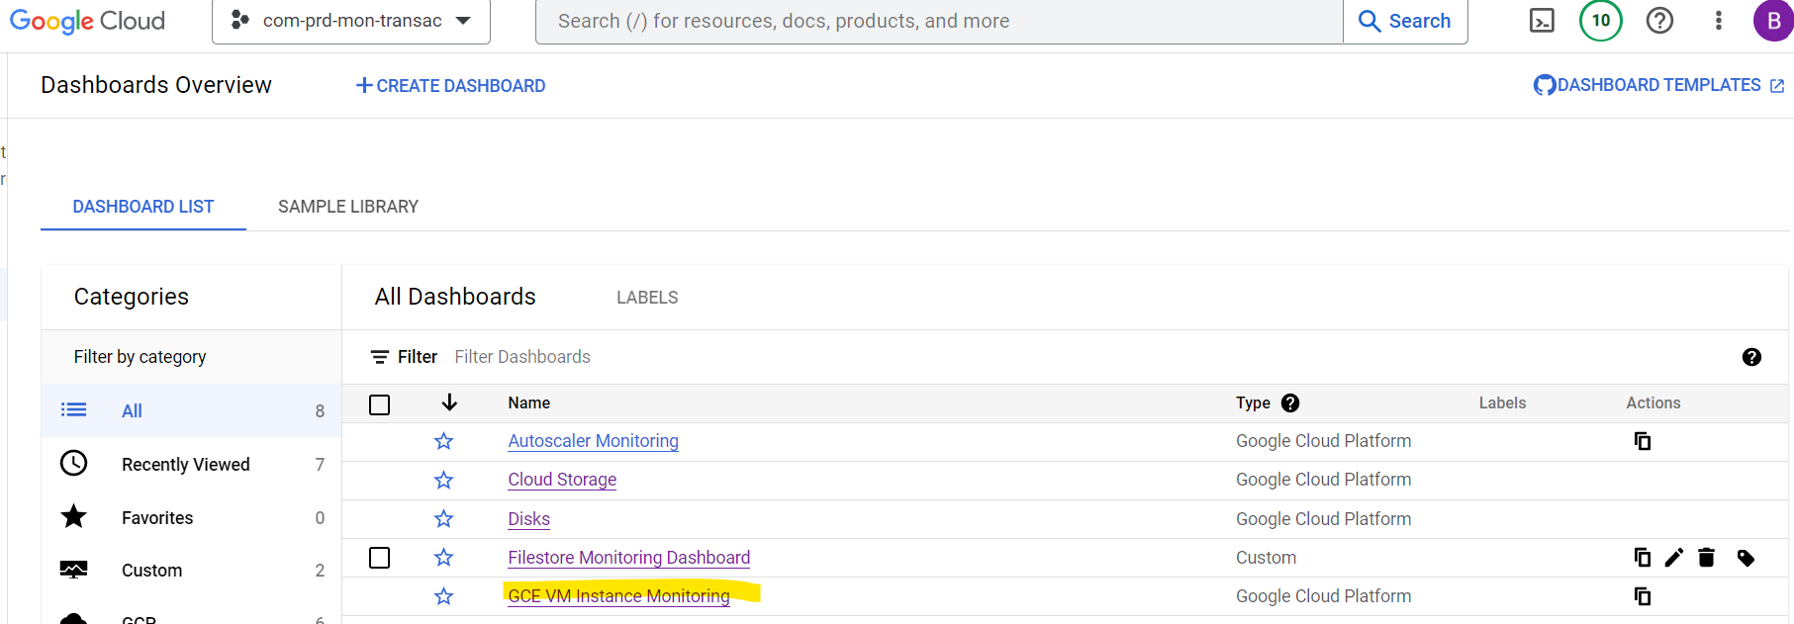

### CPU Utilization – sha-dc-prd-ad-instance-app-01

|  |  |  |
| --- | --- | --- |
| Min | Max | Mean |
| {{ min_value }} | {{ max_value }} | {{ mean_value }} |



### Memory Utilization – sha-dc-prd-ad-instance-app-01

|  |  |  |
| --- | --- | --- |
| Min | Max | Mean |
| {{ min_value }} | {{ max_value }} | {{ mean_value }} |



### Disk Utilization – sha-dc-prd-ad-instance-app-01

|  |  |  |
| --- | --- | --- |
| Min | Max | Mean |
| {{ min_value }} | {{ max_value }} | {{ mean_value }} |



### CPU Utilization – sha-dc-prd-ad-instance-app-02

|  |  |  |
| --- | --- | --- |
| Min | Max | Mean |
| {{ min_value }} | {{ max_value }} | {{ mean_value }} |



### Memory Utilization – sha-dc-prd-ad-instance-app-02

|  |  |  |
| --- | --- | --- |
| Min | Max | Mean |
| {{ min_value }} | {{ max_value }} | {{ mean_value }} |



### Disk Utilization – sha-dc-prd-ad-instance-app-02

|  |  |  |
| --- | --- | --- |
| Min | Max | Mean |
| {{ min_value }} | {{ max_value }} | {{ mean_value }} |

