If you have downloaded PP.POPS-00001, open EXECUTE.ELF : The BIOS starts at offset 0x508B0  
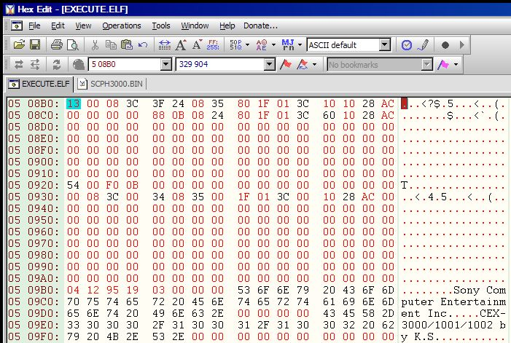  
Repace it with a console BIOS dump. Console BIOS dumps have [garbage at the EOF](http://ddata.over-blog.com/1/06/19/78/EOPS1BIOS.jpg). Do not copy the shit after 0x7FF90 (after "Copyright 1993,1994,1995 (C) Sony Computer Entertainment Inc"), it does not fit the POPS binary.  
The BIOS you put in the emulator must match the game region (examples : SCPH-3000 + NTSC U/C MYDUMP.BIN, SCPH-7502 + PAL MYDUMP.BIN...) or the game will not boot.

No, EXECUTE.KELF is not a launcher for EXECUTE.ELF. It is the KELF version of EXECUTE.ELF.  
PATINFO.KELF is the launcher for hdd0:/PP.POPS-00001/EXECUTE.ELF  
  
[QUOTE=vash32I'm dong it at PP.SLBB-00001, or does it only work at PP.POPS-00001.[/QUOTE]  
It only works at PP.POPS-00001, unless you modify the launch path at offset 0x3B90 of EXECUTE.ELF :  
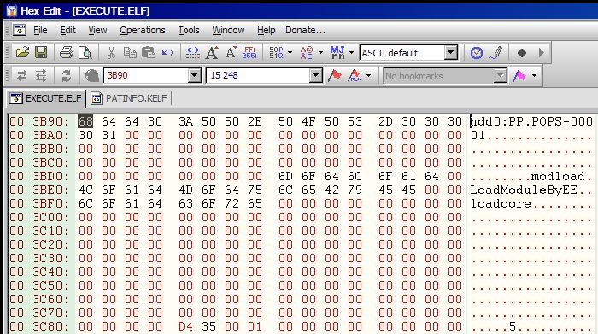  
Replace "PP.POPS-00001" with the name of your new partition. You can also write longer partition names (for example : "hdd0:PP.BISHI_BASHI_SPECIAL_3").  
If you want to use PATINFO.KELF for booting the emulator from the HDD-OSD, don't forget to change its launch path too. It's at offset 0x9E88 of the unpacked ELF :  
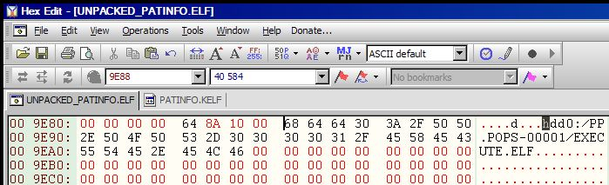

ps2unpacker should workhttp://www.assemblergames.com/forums/images/smilies/smile-new.png.  
To unpack the ELF, delete the KELF header...  
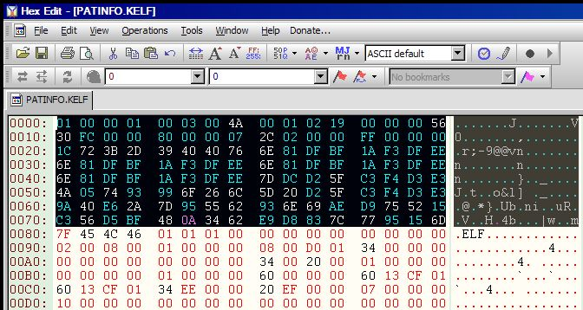  
... and save the file as "UNPACKME.ELF".  
- Unpack "UNPACKME.ELF" with ps2unpacker  
- Open the unpacked ELF in an hexeditor, change the launch path at offset 0x9E88, then save the new file as "PACKME.ELF"  
- Pack "PACKME.ELF" with ps2packer, write the re-packed ELF at offset 0x80 of PATINFO.KELF and save it  
- Inject the new PATINFO.KELF in the [PATINFO field](http://www.assemblergames.com/forums/showthread.php?42308-%28Help%29-How-to-add-Icons-to-HDLoader-KERMIT-Games-on-PS2-HDD-OSD&p=629018&viewfull=1#post629018) of your partition header, or use BOOT2 to boot PATINFO.KELF from the partition contents.

Or

Plan-B for modifying the POPS PATINFO.KELF without unpacking/packing. Hexeditor haters will get servedhttp://www.assemblergames.com/forums/images/smilies/livid.png :  
[PLANB_PATINFO.KELF](http://aybabtu.chez.com/PS2/POPS_SHIT/PLANB_PATINFO.KELF)  
Offset 3F50h = "CRAB!" (5 characters)  
Offset 3F57h = "BATTLE!" (7 characters)  
Result : hdd0:/POPS-CRAB!/BATTLE!.ELF  
  
See what I mean ? Replace "CRAB!" and "BATTLE!" with what you want. Keep the same amount of characters (keep in mind that we are messing up with packed data here), don't overwrite anything else.  
  
Examples :  
  
Offset 3F50h = "H4X0R" (5 characters)  
Offset 3F57h = "IS_LAME" (7 characters)  
Result : hdd0:/POPS-H4X0R/IS_LAME.ELF  
  
Offset 3F50h = "12345" (5 characters)  
Offset 3F57h = "EXECUTE" (7 characters)  
Result : hdd0:/POPS-12345/EXECUTE.ELF  
  
... or just code your own ELF launcher.

**Change the game lice area so it matches the BIOS region**

I think you can copy/paste from LBA0 to the start of the Volume Descriptor (in a raw 2352 bytes/sector dump, it should be from 0h to 92FCh), then scan your modified dump for ECC corruption with [ECCRegen 1.41](http://aybabtu.chez.com/PS1/ECCRegen%201.41.zip), and to finish, insert the POPS header....

As about adding JAPANESE info into disk PS1 - we have to change first 11 sectors for any from Japanese disk (this sectors are identical on all disk and exist in 3 forms: PAL, NTSC-U and NTSC-J). Maybe it will be better to change next 4 sectors (that are responsible for EDC/ECC) but in all disks that i was tested it does not affect ))  
Next check disk in ECC regen and add pops loader. If someone need i was making simple disk builder.  
  
One more trick - if you are using disk with audio tracks - you can extract first track for reducing disk image size (cause emulator doesn't support audio cd). Just open i CDmage and extract first track in any format.

PATHEADER.BIN

PATEINFO.KELF is at offset (h) C200

Notes: PS2ICON3D goes on the 8th Sector down from the PP.GAMENAME