**Docker networking Hands-on Lab**  
Paweł Kosmala  
167433

# **Section #1 - Networking Basics**

Step 1: The Docker Network Command

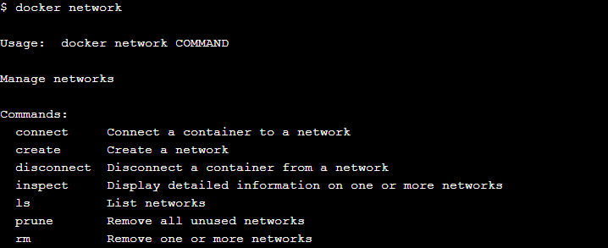  


## Step 2: List networks

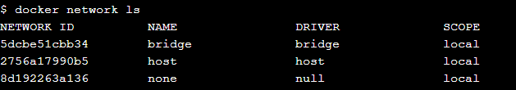

## Step 3: Inspect a network

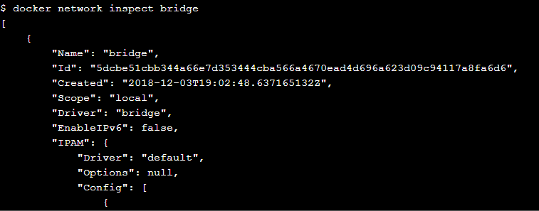  
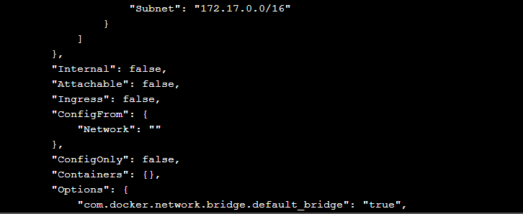  
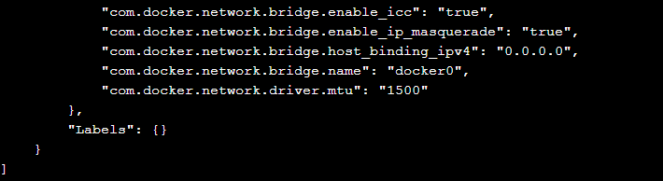

## Step 4: List network driver plugins

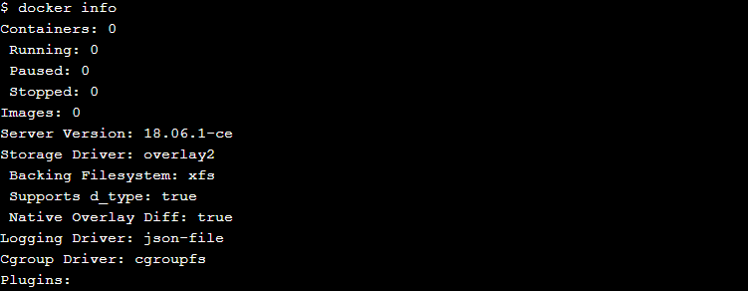  
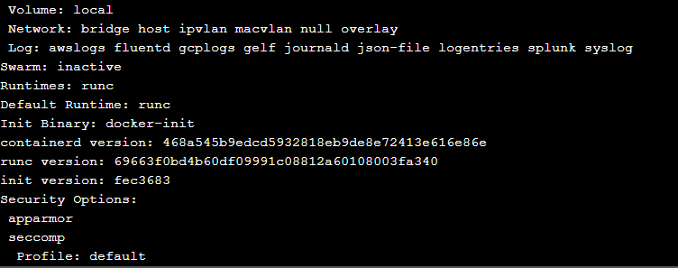  
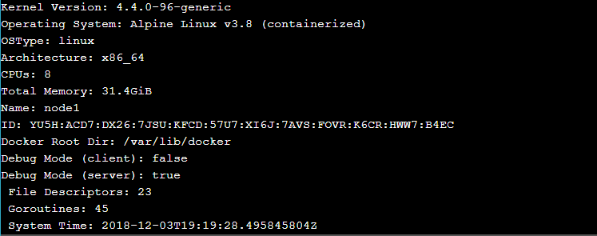  
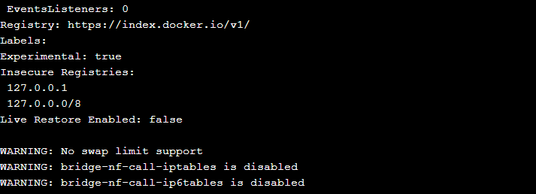

# **Section #2 - Bridge Networking**

## Step 1: The Basics

## 



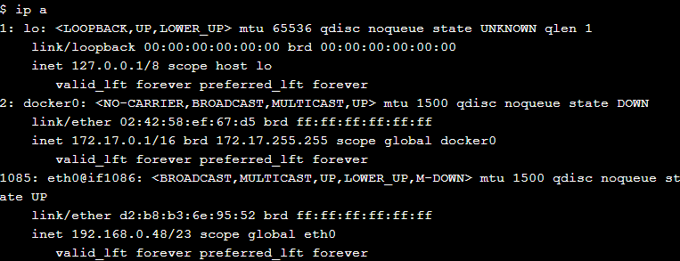  
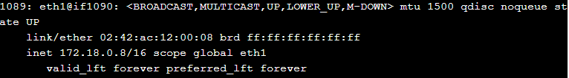

## Step 2: Connect a container

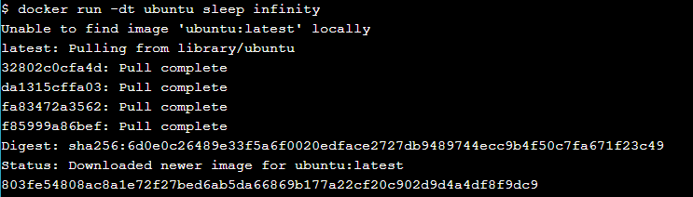

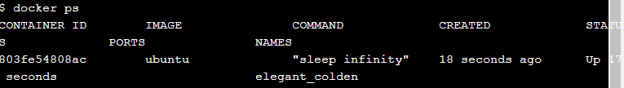



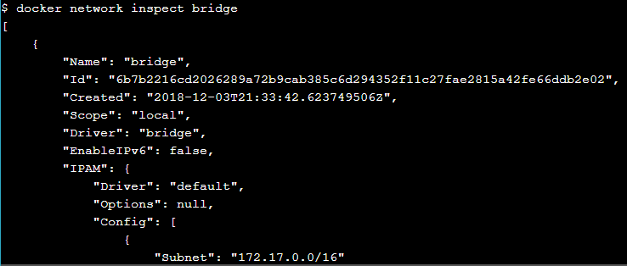  
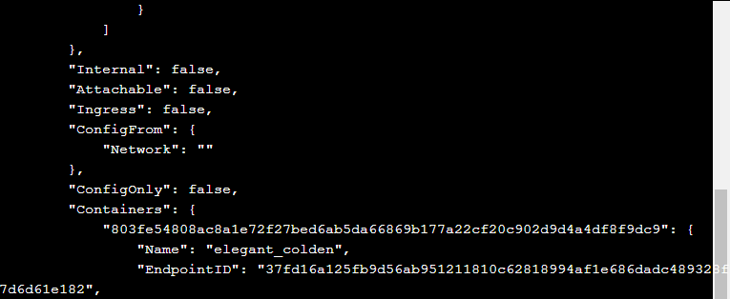  
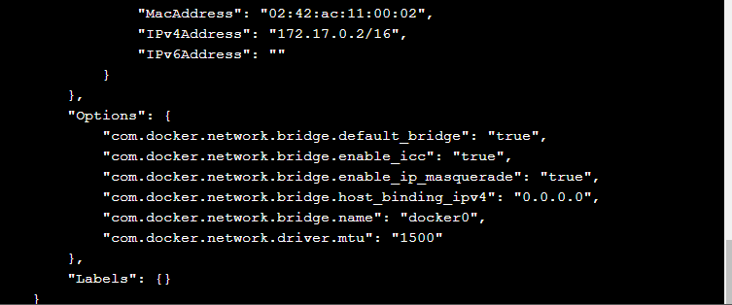

## Step 3: Test network connectivity

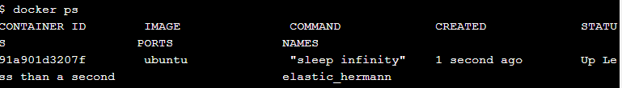

  
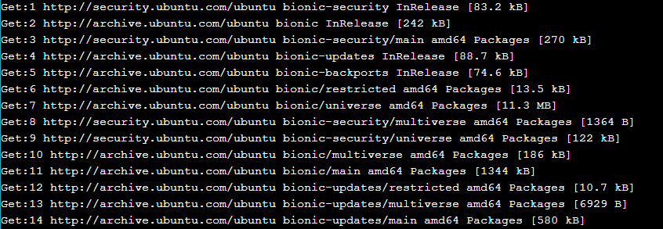  
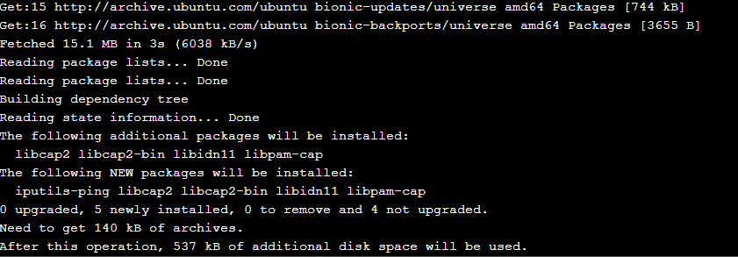  
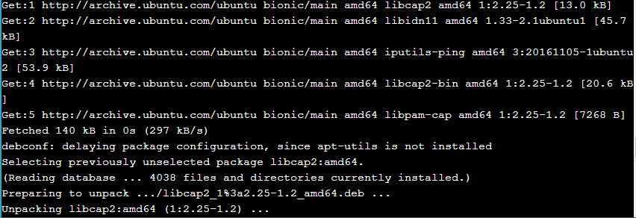  
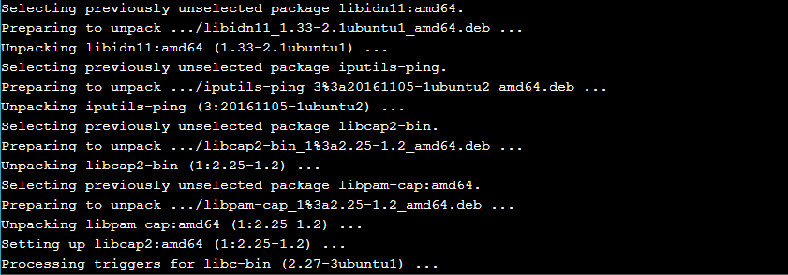  
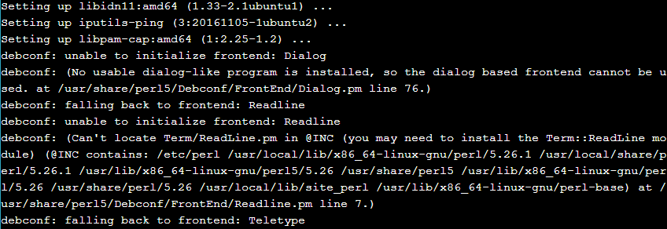  


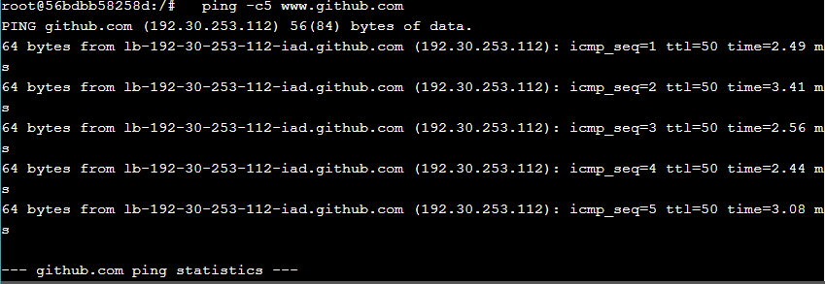  




## Step 4: Configure NAT for external connectivity

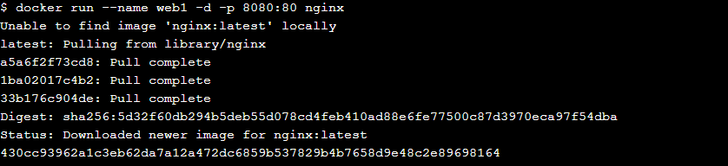

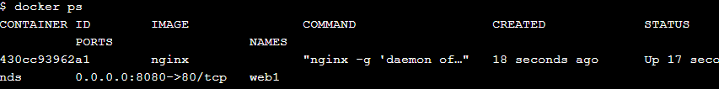

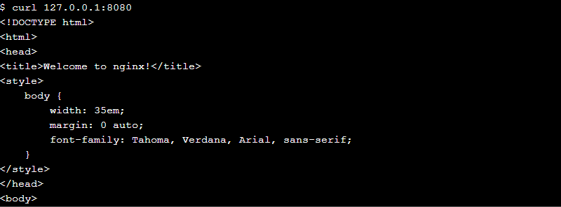  
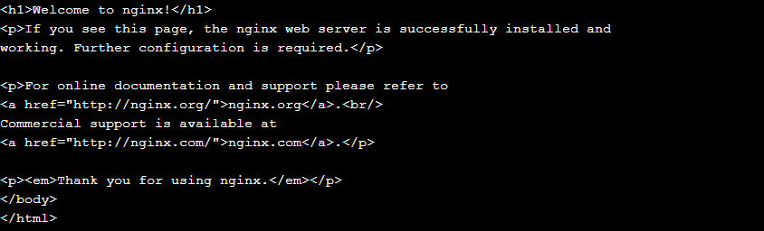

# **Section #3 - Overlay Networking**

## Step 1: The Basics

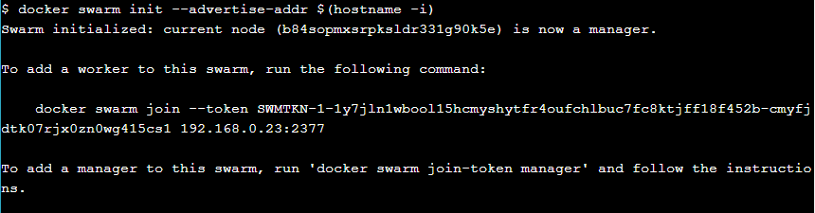



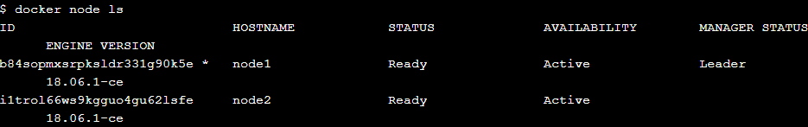

## Step 2: Create an overlay network

## 

## 

## 

## 

## Step 3: Create a service

## 

## 

## 

## 

## 

## Step 4: Test the network

## 

## 

## 

## 

## Step 5: Test service discovery

## 

## 

## 

# **Cleaning Up**

## 

## 

## 