# Problem 1

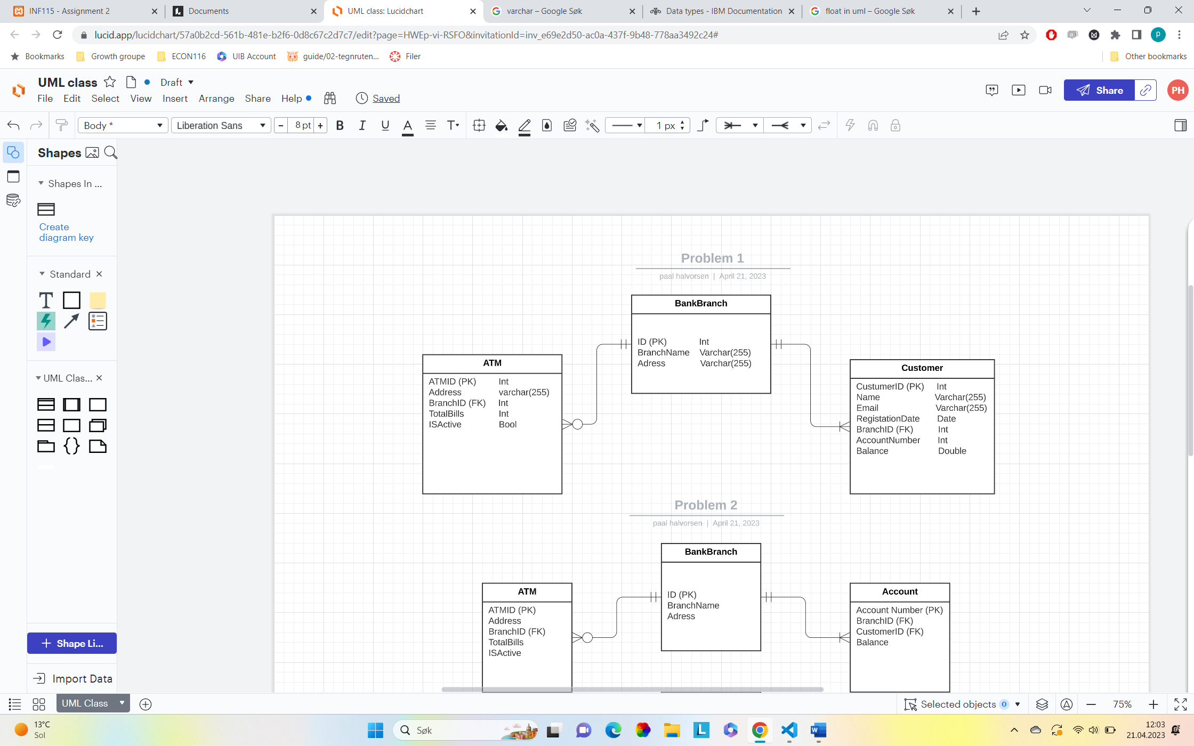

Note: The BankBranch could have non-customers or many costumers, but I think that is not relevant in this case, so therefore I have one to many relationships between them.

# Problem 2

## Task 2.1

*What is the problem with the current design?*

The current design allows only one account per customer, because the customer only have a single account number in the Customer entity. Therefore, the customer cannot have multiple accounts in different branches. If the customer would like to have multiple accounts, it would require a database that have multiple accounts number that can associate with a single customer ID.

## Task 2.2

*Suggest a solution to this problem by creating new tables.*

By creating new table Account, we can get a relationship between the tables (customer and the account) which will solve the multiple account problem. The account table can store data for the different accounts by linking it to a specific customer. Under you can see the new table account.

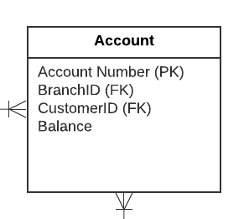

## Task 2.3

## 

# Problem 3

## Task 3.1

*Explain the Normal form 1NF and apply it to Table 1.*

First Normal Form (1NF) is a property form where every attribute in a relation is singled valued. That means that all columns in a table have atomic values and there is no repeating arrays or groups in any of the columns. Each of the columns contain unique names and the order of the information’s that is stored in the table doesn’t matters. If we want to apply NF1 to the given table, we need to make sure to get rid of columns that contain non-atomic values and assert atomic values. We also need to give each table unique names.

Here are the table in 1NF;

Eit bilete som inneheld tekst, datamaskin, skjermbilete

Automatisk generert skildring

## Task 3.2

*Explain the Normal form 2NF and apply it to the table gener-ated from 3.1.*

If a table is in Second Normal Form, it first must be in First Normal Form which I explained in 3.1. It also requires that all the non-prime attributes depend on the primary key or the candidate key. This means that the value of a non-prime attribute should be affected by the whole primary key and not just a portion of it. If we want to apply the Second Normal Form on the 3.1 table, we first need to be identifying the primary keys and the non-prime attributes. We assume that the primary keys are a combination of Customer ID, ATM ID, and Date since they are unique, and the non-prime attributes are Draw Amount and Currency. Draw Amount and Currency depends on the entire primary key (Customer ID, ATM ID and DATE) and not just part of the key.

The table is already in a Second Normal Form since it already in First Normal Form and the non-prime attribute is determined by the hole primary key (See table 3.1)

## Task 3.3

*Explain the Normal form 3NF and apply it to the table or tablesgenerated from 3.2*

If a table is in Third Normal Form it first must be in the Second Normal Form which I explained in above in 3.2 and there should be no transitive dependency for non-prime attributes. Which means that the non-attributes should not depend on others non-prime attributes that relate to a primary key. The table is already in Third Normal Form because it is in Second Normal Form and the Non-prime attributes (Draw Amount and Currency) are directly depended on the primary key (Customer ID, ATM ID, and Date. (See table 3.1)

## Task 3.4

*Explain the Normal form BCNF and apply it to the table ortables generated from the tabel 3.3*

BCNF stands for Boyce-Codd Normal Form and is a more rigorous and stronger version of Third Normal Form. If a table is in BCNF it must first be in Third Normal Form and for every functional dependency, it must be a super key. ((X 🡪 Y) x is the superKey). The table is already in Third Normal Form and we need to take a look for functional dependencies where the determining attributes are not a superkey. If we look at the table we can see that it doesn’t exist functional dependencies, because both of the non-prime attributes (Draw amount and currency) depends on the primary key. Therefore the table is in BCNF. (See table 3.1)