Mechanical Design
Overview
As first-year participants, our team prioritized a simple, possible modular, and cost-effective mechanical design. This approach allowed us to concentrate our budget toward sensors and electronics critical for autonomous navigation. The vehicle is built on a commercially available tracked drive platform from AndyMark®, the Raptor Track Drive. This track-based structure provides a reliable and robust base for mobility. For design flexibility, T-slot aluminum extrusions were mounted directly to the chassis, enabling rapid prototyping and testing of different structural configurations throughout the development process. Additionally, a modular electronics housing unit was designed that could be easily interchanged between vehicles. For our IGVC competition vehicle, we set the housing unit at the top of our chassis so the electronics could be easily accessed, thus, allowing plenty of space for our payload.

Frame Structure & Chassis Integration (Design Process)
The AndyMark Raptor Track Drive platform was selected for its robust tank-track configuration. Using the track belts, instead of regular wheels, the weight of {ROBOT NAME} is spread over a larger area increasing traction and stability across uneven terrain and obstacles encountered in the course. Attached to the base chassis is a 1/8 in thick diamond plate steel base (21.5 in × 30 in), offering a rigid and large mounting surface. This flat and large area enabled the placement of heavy components, such as the battery and payload, closer to the ground, effectively lowering the center of gravity and improving stability during turning and inclined terrain.
The structural frame was constructed using 80/20® 20-Series T-slot aluminum extrusions (80/20 Inc., USA). These extrusions allow for a modular and reconfigurable design for future competitions if the same chassis is used. To improve safety during assembly and operation, T-slot nuts were utilized within the extrusion channels, eliminating exposed threaded ends and reducing the risk of sharp edges.
Weight distribution was the most prioritized design consideration. A 48 V battery pack was mounted toward the rear of the chassis to act as a counterbalance to the 20-lb payload, which was positioned toward the front of the vehicle on a 3D printed mount.
All electronics were placed on a secondary elevated shelf specifically designed to hold the onboarding electronics including lidar and cameras. The shelf is positioned 20 inches above the ground, measuring 23in x 23 in x 6 in, providing sufficient clearance for e-stop mounting height of 24 inches. This added structure extends the overall length of the {ROBOT NAME} to meet minimum qualification requirements.
This design approach leaves enough space for all electronics to be placed in a clear, well distributed form, while T-slots allow for 3D printed brackets to be easily attached, and prevent direct contact with the steel base, maintaining balanced mass distribution across the platform while protecting sensors and other components from electrical interference.
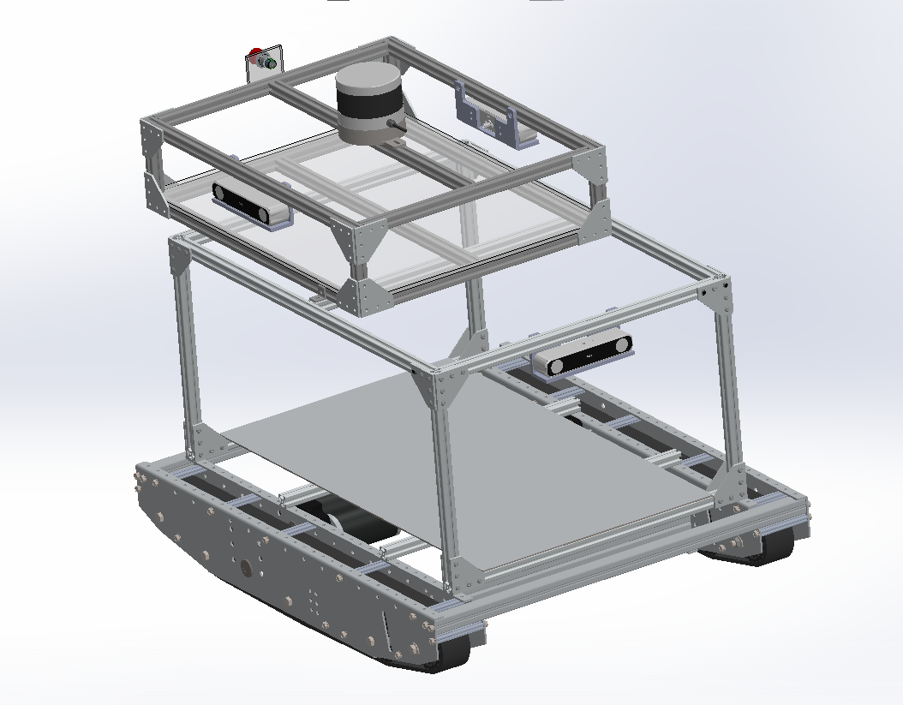
Drive System
{ROBOT NAME} utilizes a tracked differential drive system powered by two NEO brushless motors, each controlled by a REV SparkMAX motor controller. This configuration was chosen for its both mechanical and computational simplicity, as well as traction performance in outdoor environments.
The fixed belt-tracked system allows for skid-steer operation where each motor drives one side of the track independently. Straight motion is achieved when both motors rotate at the same speed, and in the same direction, while turning is accomplished by varying the relative speeds of each motor:
- Pivot Turn: One track moves forward while the other stays still. The robot pivots around the stationary track.
- In-Place rotation (Spin): The tracks rotate in opposite directions at the same speed (velocity left = - velocity right). The robot rotates around its exact center point, crucial for tight areas, and sequential cones obstacles.
- Gradual Curve: One track rotates faster than the other (velocity left > velocity right to turn right).
This approach eliminates the need for four independent motors or steering mechanisms, reducing system complexity in both mechanical design and control systems. By relying on differential control, the system simplifies wiring, reduces power consumption, and enables straightforward implementation of motion control algorithms.
3.5 Weatherproofing
To protect electronic components from rain and sun exposure, {ROBOT NAME} utilizes acrylic panel walls integrated into the T-slot frame. The acrylic sheets are cut-to-fit inside the T-slots extrusion grooves, the gaps are then filled with weatherstripping gaskets ensuring a secure fit that remains in place even with the vibration during operation. Top panel is angled for water runoff and includes a sliding door for maintenance, wiring, and payload handling.

3.6 Constraints
To satisfy the competition requirements {ROBOT NAME} was extended through the addition of the rear-mounted shelf for the mechanical E-stop button, extending the length of the vehicle over the minimum 3 ft required. This structure was mounted at 2 ft from the ground, and the e-stop button was centrally positioned allowing for easy access. These changes not only improved e-stop location but also ensure even cleaner placement of components, battery and payload on the base.

3.7 Safety
During the design process, we wanted to make sure safety features were included to our competition vehicle to keep ourselves as well as our fellow peers at the competition safe at all times. A wireless E-stop button was included into the safety package that could be pressed by an operator to bring the vehicle to a safe stop, if it is necessary. Aside from the wireless E-stop button, there was a mechanical E-stop buttton installed on the frame of the car that is located a little over 2 feet off the ground. These safety features comply with safety standards set in place for the competition and will be crucial during testing and competition.

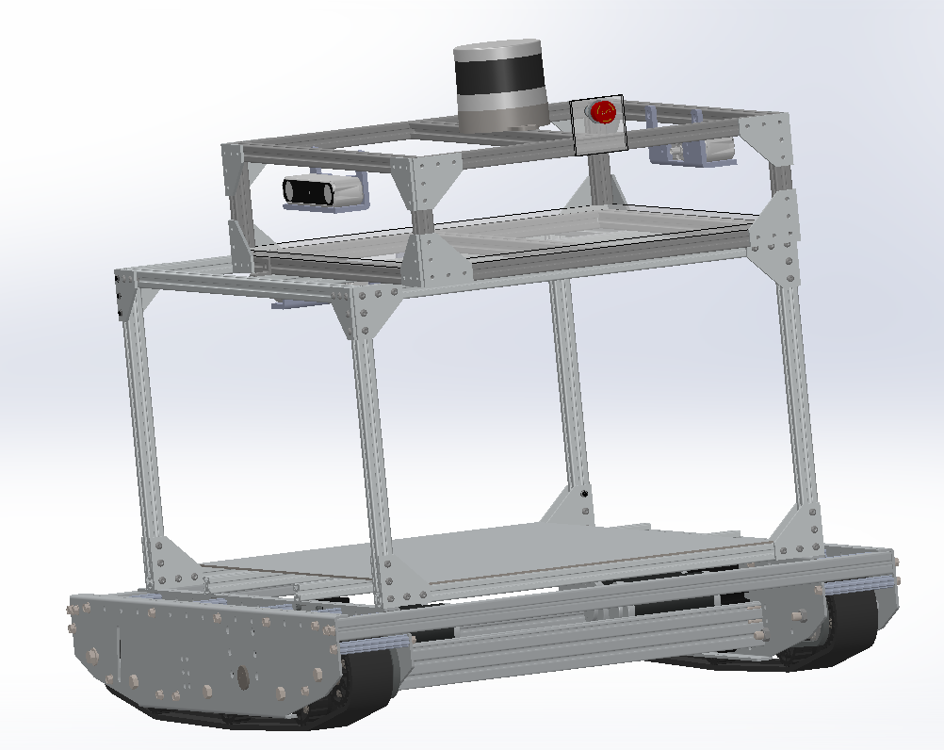

(For work cited section)
AndyMark Inc. Raptor Track Drive. https://andymark.com/products/raptor-track-drive?variant=44493433012396

