Wazuh SIEM Project Report
Centralized Security Monitoring using Wazuh SIEM with AWS, Windows, and Kali Linux Agents
Parth Srivastava

Introduction
This project demonstrates the implementation of a Security Information and Event Management (SIEM) system using Wazuh. The setup includes a cloud-based Wazuh server deployed on AWS Ubuntu instance and multiple agents (Windows 10 and Kali Linux) connected for centralized monitoring.
The project focuses on:
- File Integrity Monitoring (FIM)
- Registry Monitoring (Windows)
- SSH Brute Force Detection
- Vulnerability Detection

🎯 Objectives
- Deploy Wazuh SIEM on AWS cloud
- Configure agents on Windows and Kali Linux
- Monitor system activity and detect threats
- Implement real-time alerting

🏗️ Architecture
- Wazuh Server (AWS Ubuntu): 52.66.238.137
- Windows Agent: 192.168.153.128
- Kali Linux Agent: 192.168.253.130
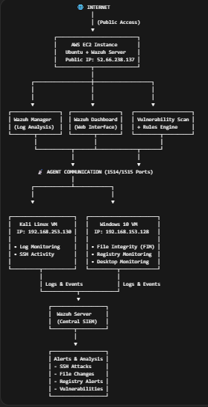
Figure 1: Wazuh SIEM Architecture

⚙️ Step 1: AWS Instance Setup
- Created an Ubuntu server instance on AWS EC2
- Configured security group to allow required ports (22, 5601, 1514, 1515)
- Connected using SSH
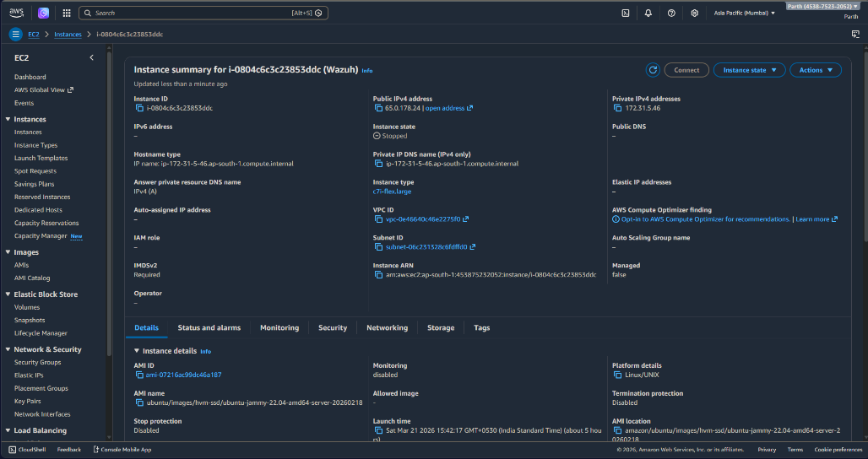
Figure 2: Wazuh SIEM Architecture
⚙️ Step 2: Wazuh Installation
- Installed Wazuh using official installation script
- Components installed:
  - Wazuh Manager
  - Wazuh Dashboard
  - Elasticsearch
- Accessed dashboard via:
https://52.66.238.137:5601
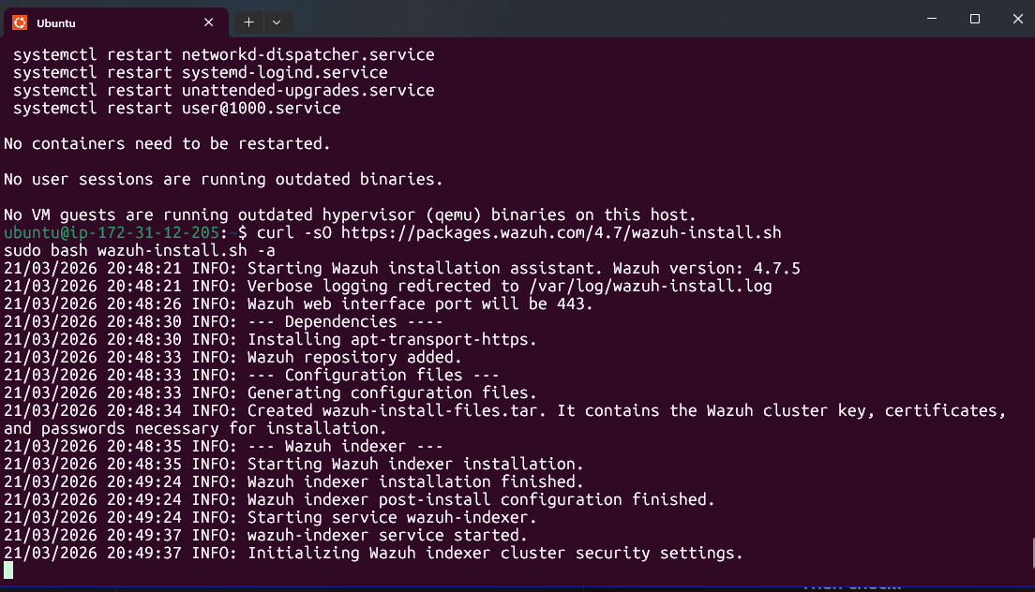
Figure 3: Wazuh Installation
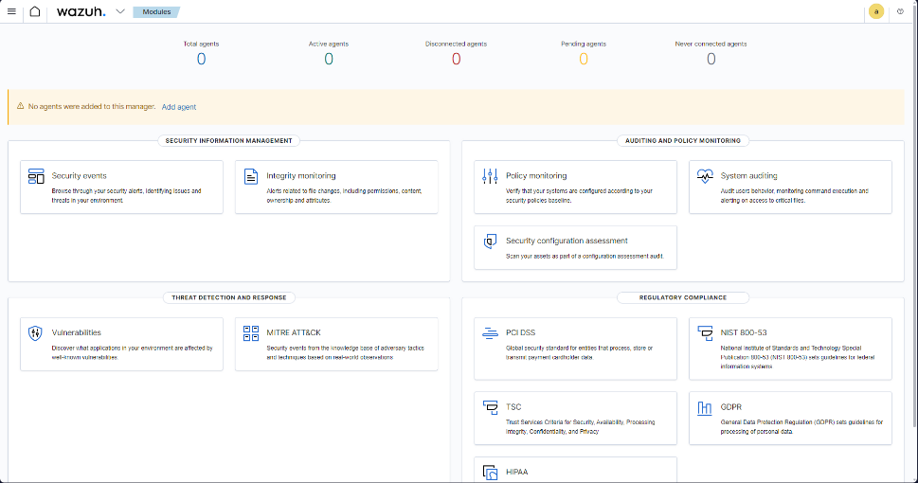
Figure 4: Wazuh Dashboard Login
⚙️ Step 3: Agent Setup (Windows & Kali)
🔹 Windows Agent
- Installed Wazuh agent
- Configured manager IP in ossec.conf
- Started Wazuh service
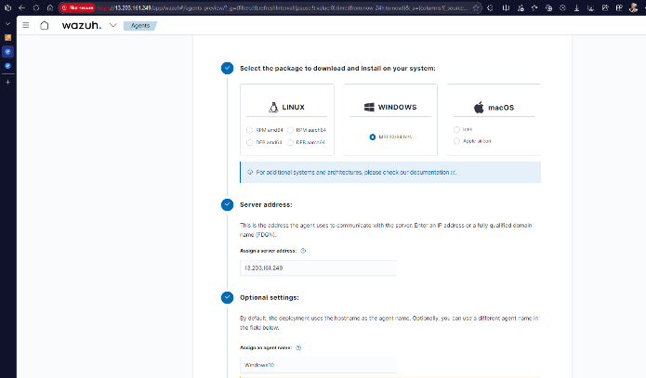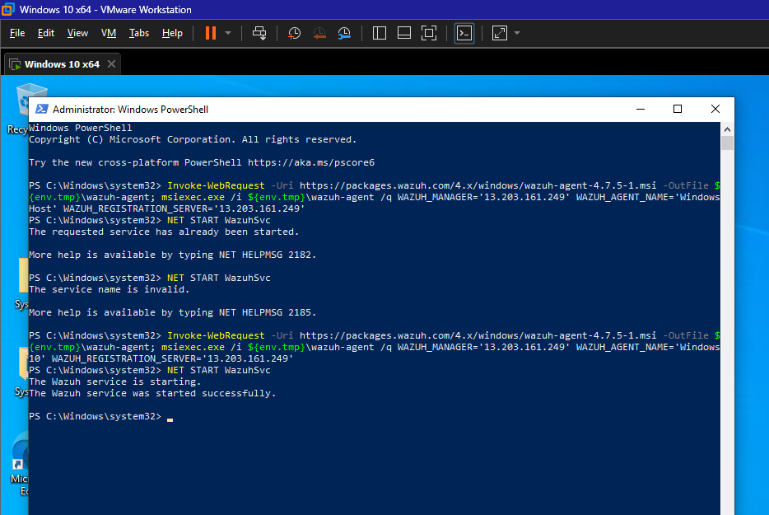
Figure 5: Windows Agent Installation

🔹 Kali Linux Agent
- Installed agent via terminal
- Connected to Wazuh server
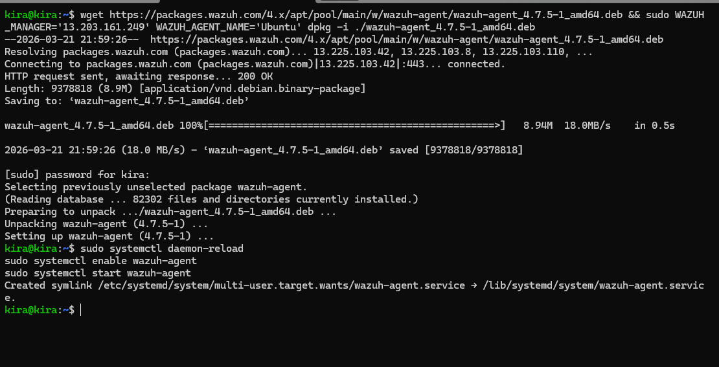
Figure 6: Kali Agent Installation

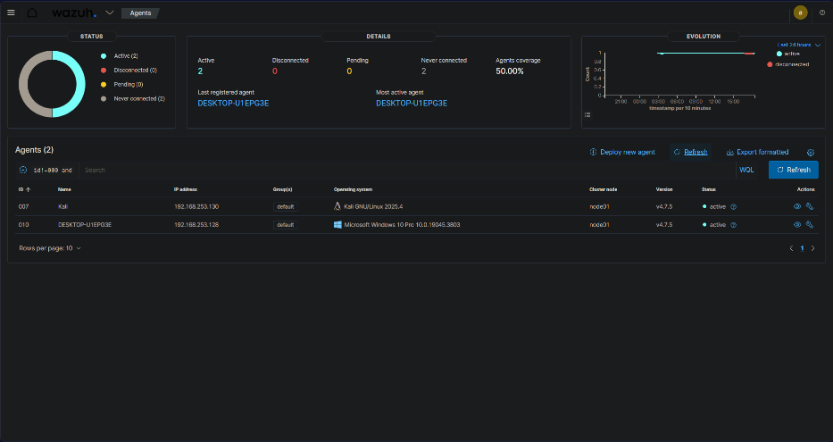
Figure 7: Wazuh Agent Dashboard
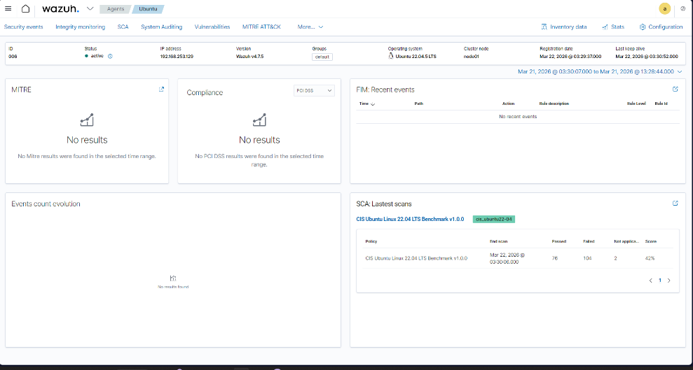
Figure 8: Agent Connected in Dashboard

⚙️ Step 4: File Integrity Monitoring (Windows)
- Modified ossec.conf file
- Added Desktop folder for monitoring:
<directories check_all="yes">C:\Users\Username\Desktop</directories>
- Restarted Wazuh agent
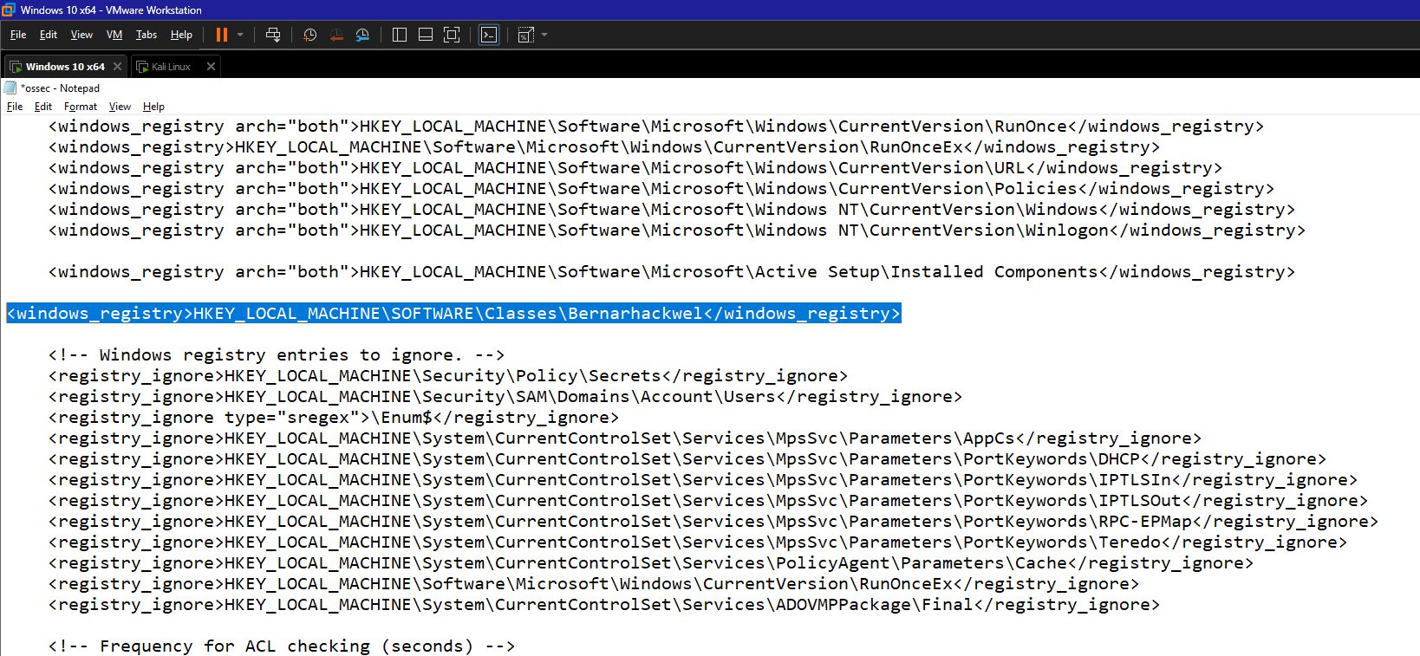
Figure 9: FIM Configuration

⚙️ Step 5: Windows Registry Monitoring
- Added registry key for monitoring:
HKEY_LOCAL_MACHINE\Software\bernarhackwel
- Verified alerts in dashboard
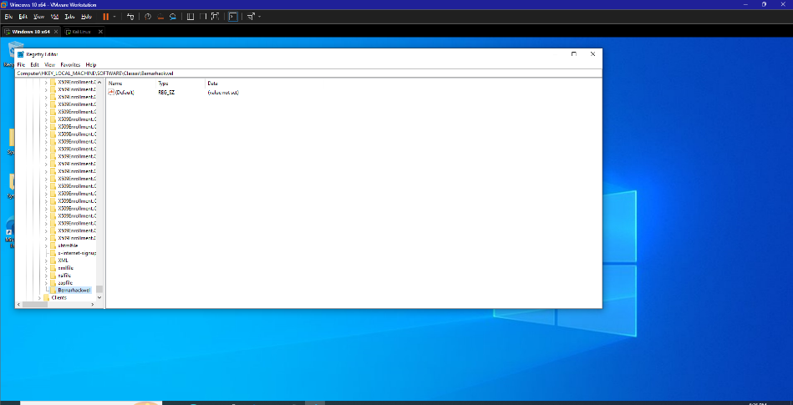
Figure 10: Creating Registry Key

Figure 11: Registry Key Setup
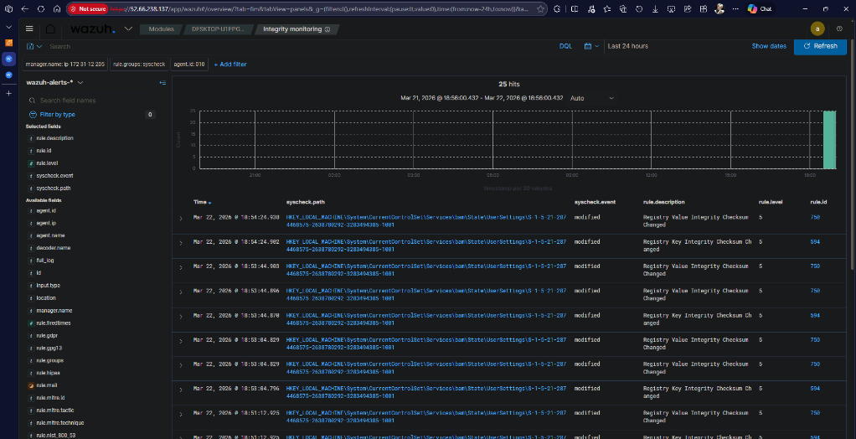
Figure 12: Registry Alert in Dashboard

⚙️ Step 6: SSH Brute Force Detection Rule
- Configured rule via Wazuh dashboard management
- Enabled SSH login monitoring
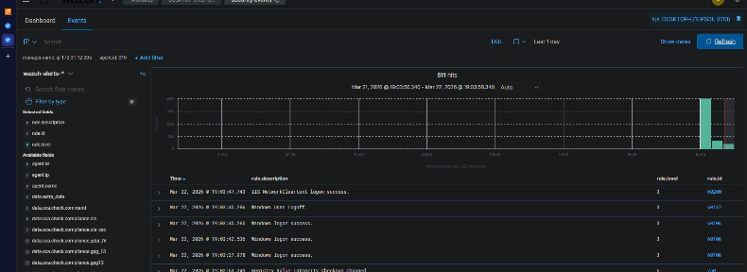
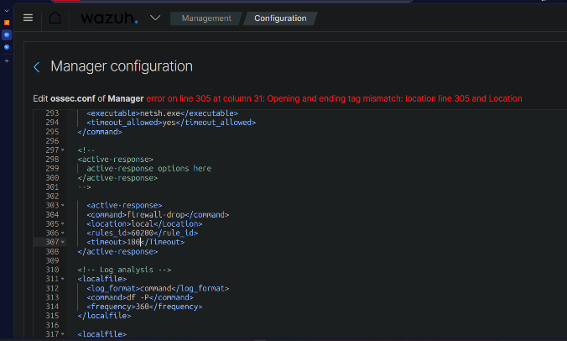
Figure 13: Rule Configuration

⚙️ Step 7: Vulnerability Detection
- Enabled vulnerability detector
- Configured scan on startup
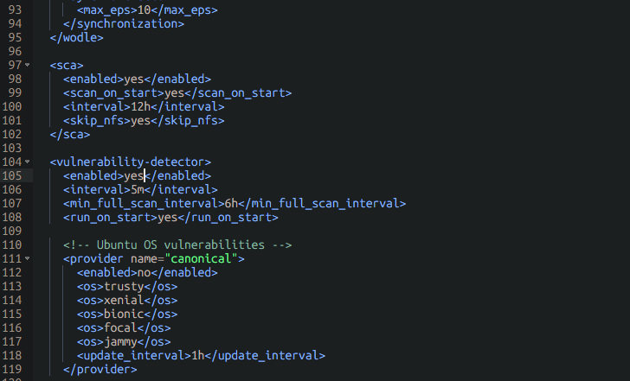
Figure 14: Configure Vulnerability Settings

📊 Results
- Successfully monitored file changes in Windows
- Detected registry modifications
- Identified SSH login attempts
- Performed vulnerability scanning

🚀 Key Learnings
- Hands-on experience with SIEM tools
- Understanding of agent-based monitoring
- Real-time threat detection concepts
- Cloud deployment of security tools

