SQL QUERIES
Q.1>Write SQL query to create a database Employee.
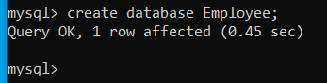
Q.2>Write SQL query to open database Employee.
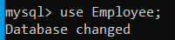
Q.3>Write SQL query to create following Table name empl.
Q.4>Write SQL query to show the structure of table.
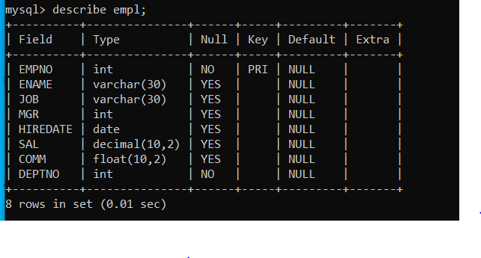
Q.5>Write SQL query to Insert 10 records same as it is in image.
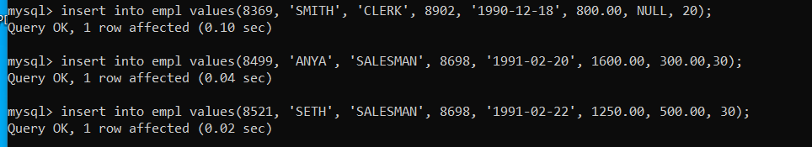

Q.6>Write SQL query to display all the records from table empl.
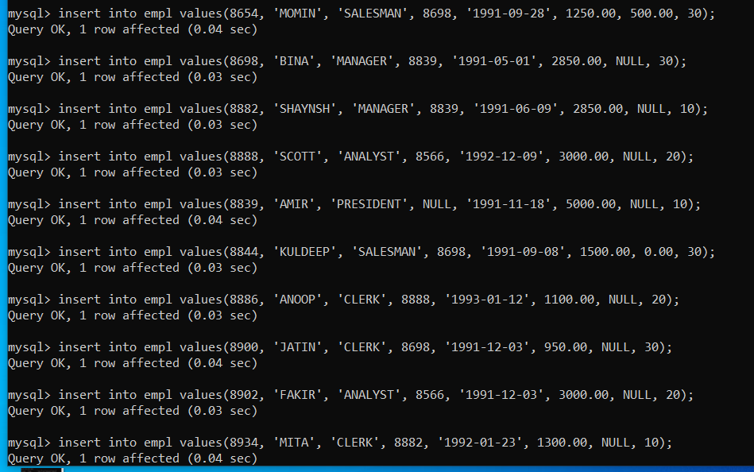

Q.7>Write SQL query to display EmpNo and EName of all employees from the table empl.
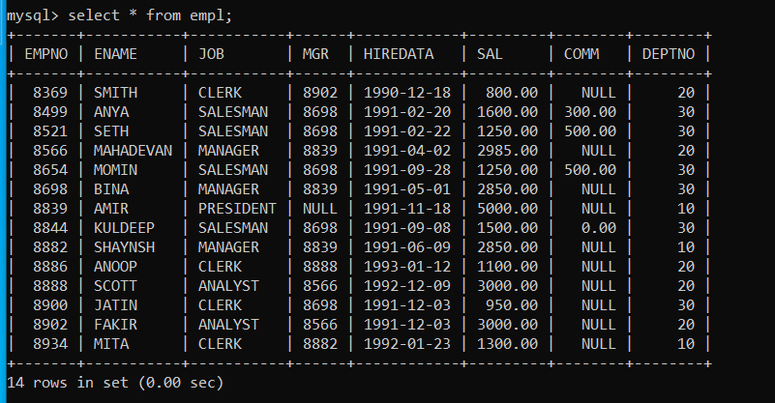
Q.8>Write SQL query to display Ename, Sal, and Sal added with comm from table empl.
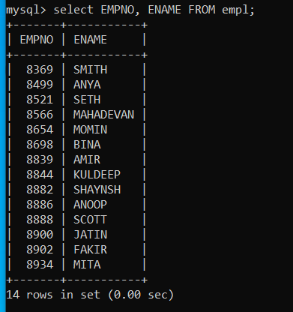
Q.9>Write SQL query to display Ename, Sal, and deptno who are not getting commission from table empl.
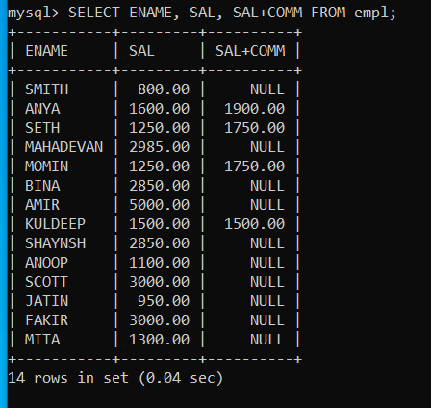

Q.10>Write SQL query to display Eno, Ename ,Sal, and Sal*12 as Annual Salary whose commission is not
NULL from table
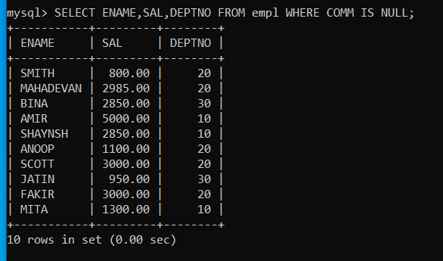
Q.11>Write SQL query to display the details of employees whose name have only four letters.
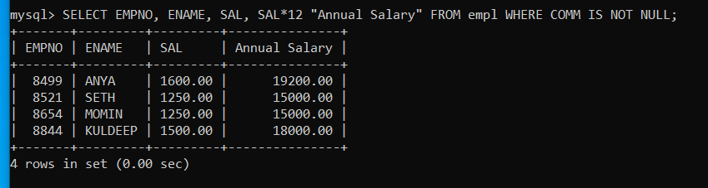
Q.12>Write SQL query to display name, job title and salary of employee who do not have manager.
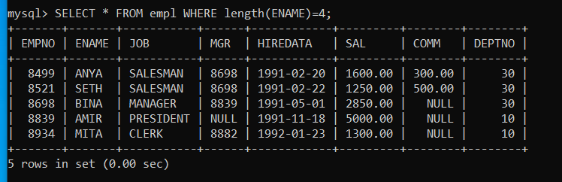
Q.13>Write SQL query to display the name of employee whose name contains “A” as third letter.
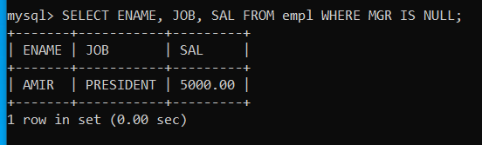
Q.14>Write SQL query to display the name of departments. Each department should be displayed once
(DISTINCT).
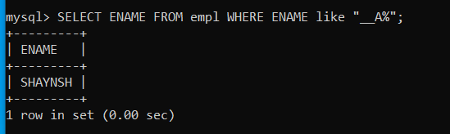
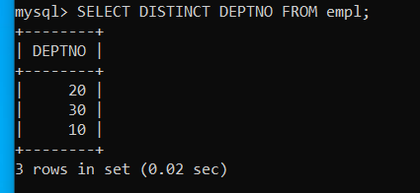
Q.15>Write SQL query to display the name and salary of those employees whose salary is between 35000 and
40000. (BETWEEN)
Q.16> Write SQL query to display tables data according to ascending order of sal.
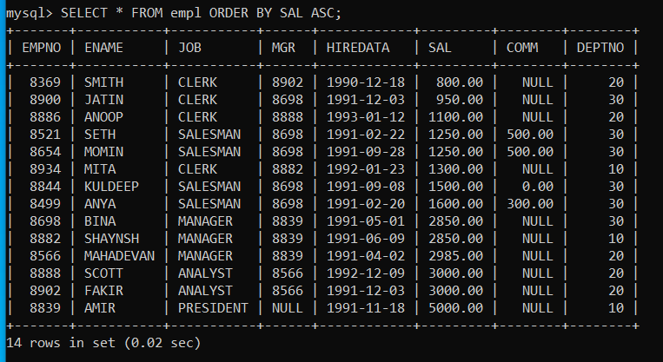
Q.17> Write SQL query to change EName MITA by MIRA.
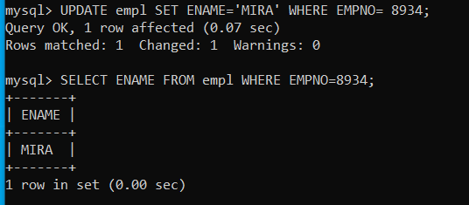
Q.18> Write SQL query to delete records whose deptno=10.
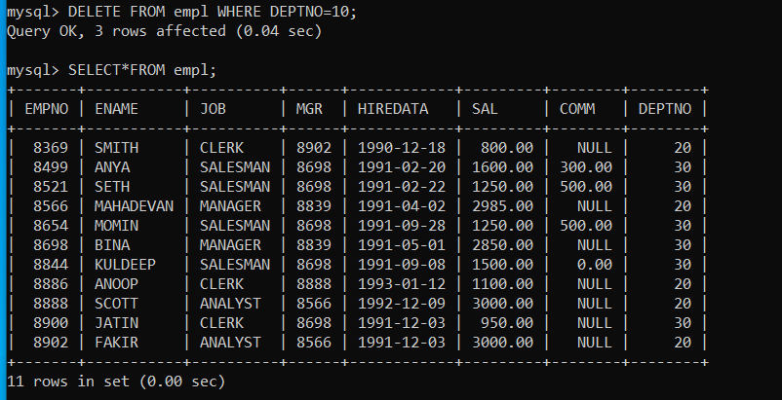
Q.19> Write SQL query to add a new column Phno.
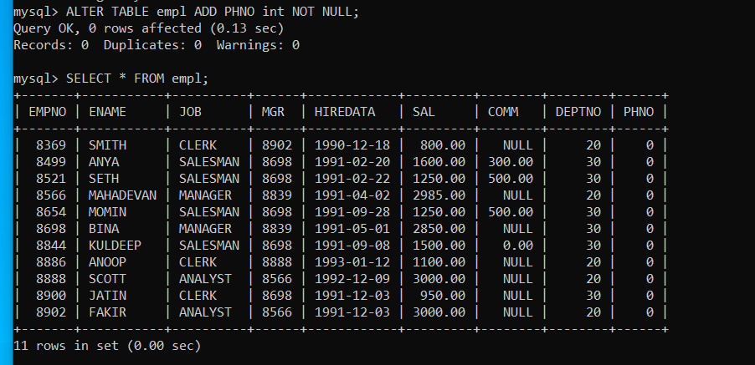
Q.20> Write SQL query to delete entire table IF EXISTING.
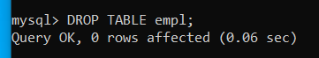
Q.21> Queries for Aggregate functions- SUM( ), AVG( ), MIN( ), MAX( ), COUNT( ) .
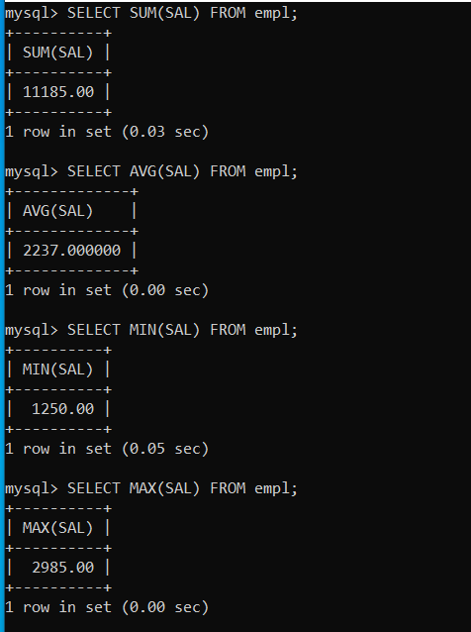
Q.22> TEXT FUNCTIONS (TRIM FUNCTION, SUBSTR FUNCTION, LEFT FUNCTION, RIGHT
FUNCTION, MID FUNCTION)
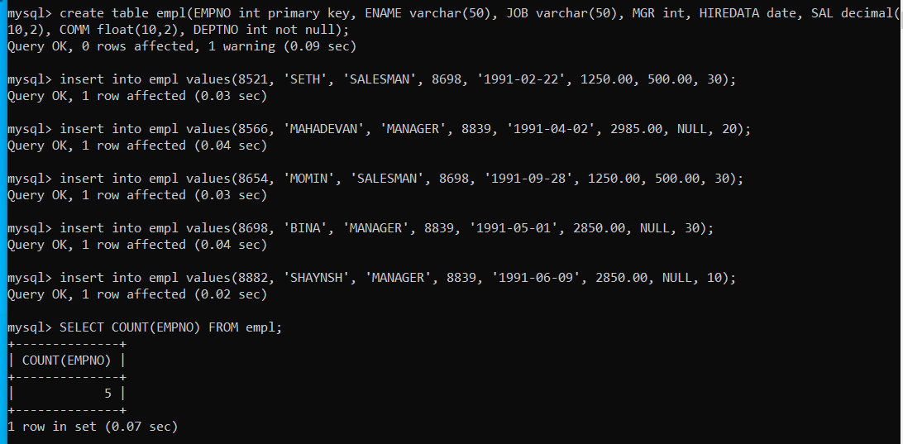
Q.23> MATH FUNCTIONS (POWER (), ROUND (), MOD ()).
