**Name:** Paarthivi D

**Superset ID:** 6410961

**DN 4.0 - Java FSE Mandatory Hands-on**

**WEEK – 2**

**TDD using JUnit5 and Mockito**

**Exercise 1: Setting Up Junit**

**pom.xml**

<project xmlns="http://maven.apache.org/POM/4.0.0"

         xmlns:xsi="http://www.w3.org/2001/XMLSchema-instance"

         xsi:schemaLocation="http://maven.apache.org/POM/4.0.0

         http://maven.apache.org/xsd/maven-4.0.0.xsd">

    <modelVersion>4.0.0</modelVersion>

    <groupId>com.example</groupId>

    <artifactId>JUnit_Basic_Testing_Exercises</artifactId>

    <version>1.0-SNAPSHOT</version>

    <dependencies>

        <!-- JUnit 4 -->

        <dependency>

            <groupId>junit</groupId>

            <artifactId>junit</artifactId>

            <version>4.13.2</version>

            <scope>test</scope>

        </dependency>

    </dependencies>

</project>

**CalculatorTest.java**

package com.example.exercise1;

import org.junit.Test;

import static org.junit.Assert.*;

public class Exercise1Test {

    @Test

    public void testSetup() {

        assertTrue(true);  // Just to confirm JUnit setup is working

    }

}

package com.example;

public class Calculator {

    public int add(int a, int b) {

        return a + b;

    }

    public int subtract(int a, int b) {

        return a - b;

    }

}

**Output:**

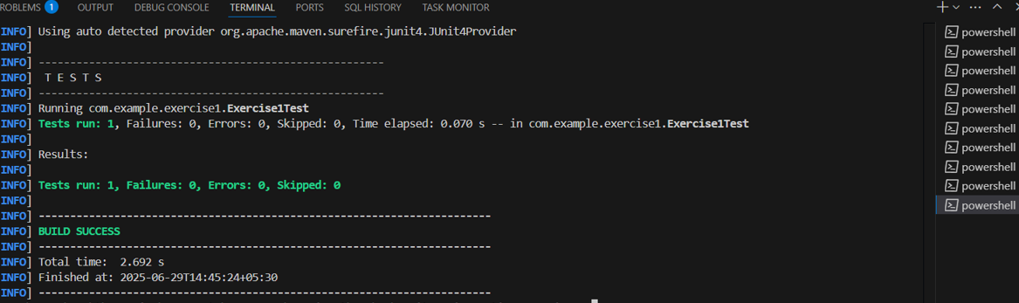

**EXERCISE 3: ASSERTIONS IN JUNIT**

**AssertionsTest.java**

package com.example.exercise3;

import org.junit.Test;

import static org.junit.Assert.*;

public class AssertionsTest {

    @Test

    public void testAssertions() {

        // Assert equals

        assertEquals(5, 2 + 3);

        // Assert true

        assertTrue(5 > 3);

        // Assert false

        assertFalse(5 < 3);

        // Assert null

        assertNull(null);

        // Assert not null

        assertNotNull(new Object());

    }

}

**Output:**

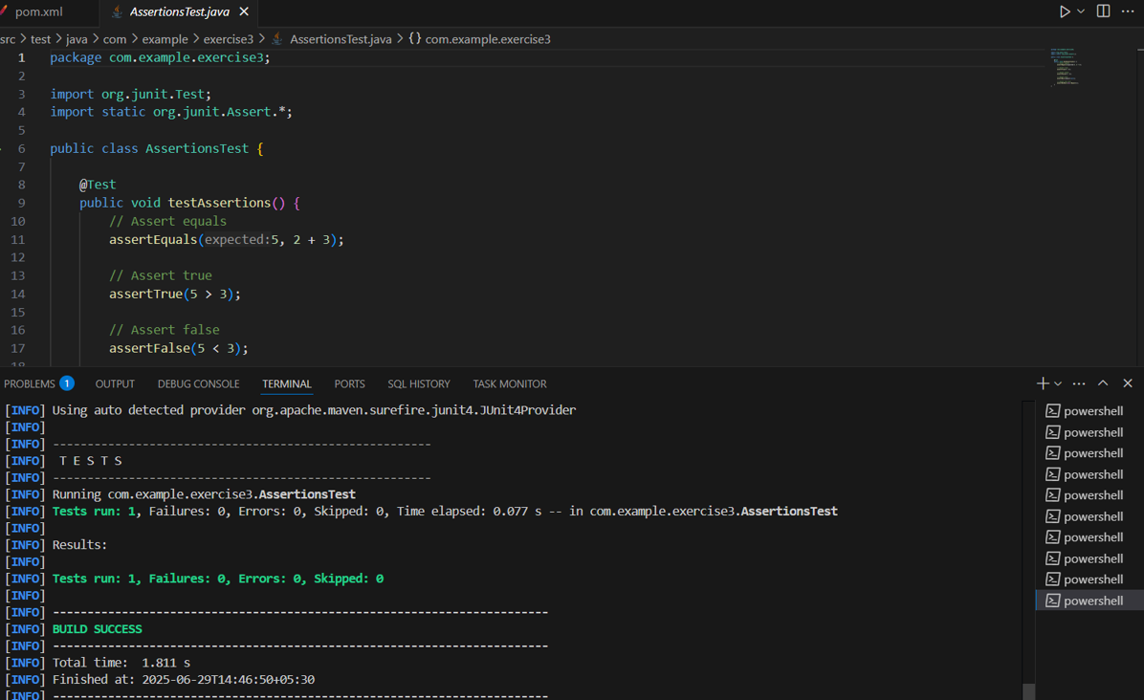

**Exercise 4: Arrange-Act-Assert (AAA) Pattern, Test Fixtures, Setup and Teardown Methods in Junit**

**Calculator.java**

package com.example;

public class Calculator {

    public int add(int a, int b) {

        return a + b;

    }

    public int subtract(int a, int b) {

        return a - b;

    }

}

**CalculatorTest.java**

package com.example.exercise4;

import org.junit.Before;

import org.junit.After;

import org.junit.Test;

import static org.junit.Assert.*;

public class Exercise4Test {

    @Before

    public void setUp() {

        System.out.println("Setup Called");

        // Initialize test resources if any

    }

    @Test

    public void testAdditionAAA() {

        // Arrange

        int a = 10;

        int b = 5;

        // Act

        int result = a + b;

        // Assert

        assertEquals(15, result);

    }

    @After

    public void tearDown() {

        System.out.println("Teardown Called");

        // Clean up resources if any

    }

}

**Output:**

