Task 1   
1. Install flutter

Download the zip from the futter website then extract it somewhere except in program files  
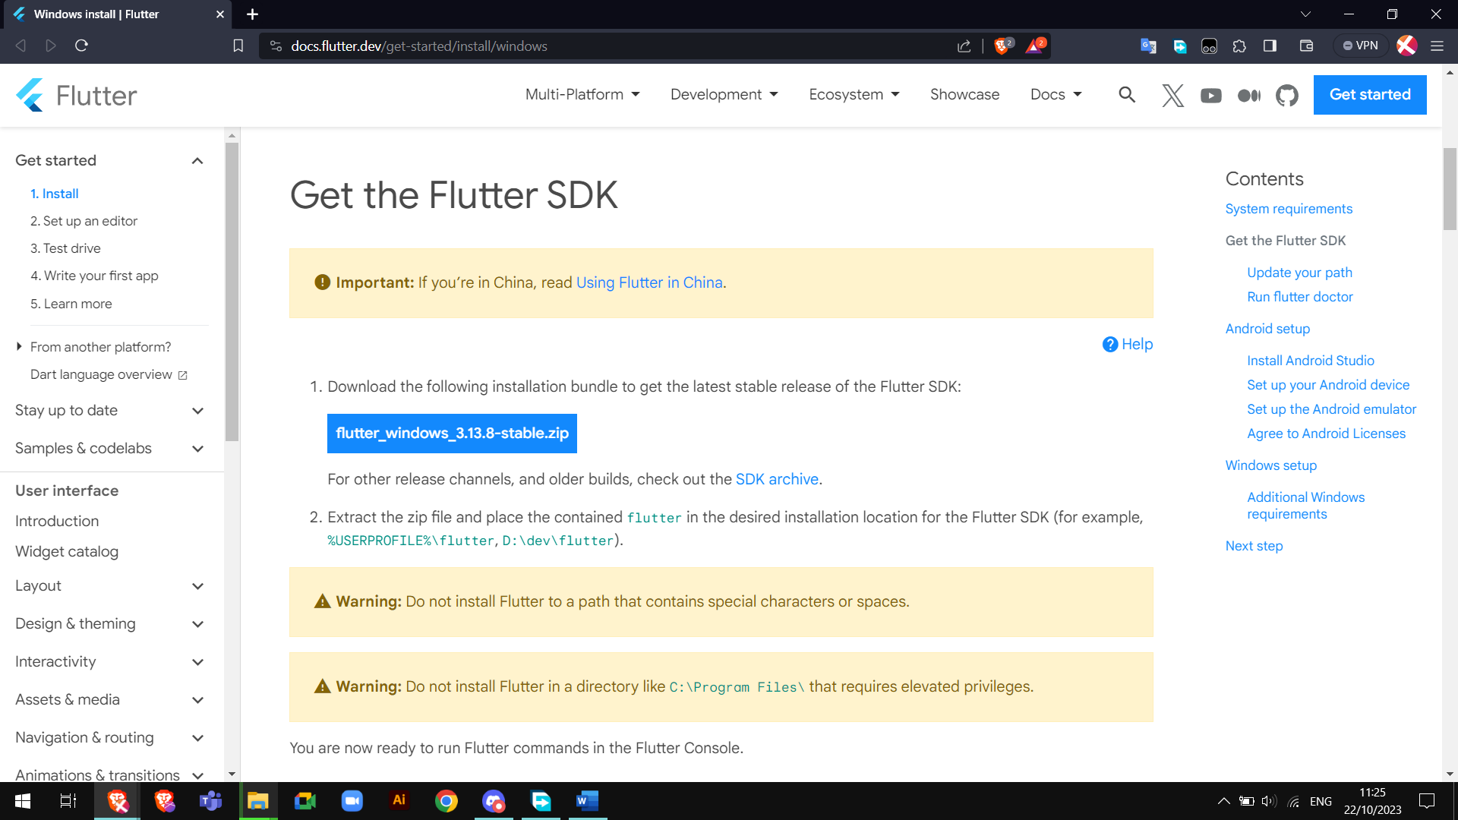

2 install Android Studio

Download the installer from the Android Studio website then run it

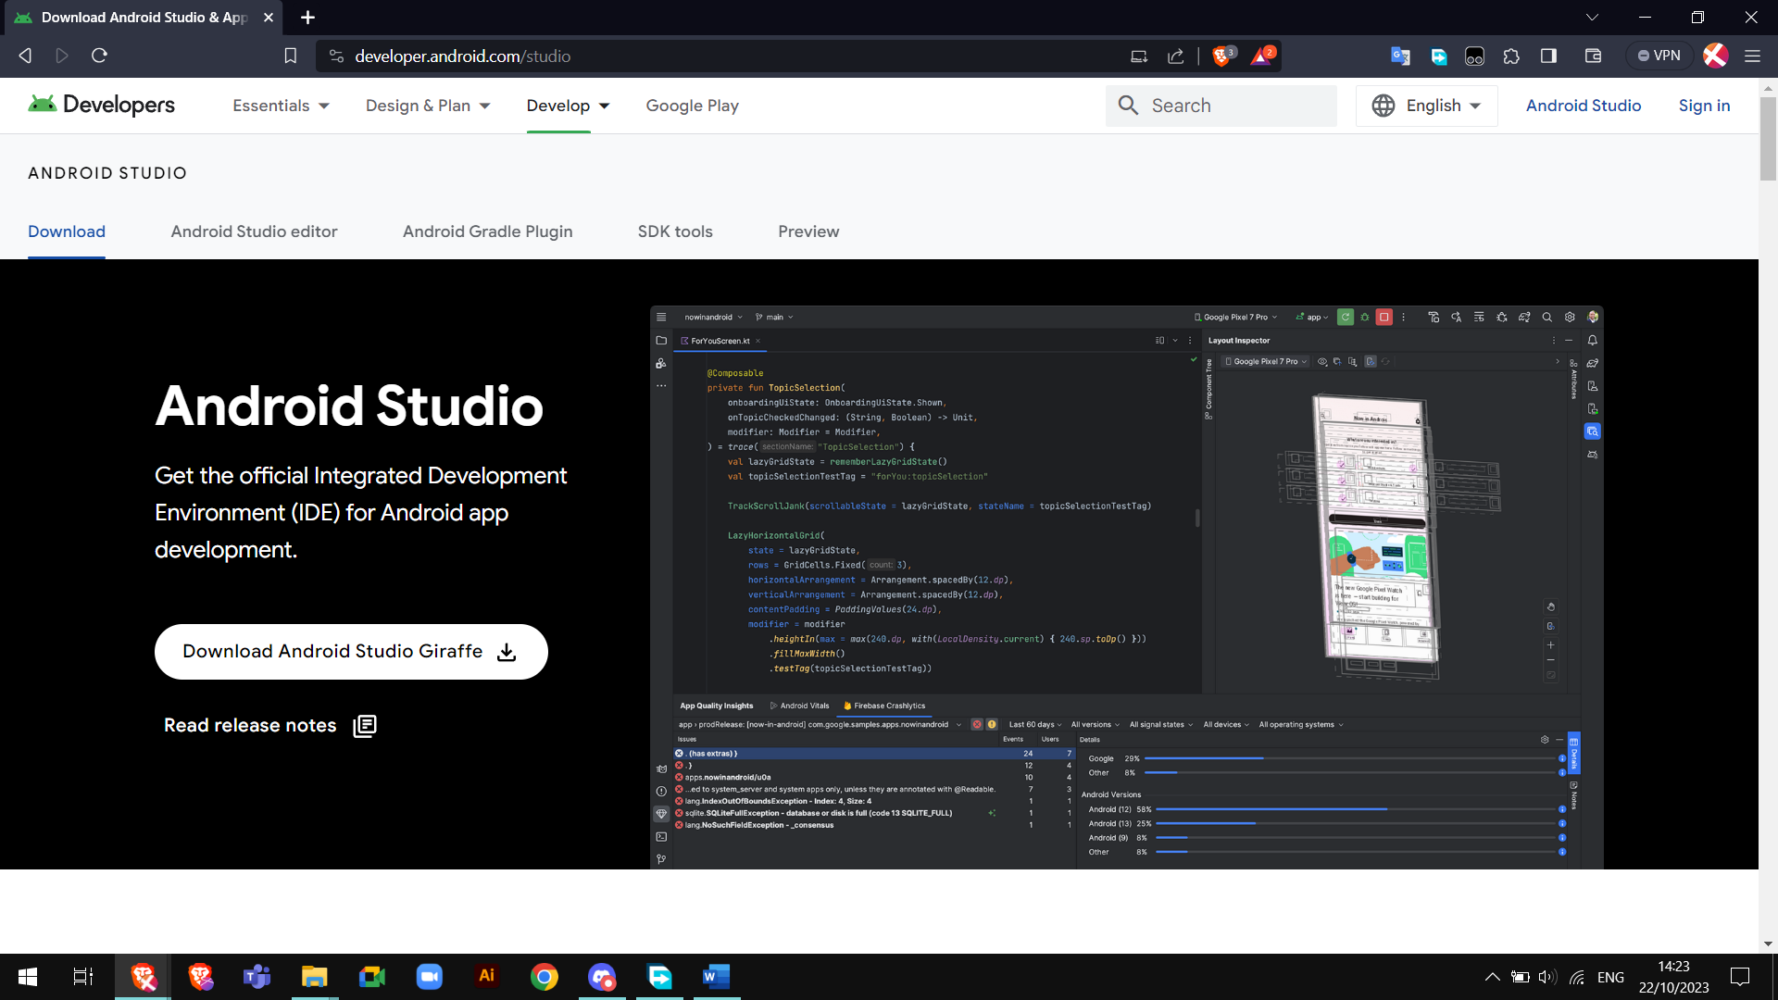

3. VS Code with Flutter Plugins

Install in flutter extension in vs code  
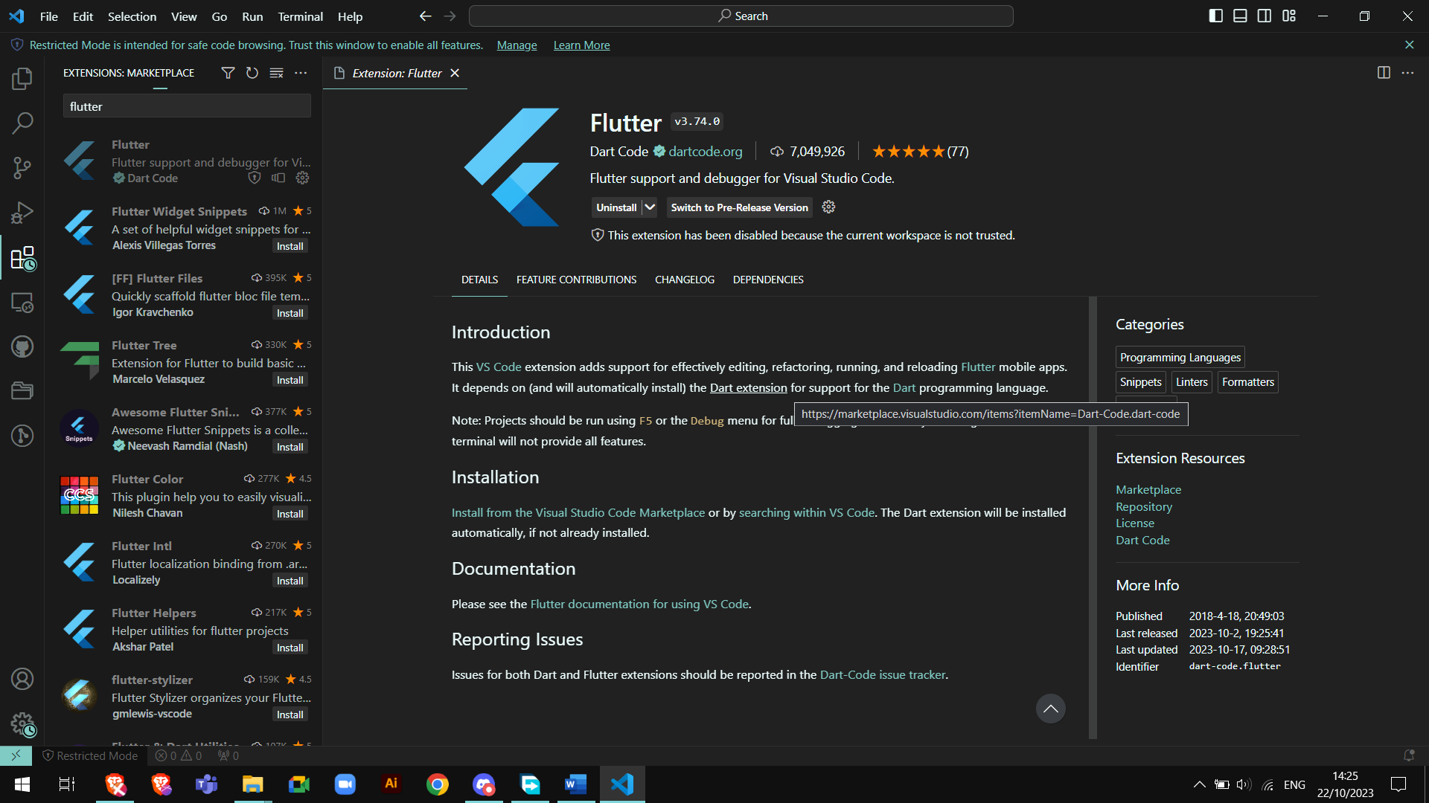

Run the command: flutter doctor -v  
 to find issues with the install  
  
Two issues found   
  
Issue 1 – Need to install Android SDK Platform Tools

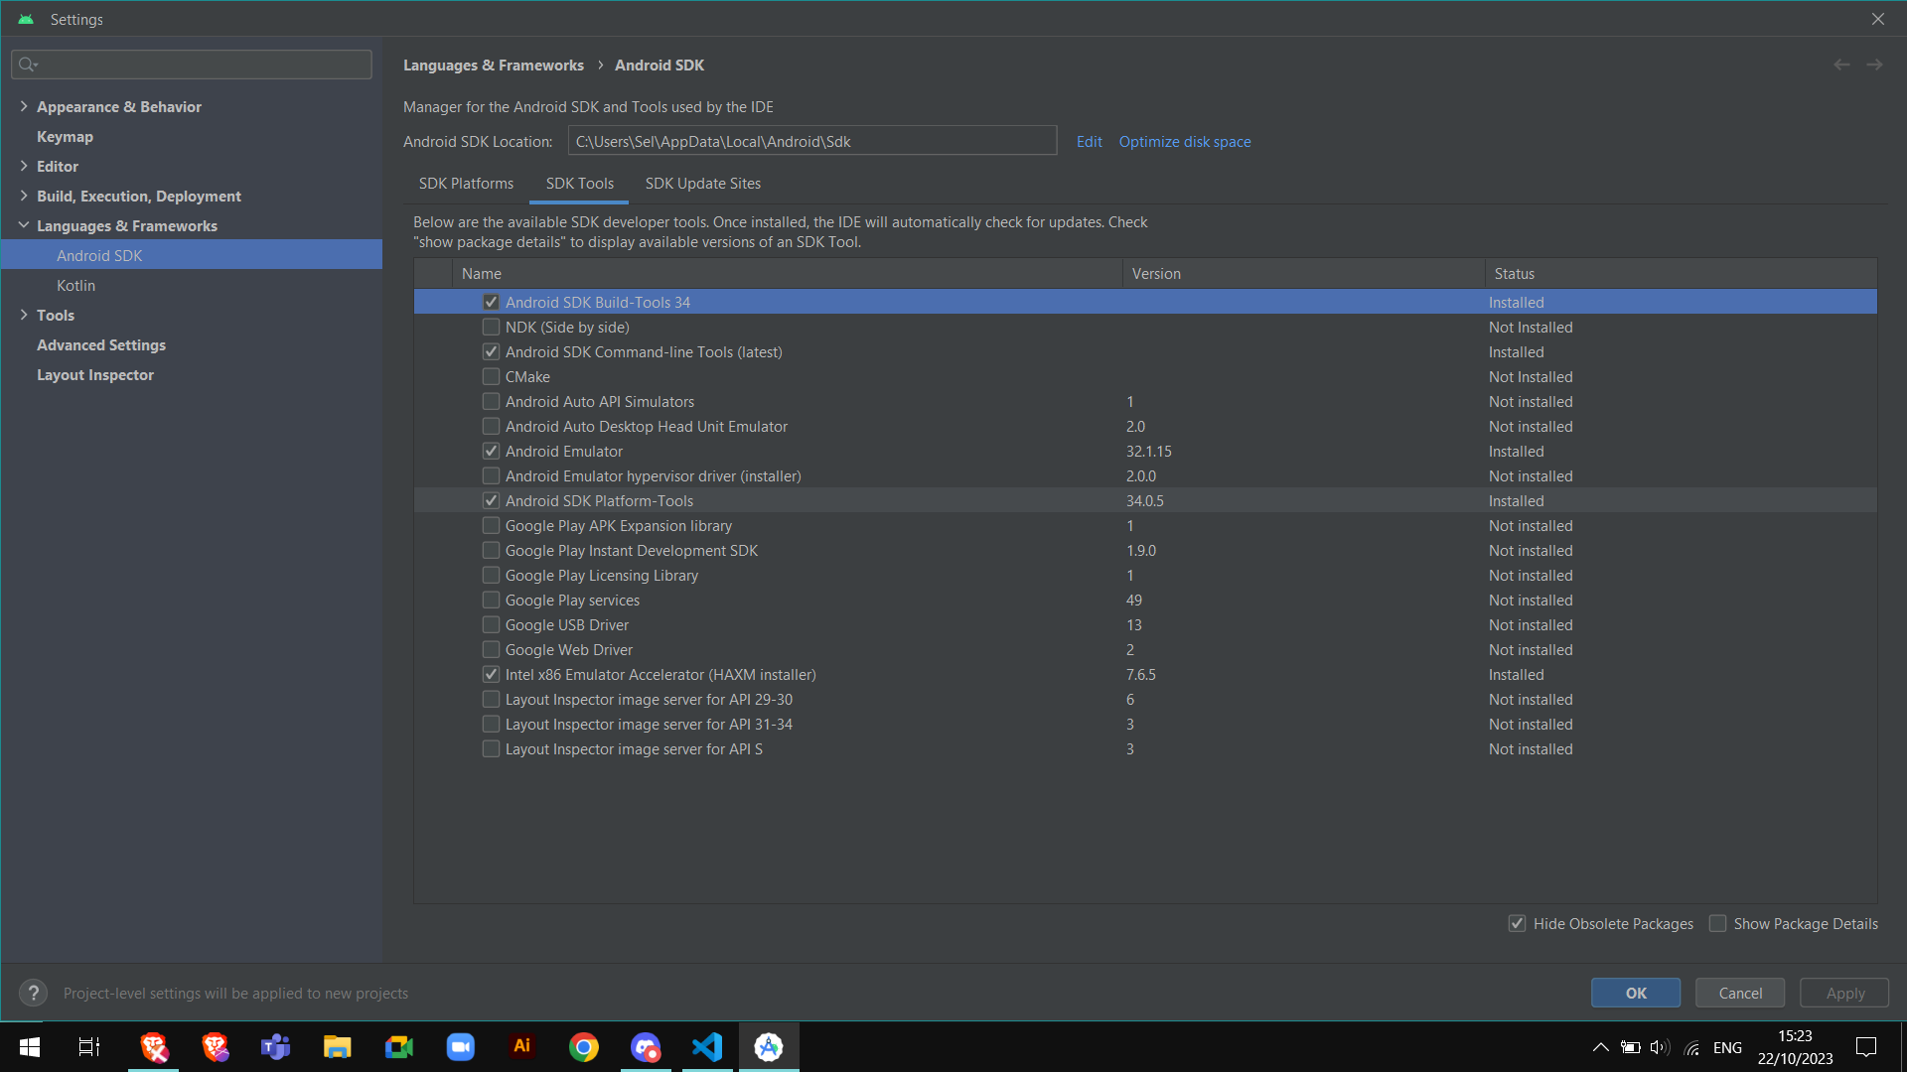

Issue 2 – need to accept the EULA  
  
run the command: flutter doctor --android-licenses  
then type y to accept the EULA

Task 5 - Create your first Flutter App in VSCode or Android Studio  
  
I followed this tutorial on [codelabs](https://codelabs.developers.google.com/codelabs/flutter-codelab-first#0)

In the command palette type flutter and select Flutter: New Project then application to create the project

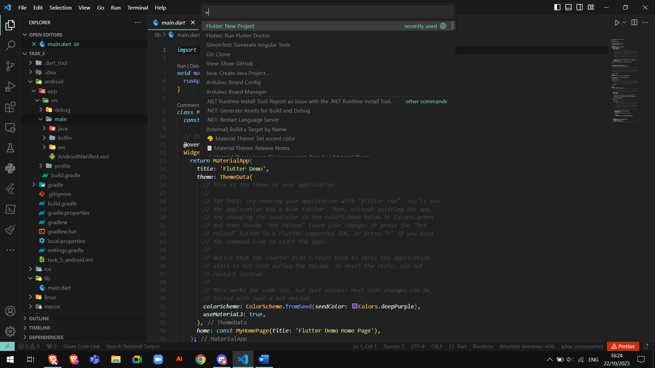

Replace the content of pubspec.yaml with the code from the tutorial  
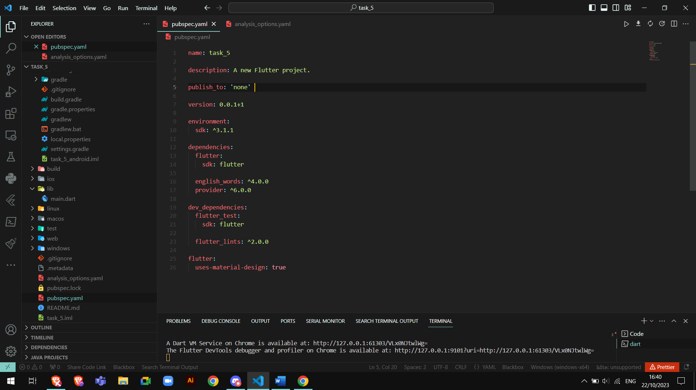

Same for the analysis_options.yaml file  
this code disable some features in order to keep the tutorial simple for beginners.

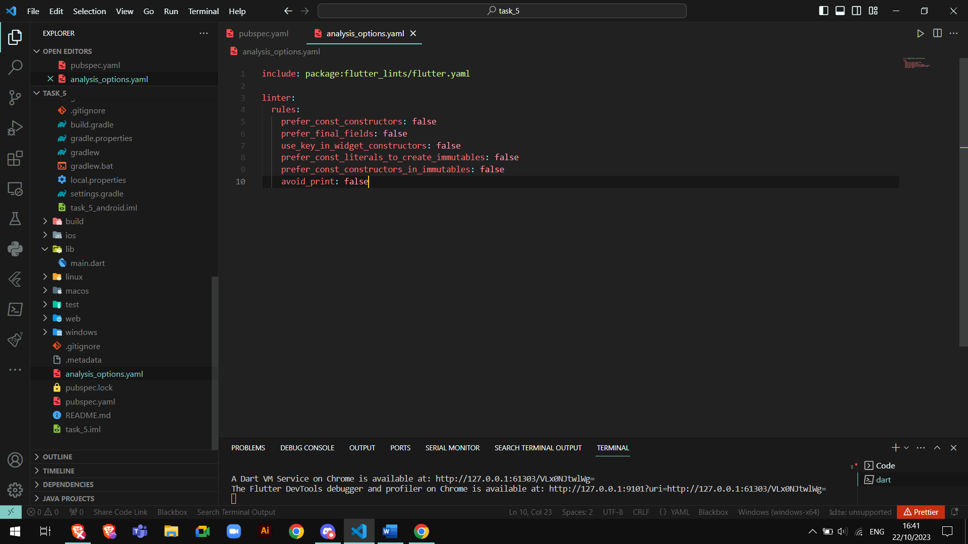

Same for the main.dart

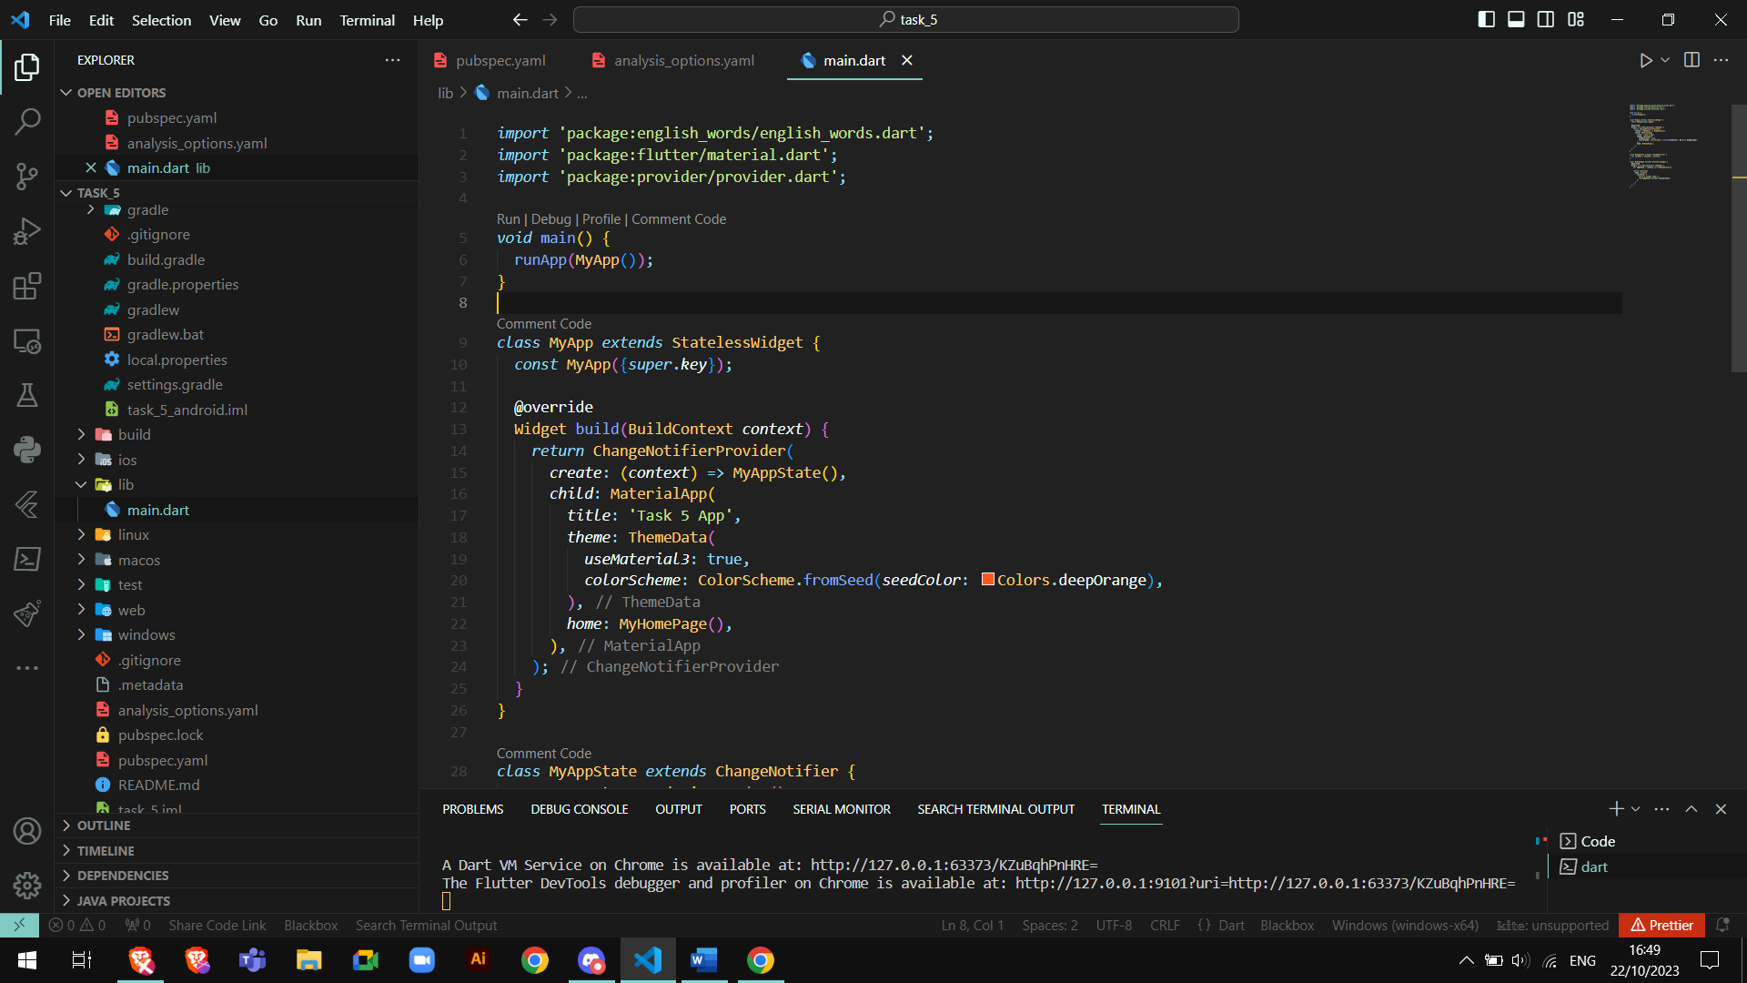

Run the application by entering flutter run in the terminal  
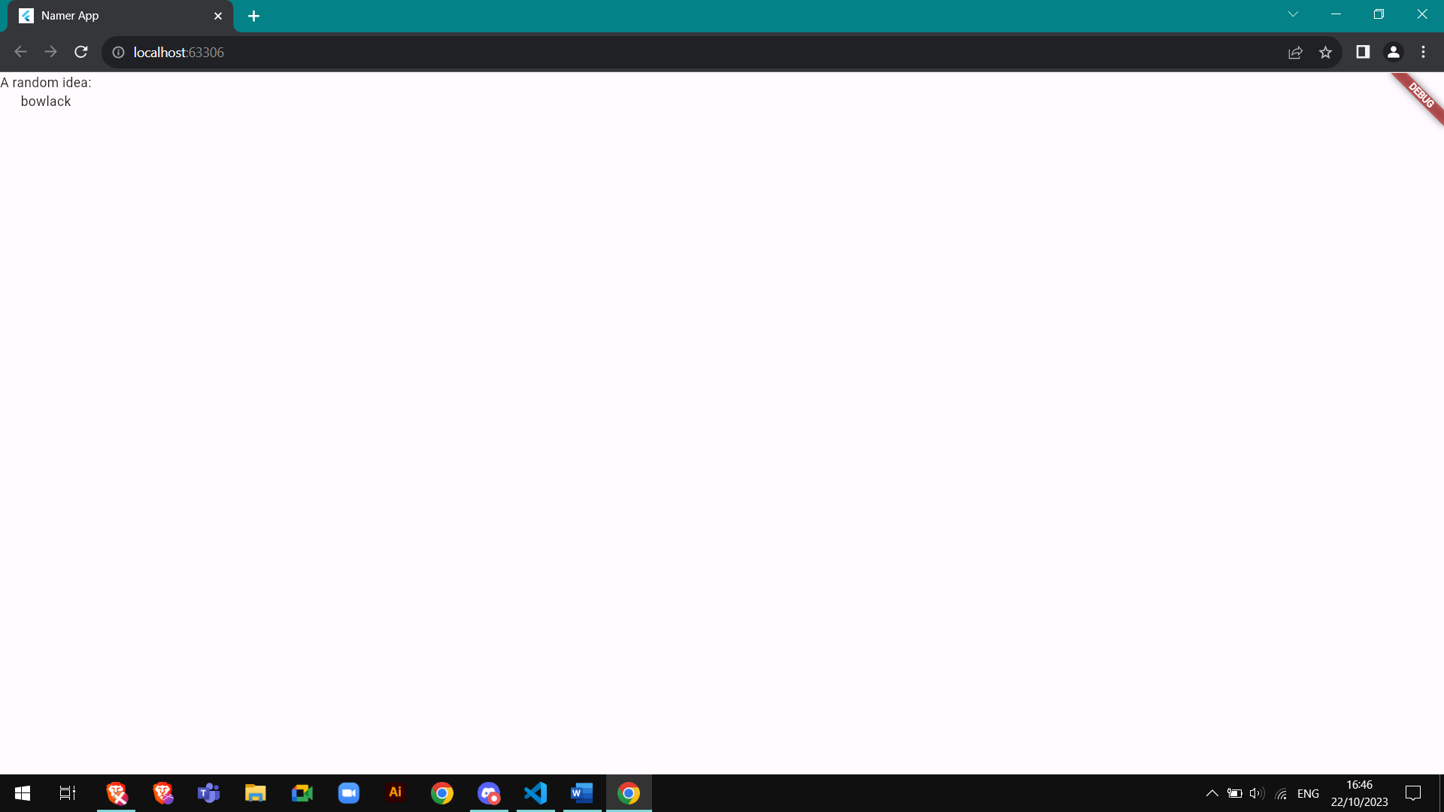

Add a button  
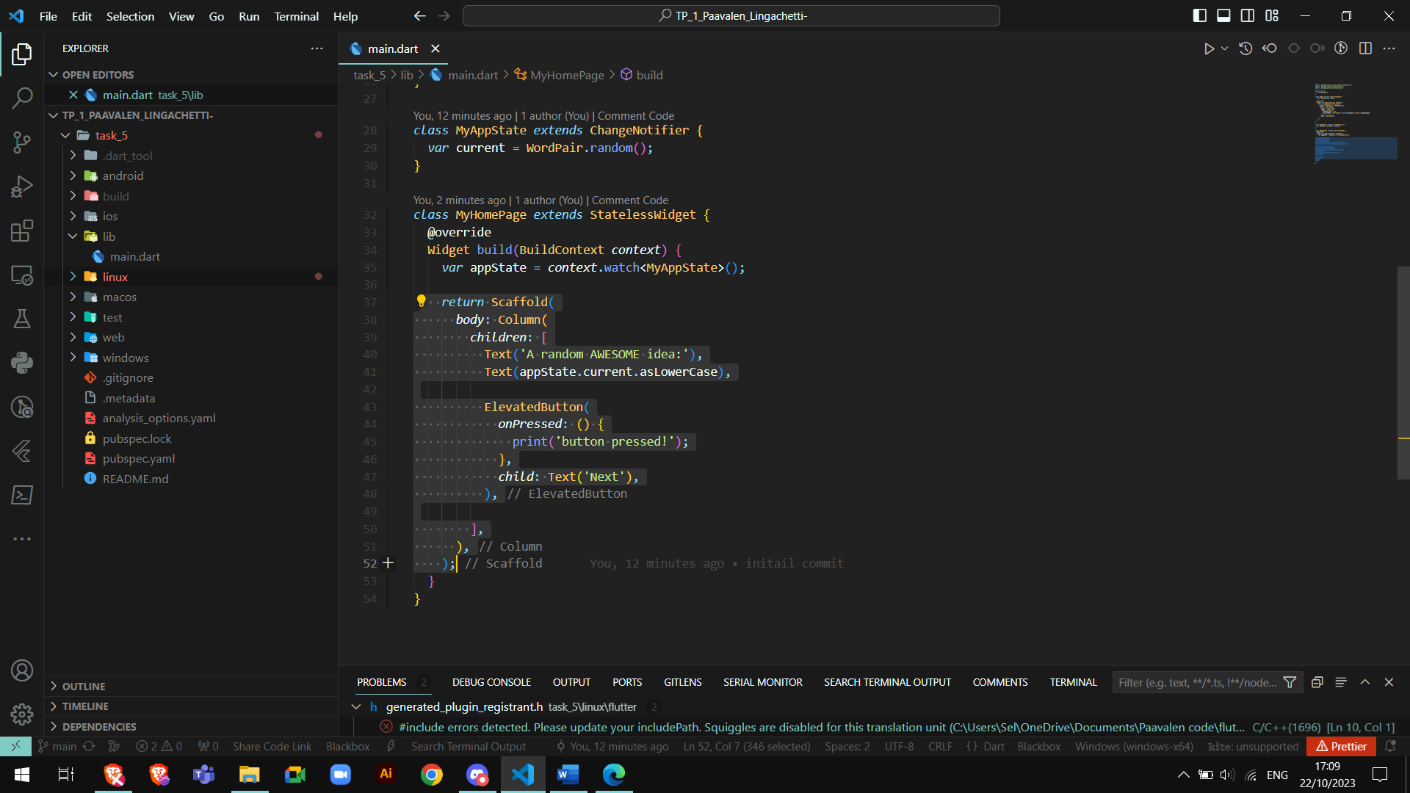

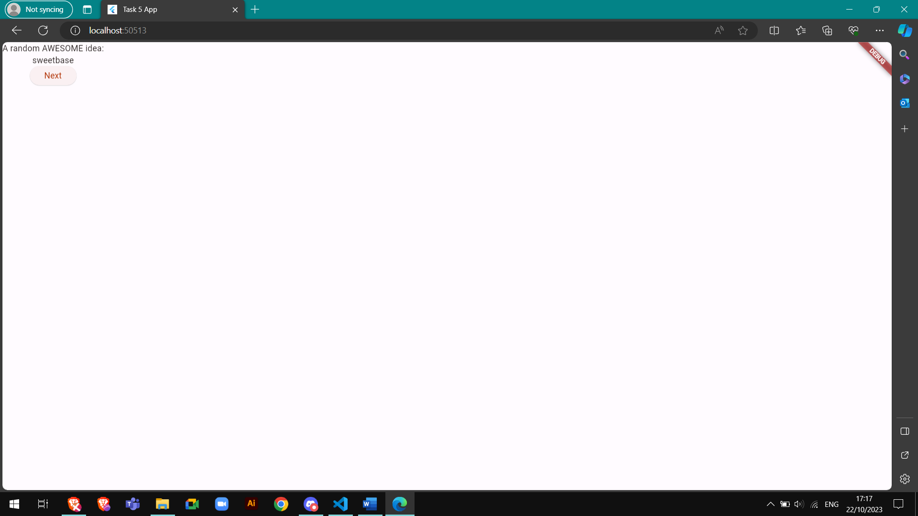

Add theme and style  
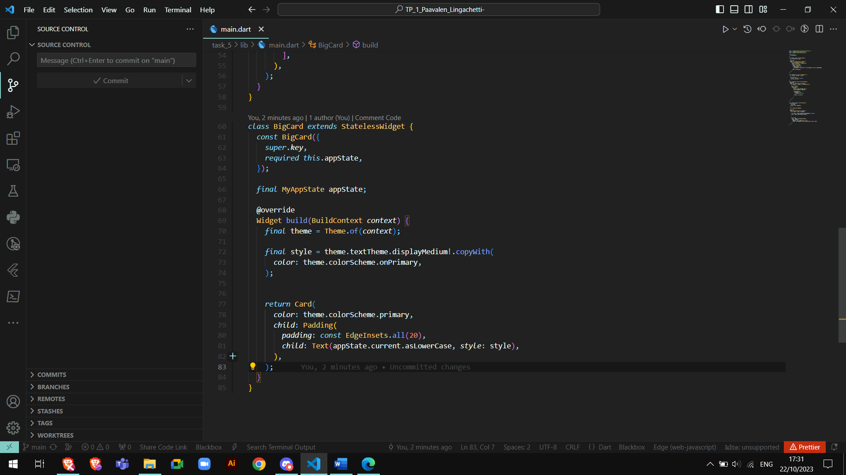

Centre the text and card  
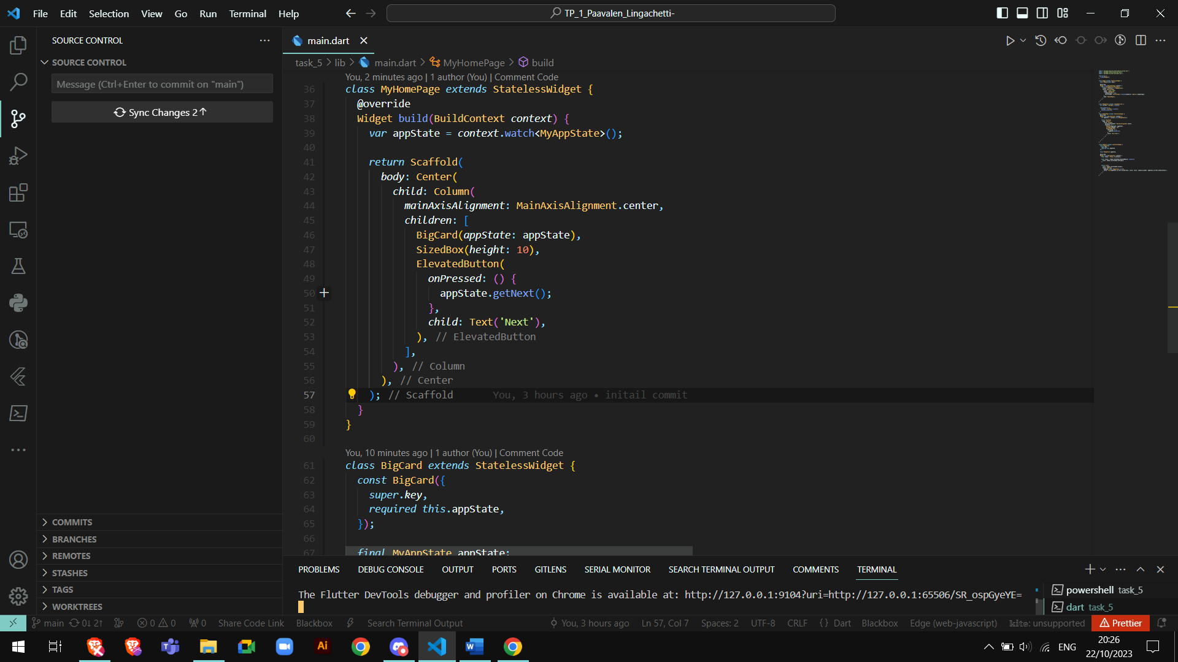

Result  
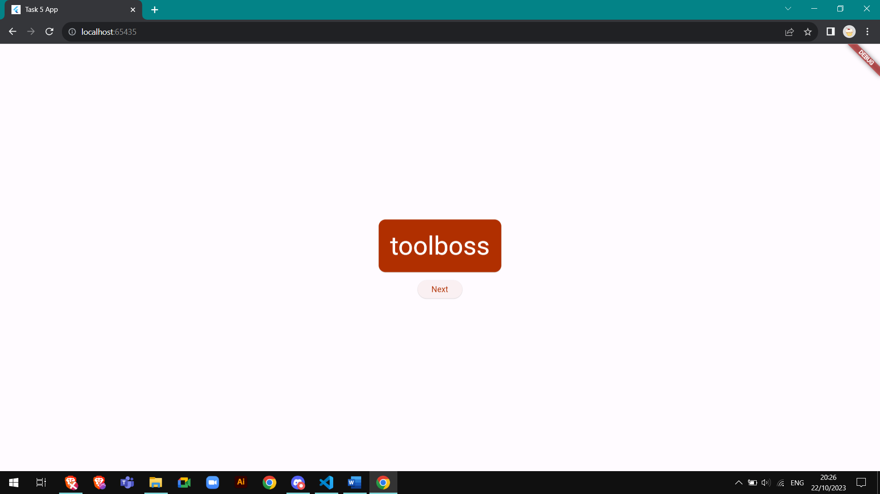

Here is the homepage with a navigation rail and a new favorite button  
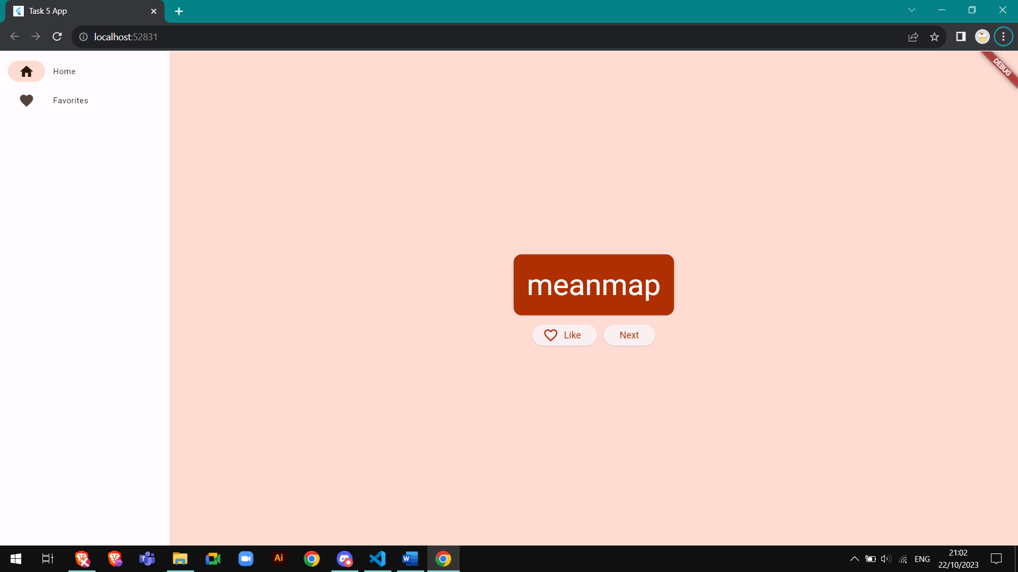

A place holder was added in the favorite page 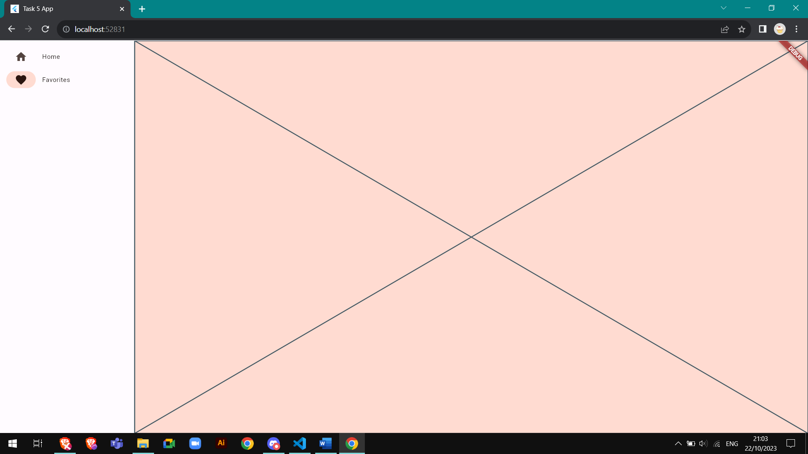

Here is the favorite page working

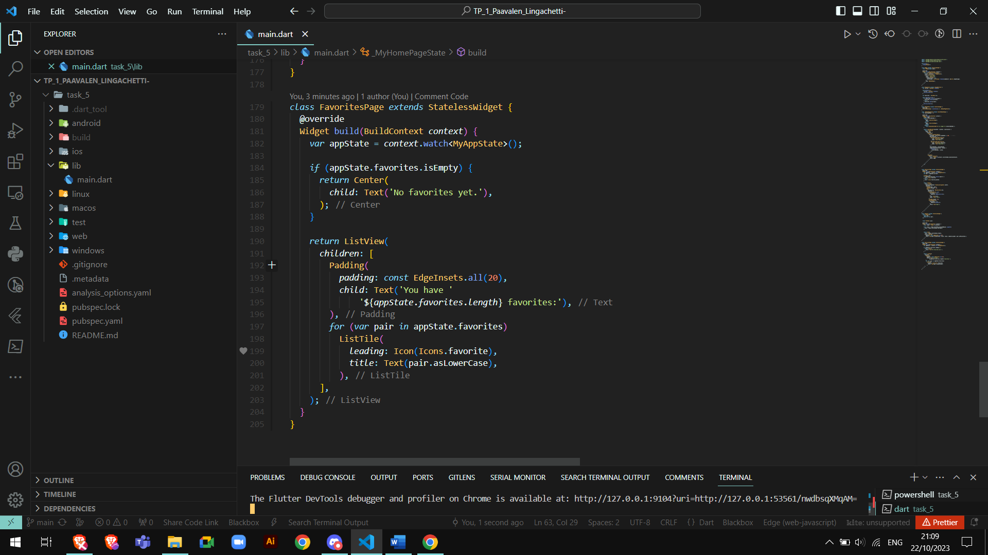  
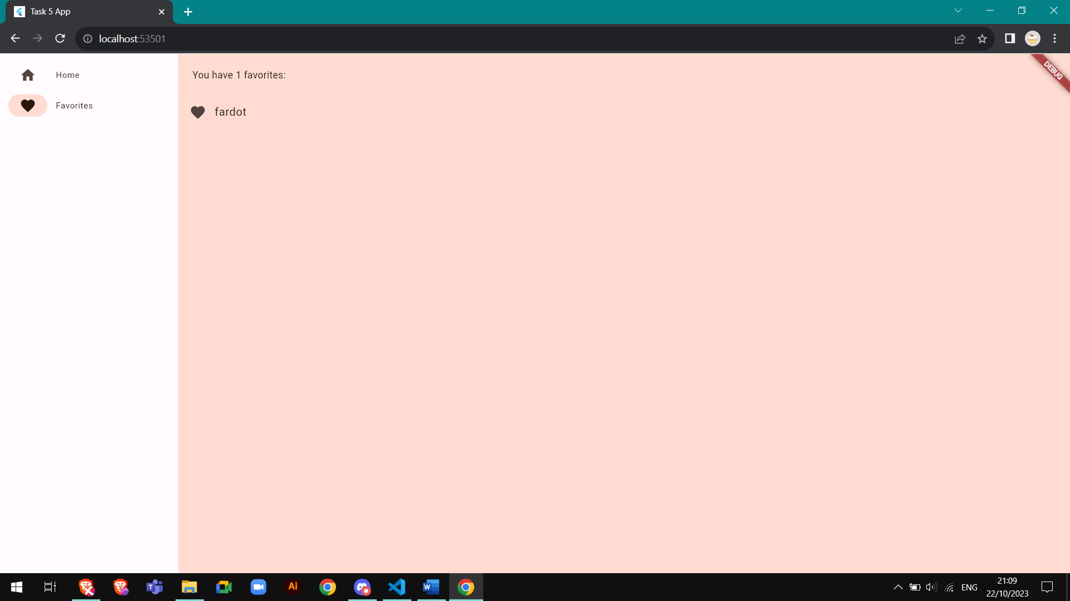

Task 6 - Visualizing dynamic color in your app