An Explainable AI Framework for Multimodal Big Data Analytics in Smart Transportation Systems

Y. Paavana Pranavasri^{A}, K. Bhavya^{A}, A. Divya Sree^{A}, J. Sree Vardhini^{A}

^{A}Department of Computer Science and Engineering, Koneru Lakshmaiah Education Foundation,
Bowrampet, Hyderabad-500043, Telangana, India.

ABSTRACT
The growing availability of transportation data, road-safety data, infrastructure data and environmental data creates chances for analyzing transportation systems using data [1]. However these kinds of data are often gathered at time-based levels, which makes it hard to combine them directly and can lead to wrong conclusions [2]. This research introduces a big data analytics framework that brings together road accident data, public transportation data and weather data for transportation and road-safety analysis. The framework handles data checking, cleaning, geographic alignment time-based grouping creating features looking at data to find patterns, statistical analysis, predicting with models combining models using explainable AI and making visual reports. The final dataset used in the experiments has 143 entries, 24 columns and 37 groups based on states with 21 features that are used for predictions. A three-level target for accident trends is made using a ±5% change, in accidents resulting in the categories Decreasing, Stable and Increasing. Four separate models and six combined models are tested using a five-GroupKFold -validation method, grouping by state. The model that uses Gradient Boosting and XGBoost and MLP/FNN with a weighted probability fusion gets the weighted F1-score of 0.7561 compared to 0.7431 for the best single model, which is Random Forest. This shows an improvement of 0.0130 and a relative improvement of 1.75%. However Random Forest has a ROC-AUC of 0.8445 compared to 0.8276 for the model showing that it is important to use different ways to check how well models work. To make things clearer the framework uses feature importance, permutation importance, SHAP and LIME. A Streamlit dashboard brings together predictions, statistical findings, transportation data, weather data and explainability features. The framework shows a way to turn transportation data into a clear analysis process and to make transportation safety alerts while making sure to take into account where the data comes from the limits of the data and responsible AI practices.
Keywords: transportation; multimodal data analytics; data analytics; road safety; machine learning; hybrid ensemble; explainable artificial intelligence; SHAP; LIME; transportation safety alerts.
1. INTRODUCTION
1.1 Background
Transportation systems generate kinds of data from car crashes, public transport, weather reports, movement services and other transportation related areas [1]. More and more machine learning is being applied within transportation systems. This opens opportunities for predicting events checking safety planning how people move around and aiding decision making [3]. Recent studies show that machine learning is increasingly used to improve transportation efficiency, transportation structures, safety, traffic management and smart movement applications [1] [13] [23]. Transportation analysis remains difficult because data from sources is usually not collected in the same way whether it concerns location, timing or organization.
For example car crash data may be available at the state or area level while public transport data might be reported annually at the city level and weather data could be recorded daily for each city. Combining these datasets row, by row can create connections because data that appears in the same row may not actually refer to the same place or time. Therefore examining types of transportation data requires data cleaning before building models to predict outcomes [1].
1.2 Problem Statement
The main issue this study looks at is analyzing types of transportation data that come in different sizes. Both in location and time.The road accident data is mostly grouped by states. It shows accidents per year. The public transportation data is broken down by cities. It includes things like roads and transit systems. The weather data has readings linked to cities. Because of these differences you can’t just line up the rows. Combine them. For example one state’s yearly accident count doesn’t match up directly with a city’s weather or a single transit record.So the study treats transportation safety as a source classification task. It brings all the data into a shared format. It does this by mapping locations. Grouping time periods to make them comparable. Then using these features it tries to predict whether accident numbers are going up down or staying the same.
The goal is to predict the risk_trend, which has three categories:
● Decreasing: when accident numbers drop by than 5%
● Stable: when changes are between -5% and +5%
● Increasing: when numbers go up by more than 5%
This study doesn’t try to say that weather causes accidents or that transit systems directly lead to more or fewer crashes. It’s not about proving cause and effect. Instead it’s focused on finding patterns in the data. Seeing what factors tend to go along with changes and which ones help predict changes, in accident rates.
1.3 Research Gap
Despite these developments many transportation studies focus on data types or individual prediction problems [1] [14] [15] [23].
1.4 Research Objectives
1. To create an integrated data analytics framework that will analyse transport, road accident and climate/weather data sets.
2. To discover transportation, road‑safety and environmental trends, patterns, relationships and risk‑related factors by analysing data and using visualisation.
3. To improve modelling by adding an ensemble layer that uses complementary predictive models.
4. To bring in SHAP and LIME techniques so that model predictions can be explained.
5. To assess performance and explainability identify factors that influence transportation and road‑safety predictions and help people make better decisions.
1.5 Research Questions
• RQ1: How can we combine road accident, public transportation infrastructure and weather data that have temporal detail into one common analytical framework?
• RQ2: To what degree does a hybrid probability‑fusion model that mixes Gradient Boosting, XGBoost and MLP/FNN make accident‑trend classification better than existing machine‑learning models?
• RQ3: How well can feature importance, permutation importance, SHAP and LIME help us understand model predictions, in transportation analytics?
• RQ4: How can an interactive dashboard bring together results, statistical analysis and explainability to aid transportation safety analysis and help people make decisions?
1.6 Contributions
This study introduces a multimodal analytics framework that brings together three types of transportation data: road accidents, public transit infrastructure and weather conditions. The framework does not just combine these data sets. It first checks the data for issues cleans it unifies the formats aggregates the information and converts everything into a shared format. After that predictive models are tested using a grouped validation method. Then the framework uses hybrid probability fusion and explainability analysis to improve the results.
The main contribution of this study is a system that integrates transportation data, predictive modeling, hybrid ensemble learning, explainable AI, multidimensional visuals and dashboard decision support into one workflow.
1.7 Organization of the Paper
Section 2 reviews the literature on machine learning, multimodal data analytics and Explainable Artificial Intelligence (XAI) in transportation systems.
Section 3 describes the proposed methodology. It includes dataset integration, preprocessing, feature selection, machine learning models, hybrid probability fusion and explainability methods.
Section 4 explains the setup, software tools, model configurations and evaluation metrics used in the study.
Section 5 presents the results. It compares the performance of models against the proposed hybrid model.
Section 6 discusses the findings, model performance, explainability results and their importance, for transportation safety analysis.
Section 7 covers the limitations of this study.
Finally Section 8 concludes the paper. It outlines research directions.
2. RELATED WORK
2.1 Existing Approaches
Machine learning is now a part of smart transportation systems. It helps handle mixed types of transportation data. Hassan and others looked at how machine learning's used in these systems. They found areas of focus: city movement, roads and bridges, safety, traffic control and making transport more efficient [1] [13] [23]. Their review shows that using data to understand transport is becoming more important.
2.2 Machine Learning / Computational Approaches
Older models like Random Forest are often used for problems with organized data. Random Forest builds decision trees using random samples of data and random groups of features. It then combines all the trees’ predictions to get more stable results on structured data [2]. Gradient Boosting builds models one after another. Each new model tries to fix the mistakes of the ones before it [3]. XGBoost improves on gradient boosting with smarter methods. It adds regularization to prevent overfitting and is built for speed and efficiency with data [4].
2.3 Advanced / Alternative Approaches
More and more accident prediction research is trying methods [6] [21] [29]. Manzoor and others created RFCNN, a system that joins Random Forest and a Convolutional Neural Network. They combine the results at the decision level to predict how serious traffic accidents will be [6]. Their work shows that mixing models, with strengths can lead to better results.
2.4 Explainability / Interpretability (or other relevant sub-theme)
Explainability is now a need in machine learning for safety-related tasks [9] [14] [20] [19][29]. Ahmed et al. Looked into how serious road accidentsre what factors cause them using models that can be explained [5]. Abdulrashid et al. Built a safety framework for road transport. They used ANN, SVM, Random Forest and XGBoost along with permutation feature importance and other explainability tools [9]. In a way Chen et al. Created a system for analyzing urban bus accidents. Their method used topic modeling, XGBoost and SHAP to explain both overall patterns and individual predictions [10].
SHAP was created to give a way to explain model predictions. It assigns values to each feature to show how much it contributed to a prediction [7]. LIME gives another way to explain predictions. It works for any model. Uses a simple local model to approximate what the complex model did [8]. These tools are especially helpful, in transportation. Analysts need to know not the prediction but also which factors led to it [5] [9] [10].
2.5 Critical Comparison
Table 1 summarizes representative studies from literature, highlighting their key contributions and limitations.

# | Study / Publication | Key Contribution | Limitation
1 | An Automated Approach for Predicting Road Traffic Accident Severity Using Transformer Learning and Explainable AI Technique (2024) | Uses Transfer Learning with SHAP for crash severity prediction and identifies important environmental and roadway factors. | Focused primarily on US highway crash data; lacks long-term climate variables.
2 | An Explainable Machine Learning Approach to Traffic Accident Fatality Prediction in Dhaka (2024) | Uses LightGBM, Random Forest, XGBoost and SHAP to identify major factors influencing accident fatality risk. | Evaluates urban metropolitan crash data without incorporating multi-decade daily rainfall/weather trends.
3 | Enhancing Traffic Accident Severity Prediction: Feature Identification Using Explainable AI (2025) | Uses Random Forest and LIME to provide global feature ranking and local explanations for accident severity | Relies heavily on static crash characteristics rather than integrating public transport operational feeds.
4 | An Explainable Multi-Task Deep Learning Framework for Crash Severity Prediction (2025) | Uses multi-task deep learning and SHAP to predict fatalities, injuries, and property loss using multiple data sources. | Complex neural network architecture creates high computational overhead for interactive real-time deployment.
5 | Complex neural network architecture creates high computational overhead for interactive real-time deployment. | Uses ensemble machine learning and SHAP to predict injury severity and explain individual crash factors | Focuses solely on injury severity outcome without integrating public transit flow or weather anomaly metrics.
6. | Explainable AI Techniques for Interpretable Traffic Prediction Models in Safety-Critical Transportation Systems (2026) | Uses GCN, attention mechanisms, ensemble models, and SHAP to identify important factors in traffic risk prediction. | High dependence on temporal features with limited multi-source data fusion from weather datasets.
7. | A Novel Hybrid XAI Solution for Autonomous Vehicles: Real-Time Traffic Risk & Safety (2026) | Combines machine learning and real-time XAI to provide human-interpretable traffic safety risk explanations. | Designed for vehicle-level edge devices rather than regional smart city dashboard networks.
8. | An Explainable Artificial Intelligence (XAI) Based Driver Fatigue Detection Framework (2024) | Uses tree ensembles, LIME, and SHAP to provide transparent explanations for driver risk events. | Concentrates on individual driver behavior rather than macro road network accidents and weather conditions.
9. | Uses tree ensembles, LIME, and SHAP to provide transparent explanations for driver risk events. (2023) | Applies Decision Trees, Random Forest, and XGBoost for traffic accident severity classification. | Functions as a pure black-box model without SHAP/LIME explainability integration.
10. | Big Data Analytics for Climate-Resilient Urban Transportation Networks (2024) | Uses PySpark, Random Forest, and time-series models to analyze weather data and identify vulnerable transportation corridors. | Lacks an interactive user dashboard for real-time risk simulation and local XAI explanations.
Table 1. Comparison of representative studies on Explainable Artificial Intelligence, highlighting their key contributions and limitations.
2.6 Research Gap (Summary)
Study differs by combining accident data, transportation infrastructure details and weather information while explicitly addressing their incompatibility. Study also evaluates combinations and adds explainability and dashboard-based visual analytics into the same framework. I find study approach because it brings together important pieces of information into one coherent system.
3. PROPOSED METHODOLOGY
3.1 Overall Framework
The method we are using includes these steps: Data collection → data checking → data fixing → standardizing → standardizing again → creating features → looking at data → looking at data again → building models → combining probabilities → explaining results → analyzing → giving a visual tool for decisions.
Streamlit Dashboard and Visual Analysis:
I created a dashboard using Streamlit to have all parts of the project in one place.
The dashboard has these sections:
1. Live Command Center
2. Smart Route
3. Accident Risk
4. Weather Intelligence
5. Transport Intelligence
6. AI
7. Model Performance
8. Analytics and Decision Support
The dashboard shows trends in accidents, summaries of weather details about transportation results from comparing models what features are important what permutation importance means, explanations from SHAP and LIME correlation studies, scatter charts and other detailed visuals I added.
The dashboard also changes the models accident trend data into words that anyone can understand. For each area the dashboard shows the predicted trend along with weather details and model explanations. The warning is to help with safety decisions not to predict accidents.
The Accident Risk part shows past risk analysis based on accident data and models.
The Weather Intelligence part gives a summary of weather conditions such as temperature, rain, snow and wind.
The Transport Intelligence part gives details about transportation systems, including where busesre terminals, stops and stands.
The Explainable AI part has information on what featuresre important what permutation importance means and explanations from SHAP and LIME.
The Model Performance part shows how well different models and combined models work, using Accuracy, Precision, Recall, F1-score and ROC-AUC.
The Analytics and Decision Support part brings together information to help make decisions based on data. The dashboard is meant to be a research tool, not a system for controlling transportation in time. The dashboard does not have access to accident data, live traffic details or real time sensor data, from roads.
3.2 Dataset(s)
- Road Accident Dataset
I am working on a road accident dataset. It contains 40 records and 14 attributes. The key attributes are State, the number of accidents each year (2019 to 2023). It also shows the ranking, change and % change in the number of accidents from year to year.
The number of accidents is the key for forming the target for prediction. Also, I use the value of accidents as a source for forming features which represent past levels of accidents, historical average and changes.
This dataset structure of number of accidents per year and per state. It is very important. It defines the scope, and temporal granularity of the analysis.

- Public Transport Dataset
The public transportation dataset has 74 records and six features:

• City Name
• Type of Bus (AC / Non-AC)
• Number of buses of that type
• Number of bus terminals
• Number of bus stands
• Number of bus stops

This dataset shows public transportation infrastructure and how available it is. Since transportation data is collected at the city level city observations are connected to their matching state-level groups.

• Weather Dataset

The weather dataset has 91,320 entries and 12 factors. The main factors are:

• City
• Date
• Maximum temperature
• Minimum temperature
• Apparent temperature
• Apparent minimum temperature
• Precipitation
• Rain
• Weather code
• Maximum wind speed
• Maximum wind gusts
• Dominant wind direction

The weather dataset gives details for transportation analysis. Since weather data is recorded at the city level every day it is put together into features before being used with state-level accident data.

3.3 Data Preprocessing
Data Validation and Cleaning
The first step checks the structure and quality of each dataset. Data types, missing values, duplicate records, inconsistencies in categories and differences in how placesre named are all looked at.
State names and city names are made consistent before mapping them. Numbers are checked for values. Duplicates and incomplete entries are reviewed before moving on.
The goal of this step is to make sure that problems in Data do not end up in the model that predicts events.
Geographic Harmonization
The three datasets have levels of detail when it comes to location. Accidents are grouped by state. Transportation data and weather data are linked to cities.
To create a way to look at the Data cities are connected to their matching states. This helps city-level transportation and weather details support the analysis of accident trends at the state level.
Geographic harmonization does not mean that every city in a state has transportation or weather conditions. Geographic harmonization means that the combined Data gives state-level information based on the city data that's available.
Temporal Harmonization
The accident data is based on information. Weather data is available every day.
Daily weather data is assembled to make features that can match yearly accident trends. This includes temperatures, as well as the number of rainy days and days, with heavy rain.
The time change makes sure that daily and yearly records are not compared directly.

3.4 [ Exploratory Analysis / Feature Engineering, as relevant ]
Feature Engineering
Feature engineering is the process of taking raw data variables and turning them into signals for analysis.
Accident Features
The features related to accidents are:
• Accidents
• Previous-year accidents
• Rolling accident mean
• Accident variation
• Historical accident totals
These features show how accidents there are and how they have changed over time.
Transportation Features
The transportation features include:
• buses
• Total bus terminals
• Total bus stands
• Total bus stops
• AC bus records
• Buses per stop
• Buses per terminal
These variables show how much transportation infrastructure is available and some basic numbers about it.
Weather Features
The weather-related features are:
• temperature
• Mean temperature
• Mean precipitation
• Total rain
• Maximum rain
• Mean wind
• Maximum wind
• Rainy days
• Extreme-rain days
These variables provide information about the weather that helps explain trends, in accidents.
Accident Analysis
Accident analysis looks at changes over the years and differences between states. It studies accident counts to find states that have fewer accidents and to see how things have changed over time.
The analysis also looks at values from the year. Uses rolling statistics to see if accident trends stay the same or change.
Transportation Analysis
Transportation analysis looks at how many buses, terminals, stands and stops are available.
Derived ratios like buses per stop and buses per terminal give information, about how strong the transportation infrastructure.
This analysis is just descriptive. It does not say that more transportation directly leads to accidents.

Weather Analysis
Weather analysis looks at temperature, precipitation, rainfall and wind conditions.
Aggregated weather variables are used to find patterns that are connected to the geographical groups in the final dataset.
Descriptive Statistics
The statistical analysis includes:
• Mean
• Median
• Standard deviation
• Variance
• Minimum
• Maximum
These statistics give a summary of the distribution of the variables.
Correlation and Covariance
Correlation and covariance analysis are used to look at relationships between accident, transportation and weather features.
Correlation heatmaps are used to see weaker associations between variables. Scatter plots are also used to look at relationships between selected features.
These relationships are seen as associations. Not as cause and effect.
Multidimensional Visualization
The framework uses visual analytics techniques, including:
Correlation heatmaps
• Scatter plots
• Three-dimensional visualizations
• Trend visualizations
• Model comparison charts
• Feature-importance visualizations
These visualizations offer views on relationships that might not be clear, from individual statistics.
3.5 Proposed Model(s) and Baselines

Predictive Models

Four individual models are evaluated:

• Random Forest

• Gradient Boosting

• XGBoost

• MLP/FNN

I have checked each model carefully.

Random Forest provides a tree-based baseline [2]. Gradient Boosting provides a boosting approach [3]. XGBoost provides a gradient-boosting model [4]. MLP/FNN represents a network-based approach. I feel these descriptions help to understand each model.

Hybrid Models

Six hybrid combinations are evaluated:

• Random Forest + MLP

• Gradient Boosting + MLP

• XGBoost + MLP

• Random Forest + XGBoost + MLP

• Random Forest + Gradient Boosting + MLP

• Gradient Boosting + XGBoost + MLP

I have also tried combining these models.

The objective of evaluating combinations is to determine whether complementary models consistently improve predictive performance rather than selecting a single hybrid without comparison. I think this thorough approach gives a picture of what works.

Explainability Techniques

Feature Importance

Feature importance gives a picture of which variables add the power to a tree based model.

Feature importance also offers a way to rank variables and spot the features that pull weight inside the fitted model.

Permutation Importance

Permutation importance checks how model performance shifts when the values of a feature are shuffled.

If shuffling a feature drops performance a lot then that feature is deemed important, to the model. Permutation importance gives a view that adds to the built in tree feature importance.

SHAP

SHAP standing for Shapley Additive exPlanations supplies values that explain how each feature contributes to a model prediction [7].

SHAP can be used at two levels:

Global interpretation seeing which features usually shape model predictions

• interpretation seeing which features drive a single prediction.

The dashboard uses SHAP to give views of how the historical Random Forest model behaved.

LIME

LIME, which stands for Local Interpretable Model- Explanations helps explain predictions by creating a simple easy‑to‑understand model that focuses on one particular observation [8].

In transportation analytics this method lets an analyst examine closely the conditions that caused a prediction.

3.6 Algorithmic / Mathematical Formulation

Target Construction

The prediction target is called risk_trend. It shows the direction in which the number of accidents is moving.

This target is built from the percentage change in accident counts:

• Change than −5% → Decreasing

• Change between −5% and +5% → Stable

• Change than +5% → Increasing

This creates a three‑class classification problem.

The ±5% threshold is used as a rule to separate changes in accident trends, from small fluctuations. It is a modelling choice. Therefore it should not be seen as a definition of transportation risk.

Weighted Probability Fusion

The hybrid design uses weighted probability fusion.

Each model gives a probability list for the three target classes. The lists are then combined using weights that the model learns.

Where:

• P_i(c|x) is the probability given to class c by model i

• w_i is the weight that the model learns

• the weights must form a mix.

The optimal hybrid uses Gradient Boosting, XGBoost and MLP/FNN.

Its average learned weights are:

• Gradient Boosting: 0.20

• XGBoost: 0.36

• MLP/FNN: 0.44

The hybrid weights are tuned inside the training part using a validation routine while the outer test part stays separate during tuning. This stops the test data from affecting the learned weights. Reduces the chance of leaking information.
4. EXPERIMENTAL SETUP
4.1 Software
I use Python for data analysis and machine learning. Python is the core language. I rely on open‑source tools that're common in this field. I use Python, Pandas for data handling NumPy for calculations Scikit‑learn for machine learning XGBoost for boosting, SHAP and LIME for model interpretation, Matplotlib and Seaborn for charts and Streamlit for web apps. All of these tools are free and open. The data sets are publicly available too. That means the whole project is simple to set up and cheap.
4.2 Dataset Split / Design
I cleaned the data set. The data set contains types of data. I test this data set with GroupKFold cross‑validation. I group the data by State so that all records from a State stay in one group. This keeps State data from leaking between training and test sets in each fold. I use the training group to build models. I keep the groups separate to see how the models predict. I pick features. Set fusion weights that combine model probabilities using only training data. This stops any data leakage. The result is that the results feel more reliable and trustworthy.
4.3 Hyperparameter Configuration
I set each machine learning model with hyperparameters so that each model works well. I test Random Forest, Gradient Boosting, XGBoost and MLP/FNN with fixed values for number of trees, tree depth, learning rate and network structure. I pick up to ten features using information gain. Information gain tells how much a feature is related to the outcome. I combine probability outputs from each model into a model. I choose the weights, for this combination using training data. I keep a fixed seed for everything so that I can repeat the results and compare all models.
4.4 Validation Strategy
Five‑fold GroupKFold cross‑validation, grouped by State is used in this controlled experiment. Grouping by State is important because without it many observations, from the geographical group could appear in both the training and validation sets.Such a split can make performance estimates look too good. The GroupKFold approach therefore gives an aware estimate of how the model will generalise.
4.5 Evaluation Metrics
- Accuracy: I use Accuracy to see how many of the observations were classified correctly out of all the observations. Accuracy gives me an idea of how the model's performing overall.
- Precision: I use Precision to see how many of the observations that I assigned to a class were actually correct. Precision uses weighted averaging across the three classes. This helps me when some classes have data, than others.
- Recall: I use Recall to measure how many of the observations that truly belong to a class were correctly identified by the model. Recall also uses weighted averaging across the three classes. This helps me see if the model is missing some cases.
- Weighted: Weighted F1‑Score blends precision and recall. Weighted F1‑Score also looks at how many data points belong to each class. Weighted F1‑Score is used as the comparison measure because the three‑class target may not contain the number of observations in each class. Weighted F1‑Score helps give a picture when one class has samples than the others.
- ROC‑AUC: ROC‑AUC measures how well the model can separate classes using the predicted probabilities. No single metric is enough, for model selection. ROC‑AUC is important because F1‑Score and ROC‑AUC evaluate model performance in ways. Metrics can give results when the classes are imbalanced. Using both metrics gives a view of the model’s strengths and weaknesses.
- Confusion Matrix :gives a picture of which items were classified correctly and which were not.
- Classification Report shows how well each class performed with metrics.
4.6 Statistical Testing
Hypothesis-testing procedures, including t-test analysis where it makes sense are used to look at differences between groups.
The goal of these tests is to add statistical proof that goes beyond basic numbers.
Since the data set is small and put together from different sources the results are looked, at carefully.
5. RESULTS
5.1 Overall Performance
The controlled experimental results are presented below.
5.2 Model / Method Comparison
Table 2. Comparative performance of the individual and hybrid models evaluated in this study.

Model | Accuracy | Precision | Recall | F1 | ROC-AUC
Gradient Boosting + XGBoost + MLP/FNN | 0.7692 | 0.7567 | 0.7692 | 0.7561 | 0.8276
Random Forest + MLP/FNN | 0.7552 | 0.7453 | 0.7552 | 0.7489 | 0.8443
Random Forest | 0.7483 | 0.7396 | 0.7483 | 0.7431 | 0.8445
XGBoost + MLP/FNN | 0.7552 | 0.7459 | 0.7552 | 0.7427 | 0.8250
RF + XGB + MLP/FNN | 0.7483 | 0.7403 | 0.7483 | 0.7415 | 0.8351
RF + GB + MLP/FNN | 0.7413 | 0.7285 | 0.7413 | 0.7331 | 0.8338
XGBoost | 0.7413 | 0.7267 | 0.7413 | 0.7287 | 0.8430
Gradient Boosting | 0.7343 | 0.7176 | 0.7343 | 0.7227 | 0.8307
GB + MLP/FNN | 0.7343 | 0.7149 | 0.7343 | 0.7190 | 0.8379
MLP/FNN | 0.5874 | 0.5574 | 0.5874 | 0.5634 | 0.6919

5.3 [ Additional Result Sub-section, e.g., Error/Confusion Analysis]
Confusion matrices will be used to look at predictions for each machine learning model. This check will help find the kinds of mistakes made by each machine learning model.
5.4 [Additional Result Sub-section, e.g., Feature/Factor Importance]
Feature Importance will be used to find out the things that affect how often accidents happen. This will be done by looking at SHAP and LIME explanations. These explanations help show which factors are most important when it comes to accident risk. The goal is to understand the trends in accident risk by using these tools.
6. DISCUSSION
6.1 Interpretation of Findings
The results show that the Gradient Boosting plus XGBoost plus MLP/FNN hybrid achieves a weighted F1-score of 0.7561.
The best individual baseline is Random Forest with a weighted F1-score of 0.7431.
Therefore, the Gradient Boosting plus XGBoost plus MLP/FNN hybrid improves the weighted F1-score by 0.0130, which's about 1.75 percent. This shows that the Gradient Boosting plus XGBoost plus MLP/FNN hybrid probability‑fusion approach offers a meaningful gain over the Random Forest baseline on the given multimodal dataset and validation setup. However, the Gradient Boosting plus XGBoost plus MLP/FNN hybrid does not perform best on every metric. Random Forest achieves a ROC-AUC of 0.8445 while the Gradient Boosting plus XGBoost plus MLP/FNN hybrid achieves 0.8276. This means the Gradient Boosting plus XGBoost plus MLP/FNN hybrid is not superior across all measures. Instead, the results suggest the Gradient Boosting plus XGBoost plus MLP/FNN hybrid excels in terms of weighted F1-score while Random Forest is better at probability‑based class discrimination as measured by ROC-AUC.
The MLP/FNN model performs overall with an F1-score of 0.5634 and a ROC-AUC of 0.6919. This indicates that for this small and structured dataset the standalone MLP/FNN neural network does not match the performance of tree-based methods.
The findings also show that adding models does not automatically lead to results. For example the combination of XGB plus MLP achieves an F1-score of 0.7415 while the combination of RF plus GB plus MLP reaches 0.7331. This highlights that the success of hybrid models depends not on the number of models used. On how well their strengths complement each other.
In summary the controlled experiment shows that combining Gradient Boosting, XGBoost and MLP/FNN creates a probability‑fusion setup for the task, at hand. It also underscores the importance of evaluating models using metrics since no single model dominates all performance measures.
6.2 Comparison with Previous Studies
Our findings align with studies that demonstrate how combining machine learning with explainable AI can improve transportation analytics. They also highlight that thorough validation, straightforward interpretation and responsible handling of aggregated data are necessary [6], [9], [10], [14], [29].
6.3 Theoretical Implications
Of focusing only on accuracy to judge how well a model works the proposed framework also considers interpretability, fidelity, sparsity and computational effectiveness. These factors reflect concerns, in AI research that go beyond simply getting the right answer [8], [19], [20], [24].
6.4 Practical Implications
I think the framework has a goal: to turn results into information that transportation analysts and decisionmakers can understand.
The data storytelling process is based on four questions:
What happened? Historical accidents change a lot between states and years. The dashboard visualizations show the direction and size of these changes.
Why did it happen? The predictive framework looks at accident, transport and environmental information together. SHAP and LIME find out which model inputs affected the predictions.
What is likely to happen? The trained classification models predict the accident-risk trend category according to the evaluation protocol.
What should we do? Use the predicted risk signal along with weather assessment and model explanations to decide where to focus monitoring and safety steps. These are help, for decisions, not sure predictions or direct advice.
6.5 Unexpected Findings
However, the hybrid model does not achieve the ROC-AUC, as the Random Forest. Random Forest reaches a ROC-AUC of 0.8445 while the proposed hybrid model scores 0.8276.
The results also show that combining models does not always improve performance. For instance Xgb + MLP achieves an F1-score of 0.7415. Rf + GB + MLP gets 0.7331. This suggests that the success of modeling depends on how well the individual models work together than simply adding more models.
7. LIMITATIONS
1. Limited Sample Size
The final research dataset contains 143 observations spread across 37 State groups. The number of groups is quite small. Limited Sample Size limits how well the results can be used in life. The GroupKFold validation method helps prevent leakage. Limited Sample Size cannot be fixed by adding validation folds. I feel that this small amount of data makes it hard to draw conclusions.
2. Geographic Aggregation
Accident data are grouped by state and year. Weather and transportation data come from city-level sources. To match the data city-level information is turned into state-level averages. This step is about making the data compatible not about capturing conditions. Geographic Aggregation is a way to harmonize the datasets. It does not reflect fine details at the city level. I think this approach simplifies the data but may hide local differences.
3. Lack of Crash-Level Information
I think that Lack of Crash-Level Information limits the ability to predict crashes. The accident data do not include crash‑level information such as:
• Exact crash coordinates
• Road geometry
• Vehicle characteristics
• Driver characteristics
• Road‑surface conditions
• Individual crash timestamps
• Traffic‑flow information
Therefore, the framework is better suited for spotting trends than forecasting individual crash events.
4. Limited Transportation Information
The transportation data set gives information about the features of the transportation system. This transportation data set does not have information about how busy the roads are, where cars are moving, how many people are travelling, how fast cars are going or current details about public transportation services.
5. Weather Aggregation
Weather information is gathered on a basis. It is averaged for each city.
Because of this way of collecting data changes in the weather at places may not be easy to see.
6. No Causal Claims
The system finds patterns and links that can predict the chance of an accident.
This system does not show that one thing causes another.
For example the system does not say that rain the way roads are built or past accidents cause crashes directly.
SHAP and LIME are used to help explain how the model makes its predictions.
These tools do not show that one thing causes another.
These tools should not be used to say that one thing causes another.
7. Explainability Scope
The explanations that are shown on the dashboard come from the Random Forest model.
These explanations do not apply directly to the model.
This difference is clearly mentioned to make sure the explainability results are not seen as stronger than they really are.
8. Responsible Use
The framework should be used as a decision-support tool rather than as an autonomous decision-maker.
Before operational deployment, additional validation should be performed using larger datasets, more detailed geographic information, calibrated probabilities, uncertainty estimation, privacy protection, security controls, and monitoring for changes in data distributions.
The safety alerts generated by the current prototype should therefore be interpreted as model-based decision-support signals rather than real-time guarantees of accident occurrence.
8. CONCLUSION AND FUTURE WORK
This study presented an explainable multimodal big data analytics framework for smart transportation systems by integrating road accident, public transportation, and weather information.
The central challenge addressed by the study is the heterogeneous geographic and temporal structure of transportation datasets. Rather than directly merging incompatible observations, the proposed framework applies systematic data validation, cleaning, geographic mapping, temporal aggregation, feature engineering, exploratory analysis, and statistical analysis before predictive modelling.
The final experimental dataset contains 143 observations, 24 columns, and 37 State groups, with 21 independent features. The prediction problem is formulated as a three-class classification task using the Decreasing, Stable, and Increasing accident-trend categories.
Four individual machine-learning models and six hybrid combinations are evaluated using five-fold GroupKFold cross-validation grouped by State. The Gradient Boosting + XGBoost + MLP/FNN weighted probability-fusion model achieves the highest weighted F1-score of 0.7561, compared with 0.7431 for the Random Forest baseline. The resulting absolute improvement is 0.0130, corresponding to approximately 1.75% relative improvement.
However, the proposed hybrid does not achieve the highest ROC-AUC. Random Forest achieves 0.8445, compared with 0.8276 for the hybrid. This demonstrates why multiple evaluation metrics are necessary when assessing predictive models.
The framework also incorporates feature importance, permutation importance, SHAP, and LIME to improve interpretability. These methods provide complementary perspectives on model behaviour and help analysts understand which variables influence predictions. Importantly, the dashboard's SHAP and LIME explanations are associated with the historical Random Forest model and are not presented as explanations of the final hybrid model.
A Streamlit analytical dashboard integrates predictive modelling, accident analysis, weather intelligence, transportation information, explainability, model comparison, multidimensional visualization, decision-support analysis, and interpretable transportation safety alerts.
Overall, the study demonstrates that heterogeneous transportation data can be transformed into an integrate analytical workflow through appropriate geographic and temporal harmonization.
understanding the trade-off between model accuracy and interpretability.
Future Work
Several extensions can improve the proposed framework.
First, future studies can incorporate road-level accident coordinates and detailed crash information. Geographic coordinates would allow analysis at road-segment or intersection level rather than relying primarily on state-level aggregation.
Second, live traffic information could be incorporated from GPS devices, traffic sensors, connected vehicles, or other intelligent transportation sources [12], [22], [24]-[28]. This would allow the system to move toward dynamic traffic-risk analysis.
Third, road geometry and road-surface information could be integrated to provide more detailed safety context.
Fourth, higher-resolution weather information could improve the representation of localized environmental conditions.
Fifth, future research can investigate graph-based and temporal deep-learning models such as Graph Neural Networks and temporal neural architectures for spatial-temporal transportation analysis.
Sixth, probability calibration and uncertainty estimation can be incorporated to provide users with more reliable confidence information.
Seventh, online learning and model-drift monitoring can be explored for systems that operate over continuously changing transportation environments.
Finally, future versions can incorporate additional real-time data sources such as IoT devices, traffic cameras, connected vehicles, and public transportation telemetry while maintaining appropriate privacy and security controls [30].
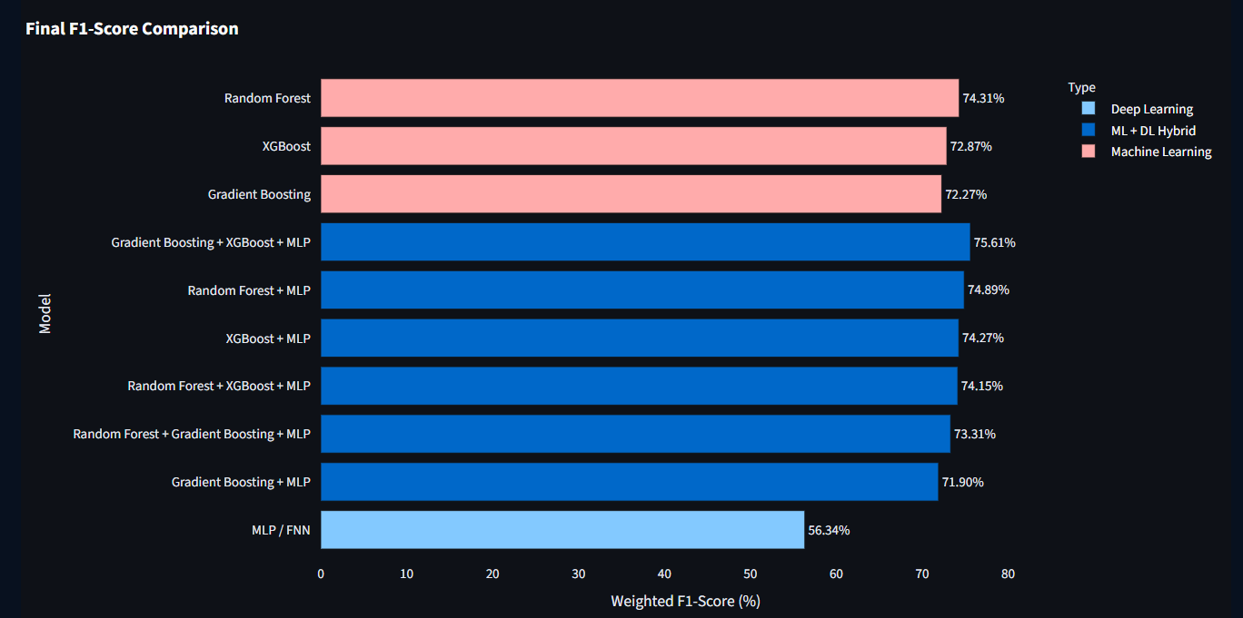
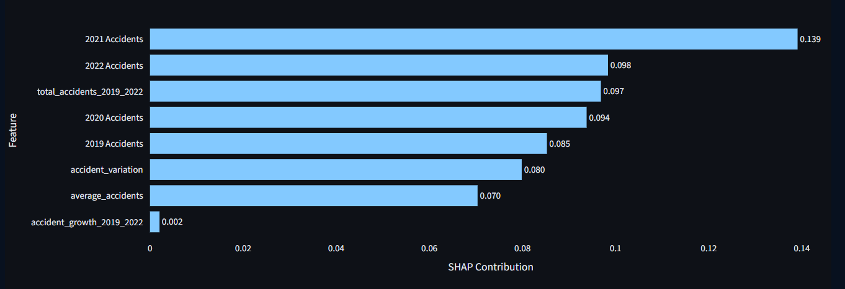
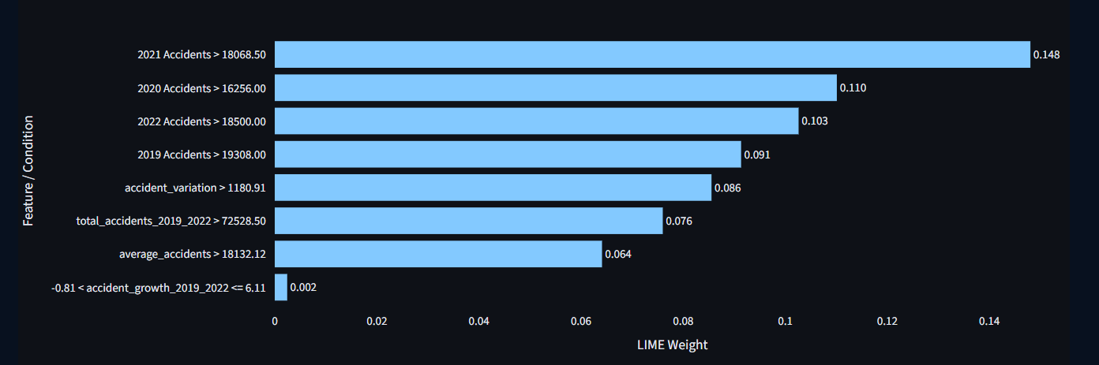
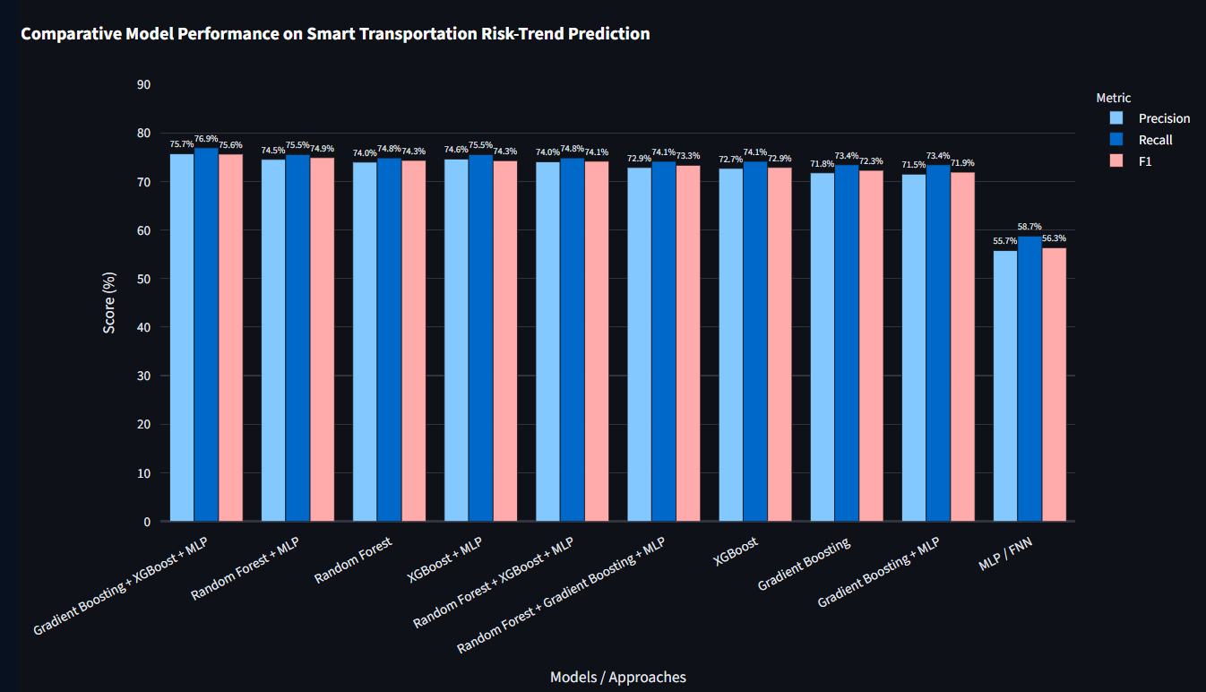
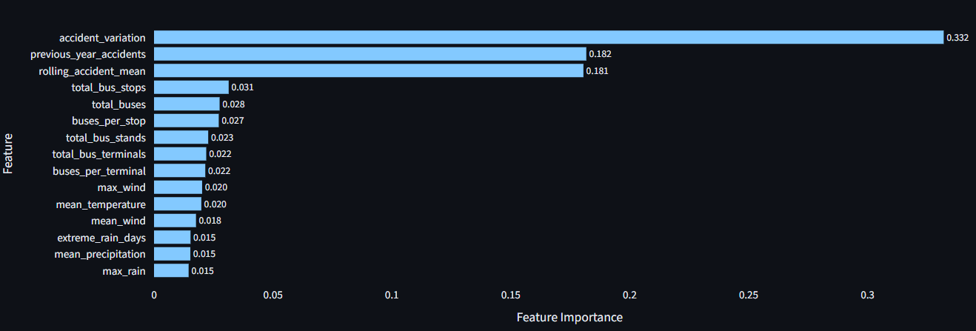

DECLARATIONS
Funding
No external funding was received for this research project.
Ethics Statement
This study uses transportation, road accidents, infrastructure, and environmental/weather datasets and does not involve the collection of personally identifiable human-subject data. No human-subject intervention was conducted as part of this study.
Data Availability
The study uses publicly available or project-provided datasets. The processed analytical data and source code may be made available through the project repository or submission location, subject to the terms and conditions of the respective data sources.
Author Contributions
Y. Paavana Pranavasri: Project conceptualization, methodology design, data preparation, machine-learning experimentation, dashboard integration, analysis, and manuscript preparation.
K. Bhavya: Literature review, research background, data collection, and dataset organization.
A. Divya Sree: Model evaluation, performance metric analysis, confusion matrix interpretation, and results documentation.
J. Sree Vardhini: Explainable AI analysis, visualization and result interpretation, manuscript review, and proofreading.
Acknowledgements
We would like to express our gratitude to Dr. K. Swapnika, Project Guide, and the Department of Computer Science and Engineering for their guidance and support throughout the project
REFERENCES
[1] M. Hassan, A. Al Nafees, S. S. Shraban, A. Paul, and H. D. Mahin, “Application of machine learning in intelligent transport systems: a comprehensive review and bibliometric analysis,” Discover Civil Engineering, vol. 2, art. no. 98, 2025, doi: 10.1007/s44290-025-00256-2.

[2] L. Breiman, “Random forests,” Machine Learning, vol. 45, pp. 5–32, 2001, doi: 10.1023/A:1010933404324.

[3] J. H. Friedman, “Greedy function approximation: A gradient boosting machine,” The Annals of Statistics, vol. 29, no. 5, pp. 1189–1232, 2001, doi: 10.1214/aos/1013203451.

[4] T. Chen and C. Guestrin, “XGBoost: A scalable tree boosting system,” in Proceedings of the 22nd ACM SIGKDD International Conference on Knowledge Discovery and Data Mining, 2016, pp. 785–794, doi: 10.1145/2939672.2939785.

[5] S. Ahmed, M. A. Hossain, S. K. Ray, M. M. I. Bhuiyan, and S. R. Sabuj, “A study on road accident prediction and contributing factors using explainable machine learning models: analysis and performance,” Transportation Research Interdisciplinary Perspectives, vol. 19, art. no. 100814, 2023, doi: 10.1016/j.trip.2023.100814.

[6] M. Manzoor, M. Umer, S. Sadiq, A. Ishaq, S. Ullah, H. A. Madni, and C. Bisogni, “RFCNN: Traffic accident severity prediction based on decision level fusion of machine and deep learning model,” IEEE Access, vol. 9, pp. 128359–128371, 2021, doi: 10.1109/ACCESS.2021.3112546.

[7] S. M. Lundberg and S.-I. Lee, “A unified approach to interpreting model predictions,” in Advances in Neural Information Processing Systems, vol. 30, pp. 4765–4774, 2017.

[8] M. T. Ribeiro, S. Singh, and C. Guestrin, “‘Why Should I Trust You?’: Explaining the predictions of any classifier,” in Proceedings of the 22nd ACM SIGKDD International Conference on Knowledge Discovery and Data Mining, 2016, pp. 1135–1144, doi: 10.1145/2939672.2939778.

[9] I. Abdulrashid, W.-C. Chiang, J.-B. Sheu, and S. Mammadov, “An interpretable machine learning framework for enhancing road transportation safety,” Transportation Research Part E: Logistics and Transportation Review, vol. 195, art. no. 103969, 2025, doi: 10.1016/j.tre.2025.103969.

[10] B. Chen, Y. Huang, Y. Zheng, and X. Liu, “From prediction to prevention: using text mining and explainable machine learning for urban bus accident analytics,” Risk Analysis, vol. 46, no. 1, e70183, 2026, doi: 10.1111/risa.70183.

[11] I. Damaj, S. K. Al Khatib, T. Naous, W. Lawand, Z. Z. Abdelrazzak, and H. T. Mouftah, “Intelligent transportation systems: A survey on modern hardware devices for the era of machine learning,” Journal of King Saud University - Computer and Information Sciences, vol. 34, no. 8, pp. 5921–5942, 2022, doi: 10.1016/j.jksuci.2021.07.020.

[12] A. Boukerche and J. Wang, “Machine Learning-based traffic prediction models for Intelligent Transportation Systems,” Computer Networks, vol. 181, art. no. 107530, 2020, doi: 10.1016/j.comnet.2020.107530.

[13] M. Veres and M. Moussa, “Deep Learning for Intelligent Transportation Systems: A Survey of Emerging Trends,” IEEE Transactions on Intelligent Transportation Systems, vol. 21, no. 8, pp. 3152–3168, 2020, doi: 10.1109/TITS.2019.2929020.

[14] J. Lacherre, J. L. Castillo-Sequera, and D. Mauricio, “Factors, prediction, and explainability of vehicle accident risk due to driving behavior through machine learning: A systematic literature review, 2013–2023,” Computation, vol. 12, no. 7, art. no. 131, 2024, doi: 10.3390/computation12070131.

[15] A. B. Z. Chai, B. T. Lau, M. K. T. Tee, and C. McCarthy, “Enhancing road safety with machine learning: Current advances and future directions in accident prediction using non-visual data,” Engineering Applications of Artificial Intelligence, vol. 137, art. no. 109086, 2024, doi: 10.1016/j.engappai.2024.109086.

[16] H. Khanum, A. Garg, M. I. Faheem, and R. Kulkarni, “A methodological framework for road accident severity prediction for Indian highways using machine learning models,” MethodsX, vol. 15, art. no. 103728, 2025, doi: 10.1016/j.mex.2025.103728.

[17] J. Yang, S. Han, and Y. Chen, “Prediction of traffic accident severity based on random forest,” Journal of Advanced Transportation, vol. 2023, art. no. 7641472, 2023, doi: 10.1155/2023/7641472.

[18] M. Yan and Y. Shen, “Traffic accident severity prediction based on random forest,” Sustainability, vol. 14, no. 3, art. no. 1729, 2022, doi: 10.3390/su14031729.

[19] F. Shala, H. Demolli, and L. Sejdiu, “The application of machine learning algorithms in predicting traffic accidents by considering weather conditions,” International Review of Civil Engineering, vol. 15, no. 2, pp. 201–208, 2024, doi: 10.15866/irece.v15i2.24368.

[20] C. D. Arteaga, A. Paz, and J. Park, “Injury severity on traffic crashes: A text mining with an interpretable machine-learning approach,” Safety Science, vol. 132, art. no. 104988, 2020, doi: 10.1016/j.ssci.2020.104988.

[21] Z. Yang, W. Zhang, and J. Feng, “Predicting multiple types of traffic accident severity with explanations: A multi-task deep learning framework,” Safety Science, vol. 146, art. no. 105522, 2022, doi: 10.1016/j.ssci.2021.105522.

[22] S. A. Sayed, Y. Abdel-Hamid, and H. A. Hefny, “Artificial intelligence-based traffic flow prediction: A comprehensive review,” Journal of Electrical Systems and Information Technology, vol. 10, art. no. 13, 2023, doi: 10.1186/s43067-023-00081-6.

[23] Zulkarnain and T. D. Putri, “Intelligent transportation systems (ITS): A systematic review using a natural language processing (NLP) approach,” Heliyon, vol. 7, no. 12, art. no. e08615, 2021, doi: 10.1016/j.heliyon.2021.e08615.

[24] A. A. Kashyap, S. Raviraj, A. Devarakonda, S. R. Nayak K, K. V. Santhosh, and S. J. Bhat, “Traffic flow prediction models – A review of deep learning techniques,” Cogent Engineering, vol. 9, no. 1, art. no. 2010510, 2022, doi: 10.1080/23311916.2021.2010510.

[25] X. Liu, L. Qin, M. Xu, Y. Zhou, B. Wang, W. Yu, and W. Xiong, “A comprehensive review of traffic flow forecasting based on deep learning,” Neurocomputing, vol. 668, art. no. 132269, 2026, doi: 10.1016/j.neucom.2025.132269.

[26] T. Matue, A. A. Akinyelu, and M. Mokotsolane, “Advances in intelligent transportation systems: ML and DL techniques for traffic congestion forecasting,” International Journal of Data Science and Analytics, vol. 22, art. no. 285, 2026, doi: 10.1007/s41060-026-01203-9.

[27] Z. Xing, M. Huang, and D. Peng, “Overview of machine learning-based traffic flow prediction,” Digital Transportation and Safety, vol. 2, no. 3, pp. 164–175, 2023, doi: 10.48130/DTS-2023-0013.

[28] J.-F. Yao, R. He, T.-T. Shi, P. Wang, and X.-M. Zhao, “Review on machine learning-based traffic flow prediction methods,” Journal of Traffic and Transportation Engineering, vol. 23, no. 3, pp. 44–67, 2023, doi: 10.19818/j.cnki.1671-1637.2023.03.003.

[29] Z. Gao, S. M. Easa, Y. Liu, Z. Chen, H. Ge, and Y. Wang, “Road traffic accident severity prediction based on large-scale data and multi-dimensional factors: An explainable ensemble learning approach,” Accident Analysis & Prevention, vol. 233, art. no. 108581, 2026, doi: 10.1016/j.aap.2026.108581.

[30] J. Jeyabharathi, K. J. Lakshmi Prasad, K. Karunakar, K. Sai Charan, and R. Sasi Preetham, “AI-driven traffic accident prediction: Integrating real-time weather, analytics, and machine learning for enhanced road safety,” in 2026 9th International Conference on Intelligent Computing and Control Systems (ICICCS), 2026, pp. 799–804, doi: 10.1109/ICICCS67901.2026.11502769.

