**Documentation: Web- Based Script Execution**

Requirements

Following need installed on the system

* Python 3.8.8
* flask == 2.0.1
* flask_session == 0.3.2
* xlrd == 2.0.1 (used in python scripts)

Starting the program

Start the program by running app.py by typing “python app.py “ in the cmd

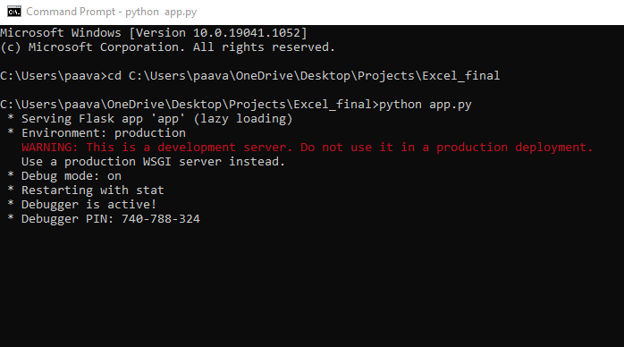

With this, the web page is hosted on localhost:5000

Script Folder

**README.txt:** include a txt file in the directory which contains the .py files which are to be run. Mention the file name without .py extension.

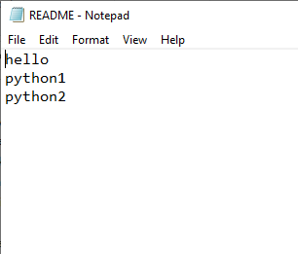

**Python Scripts:**

**Python function name:**

Functions that return data in list format which is to be displayed in a table format in html page must end in ‘_xl’, Example: datasheet_xl

Functions that return data which is to be plotted in graph must end in ‘_graph’, Example: pieChart_graph

Other functions which return text data can be named without any particular suffix

These conventions are defined in app.py

**Graphs**: graphs are added to the web page using *google charts api* in the html page. The data to be plotted and the chart type is returned from the python script. The python function must return *dictionary*, containing data table, chart type and other info about the graph.

In the data table add the titles of the columns in the 1st row, otherwise leave it empty. The 1st row of the data table is reserved for titles.

(See pieChart_graph function in python2.py or grades_graph function in python1.py)

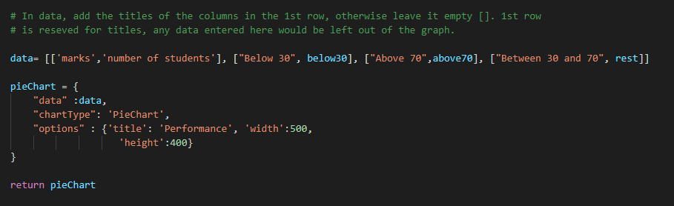

All types of graphs can be added through google charts api. See the following url and similarly define the data, chart name and other info in the python script.

More info can be found at: https://developers.google.com/chart/interactive/docs/quick_start

Scripts from a directory other than the current directory

When using a directory other than the current directory (which contains app.py), take care of the following:

* In the python scripts, clearly specify the address of the excel sheets (absolute or relative address with respect to the current directory). This is needed cause when the said script is uploaded, python would look for the excel sheets in the current directory.

Example:

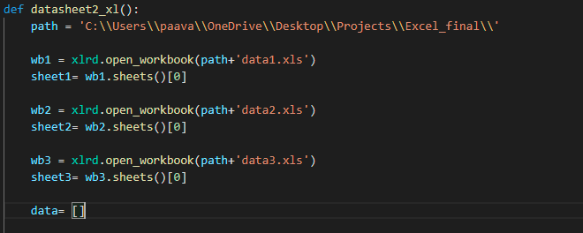

* Avoid giving same name to python scripts in two directories
* Include a ‘__init__.py ‘file in the given directory (It can be a blank file, no need to include any content in it)

Web Application:

Folder Path

Both relative and absolute address can be used. ‘.’ Refers to the current directory

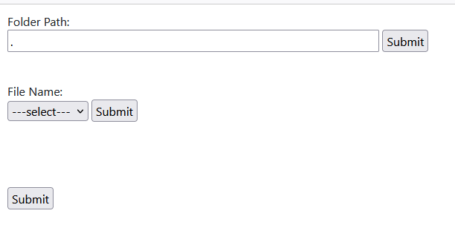

Drop-down list

After submitting folder path, name of the python scripts would be displayed in the drop-down list (script names are read from the README.txt file)

Function Name

After submitting the function name, a checkbox list consisting of the functions present within the script would appear. Select the desired function(s). The output would appear on the page

