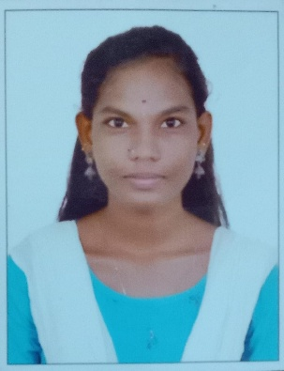BIO DATA

Name : V.Prabavathi.

Fathers Name : N.Velusamy

Mobile :9043355195

Email id : prabavathivathi900@gmail.com

Gender : Female

Date of Birth : 22-03-2006

Religion : Hindu

Nationality : Indian

Languages known : Tamil,English

Education :

|  |  |  |  |
| --- | --- | --- | --- |
| Exam name | Year of pass | Institution Name | Marks |
| 10th | 2021 | Vallalar Higher secondary school | All pass |
| 12th | 2023 | Sevamandhir girls higher secondary school | 471 |
| Ug | 2026 | Queen Mary’s college Mylapore,chennai |  |