ECOTE – preliminary project

Semester: Summer 2020/2021

Author: Paweł Borsukiewicz, 301106

Subject: ECOTE

Write a program reading regular expressions, then constructing NFA using Thompson algorithm, converting NFA into DFA and checking if input strings are generated by this expression (working on DFA).

General overview and assumptions

The aim of the project is to create a program that will take as an input RE in a form of a string. Given string will be checked if it is correct. In case of some mistakes such as unequal number of left and right brackets user will be informed that the mistake was made and he will be asked to input RE again.
Having confirmed that RE is correct, program will generate NFA and display it in a form of a graph. Then, similarly from NFA it will generate DFA and display it. Finally user will have an opportunity to enter some strings to check if they are generated by the RE. Check will be performed on DFA.

Functional requirements

The RE will be provided by the user during execution of the program. So as to make program less complex my input alphabet will be set of small letters (a-z ascii symbols 97-122) and epsilon symbol replaced by big E (ascii symbol 69) due to the fact that ε is not a part of basic ascii table.
Following operators will be allowed: “|”, “*”, “(”, “)”. Correctness of their usage will also be checked before execution of transformation code.
RE will be transformed into postfix notation so as to facilitate the process of obtaining NFA as it more clearly states the order of operations to make. The main assumption contrary to algebraic notation, where operator is between the operands, is that in postfix notation the operator follows its operands. For instance let’s take mathematic example, in algebraic notation we may have 2+3*4, while in postfix notation it will be converted to 234*+, where first operator is * meaning that we have to multiply, then we can add result of multiplication to 2. Similarly, REs can undergo such conversion. For example a|b* may be transformed to ab*|.
NFA will be obtained using Thompson algorithm. It exactly specifies methods of obtaining NFA subparts for “|”, “*” and concatenation, hence RE will be divided into smaller parts. Such subparts will be transformed to NFA and later glued together to make one coherent NFA.
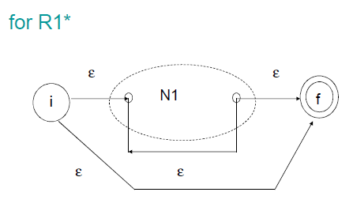
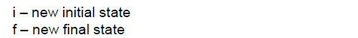
Figure 1. Thompson algorithm for R1*, taken from lecture slides
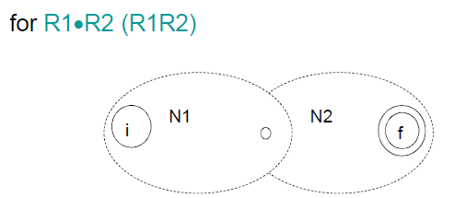
Figure 2. Thompson algorithm for R1R2, taken from lecture slides
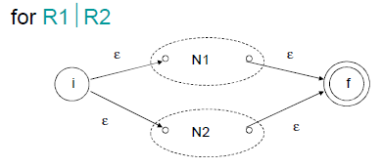
Figure 3. Thompson algorithm for R1|R2, taken from lecture slides

Having NFA, it will be converted to DFA. There will be function responsible for finding epsilon closure for a given node. Starting from initial node epsilon closure will be found to create first node of DFA. Having that node, move functions for all input symbols in our RE will be executed. If epsilon closure of any of move functions will generate new set of nodes, it will be saved as a new DFA node and the algorithm used for initial node will be repeated on it. When all new nodes are found (there is no more possibilities when all nodes were iterated though with move functions) our DFA is complete and will be ready for test input strings.
Such input strings can be composed only of letters a-z as specified earlier or E symbolizing ε. Correctness of string will be checked before testing it on NFA.

Implementation

General architecture

Program will be written in C++ in a form of console application.
It will be composed of classes storing nodes. There will be separate NFA and DFA nodes classes as their transition patters are different. Each node will be a separate object. Code will be divided into many small .h and .cpp files to make it easier to read and operate on.

Data structures

Both NFA and DFA nodes will store information about possible transitions (next node and required input symbols to get there) with the difference that for NFA there will be always only one input symbol leading to the next node, while in NFA there may be more than one. Pointers to next nodes will be stored in a vector, similarly transition strings – if there will be more than one possible transition in DFA string will consist of all possible inputs, else it will be single char.
Pointers to starting node of DFA and NFA will be stored in NodeMaster class that will have only one object. It will also store information about number of nodes. From this information we will be able to generate NFA or DFA graph if needed and present it in simplified graphical form.

Input/output description

As specified before, input has to be delivered to program via console. Output consists of information if particular string can be generated by DFA in form of output string “YES” or “NO” to console. NFA and DFA will be generated in a form of graph. Nodes will be presented with numbers, transitions with lines specifying on which symbols transition occurs e.g. “---a---” – transition on ‘a’. I will probably also implement a possibility to receive information about nodes following particular node (list them and show how to get to them – on which input symbol).

Functional test cases

Positive:
- RE: a|b INPUT: a // simple check
- RE: (ab)* INPUT: E //E will mean epsilon in my code, checks if * works
- RE: (a(a|bb))|E INPUT: abb // checks if brackets and | work
- RE: (a*b)* INPUT: baba //checks more advance * version with non-E output
- RE: aa*|b* INPUT: bbb //checks combination | and *
Negative:
- RE: (aaaa // no right bracket
- RE: )a*b( // “)” cannot be before “(”
- RE: 1234 // symbols not allowed
- RE: aa*b INPUT: baaa //such input cannot be generated by this RE, outputs “NO”
- RE: a||b // we cannot have more than one “|” in a row

