TASK-8

1, Create database name IMDB



2, Using IMDB database



3, creating movies table in IMDB database



4, inserting values in movies table

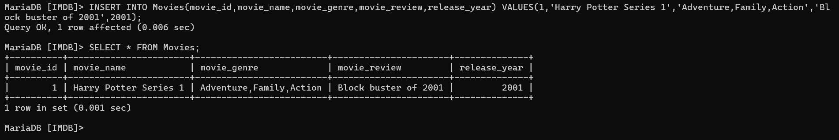

5, adding movie media column in movies table

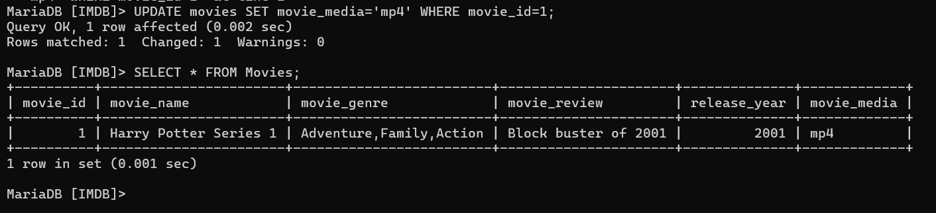

6, creating genre table and inserting values

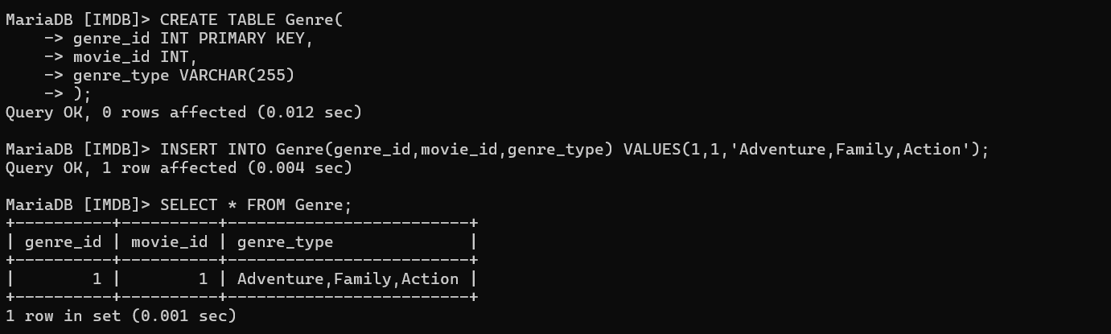

7, creating user table and inserting movie_review,movie_id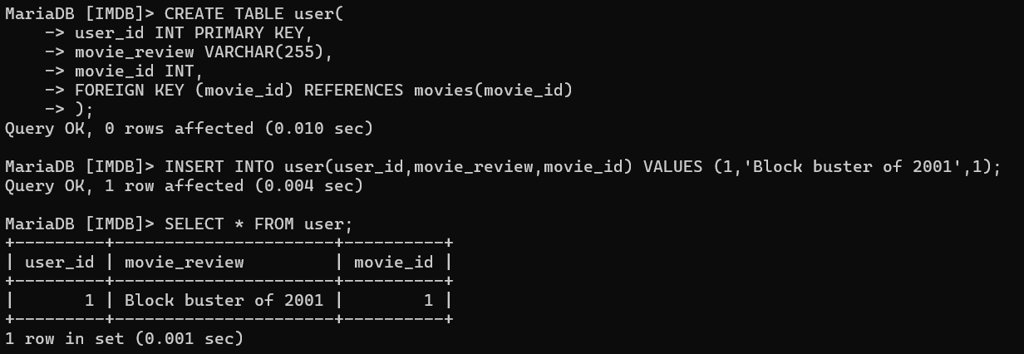

8,creating artist table and inserting artist_id,artist_skills

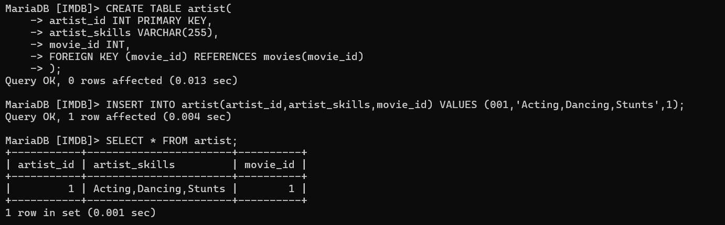

9, Adding artist_name column in artist table

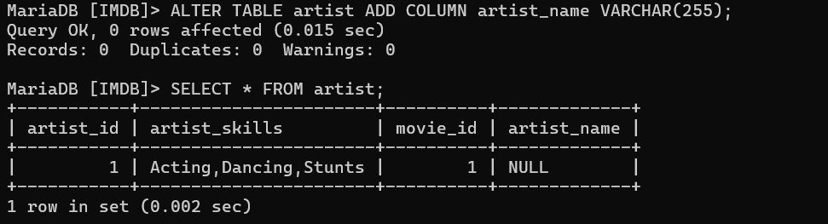

10, Updating values in artist table

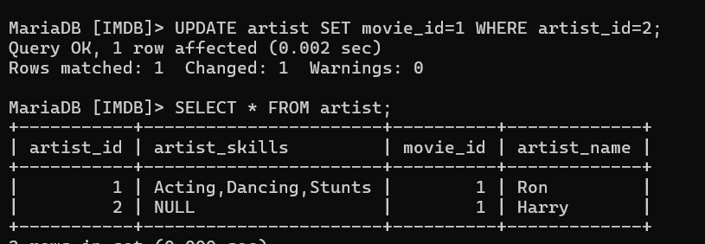

11, Retrieve data from both movies and genre tables where there is a match based on the foreign key relationship.

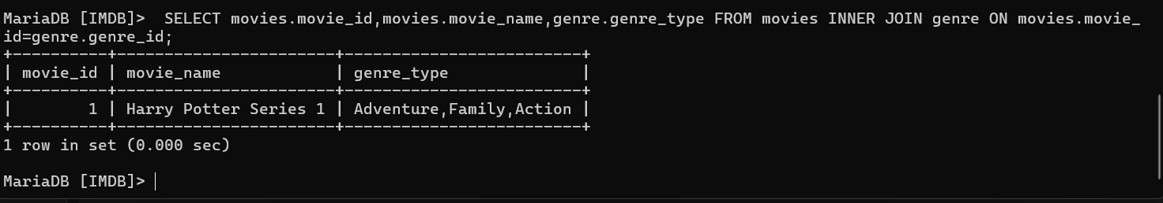

12, Retrieve data from both artist and genre tables where there is a match based on the foreign key relationship.

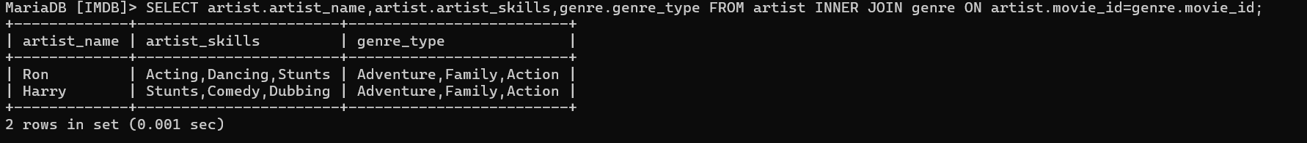

13, Creating artist_roles table, with role_id, role_name columns

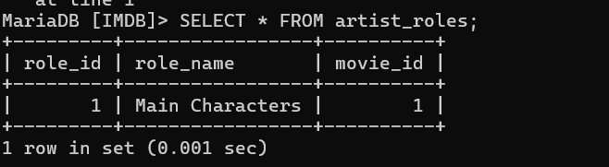

14, Display movie name, role they played, and their skills, artist names

