Online Examination System
A Mini-Project Report
Submitted in the partial fulfillment of the requirements for the award of the degree of

Bachelor of Computer Application
in
Faculty of Computer Technology
By

Pabitra Basumatary ADTU/1/2023-26/BCAO/018 Khorgeswar Koch ADTU/1/2023-26/BCAO/017 Ayush Sarkar ADTU/1/2023-26/BCAO/060

PROJECT BATCH- 2025-2026

UNDER THE ESTEEMED GUIDANCE OF

Mr. Wanraplang Nongbri



Faculty of Computer Technology Assam down town University
Sankar Madhab Path, Gandhi Nagar Panikhaiti, Guwahati, Assam 781026
Date - 26-11-2025

Assam down town University
Faculty of Computer Technology



DECLARATION

The Project Paper Report entitled “Online Examination System” is a record of bonafide work of Pabitra Basumatary, Khorgeswar Koch and Ayush Sarkar submitted in partial fulfilment for the award of BCA in Faculty of Computer Technology in Assam down town University. The results embodied in this report have not been copied from any other departments/University/Institute.

Pabitra Basumatary ADTU/1/2023-26/BCAO/018 Khorgeswar Koch ADTU/1/2023-26/BCAO/017 Ayush Sarkar ADTU/1/2023-26/BCAO/060

Assam down town University

Faculty of Computer Technology

CERTIFICATE

This is to certify that the Project Report entitled “Online Examination System” is being submitted by “Pabitra Basumatary, Khorgeswar Koch and Ayush Sarkar” in partial fulfilment for the award of BCA in Faculty of computer Technology to Assam down town University is a record of bonafide work carried out under efficient guidance and supervision. The results embodied in this report have not been copied from any other departments/University/Institute.

Signature of the Supervisor
Mr. Wanraplang Nongbri

INDEX

S.NO TITLE PAGE NO.
- Abstract 5
- Introduction 6
- Literature Survey 7
- Process Flow 9
- Implementation 10
- Process Flow diagram 11
- Experimental results 13
- Conclusion 14
- References 15

ABSTRACT

The Online Examination System is a web-based application designed to facilitate efficient, secure, and automated exam management for educational institutions. This system enables students to take exams online and allows teachers and administrators to create, schedule, and evaluate tests seamlessly. Built using the MERN stack (MongoDB, Express.js, React.js, and Node.js), the project ensures a scalable, responsive, and real-time experience. The system provides role-based access for Admin, Teacher, and Student, each with specific functionalities such as user management, exam creation, result analysis, and test participation. By eliminating manual paper-based testing, this project aims to improve accessibility, reduce human error, and enhance transparency in evaluation.

INTRODUCTION

The Online Examination System is a web-based application developed using the MERN Stack (MongoDB, Express.js, React.js, and Node.js) to simplify and automate the exam process. It allows administrators, teachers, and students to manage exams efficiently through a single platform. Teachers can create and schedule exams, while students can take tests and view results online. The system ensures security, transparency, and accuracy in evaluation, reducing manual work and human error. It provides a user-friendly interface, supports multiple devices, and offers a faster, more reliable alternative to traditional examination methods.

Literature Survey

Author(s) | Year | Source | Title | Findings
Kumar, P. & | 2021 | International | “Automation of | Demonstrated that MERN-based systems offer
Singh, V. |  | Journal of | Examination System | faster performance and real-time data
 |  | Computer | Using MERN | synchronization.
 |  | Applications | Stack”
Sharma, R. & | 2020 | IEEE Conference | “A Web-Based | Proposed an online exam system that enhances
Gupta, A. |  | on E-Learning | Examination System | scalability and reduces maintenance costs using
 |  |  | Using Cloud | cloud infrastructure.
 |  |  | Technologies”
Thomas, J. & | 2022 | Elsevier Procedia | “Secure Online | Focused on implementing role-based
Dey, N. |  | Computer Science | Testing System | authentication and data encryption for secure
 |  |  | Using Node.js and | online exams.
 |  |  | MongoDB”

LITERATURE SURVEY

From the reviewed literature, it is evident that online examination systems have evolved significantly with advancements in web technologies. Earlier systems focused primarily on web-based exam delivery and cloud scalability. Recent studies emphasize enhanced security, real-time performance, and user experience through modern stacks like MERN. Researchers such as Kumar and Singh (2021) highlighted the efficiency and responsiveness of MERN- based architectures, while others like Thomas and Dey (2022) focused on data protection through role-based authentication. The findings collectively show that integrating MongoDB, Express.js, React.js, and Node.js provides an ideal foundation for building scalable, interactive, and secure online examination platforms suitable for educational institutions.

PROCESS FLOW

The process flow of the Online Examination System begins with user authentication, where students, teachers, and administrators log into the platform using their respective credentials. Once logged in, the system identifies the user’s role and grants access to specific functionalities.

The Admin manages user accounts, exam categories, and overall system settings. The Teacher creates and schedules exams by entering questions, setting duration, and assigning them to specific student groups. Students can view available exams, attempt them within the given time, and submit their responses. The system then automatically evaluates objective-type questions, while descriptive answers are reviewed manually by teachers.

IMPLEMENTATION

Project Set Up:
- Template Selection: A modern and responsive React.js template was selected to design a clean, intuitive, and user-friendly interface. It ensures smooth navigation for students, teachers, and administrators.

- Naming: The project is named “Online Examination System”, reflecting its purpose of conducting,
managing, and evaluating exams digitally through a secure and automated process.

- Terrain Generation: In the context of this project, “terrain” represents the system architecture setup. The backend terrain was generated using Node.js and Express.js, while the front-end environment was built using React.js. MongoDB was configured as the database to store users, questions, and exam data.

- Environment Creation: The development environment was created using Visual Studio Code, MongoDB Atlas, and Node.js runtime. The application was connected through RESTful APIs to enable seamless communication between client and server.

- Character: The system defines three main “characters” or user roles — Admin, Teacher, and Student. Each has specific permissions and dashboards designed for their respective tasks.

- Mounts: Mounts symbolize the integration points where various modules (login, exam creation, test interface, and results) were connected and tested for functionality and data flow consistency.

- Opponents: Here, “opponents” refer to the system challenges such as managing concurrent users, ensuring data security, and maintaining performance efficiency. These were addressed by implementing JWT authentication, bcrypt encryption, and optimized database queries.

- Scripting: JavaScript and JSX were used extensively for front-end scripting, while Node.js scripts handled backend logic. MongoDB queries managed the database operations, and Express.js routed the APIs efficiently.

FLOW DIAGRAM

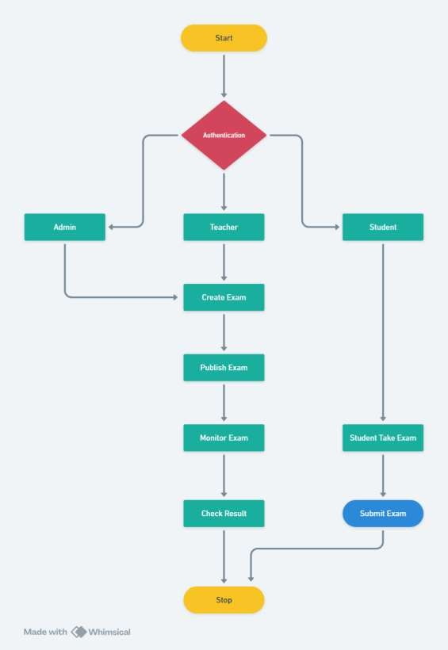

EXPERIMENTAL RESULTS

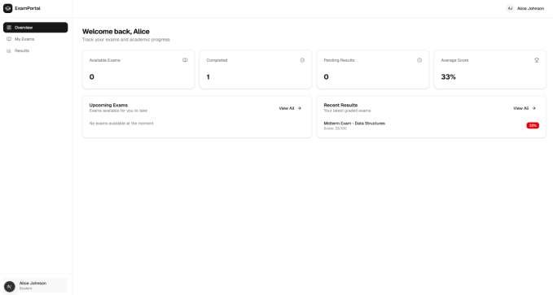
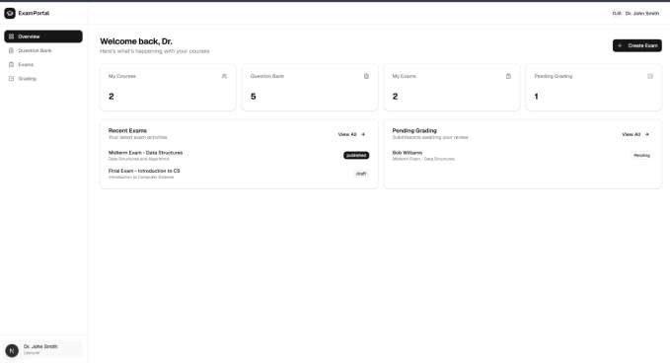

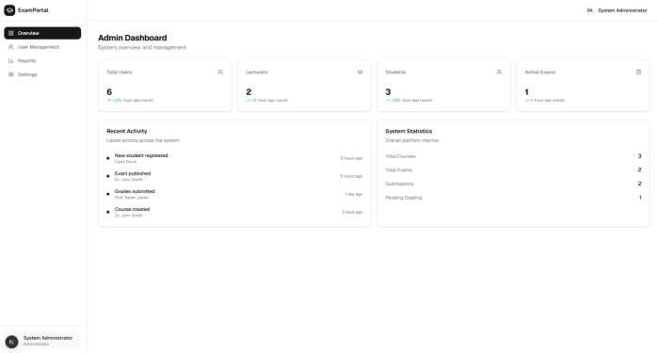

CONCLUSION

The Online Examination System provides a comprehensive and automated solution for conducting online assessments. By utilizing the MERN stack, the system achieves a high level of performance, scalability, and maintainability. It simplifies exam management for teachers, ensures transparency for students, and reduces administrative burden for institutions. The responsive UI and role-based architecture make it suitable for real-time use in diverse academic environments.

In conclusion, this project demonstrates how modern web technologies can transform traditional examination methods into a digital, efficient, and reliable system. Future enhancements may include features such as AI-based proctoring, question randomization, and detailed analytics to further improve examination integrity and user experience.

REFERENCES

- ONLINE EXAMINATION SYSTEM Deepankar Vishwas Kotwal1, Shubham Rajendra Bhadke2, Aishwarya Sanjay Gunjal3, Puspendu Biswas4 (Research Paper)

- Wikipedia

- https://github.com/caomingkai/Online-Exam-System

- https://ieeexplore.ieee.org/abstract/document/7429241

