Phase-1  
After filling the form, I have literally forgotten about the Udacity scholarship program as I was busy doing my final year project and enjoying vacation after my exams were just completed. And then I got this mail from Udacity on November 16,2019. And I was thinking that have I filled the form because I was not even remembering in which track, I have filled the form in.

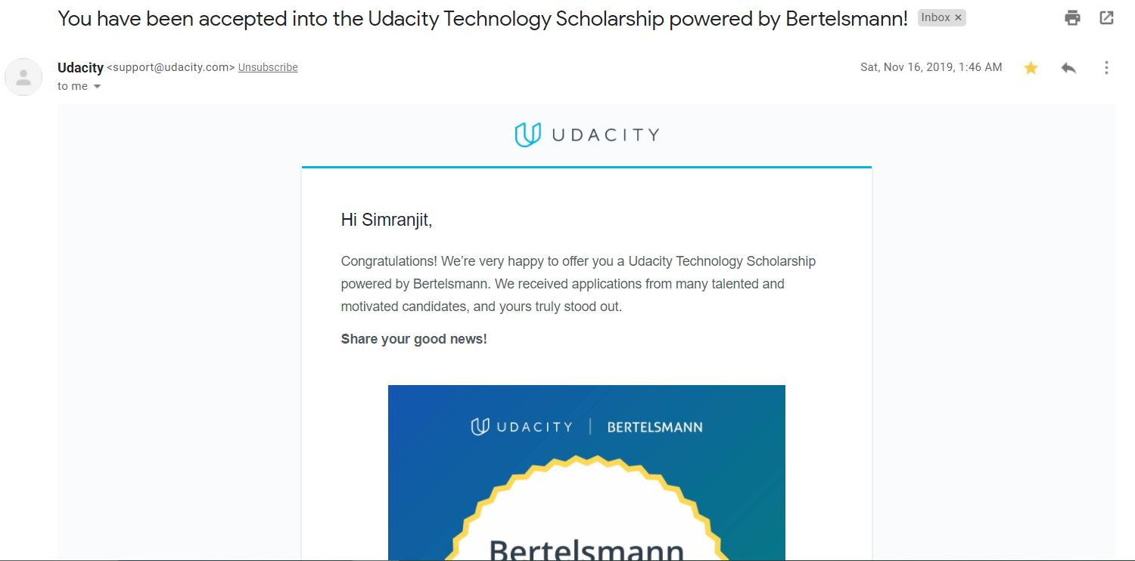

But then I came to know about the track from the slack channel that they have added me. Believe me the next 3.5 change my life, it is not that I have learned a lot, but I know where to look for the material how to read a research paper. And above all of that the community is the heart (i.e. slack channel) yes, the community is what makes this program awesome. The community was very helpful as there has been an environment just like stack overflow where one can ask the question/doubt in the specific channel and get answer from everyone.

So basically, we were learning not from the material but from other’s as well. They were explaining the concept from their point of view and then we tell them we understand this concept like this and then they correct us if we were wrong or understanding it.Then we have to completed couple of tasks like this bingo. We have to find people like minded and create a study group and can learn with them like a study buddy.

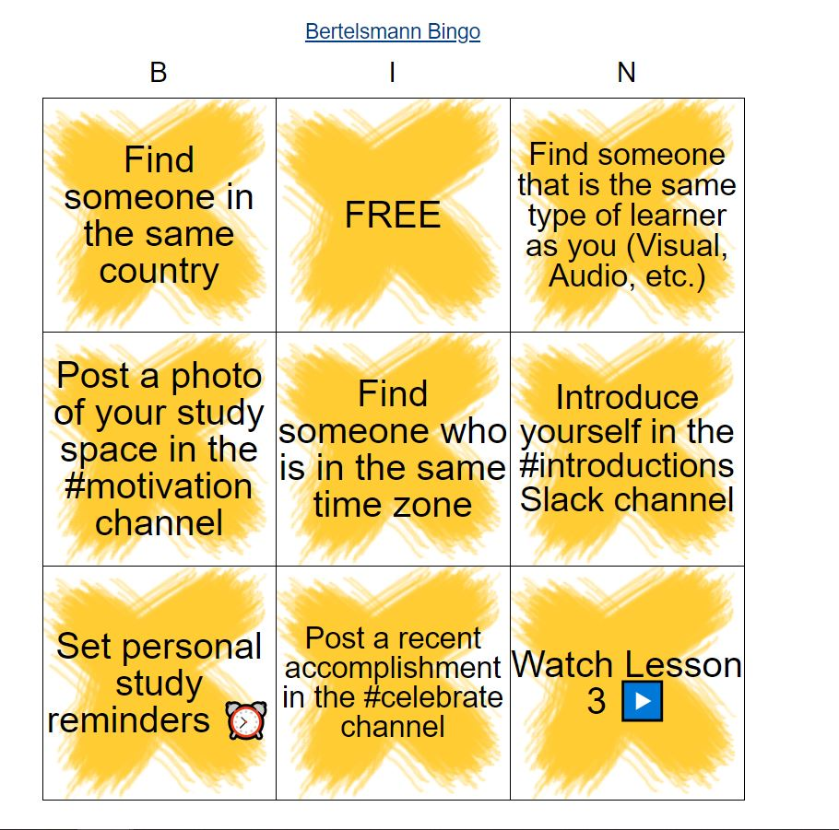

And I have also shared that I am working on this final project & was looking for satellite data and not getting it. Then a lot of people suggest me link’s and from one of that suggestion I got the High-Quality data of satellite for which I have to give the interview and luckily, I got passed in it.

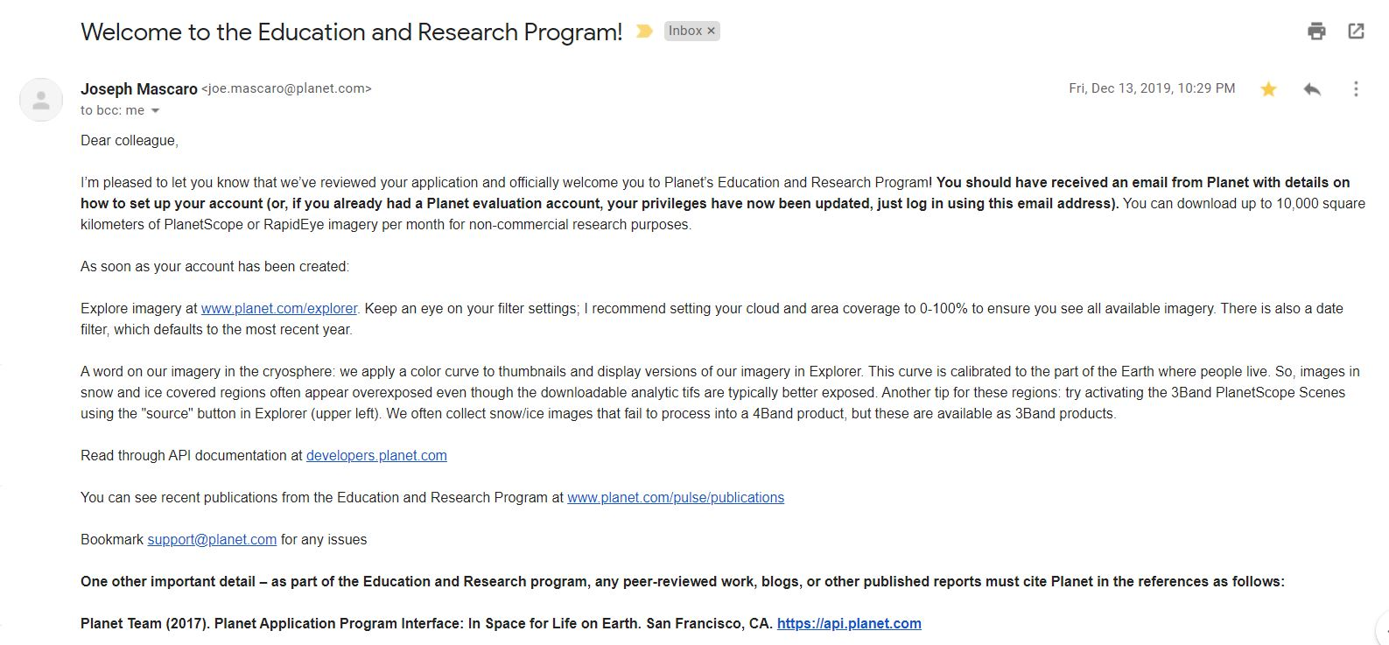

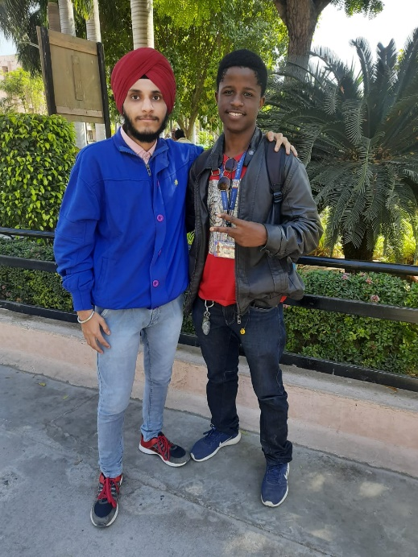

After that I found a study-buddy in the same college I was in as he was also selected in the Udacity program and we were not knowing about it till the 1.5 months. He is my junior, but the knowledge he was having at that time was expert level as he has started ML from the 1st year only. And I have started learning what is deep-learning so I was a just beginner at that time.

Then I have completed the fundamental course and helped to solve doubts by helping others in completing the course. Yes, this is the main things whether you got selected in phase 2 or not helping is the key thing. It not only helps you to revise your concept but also taught you how to explain the concept in your words. So, when you go into any interview you will be confident to answer. And I will not lie the field was new to me and at the starting I have only heard about AI and deep-learning terms. So, I have to learn a lot and have a long road to travel to understand the maths and everything so that I referred [deep-learning.ai](https://www.youtube.com/channel/UCcIXc5mJsHVYTZR1maL5l9w) video and [3Blue1Brown](https://www.youtube.com/watch?v=aircAruvnKk&list=PLZHQObOWTQDNU6R1_67000Dx_ZCJB-3pi) video as well. So basically, I have learnt a lot and along with that I have to take care of my college work and project as well. So, in the end of the 3.5 months I was confident of my learning. One thing that stands out is that Udacity not only teaching the concepts theoretically but they have practical Jupiter notebooks where we have to implement our understanding related the concept. The mentors are the real hero they make the concept look so easy that you understand it really quick.

Phase-2

Finally, I got the mail and I was very-very-very happy because after getting the mail I was having 2 options at that time either to give time to GSOC & try my luck and drop this opportunity. Then I discussed with my Big Brother and he told me to go with this opportunity because he told you already earned this and we don’t know that you will be selected in GSOC as the selection ratio is 1:20 for the project that I was working for. So I decided to leave it because I can’t focus in so many things at one time.

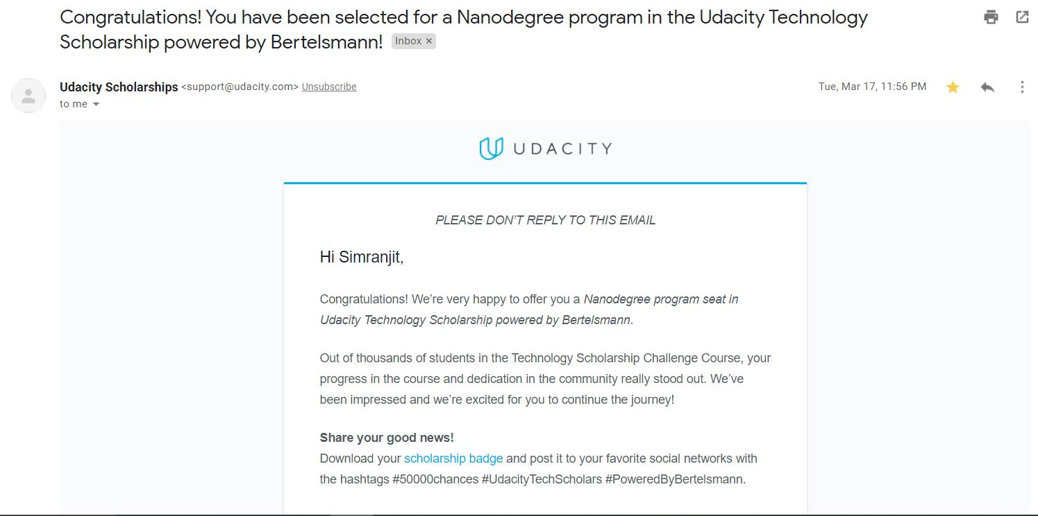

So after that the Corona outbreak stared and everything come to halt. Everything close and the exams which were to be conducted in the starting of April was being conducted in May. As I have taught earlier that I will start the Nanodegree after my exams. But then I rethink my decision and decided to complete 1 project before exams. So, I did and the bad new was the exams postpone again and finally conducted on May 15th. So, after that I started Nanodegree and targeted 1 project 1-month rule.   
  
In the second phase I have revised all the concepts again before going to project 2. And I have changed the pattern of learning. Because I was already late and running behind the time-table. I followed the [Feynman Technique](https://youtu.be/tkm0TNFzIeg) suggest by my best friend and believe me it worked really well. I learned the lesson from the Udacity Material then watches some videos on YouTube related to it to go in more depth. Ready blogs and research paper mentioned by Udacity and I can’t leave to mention about Medium post it helped a lot.   
  
After learning the concept what I do is I write what I have understood using the images and to visualize the concept and then ask the question to Mentor in the knowledge section regarding my understanding. And ask him to correct me and provide more material related to it. So, after that I jump on the project and gets my hand dirty with code after getting the green signal from the mentor. So, like this I have utilized 1 month for 1 project to learn as much as I can. And after following this approach I am getting very much confident and follow this till the end.  
But remember I told you to help others as well before, so I tried to help others and try to solve their doubts/mistakes whenever I can. And I recommend to make study buddy and do zoom meeting to understand the concept and solve doubts with them. Like this I also found people in linked-in who have taught me concepts through zoom-meeting even though we were not knowing each other.

So finally, now I have completed the ND and got the certificate I am happy for that. But I am happier that I learned new approaches to learn new things and make connections (i.e. friends) all over the globe. And now I can say I know the concepts behind deep-learning and have transformed my skills to basics to intermediate. And it will take some more time to achieve another level/form like Goku found Ultra Instinct. For that I have to either do a research-based project and apply my skills & understanding to real projects.  
  
In the end, I would like to conclude follow the approach which ever suits you. Don’t hesitate to ask the help of the mentors and the community. And everything that started also ends one day so this is the end of this journey for now, but I will again come back to this after 5 months as I another goal to achieve for now.   
Thanks to all the mentors who taught and mentors who helped in the solving the doubts without them I wouldn’t have complete this ND. Thanks to all the people who helped me in solving the doubts and complete this Nanodegree.