Guía de Laboratorio 7: Calidad, Mutation Testing, JWT y Seguridad de API en MecaTrack
Pablo Alejandro Rodriguez Suarez — Código [PENDIENTE: código]
Daniel Steven Londoño Vanegas — Código [PENDIENTE: código]
Omar David Gutierrez Torrez — Código [PENDIENTE: código]
Facultad de Ingeniería, Universidad Manuela Beltrán (UMB)
Taller de Programación — Sesiones 13 y 14
Docente: [PENDIENTE: nombre del docente]
1 de noviembre de 2026

Tabla de contenido
Introducción 3
Resultados por entregable 3
SonarCloud y Quality Gate 3
Mutation testing 8
CI/CD con mutation testing 10
JWT and RBAC (session 14) 13
OWASP API Security Top 10 2023 (session 14) 18
CodeQL and Dependabot (session 14) 21
Preguntas orientadoras 25
Aprendizajes para el quehacer profesional 25
Dificultades reales y cómo se resolvieron 26
Resumen de entregables 26
Uso de la inteligencia artificial 27
Repositorio y pipeline 28
Video 28
Referencias 29

Introducción
MecaTrack es el sistema de citas y seguimiento de vehículos de un taller mecánico (Flask, SQLAlchemy y PostgreSQL, con frontend en HTML, CSS y JavaScript sin frameworks). Esta guía endurece su calidad y seguridad: análisis estático con SonarCloud, mutation testing dentro del CI, autenticación con JWT y control de acceso por roles, controles de OWASP API Security Top 10 2023, y análisis con CodeQL y Dependabot.
Todas las cifras y capturas de este informe provienen de ejecuciones reales registradas en docs/lab7/evidence/index.json. El repositorio de trabajo cambió a Pablixsz/MecaTrack porque la cuenta que administra el proyecto no era dueña del repositorio anterior y no podía configurar secretos ni ajustes de seguridad; la historia de commits se conservó completa.

Resultados por entregable

SonarCloud y Quality Gate
El primer análisis encontró 32 bugs y 15 vulnerabilidades (Figura 1 y Figura 2). Al cierre, el Quality Gate está aprobado, sin issues abiertos de tipo Bug o Vulnerability y con 97.2 % de cobertura global (Figura 4 y Figura 3).
Ese resultado debe leerse con su alcance: tres issues se cerraron como falso positivo y dos como aceptados, con justificación escrita en SonarCloud; las herramientas de scripts/ e informe/ quedaron fuera del análisis; y siguen abiertos 2 code smells de accesibilidad. Además, el análisis detectó 4 CVE en dependencias directas, que se resolvieron actualizando los paquetes (Figura 5).
Tabla 1
Issues de SonarCloud: causa, tratamiento y verificación
Issue | Severidad | Causa | Tratamiento | Test / verificación
pythonsecurity:S5131 en api/v1/services.py:161 y api/v1/ai.py:90 | BLOCKER | Sonar ve datos del usuario devueltos en la respuesta. Se serializan como JSON, por lo que no hay HTML reflejado directo | Se anade X-Content-Type-Options: nosniff a todas las respuestas para impedir que el navegador interpretara el JSON como HTML, y se marca como falso positivo en SonarCloud con esa justificacion | test_user_input_is_echoed_only_as_non_sniffable_json: comprobado que falla sin el arreglo
python:S4502 en app.py:17 | CRITICAL | API con sesion por cookie y sin proteccion CSRF: riesgo real | Se elimino la cookie al pasar a JWT en cabecera y CORS ya no permite credenciales. Sonar no reconoce este cambio, por lo que se marco como falso positivo con esa justificacion | test_login_sets_no_cookie_so_there_is_nothing_for_csrf_to_abuse
python:S5850 en domain/ai_assistant/answer.py:17 | MAJOR | Precedencia implicita del regex. No cambiaba el resultado | Grupos explicitos | test_parse_model_answer_strips_markdown_fences: protege el comportamiento; no falla sin el cambio porque no habia fallo funcional
javascript:S9383 (28) en frontend/js/ | MAJOR | Promesas sin manejar: un rechazo se perdia en silencio | .catch(errorNoControlado) solo en funciones async. En 3 llamadas a renderizarCitas, que es sincrona, el primer arreglo causaba un TypeError; lo detecto el reanalisis (javascript:S3699) y se retiro | Revision de que cada llamada apunta a una funcion async; sin pruebas automatizadas de JS
Web:S5256 (2) en pages/mercado.html | MAJOR | Tablas sin <th> en el HTML estatico; el JS las rellena despues | Encabezado inicial que el JS reemplaza | Reanalisis de Sonar
githubactions:S7637 y S8541 en el workflow | MAJOR | Actions por etiqueta; pip podia ejecutar scripts de instalacion | Actions fijadas por SHA y --only-binary :all: | Ejecucion del CI
githubactions:S8544 en el workflow | MAJOR | Versiones exactas, pero sin hashes | Fuera de sonar.sources al analizar desde CI: dejo de reportarse, pero el riesgo sigue. No se anadieron hashes; Dependabot vigila las versiones | Sin prueba
shell:S6505 en scripts/run_all.sh y scripts/generar_evidencia.sh | MAJOR | npm install ejecutaba scripts de ciclo de vida | --ignore-scripts | Reanalisis de Sonar
python:S5332 (2) en config.py:13 | MINOR | Origenes CORS http:// solo de loopback para desarrollo | Aceptado en SonarCloud con justificacion: produccion los define con CORS_ORIGINS | test_api8_cors_rejects_unknown_origins_and_never_allows_credentials
pythonsecurity:S8701, S8707 y S6350; javascript:S4036 en scripts/ e informe/ | MAJOR / MINOR | Herramientas locales de evidencia que ejecutan comandos por diseno; no son parte del producto | Fuera de sonar.sources al analizar desde CI. No se corrigen en el codigo | El alcance queda declarado en sonar-project.properties
python:S8786 en domain/ai_assistant/answer.py:17 | Code smell (fiabilidad media) | Regex de tiempo superlineal sobre el texto del LLM | Se reemplaza el regex por operaciones de texto | test_parse_model_answer_strips_markdown_fences
javascript:S7773 (17) en frontend/js/ | Code smell (fiabilidad media) | parseInt global | Number.parseInt | node --check; sin pruebas automatizadas de JS

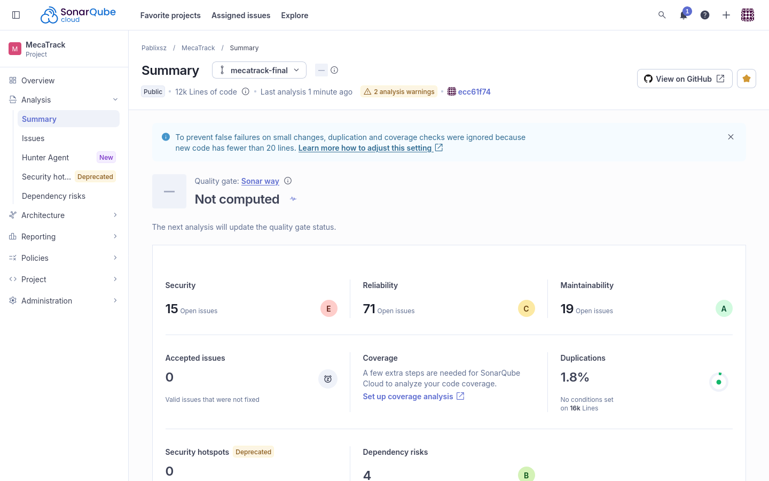
Figura 1. SonarCloud antes de las correcciones: resumen del primer análisis.
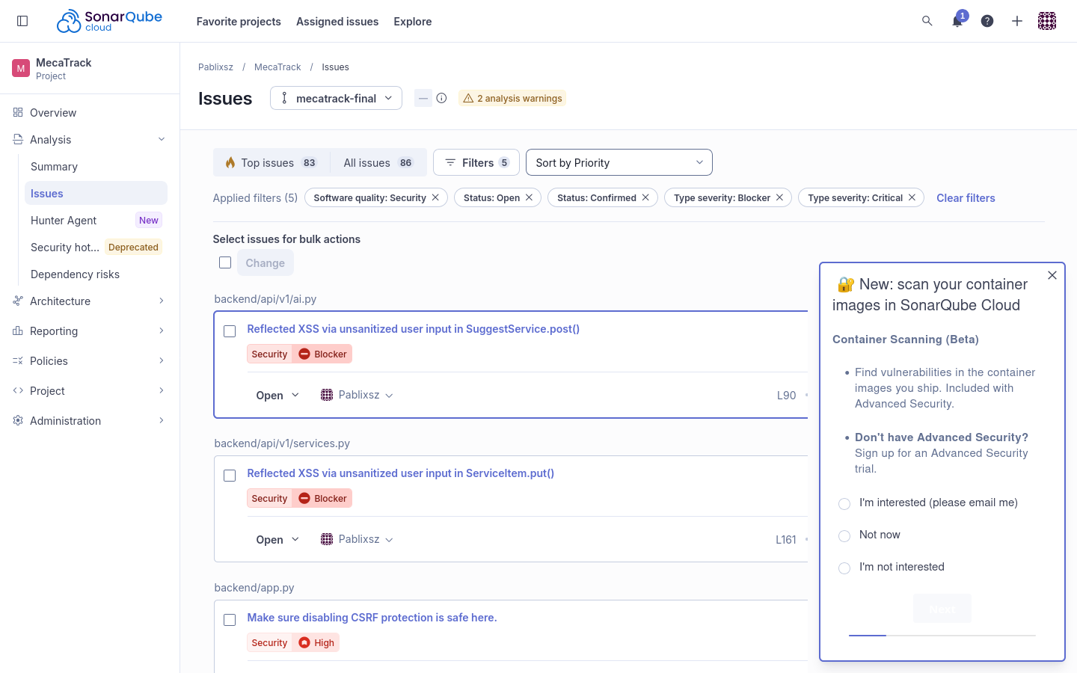
Figura 2. SonarCloud antes de las correcciones: issues de seguridad con severidad alta.
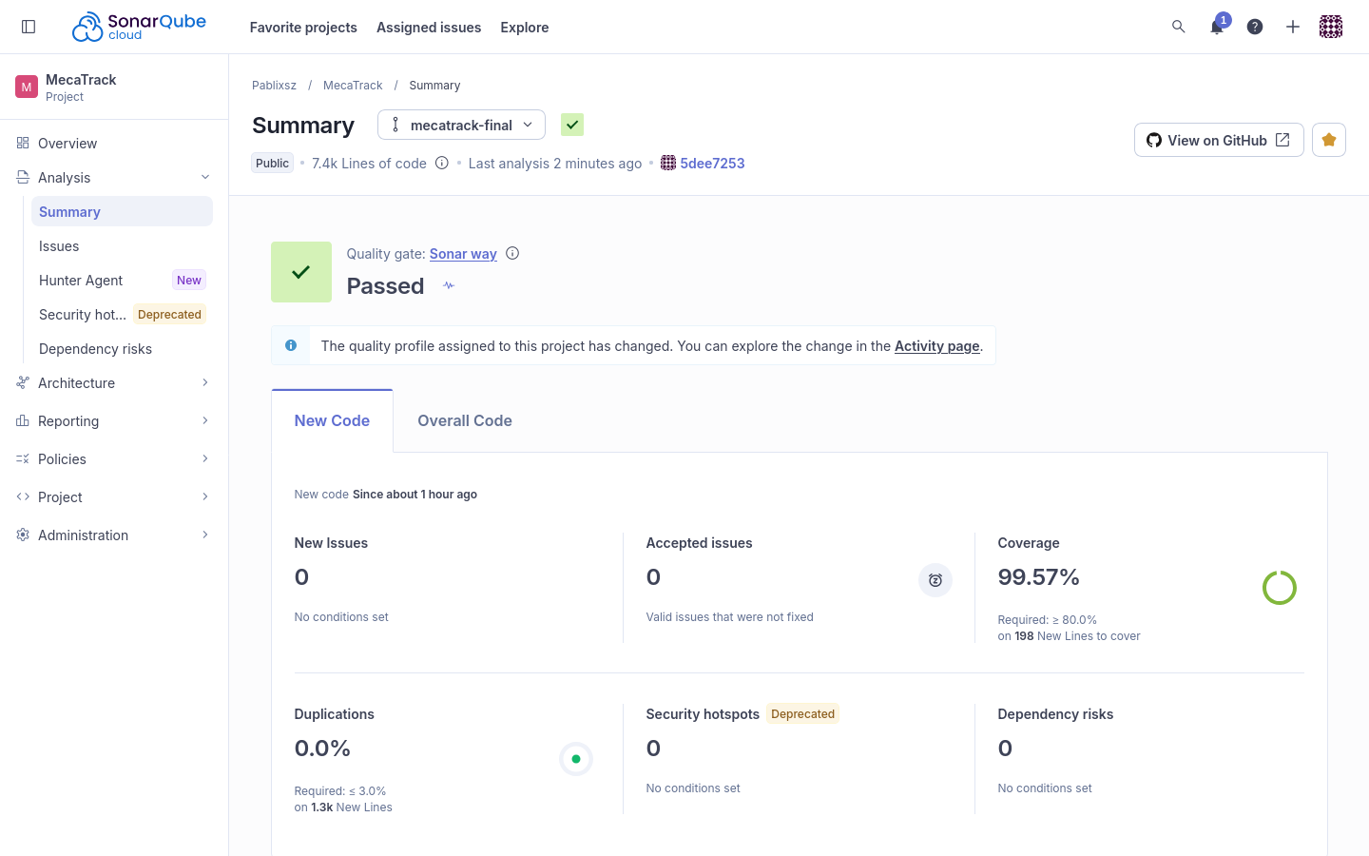
Figura 3. SonarCloud final: Quality Gate aprobado sobre el código nuevo.
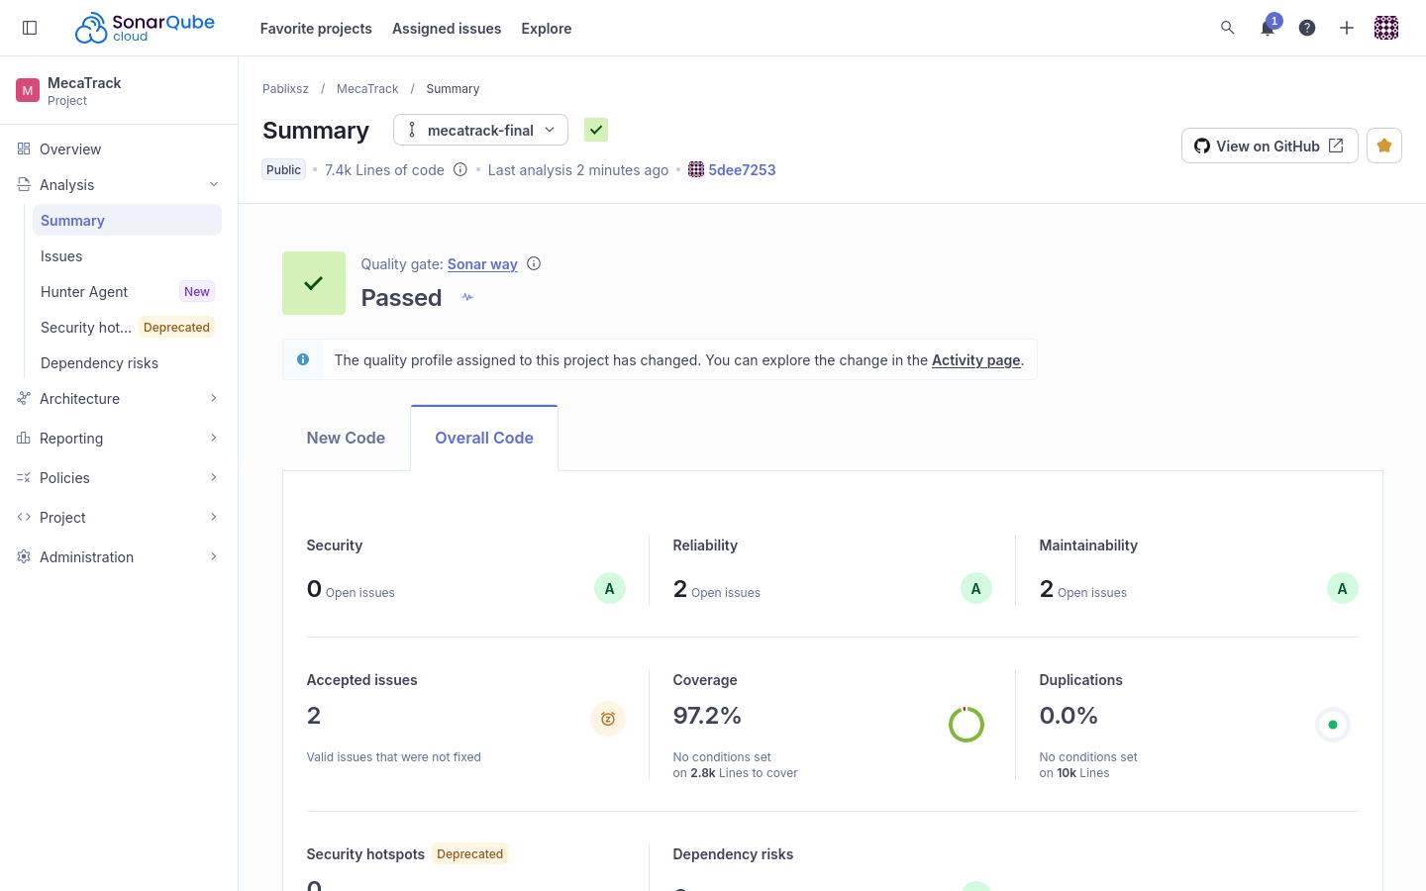
Figura 4. SonarCloud final: Quality Gate aprobado y cobertura global.
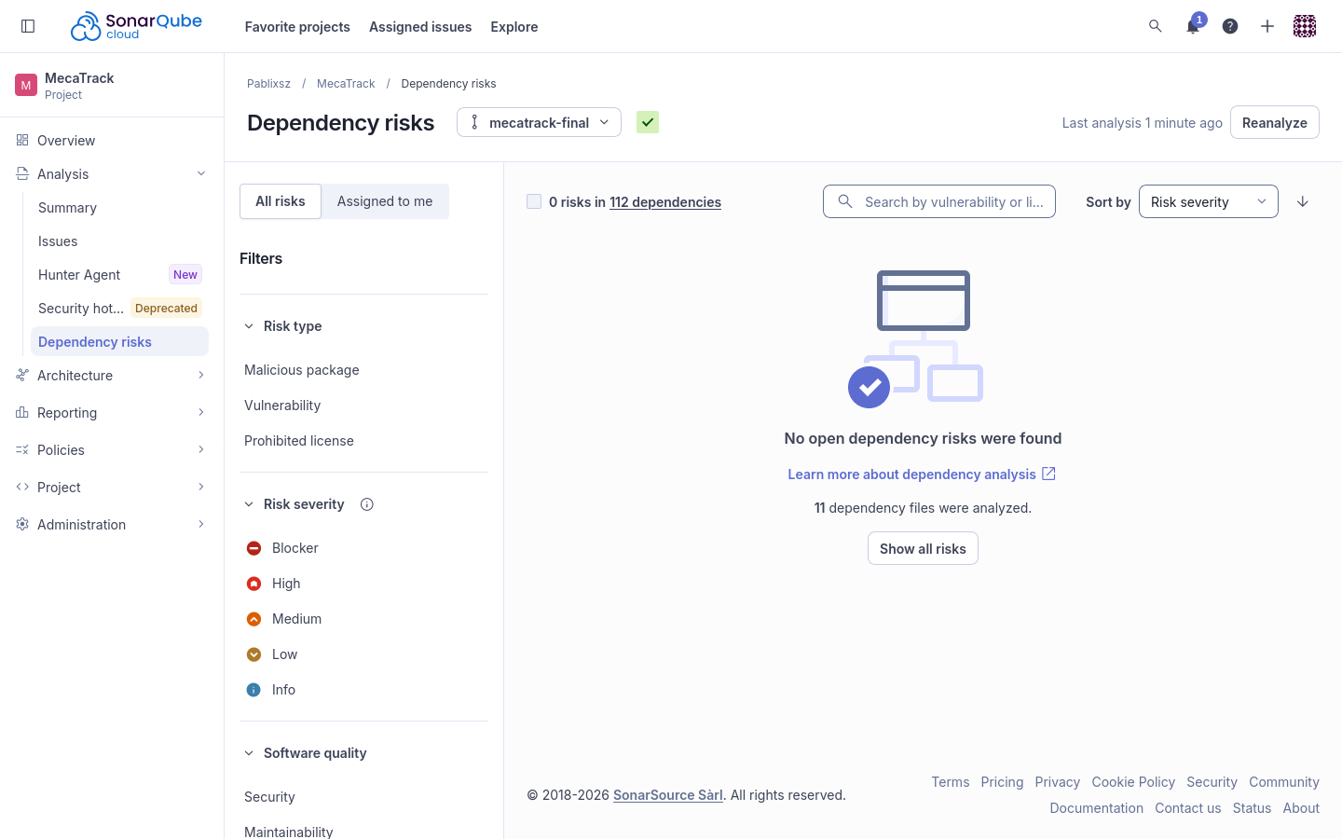
Figura 5. SonarCloud final: 0 riesgos de dependencias tras actualizar 4 paquetes.
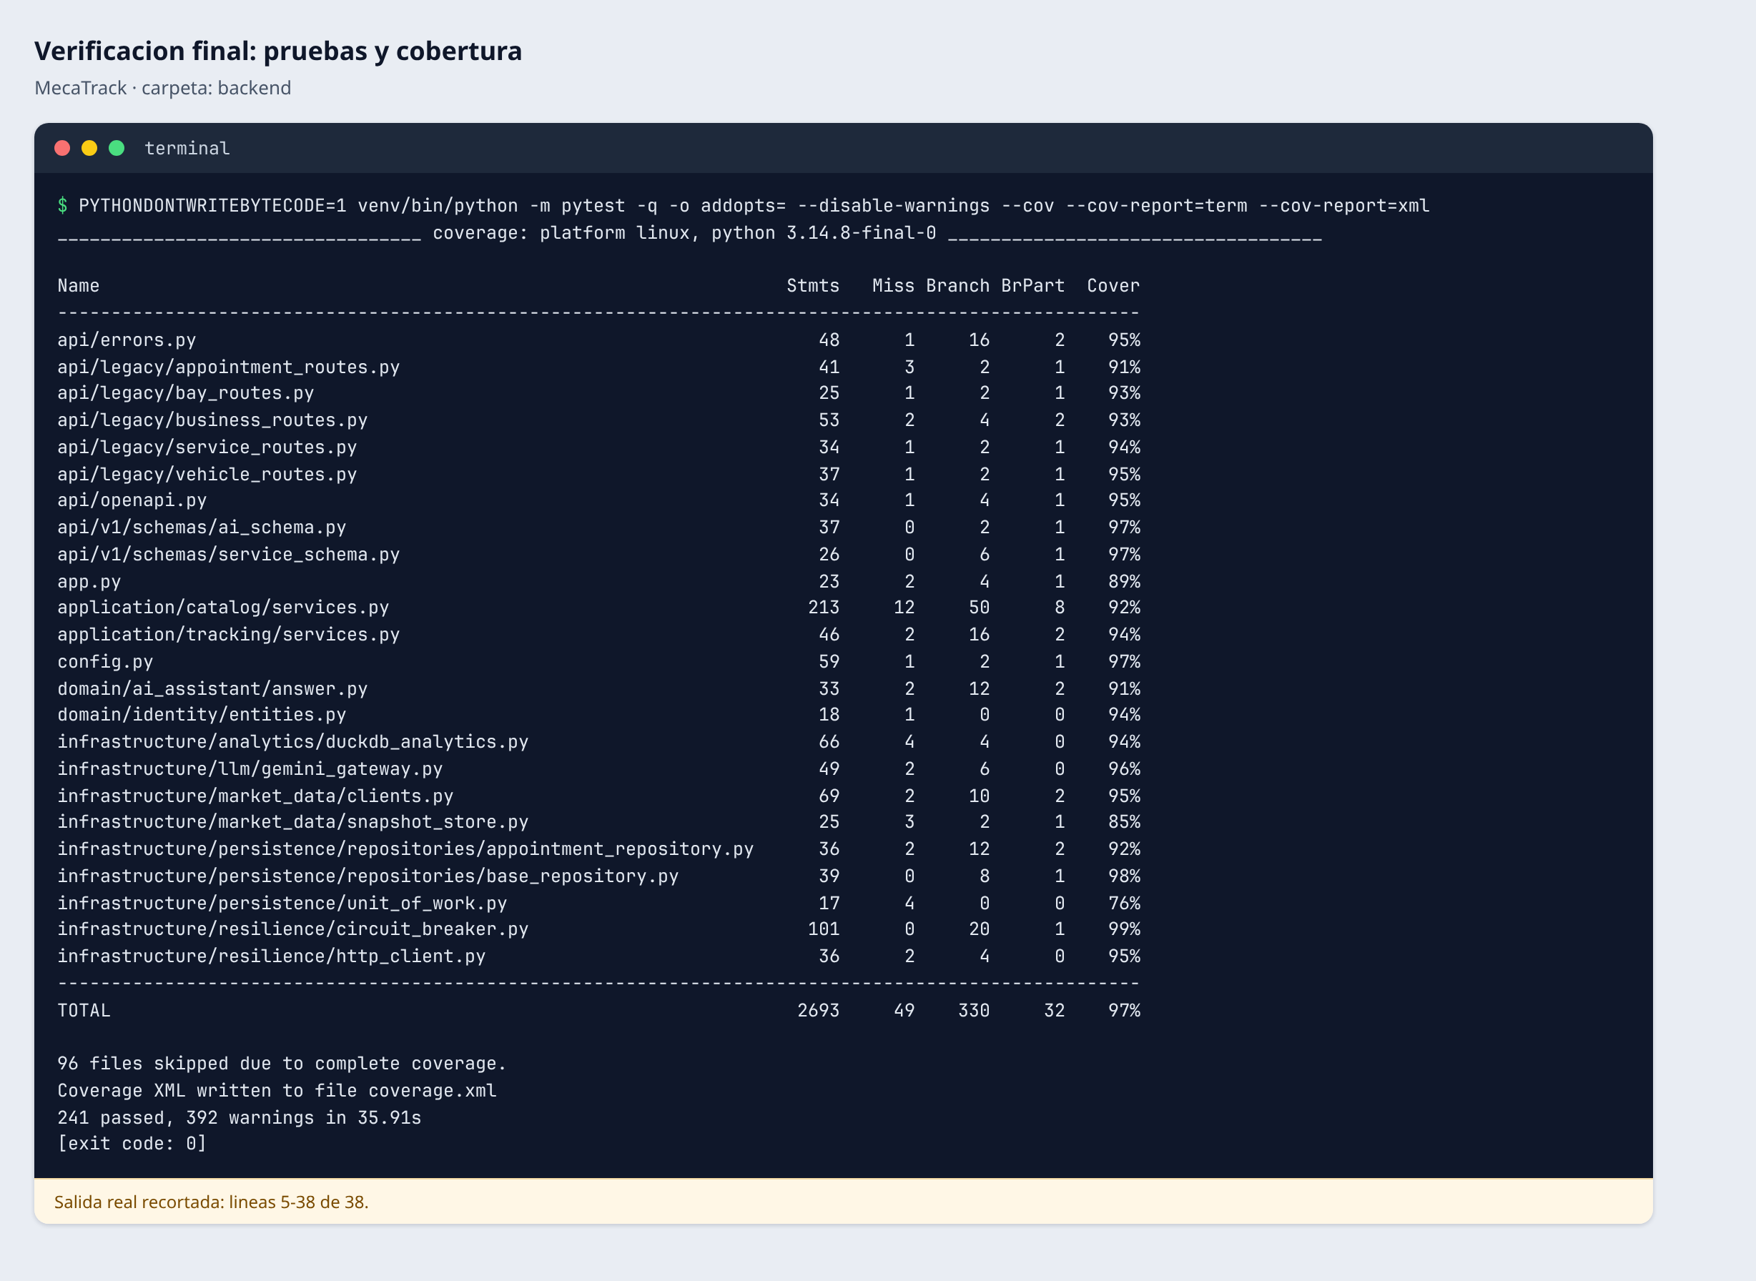
Figura 6. Verificación final: pruebas y cobertura local.

Mutation testing
Se configuró mutmut 3.8.1 sobre la lógica de negocio: disponibilidad de bahía y mecánico, pagos de depósito y saldo, y sus validaciones. El score pasó de 62.6 % a 98.4 % (Figura 7 y Figura 8). El punto de partida ya superaba el 60 % exigido, pero los mutantes sobrevivientes mostraban huecos reales: get no tenía ninguna prueba y varias pruebas no verificaban los argumentos que llegaban a los puertos.
El score mide solo ese alcance, no todo el backend. Quedan 5 sobrevivientes: dos equivalentes (quitan un valor que ya es el predeterminado) y tres que solo alteran textos de mensajes (detalle en docs/lab7/evidence/mutants.md).
Tabla 2
Score de mutación inicial y final
Momento | Killed | Survived | Sin pruebas | Total | Score
Inicial | 184 | 93 | 17 | 294 | 62.6 %
Final | 315 | 5 | 0 | 320 | 98.4 %

Tabla 3
Mutantes por función (sobrevivientes / sin pruebas)
Módulo | Función | Antes | Después | Pruebas añadidas
domain.scheduling.allocation | find_available_bay | 4 / 0 | 0 / 0 | test_bay_lookup_forwards_the_slot_and_the_excluded_appointment
domain.scheduling.allocation | find_available_mechanic | 4 / 0 | 0 / 0 | test_mechanic_lookup_forwards_the_slot_and_the_excluded_appointment
domain.scheduling.allocation | find_bay_and_mechanic | 12 / 0 | 0 / 0 | test_bay_and_mechanic_search_forwards_every_argument
domain.scheduling.rules | ensure_participant | 2 / 0 | 0 / 0 | test_ensure_participant_raises_with_the_given_message
application.scheduling.services | book | 14 / 0 | 4 / 0 | test_book_looks_up_the_requested_vehicle_and_service, test_book_defaults_to_cash_and_pending_payments, test_book_stores_vehicle_service_and_start
application.scheduling.services | _client_for | 5 / 0 | 1 / 0 | test_booking_for_someone_else_explains_why_it_is_denied, test_a_client_may_name_himself_when_booking
application.scheduling.services | list_for | 0 / 1 | 0 / 0 | test_list_for_delegates_with_the_actor
application.scheduling.services | get | 0 / 16 | 0 / 0 | test_get_returns_the_view_for_a_participant, test_get_unknown_appointment_is_not_found, test_get_denies_someone_else
application.scheduling.services | change_status | 10 / 0 | 0 / 0 | test_change_status_saves_the_new_status_and_commits, test_change_status_rejects_unknown_status
application.scheduling.services | cancel | 9 / 0 | 0 / 0 | test_cancel_loads_the_requested_appointment, test_cancel_errors_explain_why
application.scheduling.services | _get | 5 / 0 | 0 / 0 | test_change_status_of_unknown_appointment_is_not_found
application.payments.services | list_for_appointment | 10 / 0 | 0 / 0 | test_list_reads_the_payments_of_the_requested_appointment, test_list_of_unknown_appointment_is_not_found, test_list_denial_explains_why
application.payments.services | pay | 18 / 0 | 0 / 0 | test_pay_loads_the_payment_and_its_appointment, test_pay_errors_explain_why, test_unknown_payment_message

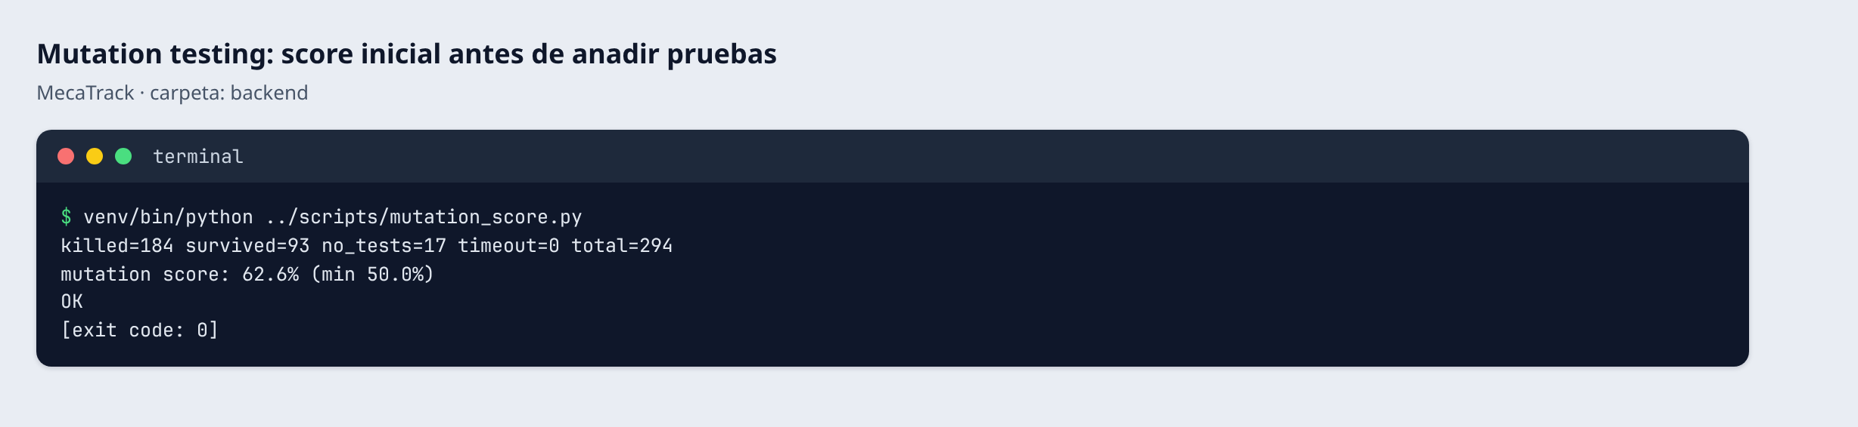
Figura 7. Mutation testing: score inicial.
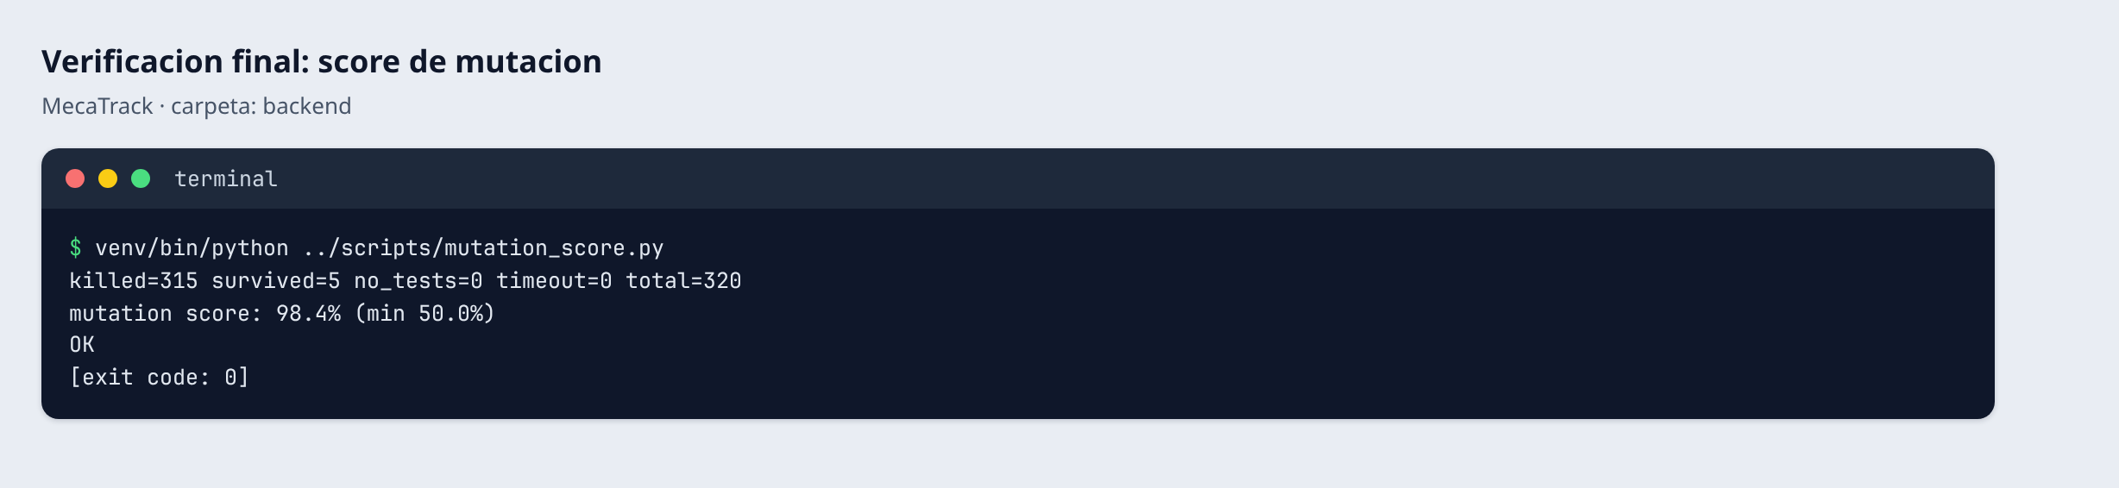
Figura 8. Mutation testing: score final.
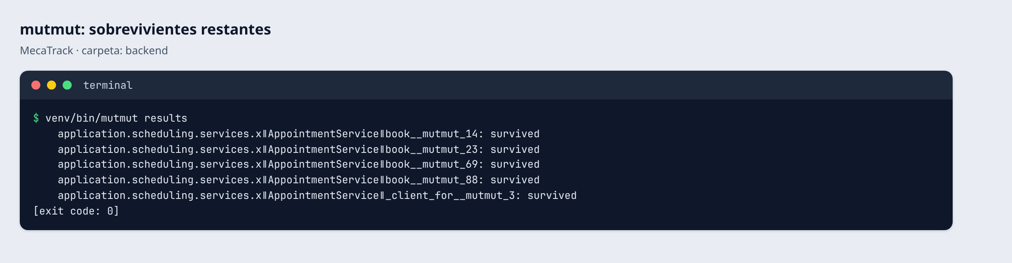
Figura 9. mutmut: sobrevivientes al cierre de la fase de pruebas.

CI/CD con mutation testing
El workflow tiene un job mutation que ejecuta mutmut y scripts/mutation_score.py, que sale con código 1 si el score es menor a 50 %. Para demostrarlo se usó una rama temporal sin las pruebas de los servicios, sin tocar el umbral: el score cayó a 6,5 % y el build falló en ese paso (Figura 10 y Figura 11). La rama se borró después. La Figura 12 muestra el estado normal y la Figura 13 los badges del README. El badge de mutation score es estático: refleja el último valor medido y se actualiza a mano.
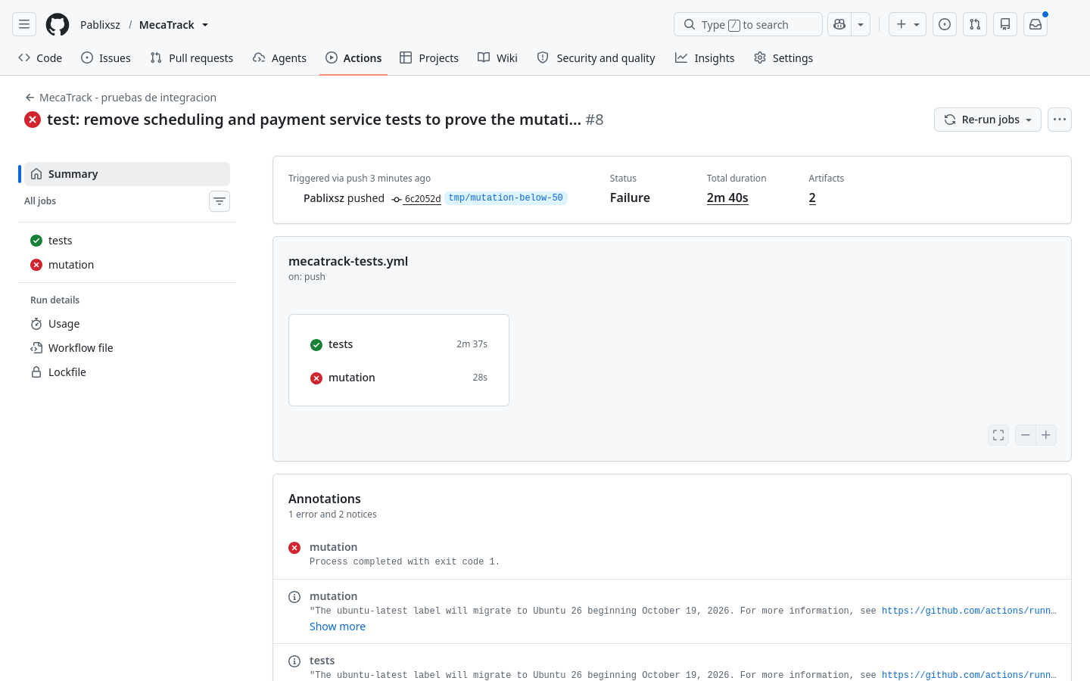
Figura 10. GitHub Actions: el job de mutation testing falla en la rama temporal.
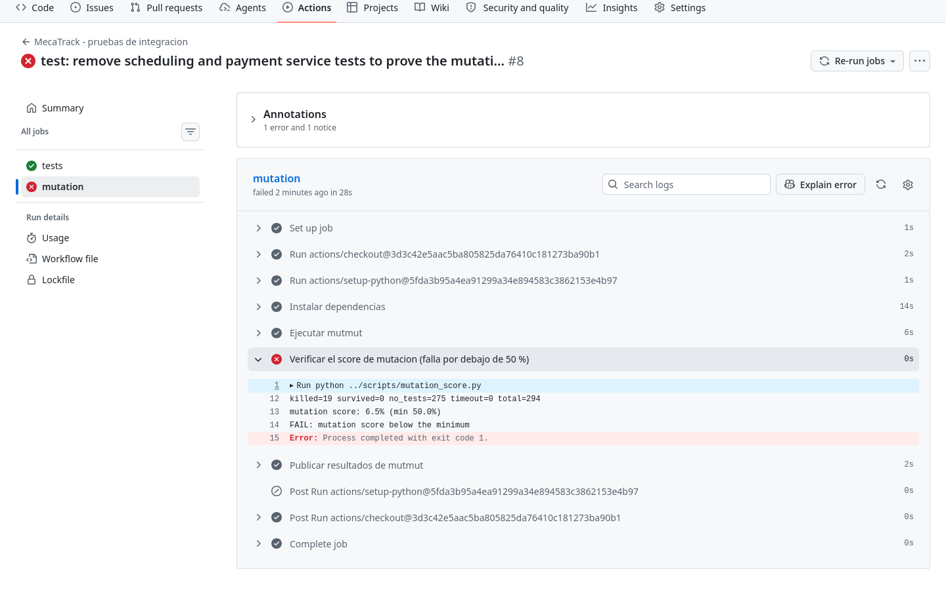
Figura 11. GitHub Actions: el paso del score falla con 6,5 %, por debajo del mínimo de 50 %.
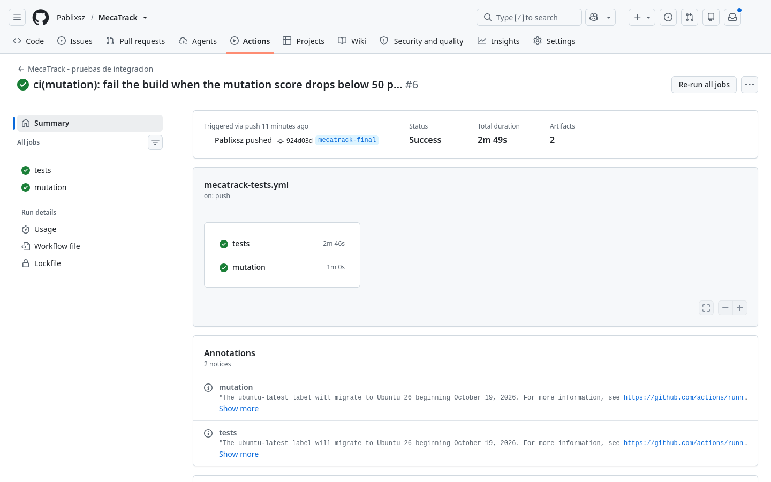
Figura 12. GitHub Actions: pruebas y mutation testing en verde.
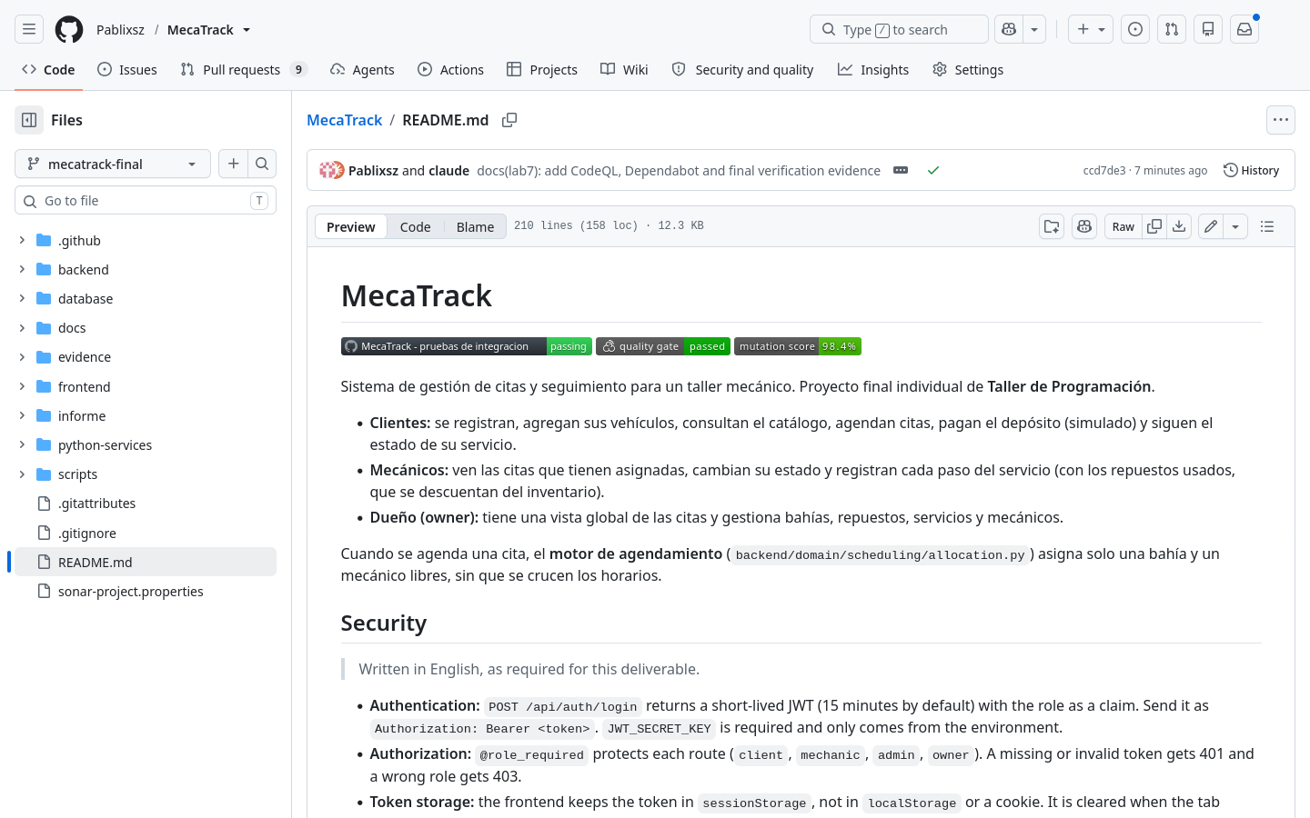
Figura 13. README con los badges de CI, Quality Gate y mutation score.

JWT and RBAC (session 14)
This section is in English, as required for session 14.
Flask-Login session cookies were replaced with Flask-JWT-Extended. POST /api/auth/login returns a 15-minute access token with the role as a claim, and JWT_SECRET_KEY only comes from the environment: the application refuses to start without it. Every route declares its roles through @role_required; a missing or invalid token gets 401 and a wrong role gets 403 (Figures 14 to 22).
Two guarantees that a purely stateless JWT would lose were kept: logout revokes the token, and each request loads the user from the database, so a deactivated account or a changed role loses access immediately. As a limitation, the revocation list lives in the memory of one server process.
The frontend keeps the token in sessionStorage and sends it in the Authorization header (Figura 23). On 401 or 403 it clears the session and returns to the login page (Figura 24 and Figura 25). Compared with an HttpOnly cookie, this removes the CSRF risk because no ambient credential exists, but any script on the page could read the token. That risk is mitigated by escaping rendered data and using short-lived tokens. sessionStorage was preferred over localStorage because it is cleared when the tab closes.
def role_required(*allowed_roles):
"""
Protects a route by role.

Without a valid token -> 401. With a role outside `allowed_roles` -> 403.
Each route declares its own roles, so access is denied unless listed.
"""
def decorator(f):
@wraps(f)
def wrapped(*args, **kwargs):
verify_jwt_in_request()
role = get_jwt().get('role')
if role not in allowed_roles:
return _auth_error(403, 'forbidden', 'Your role is not allowed to perform this action',
'No tienes permiso para realizar esta acción',
{'required_roles': list(allowed_roles), 'your_role': role})
return f(*args, **kwargs)
return wrapped
return decorator
@jwt_auth_bp.route('/login', methods=['POST'])
@limiter.limit(lambda: current_app.config['LOGIN_RATE_LIMIT'])
def login():
data = json_body()
if not data.get('email') or not data.get('password'):
raise ApiError(400, 'bad_request', 'email and password are required')

user = container().auth.authenticate(data['email'], data['password'])
token = create_access_token(identity=str(user.user_id), additional_claims={'role': user.role})
return jsonify({
'access_token': token,
'token_type': 'Bearer',
'expires_in': int(current_app.config['JWT_ACCESS_TOKEN_EXPIRES'].total_seconds()),
'user_id': user.user_id,
'role': user.role,
}), 200
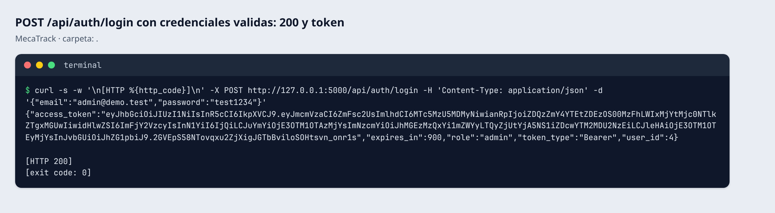
Figura 14. POST /api/auth/login with valid credentials: 200 and a token.
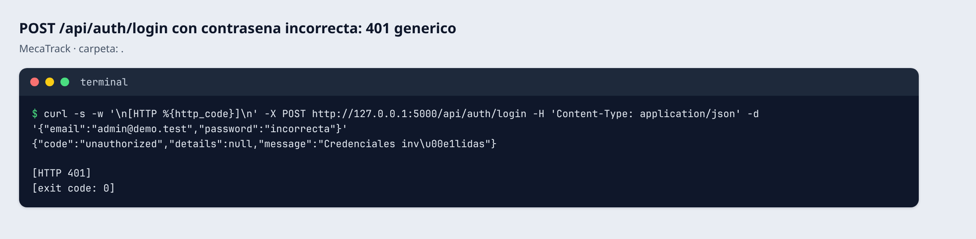
Figura 15. POST /api/auth/login with a wrong password: generic 401.
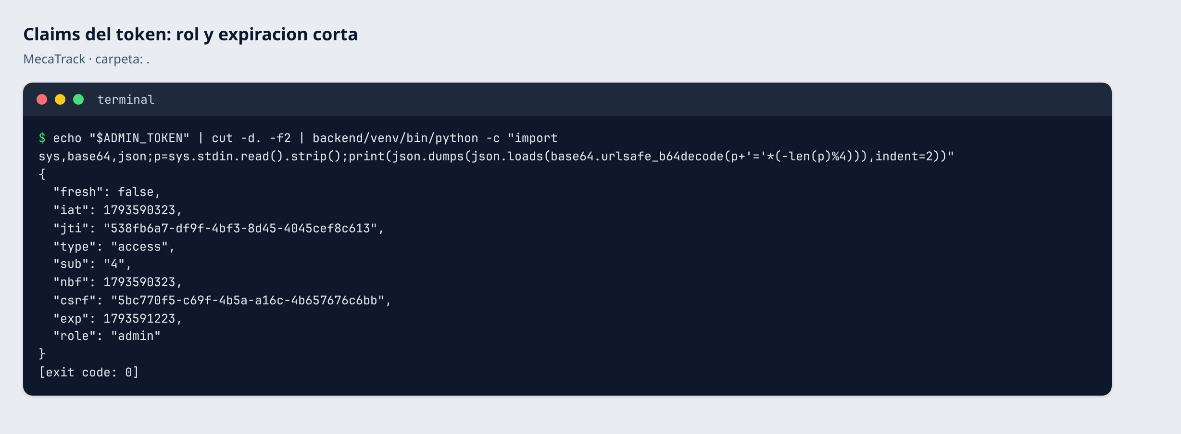
Figura 16. Token claims: role and short expiry.
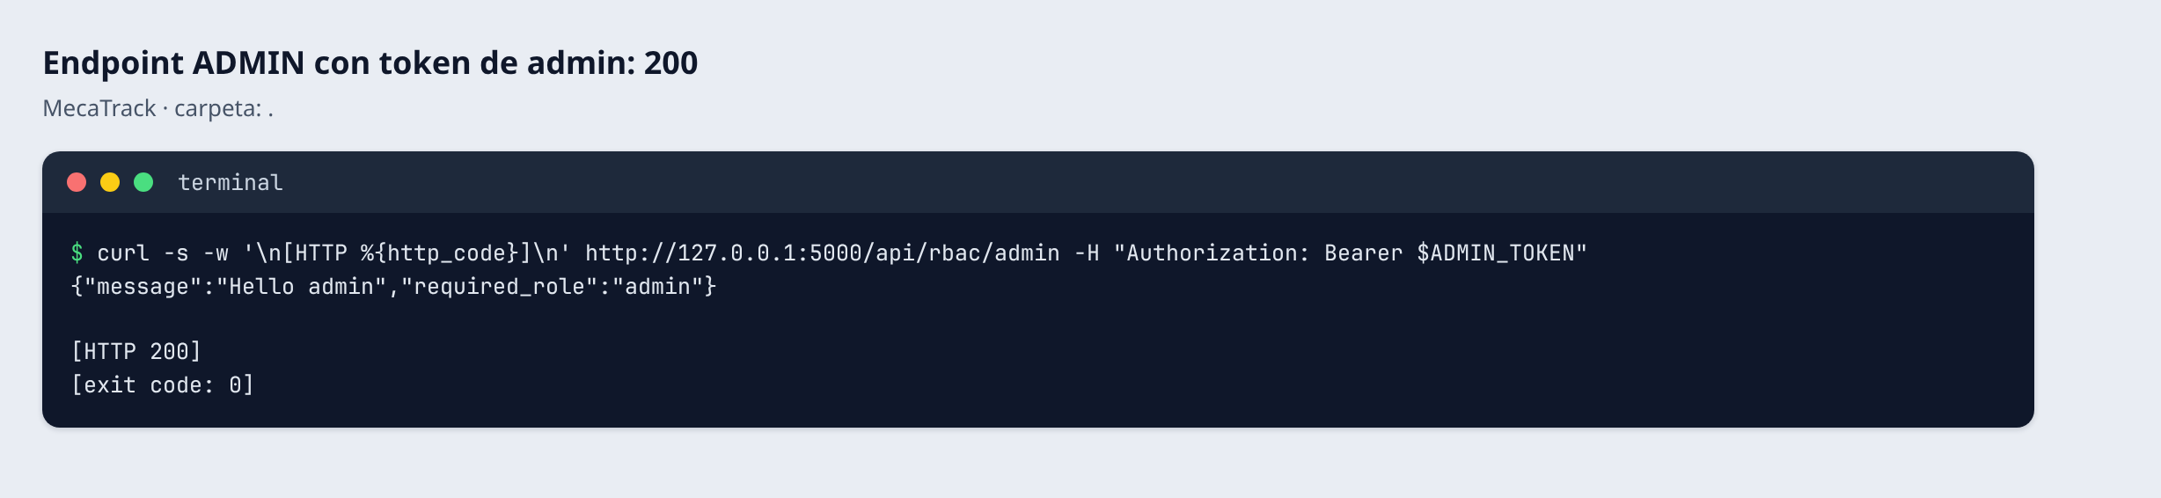
Figura 17. ADMIN endpoint with an admin token: 200.
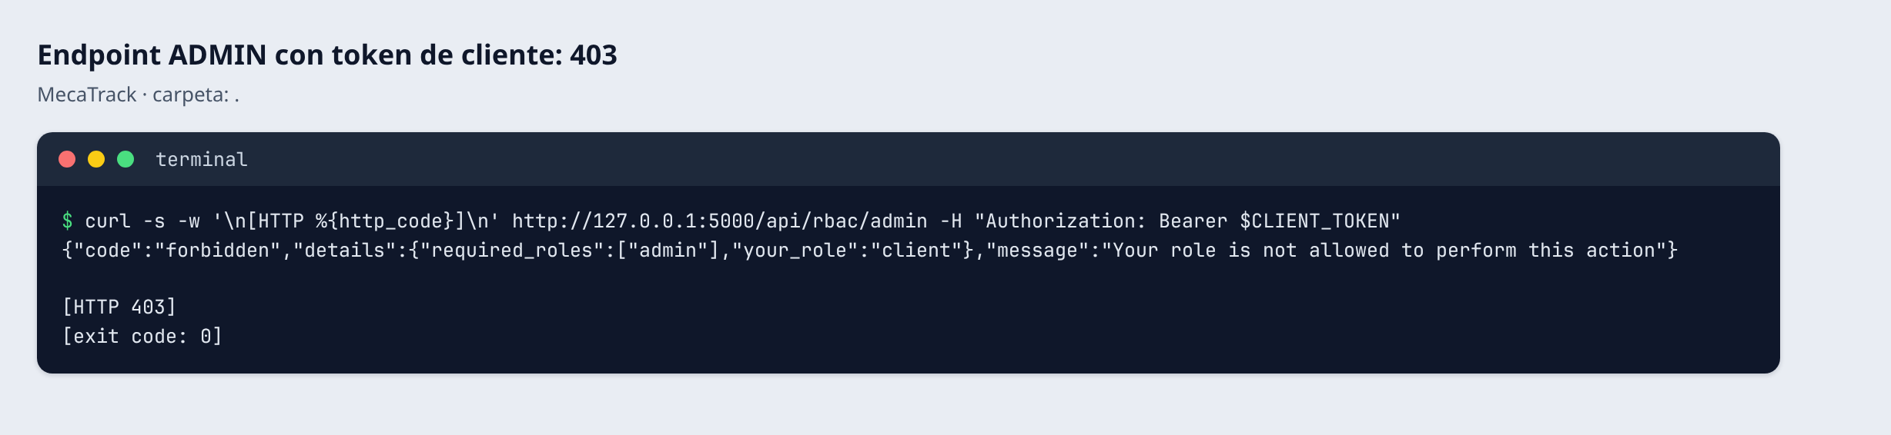
Figura 18. ADMIN endpoint with a client token: 403.
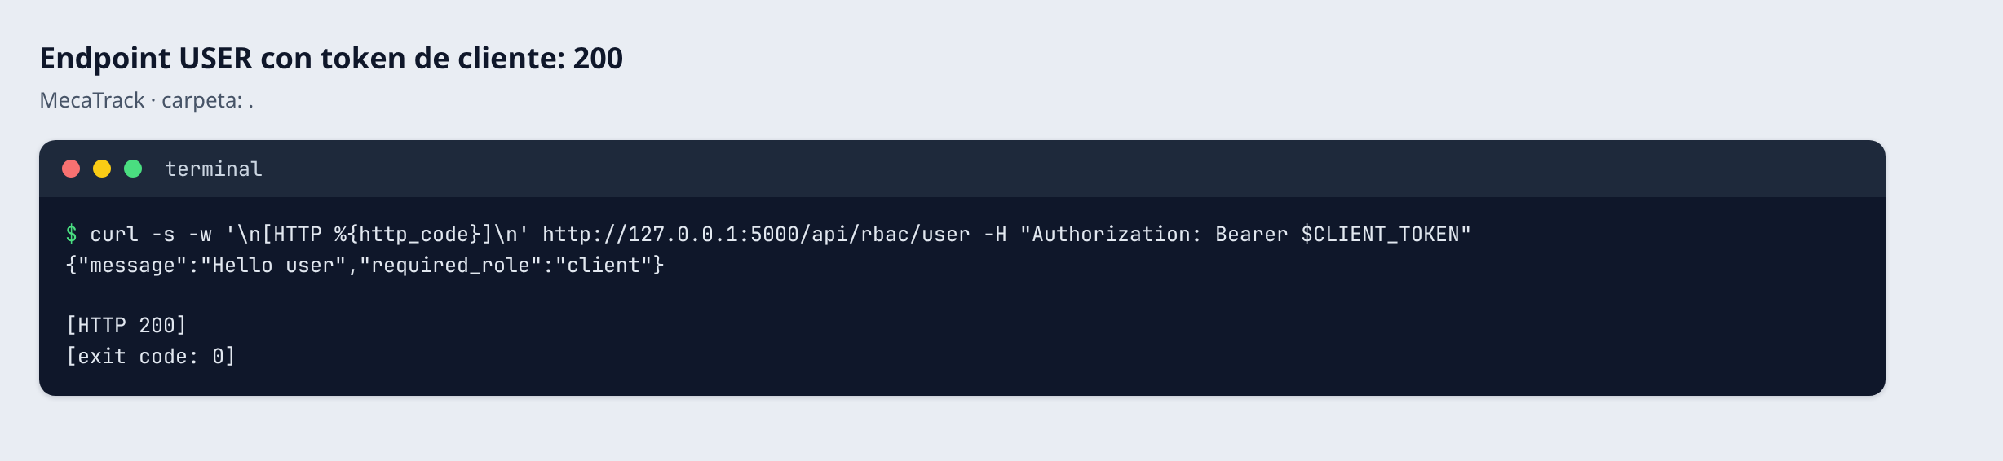
Figura 19. USER endpoint with a client token: 200.
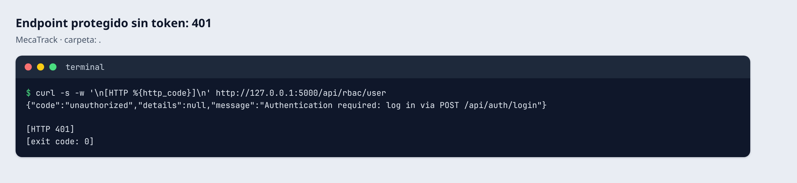
Figura 20. Protected endpoint without a token: 401.
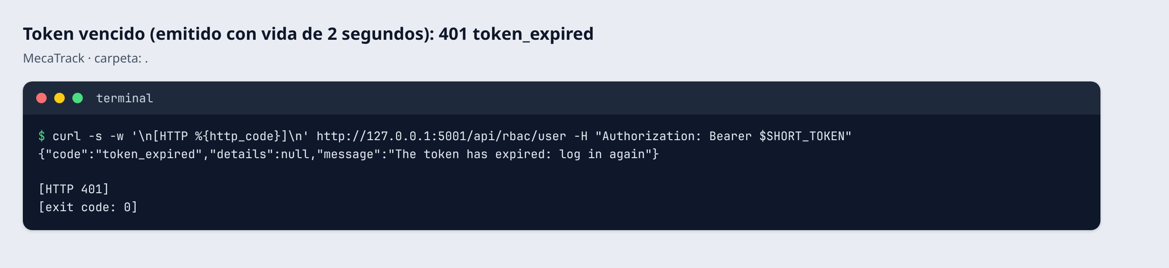
Figura 21. Expired token (issued with a 2-second lifetime): 401 token_expired.
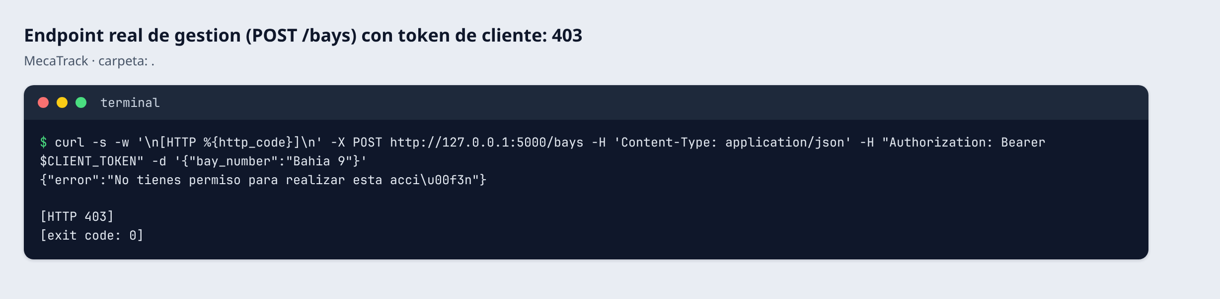
Figura 22. Real management endpoint (POST /bays) with a client token: 403.
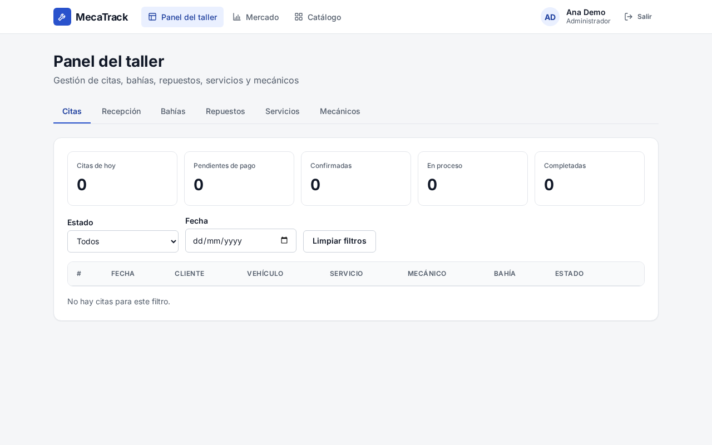
Figura 23. Frontend: admin login; requests carry Authorization: Bearer.
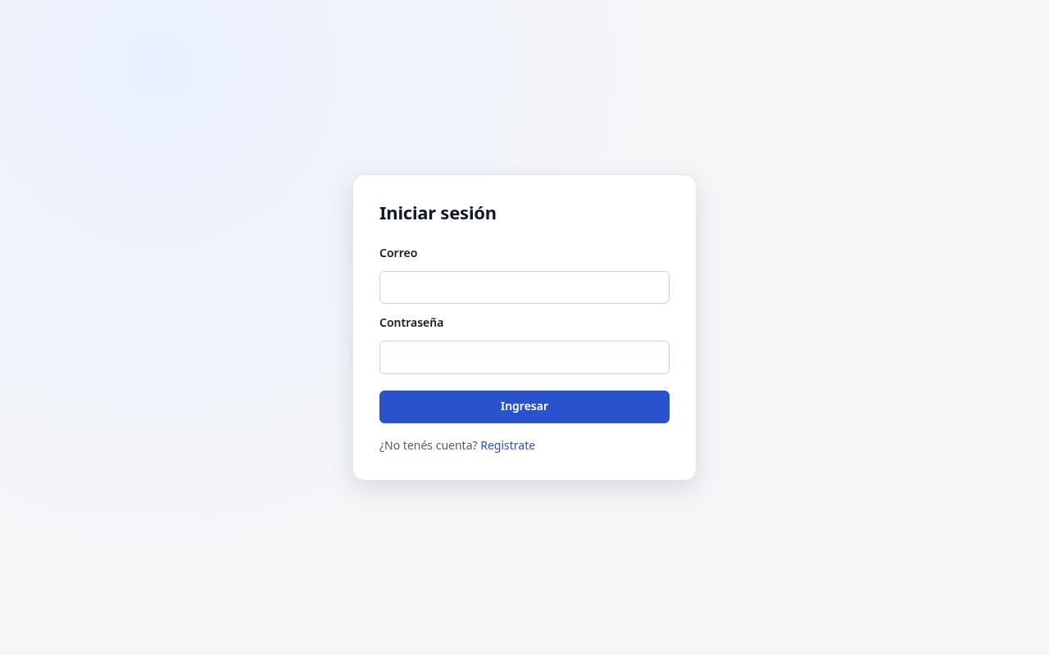
Figura 24. Frontend: an invalid token (401) clears the session and returns to login.
Figura 25. Frontend: a client gets 403 on /bays and returns to login.

OWASP API Security Top 10 2023 (session 14)
Controls and automated tests cover 9 of the 10 risks. API7 (SSRF) is not covered because no endpoint accepts a URL from the user. Some controls already existed and were verified with new tests, such as object-level authorization; others are new, such as rate limiting, security headers and the active appointment limit. File and line references are generated from the current code. Figures 26 to 28 show the tests and real responses.
Tabla 4
OWASP API Security Top 10 2023: implemented controls
Risk | Control implemented | File/line | Test/evidence
API1:2023 Broken Object Level Authorization | Every vehicle, appointment and payment lookup checks that the caller owns or participates in the object. | backend/domain/scheduling/rules.py:24  backend/application/catalog/services.py:301  backend/application/payments/services.py:38 | backend/tests/integration/test_owasp_controls.py: test_api1_*
API2:2023 Broken Authentication | Short-lived signed JWT with revocation on logout, rate-limited login, one generic message for wrong email or password, equal hashing cost for unknown accounts, and a minimum password length. | backend/config.py:25  backend/api/jwt_routes.py:17  backend/application/identity/services.py:43  backend/api/auth.py:25 | backend/tests/integration/test_owasp_controls.py: test_api2_*; backend/tests/integration/test_jwt_auth.py; backend/tests/unit/test_auth_service.py; Figures 06b and 07e
API3:2023 Broken Object Property Level Authorization | Responses are built from explicit field lists, so password_hash is never returned. Registration fixes the role to client, and updates only accept whitelisted fields. | backend/api/legacy/auth_routes.py:20  backend/api/legacy/vehicle_routes.py:53  backend/application/catalog/services.py:289 | backend/tests/integration/test_owasp_controls.py: test_api3_*
API4:2023 Unrestricted Resource Consumption | Global and login rate limits, a 1 MB request body limit and capped pagination. The AI endpoint also has a per-user hourly quota. Limitation: pagination cuts the response, not the database query. | backend/config.py:28  backend/config.py:29  backend/api/legacy/__init__.py:10  backend/application/ai_assistant/services.py:37 | backend/tests/integration/test_owasp_controls.py: test_api4_*; Figure 09c
API5:2023 Broken Function Level Authorization | Each route declares its allowed roles with @role_required; missing token gives 401 and a wrong role gives 403. Management endpoints only accept owner and admin. | backend/api/auth.py:94  backend/api/legacy/bay_routes.py:17  backend/api/v1/services.py:25 | backend/tests/integration/test_jwt_auth.py: test_admin_endpoint_accepts_only_admin, test_management_endpoints_reject_client_and_mechanic; Figures 07b and 07f
API6:2023 Unrestricted Access to Sensitive Business Flows | A client can hold at most 5 active appointments, and an appointment can only be confirmed after its deposit is paid. | backend/domain/scheduling/rules.py:8  backend/application/scheduling/services.py:49  backend/application/scheduling/services.py:104 | backend/tests/integration/test_owasp_controls.py: test_api6_*; backend/tests/unit/test_appointment_service.py
API8:2023 Security Misconfiguration | Debug is off by default, CORS is an explicit allowlist without credentials, secrets come from the environment, security headers are set on every response and unexpected errors never expose a stack trace. | backend/app.py:43  backend/app.py:24  backend/app.py:21  backend/api/__init__.py:71  backend/api/__init__.py:35 | backend/tests/integration/test_owasp_controls.py: test_api8_*; backend/tests/integration/test_jwt_auth.py: test_app_refuses_to_start_without_a_signing_key; Figure 09d
API9:2023 Improper Inventory Management | All /api/ routes must appear in the versioned OpenAPI document, and CI fails if docs/openapi.json is out of date. | backend/api/openapi.py:48  .github/workflows/mecatrack-tests.yml:84 | backend/tests/integration/test_owasp_controls.py: test_api9_every_api_route_is_documented
API10:2023 Unsafe Consumption of APIs | External API calls use timeouts, retries and a circuit breaker. LLM answers are parsed strictly, and service ids that were not in the supplied context are discarded. | backend/infrastructure/resilience/http_client.py:26  backend/infrastructure/resilience/circuit_breaker.py:46  backend/domain/ai_assistant/answer.py:12 | backend/tests/unit/test_circuit_breaker.py; backend/tests/unit/test_resilient_http_client.py; backend/tests/integration/test_api_v1_ai.py

Known limitations. The token blocklist and rate-limit counters live in one process and reset on restart. The login limit is per IP address, so it does not stop a distributed attack on one account. Pagination cuts the response, not the database query.
def security_headers(response):
# The API only serves JSON: browsers must not sniff it into executable HTML.
response.headers['X-Content-Type-Options'] = 'nosniff'
response.headers['X-Frame-Options'] = 'DENY'
response.headers['Referrer-Policy'] = 'no-referrer'
# Swagger UI needs its CDN scripts; everything else is JSON and loads nothing.
if request.path != '/docs':
response.headers['Content-Security-Policy'] = "default-src 'none'; frame-ancestors 'none'"
if request.is_secure:
response.headers['Strict-Transport-Security'] = 'max-age=31536000; includeSubDomains'
return response
def _deposit_is_paid(self, appointment_id):
"""Security (OWASP API6): staff cannot skip the deposit flow by editing the status."""
return any(p.is_deposit and p.is_completed for p in self._payments.list_by_appointment(appointment_id))
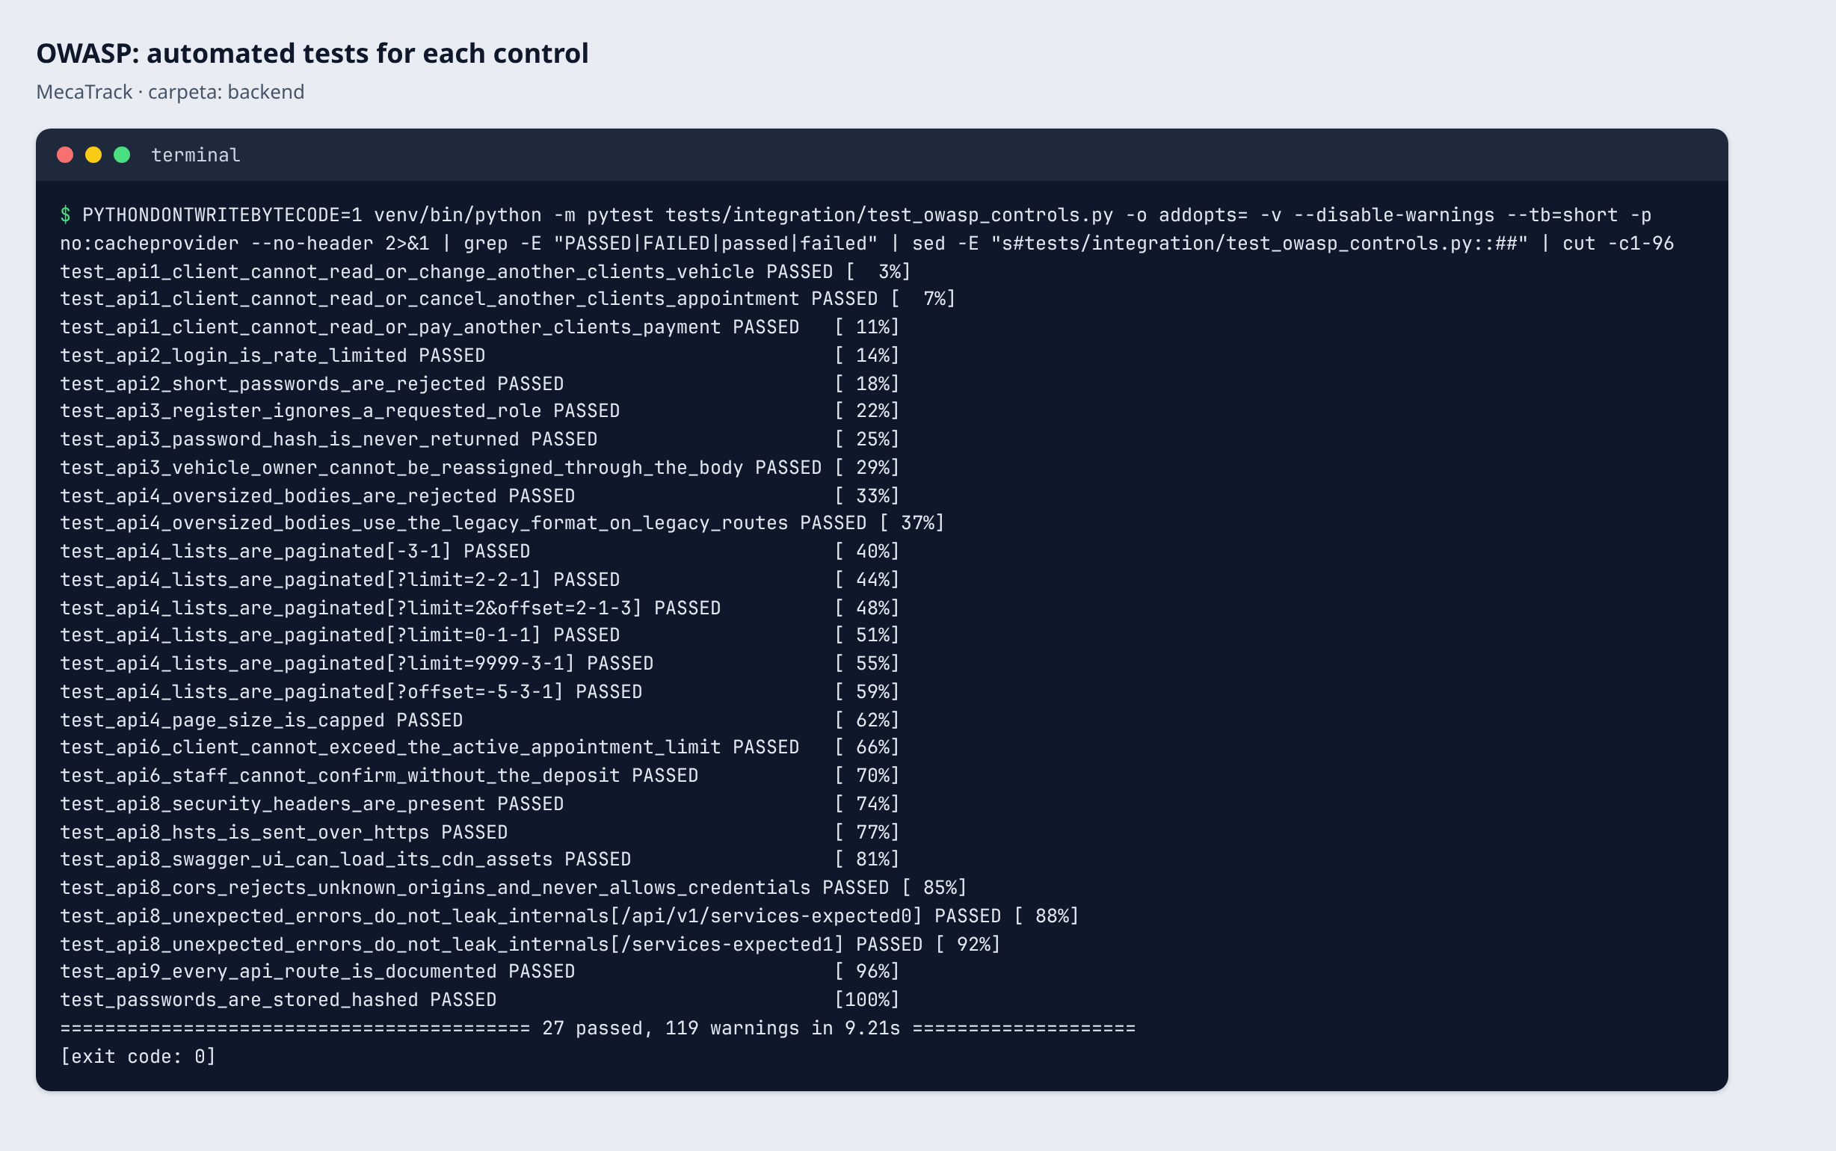
Figura 26. OWASP: automated tests for each control.
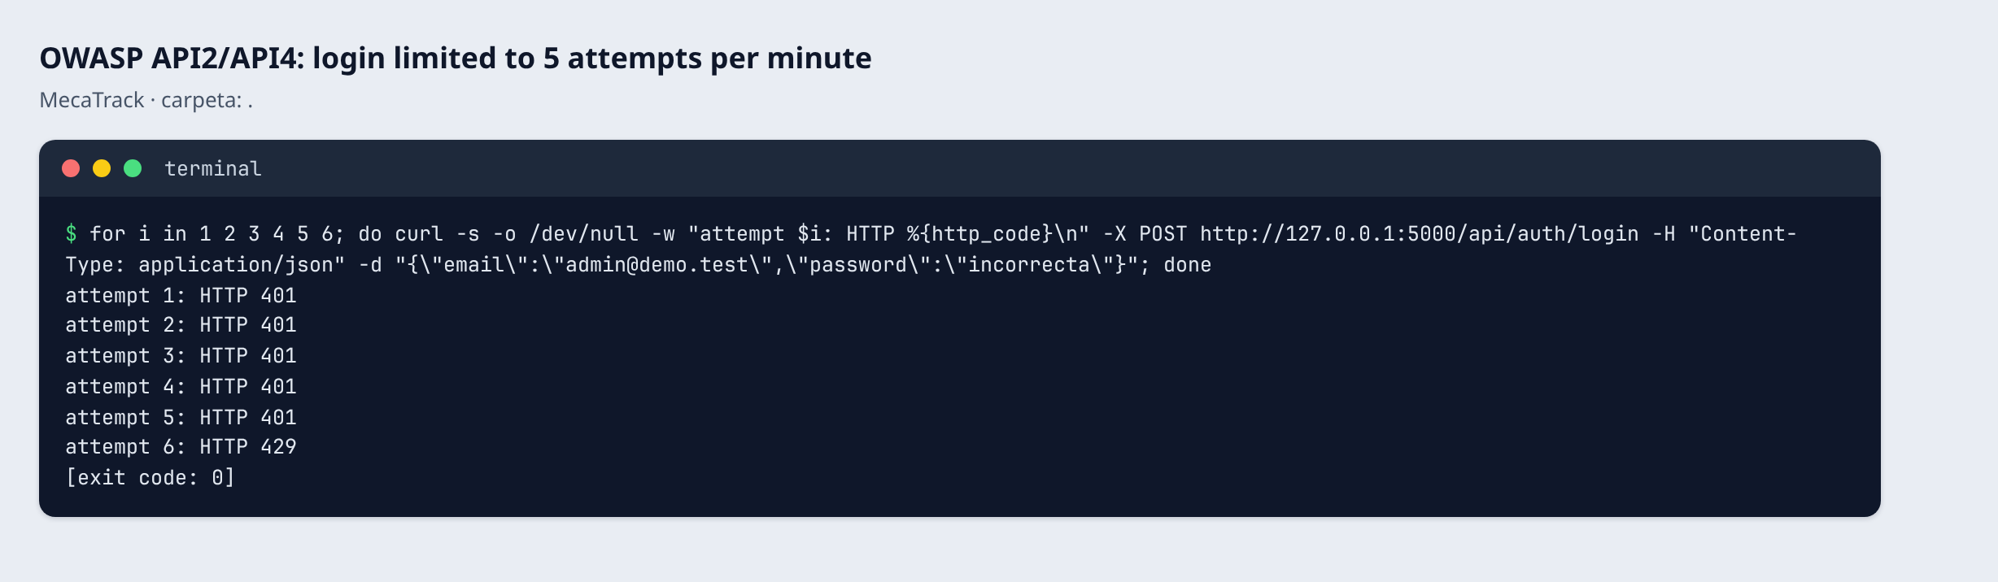
Figura 27. OWASP API2/API4: the sixth login attempt in a minute gets 429.
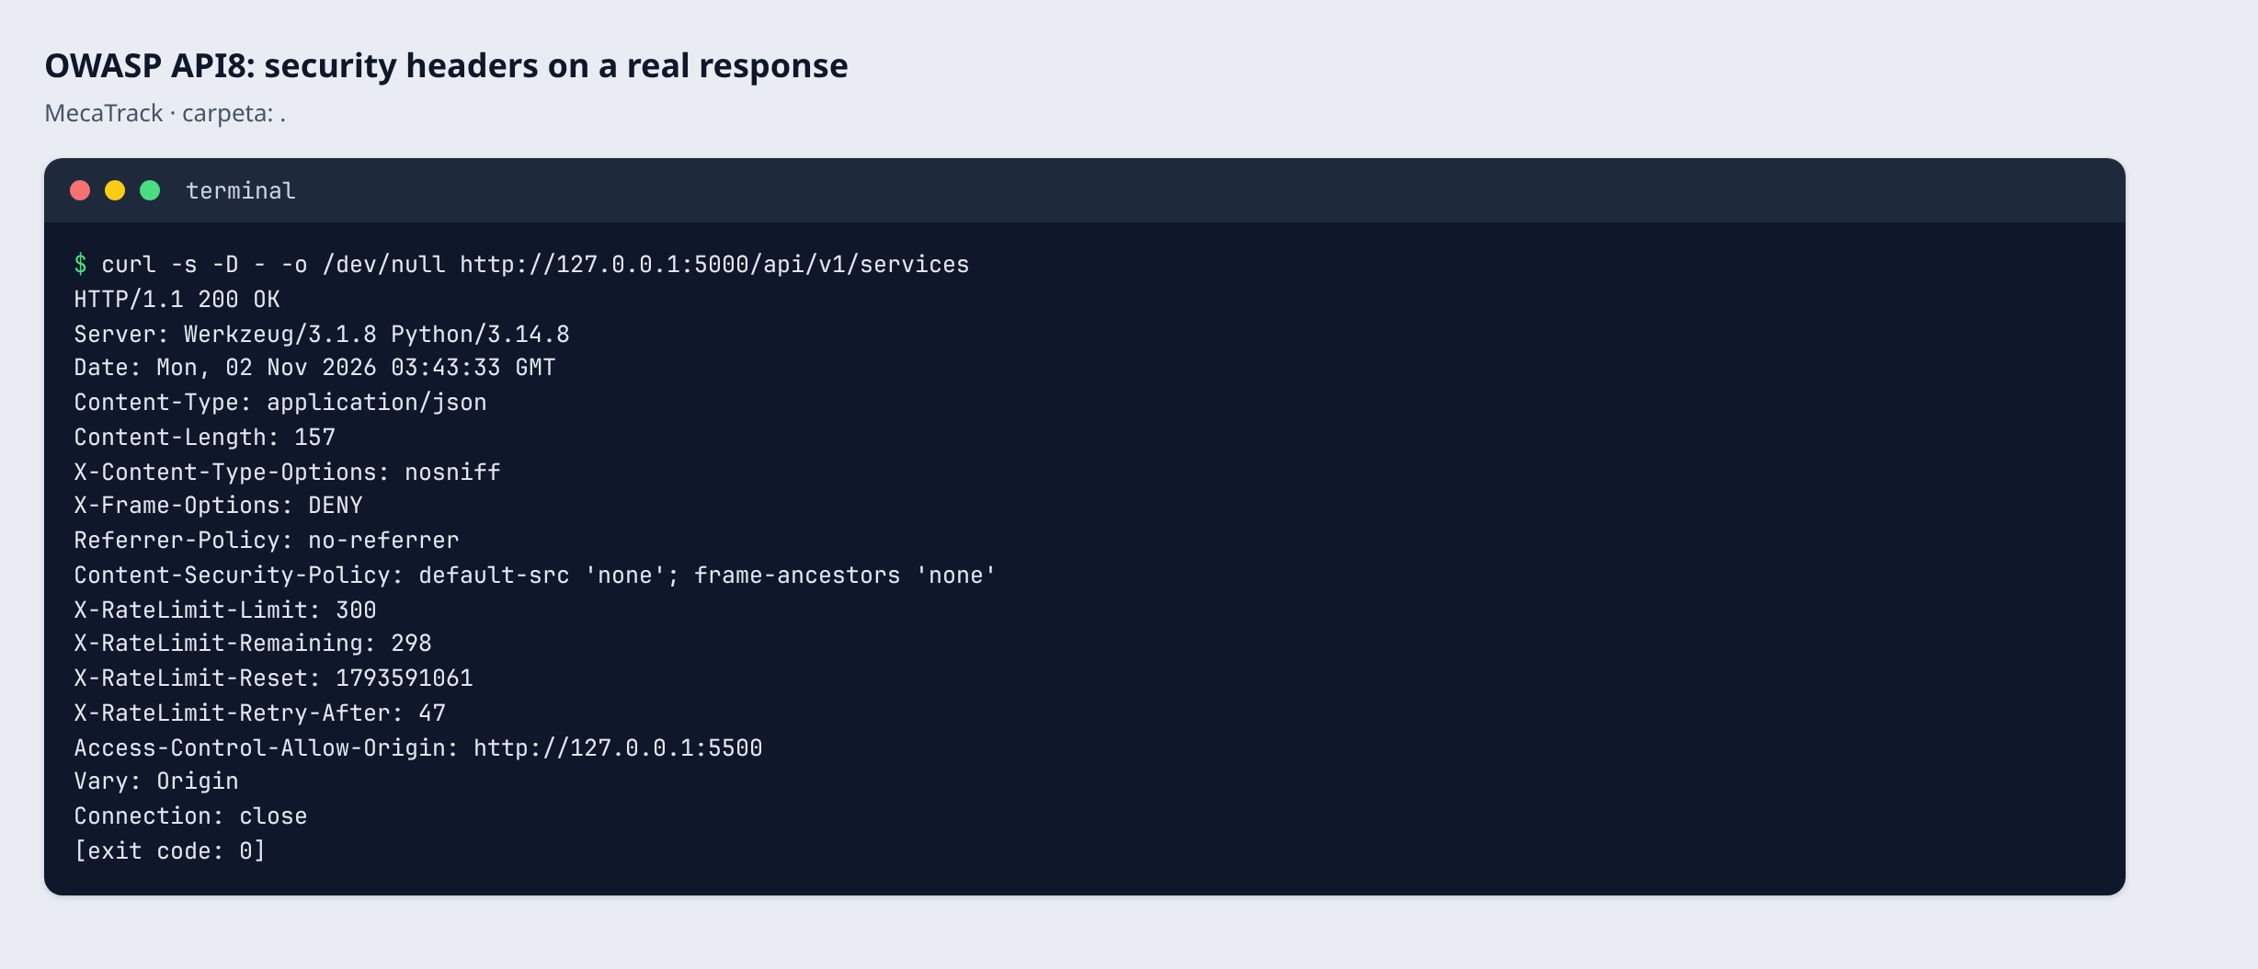
Figura 28. OWASP API8: security headers on a real response.

CodeQL and Dependabot (session 14)
CodeQL runs on every push for Python and JavaScript and reports 0 alerts (Figura 29). Because zero alerts could also mean that nothing was analyzed, the tool status page was checked: 120 Python, 11 JavaScript and 7 HTML files were scanned (Figura 30). A manual review of the 49 innerHTML uses found no real XSS: user text goes through esc(), and the rest are numeric ids or constants. debug=True was removed, and the only SQL built with an f-string inserts a constant query.
Dependency graph, Dependabot alerts and security updates were enabled in the repository settings (Figura 32). Dependabot opened 9 real pull requests without pinning any dependency to an old version on purpose (Figura 34). Three of them closed by themselves when the same packages were updated to fix CVEs, and 6 remain open (Figura 33). They were not merged because they need review; for example, duckdb 2.0.0 is a major version.
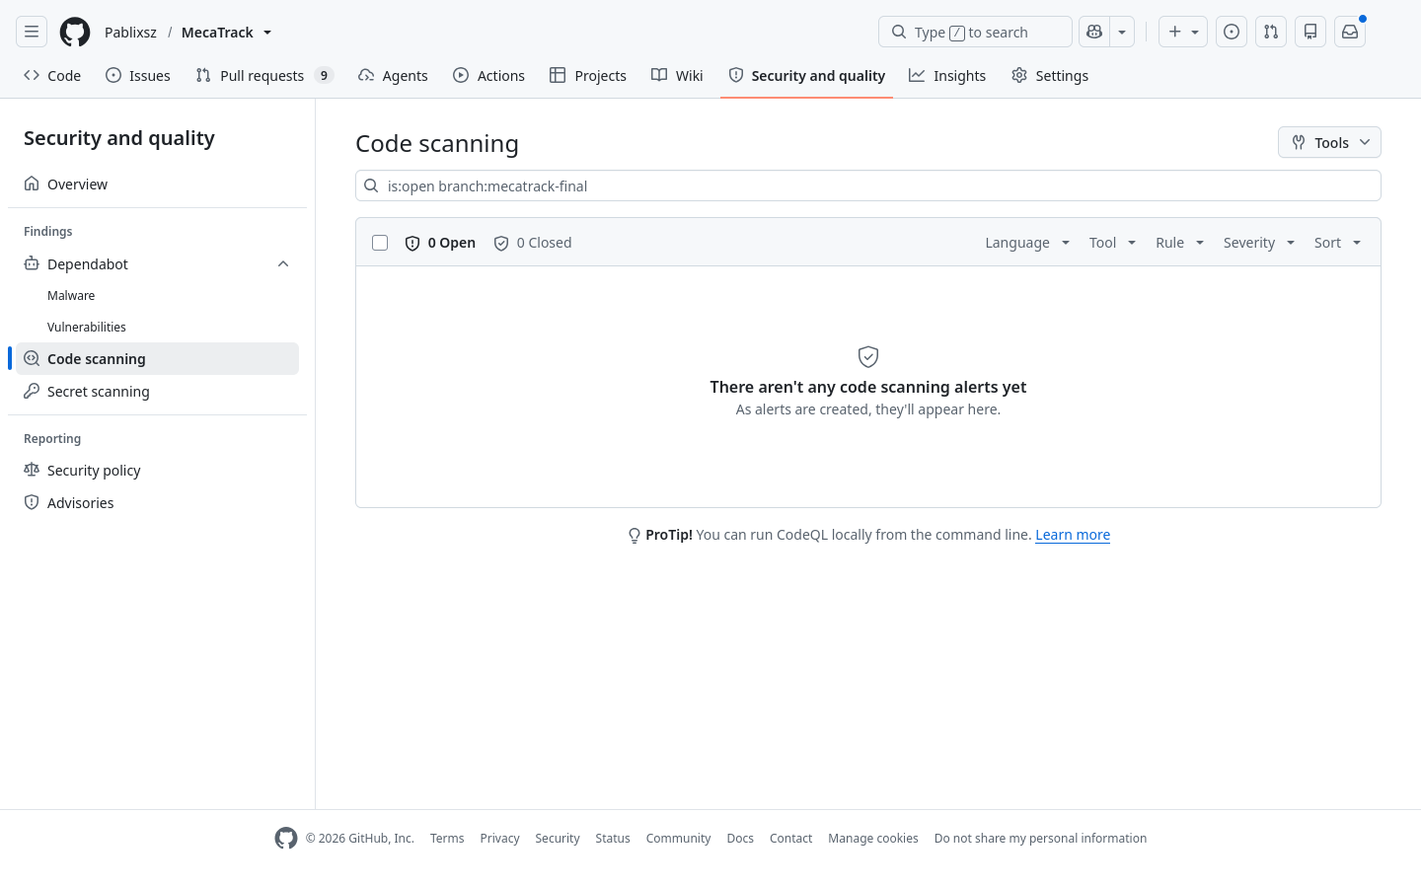
Figura 29. Security > Code scanning: 0 open CodeQL alerts.
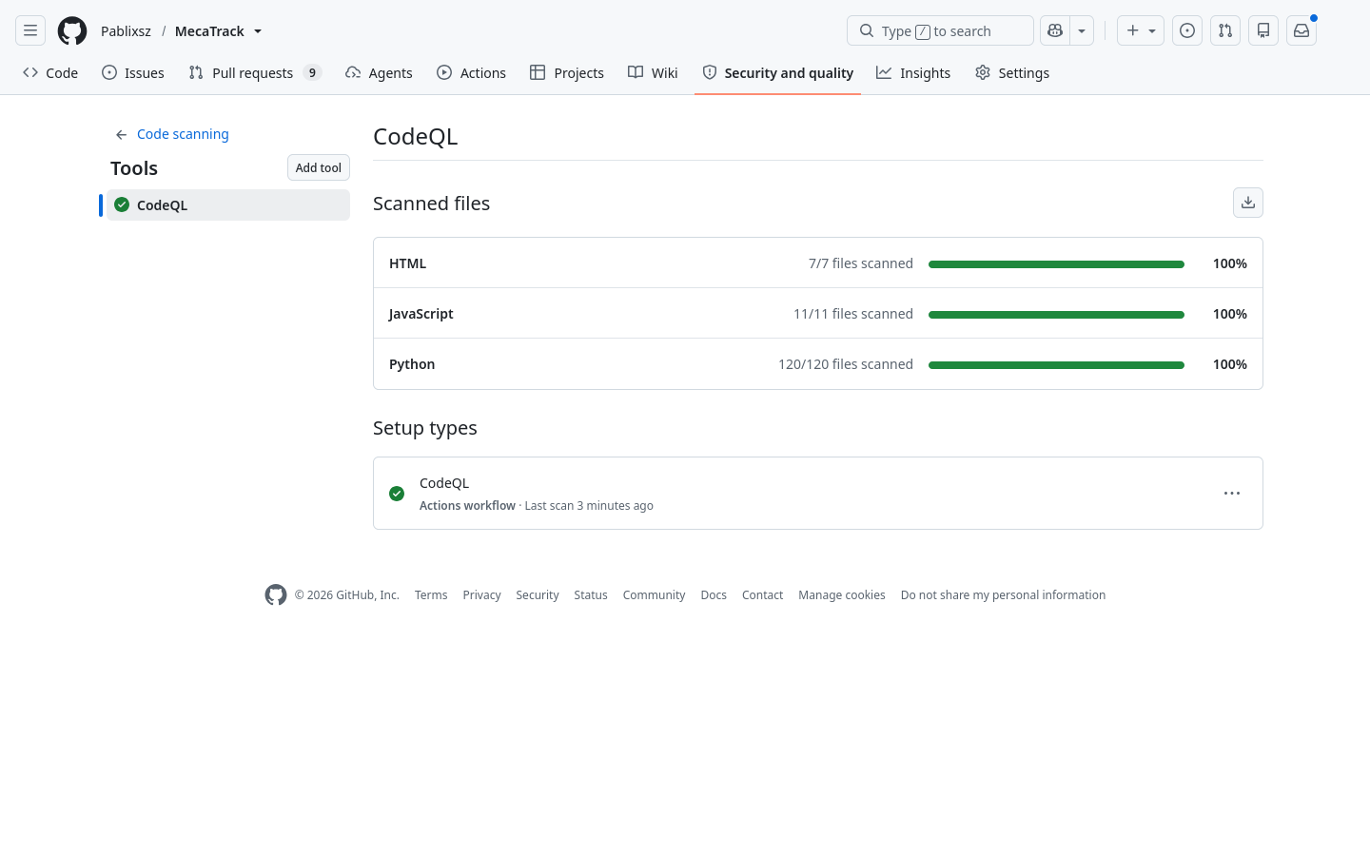
Figura 30. CodeQL: files scanned per language.
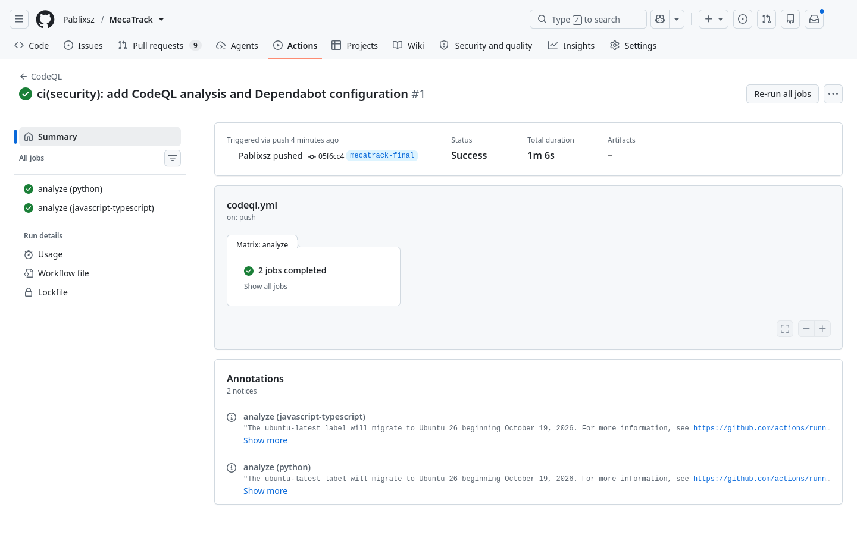
Figura 31. GitHub Actions: CodeQL analysis for Python and JavaScript.
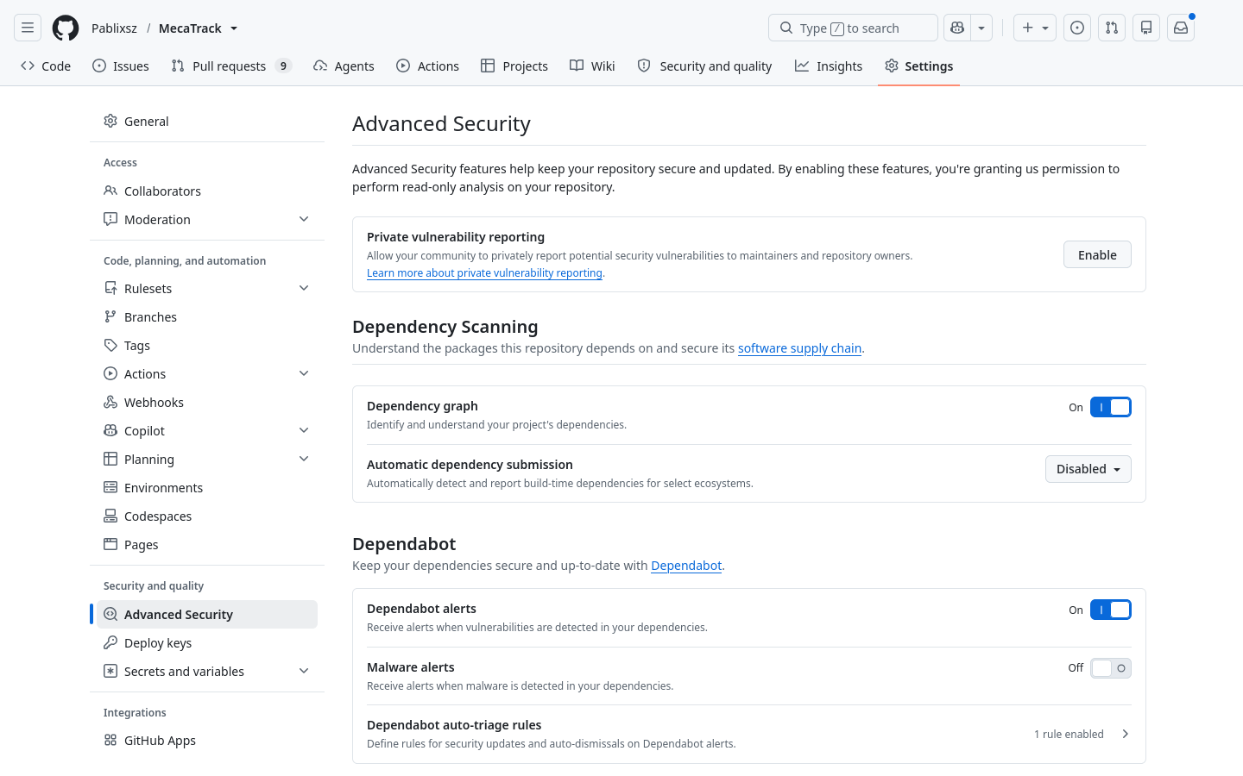
Figura 32. Settings > Advanced Security: Dependency graph and Dependabot enabled.
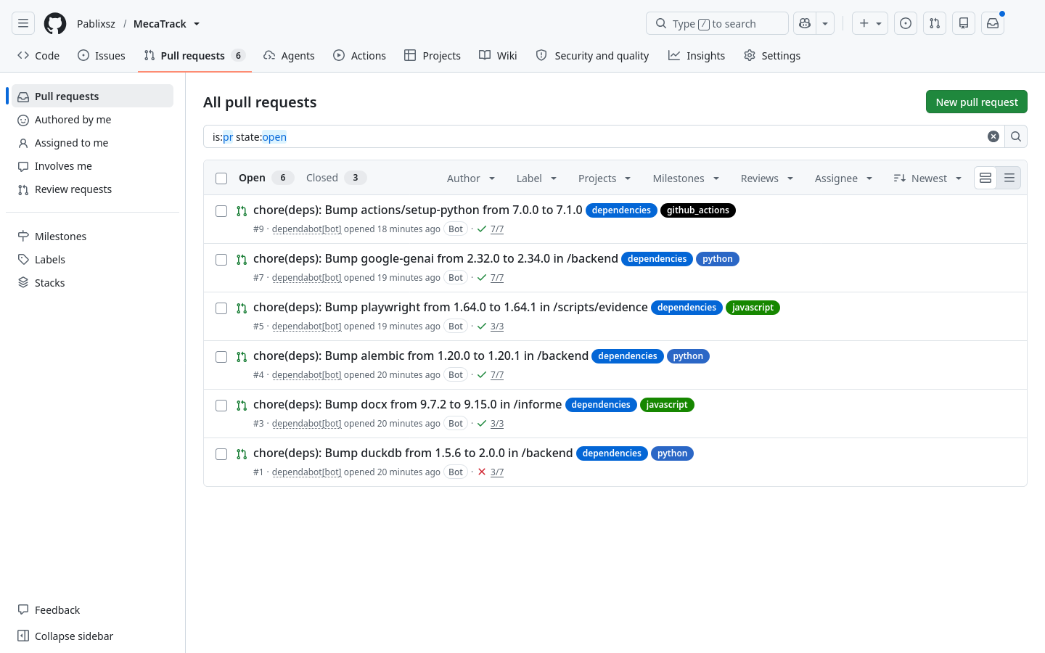
Figura 33. Pull requests opened by Dependabot that remain open.
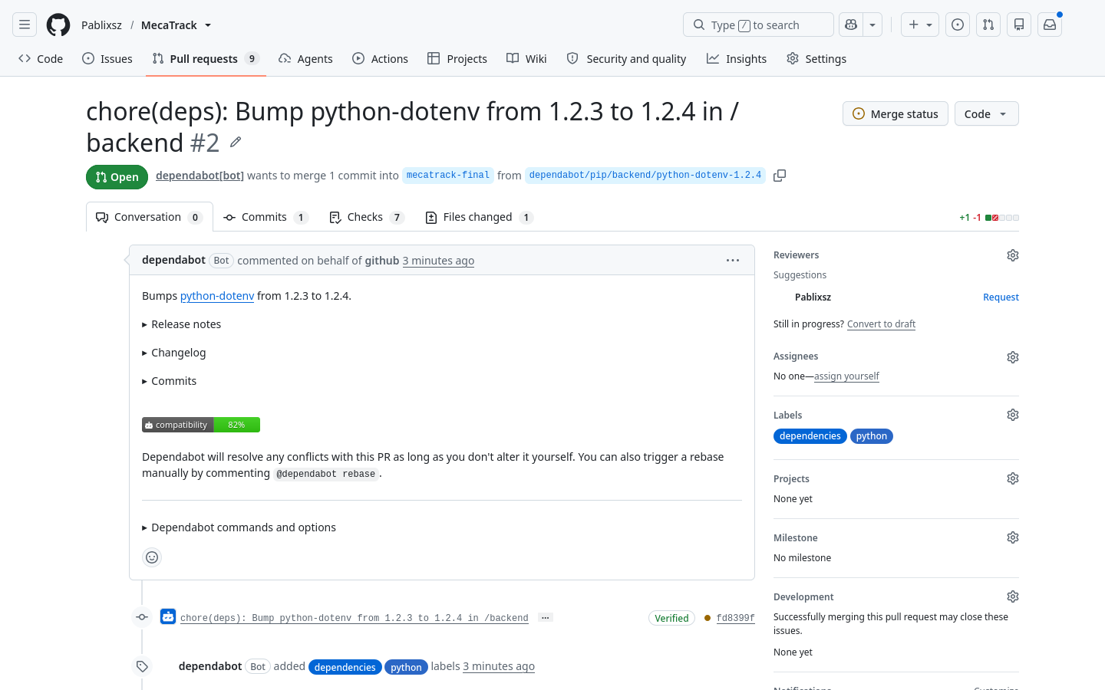
Figura 34. Detail of a Dependabot update pull request.
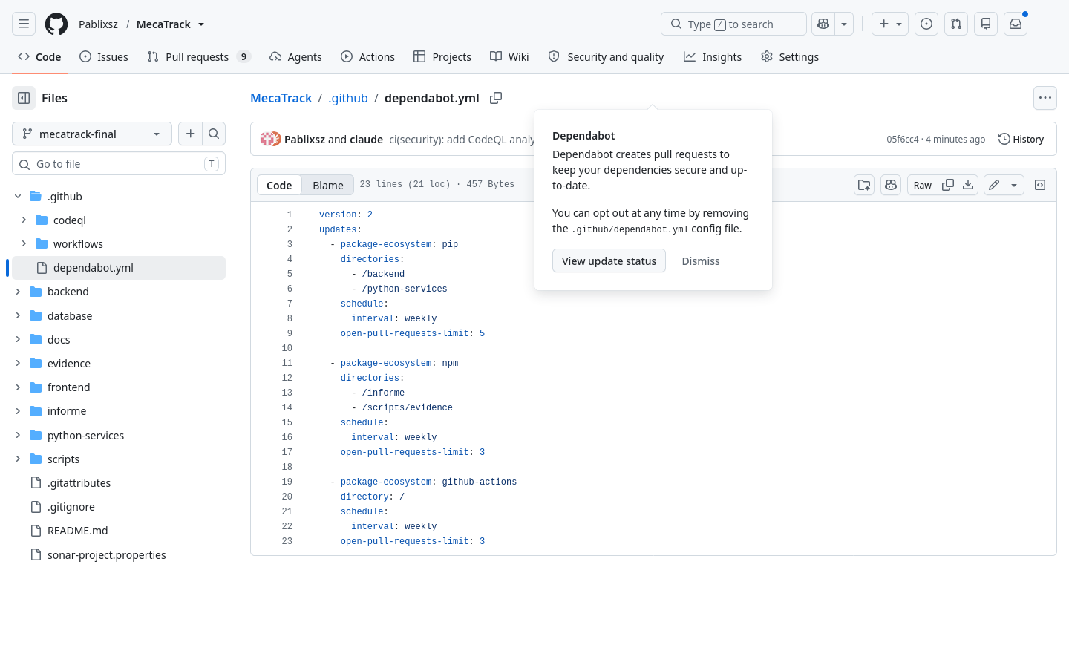
Figura 35. dependabot.yml in the repository.

Preguntas orientadoras

Aprendizajes para el quehacer profesional
- Un indicador en verde no basta; hay que saber qué mide. "0 alertas" de CodeQL pudo significar que no analizó nada, y se confirmó con 138 archivos escaneados. El API de SonarCloud decía "0 bugs" mientras el panel mostraba 20 issues de fiabilidad y 4 CVE que no aparecían en esa consulta. El "100 %" del Quality Gate inicial evaluaba solo 5 líneas.
- La cobertura no mide la calidad de las pruebas. Con 98 % de cobertura, el score inicial de mutación fue 62.6 %: había líneas ejecutadas cuyo resultado nadie comprobaba.
- Una suite de pruebas protege las migraciones grandes. Al pasar a JWT, una prueba existente detectó que se habían perdido los details del 403, y otra detectó que Flask-Limiter sobrescribía el Retry-After de la cuota de IA.
- Seguridad por diseño antes que parches. El riesgo de CSRF no se resolvió con un token adicional, sino eliminando la cookie de sesión, lo que quita la causa.

Dificultades reales y cómo se resolvieron
Tabla 5
Dificultades encontradas
Dificultad | Cómo se detectó | Resolución
La cuenta Pablixsz no era dueña del repositorio y no podía crear secretos ni cambiar ajustes | La página de Settings respondía 404 con esa sesión | Se creó Pablixsz/MecaTrack con la historia completa y una deploy key limitada a ese repositorio
SONAR_TOKEN no quedó guardado en el primer intento | La lista de secretos del repositorio seguía vacía | Se repitió el registro y se verificó la lista antes de continuar
Workflow inválido por :all: sin comillas en YAML | La ejecución no tenía nombre ni jobs (run 41379928502) | Comillas y validación local del YAML antes de cada push
.catch sobre una función síncrona rompía 3 pantallas con TypeError | El reanálisis de SonarCloud (S3699) | Se revisaron las 26 llamadas y se corrigieron las 3
La primera demostración de score < 50 % falló en mutmut run, no en el paso del score | Se leyó qué paso había fallado (run 41382364443) | Se descartó y se repitió conservando parte de las pruebas (run 41382792374)
test_architecture fallaba bajo mutmut porque lee el código instrumentado | Salida de la primera ejecución de mutmut | Se excluyó solo de esa corrida; sigue corriendo en el CI normal
Regresión en Retry-After que parecía una prueba inestable | Se repitió la prueba con y sin el cambio | Se corrigió el código y no la prueba

Resumen de entregables
Tabla 6
Entregables, métricas y evidencia
Entregable | Métrica | Figuras
SonarCloud | Quality Gate aprobado; bugs 32 a 0; vulnerabilidades 15 a 0; cobertura 97.2 % | 1, 3, 4, 5
Pruebas | 241 pruebas pasan; cobertura local 97% | 6
Mutation testing | 62.6 % a 98.4 % (315 de 320) | 7, 8
CI/CD | El build falla con score de 6,5 %; job y badges activos | 11, 12, 13
JWT + RBAC | Login, 200, 401, 403 y token vencido demostrados; 2 roles o más | 14 a 25
OWASP | 9 de 10 riesgos con control y prueba (mínimo pedido: 7) | 26 a 28
CodeQL | 0 alertas; 138 archivos escaneados | 29, 30
Dependabot | 9 PR abiertos por Dependabot; 6 siguen abiertos | 33, 34

Uso de la inteligencia artificial
Se usó Claude Code (Claude Opus 5.5) para el análisis, el código, las pruebas, la captura de evidencias y este informe, bajo los requisitos, las decisiones y la revisión del equipo. GitHub Copilot no se usó en esta guía. El registro completo está en docs/lab7/ai-log.md.
Tabla 7
Qué generó la IA y qué se revisó o corrigió
Fase | Qué generó | Revisión o corrección
0 | Diagnostico del repo y scripts de captura (scripts/evidence/) | El primer script de login aceptaba cualquier cuenta; se comprobo que la sesion abierta (Pablixsz) no tenia Settings en el repo de pablo-rodriguez091004, y se creo Pablixsz/MecaTrack por decision del usuario
1 | sonar-project.properties, .coveragerc y paso de Sonar en el workflow | Pendiente de validar con el primer analisis real
1 | Correcciones de los issues de Sonar y pruebas de regresion | Se reviso cada issue: los dos BLOCKER de XSS no eran HTML reflejado directo (la API responde JSON), asi que el arreglo real fue nosniff. La prueba del regex no falla sin el cambio y asi se documenta
1 | Instalacion de pip con --only-binary :all: en el workflow | La IA escribio :all: sin comillas en YAML y el CI fallo al arrancar (run 41379928502, sin jobs). Se detecto porque el run no tenia nombre ni jobs; se corrigio con comillas y validacion local del YAML
1 | .catch(errorNoControlado) en todas las lineas marcadas por Sonar | Correccion incorrecta de la IA: se aplico sin comprobar si la funcion era async y rompia 3 llamadas a renderizarCitas con TypeError. La detecto el reanalisis de SonarCloud (S3699); se revisaron las 26 llamadas y se corrigieron las 3
2 | setup.cfg, scripts/mutation_score.py y pruebas para matar mutantes | El primer intento fallo porque test_architecture lee el codigo instrumentado; se excluyo solo de mutmut. El score final se aclara como limitado al alcance configurado
3 | Demo del fallo del gate en rama temporal | La primera demo eliminaba todas las pruebas de los modulos: fallo mutmut run, no el paso del score (run 41382364443), asi que no demostraba el requisito y se descarto. Se detecto al leer que paso habia fallado; se repitio conservando las pruebas de reglas puras (run 41382792374, score 6.5 %)
4 | Migracion de Flask-Login a JWT, decorador de roles, frontend y pruebas | La IA perdio details del 403 al reescribir el decorador; lo detecto una prueba existente (test_write_endpoints_require_owner_or_admin). Se mantuvieron la revocacion en logout y el rechazo de cuentas inactivas, que un JWT puro habria perdido. Limitacion: la lista de revocados vive en memoria de un proceso
5 | Controles OWASP, pruebas, tabla en ingles y seccion de seguridad del README | Flask-Limiter sobrescribia el Retry-After de la cuota de IA: la IA supuso primero que era una prueba inestable, y al repetirla con y sin el cambio se vio que era una regresion real. Se corrigio el codigo, no la prueba. Limitaciones documentadas: paginacion solo sobre la respuesta y contadores en memoria
6 | codeql.yml, dependabot.yml, auditoria de innerHTML y activacion de ajustes | "0 alertas" no bastaba como evidencia: se verifico en la pagina de estado que CodeQL escaneo 120 archivos Python, 11 JavaScript y 7 HTML. Dependabot abrio 9 PR sin forzar versiones antiguas, por lo que no hizo falta pinear nada. Los PR no se fusionaron: requieren revision, por ejemplo duckdb 2.0.0 es un cambio de version mayor

Las sugerencias incorrectas se detectaron con herramientas independientes de quien las escribió: el reanálisis de SonarCloud, la suite de pruebas y la lectura de qué paso del CI había fallado. Por eso ningún arreglo se dio por bueno solo porque una advertencia desapareciera.

Repositorio y pipeline
Repositorio: https://github.com/Pablixsz/MecaTrack
Pipeline: https://github.com/Pablixsz/MecaTrack/actions?query=branch%3Amecatrack-final
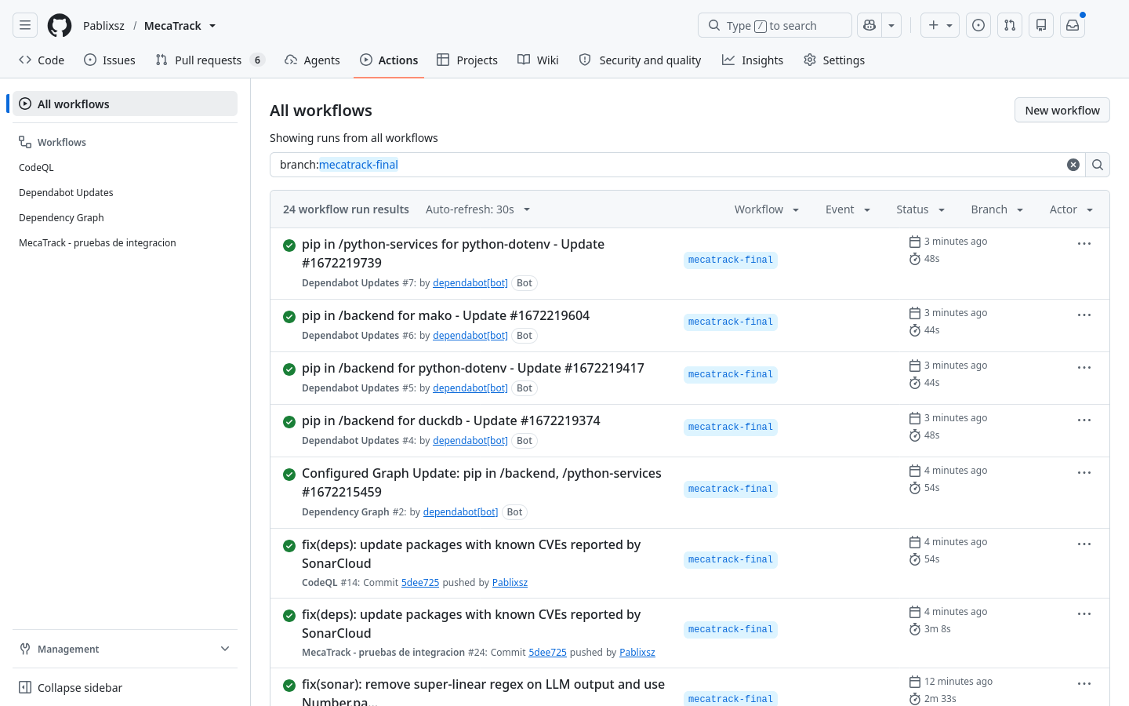
Figura 36. GitHub Actions: pipeline en verde en la rama mecatrack-final.

Video
[PENDIENTE: enlace del video]

Referencias
GitHub. (s. f.-a). About code scanning with CodeQL. GitHub Docs. https://docs.github.com/en/code-security/code-scanning/introduction-to-code-scanning/about-code-scanning-with-codeql
GitHub. (s. f.-b). Dependabot. GitHub Docs. https://docs.github.com/en/code-security/dependabot
Hallberg, A. (s. f.). mutmut: Python mutation tester. https://mutmut.readthedocs.io/
Hipp, A. (s. f.). Flask-JWT-Extended documentation. https://flask-jwt-extended.readthedocs.io/
OWASP Foundation. (2023). OWASP API Security Top 10 2023. https://owasp.org/API-Security/editions/2023/en/0x11-t10/
Sonar. (s. f.). SonarQube Cloud documentation. https://docs.sonarsource.com/sonarqube-cloud/

