**Objective of the research**  
the objective of this research is to build an Automation Test in which a "Case" is inserted in the ICP Database, an Automation Test is run to check what is necessary, and then the "Case" is deleted from the Database.  
To achieve this goal, I started researching about SQL and different Database and Frameworks managers that allow me to insert SQL code in Testing files, and different tools to test tables.  
In this way, I came to know about the existence of Stored Procedures, which are SQL sentences stored in a kind of function, that admit input and output parameters (inputs and outputs) and that are stored in the "Stored Procedures" folder inside the same Database. They can be called from the DB and executed to perform a query on specific data. In addition, they allow us to test data inside the tables, as well as the structure of the tables.

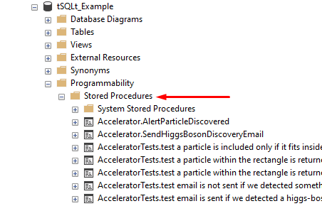

Example of a Stored Procedure in MySQL Workbench: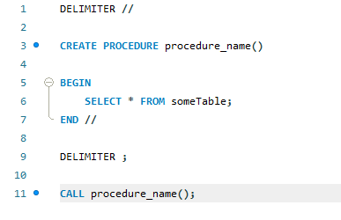

Continuing along this path, I decided to test Stored Procedures, but within the database manager with which we work in our applications (SQL Server Management Studio). For this, I downloaded SQL Server Management Studio on my local computer, set an environment in the application, and populated it with fictitious data downloaded from the Internet as an example. Once this was done, I started creating test Stored Procedures and was able to create a test suite that runs successfully.  
  
The structure of Stored Procedures in SQL Server Management Studio is as follows:

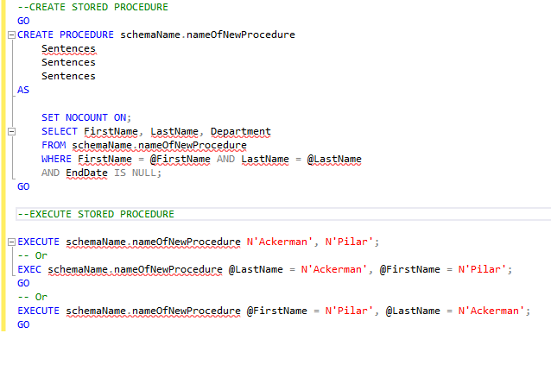

The result of it can be seen below: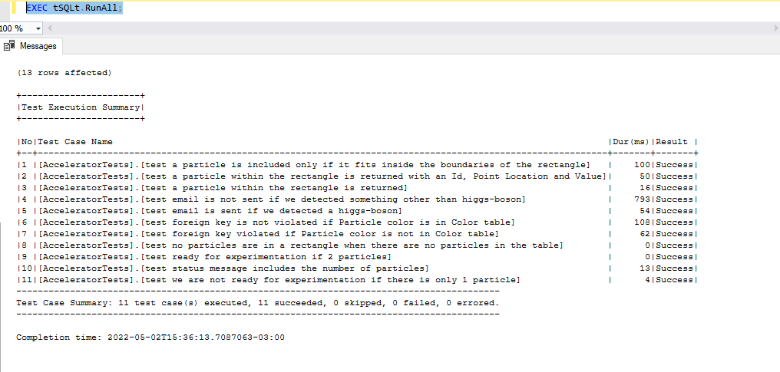

I then ran into the difficulty of importing a DB into a test file (an issue I am still trying to resolve).

Used Tools:

Database Handlers:

- MySQL Workbench 8.0

- SQL Server Management Studio

- Microsoft SQL Server

Testing tools:

- tSQLt

- SQLUnit

- SQLMap

- WebdriverIO

- Jest

- NodeJS (Express)

- MochaJs

- Jasmine

- Cypress.io