**Student Interface:**

1. **User Registration and Login:**
   * Students should be able to create an account and log in to the system.
2. **Profile Management:**
   * Students can update their personal details.
3. **Appointment Booking:**
   * A calendar view to select available time slots for appointments.
   * Form to fill in details such as the reason for counselling.
4. **Appointment History:**
   * View past and upcoming appointments.
5. **Notifications:**
   * Email or SMS notifications for booking confirmation, reminders, and cancellations.

**Counsellors/Admin Interface:**

1. **Admin Dashboard:**
   * Overview of upcoming and past appointments.
   * Statistics on the number of appointments, reasons for counselling, and referrals.
2. **Appointment Management:**
   * View, approve, or cancel appointments.
   * Add notes or feedback after each session.
3. **Reason/Cause for Counselling:**
   * Categorize the reasons for counselling (e.g., academic, personal, career guidance).
4. **Referral Information:**
   * Record who referred the student (e.g., self-referred, teacher, parent).
5. **Reports and Analytics:**
   * Generate reports on the number of appointments per year, reasons for counselling, and referral sources.

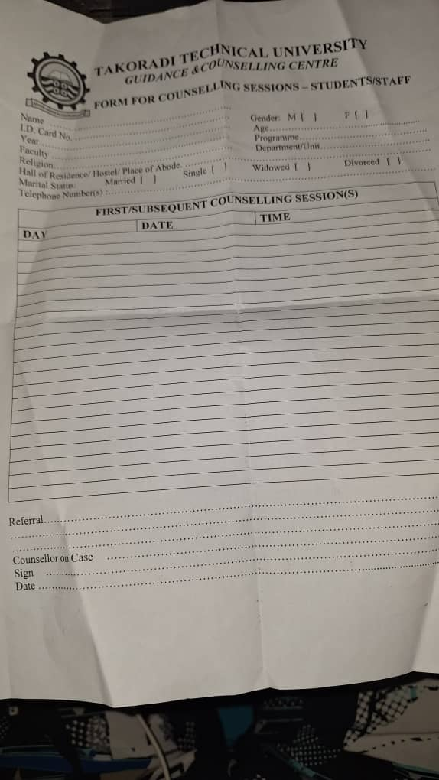

Image of their session forms