Prenatal conditions do not affect brain physiology and learning in a lizard
Pablo Recio¹,$‡$ , Dalton C. Leibold¹, Ondi L. Crino ^{1,2}, Christopher R. Friesen^{3,4}, Daniel W.A. Noble¹
¹ Division of Ecology and Evolution, Research School of Biology, The Australian National University, Canberra, ACT 2601, Australia
² Flinders University, College of Science and Engineering, Bedford Park, SA 5042, Australia
³ University of Wollongong, Wollongong, NSW 2500, Australia
⁴ Environmental Futures University of Wollongong, Wollongong, NSW 2500, Australia $‡$ Corresponding author: pablo.reciosantiago@anu.edu.au
Pablo Recio ORCID: 0000-0002-5890-0218
Dalton C. Leibold ORCID: 0000-0001-9645-2033
Ondi L. Crino ORCID: 0000-0001-5700-1387
Christopher R. Friesen ORCID: 0000-0001-5338-7454
Daniel W.A. Noble ORCID: 0000-0001-9460-8743

Keywords
cognition, corticosterone, incubation temperature, learning, mitochondria, reptiles

Abstract
Early environmental factors like heat or stress hormones can impair learning through brain metabolic function, crucial for neural development and synaptic plasticity. However, whether early environments always result in cognitive impairment through changes in neural physiology is not well-established outside of a few model systems. Here, we investigated the effects of prenatal temperature and corticosterone (CORT) on brain mitochondrial activity and spatial learning in the delicate skink (Lampropholis delicata). We treated eggs with either CORT or a control vehicle and incubated at cold (23 ± 3°C) or hot (28 ± 3°C) temperatures. Juveniles were tested in a spatial learning task over 40 days after which mitochondrial function in the medial cortex was assessed. Despite among-individual variation in learning ability, mitochondrial physiology and spatial learning in L. delicata remained robust to prenatal temperature and CORT exposure. No significant relationship was found between mitochondrial function and cognitive performance, contrary to predictions. Increased metabolic capacity correlated with higher production of reactive oxygen species but did not affect oxidative damage, possibly due to protective mechanisms. These findings highlight the physiological and cognitive resilience of L. delicata to early-life challenges. Future research should explore whether this robustness extends to other brain regions, cognitive domains, and life stages.

Introduction
Learning - the acquisition and consolidation of new information - enables animals to create new associations between events, which can be essential for coping with environmental change (Buchanan et al., 2013; Dukas, 2004; Leal and Powell, 2012). However, the capacity to form new associations varies among individuals, potentially affecting their responses to environmental challenges (Ward-Fear et al., 2016; Welklin et al., 2024). Learning faster may imply better exploitation of resources or responding more efficiently to novel threats (Ward-Fear et al., 2016). Nevertheless, learning fast can also carry potential costs, such as reduced memory accuracy or energetic trade-offs (Dukas, 2004). As such, variation in learning abilities likely reflects different evolutionary compromises, with significant implications for individual fitness (Ward-Fear et al., 2016; Welklin et al., 2024). Unravelling the mechanisms that drive these differences is crucial for understanding cognitive evolution.
Factors like age, sex, or early-life conditions can have important effects on learning abilities (Amiel and Shine, 2012; Amiel et al., 2014; Carazo et al., 2014; Lemaire et al., 2000; Noble et al., 2014; Szuran et al., 1994; Zhu et al., 2004). Adverse developmental environments are particularly influential, as the brain is highly sensitive to environmental inputs during early life (Zhu et al., 2004). For example, early experiences can alter neurotransmitter production (Amani et al., 2021), gene expression (Zhou et al., 2020), or brain structure (Amiel et al., 2017), with lasting effects on cognition. Among the physiological mechanisms underlying learning, mitochondrial activity is considered a key factor (Du et al., 2009; Picard and McEwen, 2014; Picard et al., 2018; Siegel and Albers, 1994). The neural processes involved in learning impose substantial energetic demands (Alexandrov and Pletnikov, 2022; Mann et al., 2021; McNay et al., 2000), making efficient mitochondrial respiration essential (Du et al., 2009; Picard and McEwen, 2014; Picard et al., 2018). Additionally, learning depends on a dense network of functional neurons (Amiel et al., 2017; Lefebvre, 2011), which can be compromised by excessive oxidative stress - a byproduct of mitochondrial metabolism (Du et al., 2009; Finkel and Holbrook, 2000; Gong et al., 2011; Hoffmann and Spengler, 2018; Zhu et al., 2004). Studies on mammals have shown the pervasive effects of mitochondrial physiology on cognitive abilities (Cao et al., 2014; Hara et al., 2014; Zhu et al., 2004). However, the extent to which these effects are generalisable to other taxa - particularly reptiles - remains largely unexplored (see Matsubara et al., 2017; Szabo et al., 2021).
Since mitochondria are maternally inherited, maternal condition plays a fundamental role in shaping offspring mitochondrial activity (Picard and McEwen, 2014). Maternal stress can also influence how mitochondria operate in offspring (Zhu et al., 2004). Stressful situations experienced by mothers can elevate glucocorticoids (GCs) (Sapolsky et al., 2000), which can affect developing embryos (Uller et al., 2009) altering mitochondrial physiology through transgenerational effects (Picard and McEwen, 2014). For instance, maternal stress has been shown to contribute significantly to oxidative stress in the brain of rats (Rattus norvegicus) with impacts on spatial learning abilities (Cao et al., 2014; Haussmann et al., 2012; Zhu et al., 2004).
Temperature is also a significant source of maternal stress in ectotherms. Thermal environments outside the optimal range can elevate GCs in mothers, which can be passed to the offspring (see Crino et al., 2023). Temperature can also directly influence offspring development, particularly during early life (Crino et al., 2024; Noble et al., 2018). The prenatal thermal environment is crucial in shaping mitochondrial function, affecting energy metabolism and oxidative stress (Crino et al., 2024; Stier et al., 2022). Thus, the combined effects of prenatal GCs and temperature may profoundly influence mitochondrial function, with important consequences for brain development and cognition. However, the extent to which prenatal GCs and temperature interact to shape cognitive abilities via mitochondrial physiology remains largely unknown outside of a few model species (Cao et al., 2014; Haussmann et al., 2012; Zhu et al., 2004).
Here, we examined how prenatal temperature and corticosterone (CORT) — the primary GC in reptiles — affect brain mitochondrial physiology and spatial learning in the delicate skink (Lampropholis delicata). We hypothesized that prenatal CORT and temperature would influence learning abilities by impacting brain mitochondrial activity. Specifically, we predicted that prenatal CORT would decrease energy production while increasing oxidative damage (Costantini et al., 2011; Gong et al., 2011; but see Crino et al., 2024), especially if CORT can alter cellular components increasing ROS production without enhancing ATP synthesis or making them more vulnerable to oxidative damage. Similarly, we predicted that high temperatures would decrease mitochondrial efficiency (Crino et al., 2024; Závorka et al., 2021), but would reduce oxidative stress (Treidel et al., 2016). We further predicted that the combined effects of CORT and temperature would lead to complex interactions, with both factors negatively impacting mitochondrial efficiency but having opposite effects on oxidative stress. These effects would lead to differences in learning abilities, which could be affected by the balance between energy production and oxidative stress (Alexandrov and Pletnikov, 2022; Du et al., 2009; Picard et al., 2018). By examining these interactions, we aim to clarify how prenatal environmental factors shape learning abilities through mitochondrial function, clarifying the mechanisms that mediate the role of early-life conditions on cognitive development.

Methods

Experimental animals
Lizards came from a breeding colony established in the laboratory in 2019 from wild populations in Sydney, Australia. The colony consisted of 270 adults in groups of two males and four females. Eggs were collected from these groups between November 2023 to January 2024. The collected eggs belonged to either the first or second generation of our breeding colony. After collecting the eggs, we treated them with CORT or vehicle control and incubated them under two different temperature regimes (see below). Clutch and egg identity were assigned immediately after egg collection, and the eggs were incubated in individual cups until hatching. Hatchlings were also kept in individual enclosures until the end of the experiment (see Fig. 1 A). For details on husbandry and breeding conditions see Methods 1: Animal husbandry in Supplementary Material.

Corticosterone and temperature manipulations
We tested the combined effects of prenatal CORT and temperature by elevating CORT concentrations in eggs and then incubating them under one of two temperature regimes (Cold - 23 ± 3 ºC or Hot - 28 ± 3 ºC). We used a partial split clutch design where eggs from a given clutch were distributed equally across the four treatments when clutch sizes were larger than four and randomly across treatments when less than four. CORT-treated eggs were topically supplied with 5 µL of crystalline corticosterone (Sigma, Cat. No. C2505) dissolved in 100% ethanol at a final concentration of 10 pg CORT/mL (CORT treatment), while Control eggs received an equal volume of 100% Ethanol. CORT dose increased mean yolk CORT levels 2 standard deviations higher than control eggs in previous studies (Crino et al., 2024). Eggs were then incubated in one of the two previously mentioned temperature regimes. Mean incubation temperatures represent the lower and upper limits of the natural range of nest temperatures in L. delicata (mean nesting temperatures = 27.4 ºC; Cheetham et al., 2011). Incubation temperatures fluctuated daily by ± 3 ºC with all eggs within a treatment group experiencing identical thermal cycles mimicking natural conditions. Nonetheless, recent meta-analyses suggest little difference between dial temperature fluctuation treatments and constant ones (Raynal et al., 2022; Stocker et al., 2024). The higher temperature treatment (28 ºC) was above the thermal optima estimated for L. delicata (T_{opt} = 25 ºC; Pettersen et al., 2023) and reached more stressful temperatures daily as fluctuations occurred around the mean treatment temperature (i.e., 31 ºC).

Spatial learning
The spatial learning task involved training lizards to navigate a 6-arm maze (see Fig. 1 B) to reach an exit connected to a transport box that allowed us to return the lizards to their enclosure without further contact. In each trial, lizards were placed by hand in the centre of the maze and left to acclimatise for two minutes. During acclimatisation, the central area was surrounded by a yellow device mounted on a pulley system. At the start of each trial, this device was lifted to startle the lizard. If the lizard did not immediately choose an arm, it was gently prodded with a brush at the end of the tail. A lizard was considered to have made a choice once it inserted its head into one of the arms. If the chosen arm was incorrect, we encouraged movement by gently touching the lizard with a brush, but without guiding it toward any specific arm or back to the centre of the maze. Each incorrect choice was recorded as an error, regardless of whether the same arm had been visited previously. If the lizard did not choose the correct arm after 20 errors — at which point it typically ceased responding — it was gently guided to the correct arm.
We assessed lizards’ spatial learning using external cues while avoiding intra-maze cues. External cues included a flag constructed from sticks and fabric placed in a consistent position outside the maze. In addition, the position of the overhead light and the experimenter remained fixed throughout the experiment and may have also served as orientation references. Subtle intra-maze cues were avoided by replacing the maze every three trials with one of four identical mazes. Each replacement preserved the correct arm’s orientation and the maze’s position within the room, ensuring consistency for each individual. Additionally, the maze was cleaned with 70% ethanol between trials to eliminate chemical cues. The correct arm was randomly assigned to one of the six arms for each lizard to control for potential side biases. We employed four maze orientations and counterbalanced the number of lizards assigned to each orientation across treatments.
The task was repeated once daily for 40 consecutive days. By the end of the experiment, lizards were between 44 and 76 days (mean = 62.6) post-hatching. All lizards were allowed to thermoregulate freely in their home enclosure before each trial, which was performed during the hours of peak activity (1000 – 1400). For each trial, we recorded the number of errors made, which served as the response variable in the learning analyses. We would expect the number of errors to decrease significantly over time if lizards were learning.
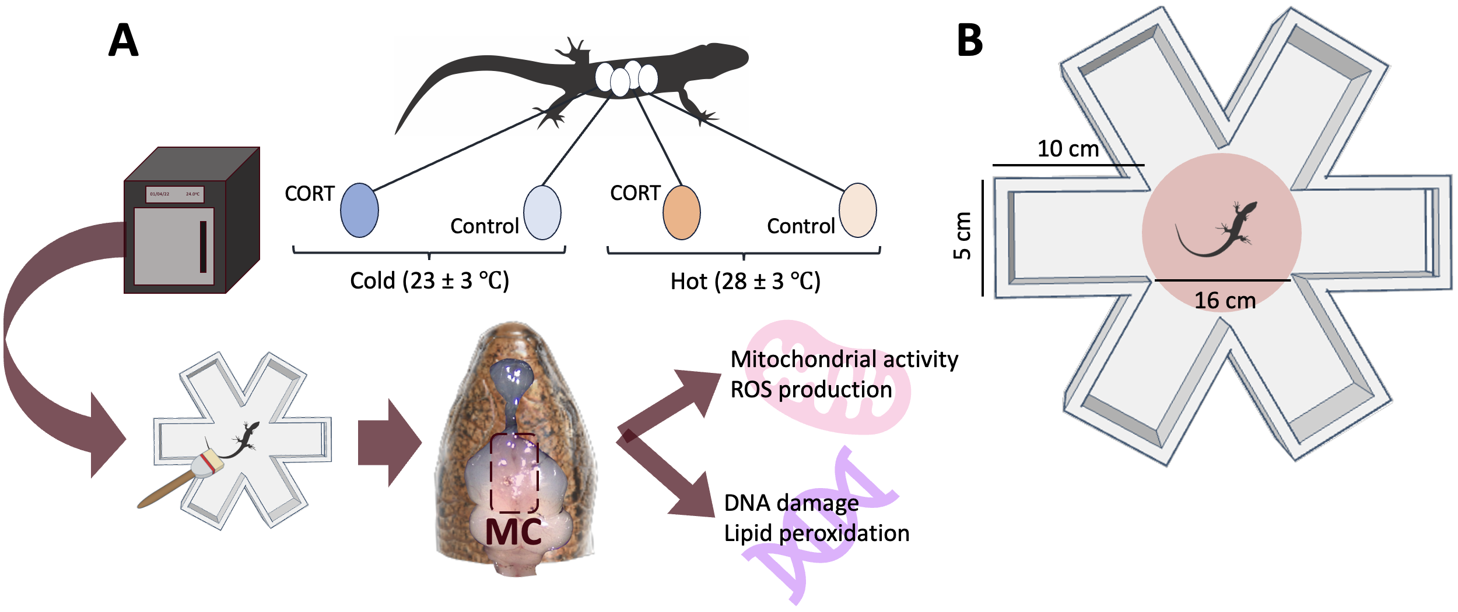
Fig. 1— Scheme of our experimental design. In panel A, we show the different stages of our experiment and the main manipulations. In panel B, we show the spatial learning maze with its dimensions.

Brain mitochondrial function
Immediately after completing the tests, we quantified mitochondrial physiology in the brains of lizards (see Fig. 1 A). We euthanized lizards via intraperitoneal injection of 10 mg/kg of a 10 mg/mL alfaxan solution (a potent anesthetic), followed by decapitation. Before decapitation, we evaluated lizard righting responses and the pinching reflexes in one of the front limbs.
We extracted the medial cortex in the telencephalon as this brain region is considered homologous to the mammalian hippocampus, where spatial cognition is encoded (Naumann et al., 2015; Rodrı́guez et al., 2002). The tissue was transferred to 1X PBS solution and then homogenized mechanically using a 100 µm mesh filter (pluriStrainer). The resultant homogenate was divided into two aliquots: one was used fresh for measuring mitochondrial density, membrane potential - a metric of mitochondrial metabolic capacity (Martı́nez-Reyes et al., 2016) - and superoxide (ROS) production; and the other was cryopreserved for later measurements of DNA damage and lipid peroxidation.
Fresh homogenate suspensions were stained with 5 µM MitoTracker Deep Red FM, 2.5 µM MitoTracker Orange CMTMRos, and 50 µM MitoSOX Red. We used these fluorescent probes to assess mitochondrial density, membrane potential, and ROS, respectively. We also added 5 µL of 10 µg/mL Hoechst 33342 Nuclear Viability Dye to each sample to differentiate viable cells from debris. These samples were analyzed in a flow cytometer within 2 hours of brain extraction.
The aliquots reserved for oxidative damage assays were stained with 10 µg/mL Hoechst 33342 Nuclear Viability Dye and 100 µM BODIPY 665/676 Lipid Peroxidation Sensor before cryopreservation. These dyes were used to measure cell viability and lipid peroxidation, respectively. The samples were then fixed in 1% Neutral-Buffered Formalin, washed, and preserved in a 1X Tris-EDTA solution with 10% DMSO at -20 °C. On the day of the oxidative damage assays, the samples were thawed, and DMSO was removed. Then, cell membranes were permeabilized in 200 µL of 1X PBS containing 20µM digitonin. Following permeabilization we stained the samples with 20µL of 70µM 8-OHdG Polyclonal Antibody - a marker of DNA damage - and allowed them to incubate overnight at 4 ºC. The following day we counterstained the cells with 20µL of 100 µg/mL H+G Goat Anti-Rabbit Conjugate Antibody with Alexa-Fluor 488 and analyzed the samples using the flow cytometer. Oxidative damage assays were performed within 6 months of the initial preparation of fresh samples.
Flow cytometry was performed on a 5-lasers flow cytometer (Becton Dickson LSRFortessa X-20) using the default wavelength filters and a high-throughput plate reader. Detectors and voltage settings for each assay were determined during pilot trials and remained consistent throughout the experiment. Data was processed using FlowJo (v. 10.1) software. We obtained the mean fluorescent intensity for mitochondrial density, metabolic capacity, ROS, DNA damage, and lipid peroxidation. For further details on the homogenization, staining, or flow cytometry assays, see Methods 2: flow cytometry in Supplementary Material. Sample sizes for DNA damage and lipid peroxidation were smaller than for the other variables because of a plater reader malfunction; however, data was missing randomly and we dealt with missing data in our analyses (see below). We validated that our homogenates contained neurons in a pilot study that used dyes specifically targeting neuronal nuclei (See Brain validation in Supplementary Material). This pilot study also ensured that our gating strategy identified these neurons using Flow cytometry.

Statistical analyses
We performed all analyses using the brm package (Bürkner, 2017), which fits Bayesian multilevel models with Stan (Stan Development Team, 2024) with R version 4.4.0 (R Core Team, 2021). We ran a series of univariate and multivariate models to test the effects of early environment on each variable separately plus quantify the relationships between physiology and learning. All models consisted of four MCMC chains of 8000 iterations, with a warmup interval of 2000 iterations.
Univariate models were used to test the effects of early environment on each variable recorded: mitochondrial density, metabolic capacity, ROS, DNA damage, lipid peroxidation, and the number of errors as a measure of learning. In all the models, we included hormone treatment (CORT vs Control), incubation temperature (Cold vs Hot), and their interaction. Sex and age were included in preliminary models and excluded from the final models when they were not significant. For all univariate models, clutch identity was included as a random factor. Mitochondrial-related variables where log-transformed when necessary, and all were mean-centered and standardized by dividing them by two times the standard deviation (Gelman, 2008). These variables followed a normal distribution.
Learning was modeled as a function of trial, CORT, temperature, and their three-way interaction. In this model, we included the trial within each level of lizard identity as a random slope. The error structure was modelled using a negative binomial distribution with a logit link function [negbinomial(link = “log”)]. Otherwise, the procedure was as in the other models.
We used the posterior distributions of parameters from these models to test for differences between treatments. Learning slopes were obtained using the ‘trial’ estimates and its interaction with hormone and temperature treatments. Slope estimates less than 0 provide evidence of learning. pMCMC was used to test the hypothesis that posterior distributions of slopes and slope contrasts differed from zero. We considered an effect statistically significant when pMCMC <0.05.
We fitted a multivariate structural equation model (SEM) using brms to explore direct and indirect links between mitochondrial function and learning. The model was structured based on theoretical expectations shown in Fig. 4. Any missing data was imputed during model fitting using data augmentation (Noble and Nakagawa, 2021), but this was largely restricted to DNA damage and lipid peroxidation. To obtain a measure of learning performance we extracted the posterior distribution of individual learning slopes (i.e., changes in error over time) by including a random trial slope for each lizard. Learning slopes and the rest of variables, were standardized as before (see above). We used Gaussian error distributions for all the variables in this model. Factors found to be non-significant in the univariate models were excluded. Clutch identity remained a random factor in our SEM model. Direct, indirect, and total effects were derived from posterior estimates (Kline, 2005) (see Table S4).

Results
We started with 80 lizards - 20 per treatment - from 33 clutches. However, due to natural mortality, only 79 lizards were included in the learning analyses, and 78 in the mitochondrial analyses. We provide final sample sizes in all our figures.
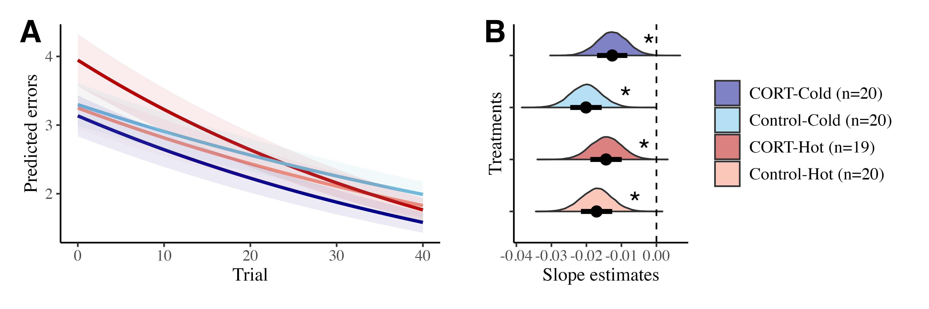
Fig. 2— Model estimates for learning analyses. (a) the predicted number of errors over trials. The lines represent the mean predicted number of errors for each trial, and the shaded areas indicate the standard error of the mean; both were obtained using the slope and intercept estimates from the posterior distributions. (b) shows the distribution of the estimates of slopes per each treatment. The x-axis represents the slope estimate, and in the y-axis are the density of the estimates. Points and bars represent the mean and standard error of the estimated slopes, respectively. Dashed lines indicate value 0. The different colors in both panels indicate the different treatments. Asterisks in (b) indicate significant differences from 0.
Univariate models suggested some variation between clutches for all the response variables as summarized in Table S3. We also found some variation across individuals in learning rates (SD trial slope = 0.204; 95% CI = [0.035, 0.343]).
We found that the lizards improved their choices over time, making less mistakes as the trials progressed (see Fig. 2 and Table S1). However, the learning rate was not influenced by CORT, temperature, or their interaction (see contrasts in Table S2).
Mitochondrial density, metabolic capacity, ROS, DNA damage, and lipid peroxidation were also not affected by prenatal conditions (see Fig. 3 and Table S2). We did not find effects of sex and age on mitochondrial physiology (see Table S3 and Tables S5-S9).
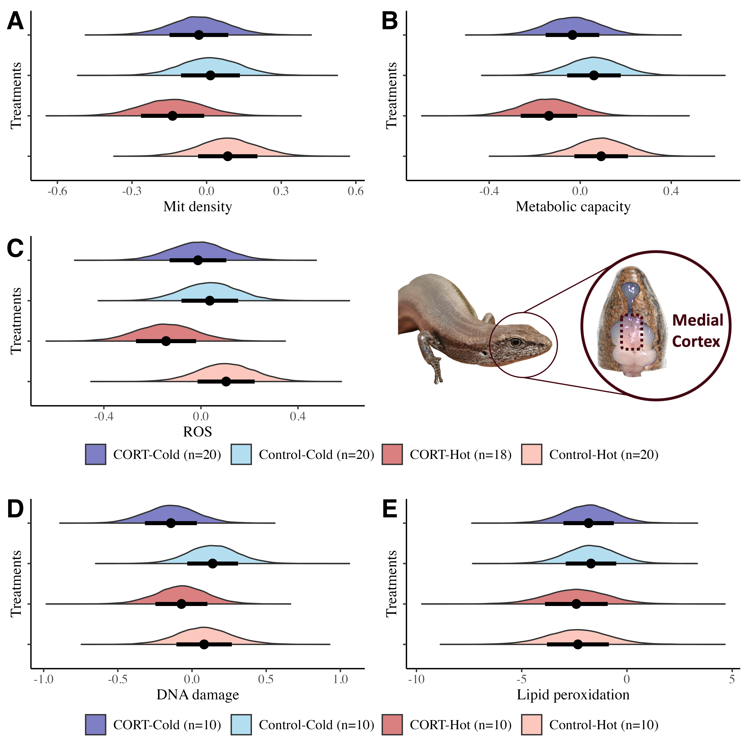
Fig. 3— Model estimates of mitochondrial density (a), metabolic capacity (b), ROS (c), DNA damage (d), and lipid peroxidation (e) in the medial cortex as a function of the different prenatal conditions. Note that for (d) and (e), these analyses do not account for missing data resulting from a flow cytometer malfunction that impacted one plate, so sample sizes are lower for univariate analyses. The x-axis represents the estimated values while the y-axis shows the density of the estimates. Points and bars represent the mean and standard error of the estimated values, respectively. The different colors in both panels indicate the different treatments.
Our SEM showed that mitochondrial physiology was unrelated to learning abilities (see Fig. 4 and table S4). While we found that ROS production increased with metabolic capacity (β = 1.090, 95% CI = [0.316, 1.862], pMCMC < 0.05), ROS was not related to oxidative damage (see Fig. 4 and Table S4).
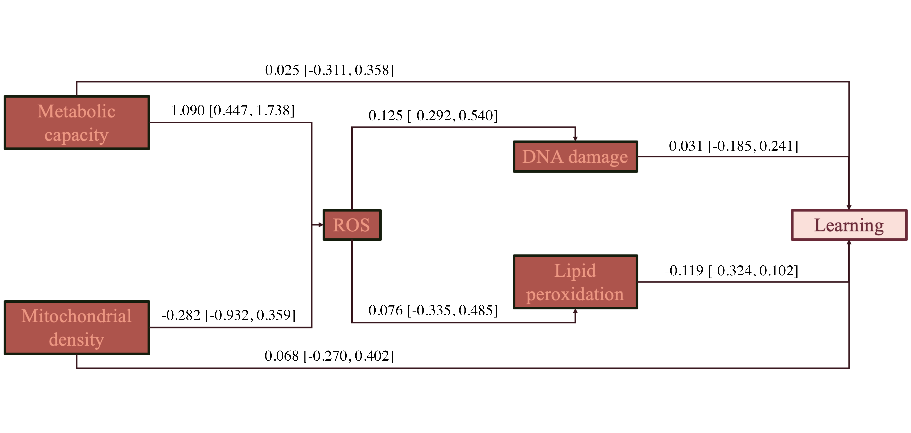
Fig. 4— Structural equation model testing hypothesized direct and indirect effects of physiology on learning. Arrows indicate the directionality of the estimate, and the values show the mean predicted coefficient and its 95% confidence interval.

Discussion
Lizards were able to learn a complex spatial task with marked improvements over time in their ability to choose the correct location. However, learning was neither influenced by prenatal conditions nor linked to mitochondrial function in the medial cortex, counter to what we predicted. Despite ROS increasing with greater metabolic capacity as expected, this did not result in a corresponding increase in oxidative damage in the medial cortex in L. delicata. We discuss our results in relation to existing work exploring the underlying mechanisms of learning and how early environments impact it below.

Spatial learning is robust to prenatal conditions
Lizards exhibited clear evidence for learning, but learning rates were not influenced by prenatal CORT or temperature as we predicted, contrasting with findings in other taxa where incubation temperature and prenatal GCs impacted learning and brain development (Amiel and Shine, 2012; Amiel et al., 2017; Dayananda and Webb, 2017; Lemaire et al., 2000; Zhu et al., 2004). Our results seem to suggest that spatial learning abilities in L. delicata are buffered from adverse early environmental conditions, consistent with our previous findings showing that behavioural flexibility in this species is also unaffected by prenatal CORT or temperature (Recio et al., 2025). L. delicata’s resilience may stem from the relevance of spatial cognition in lizards. For example, spatial learning in velvet geckos (Amalosia lesueurii) enhances survival in the wild (Dayananda and Webb, 2017).
Alternatively, the experimental treatments may not have been sufficiently challenging to elicit detectable effects, and the apparent resilience observed in L. delicata may reflect the relatively mild nature of the prenatal conditions. However, our CORT treatment elevated CORT levels in eggs above two standard deviations the natural mean concentration (Crino et al., 2024), while our thermal regimes were both beyond the T_{opt} in this species (Pettersen et al., 2023) and yet within the range of nesting temperatures in the wild (Cheetham et al., 2011). Therefore, we consider that our manipulations represent biologically relevant, ecologically realistic stressors. Nonetheless, future studies could explore whether more extreme conditions, such as prolonged exposure elevated CORT or incubation temperatures beyond the natural nesting limits would affect brain function and cognition in L. delicata or other lizard species.

Brain metabolic physiology is not affected by prenatal conditions
Contrary to our predictions, prenatal temperature and CORT did not significantly influence mitochondrial physiology in the medial cortex of L. delicata. Studies in other taxa have shown that incubation at high temperatures decreases energy production and oxidative stress (Treidel et al., 2016; Závorka et al., 2021), while elevated GCs or maternal stress is related to lower mitochondrial efficiency and higher oxidative damage (Costantini et al., 2011; Gong et al., 2011; but see Crino et al., 2024). In L. delicata, high incubation temperatures are known to decrease mitochondrial efficiency in the liver (Crino et al., 2024). However, our study shows that mitochondrial physiology in L. delicata’s brain is robust to both incubation temperature and prenatal CORT. Differences between liver and brain could reflect tissue-dependent responses to early-life conditions, highlighting the importance of studying these effects across multiple tissues (Casagrande et al., 2023).

Variation in brain metabolic physiology is not related to learning abilities
Mitochondria play a critical role in cognitive function by synthesizing energy (Du et al., 2009; Picard and McEwen, 2014; Picard et al., 2018; Siegel and Albers, 1994), and by affecting the rate of cell senescence and death caused by oxidative damage (Alexandrov and Pletnikov, 2022; Mann et al., 2021; McNay et al., 2000). Our findings contrast with past studies and suggest that energy limitations do not impact spatial learning in L. delicata. The lack of association between mitochondrial density, mitochondrial capacity, and learning abilities may result from lizards being able to maintain energy production above the threshold required to prevent cognitive dysfunction. The generally low energetic demands of ectothermic organisms compared to endotherms may make this possible and explain why we found no effect when they seem common in mammals (Cao et al., 2014; Hara et al., 2014). Alternatively, individuals with higher respiration and ROS may be upregulating antioxidant production (Rice et al., 2002).
Interestingly, despite finding a significant positive relationship between metabolic capacity and ROS in the medial cortex, the heightened ROS production did not lead to greater oxidative damage. The strong relationship between ROS and mitochondrial capacity aligns with the role of mitochondrial membrane potential in driving ATP synthesis and electron transport, processes that inherently generate ROS as byproducts (Rice et al., 2002). Normally, moderate ROS levels serve essential signaling functions and are controlled by antioxidants (Rice et al., 2002; Terman and Brunk, 2006). However, excessive ROS production can exceed antioxidant action, leading to oxidative stress and cellular dysfunction (Rice et al., 2002; Terman and Brunk, 2006). The lack of oxidative damage from increased ROS strongly suggests that antioxidants could deal with these levels of ROS. As such, DNA damage and lipid peroxidation in the medial cortex were not linked to spatial learning in L. delicata possibly because neurons were effectively buffered from damaging free radicals. Nevertheless, since oxidative damage can accumulate over time (Terman and Brunk, 2006), the relationships between oxidative damage and cognitive dysfunction could become more pronounced in older individuals (Hara et al., 2014). Future research should investigate the long-term consequences of mitochondrial activity on brain health and the potential mechanisms that sustain cognitive resilience in L. delicata.

Conclusions
We found that spatial learning in L. delicata was not influenced by prenatal CORT or temperature, nor was mitochondrial physiology in the medial cortex. Additionally, there was no relationship between mitochondrial function and learning abilities in a spatial task. However, we found that ROS production increased with metabolic capacity, suggesting that links between mitochondrial respiration and oxidative stress may become more pronounced under higher energetic demands or with aging, potentially influencing cognitive function over time.

Ethics
Both the breeding animals and the experimental lizards were provided humane laboratory housing, with thermoregulatory opportunities, light (UV and heat) and moderate humidity levels (see Methods 1: Animal husbandry in Supplementary Material for details). Euthanasia was performed by intraperitoneal injection of 10 mg/kg of a 10 mg/mL alfaxan solution (a potent anesthetic) followed by decapitation. We monitored the animals to ensure no irritation from the agent as indicated by distressed animals. Before disposing of the lizard, we confirmed the absence of righting response and the pinching reflex in one of the front limbs. All the protocols complied with Australian law and were approved by the Australian National University Animal Experimentation Ethics Committee (A2022_33).

Data accessibility
All data, data description, and R code are available in public repository https://github.com/Pablo-Recio/CORT-Temp_Spatial_learning.

Declaration of AI use
We declare Chat GPT-4 was used for questions related to code checking when there were unknown errors, but we did not rely on AI for the creation of any of the content in the manuscript, which was written fully by the authors. Last time Chat GPT-4 was used was February 2025.

Authors’ contributions
P.R.: conceptualization, methodology, data collection, data curation, formal analysis, writing—original draft, writing—review and editing; D.C.L.: conceptualization, methodology, data collection, writing—review and editing; O.C.: conceptualization, methodology, writing—review and editing; C.F.: conceptualization, methodology, funding acquisition, writing—review and editing; D.N.: conceptualization, methodology, funding acquisition, project administration, resources, supervision, writing—review and editing.
All authors gave final approval for publication and agreed to be held accountable for the work performed therein.

Conflict of interest declaration
We declare we have no competing interests.

Funding
This work was supported by a National Australian University fellowship (to P.R. and D.C.L.), and the Australian Research Council (grant no. DP210101152) to D.N. and C.R.F.

Acknowledgements
We thank Mick Devoy and the Cytometry, Histology and Spatial Multiomics team for their advice and help througout the flow cytometry protocols. We thank the help and assistance of our lab technicians Benjamin Durant and Michelle Stephens for taking care of the lizards. We also thank ANU MakerSpace, where we designed and built the prototypes of the 3D printed feeders. The authors acknowledge Microscopy Australia (ROR: 042mm0k03) at the Centre for Advanced Microscopy, The Australian National University, a facility enabled by NCRIS and university support. We specifically thank Dr Angus Rae and Dr Daryl Webb for their help with microscopy protocols. Finally, we wish to acknowledge the anonymous reviewers for their valuable feedback on the manuscript.

References
Alexandrov, Y. I. and Pletnikov, M. V. (2022). Neuronal metabolism in learning and memory: The anticipatory activity perspective. Neuroscience & Biobehavioral Reviews 137, 104664.
Amani, M., Houwing, D. J., Homberg, J. R. and Salari, A.-A. (2021). Perinatal fluoxetine dose-dependently affects prenatal stress-induced neurobehavioural abnormalities, HPA-axis functioning and underlying brain alterations in rat dams and their offspring. Reproductive Toxicology 104, 27–43.
Amiel, J. J. and Shine, R. (2012). Hotter nests produce smarter young lizards. Biology Letters 8, 372–374.
Amiel, J. J., Lindström, T. and Shine, R. (2014). Egg incubation effects generate positive correlations between size, speed and learning ability in young lizards. Animal Cognition 17, 337–347.
Amiel, J. J., Bao, S. and Shine, R. (2017). The effects of incubation temperature on the development of the cortical forebrain in a lizard. Animal Cognition 20, 117–125.
Buchanan, K. L., Grindstaff, J. L. and Pravosudov, V. V. (2013). Condition dependence, developmental plasticity, and cognition: Implications for ecology and evolution. Trends in Ecology & Evolution 28, 290–296.
Bürkner, P.-C. (2017). Brms: An r package for bayesian multilevel models using stan. Journal of statistical software 80, 1–28.
Cao, K., Zheng, A., Xu, J., Li, H., Liu, J., Peng, Y., Long, J., Zou, X., Li, Y., Chen, C., et al. (2014). AMPK activation prevents prenatal stress-induced cognitive impairment: Modulation of mitochondrial content and oxidative stress. Free Radical Biology and Medicine 75, 156–166.
Carazo, P., Noble, D. W. A., Chandrasoma, D. and Whiting, M. J. (2014). Sex and boldness explain individual differences in spatial learning in a lizard. Proceedings of the Royal Society B: Biological Sciences 281, 20133275.
Casagrande, S., Dzialo, M., Trost, L., Malkoc, K., Sadowska, E. T., Hau, M., Pierce, B., McWilliams, S. and Bauchinger, U. (2023). Mitochondrial metabolism in blood more reliably predicts whole-animal energy needs compared to other tissues. Iscience 26,.
Cheetham, E., Doody, J. S., Stewart, B. and Harlow, P. (2011). Embryonic mortality as a cost of communal nesting in the delicate skink. Journal of Zoology 283, 234–242.
Costantini, D., Marasco, V. and Møller, A. P. (2011). A meta-analysis of glucocorticoids as modulators of oxidative stress in vertebrates. Journal of Comparative Physiology B 181, 447–456.
Crino, O. L., Bonduriansky, R., Martin, L. B. and Noble, D. W. A. (2023). A conceptual framework for understanding stressinduced physiological and transgenerational effects on population responses to climate change. Evolution Letters.
Crino, O. L., Wild, K. H., Friesen, C. R., Leibold, D., Laven, N., Peardon, A. Y., Recio, P., Salin, K. and Noble, D. W. (2024). From eggs to adulthood: Sustained effects of early developmental temperature and corticosterone exposure on physiology and body size in an australian lizard. Journal of Experimental Biology 227,.
Dayananda, B. and Webb, J. K. (2017). Incubation under climate warming affects learning ability and survival in hatchling lizards. Biology Letters 13, 20170002.
Du, J., Wang, Y., Hunter, R., Wei, Y., Blumenthal, R., Falke, C., Khairova, R., Zhou, R., Yuan, P., Machado-Vieira, R., et al. (2009). Dynamic regulation of mitochondrial function by glucocorticoids. Proceedings of the National Academy of Sciences 106, 3543–3548.
Dukas, R. (2004). Evolutionary Biology of Animal Cognition. Annual Review of Ecology, Evolution, and Systematics 35, 347–374.
Finkel, T. and Holbrook, N. J. (2000). Oxidants, oxidative stress and the biology of ageing. Nature 408, 239–247.
Gelman, A. (2008). Scaling regression inputs by dividing by two standard deviations. Statistics in medicine 27, 2865–2873.
Gong, Y., Chai, Y., Ding, J.-H., Sun, X.-L. and Hu, G. (2011). Chronic mild stress damages mitochondrial ultrastructure and function in mouse brain. Neuroscience Letters 488, 76–80.
Hara, Y., Yuk, F., Puri, R., Janssen, W. G. M., Rapp, P. R. and Morrison, J. H. (2014). Presynaptic mitochondrial morphology in monkey prefrontal cortex correlates with working memory and is improved with estrogen treatment. Proceedings of the National Academy of Sciences 111, 486–491.
Haussmann, M. F., Longenecker, A. S., Marchetto, N. M., Juliano, S. A. and Bowden, R. M. (2012). Embryonic exposure to corticosterone modifies the juvenile stress response, oxidative stress and telomere length. Proceedings of the Royal Society B: Biological Sciences 279, 1447–1456.
Hoffmann, A. and Spengler, D. (2018). The Mitochondrion as Potential Interface in Early-Life Stress Brain Programming. Frontiers in Behavioral Neuroscience 12, 306.
Kline, R. B. (2005). Principles and practice of structural equation modeling 2nd ed. New York: Guilford 3,.
Leal, M. and Powell, B. J. (2012). Behavioural flexibility and problem-solving in a tropical lizard. Biology Letters 8, 28–30.
Lefebvre, L. (2011). Taxonomic counts of cognition in the wild. Biology Letters 7, 631–633.
Lemaire, V., Koehl, M., Le Moal, M. and Abrous, D. N. (2000). Prenatal stress produces learning deficits associated with an inhibition of neurogenesis in the hippocampus. Proceedings of the National Academy of Sciences 97, 11032–11037.
Mann, K., Deny, S., Ganguli, S. and Clandinin, T. R. (2021). Coupling of activity, metabolism and behaviour across the Drosophila brain. Nature 593, 244–248.
Martı́nez-Reyes, I., Diebold, L. P., Kong, H., Schieber, M., Huang, H., Hensley, C. T., Mehta, M. M., Wang, T., Santos, J. H., Woychik, R., et al. (2016). TCA cycle and mitochondrial membrane potential are necessary for diverse biological functions. Molecular cell 61, 199–209.
Matsubara, S., Deeming, D. C. and Wilkinson, A. (2017). Cold-blooded cognition: New directions in reptile cognition. Current Opinion in Behavioral Sciences 16, 126–130.
McNay, E. C., Fries, T. M. and Gold, P. E. (2000). Decreases in rat extracellular hippocampal glucose concentration associated with cognitive demand during a spatial task. Proceedings of the National Academy of Sciences 97, 2881–2885.
Naumann, R. K., Ondracek, J. M., Reiter, S., Shein-Idelson, M., Tosches, M. A., Yamawaki, T. M. and Laurent, G. (2015). The reptilian brain. Current Biology 25, R317–R321.
Noble, D. W. and Nakagawa, S. (2021). Planned missing data designs and methods: Options for strengthening inference, increasing research efficiency and improving animal welfare in ecological and evolutionary research. Evolutionary applications 14, 1958–1968.
Noble, D. W. A., Byrne, R. W. and Whiting, M. J. (2014). Age-dependent social learning in a lizard. Biology Letters 10, 20140430.
Noble, D. W. A., Stenhouse, V. and Schwanz, L. E. (2018). Developmental temperatures and phenotypic plasticity in reptiles: A systematic review and meta-analysis: Incubation temperature and plasticity. Biological Reviews 93, 72–97.
Pettersen, A. K., Feiner, N., Noble, D. W., While, G. M., Uller, T. and Cornwallis, C. K. (2023). Maternal behavioral thermoregulation facilitated evolutionary transitions from egg laying to live birth. Evolution Letters 7, 351–360.
Picard, M. and McEwen, B. S. (2014). Mitochondria impact brain function and cognition. Proceedings of the National Academy of Sciences 111, 7–8.
Picard, M., McEwen, B. S., Epel, E. S. and Sandi, C. (2018). An energetic view of stress: Focus on mitochondria. Frontiers in Neuroendocrinology 49, 72–85.
R Core Team (2021). R: A language and environment for statistical computing.
Raynal, R. S., Noble, D. W., Riley, J. L., Senior, A. M., Warner, D. A., While, G. M. and Schwanz, L. E. (2022). Impact of fluctuating developmental temperatures on phenotypic traits in reptiles: A meta-analysis. Journal of Experimental Biology 225, jeb243369.
Recio, P., Leibold, D. C., Crino, O. L., Wild, K. H., Friesen, C. R., Mauclaire, B., Peardon, A. Y. and Noble, D. W. (2025). Early environmental conditions do not impact behavioural flexibility in an invasive and noninvasive lizard species. Animal Behaviour 123106.
Rice, M., Forman, R., Chen, B., Avshalumov, M., Cragg, S. and Drew, K. (2002). Brain antioxidant regulation in mammals and anoxia-tolerant reptiles: Balanced for neuroprotection and neuromodulation. Comparative Biochemistry and Physiology Part C: Toxicology & Pharmacology 133, 515–525.
Rodrı́guez, F., López, J. C., Vargas, J. P., Gómez, Y., Broglio, C. and Salas, C. (2002). Conservation of spatial memory function in the pallial forebrain of reptiles and ray-finned fishes. Journal of Neuroscience 22, 2894–2903.
Sapolsky, R. M., Romero, L. M. and Munck, A. U. (2000). How Do Glucocorticoids Influence Stress Responses? Integrating Permissive, Suppressive, Stimulatory, and Preparative Actions. 21,.
Siegel, G. J. and Albers, R. W. (1994). Basic neurochemistry: Molecular, cellular, and medical aspects. Raven Press.
Stan Development Team (2024). RStan: The R interface to Stan.
Stier, A., Monaghan, P. and Metcalfe, N. B. (2022). Experimental demonstration of prenatal programming of mitochondrial aerobic metabolism lasting until adulthood. Proceedings of the Royal Society B 289, 20212679.
Stocker, C. W., Bamford, S. M., Jahn, M., Mazué, G. P., Pettersen, A. K., Ritchie, D., Rubin, A. M., Noble, D. W. and Seebacher, F. (2024). The effect of temperature variability on biological responses of ectothermic animals—a meta-analysis. Ecology Letters 27, e14511.
Szabo, B., Noble, D. W. A. and Whiting, M. J. (2021). Learning in non‐avian reptiles 40 years on: Advances and promising new directions. Biological Reviews 96, 331–356.
Szuran, T., Zimmermann, E. and Welzl, H. (1994). Water maze performance and hippocampal weight of prenatally stressed rats. Behavioural Brain Research 65, 153–155.
Terman, A. and Brunk, U. T. (2006). Oxidative stress, accumulation of biological’garbage’, and aging. Antioxidants & redox signaling 8, 197–204.
Treidel, L., Carter, A. and Bowden, R. (2016). Temperature experienced during incubation affects antioxidant capacity but not oxidative damage in hatchling red-eared slider turtles (trachemys scripta elegans). Journal of Experimental Biology 219, 561–570.
Uller, T., Hollander, J., Astheimer, L. and Olsson, M. (2009). Sex-specific developmental plasticity in response to yolk corticosterone in an oviparous lizard. Journal of Experimental Biology 212, 1087–1091.
Ward-Fear, G., Pearson, D., Brown, G., Rangers, B. and Shine, R. (2016). Ecological immunization: In situ training of free-ranging predatory lizards reduces their vulnerability to invasive toxic prey. Biology letters 12, 20150863.
Welklin, J. F., Sonnenberg, B. R., Branch, C. L., Heinen, V. K., Pitera, A. M., Benedict, L. M., Whitenack, L. E., Bridge, E. S. and Pravosudov, V. V. (2024). Spatial cognitive ability is associated with longevity in food-caching chickadees. Science 385, 1111–1115.
Závorka, L., Crespel, A., Dawson, N. J., Papatheodoulou, M., Killen, S. S. and Kainz, M. J. (2021). Climate change‐induced deprivation of dietary essential fatty acids can reduce growth and mitochondrial efficiency of wild juvenile salmon. Functional Ecology 35, 1960–1971.
Zhou, Q., Suzuki, A., Iinuma, M., Wang, K.-Y., Kubo, K. and Azuma, K. (2020). Effects of maternal chewing on prenatal stress-induced cognitive impairments in the offspring via multiple molecular pathways. International Journal of Molecular Sciences 21, 5627.
Zhu, Z., Li, X., Chen, W., Zhao, Y., Li, H., Qing, C., Jia, N., Bai, Z. and Liu, J. (2004). Prenatal stress causes gender-dependent neuronal loss and oxidative stress in rat hippocampus. Journal of Neuroscience Research 78, 837–844.

Suplementary Material

Methods 1: Animal husbandry
Breeding colony - Juveniles of L. delicata came from a breeding colony established in the laboratory since 2019. This colony consisted of 270 adults housed in plastic containers (41.5 L x 30.5 W x 21 H cm) with six lizards (two males and four females) per enclosure. Enclosures were provided with shelter, nonstick matting, and several small water dishes. The lizards were fed approx. 40 mid-size crickets (Acheta domestica) per enclosure three days a week, and water was given daily. The crickets were dusted with calcium weekly and multivitamin and calcium biweekly. Room temperatures were set to 22-24 ºC, but we also provided the enclosures with a heat chord and a heat lamp following a 12 h light:12 h dark cycle keeping warm side of enclosures is usually at 34 ºC.
Eggs collection and incubation - Between mid-November 2023 to mid-January 2024, we placed a small box (12.5 L x 8.3 W x 5 H cm) with moist vermiculite in one side of the communal enclosures to provide females with a place to lay the eggs. These boxes were checked three days a week. After egg collection, we measured length and width with a digital caliper to the nearest 0.1 mm and weighted the eggs with a digital scale ± 0.001g error. Then eggs were treated with CORT or vehicle (see CORT and temperature manipulation below) and were placed in individual cups (80 mL) with moist vermiculite (12 parts water to 4 parts vermiculite). The cups were covered with cling wrap to retain moisture and left in two incubators at two different temperatures (see CORT and temperature manipulation below) until hatching.
Hatchlings - Incubators were checked three times a week for hatchlings. Lizards were measured and weighed immediately after hatching. snout-vent length (SVL) and tail length (TL) were measured to the nearest millimeter, and weight was recorded using a digital scale with an accuracy of ± 0.001 g. Hatchlings were then placed in individual enclosures (18.7L x 13.2W x 6.3H cm) with nonstick matting and a small water dish. Watering, feeding, and temperature conditions were maintained as for adults (see above).

Methods 2: flow cytometry

Brain mitochondrial activity
Homogenates: After the medial cortex was extracted, it was transferred immediately to 1.5mL centrifuge tubes containing 100µL of cold 1X PBS and kept on ice until further processing. The tissue was mechanically homogenized by placing the tissue in the well of a 100µm mesh filter (pluriStrainer) affixed atop a 1.5mL centrifuge tube, then mashed with the rubber end of an insulin syringe stopper. The resulting homogenate was then rinsed through the filter with 1000µL of cold 1X PBS to prepare a homogenate suspension. Following homogenization, we centrifuged each sample at 1000 RCF for 10 minutes to pellet cells, then removed the supernatant (hereafter, this process referred to as ‘washing’) and resuspended the cells in 500µL 1x PBS. This step was performed to remove cellular debris from homogenates.
From each 500µL suspension of homogenate collected on a given trial day, we first added 100µL of homogenate to a pooled sample of each tissue type to use for single-color controls, and the remaining 400µL of homogenate was split among two 200µL aliquots. One aliquot was used fresh to measure mitochondrial function (mitochondrial density, membrane potential, ROS), one aliquot was cryopreserved for later measurements of oxidative damage (8-OHdG, lipid peroxidation), and the third aliquot was cryopreserved for a different experiment.
Staining fresh samples: From fresh homogenate suspensions, we loaded the wells of a 96-well flat-bottom plate (Nunclon) with 50µL of homogenate in duplicates (2 wells per homogenate). To each replicate well, we added 5µL of a fluorescent probe mix containing equal parts 5µM MitoTracker Deep Red FM, 2.5µM MitoTracker Orange CMTMRos, and 50µM MitoSOX Red. We used these fluorescent probes as indicators of mitochondrial density, mitochondrial membrane potential, and superoxide (ROS) production, respectively. We then added 5µL of 10 µg/mL Hoechst 33342 Nuclear Viability Dye to each sample, which we used to distinguish live, viable, intact cells from cellular debris. We then loaded 6 wells with 50µL of homogenate taken from each pooled homogenate suspension (12 wells total), which were to be negative and single-color controls. One well was left unstained as a negative control, one was stained with all the probes to be a positive control, and the remaining four wells were treated with 5µL of one of 5µM MitoTracker Deep Red FM, 2.5µM MitoTracker Orange CMTMRos, 50µM MitoSOX Red, or 10 µg/mL Hoechst 33342 Nuclear Viability Dye. Any remaining pooled homogenate was fixed and frozen as previously described. We incubated the loaded plate at 32 °C for 30 minutes to stain and then diluted the samples with 50µL cold 1x PBS to halt the staining process. Upon the completion of staining, samples were immediately transferred to flow cytometry facilities for data collection and were sampled within 2 hours. Samples prepared this way remained viable for flow cytometry for approximately 5 hours post-staining at room temperature (~19°C) before cells began rapidly degrading (DCL, personal observation).
The aliquots destined to the analysis of oxidative damage were stained with 20µL (10µL for controls) of 10 µg/mL Hoechst 33342 Nuclear Viability Dye and 20µL of 100µM BODIPY 665/676 Lipid Peroxidation Sensor and incubated at 32°C for 20 minutes. Following staining, we washed cells to prevent further binding of unbound fluorescent probes, then resuspended the pellet and continue with cryopreservation.
Cryopreservation: Aliquots were fixed first by adding the samples into a 1mL solution of 1% Neutral-Buffered Formalin (as a fixative agent) and incubating them at 32°C for 20 min. Then washed the samples and resuspended the cells in 1mL cold 1X Tris-EDTA (chelates metals that can damage DNA during freezing) and 10% DMSO (a cryoprotectant). Samples were stored at -20°C until oxidative damage assays.
Staining cryopreserved samples: Assays of oxidative damage from cryopreserved samples were performed within 6 months of the initial processing and analysis of fresh samples. On the day of oxidative damage assays, we rapidly thawed frozen samples by briefly (1-2 minutes) submerging them in hot water. We washed each thawed sample twice, the first time resuspending the pelleted cells in 1000µL warm 1X Tris-EDTA, and the second time in 200µL warm 1X PBS containing 20µM digitonin. We incubated the samples at 32°C for 20 minutes to permeabilize the cell membrane, after which we washed the homogenate and resuspended the pelleted cells in 200µL 1X PBS. We added 20µL of 70µM 8-OHdG Polyclonal Antibody to each sample, and we left the homogenate overnight (~12 hours) for the antibody to bind to 8-OHdG, a marker of oxidative damage on DNA. The following day we counterstained the cells with 20µL of 100 µg/mL H+G Goat Anti-Rabbit Conjugate Antibody with Alexa-Fluor 488 at 32°C for 20 minutes. After the cells had been tagged with 8-OHdG antibodies and counterstained, we washed the cells once more and resuspended the pellet in 400µL of 1X PBS. Unstained and single-color controls were treated identically to samples, but stained with only up to one of BODIPY 665/676, Hoechst 33342, 8-OHdG antibody, or Alexa-Fluor 488 conjugate. Additionally, one control was stained with both 8-OHdG antibody and the Alexa-Fluor 488 conjugate. We then loaded a 96-well plate with 100µL of each single-color control and 100µL in triplicate of each sample. We performed all flow cytometry assays on samples within 48-hours of thawing the samples.
Flow cytometry: All flow cytometry assays were performed using a flow cytometer with 5-lasers (blue, red, yellow-green, violet, and ultraviolet), 20 detectors, and a high-throughput plate reader (Becton Dickson LSRFortessa X-20) using the default wavelength filters on detectors. Immediately prior to all assays, we performed a quality-control check and laser alignment using the CS&T function of BD FACSDiva (v. 8.0.1) and BD CS&T fluorescent beads (Lot No. 30664) diluted at 1 drop to 150µL 1X PBS. During data collection, data for single-color controls was filtered using a liberal threshold of 200 on the FSC (roughly, cell size) detector, while data from samples was filtered using a threshold of 200 on the BUV-496 (Hoechst 33342) detector. These thresholds were chosen to filter small debris or inviable or non-intact cells from our observations. The detectors and voltage settings used in data acquisition for each assay type (mitochondrial function, oxidative damage) were determined during pilot trials prior to assays and were not changed during assays to allow for comparison among different plates and samples throughout the experiment. Voltages were chosen to center the distribution of observations in each channel at 10³ fluorescent intensity and reduce observations of off-scale (<10¹ or >10⁵) events. For the mitochondrial function assay, we recorded data from the following channels (in brackets: voltage; parameter): FSC (44; forward scatter), SSC (180; side scatter), Alexa-Fluor 488 (544; autofluorescence), BUV-496 (450; Hoechst 33342), APC (647; MitoTracker Deep Red FM), PE (522; MitoTracker Orange CMTMRos), and PerCP-Cy5-5 (592; MitoSOX Red) channels. For the oxidative damage assay, we recorded data from the following channels: FSC (425; forward scatter), SSC (300; side scatter), Alexa-Fluor 488 (275; 8-OHdG Antibody + Alexa-Fluor 488 conjugate), BUV-496 (525; Hoechst 33342), and PE-Cy5 (850; BODIPY 665/676). Fluorescent intensity data was collected via the BD FACSDiva (v. 8.0.1) software, with no compensation applied during data collection, and all on a linear scale (detectable range of 0-252166). We recorded data for both the area and height of the fluorescent signal, but only used the area in downstream analyses, with height being recorded for the sake of quality control. Data was exported from BD FACSDiva as individual *.fcs (“flow cytometry standard”) files for each sample, then imported into FlowJo (v. 10.1) for processing.
Data processing: In FlowJo v. 10.1 we first transformed all fluorescent data to a logarithmic base 10 scale, then applied a basic gating process across all channels by filtering to observations within the detectable range (10¹-10⁵) to remove any off-scale events. We then used a backgating process wherein we aimed to identify the approximate FSC (cell size) and SSC (cell complexity) range of viable cells that were positive for all stains. We primarily used the BUV-496 channel (Hoechst 33342) in the backgating process to identify intact, nucleated cells (BUV-496 > 10³). For the mitochondrial function assay, we aimed to identify populations of viable cells containing mitochondria (APC > 103) and actively respiring (PE and PerCP-Cy5-5 > 10³). For the oxidative damage assay, we aimed to identify populations of cells exhibiting both DNA damage (Alexa-Fluor 488 > 103) and lipid peroxidation (PerCP > 10³). When backgating was done, we filtered the data to the FSC by SSC range that captured the ideal population. We used the backgated population for compensation of fluorescent spillover between different fluorescent probes. To account for fluorescent spillover, we used a traditional compensation matrix using the compensation function of FlowJo v.10.1. We identified the “positive” population for each channel as the brightest ~2.5% of the distribution of observations in the respective single-color control for that channel and used unstained controls as a universal negative. We visually inspected the compensation matrix and its effects on population distributions for under- and over-compensation, whereupon we changed the compensation matrix manually until data was properly compensated. We applied the compensation matrix to all samples for downstream processing. Following compensation, we again gated the data following the same process as for backgating but using the compensated parameters for each channel. Following gating, we exported the geometric mean (mean fluorescent intensity; MFI) and robust confidence-values for each channel for each sample. For analysis, we exported summary statistics of only the area of the fluorescent signal. Although we exported robust confidence values for checking repeatability between replicate samples, we used the geometric means for each individual as our main response variables in analyses.

Results of the final models
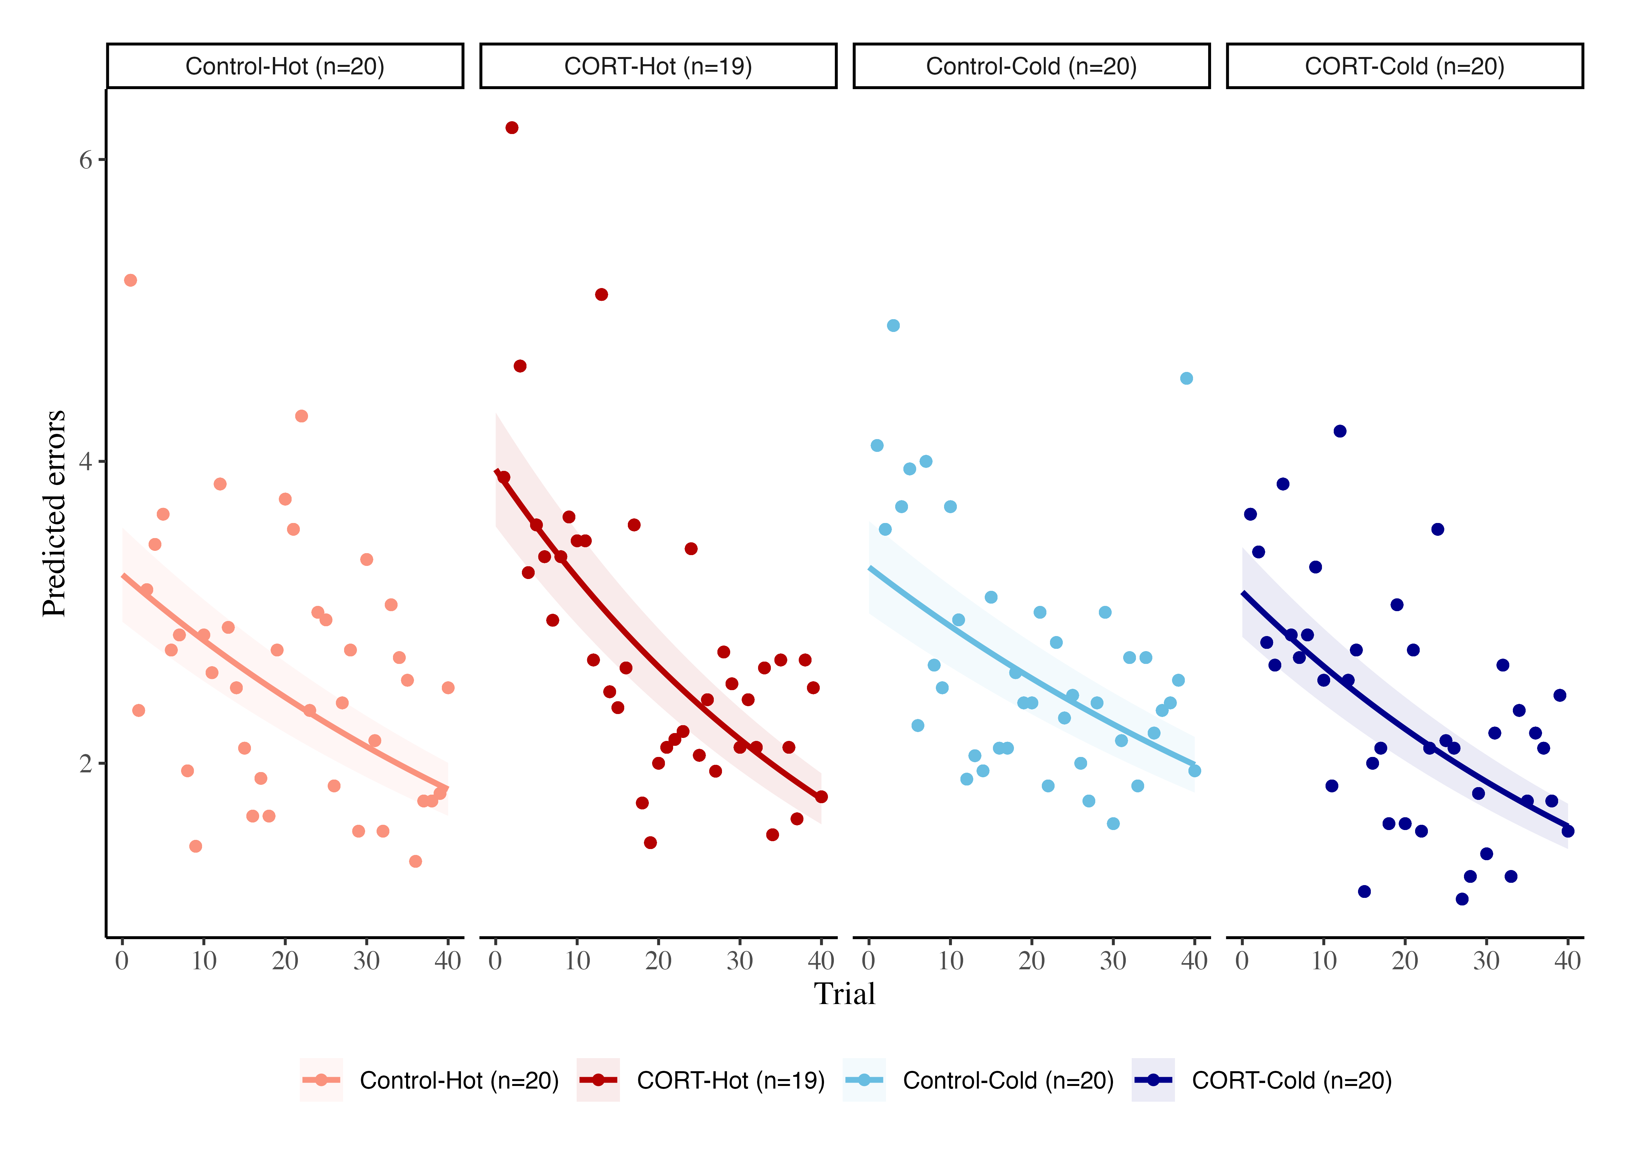
Figure S1. Raw data of the learning task. Each point represents the mean number of errors per day. The lines represent the modeled data.

Table S1. Estimates of the learning slopes per treatment, the 95% CI, and pMCMC values testing the hypothesis that slope is different from 0. In bold, the values that are significant at pMCMC < 0.05.
Treatment | Estimated slope | 95 CI | pMCMC
CORT-Cold | -0.017 | [-0.026, -0.008] | < 0.001
CORT-Hot | -0.020 | [-0.029, -0.011] | < 0.001
Control-Cold | -0.013 | [-0.021, -0.004] | < 0.05
Control-Hot | -0.014 | [-0.023, -0.006] | < 0.05

Table S2. Estimate of the contrasts between treatments for all the variables analysed, and pMCMC values testing the hypothesis that contrast is different from 0. In bold, the values that are significant at pMCMC < 0.05.
Variable | Predictor | Contrast | pMCMC contrast
Mit density | Temperature | -0.018 | 0.917
 | CORT | 0.134 | 0.471
 | Interaction | 0.176 | 0.437
Metabolic capacity | Temperature | -0.036 | 0.839
 | CORT | 0.162 | 0.364
 | Interaction | 0.135 | 0.559
ROS | Temperature | -0.032 | 0.875
 | CORT | 0.148 | 0.450
 | Interaction | 0.199 | 0.382
DNA damage | Temperature | 0.007 | 0.970
 | CORT | 0.217 | 0.394
 | Interaction | -0.128 | 0.706
Lipid peroxidation | Temperature | -0.601 | 0.106
 | CORT | 0.093 | 0.701
 | Interaction | -0.037 | 0.909
Learning slopes | Temperature | -0.002 | 0.701
 | CORT | 0.005 | 0.416
 | Interaction | 0.001 | 0.881
Contrasts were done by:
- Temperature: β_{Hot} - β_{Cold}
- CORT: β_{CORT} - β_{Control}
- Interaction: (β_{Control-Hot} - β_{CORT-Hot}) - (β_{Control-Cold} - β_{CORT-Cold})

Clutch effects of the final univariate models
Table S3. Clutch effect of the final univariate models
Variable | Mean_effect | 95% CI
Mit density | 0.192 | [0.014, 0.398]
Mit potential | 0.112 | [0.004, 0.293]
ROS | 0.123 | [0.006, 0.310]
DNA damage | 0.191 | [0.009, 0.456]
Peroxidation | 0.149 | [0.006, 0.386]
Learning | 0.073 | [0.003, 0.183]

Results SEM
Table S4. Estimated direct, indirect, and total coefficients from the multivariate model
Response | Predictor | Direct effects | Indirect effects | Total effects
Learning | Mitochondrial density | 0.068 [-0.270, 0.402] | 0.003 [-0.036, 0.049] | 0.071 [-0.269, 0.408]
 | Metabolic capacity | 0.025 [-0.311, 0.358] | -0.012 [-0.124, 0.088] | 0.013 [-0.329, 0.357]
 | ROS | - | -0.011 [-0.109, 0.080] | -0.011 [-0.109, 0.080]
 | DNA damage | 0.031 [-0.185, 0.241] | - | 0.031 [-0.185, 0.241]
 | Lipid peroxidation | -0.119 [-0.324, 0.102] | - | -0.119 [-0.324, 0.102]
DNA damage | Mitochondrial density | - | -0.037 [-0.279, 0.145] | -0.037 [-0.279, 0.145]
 | Metabolic capacity | - | 0.137 [-0.322, 0.654] | 0.137 [-0.322, 0.654]
 | ROS | 0.125 [-0.292, 0.540] | - | 0.125 [-0.292, 0.540]
Lipid peroxidation | Mitochondrial density | - | -0.023 [-0.243, 0.159] | -0.023 [-0.243, 0.159]
 | Metabolic capacity | - | 0.085 [-0.374, 0.583] | 0.085 [-0.374, 0.583]
 | ROS | 0.076 [-0.335, 0.485] | - | 0.076 [-0.335, 0.485]
ROS | Mitochondrial density | -0.282 [-0.932, 0.359] | - | -0.282 [-0.932, 0.359]
 | Metabolic capacity | 1.090 [0.447, 1.738] | - | 1.090 [0.447, 1.738]

Final univariate models diagnostics (plots)
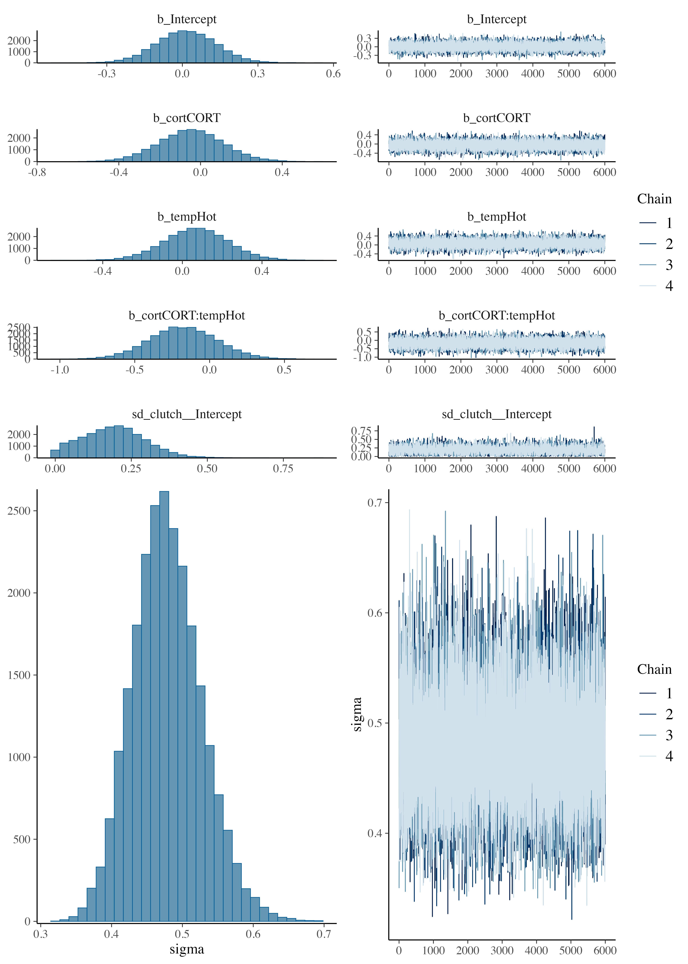

Figure S2. Posterior predictive checks for the model of Mitochondrial Density. Formula: mit_density ~ cort * temp + (1|clutch)

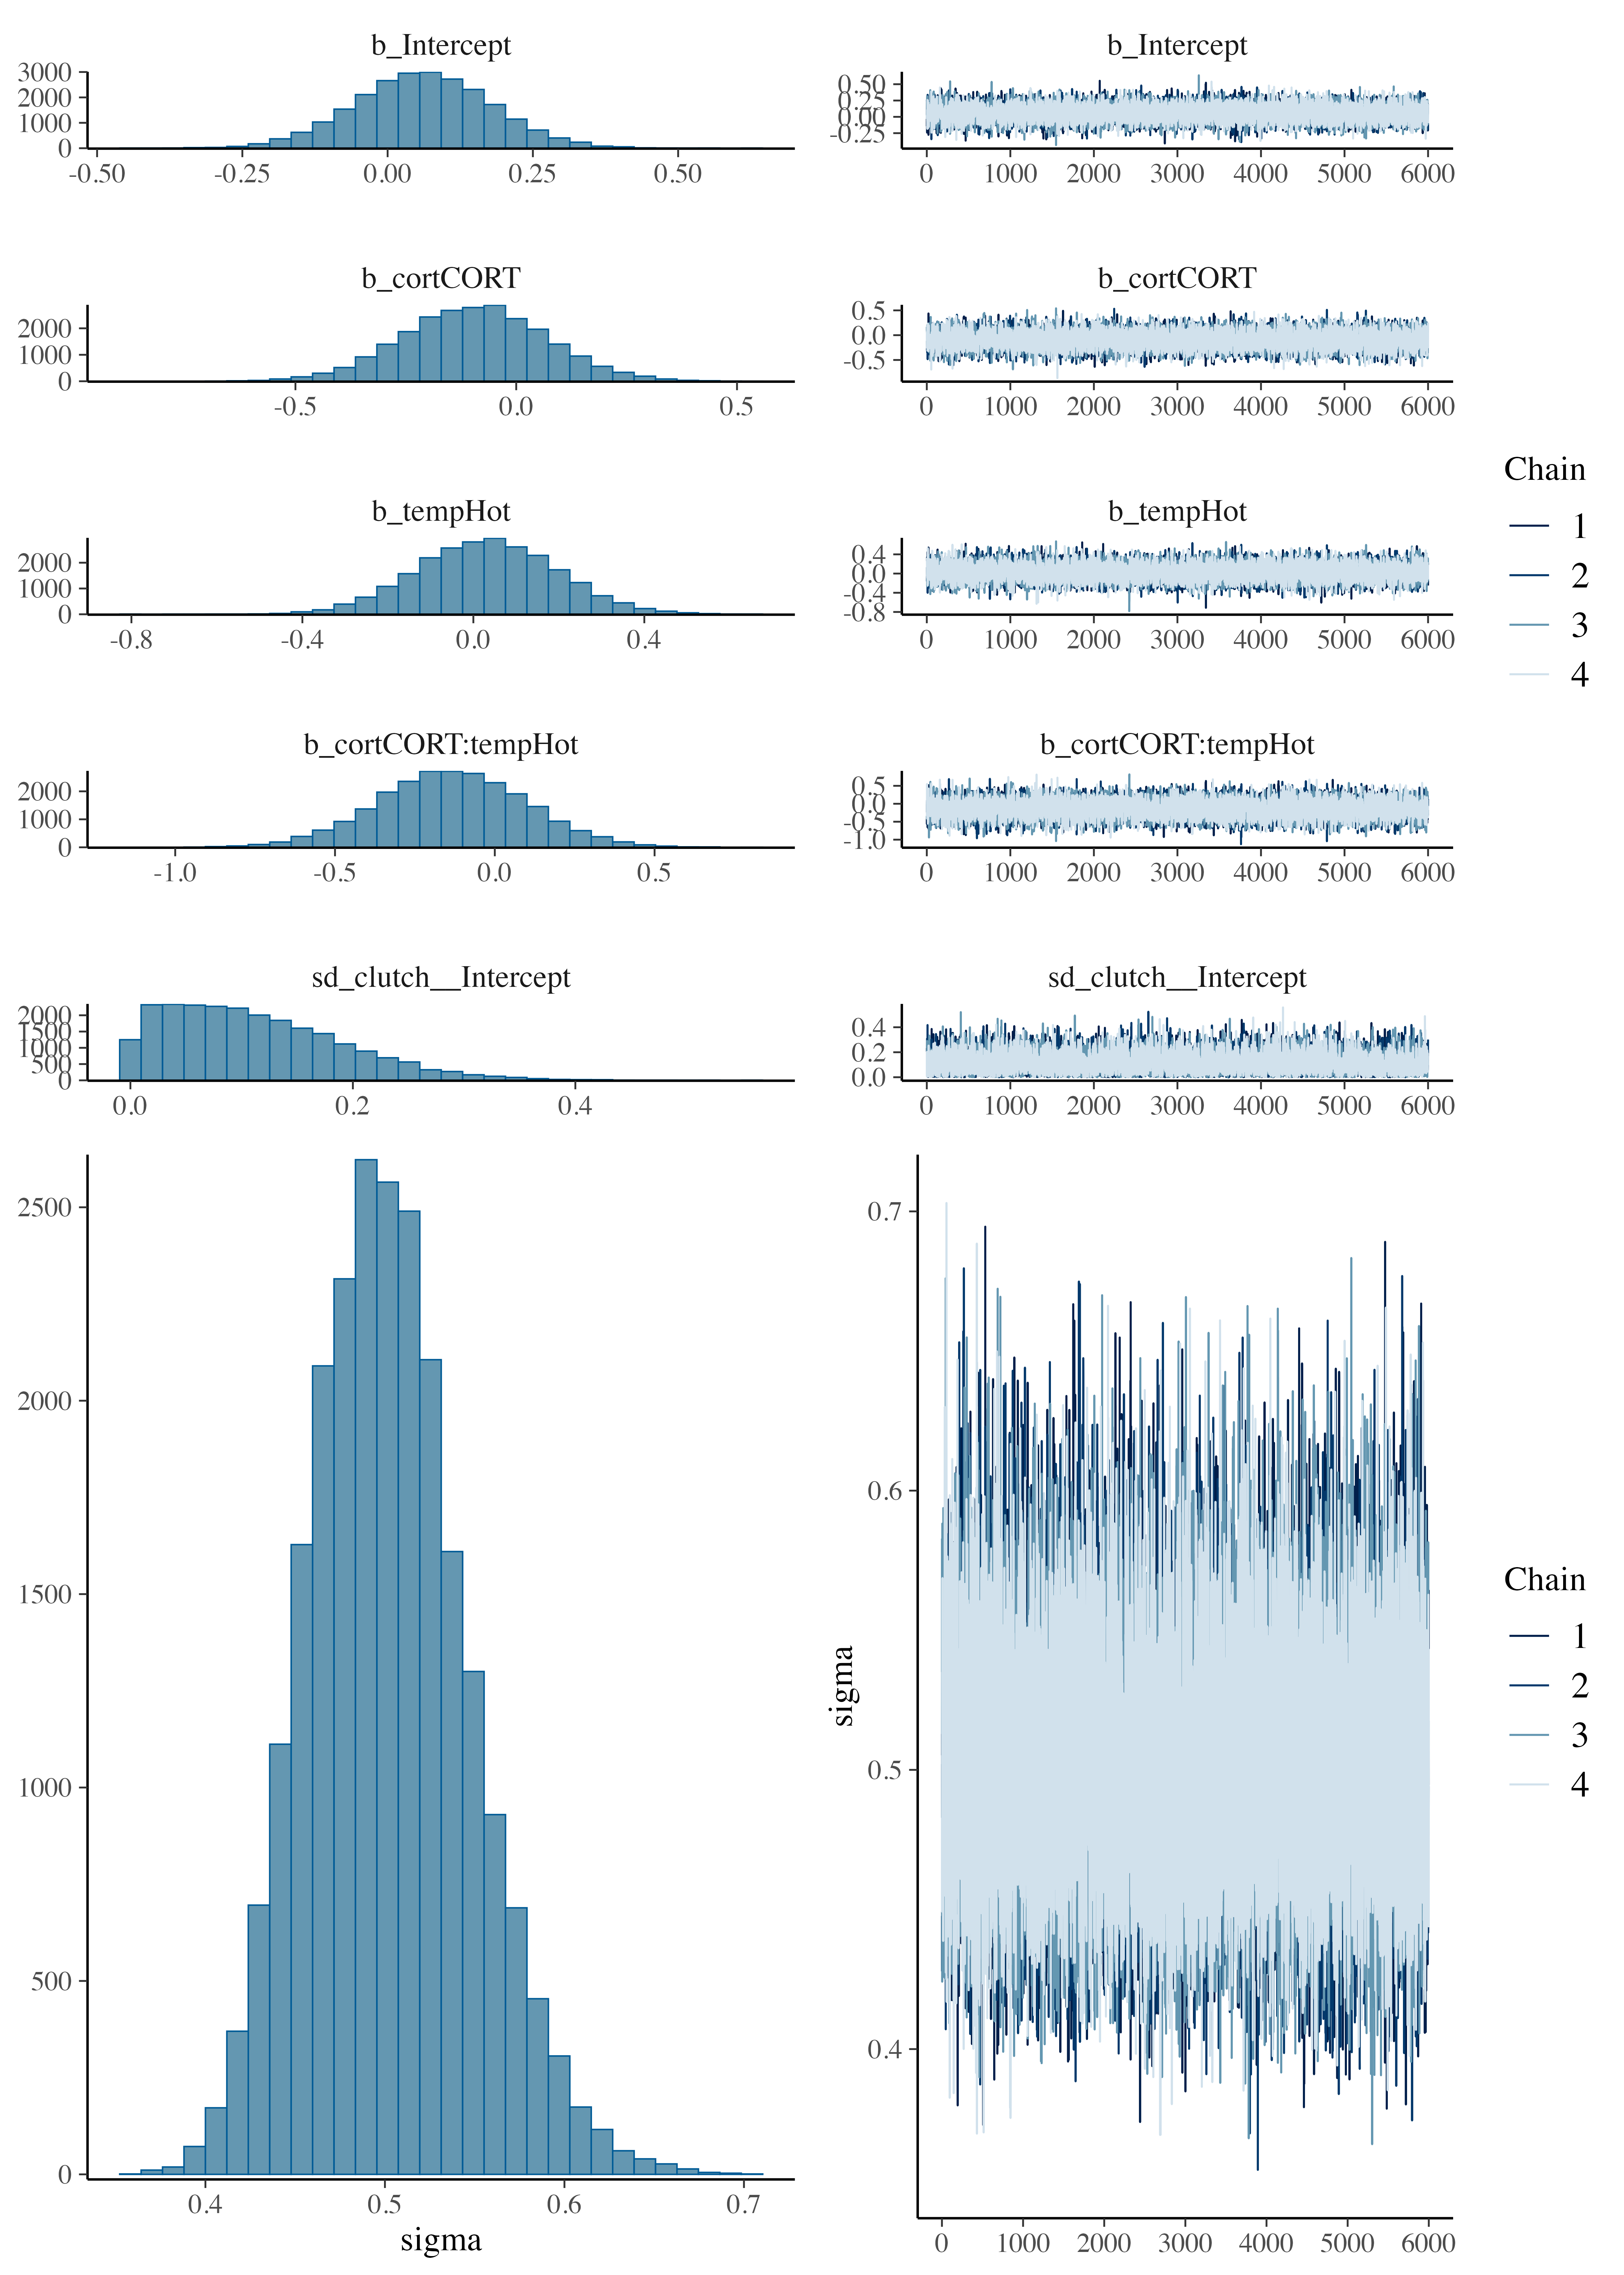

Figure S3. Posterior predictive checks for the model of metabolic capacity. Formula: mit_potential ~ cort * temp + (1|clutch)

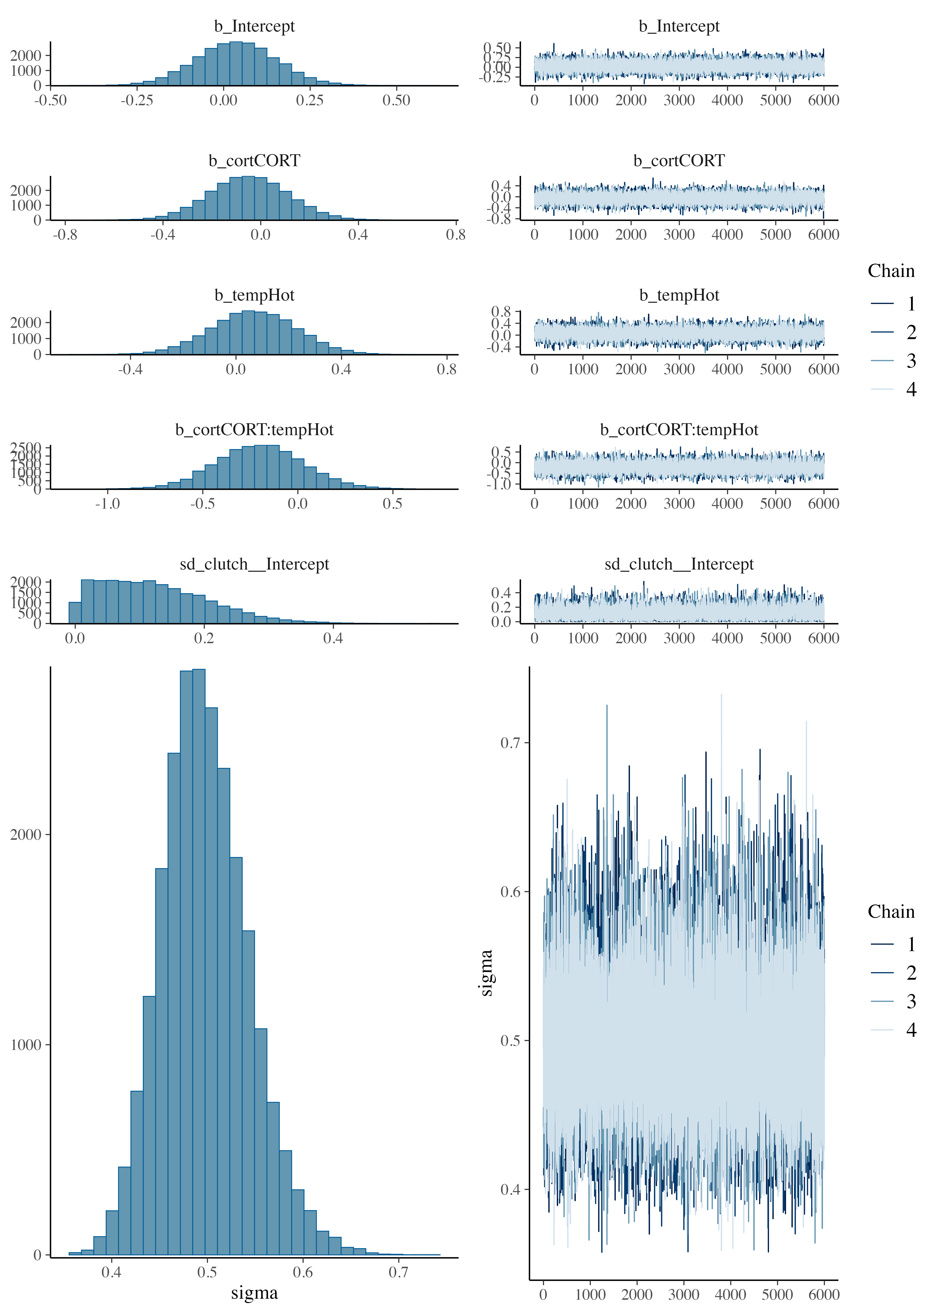

Figure S4. Posterior predictive checks for the model of ROS. Formula: ROS ~ cort * temp + (1|clutch)

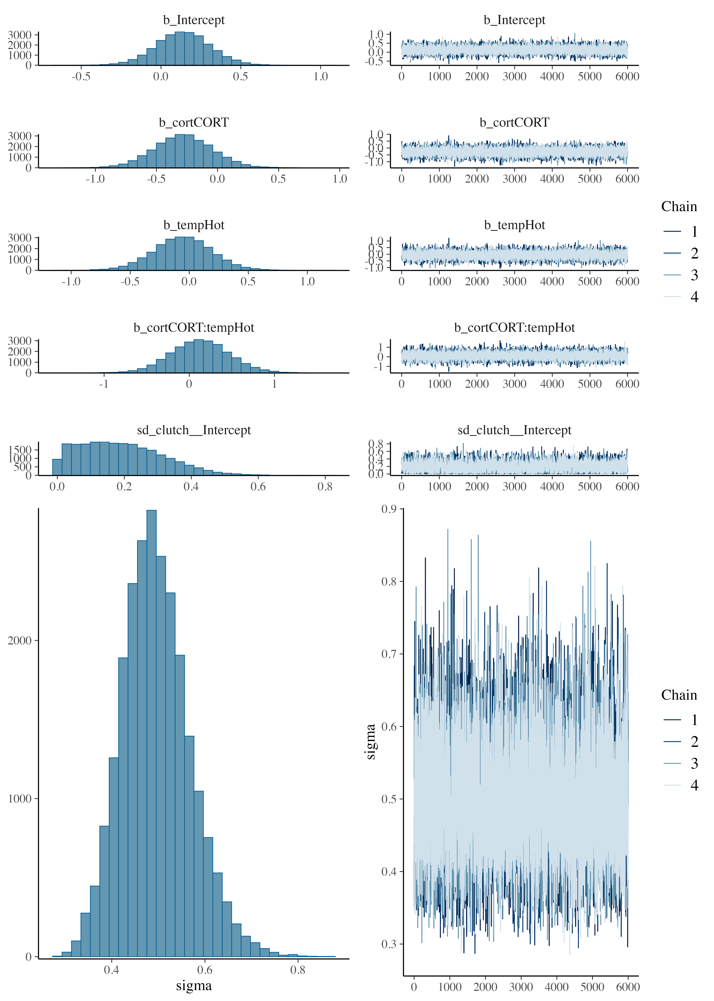

Figure S5. Posterior predictive checks for the model of DNA Damage. Formula: DNAdamage ~ cort * temp + (1|clutch)

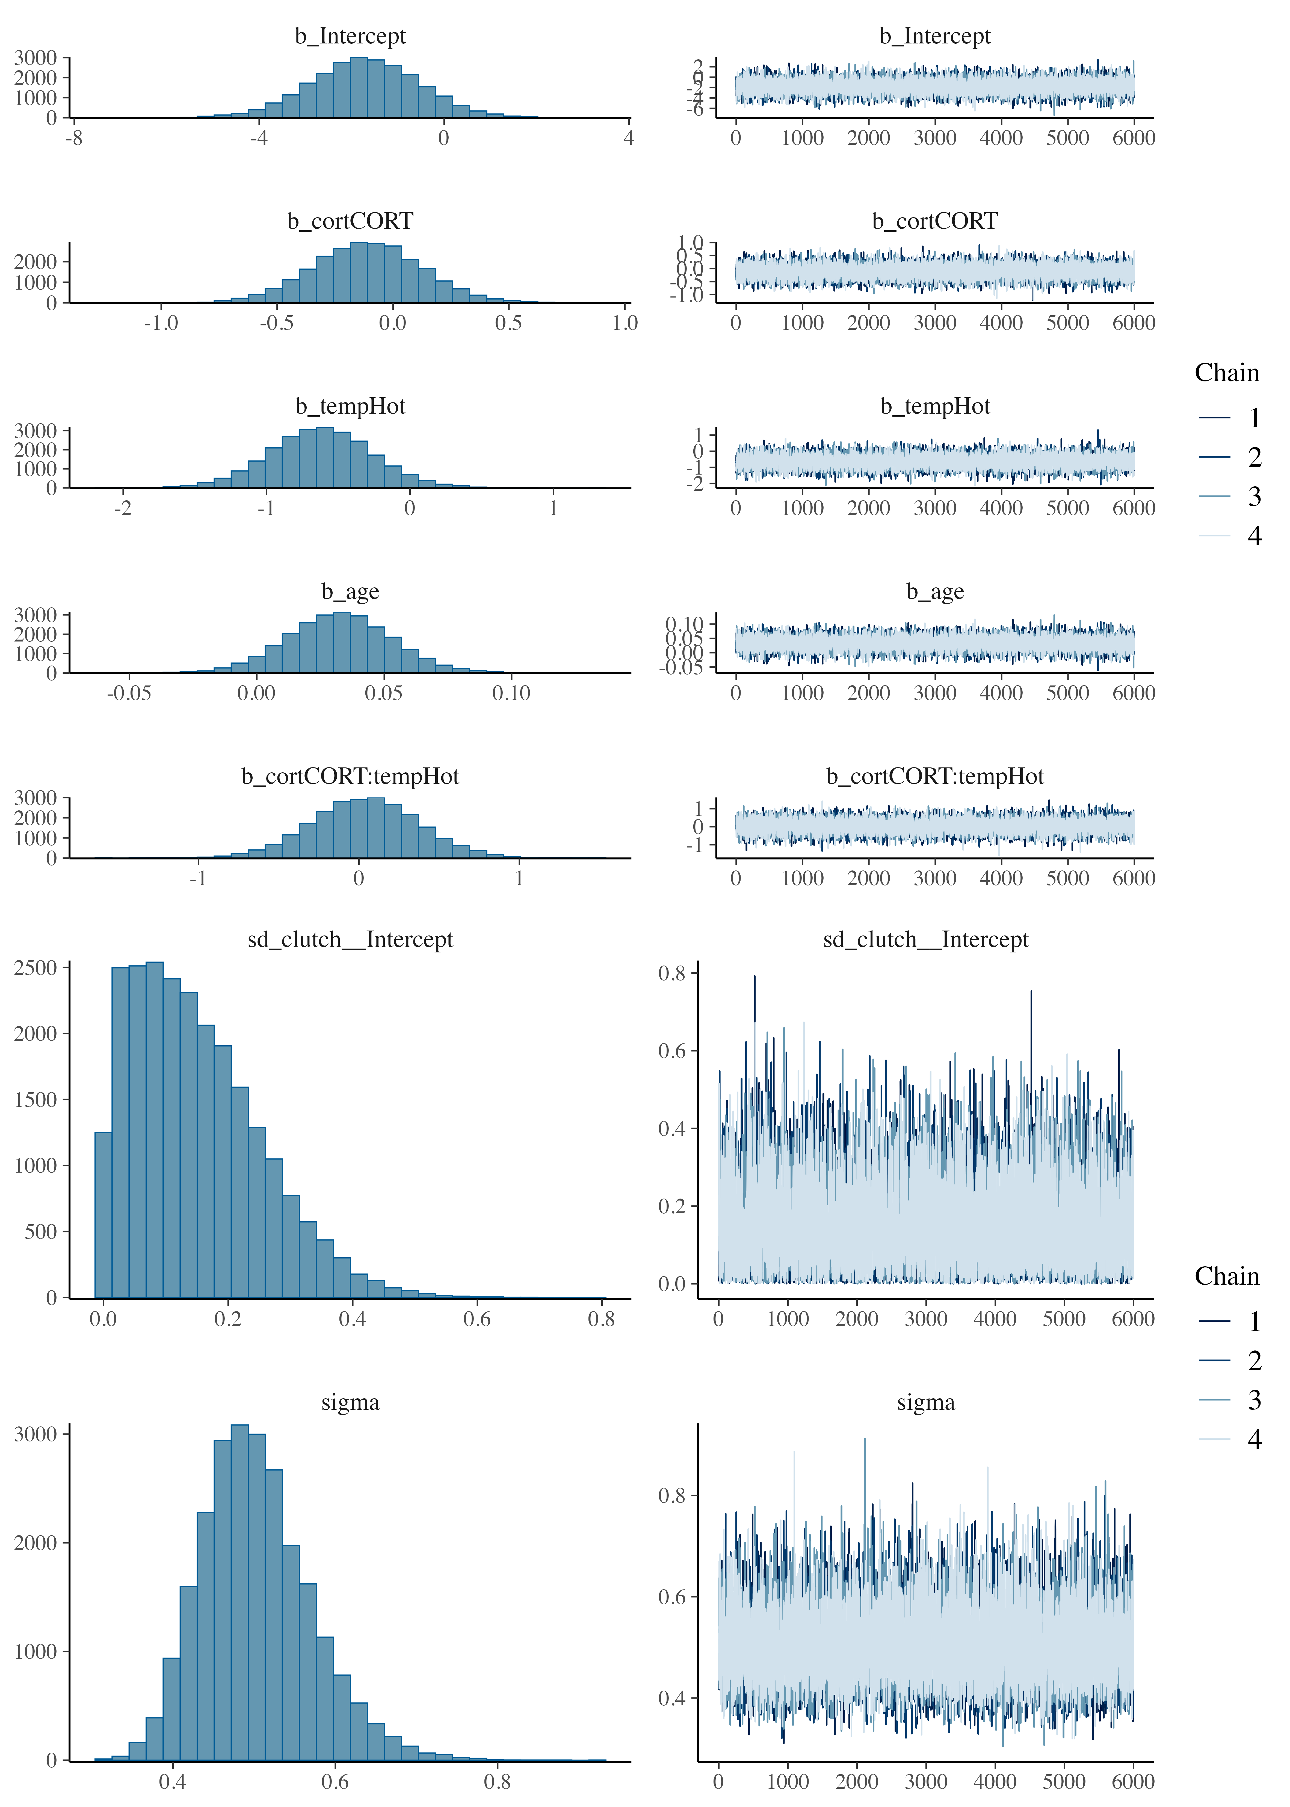

Figure S6. Posterior predictive checks for the model of lipid peroxidation. Formula: peroxidation ~ cort * temp + (1|clutch)

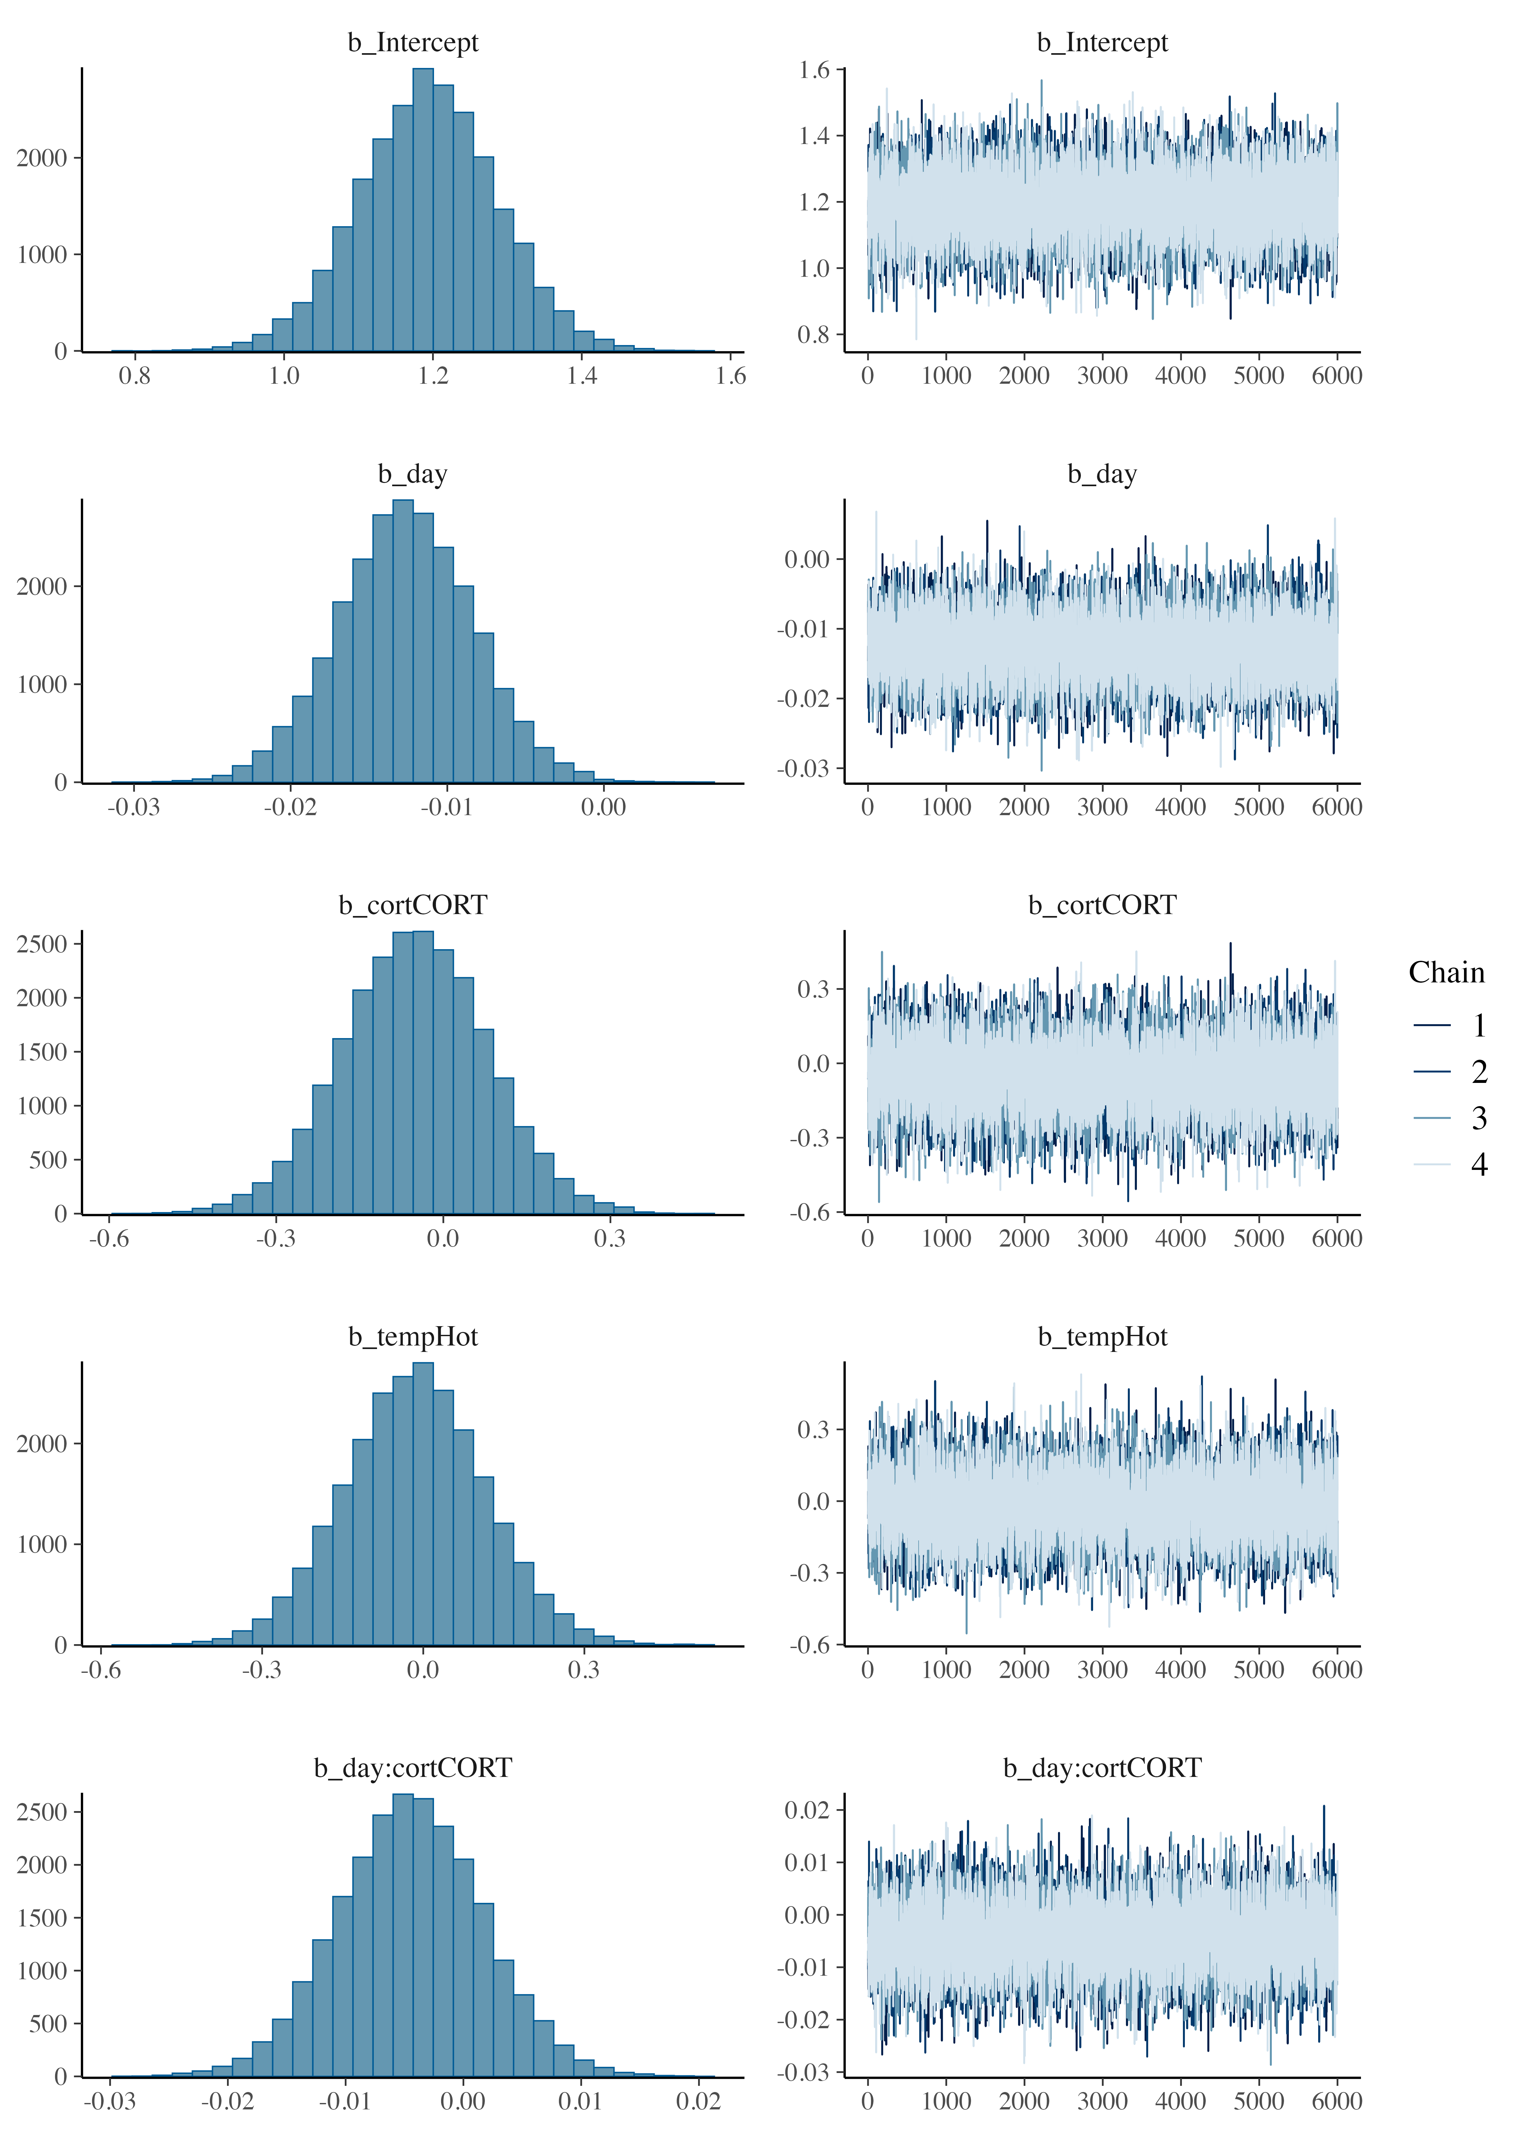

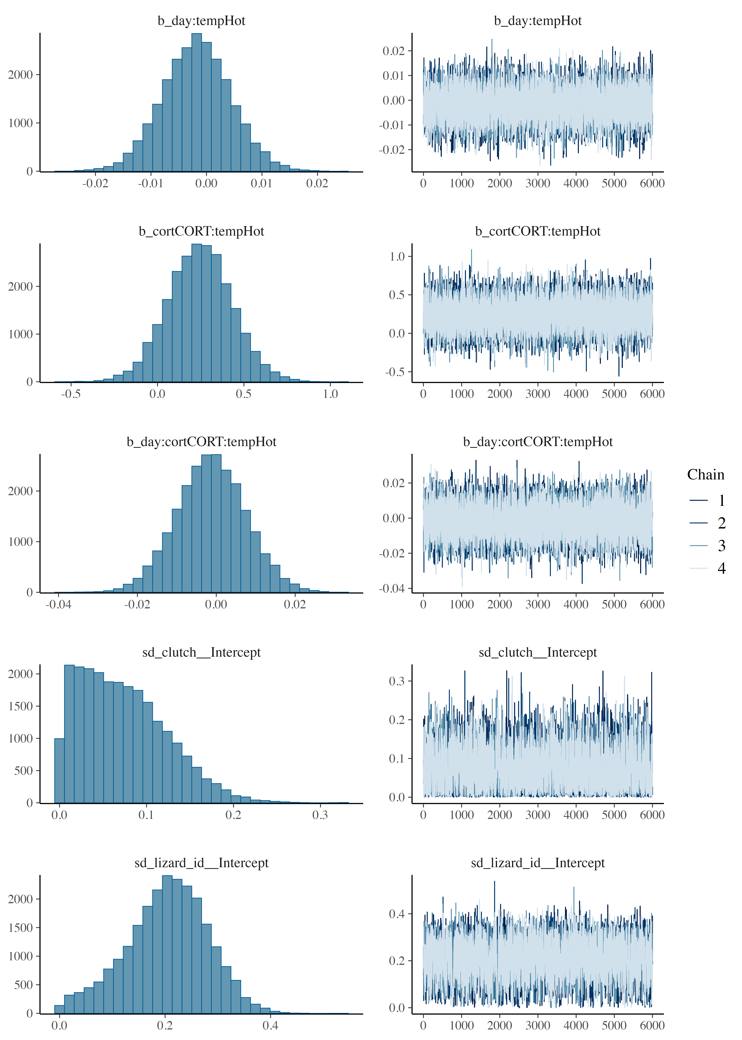

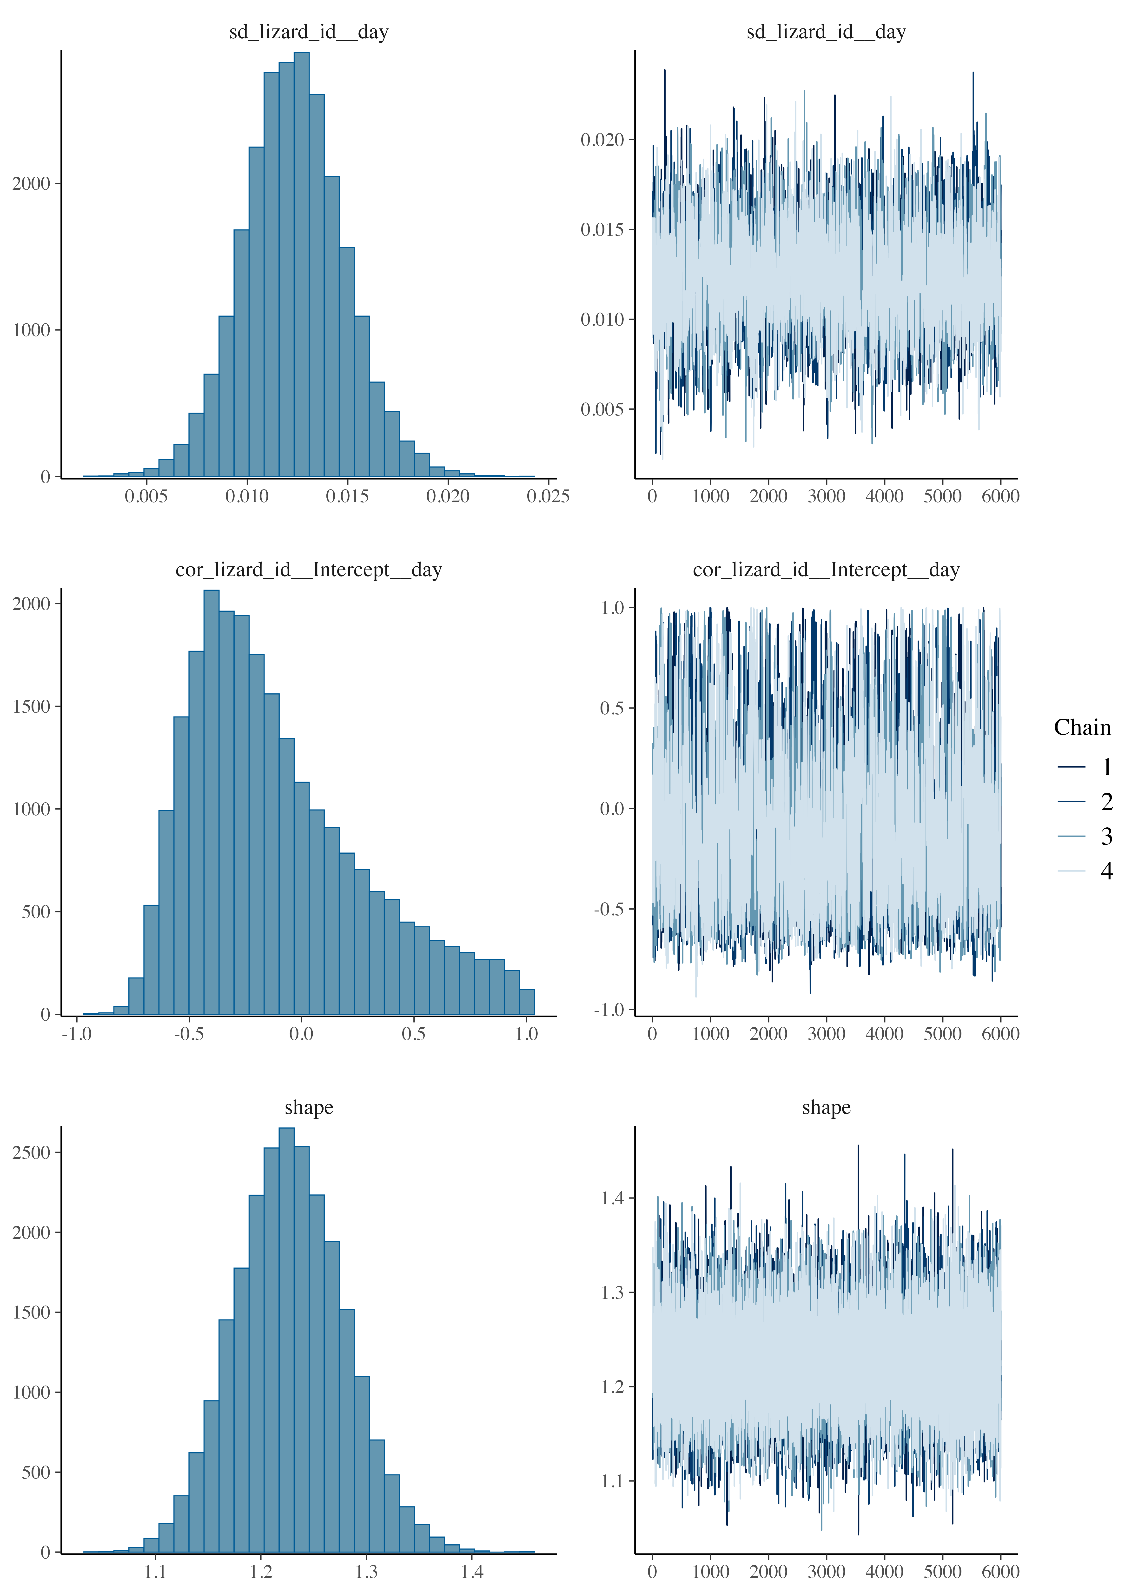

Figure S7. Posterior predictive checks for the model of spatial learning. Formula: errors ~ day * cort * temp + (1 + day|lizard_id) + (1|clutch)

Results of preliminary models
Table S5. Preliminary results of the models testing for Mitochondrial Density.
variable | mean | median | sd | mad | q5 | q95 | rhat | ess_bulk | ess_tail
b_Intercept | 0.470 | 0.460 | 0.866 | 0.855 | -0.947 | 1.907 | 1 | 19,362.26 | 16,116.88
b_cortCORT | -0.054 | -0.055 | 0.161 | 0.160 | -0.316 | 0.211 | 1 | 23,841.57 | 18,938.53
b_tempHot | 0.177 | 0.175 | 0.255 | 0.254 | -0.240 | 0.598 | 1 | 18,264.83 | 15,601.67
b_age | -0.008 | -0.008 | 0.015 | 0.015 | -0.033 | 0.016 | 1 | 18,809.92 | 15,827.44
b_sexm | -0.012 | -0.012 | 0.122 | 0.122 | -0.212 | 0.187 | 1 | 32,791.21 | 19,114.69
b_cortCORT:tempHot | -0.163 | -0.161 | 0.234 | 0.231 | -0.547 | 0.219 | 1 | 23,053.19 | 18,337.06
Model formula: mit_density ~ cort * temp + age + sex + (1|clutch). Model convergence was checked through rhat and ess_bulk values. Summary indicates no effect of sex or age, so they were discarded from the final models.

Table S6. Preliminary results of the models testing for Metabolic capacity.
variable | mean | median | sd | mad | q5 | q95 | rhat | ess_bulk | ess_tail
b_Intercept | 0.302 | 0.296 | 0.847 | 0.839 | -1.088 | 1.697 | 1 | 18,682.53 | 16,852.64
b_cortCORT | -0.095 | -0.094 | 0.166 | 0.165 | -0.369 | 0.178 | 1 | 22,493.38 | 18,602.43
b_tempHot | 0.092 | 0.091 | 0.248 | 0.247 | -0.315 | 0.501 | 1 | 18,415.30 | 16,061.12
b_age | -0.004 | -0.004 | 0.014 | 0.014 | -0.028 | 0.019 | 1 | 18,669.13 | 16,525.89
b_sexm | 0.017 | 0.016 | 0.126 | 0.125 | -0.191 | 0.225 | 1 | 31,266.98 | 17,493.28
b_cortCORT:tempHot | -0.137 | -0.137 | 0.242 | 0.240 | -0.534 | 0.258 | 1 | 21,436.04 | 16,972.70
Model formula: mit_potential ~ cort * temp + age + sex + (1|clutch). Model convergence was checked through rhat and ess_bulk values. Summary indicates no effect of sex or age, so they were discarded from the final models.

Table S7. Preliminary results of the models testing for ROS.
variable | mean | median | sd | mad | q5 | q95 | rhat | ess_bulk | ess_tail
b_Intercept | 0.441 | 0.439 | 0.845 | 0.846 | -0.938 | 1.829 | 1 | 19,954.88 | 17,733.51
b_cortCORT | -0.059 | -0.058 | 0.163 | 0.162 | -0.329 | 0.206 | 1 | 21,973.58 | 19,467.53
b_tempHot | 0.160 | 0.157 | 0.245 | 0.245 | -0.241 | 0.565 | 1 | 18,615.90 | 16,581.43
b_age | -0.007 | -0.007 | 0.014 | 0.014 | -0.031 | 0.016 | 1 | 19,777.02 | 17,300.71
b_sexm | 0.021 | 0.021 | 0.124 | 0.123 | -0.183 | 0.224 | 1 | 33,495.85 | 18,274.71
b_cortCORT:tempHot | -0.183 | -0.184 | 0.236 | 0.235 | -0.572 | 0.203 | 1 | 21,404.60 | 18,058.25
Model formula: ROS ~ cort * temp + age + sex + (1|clutch). Model convergence was checked through rhat and ess_bulk values. Summary indicates no effect of sex or age, so they were discarded from the final models.

Table S8. Preliminary results of the models testing for DNA damage.
variable | mean | median | sd | mad | q5 | q95 | rhat | ess_bulk | ess_tail
b_Intercept | -0.814 | -0.815 | 1.333 | 1.286 | -2.975 | 1.384 | 1 | 14,193.24 | 15,015.86
b_cortCORT | -0.286 | -0.287 | 0.249 | 0.244 | -0.695 | 0.125 | 1 | 16,764.42 | 17,646.72
b_tempHot | -0.278 | -0.280 | 0.402 | 0.393 | -0.936 | 0.384 | 1 | 12,803.98 | 14,601.59
b_age | 0.017 | 0.017 | 0.023 | 0.022 | -0.021 | 0.054 | 1 | 13,624.26 | 14,032.51
b_sexm | 0.030 | 0.031 | 0.185 | 0.181 | -0.274 | 0.330 | 1 | 20,984.11 | 17,159.64
b_cortCORT:tempHot | 0.108 | 0.107 | 0.355 | 0.350 | -0.475 | 0.690 | 1 | 14,479.58 | 15,703.47
Model formula: DNAdamage ~ cort * temp + age + sex + (1|clutch). Model convergence was checked through rhat and ess_bulk values. Summary indicates no effect of sex or age, so they were discarded from the final models.

Table S9. Preliminary results of the models testing for lipid peroxidation.
variable | mean | median | sd | mad | q5 | q95 | rhat | ess_bulk | ess_tail
b_Intercept | -1.960 | -1.944 | 1.280 | 1.237 | -4.098 | 0.117 | 1 | 17,308.48 | 15,369.02
b_cortCORT | -0.139 | -0.139 | 0.242 | 0.237 | -0.537 | 0.256 | 1 | 17,466.19 | 16,492.63
b_tempHot | -0.691 | -0.691 | 0.386 | 0.374 | -1.328 | -0.056 | 1 | 14,335.87 | 14,037.45
b_age | 0.036 | 0.036 | 0.022 | 0.021 | 0.000 | 0.073 | 1 | 16,551.88 | 15,440.72
b_sexm | 0.119 | 0.119 | 0.179 | 0.175 | -0.171 | 0.414 | 1 | 23,967.02 | 17,240.50
b_cortCORT:tempHot | 0.051 | 0.049 | 0.337 | 0.330 | -0.508 | 0.603 | 1 | 18,089.57 | 17,414.62
Model formula: peroxidation ~ cort * temp + age + sex + (1|clutch). Model convergence was checked through rhat and ess_bulk values. Summary indicates no effect of sex, so it was discarded from the final models. However, we saw an effect of age and we included it in our final models.

Table S10. Preliminary results of the models testing for learning.
variable | mean | median | sd | mad | q5 | q95 | rhat | ess_bulk | ess_tail
b_Intercept | 1.350 | 1.348 | 0.546 | 0.537 | 0.455 | 2.256 | 1 | 14,157.443 | 16,878.70
b_day | -0.013 | -0.013 | 0.004 | 0.004 | -0.020 | -0.005 | 1 | 9,398.846 | 13,567.40
b_cortCORT | -0.054 | -0.052 | 0.134 | 0.136 | -0.275 | 0.164 | 1 | 10,693.409 | 14,518.00
b_tempHot | 0.023 | 0.022 | 0.180 | 0.178 | -0.269 | 0.322 | 1 | 10,924.742 | 15,119.67
b_sexm | -0.005 | -0.005 | 0.080 | 0.079 | -0.136 | 0.128 | 1 | 16,727.891 | 17,160.45
b_age | -0.003 | -0.003 | 0.009 | 0.009 | -0.018 | 0.012 | 1 | 13,505.073 | 16,391.78
b_day:cortCORT | -0.004 | -0.005 | 0.006 | 0.006 | -0.015 | 0.006 | 1 | 9,216.274 | 12,908.06
b_day:tempHot | -0.002 | -0.002 | 0.006 | 0.006 | -0.012 | 0.008 | 1 | 9,945.670 | 13,744.26
b_cortCORT:tempHot | 0.242 | 0.241 | 0.194 | 0.194 | -0.076 | 0.563 | 1 | 10,111.700 | 14,279.42
b_day:cortCORT:tempHot | 0.000 | 0.000 | 0.009 | 0.009 | -0.015 | 0.014 | 1 | 9,169.257 | 12,700.42
Model formula: errors ~ day * cort * temp + sex + age+ (1 + day | lizard_id) + (1|clutch). Model convergence was checked through rhat and ess_bulk values. Summary indicates no effect of sex or age, so they were discarded from the final models.

Brain validation
To ensure that neurons were not unintentionally lost during homogenization, we performed a pilot study where we euthanized four lizards and prepared medial cortex homogenates using the same procedures as before. However, to ensure we could identify neurons, homogenates here were dyed with marker that specifically targeted neuron nuclei (Farrow et al., 2021; Storks et al., 2023). We employed fluorescence microscopy and flow cytometry to check for the presence of neurons in the homogenates.
Euthanasia and homogenization for each of brain region followed the procedures outlined above (see Methods 2: Flow cytometry). Before staining the samples, cells were also fixed and permeabilized as described previously (see Methods 2: Flow cytometry). Following permeabilization, we centrifuged the samples at 1000 RCF for 10 minutes and resuspended the pellet in 100 µL of a 1:100 dilution of NeuN + Alexa488 fluorescent conjugate to dye the neuronal nuclei (Farrow et al., 2021; Storks et al., 2023). The samples were incubated at +4 ºC overnight.
The following day we centrifuged the samples at 1000 RCF for 10 minutes and resuspended the pellet in 100 µL of PBS. Samples were split in two: 50 µL from each was reserved for examination under a Zeiss AxioObserver Z1 microscope, while the remaining 50 µL from each sample was pooled into a single tube for flow cytometry analysis. . Flow cytometry of stained cells allowed us to validate that our gating strategy was correct.
Samples examined under the microscope showed a clear presence of neuronal nuclei in the homogenates (Figure S13). Flow cytometry analysis also confirmed the presence of neuronal nuclei in the homogenates, that were similar to the size of the cells employed in the experiment (mean size cells experiment = 2.765; 95% CI = [2.093, 3.139], n = 80; size neurons = 3.977495).
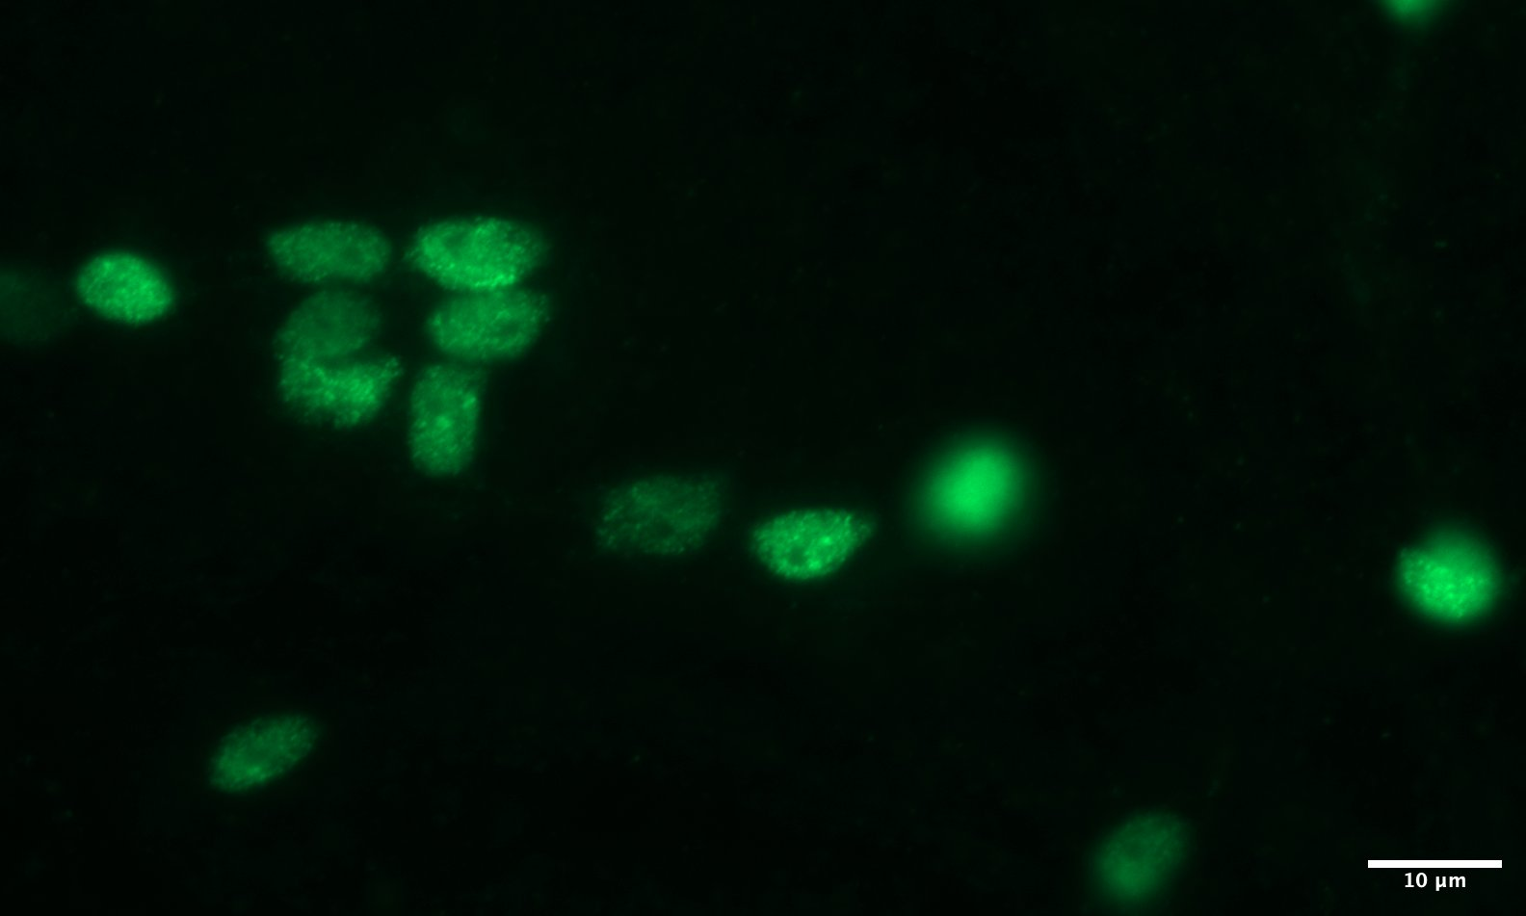
Figure S8. Fluorescence microscopy image of neuron nuclei stained with NeuN-Alexa 488. Images were taken on a Zeiss AxioObserver Z1, equipped with Zeiss Axiocam 506 monochrome camera. A Zeiss 38HE fluorescent filter set (450-490nm Ex, 500-550nm Em.) was used in conjunction with a 63x 1.4 NA.

REFERENCES
Farrow, L. F., Andronicos, N. M., McDonald, P. G. and Hamlin, A. S. (2021). Quantitative determination of neuronal size and density using flow cytometry. Journal of Neuroscience Methods, 352, 109081.
Storks, L., Powell, B. J. and Leal, M. (2023). Peeking inside the lizard brain: neuron numbers in Anolis and its implications for cognitive performance and vertebrate brain evolution. Integrative and Comparative Biology, 63(1), 223-237.

