**Table S1**

Estimates of reversal learning slope for all the different treatments per each task, species and group

| Species | Treatment | Mean | 95% CI | pmcmc |
| --- | --- | --- | --- | --- |
| *L. delicata* | CORT-Cold (*N* = 11) | **0.041** | **0.023, 0.058** | **< 0.001** |
| *N* = 47 | Control-Cold (*N* = 12) | **0.062** | **0.044, 0.081** | **< 0.001** |
| Obs = 1880 | CORT-Hot (*N* = 12) | **0.057** | **0.039, 0.075** | **< 0.001** |
|  | Control-Hot (*N* = 12) | **0.045** | **0.026, 0.063** | **< 0.001** |
| *L. guichenoti* | CORT-Cold (*N* = 10) | **0.048** | **0.024, 0.073** | **< 0.001** |
| *N* = 37 | Control-Cold (*N* = 7) | **0.061** | **0.032, 0.093** | **< 0.001** |
| Obs = 1480 | CORT-Hot (*N* = 10) | **0.065** | **0.041, 0.090** | **< 0.001** |
|  | Control-Hot (*N* = 10) | **0.062** | **0.038, 0.088** | **< 0.001** |

The mean shows the arithmetic means of the estimates obtained from the posteriors of the model, and 95% CI indicates the 95% confidence interval of the mean. All pmcmc tested the hypothesis that the mean equals zero. In bold, those values that are significant (pmcmc < 0.05).

**Table S2**

Estimates of reversal learning slope for all the different treatments per each task, species and group

| Species | Treatment | Mean | 95% CI | pmcmc |
| --- | --- | --- | --- | --- |
| *L. delicata* | CORT-Cold (*N* = 4) | **0.052** | **0.021, 0.084** | **< 0.05** |
| *N* = 19 | Control-Cold (*N* = 5) | **0.067** | **0.038, 0.096** | **< 0.001** |
| Obs = 760 | CORT-Hot (*N* = 3) | **0.073** | **0.036, 0.113** | **< 0.001** |
|  | Control-Hot (*N* = 7) | **0.046** | **0.023, 0.070** | **< 0.001** |
| *L. guichenoti* | CORT-Cold (*N* = 3) | **0.068** | **0.012, 0.124** | **< 0.05** |
| *N* = 18 | Control-Cold (*N* = 3) | **0.086** | **0.032, 0.147** | **< 0.05** |
| Obs = 720 | CORT-Hot (*N* = 5) | **0.072** | **0.030, 0.115** | **< 0.05** |
|  | Control-Hot (*N* = 7) | **0.066** | **0.031, 0.104** | **< 0.001** |

Here, we included only those individuals who made the right choice in 8 out of the last 10 trials in the previous associative task. The mean shows the arithmetic means of the estimates obtained from the posteriors of the model, and 95% CI indicates the 95% confidence interval of the mean. All pmcmc tested the hypothesis that the mean equals zero. In bold, those values that are significant (pmcmc < 0.05).

**Figure S1.** Probability of choosing correctly over trials for each of the treatments and species. The dots represent the proportion of individuals per trial that chose correctly while the lines show the mean predicted probability of choosing correctly, estimated using the posteriors of our model.

**Table S3**

Number of individuals per treatment and species that reached a learning criterion of 5 consecutive correct choices (no. of lizards) and the average of trials taken (Trial) together with the standard deviation (SD)

| Species | Treatment | No. of lizards | Mean | SD |
| --- | --- | --- | --- | --- |
| *L. delicata* | Control-Cold | 9 | 25.89 | 5.84 |
|  | CORT-Cold | 6 | 21.17 | 8.80 |
|  | Control-Hot | 2 | 33.50 | 9.19 |
|  | CORT-Hot | 4 | 24.25 | 13.20 |
| *L. guichenoti* | Control-Cold | 3 | 28.00 | 5.20 |
|  | CORT-Cold | 4 | 26.00 | 12.36 |
|  | Control-Hot | 8 | 22.62 | 9.47 |
|  | CORT-Hot | 6 | 28.33 | 9.69 |

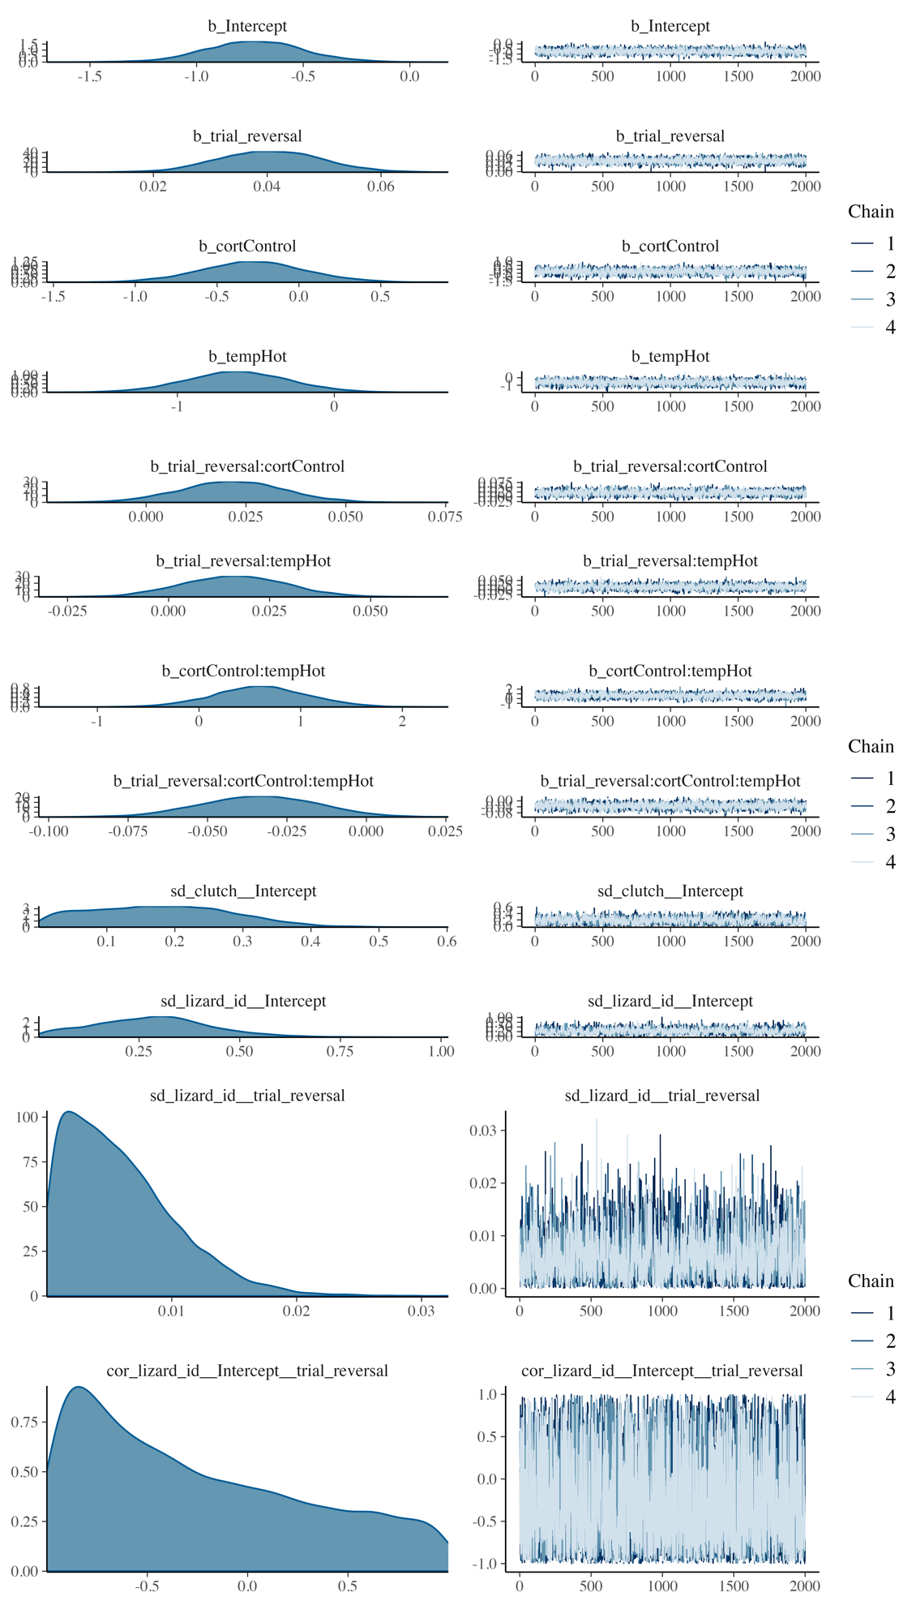

**Figure S2.** Model plot for *L. delicata*. Model formula: Choice ~ trial_reversal*cort*temp + (1 + trial_reversal|lizard_id).

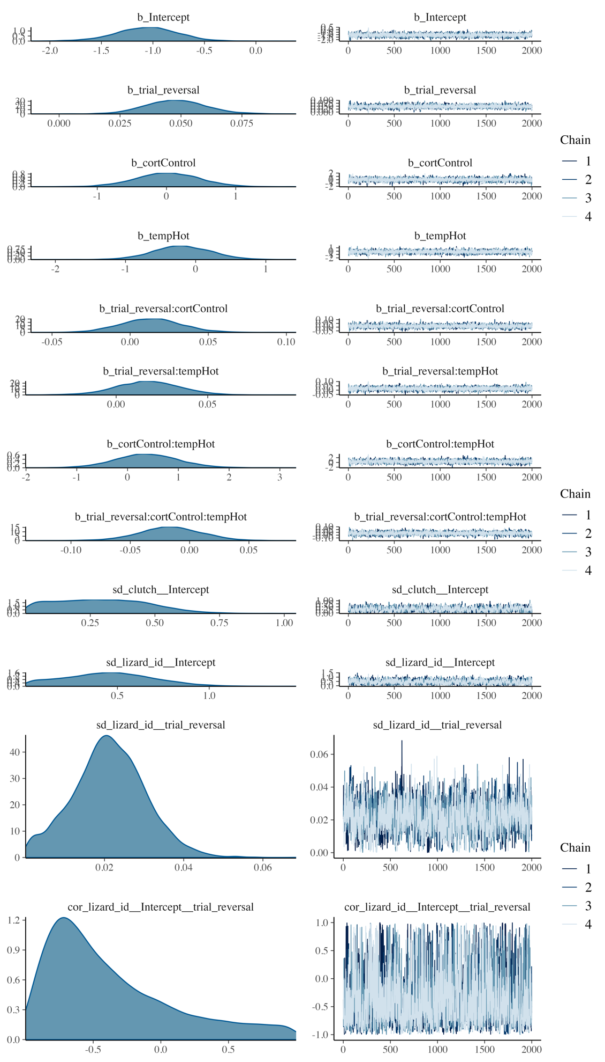

**Figure S3.** Model plot for *L. guichenoti*. Model formula: Choice ~ trial_reversal*cort*temp + (1 + trial_reversal|lizard_id).

**Table S4**

Results for *Lampropholis delicata* when the model included the age

| Predictors | Estimate | | Est. error | | l-95% CI | | u-95% CI | | Rhat | | Bulk_ESS | | Tail_ESS | |
| --- | --- | --- | --- | --- | --- | --- | --- | --- | --- | --- | --- | --- | --- | --- |
| Intercept | −0.68 | | 0.23 | | −1.14 | | −0.22 | | 1.00 | | 3099.14 | | 5364.68 | |
| age.start | 0.00 | | 0.00 | | −0.00 | | 0.01 | | 1.00 | | 7524.39 | | 6689.19 | |
| trial_reversal | | 0.04 | | 0.01 | | 0.02 | | 0.06 | | 1.00 | | 3033.03 | | 5261.65 |
| cortControl | | −0.34 | | 0.32 | | −0.99 | | 0.30 | | 1.00 | | 2845.28 | | 4978.49 |
| tempHot | | −0.69 | | 0.33 | | −1.33 | | −0.05 | | 1.00 | | 2868.81 | | 4595.09 |
| trial_reversal:cortControl | | 0.02 | | 0.01 | | −0.00 | | 0.05 | | 1.00 | | 2939.03 | | 4497.28 |
| trial_reversal:tempHot | | 0.02 | | 0.01 | | −0.01 | | 0.04 | | 1.00 | | 2759.31 | | 4331.14 |
| cortControl:tempHot | | 0.64 | | 0.46 | | −0.24 | | 1.56 | | 1.00 | | 2786.33 | | 4315.03 |
| trial_reversal:cortControl:tempHot | | −0.03 | | 0.02 | | −0.07 | | 0.00 | | 1.00 | | 2849.12 | | 4135.58 |

**Table S5**

Results for *Lampropholis guichenoti* when the model included the age

| Predictors | Estimate | Est. error | l-95% CI | u-95% CI | Rhat | Bulk_ESS | Tail_ESS |
| --- | --- | --- | --- | --- | --- | --- | --- |
| Intercept | −0.94 | 0.32 | −1.59 | −0.32 | 1.00 | 4613.34 | 5435.92 |
| age.start | 0.01 | 0.01 | −0.01 | 0.02 | 1.00 | 7490.80 | 6179.03 |
| trial_reversal | 0.05 | 0.01 | 0.02 | 0.07 | 1.00 | 4170.12 | 4876.09 |
| cortControl | −0.01 | 0.46 | −0.92 | 0.92 | 1.00 | 4008.70 | 4602.77 |
| tempHot | −0.33 | 0.45 | −1.19 | 0.57 | 1.00 | 4124.09 | 4611.95 |
| trial_reversal:cortControl | 0.01 | 0.02 | −0.02 | 0.05 | 1.00 | 3933.61 | 4885.22 |
| trial_reversal:tempHot | 0.02 | 0.02 | −0.02 | 0.05 | 1.00 | 4123.86 | 4555.44 |
| cortControl:tempHot | 0.35 | 0.63 | −0.93 | 1.58 | 1.00 | 3791.58 | 4842.61 |
| trial_reversal:cortControl:tempHot | −0.02 | 0.03 | −0.07 | 0.03 | 1.00 | 3623.25 | 4622.64 |

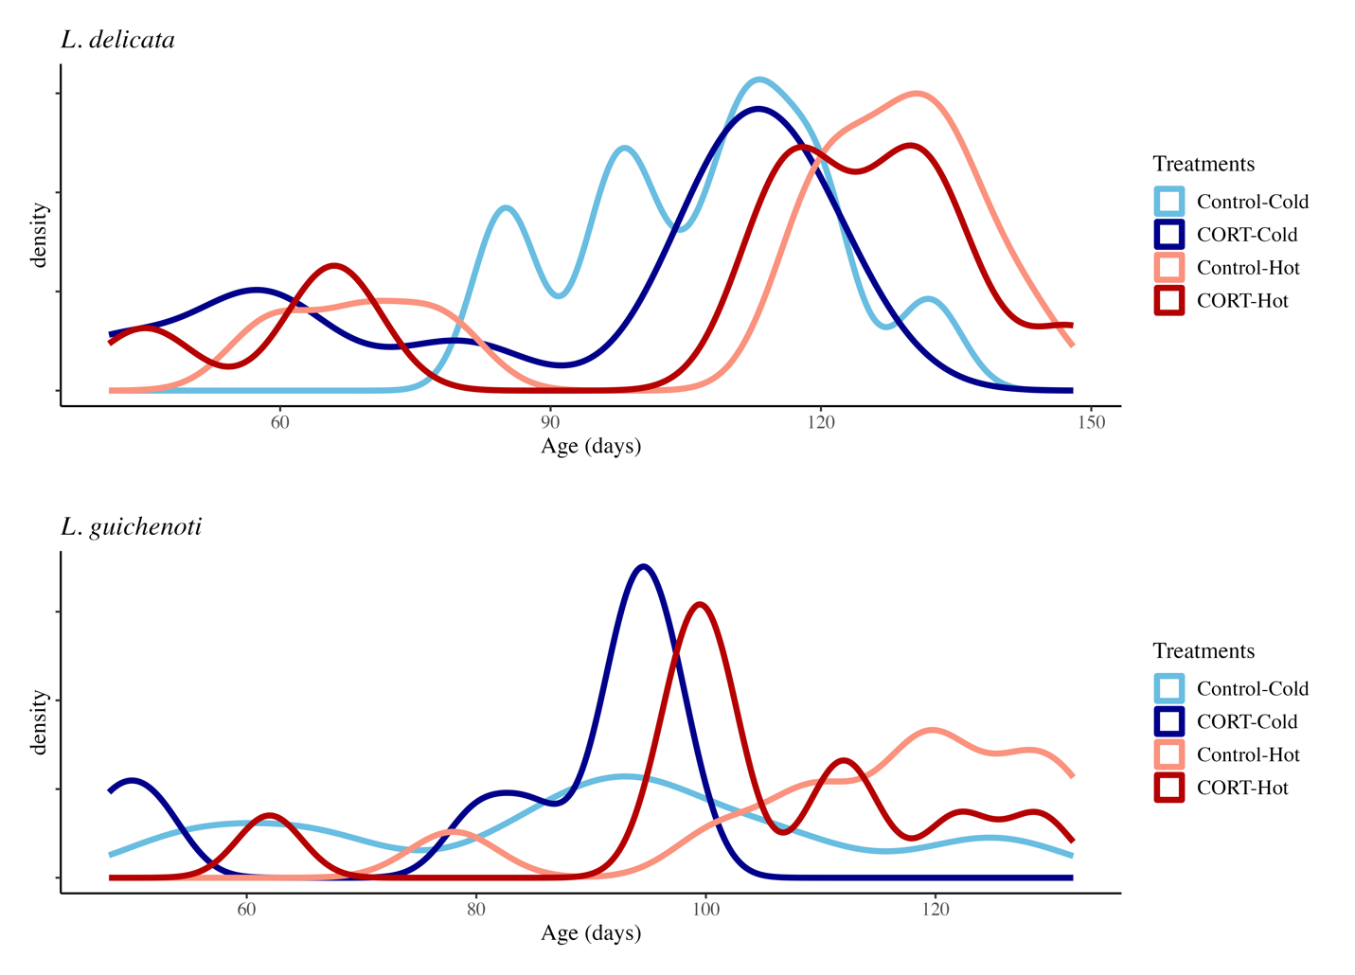

**Figure S4**. Distribution of the age of the lizards by treatment and species.