GEEMINATIVO-J.P.R

Usuario

2023-05-26

#Juan Pablo Bravo Gonzalez  
  
#25 de Mayo  
  
#Importar Datos  
  
setwd("C:/Users/Usuario.PC13/Documents")  
plantas <- read.csv("JuanPablo/Plantas.csv" , header = TRUE)  
plantas$trat <- as.factor(plantas$trat)  
  
#Grafica  
  
boxplot(plantas$PG ~ plantas$trat,  
 col= "red",  
 xlab = "TRATAMIENTOS GERMINATIVOS" ,  
 ylab = "% GERMINACION")

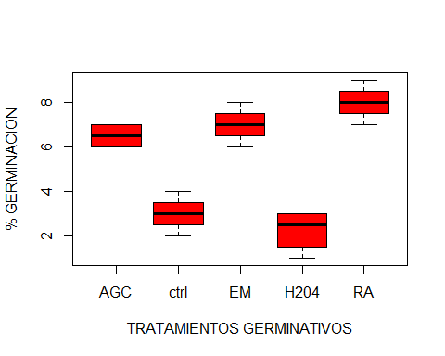

#Ordenar Tratamientos  
levels(plantas$trat)

## [1] "AGC" "ctrl" "EM" "H204" "RA"

plantas$trat <- factor(plantas$trat, levels = c("ctrl", "EM", "RA", "AGC", "H204" ))  
levels(plantas$trat)

## [1] "ctrl" "EM" "RA" "AGC" "H204"

tapply(plantas$PG, plantas$trat, mean)

## ctrl EM RA AGC H204   
## 3.00 7.00 8.00 6.50 2.25

tapply(plantas$PG, plantas$trat, var)

## ctrl EM RA AGC H204   
## 0.6666667 0.6666667 0.6666667 0.3333333 0.9166667

#Anova  
  
plantas.aov <- aov(plantas$PG ~ plantas$trat)  
summary(plantas.aov)

## Df Sum Sq Mean Sq F value Pr(>F)   
## plantas$trat 4 104.80 26.20 40.31 7.42e-08 ***  
## Residuals 15 9.75 0.65   
## ---  
## Signif. codes: 0 '***' 0.001 '**' 0.01 '*' 0.05 '.' 0.1 ' ' 1

#Prueba de Tuckey  
TukeyHSD(plantas.aov, conf.level = 0.95)

## Tukey multiple comparisons of means  
## 95% family-wise confidence level  
##   
## Fit: aov(formula = plantas$PG ~ plantas$trat)  
##   
## $`plantas$trat`  
## diff lwr upr p adj  
## EM-ctrl 4.00 2.2396122 5.7603878 0.0000356  
## RA-ctrl 5.00 3.2396122 6.7603878 0.0000024  
## AGC-ctrl 3.50 1.7396122 5.2603878 0.0001587  
## H204-ctrl -0.75 -2.5103878 1.0103878 0.6862491  
## RA-EM 1.00 -0.7603878 2.7603878 0.4332120  
## AGC-EM -0.50 -2.2603878 1.2603878 0.9009428  
## H204-EM -4.75 -6.5103878 -2.9896122 0.0000045  
## AGC-RA -1.50 -3.2603878 0.2603878 0.1140897  
## H204-RA -5.75 -7.5103878 -3.9896122 0.0000004  
## H204-AGC -4.25 -6.0103878 -2.4896122 0.0000175

##Entre EM- ctrl diferencia de 4% y si hay diferencia  
##Entre RA- ctrl diferencia de 5% y si hay diferencia  
##Entre AGC- ctrl diferencia de 3.5% y si hay diferencia  
  
plot(TukeyHSD(plantas.aov), las= 1, col="blue")

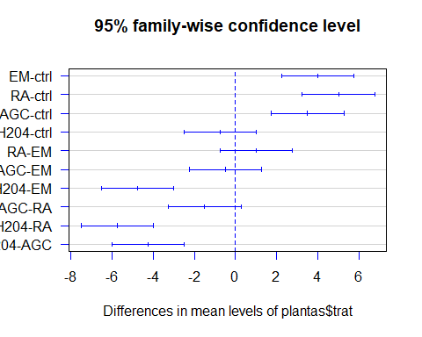

#Agregar letras de diferencia  
  
boxplot(plantas$PG ~ plantas$trat,  
 col= "red",  
 xlab = "TRATAMIENTO GERMINATIVO",  
 ylab= "% GERMINACION",  
 ylim= c(0,10))  
text(1,4.2, "A", col= "green")  
text(2,8.3, "B", col= "orange")  
text(3,9.4, "B", col= "orange")  
text(4,7.4, "B", col= "orange")  
text(5,3.3, "A", col= "green")

