# Demo heading, level 1

1. First item in ordered list
2. Second item in ordered list

|  |  |  |
| --- | --- | --- |
| **Qty** | **Id** | **Desc** |
| 3 | 101 | Spam |
| 7 | 422 | Eggs |
| 4 | 631 | Spam, spam, eggs, and spam |

Good Morning every body,This is my graph : 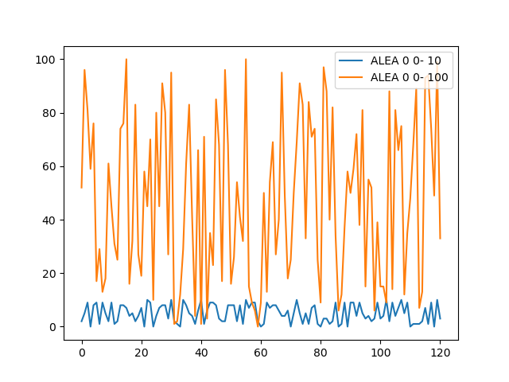Demo image with demo data