Online adaption approaches for intensity modulated proton therapy for head and neck patients based on cone beam CTs and Monte Carlo simulations

1 Introduction

Head and neck (H&N) tumors are often very close to organs at risk (OARs) such as the parotids, larynx, submandibular glands or others. Due to this, H&N cases may benefit from steep dose gradients in the planned dose distribution to better spare the OARs while giving therapeutic doses to the target. Intensity modulated proton therapy (IMPT) is capable of producing such steep gradients while also reducing the integral dose, offering dosimetric benefits over photon treatments [Lee 2018, waddlw 2018]. However, proton plans, and in particular IMPT plans, can be very sensitive to geometrical changes that may distort the planned dose distribution impacting the treatment quality [Ahn, Paganetti ...]. There are several reasons why the patient’s geometry might be different from the one used for the planned dose distribution, e.g. uncertainties in patient setup or interfractional anatomy changes. The setup uncertainty arises from the patient location on the treatment couch being different to the one recorded in the planning CT. The anatomy changes arises from the patient anatomy evolution throughout the course of treatment, not only due to loss of weight modifying subcutaneous tissue and/or structure locations, but also due to the posture on the treatment couch. Both uncertainty sources might modify the radiological pathway, by introducing high/low density materials in the beamlet’s path, affecting the planned dose distribution and affecting the planned target coverage and OAR sparing. This is particularly true in proton therapy due to the impact of uncertainties and geometrical changes on the predicted range of each beamlet.
These uncertainty sources are usually taken into account during the planning procedure with the creation of margins (PTV plus range margin) around the target in an attempt to guarantee treatment quality throughout the fractions. As a consequence, the high dose volume in the patient is enlarged and organs at risk (OARs) receive higher doses. It is therefore desirable to shrink the margin to improve IMPT plan quality. Additionally, this method does not guarantee the planning standards throughout the treatment. An alternative to the target expansion is to perform robust IMPT optimization, which entails optimizing the plan considering different patient scenarios at the same time. With this approach, the resultant plan provides target coverage within OAR constraints at delivery, as long as the current patient characteristics were included as a scenario during the optimization. If the current patient anatomy and position were not considered in the optimization, then the treatment is stopped and the patient is re-planned. Nevertheless, robust optimization is able to maintain the original plan standards better than the margin approach in the general case. However, robust planning usually softens dose gradients, which, again, results in enlarged high dose volumes and higher dose to OARs compared to a plan performed in a single scenario. Uncertainties can also be minimized by careful selection of beam angles, but this does not offer a general solution to account for setup and anatomy uncertainties and shrink margins at the same time.
Two solutions that might fulfill both requirements are to either perform online IMPT plan adaptation at every fraction or to perform offline treatment re-planning in scenarios when the robust IMPT plan does not fulfill treatment constraints and prescriptions. Online adaptation has the advantages that the treatment delivery is not delayed and that it accounts for the current setup and anatomy, potentially allowing margin reduction, therefore being the ideal solution.
The goal of online plan adaptation is to correct the original IMPT plan to account for patient setup and anatomy at each fraction. The method would require an imaging system capable of providing the patient anatomy at treatment position and an updated set of contours localizing the target and OARs. There are currently three main options to provide the patient anatomy information: performing a new CT in treatment position, using the information of a cone beam CT (CBCT) to deform the original CT or using a CBCT [REFS, REFS, REFS]. However, an adaptation algorithm should be agnostic of the image source. With the new image, an algorithm would then generate an appropriate set of new or modified beamlets for the new geometry. All these steps should occur in a few minutes to fit into the clinical workflow.
Several studies have reported on online and offline IMPT adaptation. Automatic offline full plan reoptimization for H&N cases on deformed planning CT and contours was reported by [KURZ 2016], where new beamlet maps were created and optimized. Jagt et al. [JAGT 2017] published an online dose restoration procedure that is capable of restoring the daily dose distribution to the original plan in prostate cases on the original contours, correcting the beamlet energies and fully reoptimizing the beamlet weights. Recently, Bernatowicz et al. [BERNATOWICZ 2018] extended the work presented by Jagt et at. to allow other reoptimization strategies, applying them to nasopharynx, H&N and lung (1 case each). These approaches rely on full plan reoptimization, which, in turn, requires the costly calculation of full dose-influence matrices. A different approach without full plan reoptimization was presented by Moriya et at. [MORIYA] in a different context. In this study the range shifter thickness was adapted in passive scattering plans for lung cancer. This methodology could be expected to have limited success if non-uniform energy shifts are needed, but it is an example of possible adaptation approaches that do not require full plan reoptimization. In summary, previous work either did not apply an online algorithm (Kurz et al.), did not consider deformed contours (Jagt et al. and Bernatowicz et al.) or was not tested for IMPT plans (Moriya et al.). Furthermore, none of the proposed methods include Monte Carlo simulations (MC) as dose calculation engine.
It has been shown that MC dose calculation significantly increases accuracy in proton therapy. In the case of H&N and other sites [GRASSBERGER lung and others], analytical dose calculations accuracy of proton beams might be compromised by tissue heterogeneity [JAN and many others]. If margins are intended to be reduced in H&N plans, MC-based adaptation is desirable. However, using MC calculations for online adaptation imposes time constrains on the design and applicability of the adaptation framework, as they are typically slower than analytical algorithms. Employing graphics processing units (GPU) for MC simulations and novel adaptation strategies, could potentially allow online IMPT plan adaptation on clinically applicable times.
The main goal of this work was to demonstrate the feasibility of online adaptation of IMPT plans on daily acquired cone beam CT (CBCT) scans of H&N patients, with automatically propagated deformed contours and using a GPU MC code, gPMC [XUN, NAN], as dose calculation engine. The adaptation would be applied while the patient is on the couch and could potentially allow margins reduction and reduction of the number of re-planning steps, increasing workflow efficiency. An immediate challenge of this goal was to design an algorithm that minimized the calculation burden to allow its online application. As a secondary goal, different adaptation approaches were studied. Some plan adaptation procedures may modify individual beamlet’s energy, drastically increasing the number of energy layers and possibly rendering the new plan undeliverable. Other approaches could be successful, yet simpler than using the delivery system to modify the energy and position of individual beamlets independently. Therefore, the utilization of range shifters and couch shifts was compared against the independent adaptation of individual beamlet’s energies and positions.

2 Methods

In this section, first, an adaptive delivery workflow is introduced to explain the adaptation algorithm. Next, based on patient data, different approaches applying the algorithm’s operation modes are explained along with the quantities selected to judge the performance.

2.1 Patient cohort and treatment planning
A representative set of 10 H&N patients with 5-7 CBCT each was studied, for a total of 60 cases. The CBCTs were taken weekly as opposed to daily, however, the same adaptation results would apply to daily scans. The set is summarized in table 1. All patients were treated with photons (IMRT), so new plans were created for IMPT. The plans were designed as 60 Gy(RBE) to the clinical target volume (CTV) delivered with no PTV or range margin considered in as many fractions as the number of available CBCTs per patient. A single homogeneous dose level was prescribed for the CTV, creating a more challenging scenario for the plan adaptation, as allowing higher dose in the innermost part of the CTV potentially reduces the cold spots in the periphery of the structure.
The tumor locations included larynx, oropharynx, mouth, tonsil, tongue and hypopharynx. Tumor volumes ranged from 9.0 to 116.5 cm³, with an average of 53.2 $±$ 38.4 cm³. Deformable image registration between the CT and the CBCTs was perform to obtain vector fields (VF) representing the patient evolution (further details in section 2.3). The contours were propagated from the original CT to the CBCTs by applying the VFs. For the purpose of this study, the VF and the warped contours were accepted as long as the VF was observed to map the structures with high tissue contrast (i.e. mandible, spinal cord, etc.) well from the planning CT to the CBCTs. In H&N cases, the target volume and some OARs are often very hard to delineate and, therefore, they were only required to present a smooth deformation (in terms of the VF nominal values and Jacobian) to be accepted as plausible. The target volume was observed to evolve throughout the CBCT sets. The dice similarity coefficient, measuring the overlap between the original target contour and the contour propagated to each CBCT, was on average 0.83 $±$ 0.09. The small dice coefficient value in patient 1 was due to the fact that this oropharynx case had a thin target and a small displacement caused a drop in this coefficient.

Pat. No. | Tumor location | N fields | N CBCTs | Plan CTV volume (cm³) | Average CTV vol. ratio change (min, max) | Average CTV dice (min, max)
1 | Oropharynx | 4 | 6 | 22.3 | 1.00 (0.97, 1.05) | 0.58 (0.50, 0.67)
2 | Tonsil | 2 | 6 | 9.0 | 1.02 (0.94, 1.12) | 0.87 (0.83, 0.90)
3 | Oropharynx | 3 | 7 | 30.7 | 0.93 (0.90, 1.00) | 0.82 (0.77, 0.88)
4 |  | 4 | 6 | 81.3 | 1.03 (0.98, 1.06) | 0.79 (0.75, 0.84)
5 | Hypopharynx | 3 | 5 | 59.6 | 0.97 (0.95, 0.98) | 0.89 (0.87, 0.91)
6 | Mouth | 3 | 7 | 116.5 | 0.78 (0.75, 0.82) | 0.87 (0.83, 0.90)
7 | Larynx | 3 | 6 | 25.0 | 1.21 (1.08, 1.34) | 0.84 (0.77, 0.88)
8 | Tongue | 4 | 5 | 79.9 | 1.06 (1.04, 1.11) | 0.87 (0.82, 0.91)
9 | Tonsil | 2 | 6 | 12.0 | 0.98 (0.95, 1.00) | 0.87 (0.83, 0.93)
10 | Oropharynx | 3 | 7 | 95.9 | 0.96 (0.91, 1.02) | 0.89 (0.85, 0.92)
Summary: | - | - | 60 | 53.2 $±$ 38.4 | 0.99 $±$ 0.11 | 0.83 $±$ 0.09
Table 1: Patient cohort.

The gPMC code was utilized as dose calculation engine to create the IMPT plans. This approach provided high accuracy at this step and a consistent framework throughout the study, avoiding systematic differences between the adapted plan evaluations also performed with gPMC and a treatment planning system (TPS). To create the IMPT plans, all the necessary information was extracted from the TPS, including non-optimized fluence maps. Dose-influence matrices ($D$ matrices) were created with gPMC and optimized with Opt4D, an in-house optimization tool originally developed for temporo-spatial studies (TROFIMOV, 2005). The optimization was perform with an implementation of the L-BFGS algorithm (Limited-memory . Beam angles were selected to spare OARs and avoid artifact regions in the CT and the set of CBCTs.

2.2 Adaptation workflow
The current planning-delivery workflow, shown in figure 1 from the planning stage to the left, is sensitive to the uncertainties of the patient positioning and anatomy, as explained in the introduction (uncertainties are represented with the red arrows). This may be solved by employing an adaptive workflow, shown in figure 1 from the planning stage to the right.

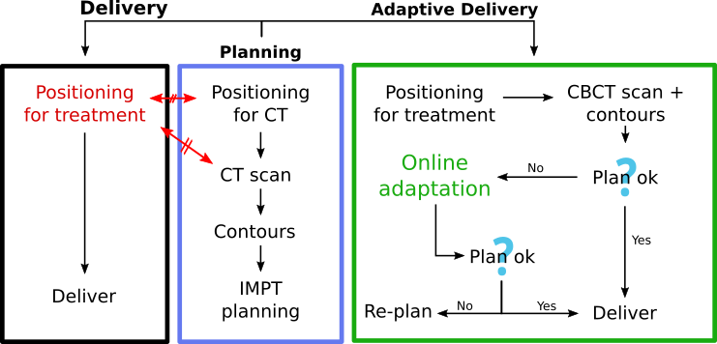
Figure 1: The usual (to the left) and adaptive (to the right) planning-delivery workflows. The red arrows indicate that the patient anatomy and setup might differ between the delivery and the planning stage.

The first step of such adaptive workflow would be to acquire information about the patient geometry immediately before treatment, including a possible automatic generation of contours. Then the original IMPT plan would be evaluated on the new patient geometry with a GPU MC simulation. If the clinical requirements were still met, then the plan would be delivered to the patient. However, if the clinical requirements were not met, the patient information would be used as inputs to an online adaptation algorithm. If the adaptation was successful, the patient would be treated, else, a re-planning and re-scheduling of treatment would be necessary. Our goal was to maintain high dose calculation accuracy at every step by using GPU MC simulations, therefore, gPMC was employed as dose calculation engine at the initial IMPT planning step, at the plan evaluation on the individual CBCTs and within the adaptation algorithm.

2.3 Imaging inputs: CBCT, vector field map and contours
The adaptation decision is based on the patient geometry as obtained by CBCT, a vector field (VF) mapping the original planning CT to the CBCT, and a set of new contours localizing the structures on the CBCT.
CBCTs are known to provide limited accuracy for dose calculation [REFERENCES]. In order to employ CBCT images for dose calculation, an a priori planning CT-based scatter-correction algorithm [PARK, KURZ 2015] was applied. Park et al. have reported average accumulated WEPL errors across different locations of 2.3 ± 1.9 %. The CT and CBCTs were aligned at the plan isocenter, which better maintains the target coverage of the original plan at every evaluation, as opposed to aligning to a given OAR. While we employed this method, our algorithm does not depend on it and would work the same if a given OAR needs to be prioritized instead.
The contours defined in the planning CT were propagated onto the CBCTs applying a VF. The VF map was calculated between the planning CT and the CBCT with deformable image registration (DIR) using the GPU parallelized B-spline algorithm in Plastimatch, an open source suite for radiotherapy and medical imaging [SHACKLEFORD, PLASTIMATCH]. The correctness of the structures on the CBCTs had to be visually verified because there is no automatic and reliable procedure to validate the structure contours for H&N cases [REFERENCE???]. The deformed contours were seen to represent the visible structures, while the contours of the non-visible structures were required to present smooth deformations (i.e. the VF nominal values and Jacobian was did not present steep gradients).
The accuracy of the CBCTs and the VFs employed in this our method manuscript does not affect the evaluation of the adaptation algorithm. It is understood that the CBCTs and VFs introduce uncertainties. However, even though the CBCTs and VFs may not perfectly represent the current patient geometry and deformation, they represent plausible and consistent geometries and deformations of the patient. As long as the geometry contained in the CBCTs isconsistent, the algorithm should be able to adapt the initial plan to it. The same argument can be applied to the VF and, therefore to the propagated contours. Improvement of CBCT accuracy and automatic propagation/generation of structure sets is still a research focus in the field [CITATIONS]. Several approaches have been followed regarding the imaging modality best suited to perform online adaptation. An alternative option as the one utilized here is to register and warp the planning CT to the CBCT. However, this method, for instance employed by Kurz et al [MORE EXAMPLES], has the issue that it has the accuracy of the VF which may not behave properly everywhere and may introduce artifacts, specially in the surface of the patient or in areas where the intensity contrast is low.

2.4 Adaptation algorithm
The adaptation algorithm was designed as two consecutive methods connected by a GPU based MC validation. First, the geometrical method adjusts the beamlets positions and energies, creating a geometrically adapted plan. The geometrically adapted plan is verified on the CBCT with GPU-MC. If the result is satisfactory, the plan is delivered, if not, the second adaptation method is applied, performing the weight tuning of the beamlets of the geometrically adapted plan. The algorithm performs the following steps:
- Geometrical adaptation method
- Verification with GPU-MC on CBCT
- Weights tuning (if necessary)
The algorithm was implemented in C++/OpenMP with the raytracing parallelized for NVIDIA GPUs with CUDA. The GPU MC code, gPMC, and the IMPT optimizer, Opt4D, were spawned as subprocesses, automatically providing the required inputs.

2.4.1 Geometrical adaptation
The geometrical adaptation method adjusted the position and energy of the beamlets to the new geometry.
The geometrical adaptation method steps are depicted in figure 2 (left). Each beamlet in the plan was raytraced along its central axis until the end of range in the planning CT (1). The locations resulting from the raytracing were called endpoints. To capture the heterogeneity of the patient’s tissue and the subsequent deformation of the Bragg peak, the density of each voxel along the central axis was averaged with its surroundings. The averaging procedure consisted of adding a set of 8 radial probes defined as an octagon on the orthogonal plane around the central axis, which contained the central probe. The radius of the octagon was equal to the σ of the beamlet profile (Gaussian) in water at the equivalent radiological depth. The radial probes weights were set from the same Gaussian profile. The angular position of the first radial probe was randomized. Because the patient deformation was captured in the VF, the set of original endpoints defined in the CT was warped applying the VF, yielding the position that should be occupied in the new geometry by each endpoint, and, therefore, by the high dose region of each beamlet (2). This was the same deformation previously applied to the contours propagation. The new position of each warped beamlet in the particle source plane was calculated next (3). Then, the shifted beamlets were raytraced in the CBCT applying the averaging procedure (4). Finally, the energies were adjusted to match the end of ranges in the CBCT with the warped endpoints (5).
In some cases, the endpoints in the original CT (step 1 in figure 2) were located far from the CTV. The VF would have been probed far from the CTV and the beamlets potentially moved a distance and a direction not representing the CTV deformation. To avoid this issue, the endpoints were forced to be within successive expanded CTVs called shells: CTV + 1.0, 1.5, 2.0 and 3.0 cm. Figure 2 (right) exemplifies this procedure. If the central axis of a beamlet entered the first shell (CTV+1.0cm), then its endpoint would be either its end-of-range position or its last position within this shell. If the central axis of a beamlet entered the second shell, but not the first one, then its endpoint would be either its end-of-range position or the its position within this shell. The same logic is applied to the other shells. This assures that the deformation of the CTV, or at least its vicinity, is applied to the beamlets.

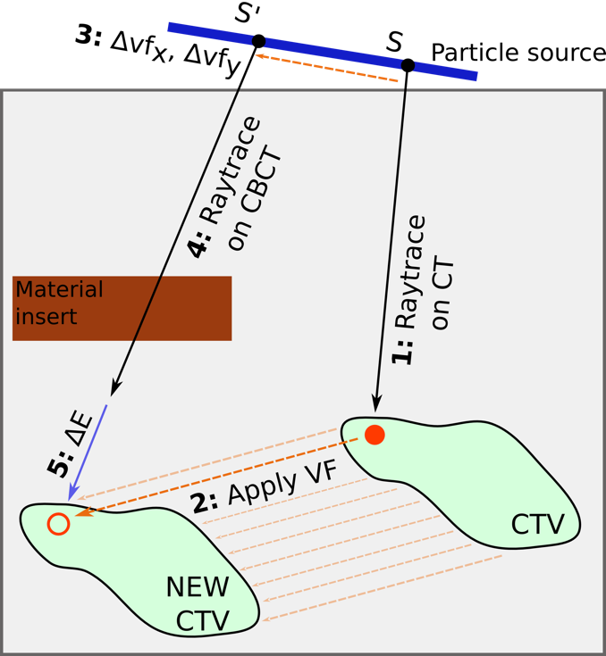 | 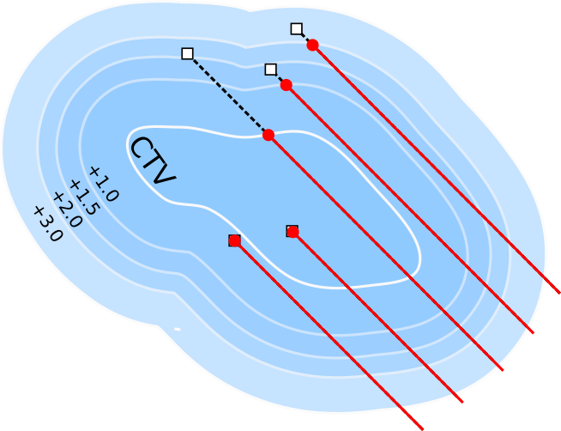
 | Figure 2: Left: Geometrical adaptation method. (see text for explanation). Right: Beamlet’s endpoint selection following the expanded CTV shells. The endpoints are represented with the red dots, the end-of-range position of each beamlet with the rhomboid.

After the geometrical adaptation, the adjusted plan was simulated with gPMC on the CBCT. If the dose distribution fulfilled the clinical requirements, the plan would be delivered. If not, the weight tuning method would be applied.

2.4.2 Weight tuning
The IMPT optimization solves an expression of the form of equation 1, with some objectives and constraints to the final dose distribution $d$. In equation 1, $D$ is the dose-influence matrix containing the dose distribution given at each voxel by each beamlet and unit of fluence. $ω$ represents the beamlets weights to be optimized. Therefore, $D$ provides the all system information. However, calculating a $D$ matrix with GPU MC with similar uncertainty per beamlet to solve such a problem is computationally demanding and generally not suitable for an online application. In order to comply with the requirements of an online application, a solution to extract enough information to define a smaller $D$ matrix from the geometrically adapted plan validation was found. We found that a minority of the beamlets in an IMPT plan carried the majority of the weight and, therefore, deliver the majority of the dose to the patient. In MC simulations the simulation uncertainty decreases as the number of simulated protons increase. As a consequence, this implies that there was a subset of beamlets simulated at the verification step with enough precision to be used for the weight tuning. Additionally, this subset was responsible for the majority of the dose in the patient and, therefore, would have the biggest influence on the plan performance.

$\left(1\right)Dω=d\left(2\right)\left(ω_{0}D\right)ω=d$

Consequently, the dose distribution calculated as verification after the geometrical adaptation was stored in the GPU beamlet by beamlet, forming a weighted full $D$ matrix containing all the beamlets ($ω_{0F}D_{F}$, where $ω_{0}$ are the original IMPT weights and F stands for full). Accumulating the dose of each beamlet, the total dose per voxel given by the geometrically adapted plan was retrieved. The smallest set of beamlets carrying at least 50% of the total weight was extracted from $ω_{0F}D_{F}$, obtaining the matrix representing the subset $ω_{0}D$. The number of selected beamlets was enforced to be at least 10% of the total to provide more flexibility to the weight tuning process. The dose provided by the non-selected beamlets was accumulated as baseline dose for each voxel. The prescription dose in the target minus the baseline was the dose that the selected beamlets should provide. The weights of the selected beamlets were then tuned to complement the baseline and give the dose prescription in the target while sparing the OARs with the same set of objectives and constraints as in the original plan. Equation (1) was therefore changed to equation (2), where $ω$ are, in practice, scaling factors of the initial plan weights.
The same optimizer, Opt4D, from the original IMPT plan was used (see patient cohort section for details). The same OAR objectives and constraints from the original plans were enforced. This is not necessarily the case for other studies or applications. Specific dose volume histogram (DVH) points must be specified taking into account the dose baseline. In the case of the target, the weight tuning enforced the same dose levels as in the original plans providing voxel-dependent maps to define the required dose per voxel. Two voxel-dependent dose maps were provided, setting the minimum and maximum dose desired in the target. After the weight tuning, another verification with GPU MC would not be required, as the new plan dose was computed from $\left(ω_{0}D\right)ω$ and the baseline.
The $D$ matrices can be large files that could cause an overflow in the memory of GPU devices during MC simulations as they are being created. Usually, to facilitate storage and speed up the optimization, $D$ matrices are post-processed and voxels below a certain small dose threshold are dropped without biasing the resultant plan. However, this approach cannot be used while $D$ is being constructed in the GPU because that information is only available after all the protons have been simulated. Therefore, to fit the $D$ matrices in the GPU, gPMC was extended to score dose in arbitrarily-shaped regions of interest defined by voxelized masks, allowing a significant reduction of the $D$ matrices size. The region of interest defined by the masks covered the dose bath.
The conditions to select the subset of beamlets (the minimum weight of 50% they had to provide, being at least 10% of the total plan spots) were chosen empirically by observing the shape of the cumulative weight distribution and early adaptation results. Different optimizers produce different weight distributions, some giving more weight to individual beamlets and others producing more balanced plans. The L-BFGS algorithm, implemented in Opt4D and utilized here, has been reported to produce individual beamlets with high weights. It has not been studied how this method would work with optimizers producing plans with a more balanced weight distribution. Additionally, selecting the beamlets with higher weights may also bias the selection towards the beamlets with higher energies. However, when employing several fields this situation should be alleviated.

2.5 Studied approaches and evaluation metrics
The geometrical adaptation method and geometrical+weights adaptation methods were studied and compared against the original plans and the original plans delivered to the CBCTs. The geometrical adaptation method was applied in four modes:
- Free: Allowing free beamlet position and energy changes by the delivery system.
- Iso: Changing the plan isocenter with a couch shift, calculated from the average probed VF at the beamlet’s endpoints. The energies were changed as in the Free mode.
- RS: Changing the energy with range shifters, calculated from the average energy shift per field. The positions were changed as in the Free mode.
- Iso-RS: Constraining the position and energy changes with a isocenter and constant range shift.
The geometrical adaptation method is the basis of the weight tuning method, therefore each of these modes was studied with and without weight tuning. Thus, forming 8 adaptation approaches that were compared against the original plans and the original plans delivered to the CBCTs without adaptation.
Dosimetric comparisons in the target were performed based on V95, V98, V107, V110, D2 and D98 (all in % of structure volume or prescription dose). The dose to OARs was analyzed in terms of mean and maximum dose. The performance was analyzed based on the cumulative dose at the end of treatment (cum.) and also on the individual CBCT scans, extrapolating the values per week to full treatment for easier comparison. Although the cumulative dose is more clinically meaningful, this is a procedure to be used at each fraction, so its performance was judge on this basis as well. Also, if hypofractionation schemes are intended to be employed, good performance at every fraction is desired. A constant RBE = 1.1 was applied throughout the study. Boxplots were utilized to summarize the results, with the median, the lower/upper hinges corresponding to the first and third quartiles (the 25th and 75th percentiles), the lower/upper whisker extending from the hinge to the smallest/largest value no further than 1.5 times the inter-quartile range from the hinge, and observations beyond the whiskers plotted individually as outliers.

3 Results and discussion

In this section, the performance of the original plans on the CBCT scans was analyzed first. Afterwards, the adaptation performance was investigated and compared, first using only the geometrical adaptation and secondly using also the weight tuning. Lastly, the time it took the algorithm to produce the adaptations was given. Appendix 1 in the supporting documents shows the example of 2 patients’ VFs as probed by the adaptation procedureand the beamlet’s energy, positions and weights change with the adaptation procedure in Free geometrical mode and weight tuning.

3.1 Original plans on changing geometries
The performance of the original plans on the new geometries defined the corrections the adaptation algorithms must achieve. This was expected to be challenging because the plans were performed without CTV margins for the purpose of this study. The scans were taken weekly, which may increase the observed anatomy evolution, but not the setup errors.
Figure 3(left) shows ${V95}_{unadapt}−{V95}_{plan}$ in the CTV for the cumulative (cum.) dose and the dose in the individual CBCTs, per patient. The cumulative distribution was the result of delivering the whole treatment to the successive CBCTs. The results per patient were also plotted with boxplots to better represent the plan evolution trend. A gradual descend on the value of this parameter was observed as treatment progressed from scan 1 to scan 7. All the patients except 2 and 5 presented a 5% drop in at least one scan. Half the patients showed a drop of the accumulated dose of at least 5% in V95, which was 100% in the plans. If V95 = 95 % were employed as re-planning criteria for the target coverage, half the cases here presented should have been re-planned based on this criteria only. Few evaluations on the scans had a V100 > 90% and, although not shown explicitly for brevity, only patient 5 presented a cumulative V100 > 90 % (V100 = 91.0 %), which might have triggered re-planning for all cases, depending on the institution protocol. The average D98, mean and D2 dose percentage in the target changed from 98.9, 103.3 and 106.9 % at the original plans to 90.2, 101.8 and 108.4 % in the cumulative distributions. If maintaining target coverage in the target is the main goal, the parameters measuring target overdose should be judge having the coverage in mind, as a D2 value similar or better than the plan is only relevant if coverage is provided as well.
Some cases, such as patient 5, did not show big CTV coverage degradations (figure 3(top-right)), but the dose levels to OARs increased due to the geometry changes and the loss of conformality. On the other hand, patients such as 4, 7 and 8 showed drastic drops in plan quality. The original plan and cumulative dose DVHs for patient 7 are shown in figure 3 (right-bottom).

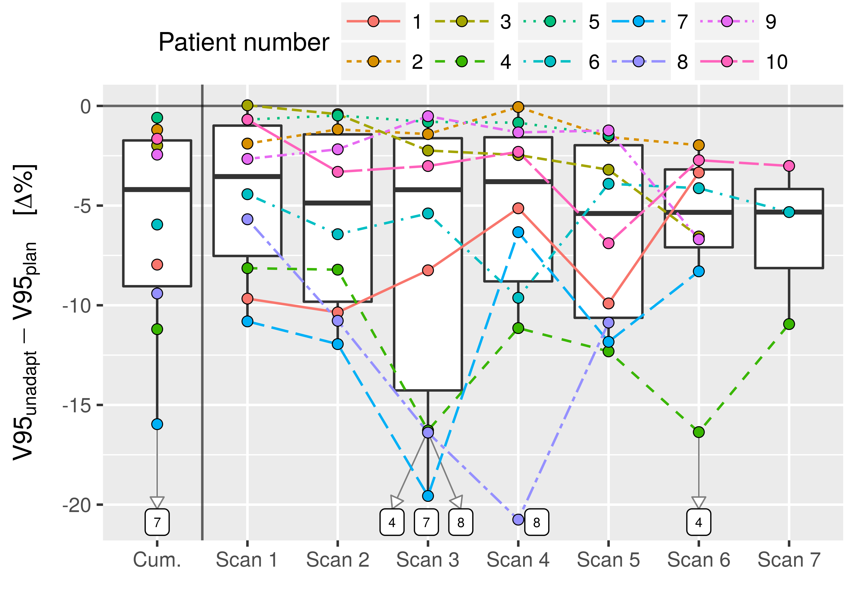 | 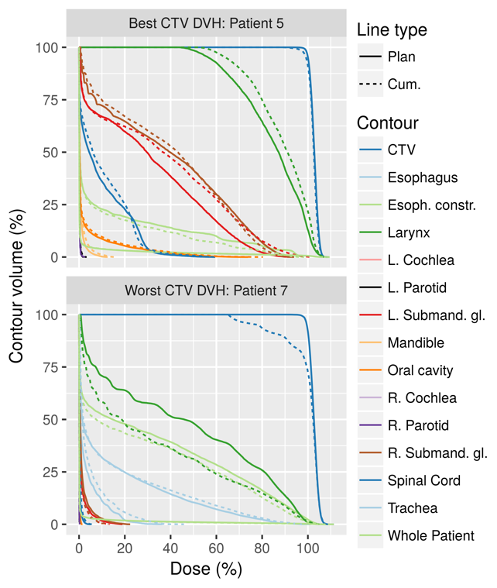
Figure 3: Performance of the original plans on the individual CBCTs and cumulative (Cum.) distribution. Top: Evolution of V95 at every week and cumulative distribution minus the original plan’s V95. Individual points are plotted and joined per patient, as well as their total behavior (boxplots). Patients 4, 7 and 8, with low plan performance, were labelled. Top-right: cumulative dose DVHs of patient 5. Bottom-right: cumulative dose DVHs of patient 7, showing big changes in the CTV.

In general, the studied conditions produced a decrease in parameters measuring target coverage with respect to the original plan, while parameters measuring target overdose increased, smoothing the target DVH. Dose to OARs was increased on average. The evolution of additional CTV DVH points were included in figure 4 and are explained in the next subsection.

3.2 Geometrical adaptation method
Figure 4 shows boxplots of the distributions of V95, V98, V107, V110, D2 and D98 (%) for the 10 patients. Boxplots for the original plans and the cumulative plan delivered to the CBCTs with and without geometrical adaptation were included and separated by color, allowing the comparison of several CTV DVH bands. Each boxplot summarized 10 patients. Boxplots were included for the original plans in the planning CTs (Plan), the plans delivered to the CBCT scans with no adaptation (None) and the 4 geometrical adaptation modes described in the methods: free energy and position changes (Free), isocenter shifts (Iso), range shifters (RS) and the last two combined (Iso-RS).
The plot shows the original plan delivered 95 and 98 % of the prescription dose to the whole CTV volume (orange, leftmost boxplots). The volume percentage decreased as the dose increased until it was ~5% for V107 and close to 0% at V110. The average D98, D2 doses were 99.0 and 107.0 % for the original plans. However, this behavior was not reproduced when the original plans were delivered to the CBCTs without adaptation (None method, yellow, second boxplot from the left), as explained in the previous subsection.
Figure 4: Performance of the cumulative dose of the geometrical adaptation method compared to the original plan and the original plan (Plan) delivered to the CBCTs (None). The geometrical adaptation methods are split into the implemented modes: free energy and position changes (Free), isocenter shifts (Iso), range shifters (RS) and the last two combined (Iso-RS). The modes fail to reproduce the original plan’s values.

It was clear from figure 4 that the geometrical adaptation method failed to recover the original plans’ prescriptions in the 4 modes here studied. The Free and Iso modes improved in some cases the performance with respect to not adapting the plan, according to V95 and V98, but in others they performed worse. The beamlets movement created hot-spots in the CTV as show by V107, V110 and D2. Both modes adapting with range shifters (RS, Iso-RS) worsened the CTV coverage as shown with V95 and V98.
In general, the geometrical adaptation method did not recover target coverage. There are several reasons, individually or in combination. Although theses methods relocated the beamlets’ end-of-range position in the target according to the deformation, the change of shape of the dose distribution of each beamlet after adaptation produced by the new patient geometry could generate cold/hot spots in the target that impacted the plan quality. Not only the materials traversed may have affected the adapted beamlets, but also the beamlet energy may have changed, which would have changed the beamlet width and energy spread coming from the delivery system. Additionally, the relative positions between endpoints may be different if the VF contained non-parallel deformations, creating potential cold/hot-spots. Because the VFs were probed at certain individual positions, there was an underlying assumption that the VFs behaved smoothly. Any non-smooth regions of the VFs might not be captured by the probing procedure, but they would certainly be used to warp the original contours, potentially creating deformations that the adaptation algorithm did not take into account. However, non-smooth regions of the VFs, specially in low contrast tissue, might be an artifact of the DIR and not actually represent the anatomy deformation. A good way of testing this situation is still unknown.

3.3 Geometrical adaptation and weight tuning methods
The weight tuning algorithm described in the methods, section 2.3.2, was applied after simulating the geometrical adaptations in a per-beamlet fashion.

3.3.1 Target coverage
As shown in figure 5, the weight tuning was able to recover good plan quality in terms of the CTV DVH parameters. Again, the boxplots represent the distribution of values for the given parameter evaluated at every patient’s cumulative dose distribution. The Free and Iso modes represented better the results by the initial plan boxplots in all dosimetric indices, except in V107, where the modes showed higher values. These higher values were not reflected in V110, which means that the DVHs had high slopes in the V107-V110 region. Comparing against the non-adapted and the geometrical adaptation method in figure 4, all modes with weight tuning represented an improvement. The modes utilizing range shifters necessitated higher dose levels to achieve similar coverage, as shown in V107, V110 and D2. Figure 5 provides information about the general distribution of DVH parameters values in the same or similar scale as in figure 4, but it does not provide information about what values each patient presents, specifically about the difference between the adaptation and the original plan per patient.

Figure 5: Performance of the cumulative dose of the weight tuned adaptation modes compared to the original plan and the original plan (Plan) delivered to the CBCTs (None). The Free and Iso modes closely reproduce the original plan’s values. RS and Iso-RS present lower V95 and V98 and higher V107 and V110. The plot scale may have hidden the boxplot color, the order is the same as in the legend.

Figure 6 shows the difference of each adaptation mode minus the original plan per patient (mode – plan, Δ%). The modes utilizing range shifters were not included in this figure for clarity and because the previous plot showed they had worse performance than the Free and Iso modes. The previous plots focused on the cumulative dose as it was recognized as having more clinical relevance. In this plot, however, the performance of the adaptations on the individual CBCTs was included. Table 2 shows the results for the selected dosimetric indices for the original plan, its performance on the CBCTs and the weight adaptation modes.
Figure 6: Distribution of the difference between the adaptations and the original plans. The difference was taken patient by patient, either using the cumulative dose distribution or using the dose distributions on the individual scans. Both adaptation modes here included behaved similarly. Target coverage was well maintained in the cumulative distribution. The distributions on the individual CBCTs presented bigger fluctuations.

The distribution of differences from the cumulative doses shown in figure 6 are analyzed first. The difference between the original plan and the Free and Iso modes was small in the CTV. The Free mode showed slightly improved nominal values with respect to the Iso mode, but the difference was not statistically significant. The average difference across patients between the adaptations and the original plan for V95 was less than 1% as shown in the figure and in table 2 (99.4 – 99.9 for the free mode). For V98 it was less than 2% (97.4 – 98.9 for the free mode). In order to deliver such coverage, the adaptations increased V107 by ~ 4% on average, from 2.4 to 6.4 %, however it impacted V110 by less than 1%. The minimum and maximum dose were also well maintained with average differences smaller than 2%. These small differences contrast with the values shown by the original plan without the adaptation algorithm.
The results based on single CBCT images showed a wider distribution than the cumulative doses and thus tended to be worse than the cumulative results. Fluctuations occurred at every fraction that compensated each other when summing the total dose. In this case the Free mode also performed slightly better than the Iso. The average V95 and V98 of the adaptations on the individual CBCTs and Free mode were 99.0 and 96.4, meaning 0.9 and 2.3 % drops from the original plan. The bigger impact of the fluctuations in the individual CBCTs were seen at V107, where differences of up to ~30% were observed, with an average increase from 2.4 to 12.8 between the plan and the Free mode.

 |  |  | Cumulative |  |  |  |  |  |  | Individual CBCTs
All in % |  | Min |  | Mean $±$ sd |  | Median (IQR) |  | Max | Min |  | Mean $±$ sd |  | Median (IQR) |  | Max
V95 | Plan |  | 99.6 |  | 99.9 $±$ 0.1 |  | 99.9 (0.0) | 100.0 |  | 99.6 |  | 99.9 $±$ 0.1 |  | 99.9 (0.0) |  | 100.0
V95 | Free |  | 96.7 |  | 99.4 $±$ 0.9 |  | 99.7 (0.2) | 99.9 |  | 96.1 |  | 99.0 $±$ 1.0 |  | 99.4 (0.6) |  | 100.0
V95 | Iso |  | 96.8 |  | 99.1 $±$ 1.2 |  | 99.7 (0.4) | 100.0 |  | 94.9 |  | 98.9 $±$ 1.1 |  | 99.4 (0.7) |  | 99.9
V95 | None |  | 84.0 |  | 94.1 $±$ 5.2 |  | 95.6 (7.3) | 99.4 |  | 79.2 |  | 93.9 $±$ 5.2 |  | 95.2 (8.0) |  | 100.0
V98 | Plan |  | 97.2 |  | 98.9 $±$ 1.0 |  | 99.4 (1.4) | 100.0 |  | 97.2 |  | 98.9 $±$ 1.0 |  | 99.4 (1.4) |  | 100.0
V98 | Free |  | 93.1 |  | 97.4 $±$ 1.7 |  | 98.2 (0.8) | 98.6 |  | 92.1 |  | 96.4 $±$ 1.8 |  | 97.2 (2.6) |  | 98.5
V98 | Iso |  | 93.1 |  | 97.2 $±$ 2.0 |  | 98.0 (1.8) | 99.0 |  | 90.6 |  | 96.5 $±$ 1.9 |  | 97.4 (2.0) |  | 98.4
V98 | None |  | 71.4 |  | 87.3 $±$ 9.4 |  | 89.2 (14.8) | 97.7 |  | 63.7 |  | 86.0 $±$ 9.0 |  | 87.5 (13.4) |  | 99.5
V107 | Plan |  | 0.2 |  | 2.4 $±$ 1.9 |  | 2.4 (3.2) | 5.2 |  | 0.2 |  | 2.4 $±$ 1.9 |  | 2.4 (3.2) |  | 5.2
V107 | Free |  | 0.5 |  | 6.4 $±$ 4.7 |  | 5.1 (3.7) | 14.5 |  | 5.2 |  | 12.8 $±$ 5.8 |  | 12.0 (8.4) |  | 30.6
V107 | Iso |  | 0.4 |  | 6.6 $±$ 6.2 |  | 4.1 (7.5) | 19.2 |  | 4.6 |  | 12.3 $±$ 6.4 |  | 9.8 (9.9) |  | 31.7
V107 | None |  | 0.1 |  | 6.3 $±$ 5.9 |  | 4.9 (6.2) | 19.5 |  | 0.8 |  | 9.0 $±$ 5.0 |  | 8.3 (5.3) |  | 26.1
V110 | Plan |  | 0.0 |  | 0.1 $±$ 0.1 |  | 0.0 (0.0) | 0.3 |  | 0.0 |  | 0.1 $±$ 0.1 |  | 0.0 (0.0) |  | 0.3
V110 | Free |  | 0.0 |  | 0.4 $±$ 0.7 |  | 0.1 (0.2) | 2.1 |  | 0.0 |  | 2.1 $±$ 2.4 |  | 1.1 (2.5) |  | 11.8
V110 | Iso |  | 0.0 |  | 0.9 $±$ 1.9 |  | 0.0 (1.1) | 6.0 |  | 0.1 |  | 2.1 $±$ 3.1 |  | 0.6 (2.9) |  | 16.6
V110 | None |  | 0.0 |  | 1.1 $±$ 1.3 |  | 0.6 (1.1) | 3.8 |  | 0.0 |  | 2.2 $±$ 2.4 |  | 1.8 (1.6) |  | 15.2
D98 | Plan |  | 97.5 |  | 98.9 $±$ 1.0 |  | 99.1 (1.3) | 100.3 |  | 97.5 |  | 98.9 $±$ 1.0 |  | 99.1 (1.3) |  | 100.3
D98 | Free |  | 93.5 |  | 97.5 $±$ 1.5 |  | 98.2 (0.8) | 98.5 |  | 91.2 |  | 96.7 $±$ 1.7 |  | 97.3 (1.3) |  | 98.3
D98 | Iso |  | 92.7 |  | 97.2 $±$ 2.1 |  | 98.0 (1.3) | 99.0 |  | 86.5 |  | 96.6 $±$ 2.2 |  | 97.5 (1.5) |  | 98.3
D98 | None |  | 67.5 |  | 90.2 $±$ 8.9 |  | 92.8 (6.8) | 97.8 |  | 40.5 |  | 89.5 $±$ 9.0 |  | 91.3 (8.8) |  | 99.0
D2 | Plan |  | 105.8 |  | 106.9 $±$ 0.7 |  | 107.1 (1.0) | 108.0 |  | 105.8 |  | 106.9 $±$ 0.7 |  | 107.1 (1.0) |  | 108.0
D2 | Free |  | 106.3 |  | 108.0 $±$ 1.1 |  | 107.9 (0.8) | 110.2 |  | 107.8 |  | 109.7 $±$ 1.4 |  | 109.3 (2.0) |  | 113.7
D2 | Iso |  | 106.3 |  | 108.2 $±$ 1.8 |  | 107.6 (1.9) | 112.3 |  | 107.7 |  | 109.8 $±$ 2.4 |  | 108.8 (2.3) |  | 122.8
D2 | None |  | 105.8 |  | 108.4 $±$ 1.7 |  | 108.8 (2.2) | 110.7 |  | 106.3 |  | 109.8 $±$ 1.9 |  | 109.8 (1.5) |  | 117.5
Table 2: Dosimetric values from the cumulative dose distributions and the dose distributions on the individual CBCTs.

3.3.2 OAR sparing
The difference in mean and max dose between the weight tuned adaptations minus the original plans is shown in figure 7 for all adaptation modes. Only the larynx, mandible and submandible glands had high enough dose levels across patients to allow the comparison, so the analysis was focused on them. The OAR dose levels were kept similar to the original plan by the Free and Iso modes, as the distribution of differences is close to 0. The modes with range shifters displayed increased dose to the larynx and mandible. Because the patient anatomy changed, in some situations the weight adaptation algorithm was able to find better sparing than the original plan in the original patient geometry, confirming that the original plan dose distribution might not the optimal for every patient geometry. Although the OAR dose levels were very patient-specific, it was shown that the adaptations gave similar dose levels as the original plans.
Figure 7: Dose difference given to OARs by the adaptations with respect to the plans. The dose levels were well maintained by the adaptations, specially the Free and Iso modes.

3.3.3 Modes comparison
So far, the Free mode was seen to produce better results than the other modes, but the difference between them was not yet explored. In order to do that, the Free mode was taken as reference and the dosimetric differences between the modes and the reference were calculated (Iso/RS/Iso-RS - Free). The results were plotted in figure 8 for the CTV and main OARs.

Figure 8: Comparison of weight-tuned adaptation modes with respect to the Free mode. The values show the difference between the given mode and the Free mode. The Iso mode was seen to perform similarly to the Free mode, as most values are close to 0, but the Iso-RS and RS performed worse. The mean differences were plotted over the boxplots for the cumulative dose distributions and the dose distributions at each individual scan.

The modes using range shifters again delivered higher dose than the Free mode to the target and OARs. The Iso mode had a lower minimum dose in the CTV, which was also reflected by the lower V95 and V98 seen in table 2. The Iso mode also displayed lower dose to the larynx, but higher to the submandibular glands. However, the dose to OARs had a high dependency on the specific case, so no conclusion could be drawn for the difference here observed. The comparisons performed on the individual scans’ dose distributions showed similar behavior as the cumulative distributions, but with higher variance. In conclusion, the Free mode performed better than the modes with the range shifters, as had already been indicated in the previous series of plots, and only slightly better than the Iso mode according to V95 and V98 in the CTV (table 2). The studied parameters did not yield any statisticallly significant difference between the Iso and the Free mode.

3.4 Patients DVHs
Figure 9 shows DVHs of four patients and the performance of the Free adaptation mode with weight tuning. The adaptations restored the plan to a quality comparable to the original plan, both in the CTV and in the OARs.
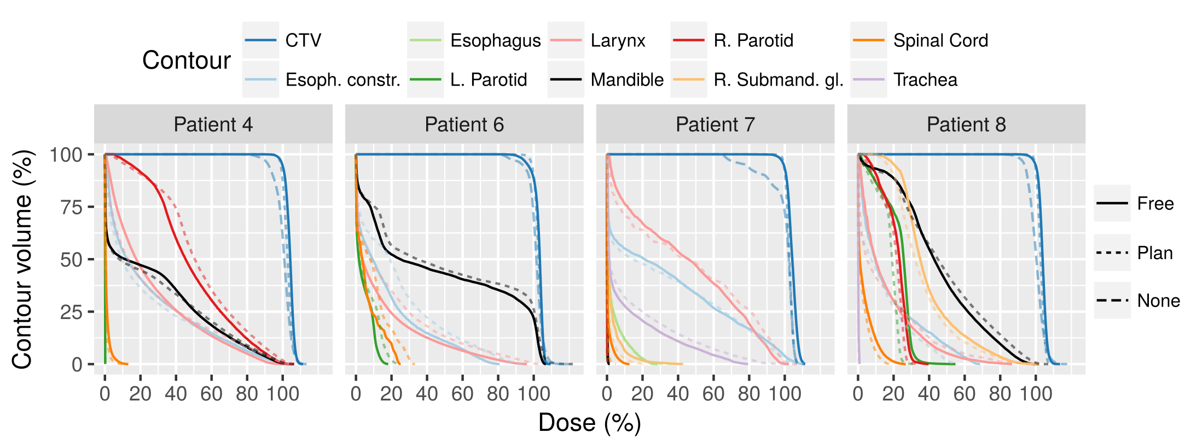
Figure 9: Patient DVHs of the original plan (dotted line), the cumulative unadapted plan (dashed line) and the cumulative plan adapted with Free geometrical adaptation and weight tuning (solid line).

3.5 Time performance
The framework time is reported without considering the time required for CBCT imaging and the DIR. It was summarized step-by-step in table 3. All the calculations were performed on a Dell Precision 7600 workstation (two Intel Xenon CPUs, 8 cores total at 2.4 GHz) with a NVIDIA Tesla K40 GPU.
The geometrical adaptation method times included all data transfers between the host and the GPU, the VF probing and geometry changes to adapt to internal code coordinates. It took an average of 16.9 seconds, however, improvements could be implemented to minimize data conversions and transfers, reducing the overhead of operations and increasing algorithm speed. It is also not clear whether a CPU parallelization would improve the efficiency for this step. In the current GPU implementation of the geometrical adaptation method, a beamlet is processed per thread, but the number of beamlets might not be high enough so that the acceleration in the GPU compensates the data transfer time. On the other hand, however, more modern connection ports between the GPU and the host allow faster data transfer.
The simulation with gPMC took between 115.6 and 419.2 seconds on our card. These values can be drastically reduced by launching the calculation in a multi-GPU system. Newer GPUs and motherboard-GPU connections would also improve the performance, although it is hard to predict what the expected improvement would be. Just with a 10 GPU system of the device here utilized, the calculation time would be in the order of 10-60 s for any of the cases here included.
The weight tuning with Opt4D presented a wide range of calculation times, from 12 to 198 s. The calculation times of optimization processes are hard to predict. All dose calculations were perform on the CT grid. Should this grid be resampled to a coarser one, the optimization time would be expected to decrease as the problem size decreases. Another factor impacting the weight tuning time was the number of beamlets to consider. Currently the beamlet selection criteria does not take into account the position of the problematic areas. Including that information might reduce the number of beamlets to be considered, reducing the total tuning time. Lastly, a multithreaded implementation of Opt4D would also be expected to have a big impact. A ballpark prediction of the optimization duration after reducing the dose calculation grid and the parallelization could be in the range of 5-120 s, however, this is speculative, which is the reason it was not included in the table.

(All in s) | Minimum | Average | Maximum | Expected
Geometrical adapt. | 11.7 | 16.9 | 26.6 | 1 - 5
gPMC simulation | 115.6 | 261.9 | 419.2 | 10 - 60
Weight tuning | 12.0 | 44.8 | 198.0 | ?
Total | - | 322.7 | - | ~ 60 - 120
Table 3: Time needed with the available hardware and software. To the right, expected time with the improvements explained in the text.

Conclusions and outlook

An algorithm was presented that was capable of yielding adapted plans of similar quality as the original treatment plans. Adaptation of beamlet’s position and energy alone (here termed as geometrical adaptation) was proven to be insufficient. However, tuning the weight of a subset of beamlets after this geometrical adaptation was proven successful. Several geometrical adaptation modes were individually tested and compared. It was shown that allowing the change of individual beamlets position and energy (the Free mode) yielded the best results, although using an isocenter shift with free energy changes also yielded results very close to it. A consequence of these adaptation modes is the creation of many energy layers that might deem the plan undeliverable. This would be alleviated by clustering them in a number of layers considered deliverable, but it was not yet studied. The usage of range shifters for the energy adaptation may prevent the creation of these energy layers, however, these modes gave higher doses to the CTV and OARs.
The timing here reported might grant its usability within an online adaptation workflow, depending on the institution requirements. Furthermore, simple parallelization and hardware improvements will bring the framework into faster times. The full adaptation workflow would also need to perform the CBCT acquisition and processing, the DIR calculation and the contour propagation and verification. Further investigations on these topics should be conducted.
Thus, the algorithm here presented has the potential to be applied within an online adaptation workflow. Its application may allow margin reduction and the consequent plan quality improvement, as well as reduce the number of need re-plans in H&N.

APPENDIX 1
This appendix illustrates the change in energy, position and weight for patients 4 and 9 during the adaptation process. The adaptations consisted of the geometrical method in Free mode and the weight tuning. The plots were automatically generated by the adaptation algorithm.
Figures A1 and A2 show the vector field (VF) at the probed positions probed for patient 4 and 9, both from the first scan anatomy. Please, see the captions for the interpretation of each element in the figure.
Figure A1 shows a VF that resembles a shift in a single direction, with variable size. The VF was well aligned with the Y axis, almost orthogonal with the X axis, had a media modulus of ~3 mm and no probe presented a vector of 0 modulus. There were no noticeable convergent/divergent regions, which indicated that the beamlets were moved in a similar direction and small cold/hot spots in the target would be created from the movement.
The VF in figure A2 showed a more complex behavior. The target in this case was bigger (see table 1 or scale of the probed are in bottom-left/right panels in figure A1 and A2), which increased the probability of having a non-uniform displacement. The median modulus was smaller than in the previous case (~2.5 mm), but the modulus histogram presented a wider range (from 0 to ~6 mm). The angular histogram showed a lot of variation and this can also be seen in the bottom panels. This situation indicated that the deformation would bring some beamlets closer together and some further apart, creating hot/cold spots after the geometrical adaptation method that would be solved by the weight tuning method.

Figure A1: Analysis of the patient 9 vector field at scan 1. Top-left: Histogram of the vector modulus, the lines show the 1st, 2nd (median) and 3rd quartiles. Top-center: Histogram of the angle subtended by the probed vectors with the X axis, weighted by the vector lengths. Top-right: Same as the top-center, but with the Y axis. Bottom-left: Vector field in the XY plane at the probed positions, with collapsed Z dimension. Bottom-right: Same as bottom-left, but in the YZ plane. The colors in the top-left panel are the same as in the bottom panels. | 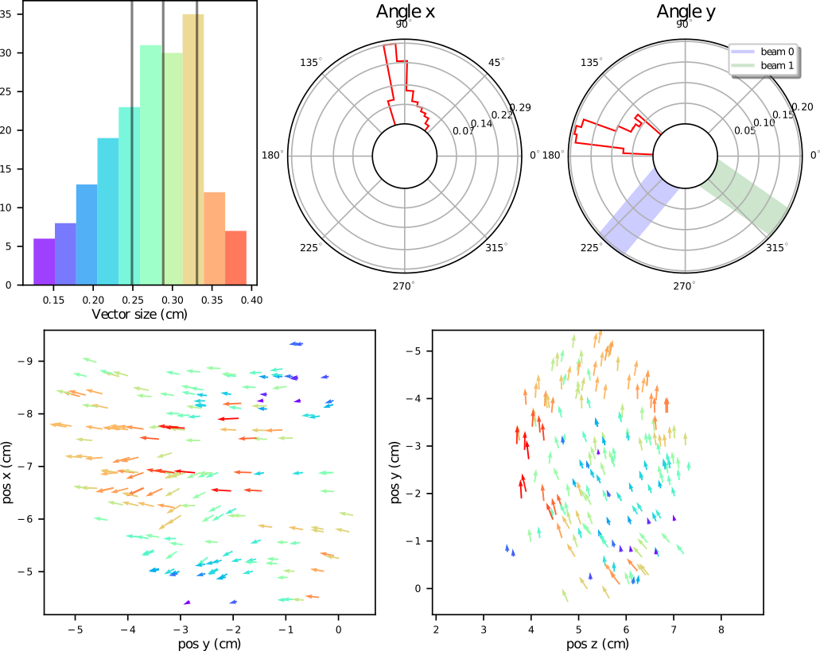
Figure A2: Same as figure A1, but for patient 4 at CBCT 1. | 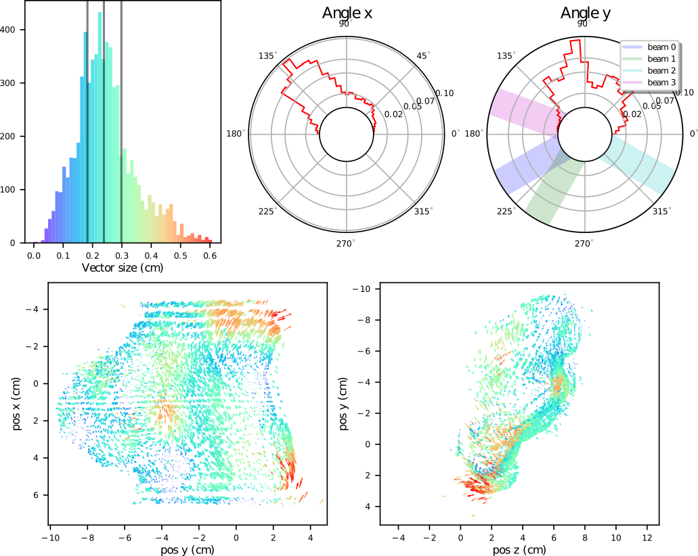

Figures A3 and A4 show the effect of the deformations of patient 9 and 4 (scan 1) on the energy of the beamlets (top panels) and the beamlet’s weight correction performed by the weight tuning method (bottom panels). Please, see the captions for the interpretation of each element in the figure.
The beamlet’s energy changes of patient 9 in this scan were approximately between -6 and 0 MeV, with an average energy loss per layer of about 3%, which indicated a decrease in the radiological depth of the patient. The small cold/hot spots in the target created by the beamlet displacements (seen in figure A1) and the effects of the energy changes (seen in the top panels of figure A3) were solved by the weight tuning method, while minimizing the dose to OARs. The weight changes were plotted in the bottom panels of figure A3. Most beamlet’s weight change ratios were kept at 1, by definition of the method, since it only tuned the weights of a subset (bottom-left panel). The tuning method mostly changed the weights of the most energetic layers (bottom-right), also by definition, since it selected the higher weighted beamlets, which are usually among the most energetic.
On the other hand, figure A4 shows the plan for patient 4 underwent bigger changes at scan 1. The beamlet’s energies changed from -15 to 25 MeV, approximately. On the top-left panel, it can be seen that at the beginning of the layers, the spots tended to lose energy, while they gained energy towards the end of the layers. The beginning and ends of the layers correspond to specific regions of the target, which means that some lost radiological depth, while others gained. The median energy change was, however, close to 0. Most beamlets did not experience weight tuning, so the ratio was 1 for the majority. Some beamlets were rejected, while others were given ~ 4.5-5 times the number of initial protons (bottom panels). Contrary to the previous case, the weight tuning was applied to beamlets belonging to less energetic layers.

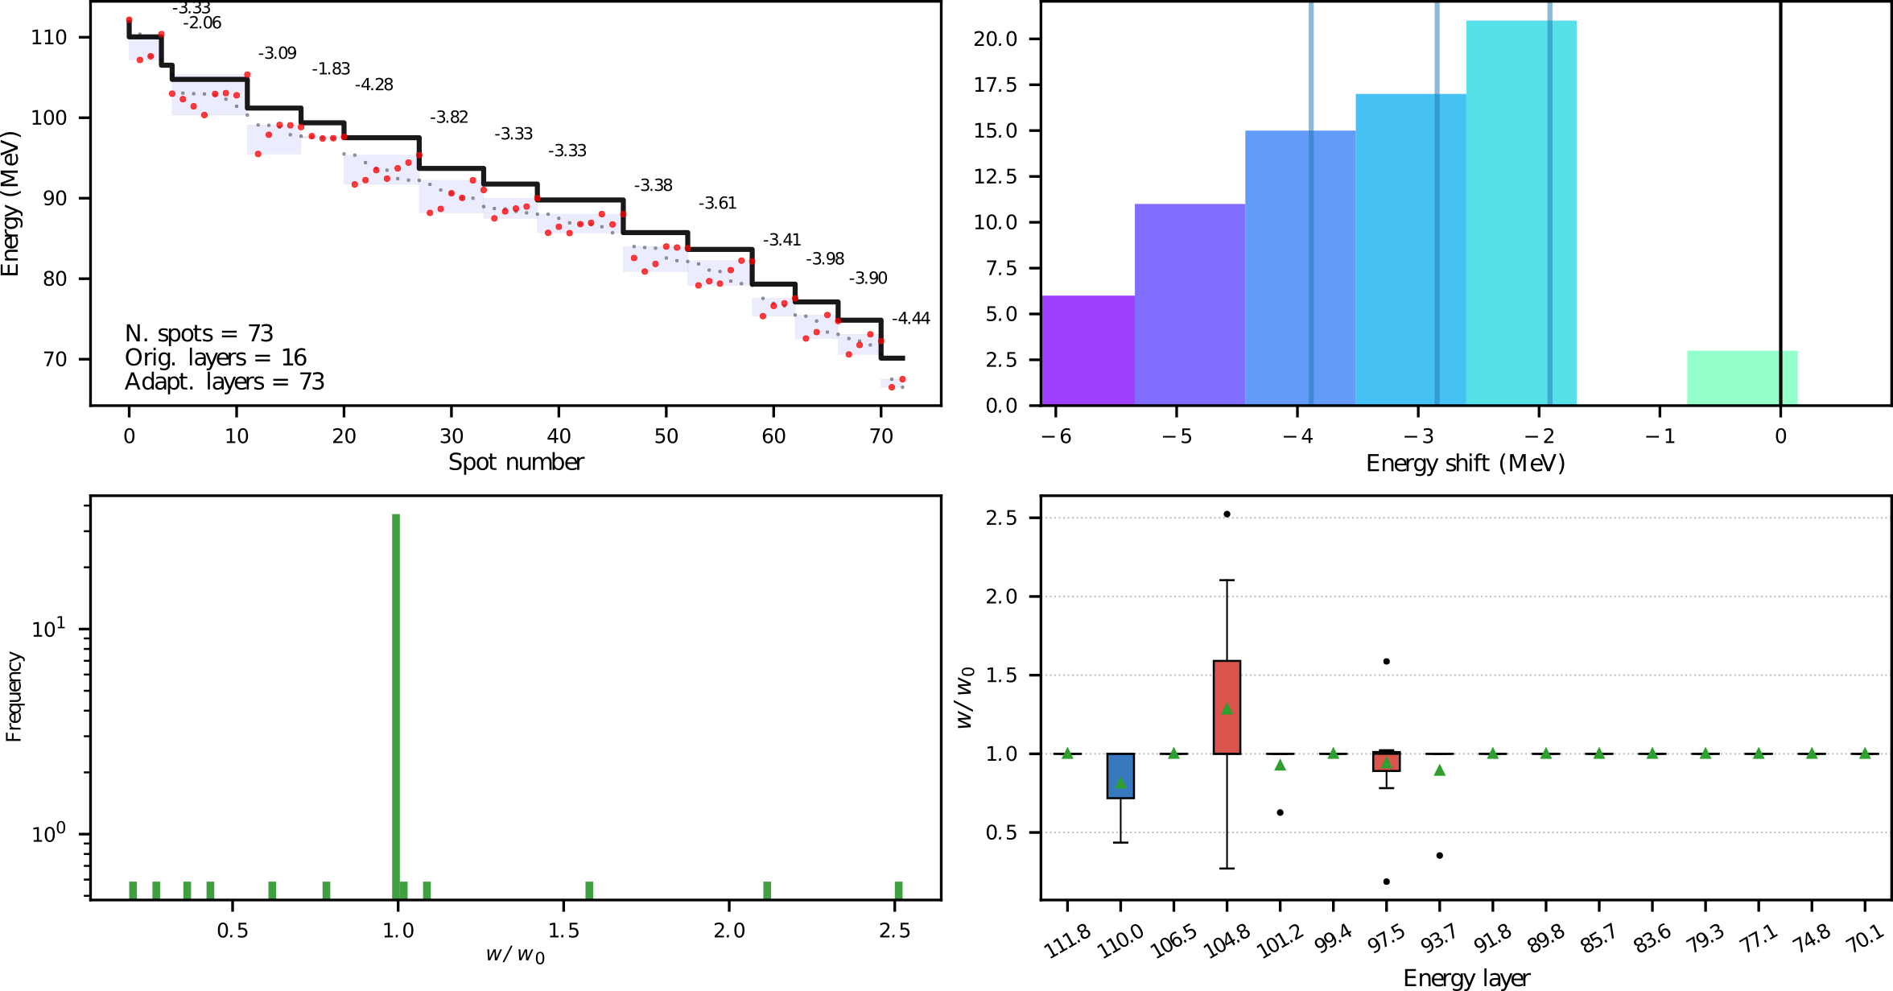
Figure A3: Beamlet’s energy and weight changes of patient 9 at CBCT 1. Top-left: Energy of each beamlet (spot). The original plan in black, showing the 9 energy layers, in red the new energies after the geometrical method, in light gray, the new energies in descendant order, the numbers represent the % change of the new average energies of the beamlets previously forming a layer. Top-right: Histogram of the energy change, the lines show the 1st, 2nd (median) and 3rd quartiles. Bottom-left: Histogram of the weight scaling factor after the weight tuning (most beamlets are unchanged). Bottom-right: Boxplots of the weight scaling factors as a function of the original energy layers. The boxplots follow the explanation given at the end of the methodology section, the top-bottom hinge distance might be 0, the mean is shown by the triangle.
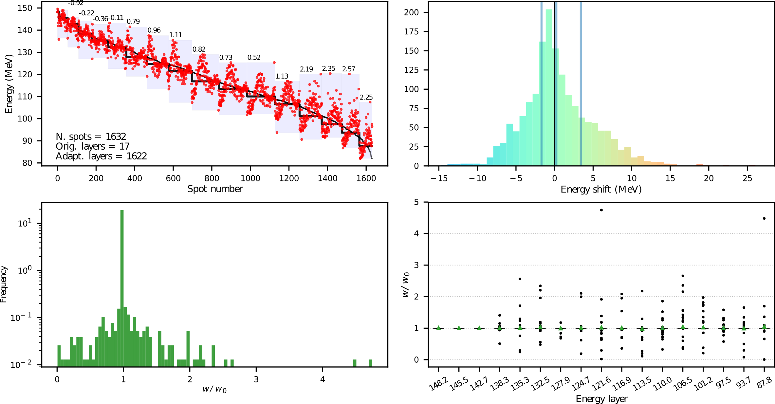
Figure A4: Same as figure A3, but for patient 4 at CBCT 1.

