Online adaption approaches for intensity modulated proton therapy for head and neck patients based on cone beam CTs and Monte Carlo simulations

P. Botas^{1,2}, J. Kim³, B. Winey¹, H. Paganetti¹

¹ Massachusetts General Hospital & Harvard Medical School, Boston, USA
² Physics faculty, Heidelberg University, Heidelberg, Germany
³ Yonsei University, Seoul, South Korea

Abstract
Purpose: To demonstrate an online IMPT plan adaptation algorithm based on GPU Monte Carlo (gPMC) and cone beam CT (CBCT) imaging on head and neck cases.
Methods: 10 head and neck patients with an average of 6 CBCT scans were studied. To adapt to the new patient geometry, contours were propagated to the CBCTs with a vector field (VF) calculated with deformable image registration between the CT and the CBCTs. Within the adaptive algorithm, beamlets were shifted following the VF at their distal falloff and raytraced in the CBCT to adjust their energies, creating a geometrically adapted plan. Four geometric adaptation modes were studied: unconstrained geometric shifts (Free), isocenter shift (Iso), a range shifter (RS) or isocenter shift and range shifter (Iso-RS) were employed. After evaluation of the geometrical adaptation, the weights of a selected subset of beamlets were automatically tuned using gPMC-generated influence matrices to fulfill the original plan requirements.
Results: Geometrical adaptation alone only worked with small anatomy changes. The weight-tuned adaptation worked for every fraction, with the Free and Iso modes performing similarly and being superior than the range shifters modes. The mean V95 and V107 were 99.4 $±$ 0.9 and 6.4 $±$ 4.7 % in the Free mode with weight tuning. The calculation time per fraction was ~5 min, but simple task parallelization can reduce it to ~1-2 min.
Conclusions: An online adaptation algorithm was developed that significantly improved the treatment quality in every studied fraction, with high accuracy and clinically feasible time. The algorithm might allow planning margin reductions.

1 Introduction
Head and neck (H&N) tumors are often very close to organs at risk (OARs) such as the parotids, larynx, submandibular glands or others. Due to this, H&N cases may benefit from steep dose gradients in the planned dose distribution to better spare the OARs while giving therapeutic doses to the target. Intensity modulated proton therapy (IMPT) is capable of producing such steep gradients while also reducing dose to OARs and integral dose, thus offering dosimetric benefits over photon treatments (Ahn et al., 2014; Blanchard et al., 2016; Leeman et al., 2017; McKeever et al., 2016; Sio et al., 2016). However, proton plans, and in particular IMPT plans, can be very sensitive to geometrical changes that may distort the planned dose distribution impacting the treatment quality (Ahn et al., 2014; Albertini et al., 2008; Arts et al., 2017; Liebl et al., 2014; Lomax, 2008; Paganetti, 2012; Stützer et al., 2017; Szeto et al., 2016). There are several reasons why the patient’s geometry might be different from the one used for the planned dose distribution, e.g. uncertainties in patient setup or interfractional anatomy changes. The setup uncertainty arises from the patient location on the treatment couch being different to the one recorded in the planning CT. The anatomy changes arises from the patient anatomy evolution throughout the course of treatment, not only due to loss of weight modifying subcutaneous tissue and/or structure locations, but also due to the posture on the treatment couch. Both uncertainty sources might modify the radiological pathway, by introducing high/low density materials in the beamlet’s path, affecting the planned dose distribution and affecting the planned target coverage and OAR sparing. This is particularly true in proton therapy due to the impact of uncertainties and geometrical changes on the predicted range of each beamlet.
These uncertainty sources are usually taken into account during the planning procedure with the creation of margins (PTV plus range margin) around the target in an attempt to guarantee treatment quality throughout the treatment course. As a consequence, the high dose volume in the patient is enlarged and organs at risk (OARs) receive higher doses. It is therefore desirable to shrink the margin to improve IMPT plan quality. More importantly,this method does not guarantee target coverage and OAR sparing throughout the treatment. An alternative to the target expansion is to perform robust IMPT optimization, which entails optimizing the plan considering different patient scenarios at the same time. With this approach, the resultant plan provides target coverage within OAR constraints at delivery, as long as the current patient characteristics were included as a scenario during the optimization (Liu et al., 2013; Stuschke et al., 2013; van Dijk et al., 2016). As it is shown in the cited studies, robust optimization is generally able to maintain the original plan target coverage and OAR sparing better than the margin approach. However, robust planning usually softens dose gradients, which, again, results in enlarged high dose volumes and higher dose to OARs compared to a plan performed in a single scenario (van de Water et al., 2016). Uncertainties can also be minimized by careful selection of beam angles, but this does not offer a general solution to account for setup and anatomy uncertainties and shrink margins at the same time.
Two solutions that might fulfill both requirements are to either perform online IMPT plan adaptation at every fraction or to perform offline treatment re-planning in scenarios when the robust IMPT plan does not fulfill treatment constraints and prescriptions. Online adaptation has the advantages that the treatment delivery is not delayed and that it accounts for the current setup and anatomy, potentially allowing margin reduction.
Online plan adaptation requires an imaging system capable of providing the patient anatomy at treatment position and an updated set of contours localizing the target and OARs. There are currently three options to provide the patient anatomy information: performing a new CT in treatment position, using the information of a cone beam CT (CBCT) to deform the original CT or using a CBCT directly (Kurz et al., 2015, 2016a; Landry et al., 2015; Oliver et al., 2018). However, an adaptation algorithm should be agnostic of the image source. With the new image, an algorithm would then generate an appropriate set of new or modified beamlets for the new geometry. All these steps should occur in a few minutes to fit into the clinical workflow.
Several studies have reported on online and offline IMPT adaptation. Automatic offline full plan reoptimization for H&N cases on deformed planning CT and contours was reported by (Kurz et al., 2016b), where new beamlet maps were created and optimized. In 2017 Jagt et al. published an online dose restoration procedure (Jagt et al., 2017) and recently an adaptation algorithm (Jagt et al., 2018) capable of tailoring the daily dose distribution to the original plan in prostate cases by adding new beamlets to the plan after correcting the beamlet energies. Also recently, Bernatowicz et al. (Bernatowicz et al., 2018) extended the work presented by Jagt et at. to allow other reoptimization strategies in the dose restoration, applying them to nasopharynx, H&N and lung (1 case each). Except (Jagt et al., 2018), these approaches rely on full plan reoptimization, which, in turn, requires the costly calculation of full dose-influence matrices. A different approach was presented by Moriya et at. (Moriya et al., 2017) in a different context. In this study the range shifter thickness was adapted in passive scattering plans for lung cancer. This methodology could be expected to have limited success if non-uniform energy shifts are needed, but it is an example of possible adaptation approaches that do not require full plan reoptimization. Although these studies have shown many advances towards online adaptation have been, none of the proposed methods include Monte Carlo simulations (MC) as dose calculation engine.
It has been shown that MC dose calculation significantly increases accuracy in proton therapy. Specifically for H&N analytical dose calculations accuracy is compromised due to tissue heterogeneities (Geng et al., 2017; Grassberger et al., 2014; Lomax, 2008b; Paganetti, 2012; Schuemann et al., 2015, 2014). Using MC calculations for online adaptation imposes time constrains on the design and applicability of the adaptation framework, as they are typically slower than analytical algorithms. Employing graphics processing units (GPU) for MC simulations could potentially allow online IMPT plan adaptation at acceptable efficiency.
The main goal of this work was to demonstrate the feasibility of online adaptation of IMPT plans on daily acquired cone beam CT (CBCT) scans of H&N patients, with automatically propagated deformed contours and using a GPU MC code gPMC (Giantsoudi et al., 2015; Jia et al., 2012; Qin et al., 2016), as dose calculation engine. The adaptation would be applied while the patient is on the couch and could potentially allow margins reduction and reduction of the number of re-planning steps, increasing workflow efficiency. An immediate challenge of this goal was to design an algorithm that minimized the calculation burden to allow its online application. As a secondary goal, different adaptation approaches were studied. Some plan adaptation procedures may modify individual beamlet’s energy, drastically increasing the number of energy layers and possibly rendering the new plan undeliverable. Other approaches could be successful, yet simpler than using the delivery system to modify the energy and position of individual beamlets independently. Therefore, the utilization of range shifters and couch shifts was compared against the independent adaptation of individual beamlet’s energies and positions.

2 Methods
In this section, first, an adaptive delivery workflow is introduced to explain the adaptation algorithm. Next, based on patient data, different approaches applying the algorithm’s operation modes are explained along with the quantities selected to assess their performance.

2.1 Patient cohort and treatment planning
A representative set of 10 H&N patients with 5-7 CBCT each was studied, for a total of 60 scenarios. The CBCTs were taken weekly as opposed to daily but serve as proof of principle for our daily adaptation workflow. The set is summarized in table 1. All patients were treated with photons (IMRT) and new plans were created for IMPT. The plans were designed as 60 Gy(RBE) to the clinical target volume (CTV) delivered with no PTV or range margin considered in as many fractions as the number of available CBCTs per patient. A single homogeneous dose level was prescribed for the CTV, creating a more challenging scenario for the plan adaptation, as allowing higher dose in the innermost part of the CTV potentially reduces the cold spots in the periphery of the structure. The minimum and maximum doses in the CTV were 60 and 63 Gy(RBE), weighting the under/over-dose by 20 and 10, respectively. The dose conformity was enforced by a voxel dependent gradient from the prescription dose at the edge of the CTV to 15 Gy(RBE) at 1 cm from the CTV (overdose weight = 3). The generalized uniform dose (gEUD) to the main OARs was minimized (exponent = 5, weight = 1). In cases this approach did not provide appropriate sparing to specific OARs, additional objectives were created to minimize the dose. The maximum and mean dose to the healthy tissue were minimized (weight = 1).
The tumor locations included larynx, oropharynx, mouth, tonsil, tongue and hypopharynx. Tumor volumes ranged from 9.0 to 116.5 cm³, with an average of 53.2 $±$ 38.4 cm³. Deformable image registration between the CT and the CBCTs was performed to obtain vector fields (VF) representing the patient evolution (see details in section 2.3). The contours were propagated from the original CT to the CBCTs by applying the VFs. The VF and the warped contours were accepted as long as the VF was observed to map the structures with high tissue contrast (i.e. mandible, spinal cord, etc.) well from the planning CT to the CBCTs. In H&N cases, the target volume and some OARs are often very hard to delineate and, therefore, they were only required to present a smooth deformation (in terms of the VF nominal values and Jacobian) to be accepted as plausible. The target volume was observed to evolve throughout the CBCT sets. The dice similarity coefficient, measuring the overlap between the original target contour and the contour propagated to each CBCT, was on average 0.83 $±$ 0.09. The small dice coefficient value in patient 1 was due to the fact that this oropharynx case had a thin target and a small displacement.

Pat. No. | Tumor location | N fields | N CBCTs | Plan CTV volume (cm³) | Average CTV vol. ratio change (min, max) | Average CTV dice (min, max)
1 | Oropharynx | 4 | 6 | 22.3 | 1.00 (0.97, 1.05) | 0.58 (0.50, 0.67)
2 | Tonsil | 2 | 6 | 9.0 | 1.02 (0.94, 1.12) | 0.87 (0.83, 0.90)
3 | Oropharynx | 3 | 7 | 30.7 | 0.93 (0.90, 1.00) | 0.82 (0.77, 0.88)
4 | R. Neck | 4 | 6 | 81.3 | 1.03 (0.98, 1.06) | 0.79 (0.75, 0.84)
5 | Hypopharynx | 3 | 5 | 59.6 | 0.97 (0.95, 0.98) | 0.89 (0.87, 0.91)
6 | Mouth | 3 | 7 | 116.5 | 0.78 (0.75, 0.82) | 0.87 (0.83, 0.90)
7 | Larynx | 3 | 6 | 25.0 | 1.21 (1.08, 1.34) | 0.84 (0.77, 0.88)
8 | Tongue | 4 | 5 | 79.9 | 1.06 (1.04, 1.11) | 0.87 (0.82, 0.91)
9 | Tonsil | 2 | 6 | 12.0 | 0.98 (0.95, 1.00) | 0.87 (0.83, 0.93)
10 | Oropharynx | 3 | 7 | 95.9 | 0.96 (0.91, 1.02) | 0.89 (0.85, 0.92)
Summary: | - | - | 60 | 53.2 $±$ 38.4 | 0.99 $±$ 0.11 | 0.83 $±$ 0.09
Table 1: Patient cohort.

The gPMC GPU based MC code (Giantsoudi et al., 2015; Jia et al., 2012; Qin et al., 2016) was utilized as dose calculation engine to create the IMPT plans. This approach provided high accuracy at this step and a consistent framework throughout the study, avoiding systematic differences between the adapted plan evaluations also performed with gPMC and a treatment planning system (TPS). To create the IMPT plans, all the necessary information was extracted from the TPS, including non-optimized fluence maps. Dose-influence matrices ($D$ matrices) were created with gPMC and optimized with Opt4D, an in-house optimization tool originally developed for temporo-spatial studies (Trofimov et al., 2005). The optimization was perform with an implementation of the L-BFGS algorithm (Limited-memory Broyden-Fletcher-Goldfarb-Shanno). Beam angles were selected to spare OARs and avoid artifact regions in the CT or CBCT.

2.2 Adaptation workflow
The current planning-delivery workflow shown in figure 1 (left side) is sensitive to the uncertainties of the patient positioning and anatomy, as explained in the introduction (uncertainties are represented by the red arrows). This may be solved by employing an adaptive workflow, shown in figure 1 (right side).

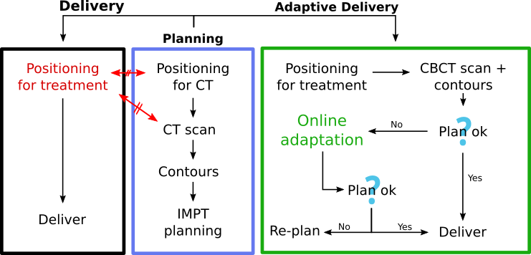
Figure 1: The usual (to the left) and adaptive (to the right) planning-delivery workflows. The red arrows indicate that the patient anatomy and setup might differ between the delivery and the planning stage.

The first step of such an adaptive workflow would be to acquire information about the patient geometry immediately before treatment, including a possible automatic generation of contours. Then the original IMPT plan would be evaluated on the new patient geometry with a GPU MC simulation. If the clinical requirements were still met, then the plan would be delivered. If the clinical requirements were not met, the patient information would be used as input into an online adaptation algorithm. If the adaptation was successful, the patient would be treated, else, a re-planning and re-scheduling of treatment would be necessary. Our goal was to maintain high dose calculation accuracy at every step by using GPU MC simulations, therefore, gPMC was employed as dose calculation engine at the initial IMPT planning step, at the plan evaluation on the individual CBCTs and within the adaptation algorithm.

2.3 Imaging inputs: CBCTs, vector field maps and contours
The adaptation decision is based on the patient geometry as obtained by CBCT, the VF mapping the original planning CT to the CBCT, and a set of new contours localizing the structures on the CBCT.
CBCTs are known to provide limited accuracy for dose calculation, but strategies have been developed to reduce uncertainties (Arai et al., 2017; Kim et al., 2017; Kurz et al., 2016a; Niu et al., 2010, 2012; Park et al., 2015). We applied an a priori planning CT-based scatter-correction algorithm developed in-house (Kim et al., 2017; Park et al., 2015). Park et al. have reported average accumulated WEPL errors across different locations of 2.3 ± 1.9 %. The CT and CBCTs were aligned at the plan isocenter, which better maintains the target coverage of the original plan at every evaluation, as opposed to aligning to a given OAR. While we employed this method, our algorithm does not depend on it and would be applicable if a given OAR needs to be prioritized.
The contours defined in the planning CT were propagated onto the CBCTs applying a VF. The VF map was calculated between the planning CT and the CBCT with deformable image registration (DIR) using the GPU parallelized B-spline algorithm in Plastimatch, an open source suite for radiotherapy and medical imaging (Shackleford et al., 2010; Shackleford, n.d.). The correctness of the structures on the CBCTs had to be visually verified because there is no automatic and reliable procedure to validate the structure contours for H&N cases (Li et al., 2017; Peroni et al., 2012). The deformed contours represented well the visible structures, while the others were required to present smooth deformations (i.e. the VF nominal values and Jacobian did not present steep gradients) to be accepted.
The accuracy of the CBCTs and the VFs employed does not affect the evaluation of the adaptation algorithm. Even though the CBCTs and VFs may not perfectly represent the current patient geometry and deformation, they represent plausible and consistent geometries and deformations of the patient as well as the propagated contours. Improvement of CBCT accuracy and automatic propagation/generation of structure sets is an active field of research (Li et al., 2017). Several approaches have been followed regarding the imaging modality best suited to perform online adaptation. An alternative option as the one utilized here is to register and warp the planning CT to the CBCT. However, this method, for instance employed by Kurz et al., has the accuracy of the VF which may introduce artifacts, specially in the surface of the patient or in areas where the contrast is low .

2.4 Adaptation algorithm
The adaptation algorithm was designed as two consecutive methods connected by a GPU based MC validation. First, the geometrical method adjusted the beamlets positions and energies, creating a geometrically adapted plan. The geometrically adapted plan was verified on the CBCT. If the result was satisfactory, the plan would be delivered, if not, the second adaptation method would be applied, performing the weight tuning of the beamlets of the geometrically adapted plan. The algorithm performed the following steps:
- Geometrical adaptation method
- Verification with GPU-MC on CBCT
- Weights tuning (if necessary)
The algorithm was implemented in C++/OpenMP with the raytracing parallelized for NVIDIA GPUs with CUDA. The GPU MC code, gPMC, and the IMPT optimizer, Opt4D, were spawned as subprocesses, automatically providing the required inputs.

2.4.1 Geometrical adaptation
The geometrical adaptation method adjusted the position and energy of the beamlets to the new geometry as depicted in figure 2 (left). Each beamlet was raytraced along its central axis until the end of range in the planning CT (1). The locations resulting from the raytracing are called endpoints. To capture the heterogeneity of the patient’s tissue and the subsequent deformation of the Bragg peak, the density of each voxel along the central axis was averaged with its surroundings. The averaging procedure consisted of adding a set of 8 radial probes defined as an octagon on the orthogonal plane around the central axis, which contained the central probe. The radius of the octagon was equal to the σ of the beamlet profile (Gaussian) in water at the equivalent radiological depth. The radial probes weights were set from the same Gaussian profile. The angular position of the first radial probe was randomized. Because the patient deformation was captured in the VF, the set of original endpoints defined in the CT was warped applying the VF, yielding the position that should be occupied in the new geometry by each endpoint, and, therefore, by the high dose region of each beamlet (2). This was the same deformation previously applied to the contours propagation. Next, the new position of each warped beamlet in the particle source plane was calculated (3). Then, the shifted beamlets were raytraced in the CBCT applying the averaging procedure (4). Finally, the energies were adjusted to match the end of ranges in the CBCT with the warped endpoints (5).
In some cases, the endpoints in the original CT (step 1 in figure 2) were located far from the CTV. The VF would have been probed far from the CTV and the beamlets potentially moved a distance and a direction not representing the CTV deformation. To avoid this issue, the endpoints were forced to be within successive expanded CTVs called shells: CTV + 1.0, 1.5, 2.0 and 3.0 cm. Figure 2 (right) exemplifies this procedure. The shells are ordered in importance, being the innermost the most important. The endpoint of a beamlet was taken as the last position within the shell of the highest importance its central axis traversed. This assures that the deformation of the CTV, or at least its vicinity, is applied to the beamlets.

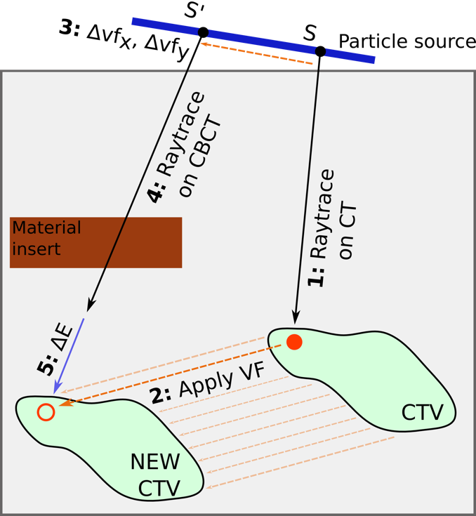 | 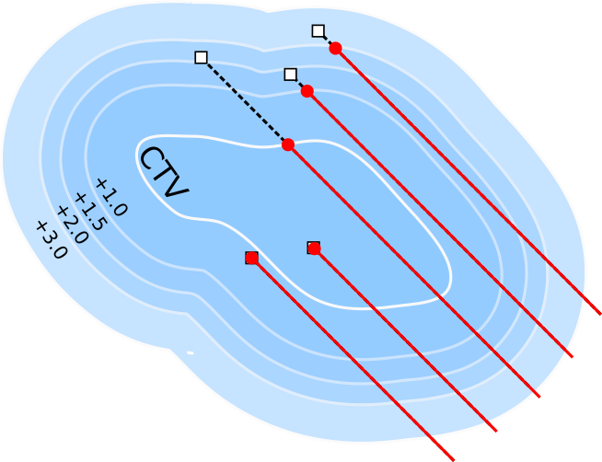
 | Figure 2: Left: Geometrical adaptation method. (see text for explanation). Right: Beamlet’s endpoint selection following the expanded CTV shells. The endpoints arerepresented with the red dots and the end-of-range position of each beamlet with the rhomboid.

After the geometrical adaptation, the adjusted plan was simulated with gPMC on the CBCT. If the dose distribution fulfilled the clinical requirements, the plan would be delivered. If not, the weight tuning method would be applied.

2.4.2 Weight tuning
The IMPT optimization solves an expression of the form of equation 1, with some objectives and constraints to the final dose distribution $d$. In equation 1, $D$ is the dose-influence matrix containing the dose distribution given at each voxel by each beamlet and unit of fluence. $ω$ represents the beamlets weights to be optimized. Therefore, $D$ provides the all system information. However, calculating a $D$ matrix with GPU MC with similar uncertainty per beamlet to solve such a problem is computationally demanding and generally not suitable for online application. In order to comply with the requirements of an online application, a solution to extract enough information to define a smaller $D$ matrix from the geometrically adapted plan validation was found. We found that a minority of the beamlets in an IMPT plan carried the majority of the weight and, therefore, deliver the majority of the dose to the patient. In MC simulations the simulation uncertainty decreases as the number of simulated protons increase. As a consequence, this implies that there was a subset of beamlets simulated at the verification step with enough precision to be used for the weight tuning. Additionally, this subset was responsible for the majority of the dose in the patient and, therefore, would have the biggest influence on the plan performance.

$\left(1\right)Dω=d\left(2\right)\left(ω_{0}D\right)ω=d$

Consequently, the dose distribution calculated as verification after the geometrical adaptation was stored in the GPU beamlet by beamlet, forming a weighted full $D$ matrix containing all the beamlets ($ω_{0F}D_{F}$, where $ω_{0}$ are the original IMPT weights and F stands for full). Accumulating the dose of each beamlet, the total dose per voxel given by the geometrically adapted plan was retrieved. The smallest set of beamlets carrying at least 50% of the total weight was extracted from $ω_{0F}D_{F}$, obtaining the matrix representing the subset $ω_{0}D$. The number of selected beamlets was enforced to be at least 10% of the total to provide more flexibility to the weight tuning process. The dose provided by the non-selected beamlets was accumulated as baseline dose for each voxel. The prescription dose in the target minus the baseline was the dose that the selected beamlets should provide. The weights of the selected beamlets were then tuned to complement the baseline and give the dose prescription in the target while sparing the OARs with the same set of objectives and constraints as in the original plan. Equation (1) was therefore changed to equation (2), where $ω$ are, in practice, scaling factors of the initial plan weights.
The same optimizer, Opt4D, from the original IMPT plan was used (see patient cohort section). The same target and OAR objective values from the original plans were enforced. Because the dose baseline provided by the non-selected beamlets was not homogeneous, the prescription dose in the target was given to the optimizer as a voxel-dependent objective complementing the baseline. The same was done to set the maximum acceptable overdose in the target. After the weight tuning, another verification with GPU MC would not be required, as the new plan dose was computed from $\left(ω_{0}D\right)ω$ and the baseline.
The $D$ matrices can be large files that could cause an overflow in the memory of GPU devices during MC simulations. Usually, to facilitate storage and speed up the optimization, $D$ matrices are post-processed and voxels below a certain small dose threshold are dropped without biasing the resultant plan. However, this approach cannot be used while $D$ is being constructed in the GPU because that information is only available after all the protons have been simulated. Therefore, to fit the $D$ matrices in the GPU, gPMC was extended to score dose in arbitrarily-shaped regions of interest defined by voxelized masks, allowing a significant reduction of the $D$ matrices size. The region of interest defined by the masks covered the dose bath.
The conditions to select the subset of beamlets (the minimum weight of 50% they had to provide, being at least 10% of the total plan spots) were chosen empirically by observing the shape of the cumulative weight distribution and early adaptation results. Different optimizers produce different weight distributions, some giving more weight to individual beamlets and others producing more balanced plans. The L-BFGS algorithm, implemented in Opt4D and utilized here, produces individual beamlets with high weights. The performance of our method would for sure depend on the individual optimizer. Additionally, selecting the beamlets with higher weights may bias the selection towards the beamlets with higher energies. However, when employing several fields this situation should be alleviated.

2.5 Studied approaches and evaluation metrics
The geometrical adaptation method and geometrical+weights adaptation methods were studied separately. The geometrical adaptation method was applied in four modes:
- Free: Allowing free beamlet position and energy changes by the delivery system.
- Iso: Changing the plan isocenter with a couch shift, calculated from the average probed VF at the beamlet’s endpoints. The energies were changed as in the Free mode.
- RS: Changing the energy with range shifters, calculated from the average energy shift per field. The positions were changed as in the Free mode.
- Iso-RS: Constraining the position and energy changes with a isocenter and constant range shift.
The geometrical adaptation method is the basis of the weight tuning method, therefore each of these modes was studied with and without weight tuning. Thus, forming 8 adaptation approaches that were compared against the original plans and the original plans delivered to the CBCTs without adaptation.
Dosimetric comparisons in the target were performed based on V95, V98, V107, V110, D2 and D98 (all in % of structure volume or prescription dose). The dose to OARs was analyzed in terms of mean and maximum dose. The performance was analyzed based on the cumulative dose at the end of treatment (cum.) and also on the individual CBCT scans, extrapolating the values per scan to full treatment for easier comparison. Although the cumulative dose is more clinically meaningful, this is a procedure to be used at each fraction, so its performance was judge on this basis as well. Also, if hypofractionation schemes are employed, good performance at every fraction is desired. A constant RBE = 1.1 was applied throughout the study. Boxplots were utilized to summarize the results, with the median, the lower/upper hinges corresponding to the first and third quartiles (the 25th and 75th percentiles), the lower/upper whisker extending from the hinge to the smallest/largest value no further than 1.5 times the inter-quartile range from the hinge, and observations beyond the whiskers plotted individually as outliers.

3 Results and discussion
In this section, the performance of the original plans on the CBCT scans was analyzed first. Afterwards, the adaptation performance was investigated and compared, first using only the geometrical adaptation and secondly using also the weight tuning. Furthermore, the time it took the algorithm to produce the adaptations was recorded. Additional results were included, in appendix 1, showing the example of 2 patients’ VFs as probed by the adaptation procedure and the beamlet’s energy, positions and weights change.

3.1 Original plans on changing geometries
The performance of the original plans on the new geometries defined the corrections the adaptation algorithms must achieve. This was expected to be challenging because the plans were performed without CTV margins for the purpose of this study. The scans were taken weekly, which may increase the observed anatomy evolution, but not the setup errors.
Figure 3 (left) shows ${V95}_{unadapt}−{V95}_{plan}$ in the CTV for the cumulative (cum.) dose and the dose in the individual CBCTs, per patient. The cumulative distribution was the result of delivering the whole treatment to the successive CBCTs. The results per patient were also plotted with boxplots to better represent the plan evolution trend. A gradual descend on the value of this parameter was observed as treatment progressed from scan 1 to scan 7. All the patients, except for 2 and 5, presented a 5% drop in at least one scan. Half the patients showed a drop of the accumulated dose of at least 5% in V95, which was 100% in the plans (see figure 4). If V95 = 95 % were employed as re-planning criteria for the target coverage, half the cases would have been re-planned. Few evaluations on the scans had a V100 > 90% and, although not shown explicitly for brevity, only patient 5 presented a cumulative V100 > 90 % (V100 = 91.0 %), which might have triggered re-planning for all cases, depending on the institution protocol. The average D98, mean and D2 dose percentage in the target changed from 98.9, 103.3 and 106.9 % at the original plans to 90.2, 101.8 and 108.4 % in the cumulative distributions. If maintaining target coverage in the target is the main goal, the parameters measuring target overdose should be judge having the coverage in mind, as a D2 value similar or better than the plan is only relevant if coverage is provided as well.
Some cases, such as patient 5, did not show big CTV coverage degradation (figure 3 (top-right)), but the dose levels to OARs increased due to the geometry changes and the loss of conformality. On the other hand, patients such as 4, 7 and 8 showed drastic drops in plan quality. The original plan and cumulative dose DVHs for patient 7 are shown in figure 3 (right-bottom).

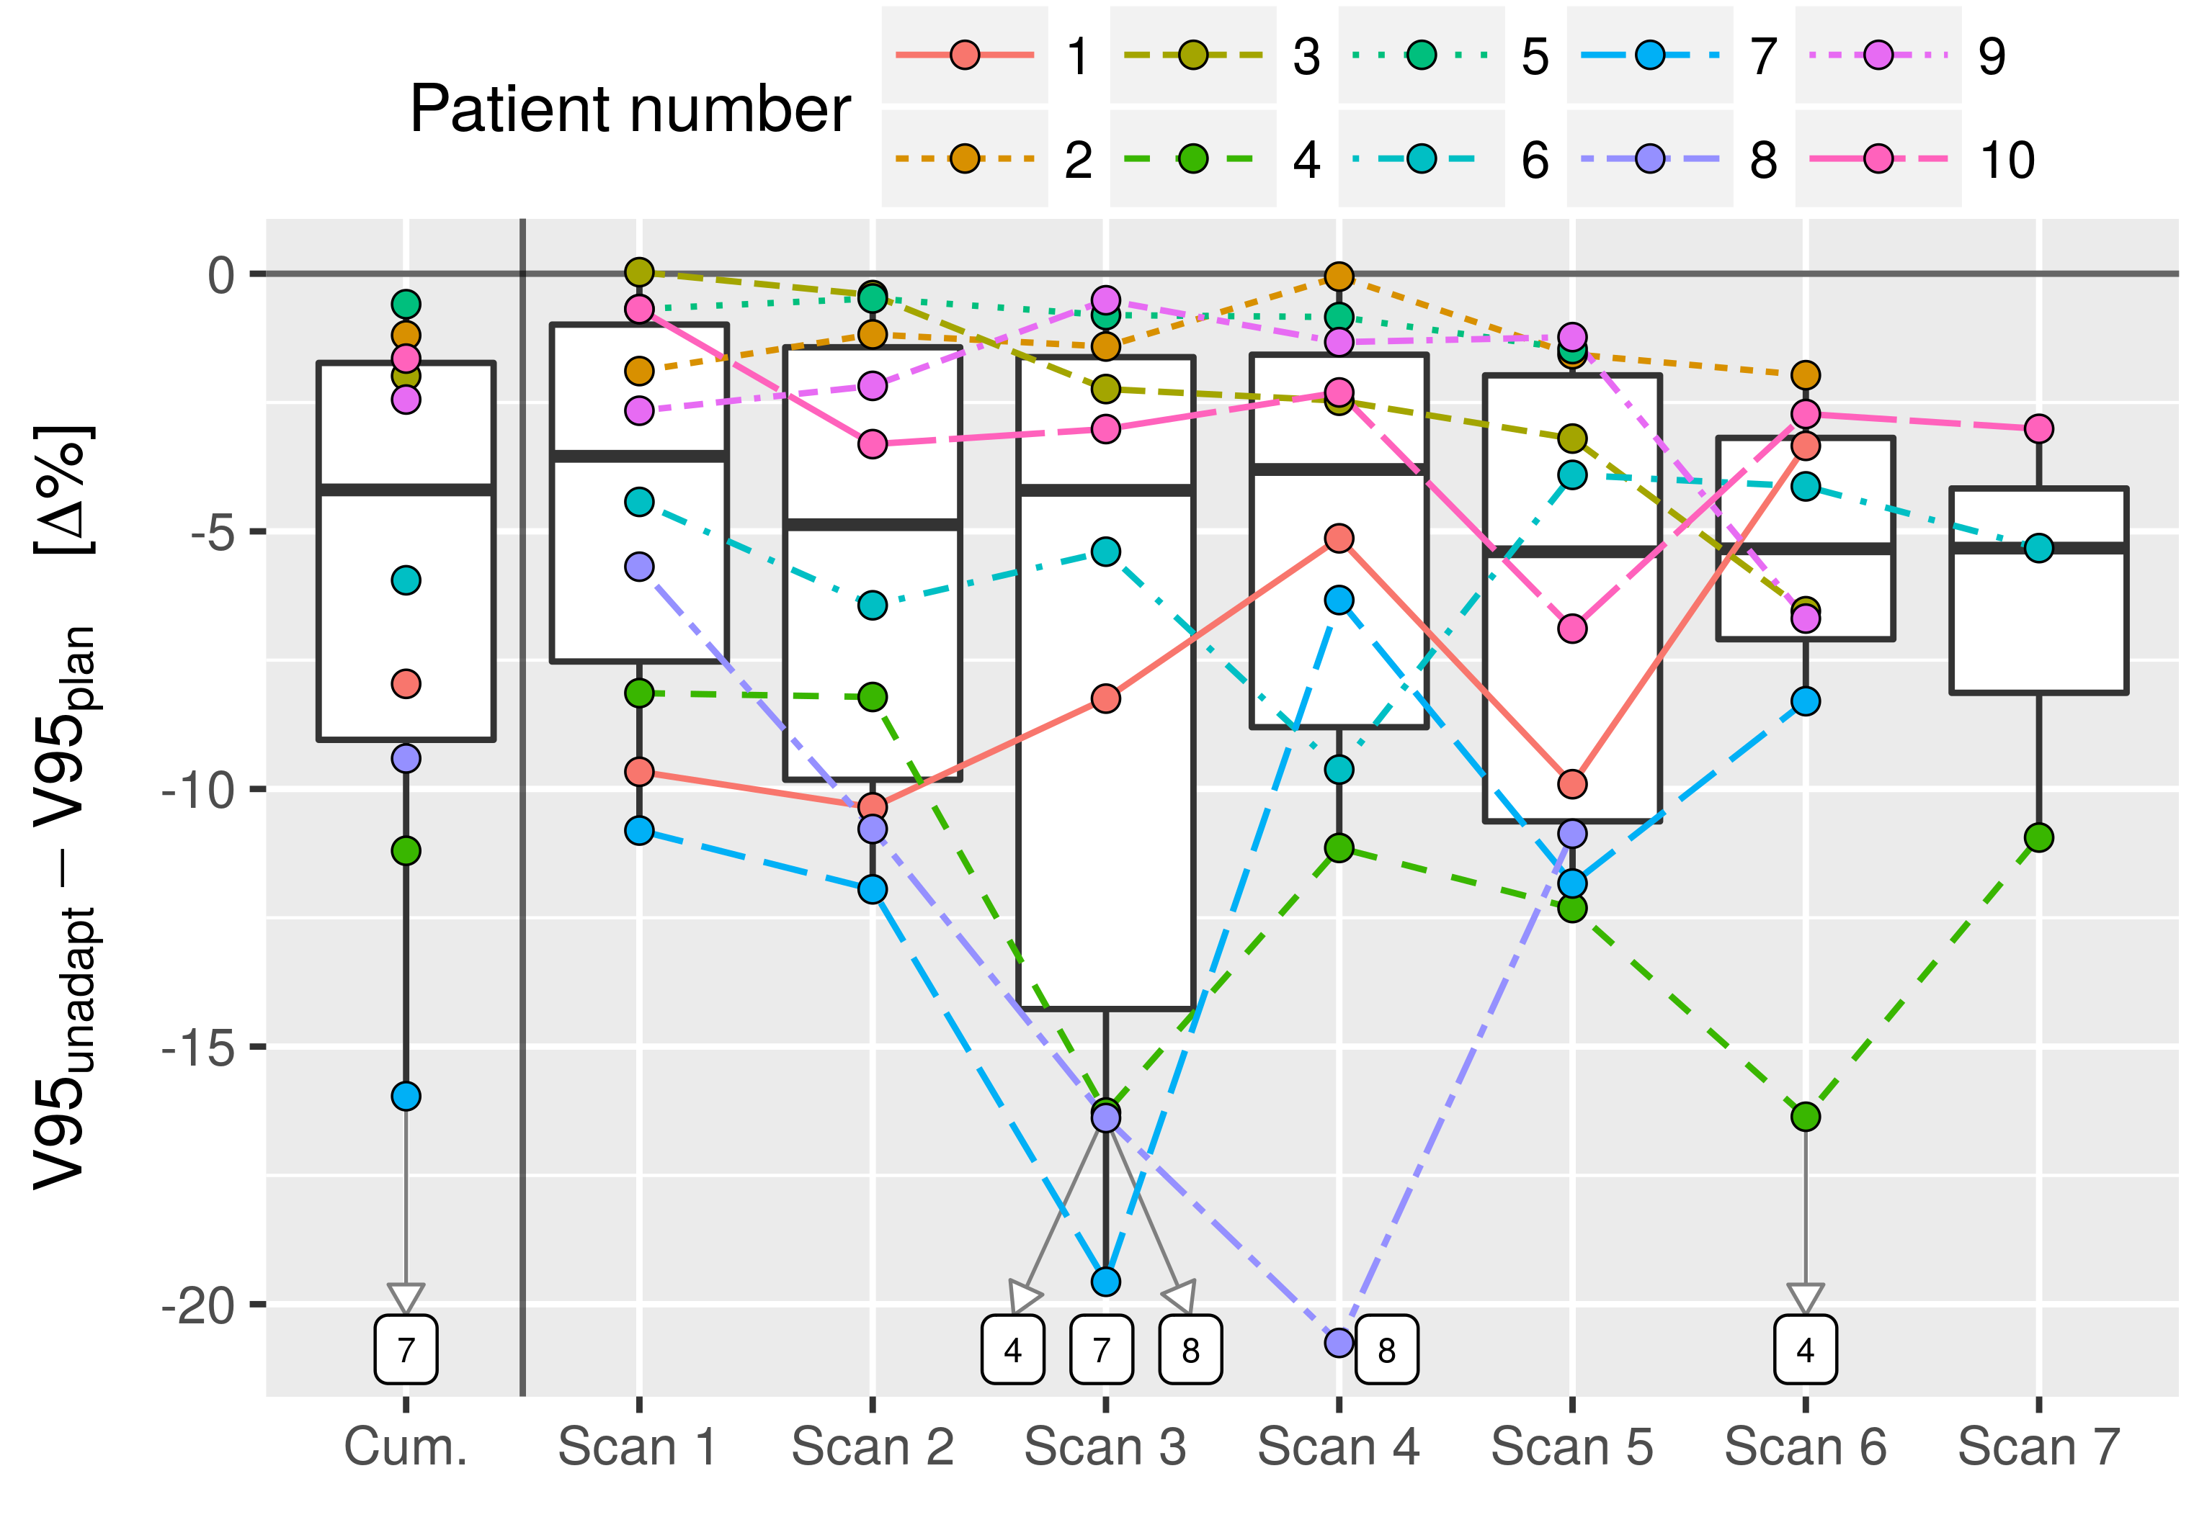 | 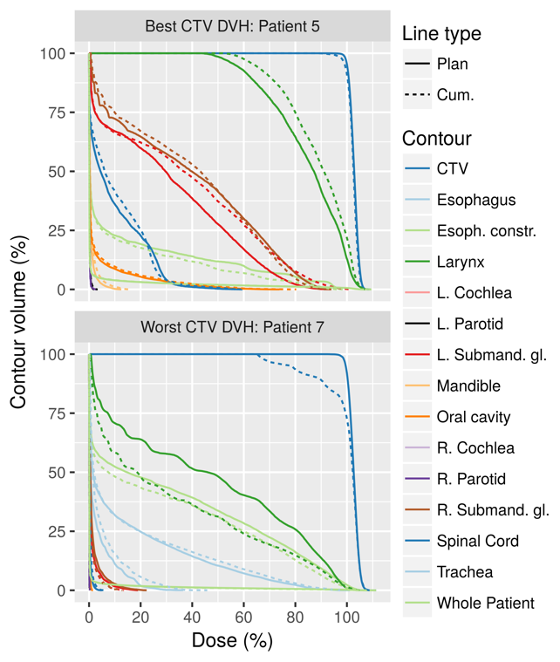
Figure 3: Performance of the original plans on the individual CBCTs and cumulative (Cum.) distribution. Top: Evolution of V95 at every week and cumulative distribution minus the original plan’s V95. Individual points are plotted and joined per patient, as well as their total behavior (boxplots). Patients 4, 7 and 8, with low plan performance, were labelled. Top-right: cumulative dose DVHs of patient 5. Bottom-right: cumulative dose DVHs of patient 7, showing big changes in the CTV.

In general, the studied conditions produced a decrease in parameters measuring target coverage with respect to the original plan, while parameters measuring target overdose increased, smoothing the target DVH. Dose to OARs was increased on average. The evolution of additional CTV DVH points was included in figure 4 and are explained in the next subsection.

3.2 Geometrical adaptation method
Figure 4 shows V95, V98, V107, V110, D2 and D98 (%) for the 10 patients. Boxplots for the original plans and the cumulative plan delivered to the CBCTs with and without geometrical adaptation were included and separated by color, allowing the comparison of several CTV DVH bands. Each boxplot illustrate the variations amongst the 10 patients. Boxplots were included for the original plans in the planning CTs (Plan), the plans delivered to the CBCT scans with no adaptation (None) and the 4 geometrical adaptation modes described in the methods: free energy and position changes (Free), isocenter shifts (Iso), range shifters (RS) and the last two combined (Iso-RS).
The plot shows the original plan delivered 95 and 98 % of the prescription dose to the whole CTV volume (orange, leftmost boxplots). The volume percentage decreased as the dose increased until it was ~5% for V107 and close to 0% at V110. The average D98, D2 doses were 99.0 and 107.0 % for the original plans. However, this behavior was not reproduced when the original plans were delivered to the CBCTs without adaptation (None method, yellow, second boxplot from the left), as explained in the previous subsection.
Figure 4: Performance of the cumulative dose of the geometrical adaptation method compared to the original plan and the original plan (Plan) delivered to the CBCTs (None). The geometrical adaptation methods are split into the implemented modes: free energy and position changes (Free), isocenter shifts (Iso), range shifters (RS) and the last two combined (Iso-RS). The modes fail to reproduce the original plan’s values.

As shown in figure 4, the geometrical adaptation method failed to recover the original plans’ prescriptions for all 4 modes. The Free and Iso modes improved in some cases the performance with respect to not adapting the plan, according to V95 and V98, but in others they performed worse. The beamlets movement created hot-spots in the CTV as show by V107, V110 and D2. Both modes adapting with range shifters (RS, Iso-RS) worsened the CTV coverage as shown with V95 and V98.
In general, the geometrical adaptation method did not recover target coverage. There are several reasons, individually or in combination. Although theses methods relocated the beamlets’ end-of-range position in the target according to the deformation, the change of shape of the dose distribution of each beamlet after adaptation produced by the new patient geometry could generate cold/hot spots in the target that impacted the plan quality. Not only the materials traversed may have affected the adapted beamlets, but also the beamlet energy may have changed, which would have changed the beamlet width and energy spread. Additionally, the relative positions between endpoints may be different if the VF contained non-parallel deformations, creating potential cold/hot-spots. Because the VFs were probed at certain individual positions, there was an underlying assumption that the VFs behaved smoothly. Any non-smooth regions of the VFs might not be captured by the probing procedure, but they would certainly be used to warp the original contours, potentially creating deformations that the adaptation algorithm did not take into account. However, non-smooth regions of the VFs, specially in low contrast tissue, might be an artifact of the DIR and not actually represent the anatomy deformation.

3.3 Geometrical adaptation and weight tuning methods
The weight tuning algorithm was applied after simulating the geometrical adaptations in a per-beamlet fashion.

3.3.1 Target coverage
As shown in figure 5, the weight tuning was able to recover good plan quality in terms of the CTV DVH parameters. Again, the boxplots represent the distribution of values for the given parameter evaluated at every patient’s cumulative dose distribution. The Free and Iso modes represented better the results by the initial plan boxplots for all dosimetric indices, except for V107, where the modes showed higher values. These higher values were not reflected in V110 indicating that the DVHs had high slopes in the V107-V110 region. Comparing against the non-adapted and the geometrical adaptation method in figure 4, all modes with weight tuning represented an improvement. The modes utilizing range shifters necessitated higher dose levels to achieve similar coverage, as shown in V107, V110 and D2. Figure 5 provides information about the general distribution of DVH parameters values in the same or similar scale as in figure 4, but it does not provide information about what values each patient presents, specifically about the difference between the adaptation and the original plan per patient.

Figure 5: Performance of the cumulative dose of the weight tuned adaptation modes compared to the original plan and the original plan (Plan) delivered to the CBCTs (None). The Free and Iso modes closely reproduce the original plan’s values. RS and Iso-RS present lower V95 and V98 and higher V107 and V110. The plot scale may have hidden the boxplot color, the order is the same as in the legend.

Figure 6 shows the difference of each adaptation mode minus the original plan per patient (mode – plan, Δ%). The modes utilizing range shifters were not included in this figure for clarity and because the previous plot showed they had worse performance than the Free and Iso modes. The previous plots focused on the cumulative dose as it was recognized as having more clinical relevance. In this plot, however, the performance of the adaptations on the individual CBCTs was included. Table 2 shows the results for the selected dosimetric indices for the original plan, its performance on the CBCTs and the weight adaptation modes.
Figure 6: Distribution of the difference between the adaptations and the original plans. The difference was taken patient by patient, either using the cumulative dose distribution or using the dose distributions on the individual scans. Both adaptation modes here included behaved similarly. Target coverage was well maintained in the cumulative distribution. The distributions on the individual CBCTs presented bigger fluctuations.

As shown in figure 6, the difference between the original plan and the Free and Iso modes was small in the CTV. The Free mode showed slightly improved nominal values with respect to the Iso mode, but the difference was not statistically significant. The average difference across patients between the adaptations and the original plan for V95 was less than 1% as shown in the figure and in table 2 (99.4 – 99.9 for the free mode). For V98 it was less than 2% (97.4 – 98.9 for the free mode). In order to deliver such coverage, the adaptations increased V107 by ~ 4% on average, from 2.4 to 6.4 %, however it impacted V110 by less than 1%. The minimum and maximum dose were also well maintained with average differences smaller than 2%. These small differences contrast with the values shown by the original plan without the adaptation algorithm.
The results based on single CBCT images showed a wider distribution than the cumulative doses and thus tended to be worse than the cumulative results. Fluctuations occurred at every fraction that compensated each other when summing the total dose. In this case the Free mode also performed slightly better than the Iso. The average V95 and V98 of the adaptations on the individual CBCTs and Free mode were 99.0 and 96.4, i.e. a 0.9 and 2.3 % drop from the original plan, respectively. The bigger impact of the fluctuations in the individual CBCTs were seen at V107, where differences of up to ~30% were observed, with an average increase from 2.4 to 12.8 between the plan and the Free mode.

 |  | Cumulative |  |  |  |  | Individual CBCTs
All in % |  | Min | Mean $±$ sd | Median (IQR) | Max | Min |  | Mean $±$ sd | Median (IQR) | Max
V95 | Plan | 99.6 | 99.9 $±$ 0.1 | 99.9 (0.0) | 100.0 | 99.6 |  | 99.9 $±$ 0.1 | 99.9 (0.0) | 100.0
V95 | Free | 96.7 | 99.4 $±$ 0.9 | 99.7 (0.2) | 99.9 | 96.1 |  | 99.0 $±$ 1.0 | 99.4 (0.6) | 100.0
V95 | Iso | 96.8 | 99.1 $±$ 1.2 | 99.7 (0.4) | 100.0 | 94.9 |  | 98.9 $±$ 1.1 | 99.4 (0.7) | 99.9
V95 | None | 84.0 | 94.1 $±$ 5.2 | 95.6 (7.3) | 99.4 | 79.2 |  | 93.9 $±$ 5.2 | 95.2 (8.0) | 100.0
V98 | Plan | 97.2 | 98.9 $±$ 1.0 | 99.4 (1.4) | 100.0 | 97.2 |  | 98.9 $±$ 1.0 | 99.4 (1.4) | 100.0
V98 | Free | 93.1 | 97.4 $±$ 1.7 | 98.2 (0.8) | 98.6 | 92.1 |  | 96.4 $±$ 1.8 | 97.2 (2.6) | 98.5
V98 | Iso | 93.1 | 97.2 $±$ 2.0 | 98.0 (1.8) | 99.0 | 90.6 |  | 96.5 $±$ 1.9 | 97.4 (2.0) | 98.4
V98 | None | 71.4 | 87.3 $±$ 9.4 | 89.2 (14.8) | 97.7 | 63.7 |  | 86.0 $±$ 9.0 | 87.5 (13.4) | 99.5
V107 | Plan | 0.2 | 2.4 $±$ 1.9 | 2.4 (3.2) | 5.2 | 0.2 |  | 2.4 $±$ 1.9 | 2.4 (3.2) | 5.2
V107 | Free | 0.5 | 6.4 $±$ 4.7 | 5.1 (3.7) | 14.5 | 5.2 |  | 12.8 $±$ 5.8 | 12.0 (8.4) | 30.6
V107 | Iso | 0.4 | 6.6 $±$ 6.2 | 4.1 (7.5) | 19.2 | 4.6 |  | 12.3 $±$ 6.4 | 9.8 (9.9) | 31.7
V107 | None | 0.1 | 6.3 $±$ 5.9 | 4.9 (6.2) | 19.5 | 0.8 |  | 9.0 $±$ 5.0 | 8.3 (5.3) | 26.1
V110 | Plan | 0.0 | 0.1 $±$ 0.1 | 0.0 (0.0) | 0.3 | 0.0 |  | 0.1 $±$ 0.1 | 0.0 (0.0) | 0.3
V110 | Free | 0.0 | 0.4 $±$ 0.7 | 0.1 (0.2) | 2.1 | 0.0 |  | 2.1 $±$ 2.4 | 1.1 (2.5) | 11.8
V110 | Iso | 0.0 | 0.9 $±$ 1.9 | 0.0 (1.1) | 6.0 | 0.1 |  | 2.1 $±$ 3.1 | 0.6 (2.9) | 16.6
V110 | None | 0.0 | 1.1 $±$ 1.3 | 0.6 (1.1) | 3.8 | 0.0 |  | 2.2 $±$ 2.4 | 1.8 (1.6) | 15.2
D98 | Plan | 97.5 | 98.9 $±$ 1.0 | 99.1 (1.3) | 100.3 | 97.5 |  | 98.9 $±$ 1.0 | 99.1 (1.3) | 100.3
D98 | Free | 93.5 | 97.5 $±$ 1.5 | 98.2 (0.8) | 98.5 | 91.2 |  | 96.7 $±$ 1.7 | 97.3 (1.3) | 98.3
D98 | Iso | 92.7 | 97.2 $±$ 2.1 | 98.0 (1.3) | 99.0 | 86.5 |  | 96.6 $±$ 2.2 | 97.5 (1.5) | 98.3
D98 | None | 67.5 | 90.2 $±$ 8.9 | 92.8 (6.8) | 97.8 | 40.5 |  | 89.5 $±$ 9.0 | 91.3 (8.8) | 99.0
D2 | Plan | 105.8 | 106.9 $±$ 0.7 | 107.1 (1.0) | 108.0 | 105.8 |  | 106.9 $±$ 0.7 | 107.1 (1.0) | 108.0
D2 | Free | 106.3 | 108.0 $±$ 1.1 | 107.9 (0.8) | 110.2 | 107.8 |  | 109.7 $±$ 1.4 | 109.3 (2.0) | 113.7
D2 | Iso | 106.3 | 108.2 $±$ 1.8 | 107.6 (1.9) | 112.3 | 107.7 |  | 109.8 $±$ 2.4 | 108.8 (2.3) | 122.8
D2 | None | 105.8 | 108.4 $±$ 1.7 | 108.8 (2.2) | 110.7 | 106.3 |  | 109.8 $±$ 1.9 | 109.8 (1.5) | 117.5
Table 2: Dosimetric values from the cumulative dose distributions and the dose distributions on the individual CBCTs.

To better compare the adaptation modes, the Free mode was taken as reference and dosimetric indices differences were calculated per patient (Iso/RS/Iso-RS - Free). The results were plotted in figure 7, also including the OARs, which are analyzed in the next subsection. The mean V95, V98, V107 and V110 difference were -0.23 $±$ 0.83, -0.23 $±$ 1.05, 0.21 $±$ 3.17 and 0.57 $±$ 1.66 % in the cumulative doses, respectively. All the values indicate the Free strategy had a better performance, but they did not reach a level of significance. The modes using range shifters delivered higher dose than the Free mode to the CTV. For the RS mode, the mean difference in V107 and V110 were 9.55 $±$ 5.98 and 2.17 $±$ 2.70 %, respectively. For Iso-RS they were 10.49 $±$ 7.68 and 2.66 $±$ 3.40 %. In both modes with range shifters V107 was significantly worse than the Free strategy, with p = 0.0003 for the RS mode and p = 0.0010 for the Iso-RS, at a 95% confidence level. The comparisons performed on the individual scans’ dose distributions showed similar behavior as the cumulative distributions, but with higher variance.

Figure 7: Comparison of weight-tuned adaptation modes with respect to the Free mode. The values show the difference between the given mode and the Free mode. The Iso mode was seen to perform similarly to the Free mode, as most values are close to 0 or symmetrical around it, but the Iso-RS and RS performed worse. The mean differences were plotted over the boxplots for the cumulative dose distributions and the dose distributions at each individual scan.

3.3.2 OAR sparing
Although the adaptation workflow focused on recovering tumor coverage, OAR dose constraints need to be met. The difference in mean and max dose between the weight tuned adaptations minus the original plans is shown in figure 8 for all adaptation modes. Only the larynx, mandible and submandible glands had high enough dose levels across patients to allow the comparison, so the analysis was focused on these structures. The OAR dose levels were kept similar to the original plan by the Free and Iso modes, as the distribution of differences is close to 0. The modes with range shifters displayed increased dose to the larynx and mandible. Because the patient anatomy changed, in some situations the weight adaptation algorithm was able to find better sparing than the original plan in the original patient geometry, confirming that the original plan dose distribution might not the optimal for every patient geometry. Although the OAR dose levels were very patient-specific, it was shown that the adaptations gave similar dose levels as the original plans.

Figure 8: Dose difference given to OARs by the adaptations with respect to the plans. The dose levels were well maintained by the adaptations, specially the Free and Iso modes.

The modes comparison in figure 7 showed that the Iso mode had lower dose to the larynx, but higher to the submandibular glands w.r.t. the Free mode The modes with range shifter had higher dose to OARs. However, the dose to OARs had a high dependency on the specific case so that no conclusion could be drawn regarding the differences as to whether the Free mode was better than the Iso. As in the CTV, the comparisons performed on the individual scans’ dose distributions showed similar behavior as the cumulative distributions, but with higher variance.

3.3.3 Patients DVHs
Figure 9 shows DVHs of four patients and the performance of the Free adaptation mode with weight tuning. The adaptations restored the plan to a quality comparable to the original plan, both in the CTV and in the OARs.
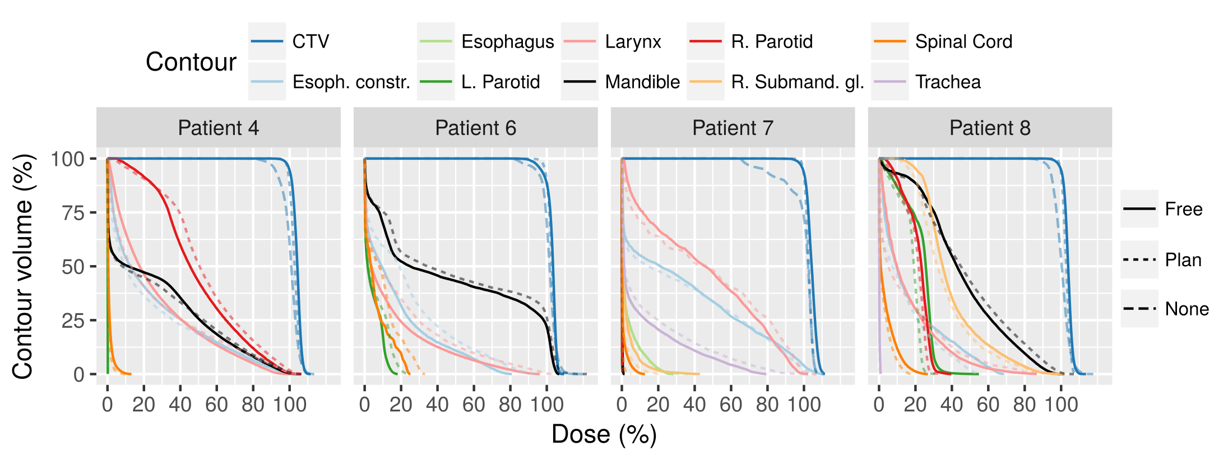
Figure 9: Patient DVHs of the original plan (dotted line), the cumulative unadapted plan (dashed line) and the cumulative plan adapted with Free geometrical adaptation and weight tuning (solid line).

3.5 Time performance
The framework time is reported in table 3 without considering the time required for CBCT imaging and the DIR. All calculations were performed on a Dell Precision 7600 workstation (two Intel Xenon CPUs, 8 cores total at 2.4 GHz) with a NVIDIA Tesla K40 GPU obtained from NVIDIA’s GPU Grant Program.
The geometrical adaptation method times include all data transfers between the host and the GPU, the VF probing and geometry changes to adapt to internal code coordinates. It took an average of 16.9 seconds. Improvements could be implemented to minimize data conversions and transfers, reducing the overhead of operations and increasing algorithm speed. A CPU parallelization might improve the efficiency for this step. In the current GPU implementation of the geometrical adaptation method, a beamlet is processed per thread, but the number of beamlets might not be high enough so that the acceleration in the GPU compensates the data transfer time. On the other hand, more modern connection ports between the GPU and the host allow faster data transfer.
The simulation with gPMC took between 115.6 and 419.2 seconds. These values can be drastically reduced by launching the calculation in a multi-GPU system. Newer GPUs and motherboard-GPU connections would also improve the performance, although it is hard to predict what the expected improvement would be. Just with a 10 GPU system of the device here utilized, the calculation time would be in the order of 10-60 s for any of the cases here included.
The weight tuning with Opt4D presented a wide range of calculation times, from 12 to 198 s. All dose calculations were performed on the CT grid. Should this grid be resampled to a coarser one, the optimization time would decrease as the problem size decreases. Another factor impacting the weight tuning time was the number of beamlets to consider. Currently, the beamlet selection criteria does not take into account the position of the problematic areas. Including that information might reduce the number of beamlets to be considered, reducing the total tuning time. Lastly, a multithreaded implementation of Opt4D would also have an impact. A ballpark prediction of the optimization duration after reducing the dose calculation grid and the parallelization could be in the range of 5-120 s.

(All in s) | Minimum | Average | Maximum | Expected
Geometrical adapt. | 11.7 | 16.9 | 26.6 | 1 - 5
gPMC simulation | 115.6 | 261.9 | 419.2 | 10 - 60
Weight tuning | 12.0 | 44.8 | 198.0 | ?
Total | - | 322.7 | - | ~ 60 - 120
Table 3: Time needed with the available hardware and software. To the right, expected time with the improvements explained in the text.

Conclusions and outlook
An algorithm was presented that is capable of yielding adapted plans of similar quality as the original treatment plans. Adaptation of beamlet’s position and energy alone (geometrical adaptation) was shown to be insufficient. However, tuning the weight of a subset of beamlets after this geometrical adaptation was successful. Several geometrical adaptation modes were individually tested and compared. It was shown that allowing the change of individual beamlets position and energy (the Free mode) yielded the best results, although using an isocenter shift with free energy changes yielded results very close to it. A consequence of these adaptation modes is the creation of many energy layers that might deem the plan undeliverable. This could be alleviated by clustering them in a number of layers considered deliverable. While the usage of range shifters for the energy adaptation may prevent the creation of these energy layers, these modes gave higher doses to the CTV and OARs.
The efficiency of our online adaptation workflow makes the method applicable for on-line adaptation while the patient is set up for treatment. Parallelization and hardware improvements might improve the framework even further. The full adaptation workflow would need to perform the CBCT acquisition and processing, the DIR calculation and the contour propagation and verification.
Our methods may allow margin reduction and the consequent plan quality improvement, as well as reduce the number of required re-plans for H&N cancer treatments.

Acknowledgments
We would like to thank Dr. C. Grassberger for the very fruitful discussions.

References
Ahn, P.H., Lukens, J.N., Teo, B.-K.K., Kirk, M., Lin, A., 2014. The use of proton therapy in the treatment of head and neck cancers. Cancer J. Sudbury Mass 20, 421–426. https://doi.org/10.1097/PPO.0000000000000077
Albertini, F., Bolsi, A., Lomax, A.J., Rutz, H.P., Timmerman, B., Goitein, G., 2008. Sensitivity of intensity modulated proton therapy plans to changes in patient weight. Radiother. Oncol. J. Eur. Soc. Ther. Radiol. Oncol. 86, 187–194. https://doi.org/10.1016/j.radonc.2007.11.032
Arai, K., Kadoya, N., Kato, T., Endo, H., Komori, S., Abe, Y., Nakamura, T., Wada, H., Kikuchi, Y., Takai, Y., Jingu, K., 2017. Feasibility of CBCT-based proton dose calculation using a histogram-matching algorithm in proton beam therapy. Phys. Medica PM Int. J. Devoted Appl. Phys. Med. Biol. Off. J. Ital. Assoc. Biomed. Phys. AIFB 33, 68–76. https://doi.org/10.1016/j.ejmp.2016.12.006
Arts, T., Breedveld, S., de Jong, M.A., Astreinidou, E., Tans, L., Keskin-Cambay, F., Krol, A.D.G., van de Water, S., Bijman, R.G., Hoogeman, M.S., 2017. The impact of treatment accuracy on proton therapy patient selection for oropharyngeal cancer patients. Radiother. Oncol. J. Eur. Soc. Ther. Radiol. Oncol. 125, 520–525. https://doi.org/10.1016/j.radonc.2017.09.028
Bernatowicz, K., Geets, X., Barragan, A., Janssens, G., Souris, K., Sterpin, E., 2018. Feasibility of online IMPT adaptation using fast, automatic and robust dose restoration. Phys. Med. Biol. https://doi.org/10.1088/1361-6560/aaba8c
Blanchard, P., Garden, A.S., Gunn, G.B., Rosenthal, D.I., Morrison, W.H., Hernandez, M., Crutison, J., Lee, J.J., Ye, R., Fuller, C.D., Mohamed, A.S.R., Hutcheson, K.A., Holliday, E.B., Thaker, N.G., Sturgis, E.M., Kies, M.S., Zhu, X.R., Mohan, R., Frank, S.J., 2016. Intensity-modulated proton beam therapy (IMPT) versus intensity-modulated photon therapy (IMRT) for patients with oropharynx cancer - A case matched analysis. Radiother. Oncol. J. Eur. Soc. Ther. Radiol. Oncol. 120, 48–55. https://doi.org/10.1016/j.radonc.2016.05.022
Giantsoudi, D., Schuemann, J., Jia, X., Dowdell, S., Jiang, S., Paganetti, H., 2015. Validation of a GPU-based Monte Carlo code (gPMC) for proton radiation therapy: clinical cases study. Phys. Med. Biol. 60, 2257. https://doi.org/10.1088/0031-9155/60/6/2257
Jagt, T., Breedveld, S., van Haveren, R., Heijmen, B., Hoogeman, M., 2018. An automated planning strategy for near real-time adaptive proton therapy in prostate cancer. Phys. Med. Biol. 63, 135017. https://doi.org/10.1088/1361-6560/aacaa7
Jagt, T.Z., Breedveld, S., van de Water, S., Heijmen, B., Hoogeman, M., 2017. Near real-time automated dose restoration in IMPT to compensate for daily tissue density variations in prostate cancer. Phys. Med. Biol. https://doi.org/10.1088/1361-6560/aa5c12
Jia, X., Schümann, J., Paganetti, H., Jiang, S.B., 2012. GPU-based fast Monte Carlo dose calculation for proton therapy. Phys. Med. Biol. 57, 7783. https://doi.org/10.1088/0031-9155/57/23/7783
Kim, J., Park, Y.-K., Sharp, G., Busse, P., Winey, B., 2017. Water equivalent path length calculations using scatter-corrected head and neck CBCT images to evaluate patients for adaptive proton therapy. Phys. Med. Biol. 62, 59–72. https://doi.org/10.1088/1361-6560/62/1/59
Kurz, C., Dedes, G., Resch, A., Reiner, M., Ganswindt, U., Nijhuis, R., Thieke, C., Belka, C., Parodi, K., Landry, G., 2015. Comparing cone-beam CT intensity correction methods for dose recalculation in adaptive intensity-modulated photon and proton therapy for head and neck cancer. Acta Oncol. 54, 1651–1657. https://doi.org/10.3109/0284186X.2015.1061206
Kurz, C., Kamp, F., Park, Y.-K., Zöllner, C., Rit, S., Hansen, D., Podesta, M., Sharp, G.C., Li, M., Reiner, M., Hofmaier, J., Neppl, S., Thieke, C., Nijhuis, R., Ganswindt, U., Belka, C., Winey, B.A., Parodi, K., Landry, G., 2016a. Investigating deformable image registration and scatter correction for CBCT-based dose calculation in adaptive IMPT. Med. Phys. 43, 5635. https://doi.org/10.1118/1.4962933
Kurz, C., Nijhuis, R., Reiner, M., Ganswindt, U., Thieke, C., Belka, C., Parodi, K., Landry, G., 2016b. Feasibility of automated proton therapy plan adaptation for head and neck tumors using cone beam CT images. Radiat. Oncol. Lond. Engl. 11. https://doi.org/10.1186/s13014-016-0641-7
Landry, G., Nijhuis, R., Dedes, G., Handrack, J., Thieke, C., Janssens, G., Xivry, J.O. de, Reiner, M., Kamp, F., Wilkens, J.J., Paganelli, C., Riboldi, M., Baroni, G., Ganswindt, U., Belka, C., Parodi, K., 2015. Investigating CT to CBCT image registration for head and neck proton therapy as a tool for daily dose recalculation. Med. Phys. 42, 1354–1366. https://doi.org/10.1118/1.4908223
Leeman, J.E., Romesser, P.B., Zhou, Y., McBride, S., Riaz, N., Sherman, E., Cohen, M.A., Cahlon, O., Lee, N., 2017. Proton therapy for head and neck cancer: expanding the therapeutic window. Lancet Oncol. 18, e254–e265. https://doi.org/10.1016/S1470-2045(17)30179-1
Li, X., Zhang, Y., Shi, Y., Wu, S., Xiao, Y., Gu, X., Zhen, X., Zhou, L., 2017. Comprehensive evaluation of ten deformable image registration algorithms for contour propagation between CT and cone-beam CT images in adaptive head & neck radiotherapy. PloS One 12, e0175906. https://doi.org/10.1371/journal.pone.0175906
Liebl, J., Paganetti, H., Zhu, M., Winey, B.A., 2014. The influence of patient positioning uncertainties in proton radiotherapy on proton range and dose distributions. Med. Phys. 41, n/a-n/a. https://doi.org/10.1118/1.4892601
Liu, W., Frank, S.J., Li, X., Li, Y., Park, P.C., Dong, L., Ronald Zhu, X., Mohan, R., 2013. Effectiveness of robust optimization in intensity-modulated proton therapy planning for head and neck cancers. Med. Phys. 40, 051711. https://doi.org/10.1118/1.4801899
Lomax, A.J., 2008. Intensity modulated proton therapy and its sensitivity to treatment uncertainties 2: the potential effects of inter-fraction and inter-field motions. Phys. Med. Biol. 53, 1043. https://doi.org/10.1088/0031-9155/53/4/015
McKeever, M.R., Sio, T.T., Gunn, G.B., Holliday, E.B., Blanchard, P., Kies, M.S., Weber, R.S., Frank, S.J., 2016. Reduced acute toxicity and improved efficacy from intensity-modulated proton therapy (IMPT) for the management of head and neck cancer. Chin. Clin. Oncol. 5, 54. https://doi.org/10.21037/cco.2016.07.03
Moriya, S., Tachibana, H., Hotta, K., Nakamura, N., Sakae, T., Akimoto, T., 2017. Feasibility of dynamic adaptive passive scattering proton therapy with computed tomography image guidance in the lung. Med. Phys. 44, 4474–4481. https://doi.org/10.1002/mp.12444
Niu, T., Al-Basheer, A., Zhu, L., 2012. Quantitative cone-beam CT imaging in radiation therapy using planning CT as a prior: First patient studies. Med. Phys. 39, 1991–2000. https://doi.org/10.1118/1.3693050
Niu, T., Sun, M., Star-Lack, J., Gao, H., Fan, Q., Zhu, L., 2010. Shading correction for on-board cone-beam CT in radiation therapy using planning MDCT images. Med. Phys. 37, 5395–5406. https://doi.org/10.1118/1.3483260
Oliver, J.A., Zeidan, O., Meeks, S.L., Shah, A.P., Pukala, J., Kelly, P., Ramakrishna, N.R., Willoughby, T.R., 2018. Commissioning an in-room mobile CT for adaptive proton therapy with a compact proton system. J. Appl. Clin. Med. Phys. 19, 149–158. https://doi.org/10.1002/acm2.12319
Paganetti, H., 2012. Range uncertainties in proton therapy and the role of Monte Carlo simulations. Phys. Med. Biol. 57, R99. https://doi.org/10.1088/0031-9155/57/11/R99
Park, Y.-K., Sharp, G.C., Phillips, J., Winey, B.A., 2015. Proton dose calculation on scatter-corrected CBCT image: Feasibility study for adaptive proton therapy. Med. Phys. 42, 4449–4459. https://doi.org/10.1118/1.4923179
Peroni, M., Ciardo, D., Spadea, M.F., Riboldi, M., Comi, S., Alterio, D., Baroni, G., Orecchia, R., 2012. Automatic Segmentation and Online virtualCT in Head-and-Neck Adaptive Radiation Therapy. Int. J. Radiat. Oncol. 84, e427–e433. https://doi.org/10.1016/j.ijrobp.2012.04.003
Qin, N., Botas, P., Giantsoudi, D., Schuemann, J., Tian, Z., Jiang, S.B., Paganetti, H., Jia, X., 2016. Recent developments and comprehensive evaluations of a GPU-based Monte Carlo package for proton therapy. Phys. Med. Biol. 61, 7347–7362. https://doi.org/10.1088/0031-9155/61/20/7347
Shackleford, J.A., n.d. Plastimatch 1.6 - Current Capabilities and Future Directions [WWW Document]. URL http://igtpg.spl.harvard.edu/publications/item/view/2371 (accessed 4.4.17).
Shackleford, J.A., Kandasamy, N., Sharp, G.C., 2010. On developing B-spline registration algorithms for multi-core processors. Phys. Med. Biol. 55, 6329. https://doi.org/10.1088/0031-9155/55/21/001
Sio, T.T., Lin, H.-K., Shi, Q., Gunn, G.B., Cleeland, C.S., Lee, J.J., Hernandez, M., Blanchard, P., Thaker, N.G., Phan, J., Rosenthal, D.I., Garden, A.S., Morrison, W.H., Fuller, C.D., Mendoza, T.R., Mohan, R., Wang, X.S., Frank, S.J., 2016. Intensity Modulated Proton Therapy Versus Intensity Modulated Photon Radiation Therapy for Oropharyngeal Cancer: First Comparative Results of Patient-Reported Outcomes. Int. J. Radiat. Oncol. Biol. Phys. 95, 1107–1114. https://doi.org/10.1016/j.ijrobp.2016.02.044
Stuschke, M., Kaiser, A., Abu Jawad, J., Pöttgen, C., Levegrün, S., Farr, J., 2013. Multi-scenario based robust intensity-modulated proton therapy (IMPT) plans can account for set-up errors more effectively in terms of normal tissue sparing than planning target volume (PTV) based intensity-modulated photon plans in the head and neck region. Radiat. Oncol. Lond. Engl. 8, 145. https://doi.org/10.1186/1748-717X-8-145
Stützer, K., Jakobi, A., Bandurska-Luque, A., Barczyk, S., Arnsmeyer, C., Löck, S., Richter, C., 2017. Potential proton and photon dose degradation in advanced head and neck cancer patients by intratherapy changes. J. Appl. Clin. Med. Phys. 18, 104–113. https://doi.org/10.1002/acm2.12189
Szeto, Y.Z., Witte, M.G., van Kranen, S.R., Sonke, J.-J., Belderbos, J., van Herk, M., 2016. Effects of anatomical changes on pencil beam scanning proton plans in locally advanced NSCLC patients. Radiother. Oncol. J. Eur. Soc. Ther. Radiol. Oncol. 120, 286–292. https://doi.org/10.1016/j.radonc.2016.04.002
Trofimov, A., Rietzel, E., Lu, H.-M., Martin, B., Jiang, S., Chen, G.T.Y., Thomas Bortfeld, 2005. Temporo-spatial IMRT optimization: concepts, implementation and initial results. Phys. Med. Biol. 50, 2779. https://doi.org/10.1088/0031-9155/50/12/004
van de Water, S., van Dam, I., Schaart, D.R., Al-Mamgani, A., Heijmen, B.J.M., Hoogeman, M.S., 2016. The price of robustness; impact of worst-case optimization on organ-at-risk dose and complication probability in intensity-modulated proton therapy for oropharyngeal cancer patients. Radiother. Oncol. J. Eur. Soc. Ther. Radiol. Oncol. 120, 56–62. https://doi.org/10.1016/j.radonc.2016.04.038
van Dijk, L.V., Steenbakkers, R.J.H.M., ten Haken, B., van der Laan, H.P., van ’t Veld, A.A., Langendijk, J.A., Korevaar, E.W., 2016. Robust Intensity Modulated Proton Therapy (IMPT) Increases Estimated Clinical Benefit in Head and Neck Cancer Patients. PloS One 11, e0152477. https://doi.org/10.1371/journal.pone.0152477
APPENDIX 1

This appendix illustrates the change in energy, position and weight for patients 4 and 9 during the adaptation process. The adaptations consisted of the geometrical method in Free mode and the weight tuning. The plots were automatically generated by the adaptation algorithm.
Figures A1 and A2 show the vector field (VF) at the probed positions probed for patient 4 and 9, both from the first scan anatomy. Please, see the captions for the interpretation of each element in the figure.
Figure A1 shows a VF that resembles a shift in a single direction, with variable size. The VF was well aligned with the Y axis, almost orthogonal with the X axis, had a media modulus of ~3 mm and no probe presented a vector of 0 modulus. There were no noticeable convergent/divergent regions, which indicated that the beamlets were moved in a similar direction and small cold/hot spots in the target would be created from the movement.
The VF in figure A2 showed a more complex behavior. The target in this case was bigger (see table 1 or scale of the probed are in bottom-left/right panels in figure A1 and A2), which increased the probability of having a non-uniform displacement. The median modulus was smaller than in the previous case (~2.5 mm), but the modulus histogram presented a wider range (from 0 to ~6 mm). The angular histogram showed a lot of variation and this can also be seen in the bottom panels. This situation indicated that the deformation would bring some beamlets closer together and some further apart, creating hot/cold spots after the geometrical adaptation method that would be solved by the weight tuning method.

Figure A1: Analysis of the patient 9 vector field at scan 1. Top-left: Histogram of the vector modulus, the lines show the 1st, 2nd (median) and 3rd quartiles. Top-center: Histogram of the angle subtended by the probed vectors with the X axis, weighted by the vector lengths. Top-right: Same as the top-center, but with the Y axis. Bottom-left: Vector field in the XY plane at the probed positions, with collapsed Z dimension. Bottom-right: Same as bottom-left, but in the YZ plane. The colors in the top-left panel are the same as in the bottom panels. | 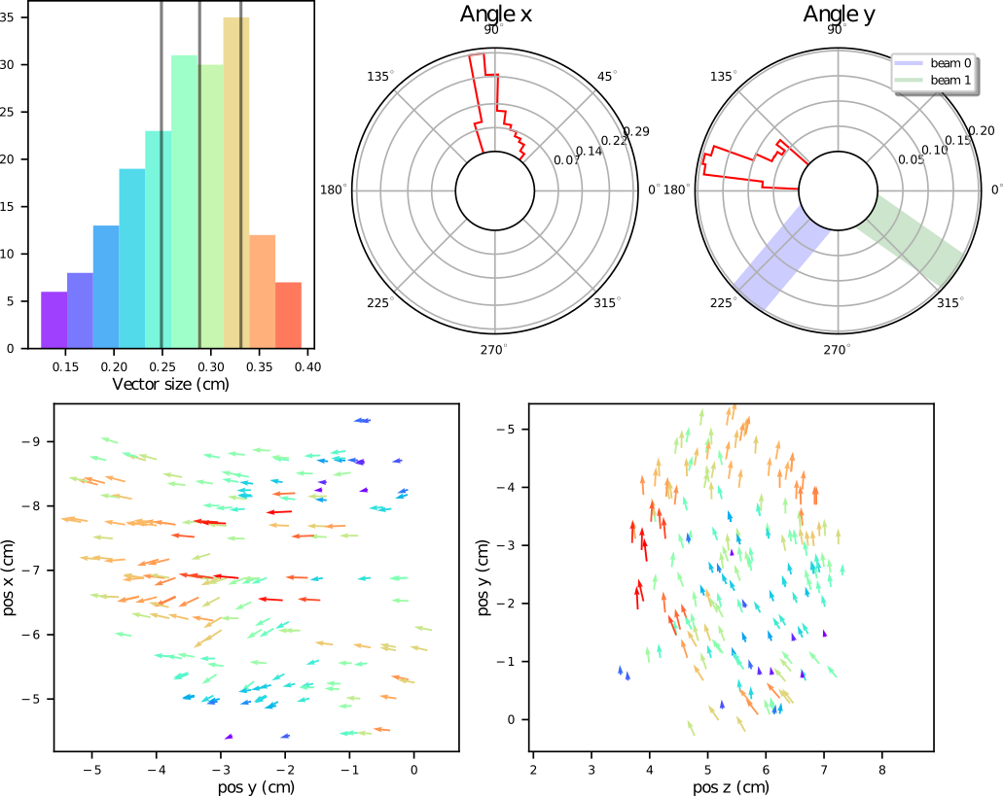
Figure A2: Same as figure A1, but for patient 4 at CBCT 1. | 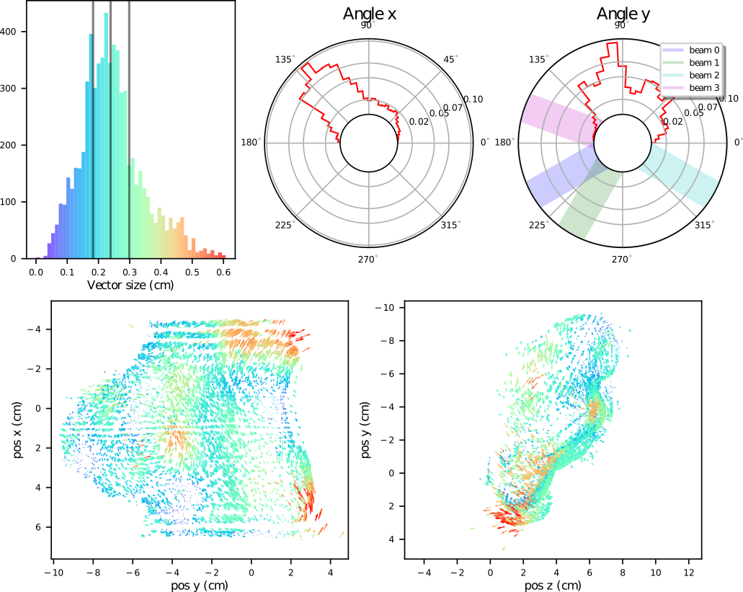

Figures A3 and A4 show the effect of the deformations of patient 9 and 4 (scan 1) on the energy of the beamlets (top panels) and the beamlet’s weight correction performed by the weight tuning method (bottom panels). Please, see the captions for the interpretation of each element in the figure.
The beamlet’s energy changes of patient 9 in this scan were approximately between -6 and 0 MeV, with an average energy loss per layer of about 3%, which indicated a decrease in the radiological depth of the patient. The small cold/hot spots in the target created by the beamlet displacements (seen in figure A1) and the effects of the energy changes (seen in the top panels of figure A3) were solved by the weight tuning method, while minimizing the dose to OARs. The weight changes were plotted in the bottom panels of figure A3. Most beamlet’s weight change ratios were kept at 1, by definition of the method, since it only tuned the weights of a subset (bottom-left panel). The tuning method mostly changed the weights of the most energetic layers (bottom-right), also by definition, since it selected the higher weighted beamlets, which are usually among the most energetic.
On the other hand, figure A4 shows the plan for patient 4 underwent bigger changes at scan 1. The beamlet’s energies changed from -15 to 25 MeV, approximately. On the top-left panel, it can be seen that at the beginning of the layers, the spots tended to lose energy, while they gained energy towards the end of the layers. The beginning and ends of the layers correspond to specific regions of the target, which means that some lost radiological depth, while others gained. The median energy change was, however, close to 0. Most beamlets did not experience weight tuning, so the ratio was 1 for the majority. Some beamlets were rejected, while others were given ~4.5-5 times the number of initial protons (bottom panels). Contrary to the previous case, the weight tuning was applied to beamlets belonging to less energetic layers.

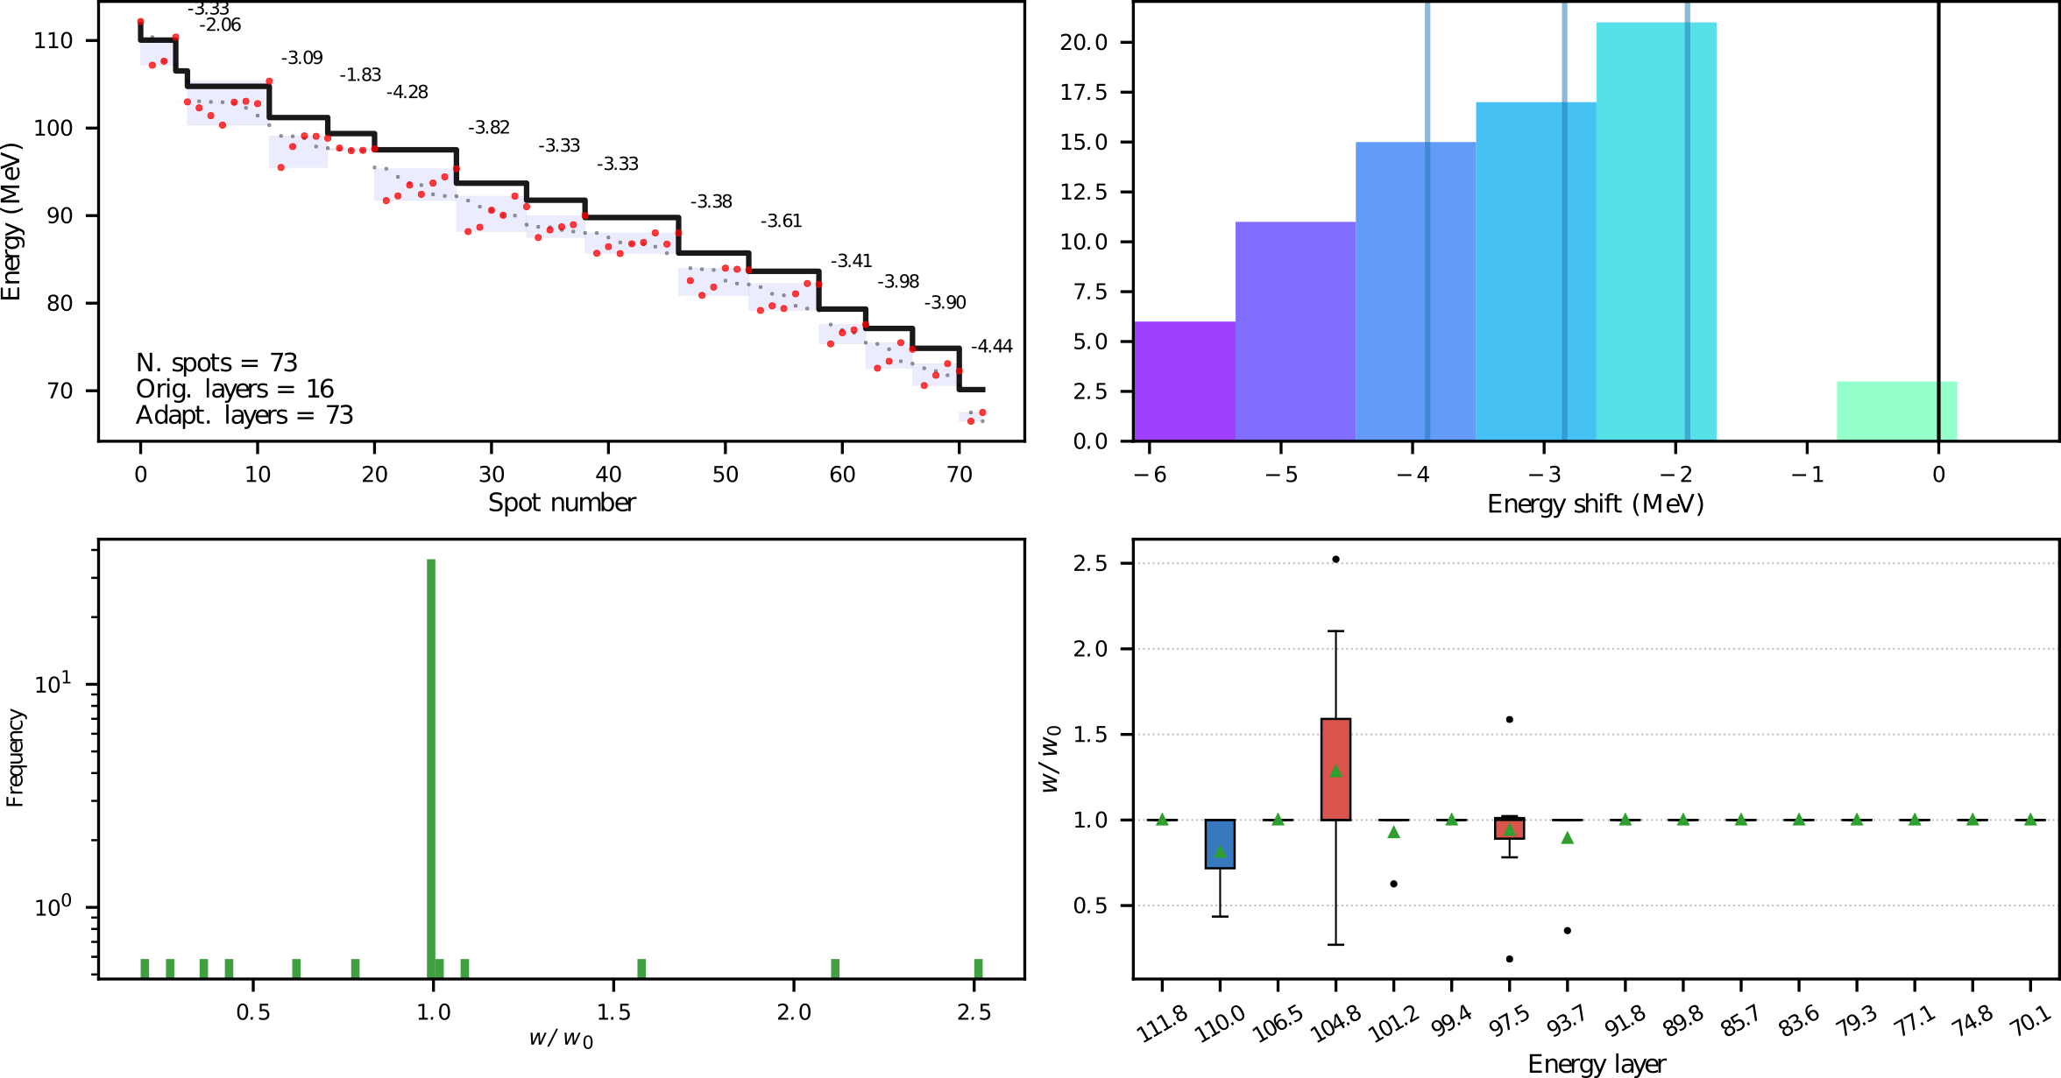
Figure A3: Beamlet’s energy and weight changes of patient 9 at CBCT 1. Top-left: Energy of each beamlet (spot). The original plan in black, showing the 9 energy layers, in red the new energies after the geometrical method, in light gray, the new energies in descendant order, the numbers represent the % change of the new average energies of the beamlets previously forming a layer. Top-right: Histogram of the energy change, the lines show the 1st, 2nd (median) and 3rd quartiles. Bottom-left: Histogram of the weight scaling factor after the weight tuning (most beamlets are unchanged). Bottom-right: Boxplots of the weight scaling factors as a function of the original energy layers. The boxplots follow the explanation given at the end of the methodology section, the top-bottom hinge distance might be 0, the mean is shown by the triangle.
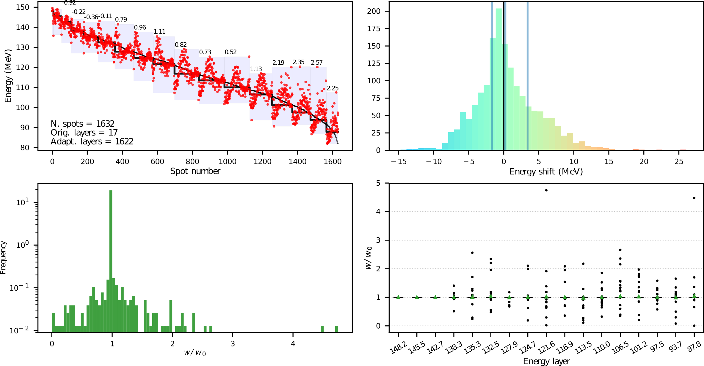
Figure A4: Same as figure A3, but for patient 4 at CBCT 1.

NVIDIA GPU Grant Program: https://developer.nvidia.com/academic_gpu_seeding

