Backup

Apartado 1

Apartado 2



Da error porque largo se soluciona si no largo

Apartado 3

Consulta sobre todos los valores que no permiten Null pero tienen Null por defecto





En la izquierda confirmamos que ha sido creado, y luego intentamos acceder en la derecha.

Apartado 4

Apartado 5

Apartado 6

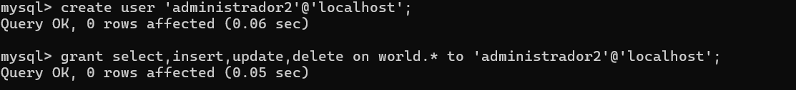

Apartado 7



Apartado 8

Apartado 10

Apartado 11

Servidor de Pablo :

Conexión desde ordenador de Pilar

Cambio de nombre:



Servidor local:

Remoto:

