**Coding Problem** **Fundamentals**

**Task: Make all test pass by completing the functions in Fundamentals.swift**

1. To get started, run all the test cases by clicking on the “run” button in CodingFundamentalsTests class:



1. Open Fundamentals.swift and start with problem #1
2. Run the test cases again to see if you succeeded in solving the problem.
3. Solve all problems

Tips for Solving Coding Problems:

1. Understand and Analyze the Problem
2. Go through the sample inputs and tests thoroughly. You can figure out a lot from looking at the test cases:

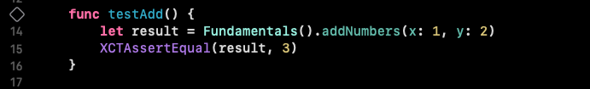

You can see exactly what the test is expecting as a result given x = 1 and y = 2

1. Break down the problem:

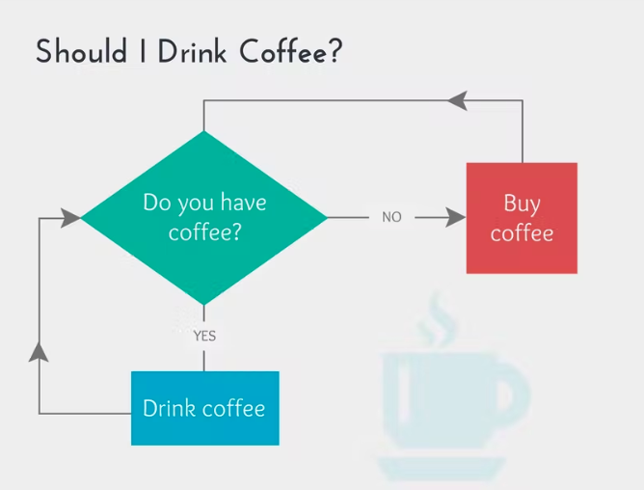

1. Start solving/coding